E.SRIHARI

192124168

1. **DATA PREPROCESSING AND PREPARATION FOR KNOWLEDGE ANALYSIS USING WEKA.**

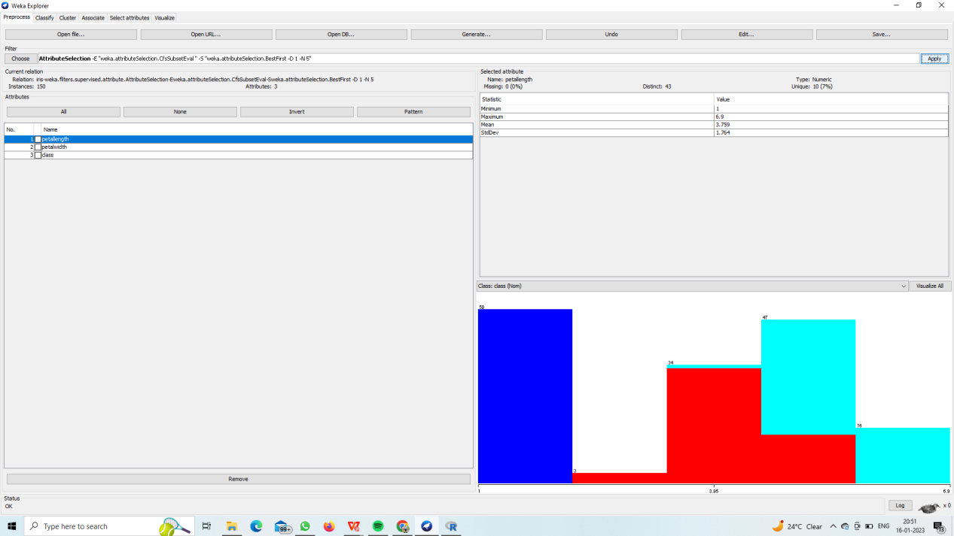

**2.K-MEANS CLUSTER ANALYSIS USING WEKA.**

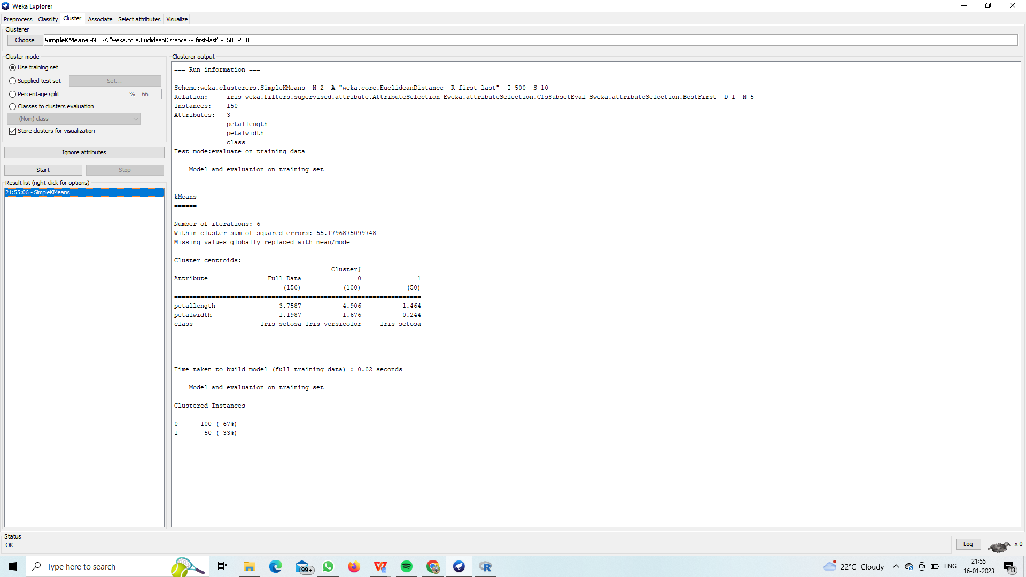

**3.DATA ANALYSIS BY COBWEB-HIERARCHAL CLUSTERING ALGORITHM USING WEKA.**

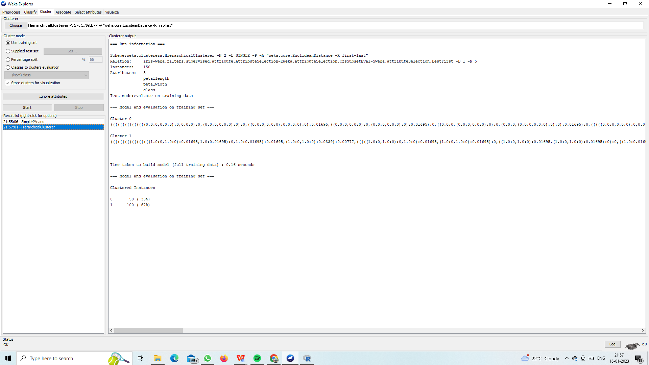

1. **KNOWLEDGE MINING USING ASSOCIATION RULE USING WEKA.**

APRIORI:-

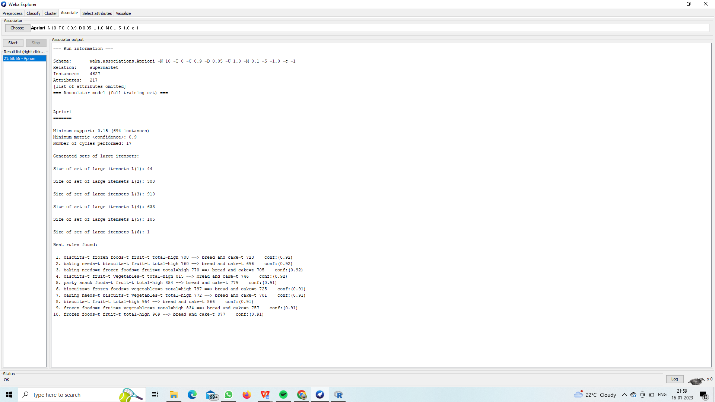

FILTERED ASSOSIATOR:-

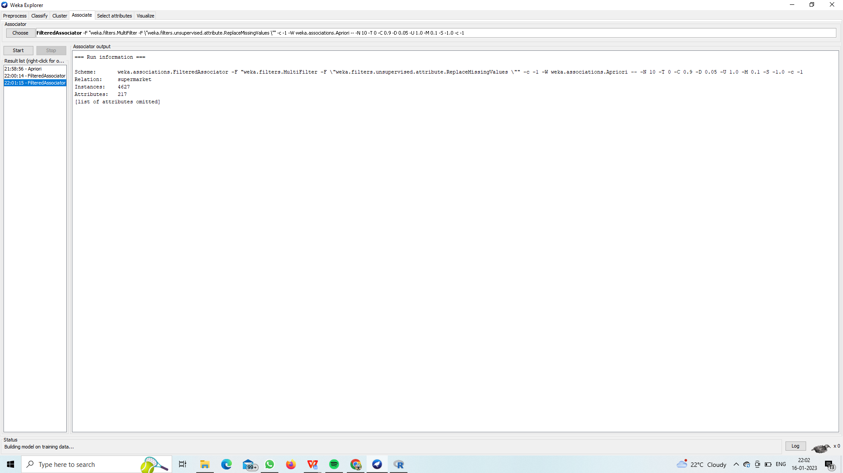

FP GROWTH:-

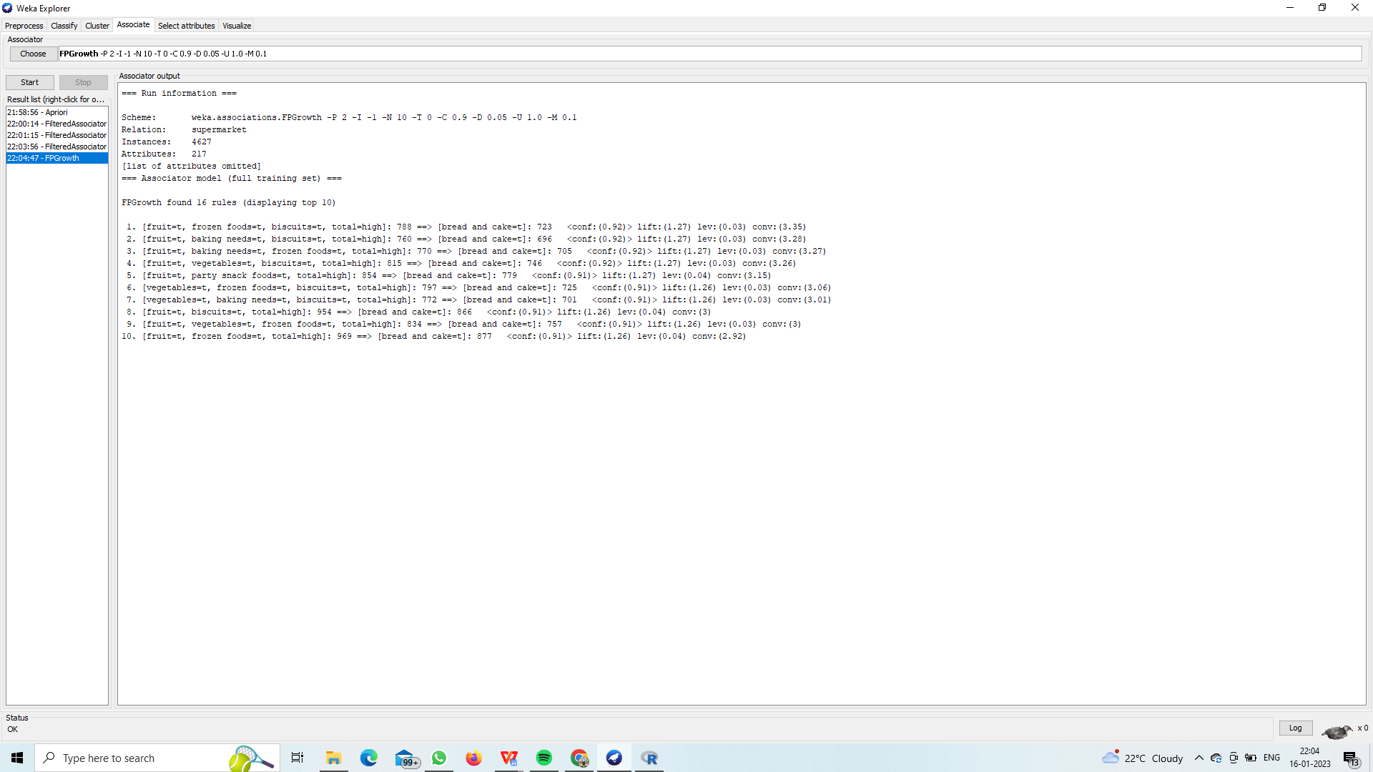

1. **FP GROWTH ALGORITHM USING WEKA.**



1. **PREDICTION OF CATEGORICAL DATA USING DECISION TREE ALGORITHM USING WEKA.**

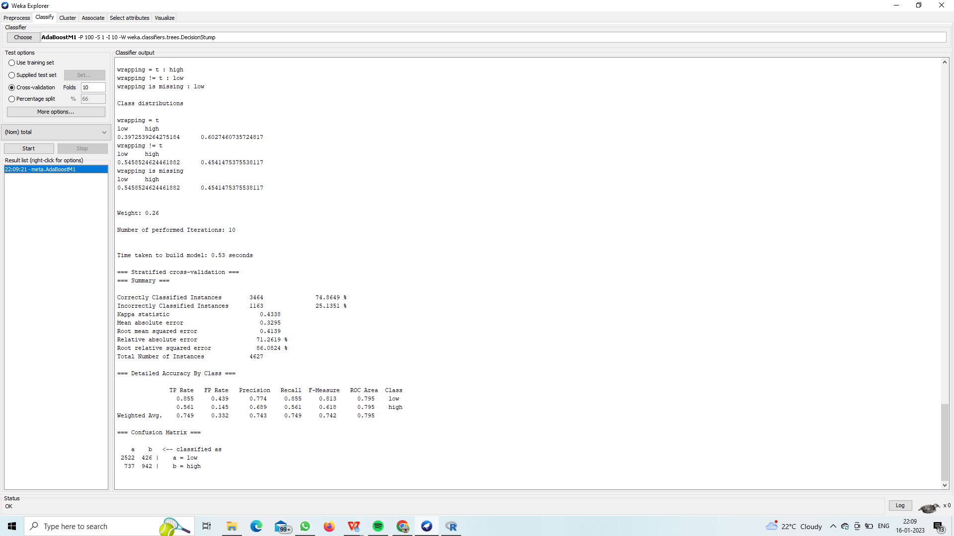

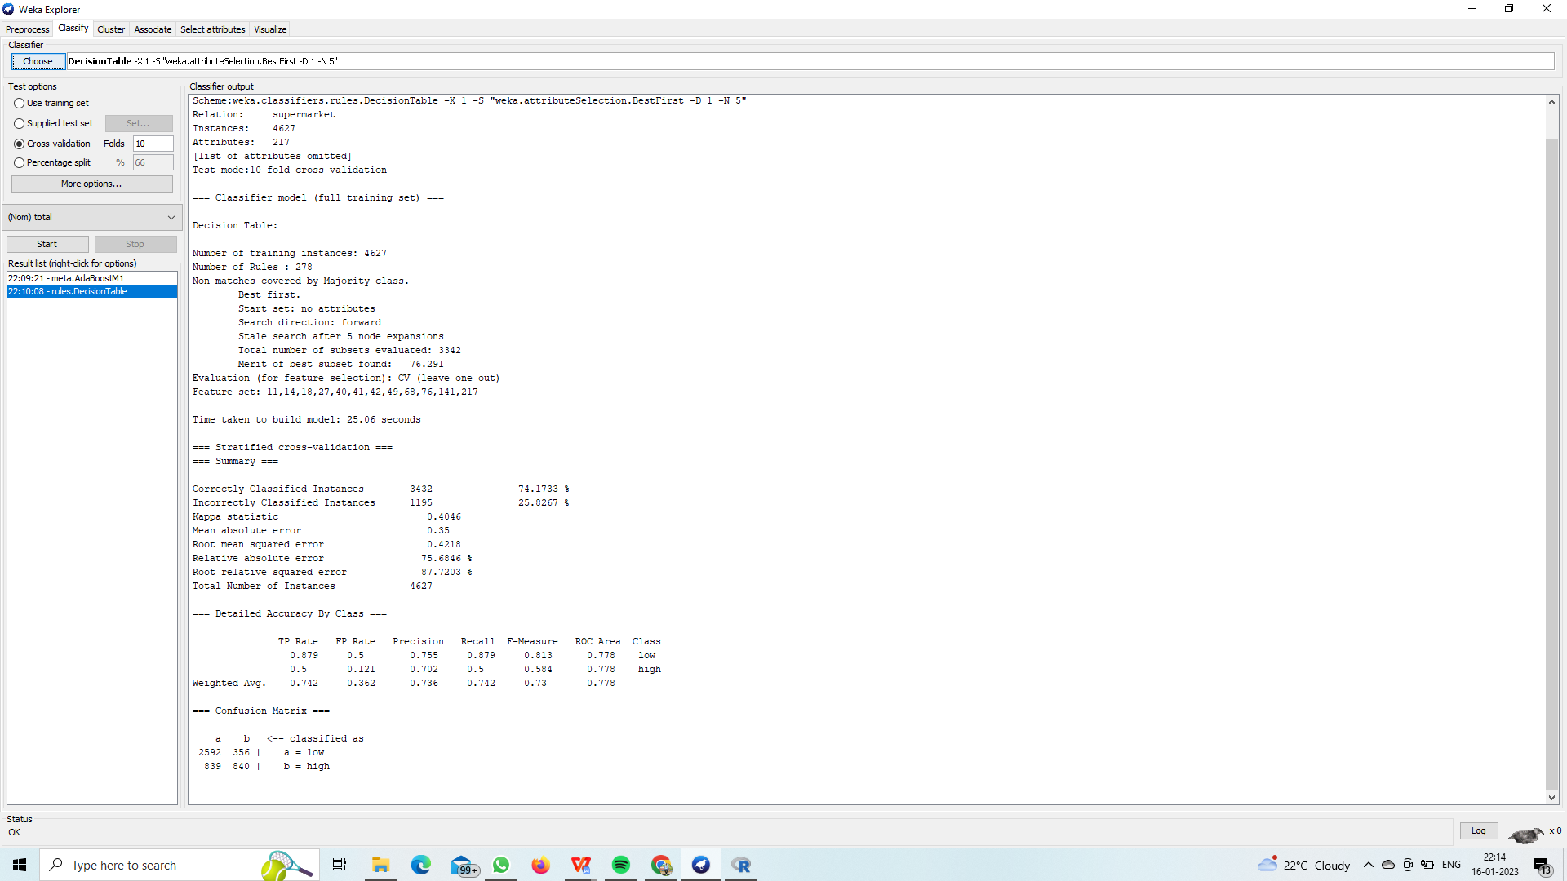

1. **EVALUATING THE ACCURACY OF THE CLASSIFIERS USING WEKA.**

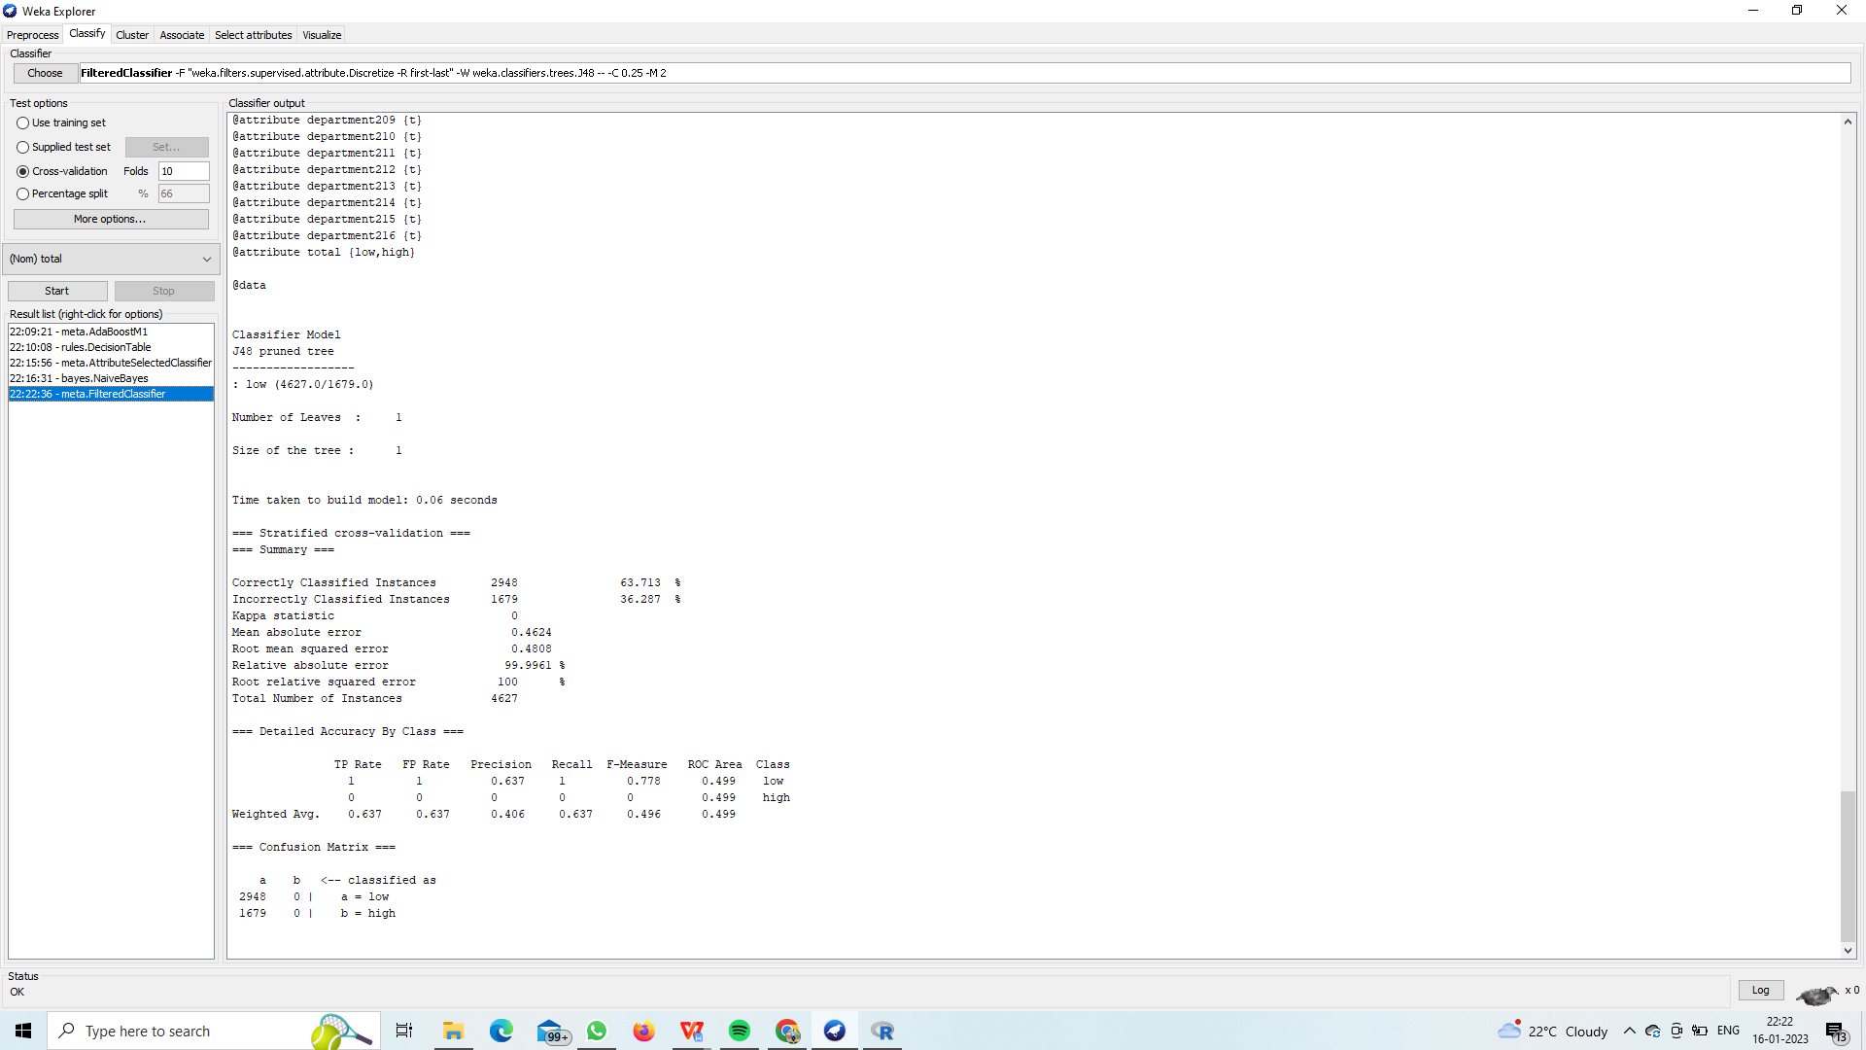

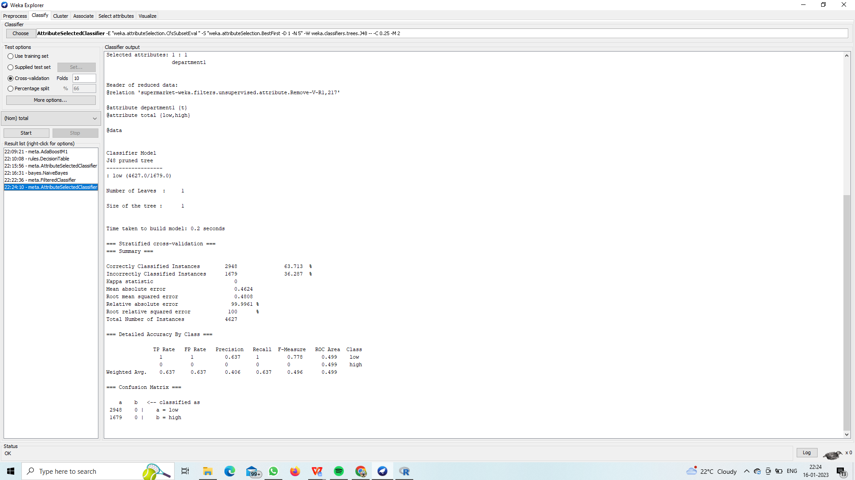

1. **PREDICTION OF CATEGORICAL DATA USING BAYESIAN ALGORITHM USING WEKA.**

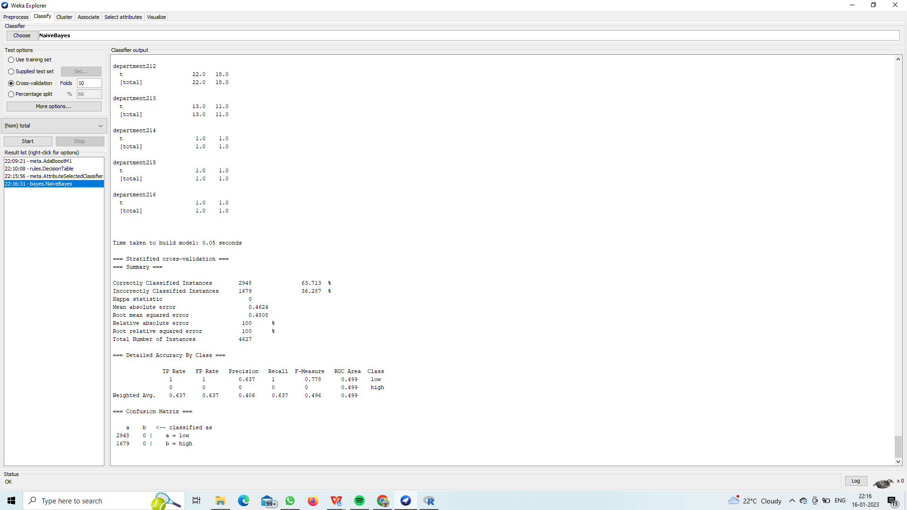

**9.DATA ANALYSIS BY DENSITY BASED CLUSTERING ALGORITHM USING WEKA.**

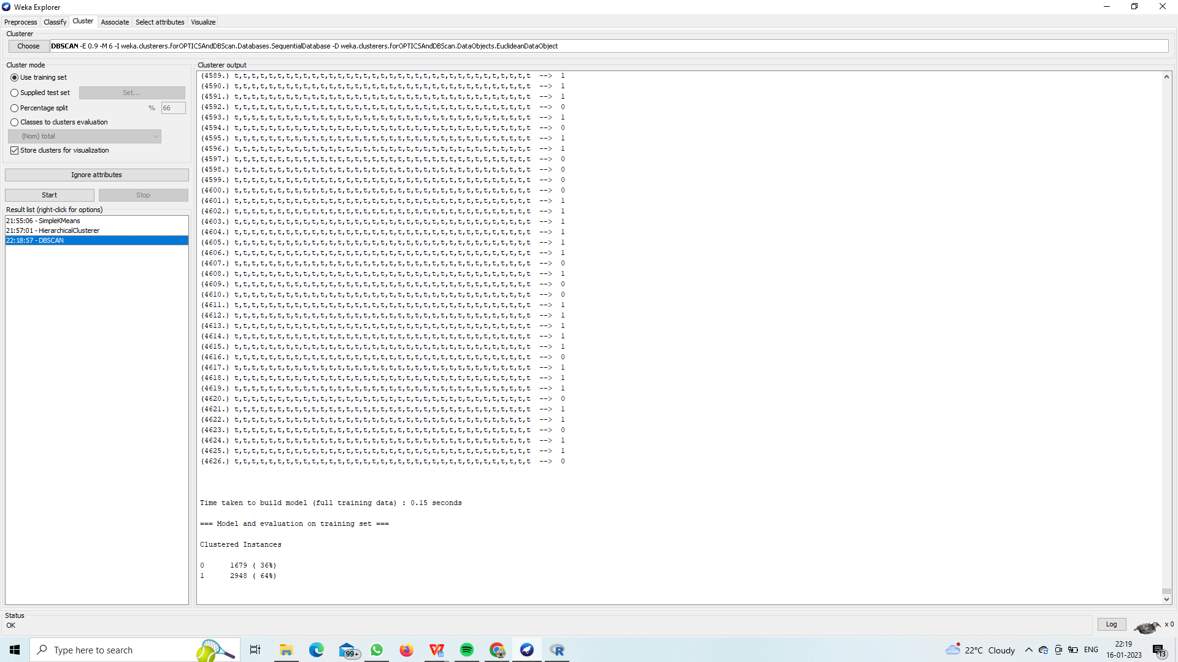

#### DATAPREPROCESSING (SUPERVISED)

ADDCLASSIFICATION:-

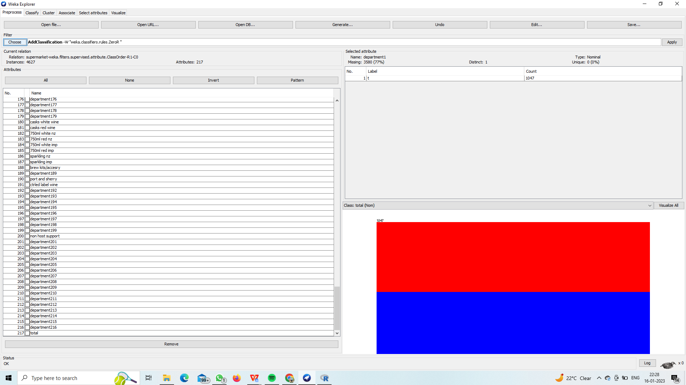

ATTRIBUTESELECTION:-

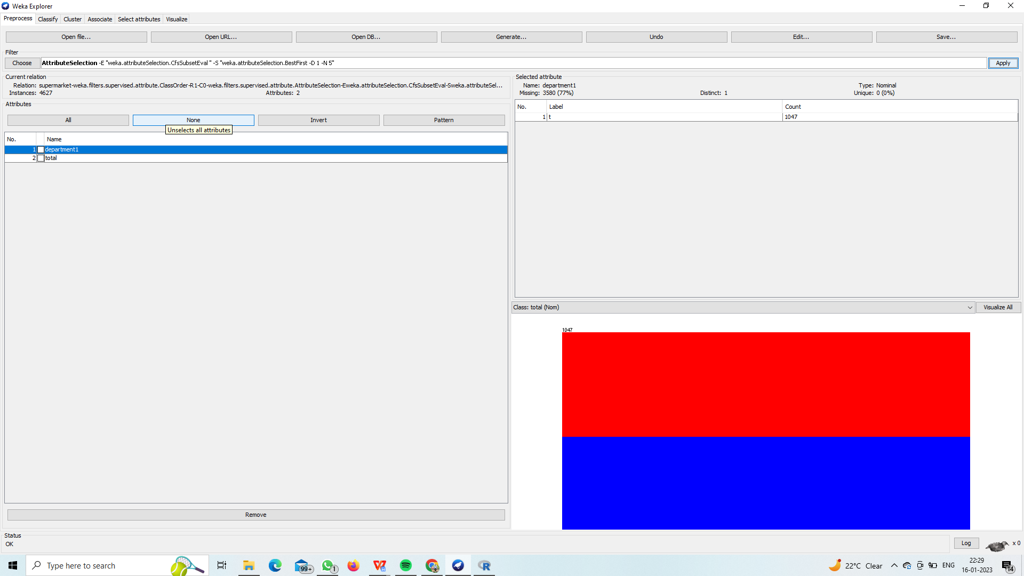

DISCRETIZE:-

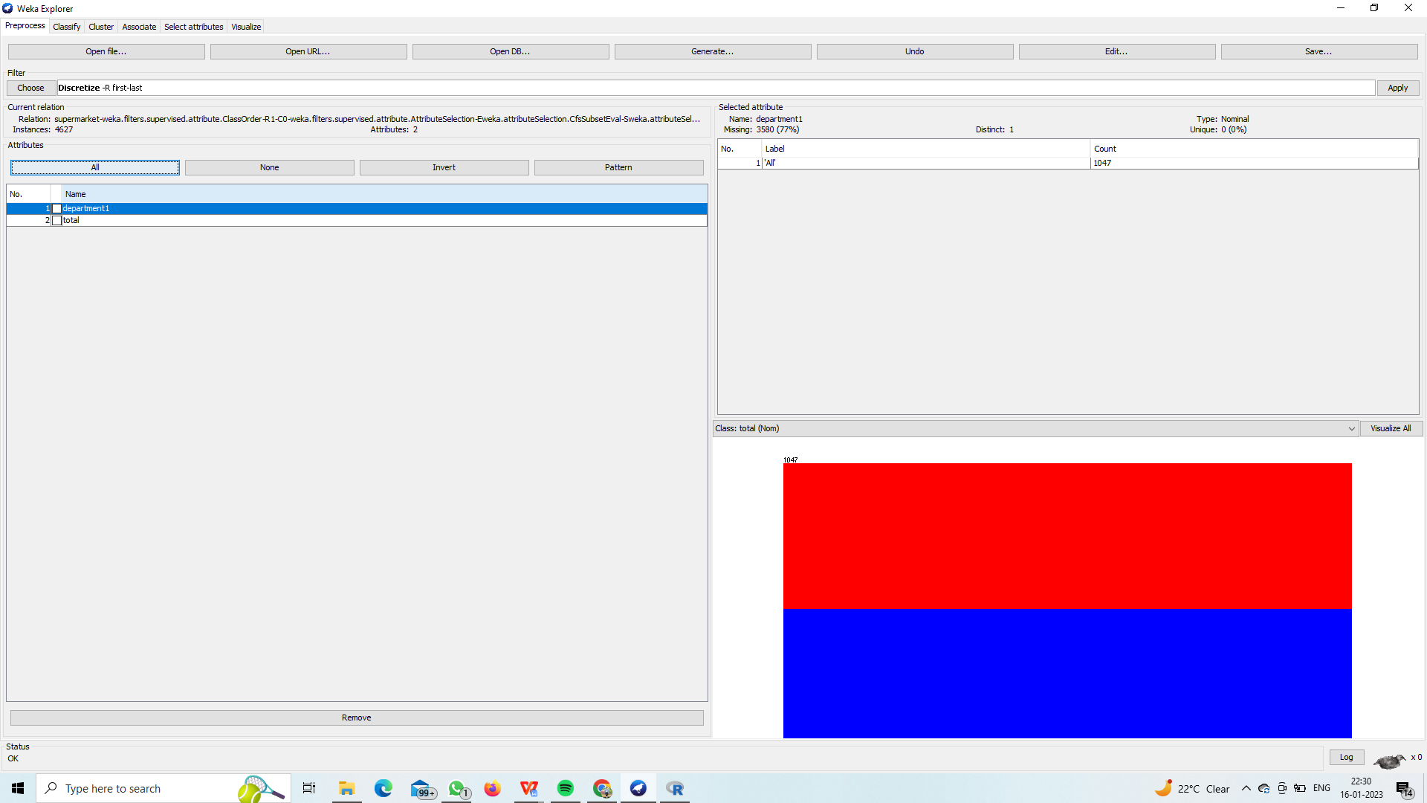

NOMINAL TO BINARY:-

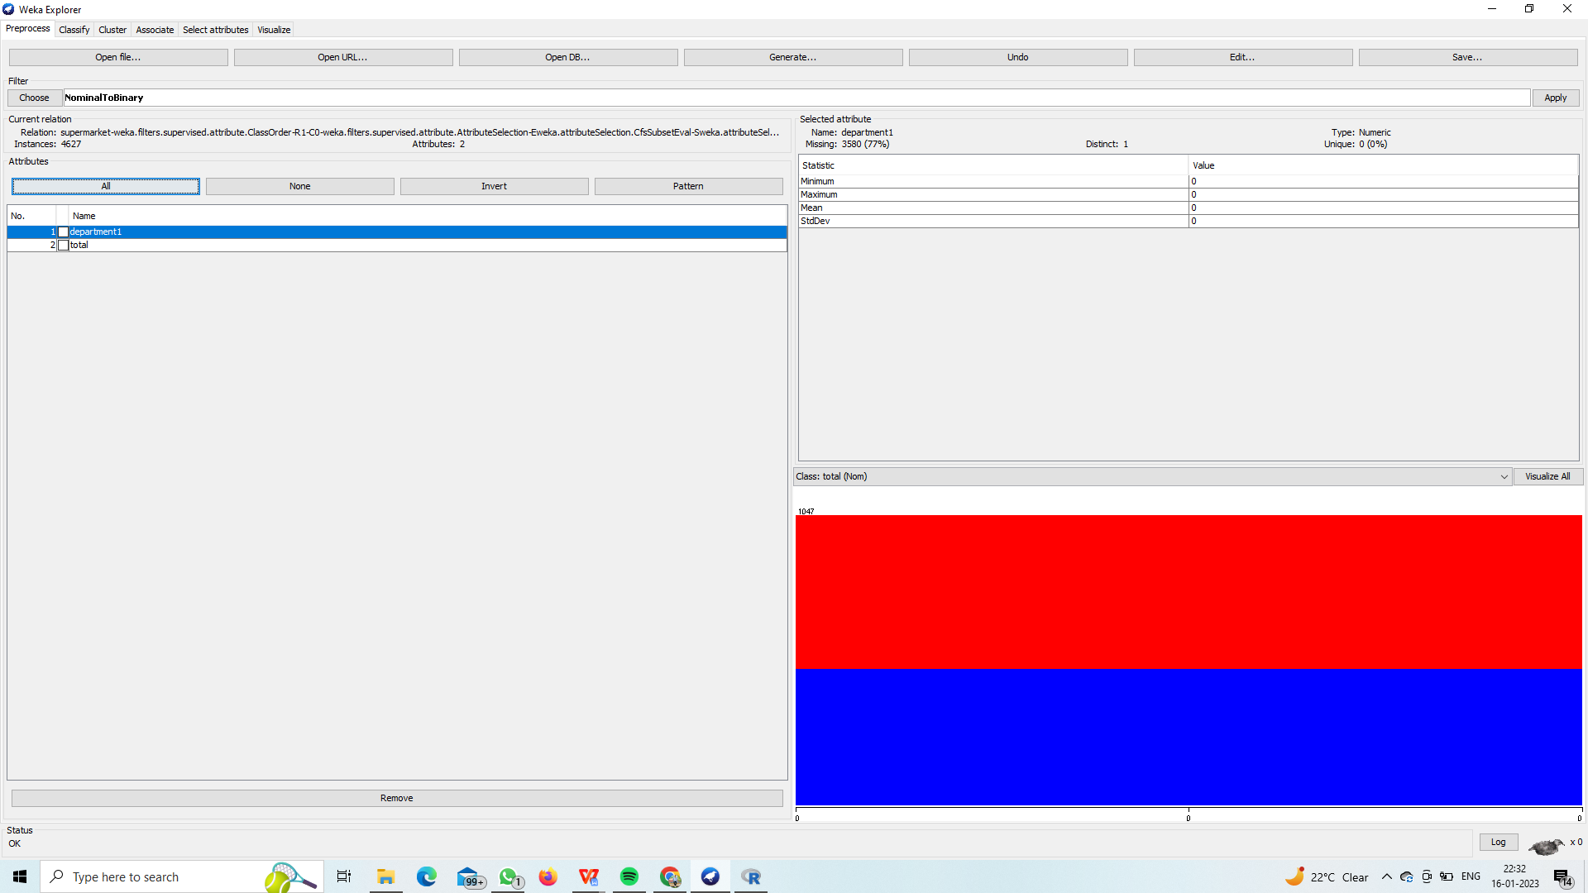

(UNSUPERVISED)

REPLACINGMISSING VALUES:-

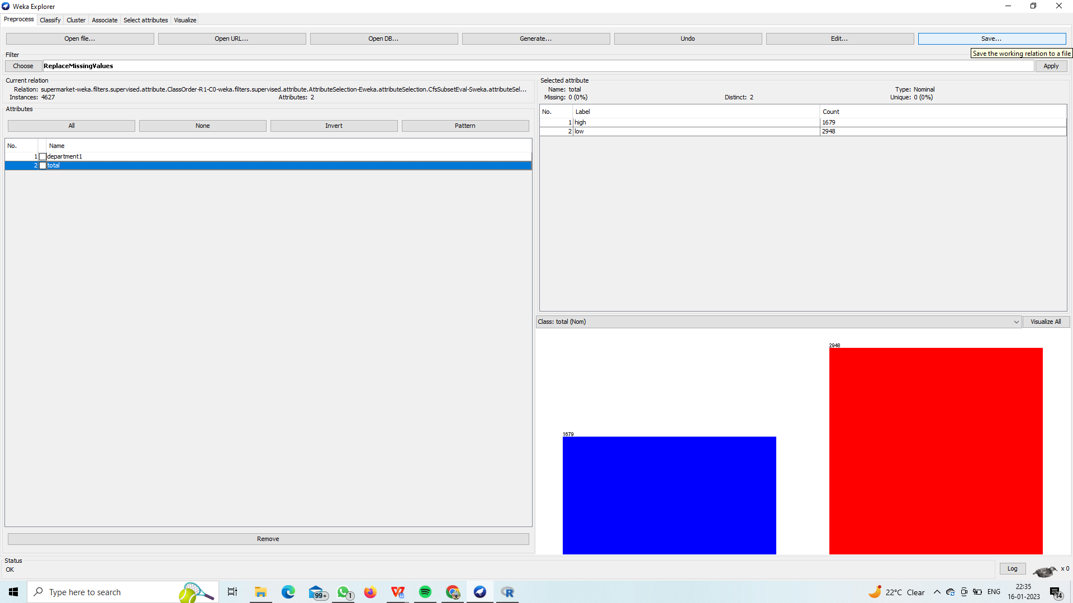

IQR:-

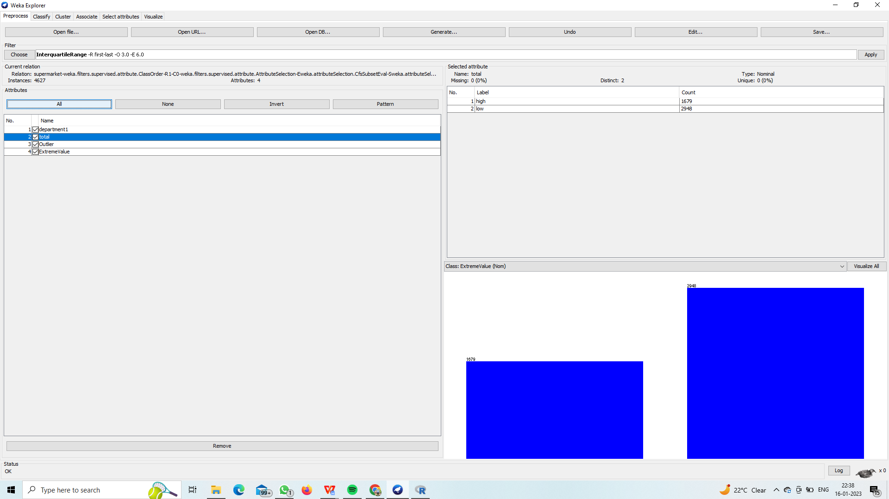

NORMALIZE:-

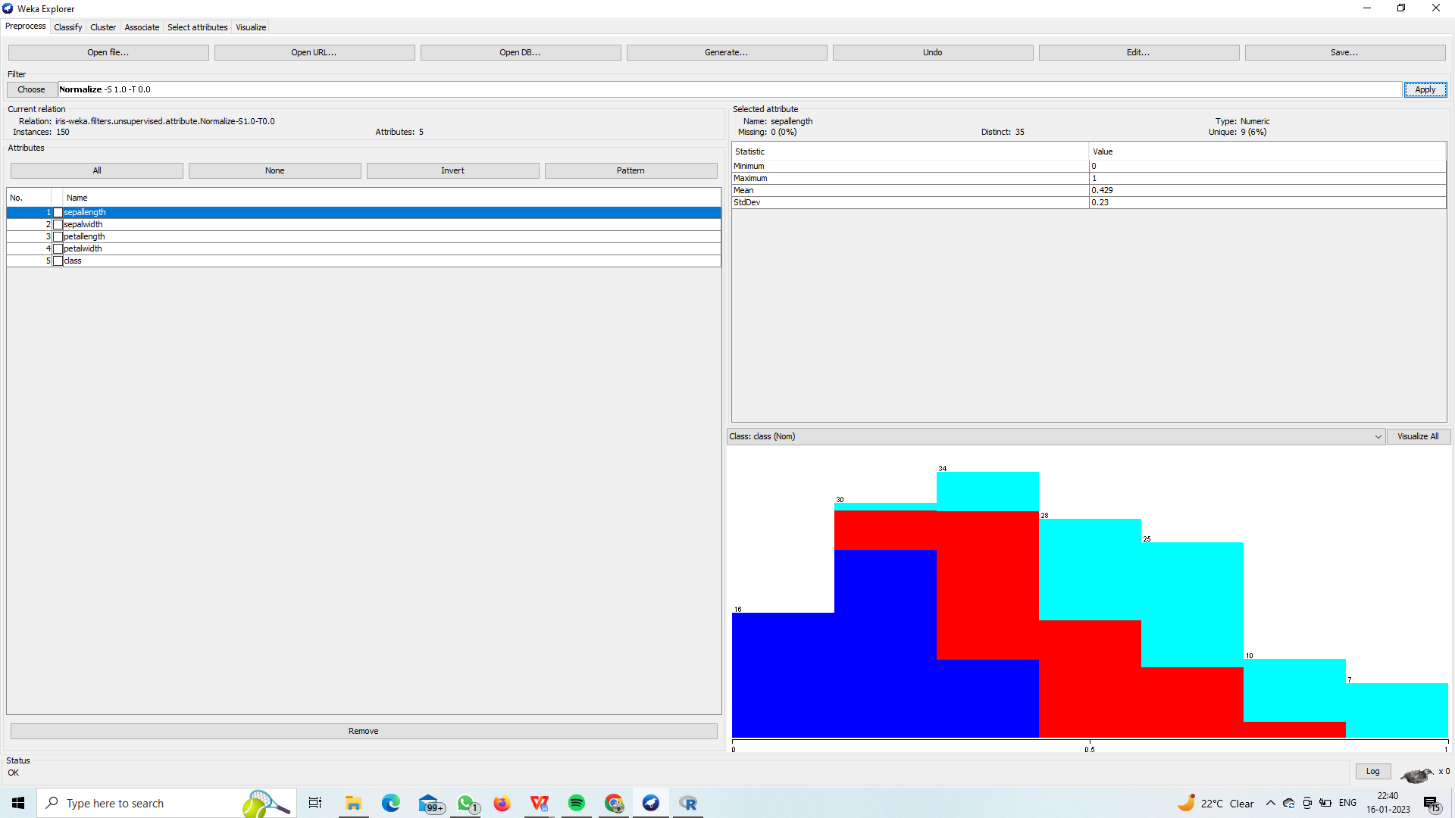

#### CLASSIFICATIONS:-

ATTRIBUTESELLECTION CLASIFIER:-\

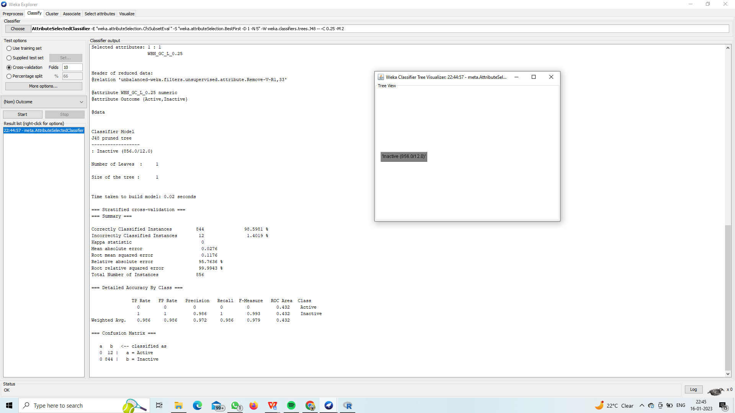

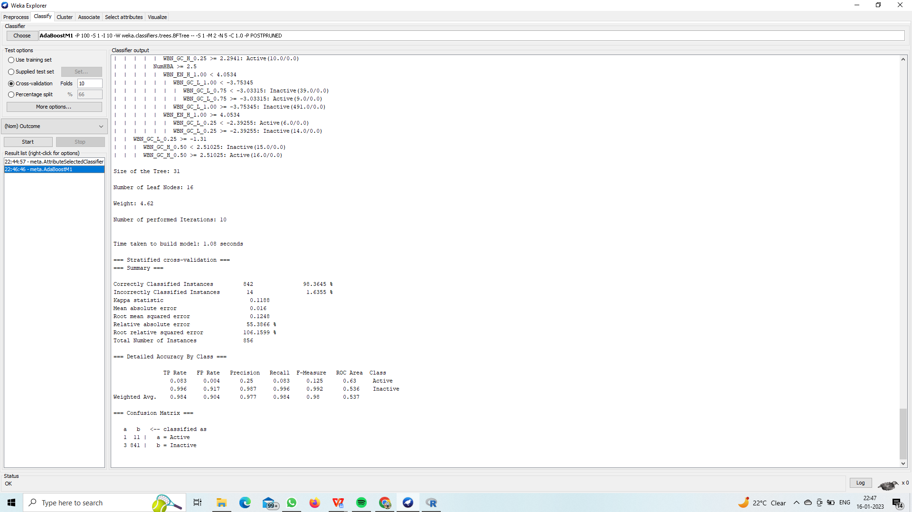

NAIVEBAYES:

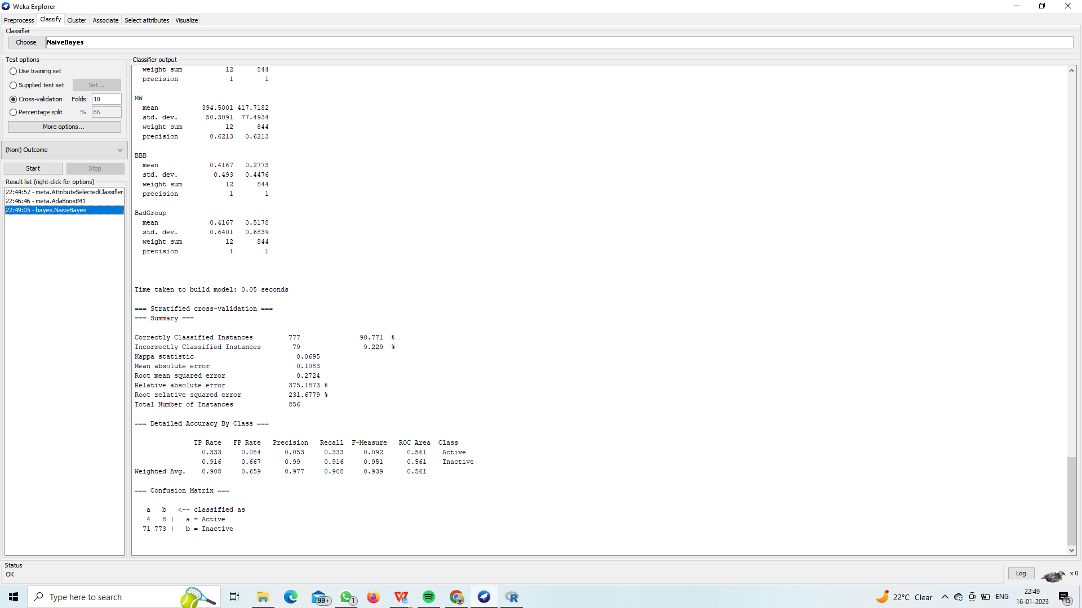

BE TREE:-

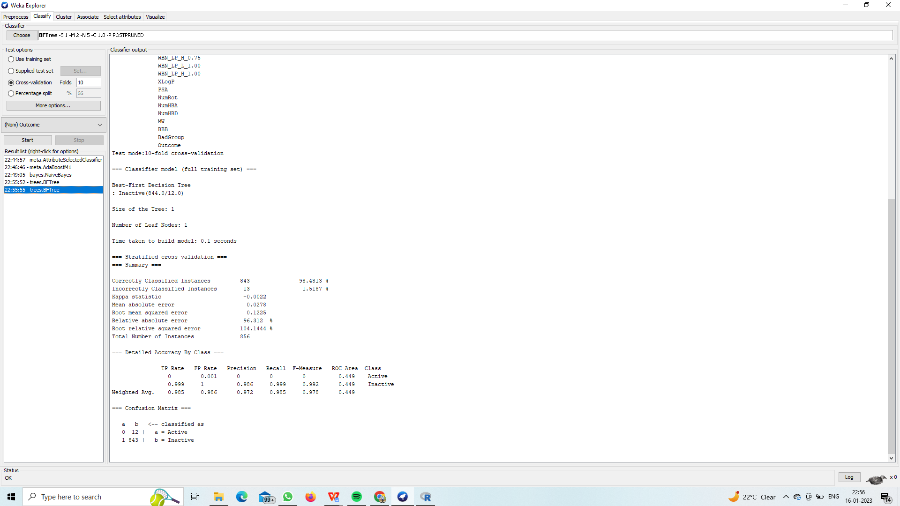

DECISION TREE:-

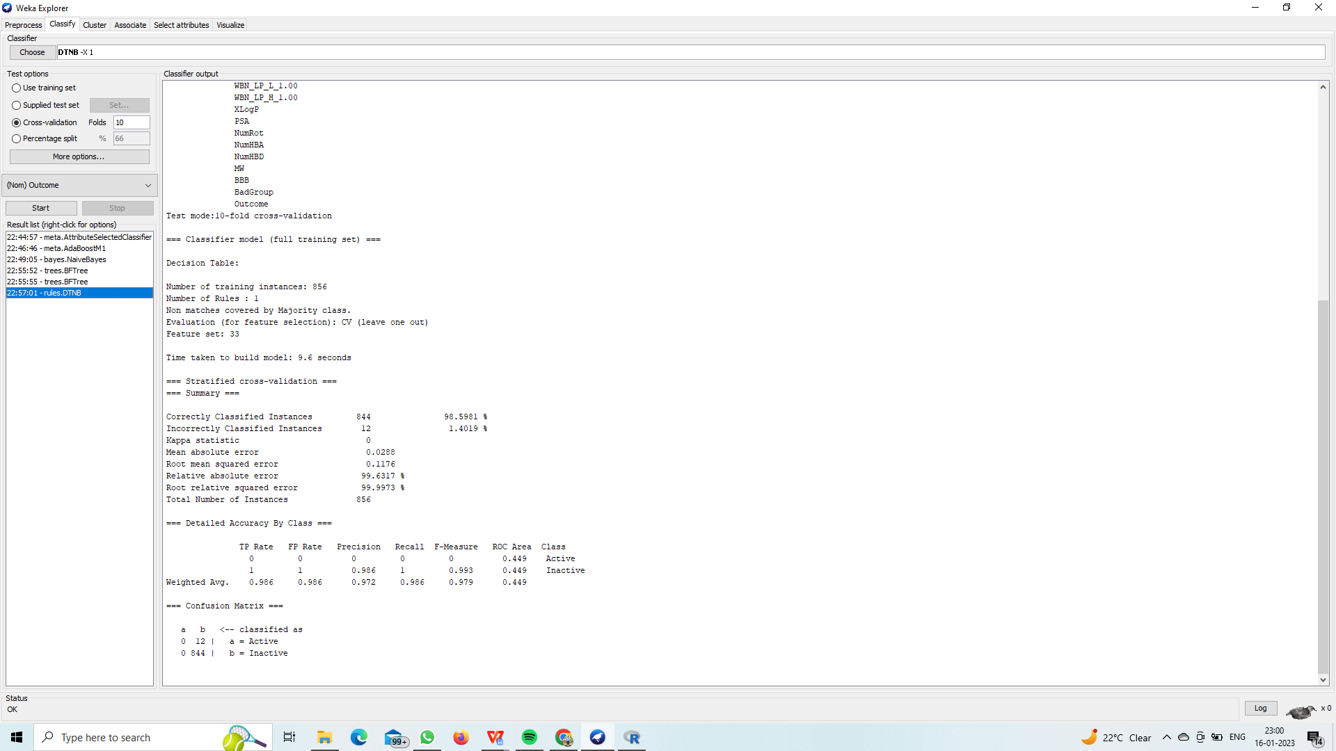

FILTERED CLSIFIER:-

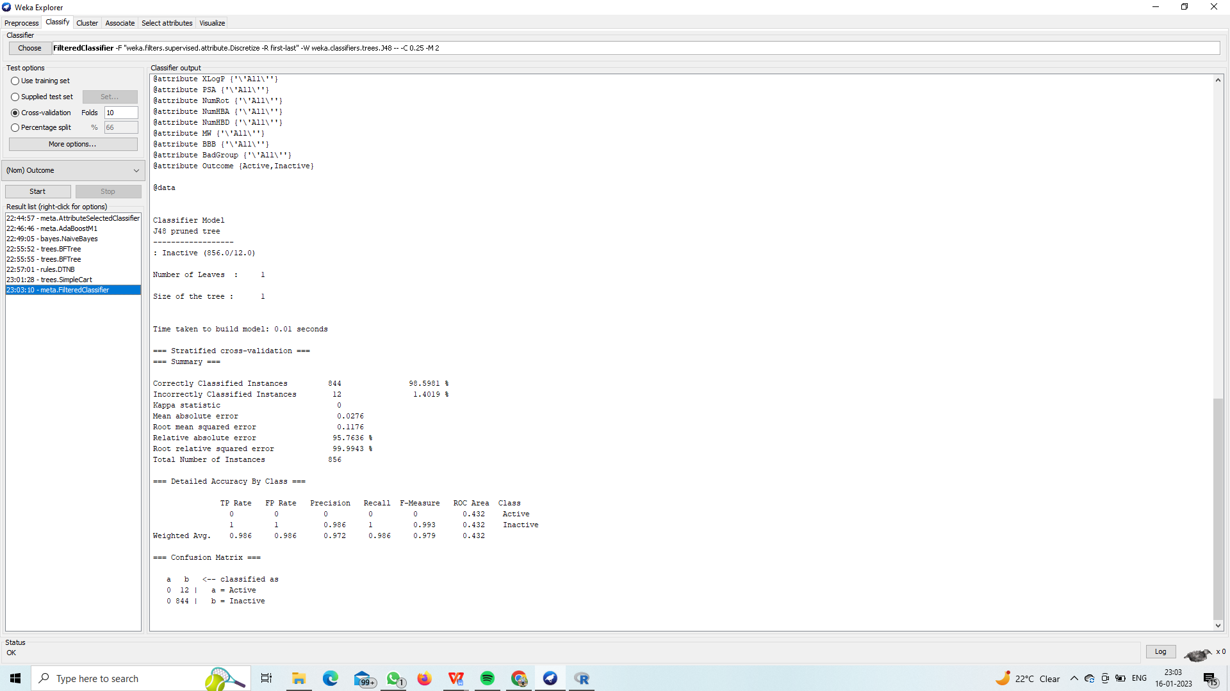

#### CLUSTRING:-

FILTERED CLUSTRING:-

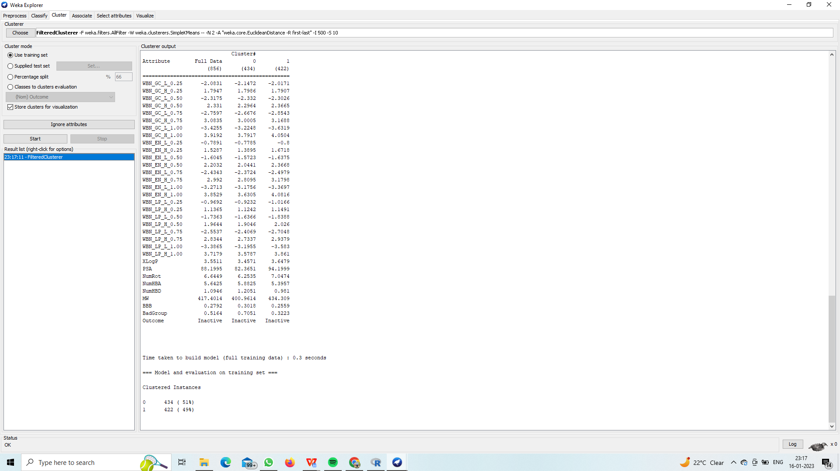

SIMPLEKMEANS:-

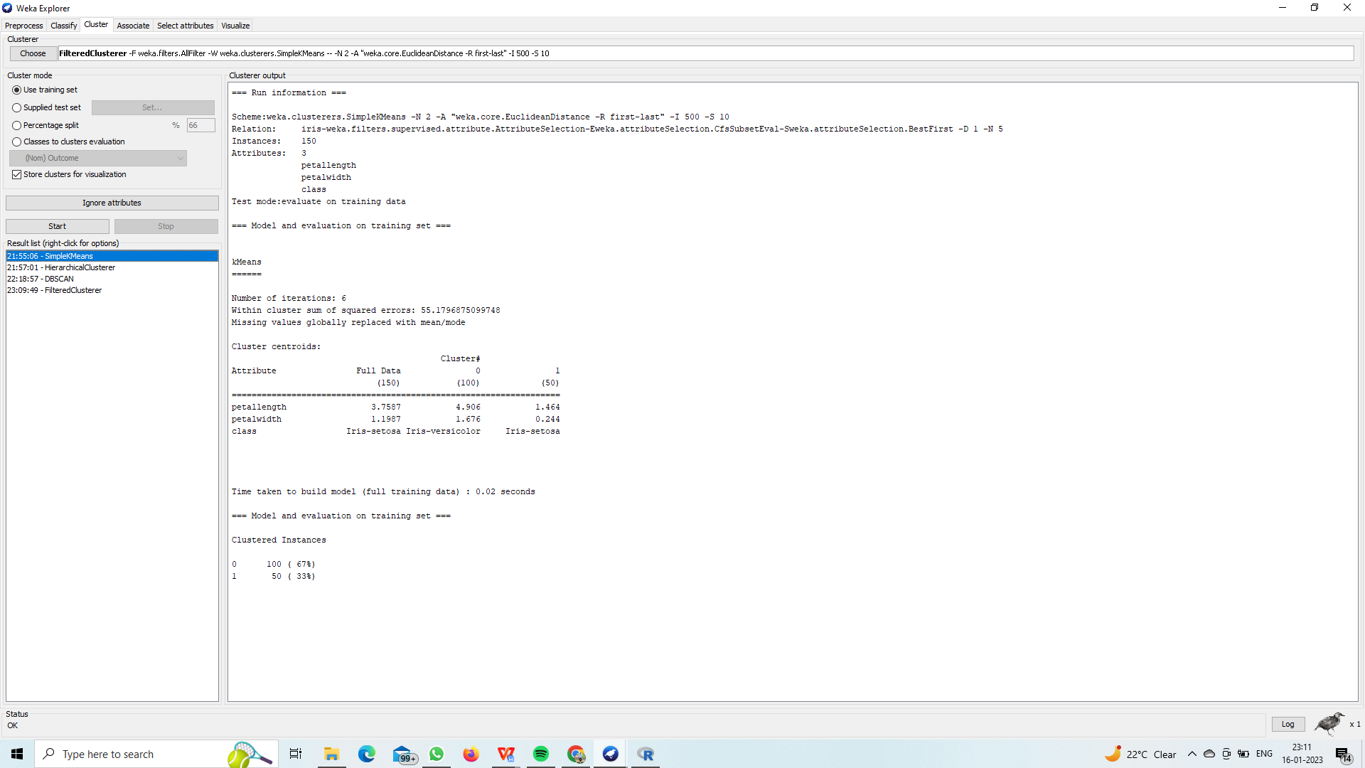

HIRARICHAL CLUSTRING:-

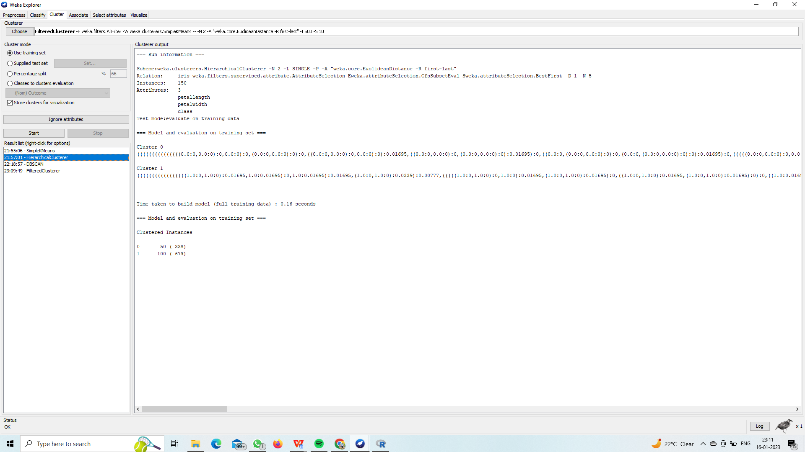

**ASSOCIATIVE:-**

APRIORI ALGORITHM:-

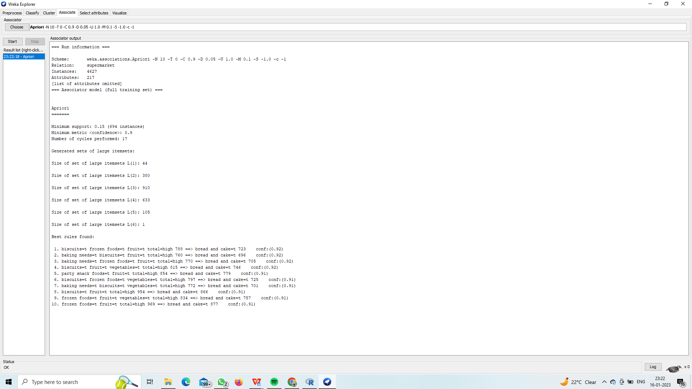

FP GROWTH ALGORITHM:-

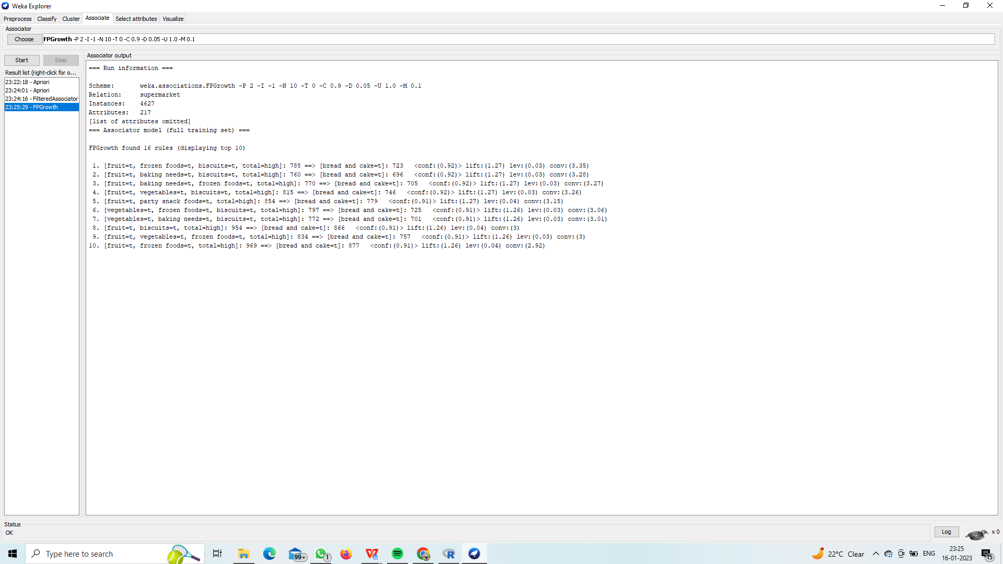

PREDICTIVE APRIORI:-

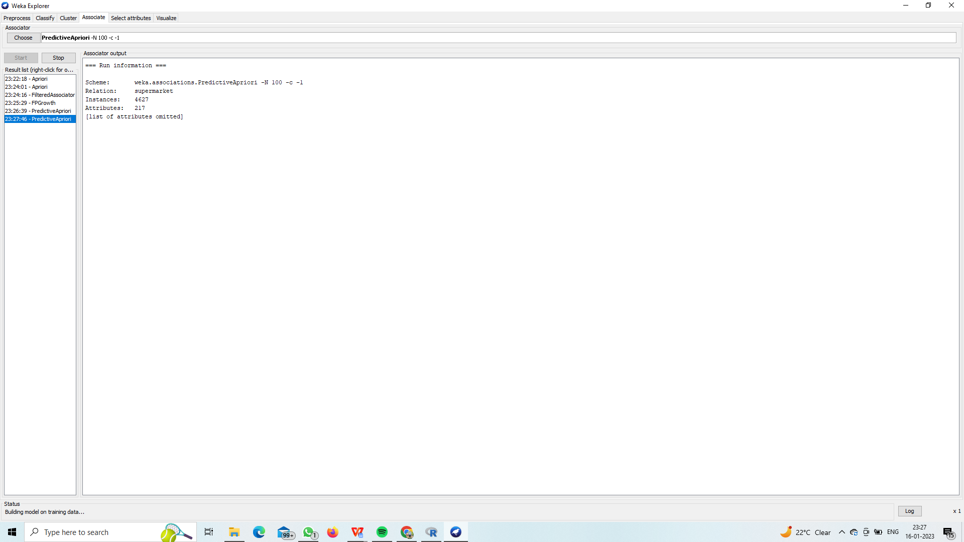

SELECTATTRIBUTES:

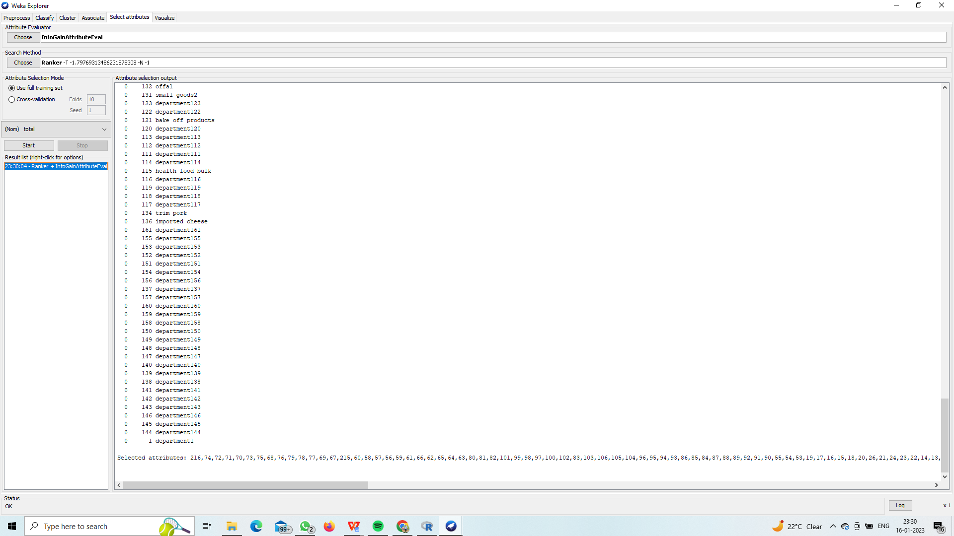

VISUVALIZATION:-

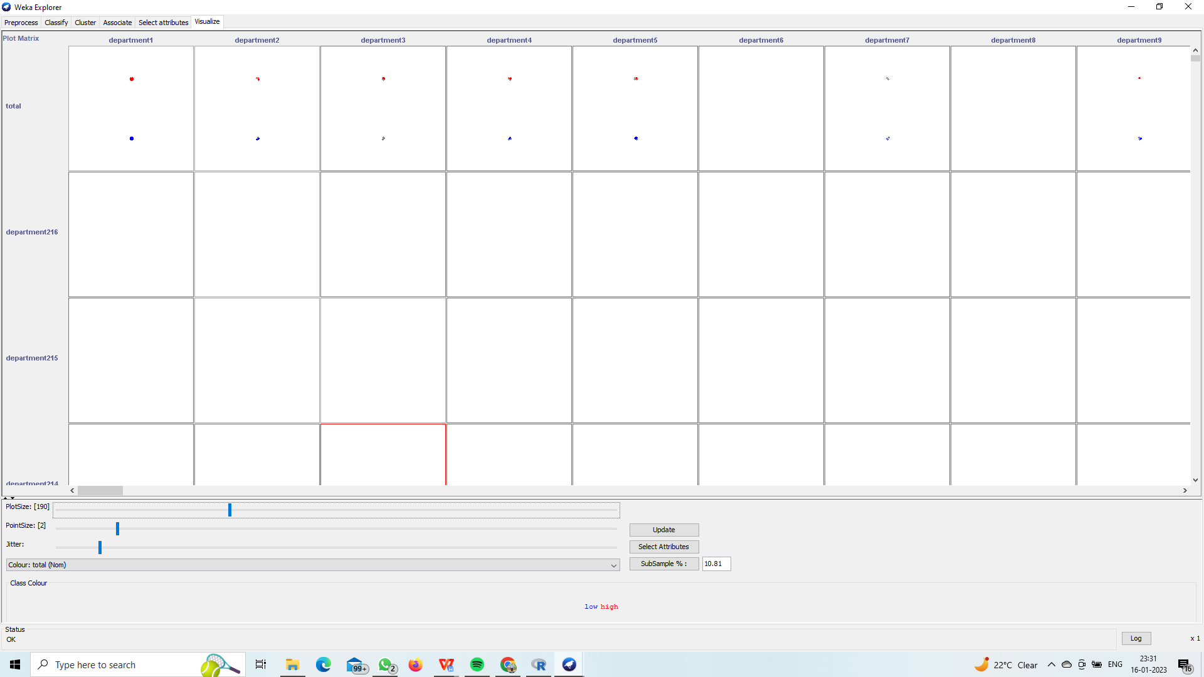

1. IN CLSSIFICATION,RANDOM TREE VISUVALIZATION.

