1. Write a program to print the names of students by creating a Student class. If no name is passed while creating an object of the Student class, then the name should be "Unknown", otherwise the name should be equal to the String value passed while creating the object of the Student class.

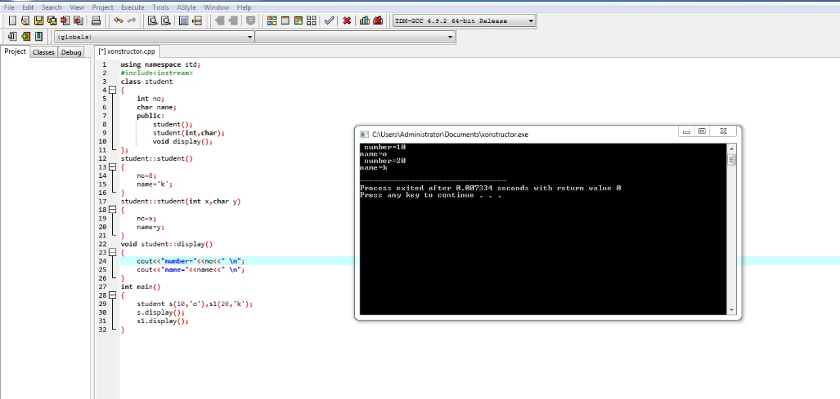

1. Create a class named 'Rectangle' with two data members- length and breadth and a function to calculate the area which is 'length\*breadth'. The class has three constructors which are :  
   1 - having no parameter - values of both length and breadth are assigned zero.  
   2 - having two numbers as parameters - the two numbers are assigned as length and breadth respectively.  
   3 - having one number as parameter - both length and breadth are assigned that number.  
   Now, create objects of the 'Rectangle' class having none, one and two parameters and print their areas.

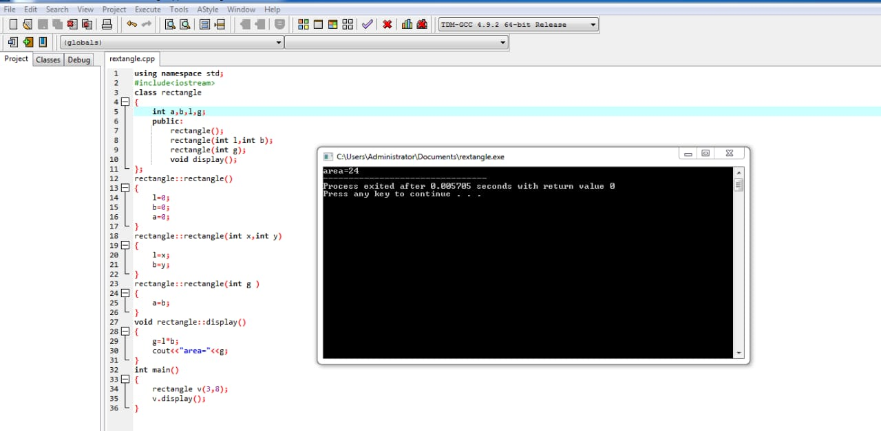

1. . Create a class 'AddAmount' with a data member named 'amount' with an initial value of $50. Now make two constructors of this class as follows:  
   1 - without any parameter - no amount will be added to the Piggie Bank  
   2 - having a parameter which is the amount that will be added to the Piggie Bank  
   Create an object of the 'AddAmount' class and display the final amount in the Piggie Bank.

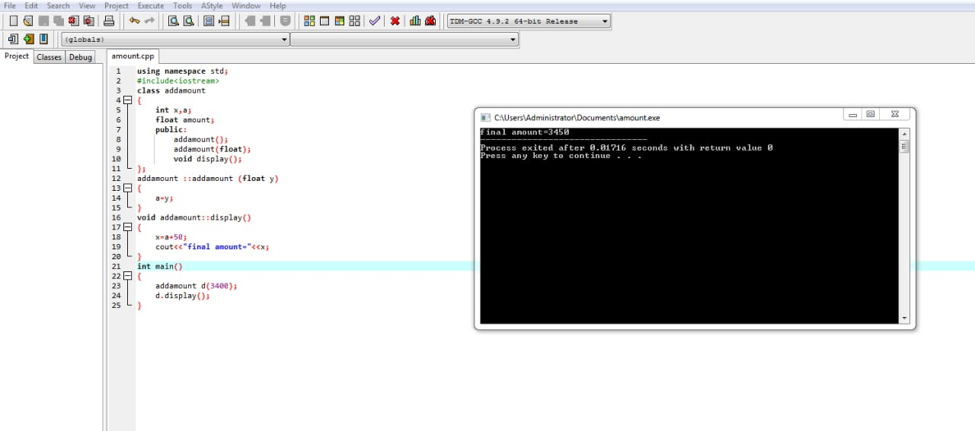

1. Create a class named 'PrintNumber' to print various numbers of different datatypes by creating different functions with the same name 'printn' having a parameter for each datatype.

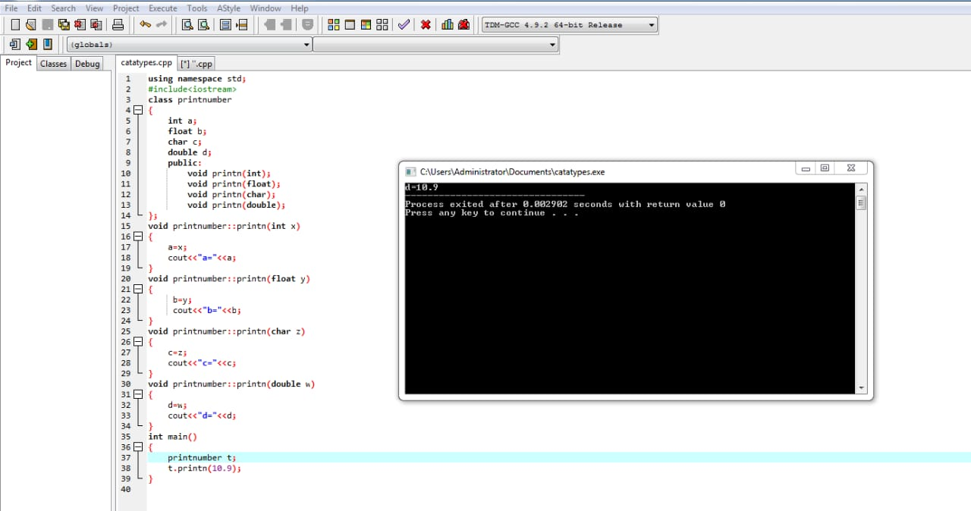

1. Create a class to print an integer and a character using two functions having the same name but different sequence of the integer and the character parameters.  
   For example, if the parameters of the first function are of the form (int n, char c), then that of the second function will be of the form (char c, int n).

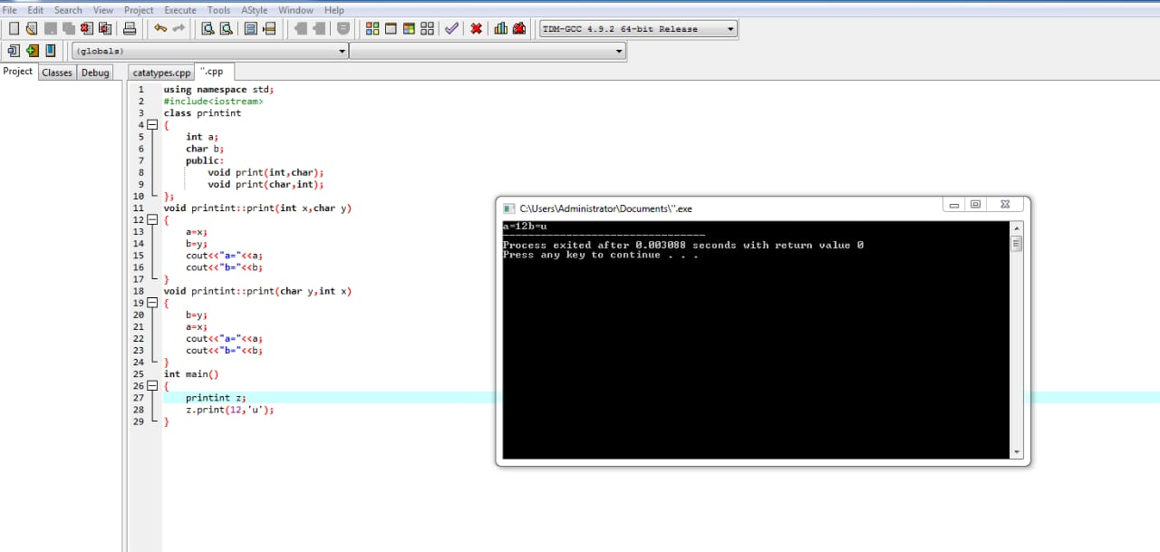

1. Create a class 'Student' with three data members which are name, age and address. The constructor of the class assigns default values to name as "unknown", age as '0' and address as "not available". It has two functions with the same name 'setInfo'. First function has two parameters for name and age and assigns the same whereas the second function takes has three parameters which are assigned to name, age and address respectively. Print the name, age and address of 10 students.  
   Hint - Use array of objects

