1.WRITE A C++ PROGRAM FOR THE SUM OF TWO NUMBERS USING CLASS AND OBJECT.USE THE GETDATA AND PUTDATA AS THE MUMBER FUNCTIONS.

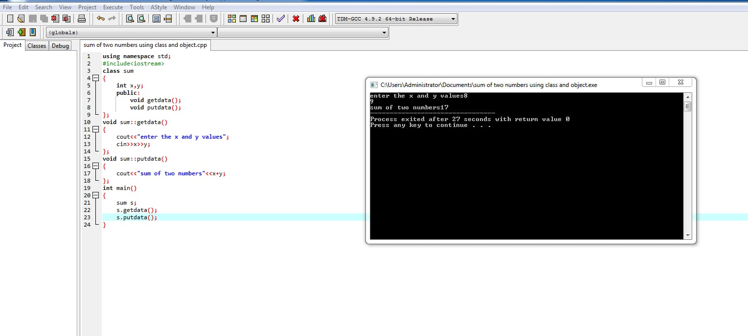

2.WRITE A C++ PROGRAMMING FOR FINDING THE BIGGEST OF 3 NUMBERS USING CLASS AND OBJECT.

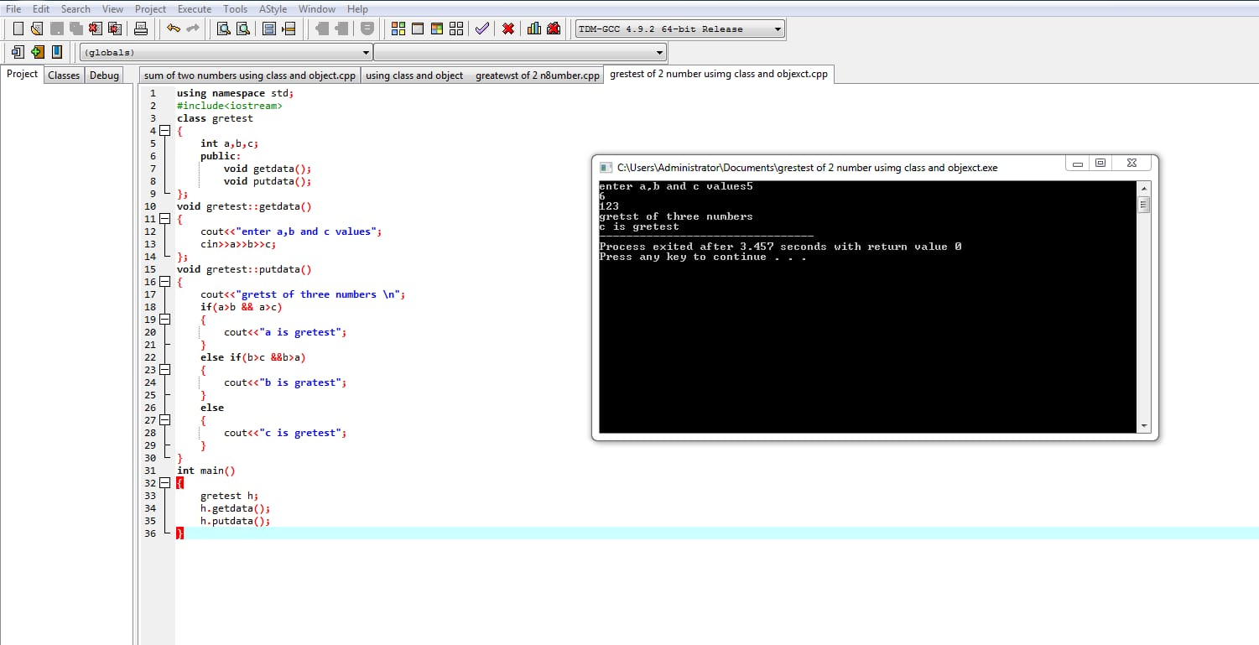

3.WRITE A C++ PROGRAM FOR STUDENTS DETAILS AND MARKS REPORT(MARKS AGGEGATION) USING CLASS AND OBJECT.

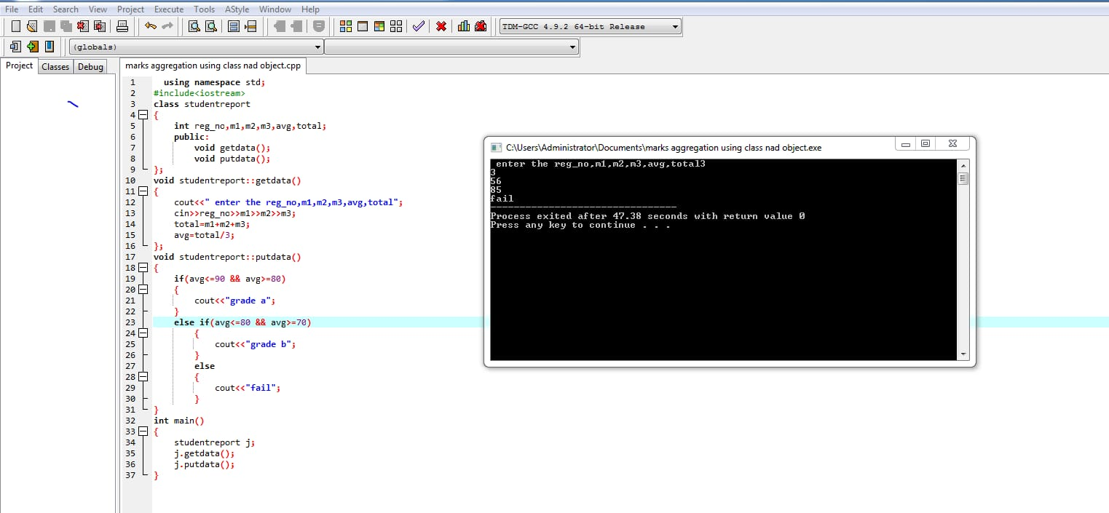

4.WRITE A C++ PROGRM FOR ARTHEMATIC OPERATION USING CLASS AND OBJECT.

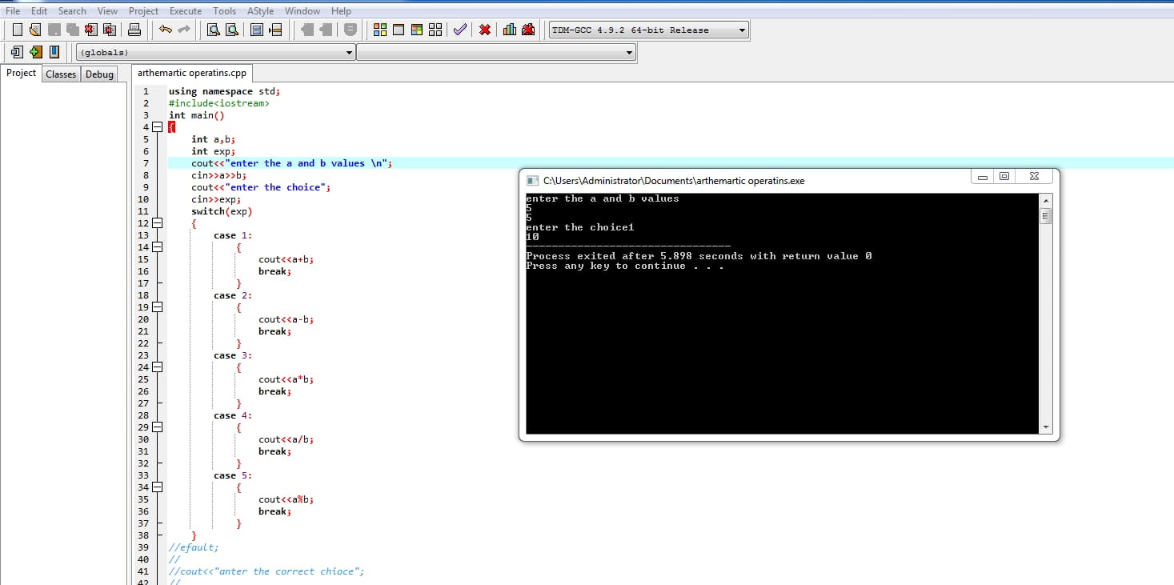

5.WRITE A C++ PROGARM FOR FUNCTIONS OVERLODING.

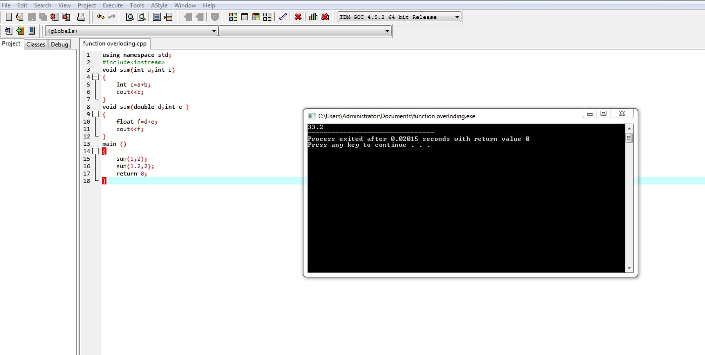

6.WRITE A C++ PROGARM FOR SWAPPING OF 2 NUMBERS BY USING CALL BY REFERENCE AND CALL BY VALUE.

