**AUTOMOBILE PRUDENT SYSTEM**

**USE CASE MODEL AND DOCUMENTATION**

**GOKUL.S 2018103026**

**SRIHARI.S 2018103601**

**Use Case Diagram - 1**

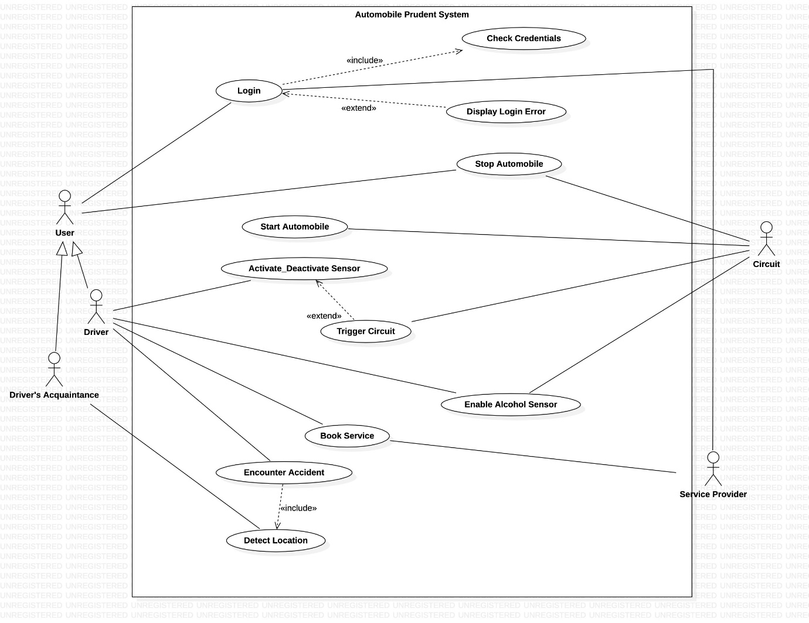

**Use Case Diagram - 2**

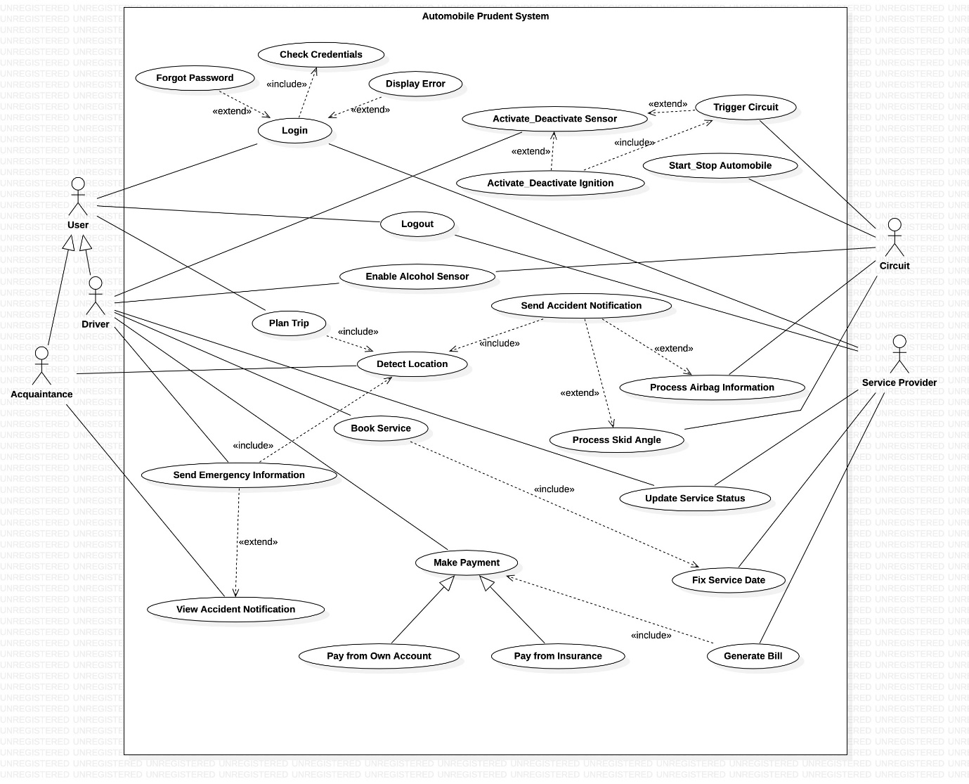

**Use Case: Activate/Deactivate Sensor**

**Scope:** System

**Level:** User goal level

**Primary Actor:** Driver

**Stakeholders and Interests:**

* Driver – Wears helmet/seatbelt to initiate the sensor.
* Co-passengers – Reach destination on time.

**Preconditions:**

Should be a registered and authenticated user.

**Success Guarantee:**

Should be allowed to start/stop the vehicle based on the state of the scenario.

**Main Success Scenario:**

* User wears the seat belt.
* Sensor detects the heart-beat and gets activated.
* User is able to start the vehicle.

**Extensions:**

* User inserts the seatbelt into the buckle.
* Heartbeat isn’t detected as he isn’t positioned properly.
* Tries starting vehicle but fails.

**Special Requirements:**

* Requires a state-of-the-art heartbeat sensor (four wheelers)/pressure sensor (two wheelers).

**Frequency of Occurrence:**

Continuous

**Use Case: Activate/Deactivate Ignition**

**Scope:** System

**Level:** Usergoal level

**Primary Actor:** Driver

**Stakeholders and Interests:**

* Driver – Uses the application to start vehicle without the keys.
* Co-passengers – Reach destination on time.

**Preconditions:**

Sensor should be activated/deactivated respectively.

**Success Guarantee:**

Circuit gets triggered to start/stop the automobile.

**Main Success Scenario:**

* User logs into the application.
* Driver wears the helmet/seatbelt.
* Uses application to start vehicle.
* Vehicle starts.

**Extensions:**

* User attempts logging into the application.
* Gets flagged with an error due to incorrect credentials.

**Special Requirements:**

* Needs a well-designed circuit and an interactive application that integrates it with the vehicle’s ignition.

**Frequency of Occurrence:**

Rare

**Use Case: Start Automobile**

**Scope:** System

**Level:** User goal level

**Primary Actor:** Circuit

**Stakeholders and Interests:**

* Driver – Gets the vehicle on the fly.
* Co-passengers – Reach destination on time.
* Circuit – Enables start of the automobile depending on the state of the system.

**Preconditions:**

Triggered and activated circuit which enables to driver to start the vehicle.

**Success Guarantee:**

Drivers drives the vehicle.

**Main Success Scenario:**

* Sensor gets activated.
* Circuit gets triggered.
* Driver gets the vehicle moving.

**Extensions:**

* Sensor gets activated.
* Circuit gets triggered.
* Vehicle doesn’t start due to insufficient battery charge.

**Special Requirements:**

* Circuit should be synchronized with the ignition of the vehicle.

**Frequency of Occurrence:**

Continuous.

**Use Case: Stop Automobile**

**Scope:** System

**Level:** User goal level

**Primary Actor:** Circuit

**Stakeholders and Interests:**

* Driver – Gets the vehicle to a halt.
* Co-passengers – Remain safe during the journey.
* Circuit – Enables stop of the automobile depending on the state of the system.

**Preconditions:**

Triggered and de-activated circuit which enables to driver to stop the vehicle.

**Success Guarantee:**

Drivers unable to drive the vehicle.

**Main Success Scenario:**

* Vehicle is moving.
* Sensor gets de-activated as the user removes seatbelt/helmet.
* Circuit gets triggered.
* Vehicle comes to a halt.

**Extensions:**

* Sensor gets de-activated.
* Circuit gets triggered.
* Vehicle doesn’t stop due to insufficient battery charge.

**Special Requirements:**

* Circuit should be synchronized with the ignition of the vehicle.

**Frequency of Occurrence:**

Continuous.

**Use Case: Trigger Circuit**

**Scope:** System

**Level:** User goal level

**Primary Actor:** Circuit

**Stakeholders and Interests:**

* Driver – Start/Stop the vehicle.
* Co-passengers – Reach destination on time.
* Circuit – Enables start/stop of the automobile depending on the state of the system.

**Preconditions:**

An activated/de-activated sensor.

**Success Guarantee:**

Vehicle starts/stops depending on why the circuit got triggered.

**Main Success Scenario:**

* User wears the seat belt.
* Sensor detects the heart-beat and gets activated.
* Circuit gets triggered.
* User is able to start/stop the vehicle.

**Extensions:**

* User wears the seat belt.
* Sensor detects the heart-beat and gets activated.
* Circuit doesn’t get triggered due to inconsistent communication with the ignition.

**Special Requirements:**

* Activate/deactivate functionality of the application should be synchronized with the circuit.

**Frequency of Occurrence:**

Always

**Use Case: Login**

**Scope:** System

**Level:** User goal level

**Primary Actor:** User, Service Provider

**Stakeholders and Interests:**

* User – Avail the services of the system
* Service Provider – Provide services to the users of the system
* Helpline workers – Help the users during crisis.

**Preconditions:**

Should be a registered and authenticated user of the system.

**Success Guarantee:**

* User can avail system services.
* Service provider offers required services.

**Main Success Scenario:**

* User enters login credentials.
* Logs in successfully.

**Extensions:**

* User enters login credentials.
* Log in unsuccessful.

**Special Requirements:**

* User needs to be registered to the application.

**Frequency of Occurrence:**

As and when required.

**Use Case: Forgot Password**

**Scope:** System

**Level:** Sub-functional level

**Primary Actor:** User, Service Provider

**Stakeholders and Interests:**

* User – Reset the forgotten password
* Service Provider - Reset the forgotten password, offer services to the user

**Preconditions:**

Should be a registered and authenticated user of the system.

**Success Guarantee:**

Enter valid new password.

**Main Success Scenario:**

* User logs in successfully.

**Extensions:**

* User enters new password.
* Password requirements not satisfied.
* User unable to reset password.

**Special Requirements:**

* User needs to be registered to the application.

**Frequency of Occurrence:**

Rare

**Use Case: Check Credentials**

**Scope:** System

**Level:** Sub-functional level

**Primary Actor:** User, Service Providers

**Stakeholders and Interests:**

* User – Avail the services of the system
* Service Provider – Provide services to the users of the system
* Helpline workers – Help the users during crisis.

**Preconditions:**

* Registered user should have entered login credentials.

**Success Guarantee:**

* If login credentials match, user can avail services of the system.

**Main Success Scenario:**

* Registered user enters login credentials.
* System checks its validity.
* User successfully logs in upon entering consistent details.

**Extensions:**

* Registered user enters login credentials.
* System checks its validity.
* User is unable to log-in due to inconsistency in the entered details.

**Special Requirements:**

* User needs to be registered to the application.

**Frequency of Occurrence:**

Whenever user tries to log in.

**Use Case: Display Error**

**Scope:** System

**Level:** Sub-functional level

**Primary Actor:** User, Service Providers

**Stakeholders and Interests:**

* User – Avail a flawless entry into the application.
* Service Provider – Provide services to the users of the system
* Helpline workers – Help the users during crisis.

**Preconditions:**

* Registered user should have entered login credentials.

**Success Guarantee:**

* Enters incorrect login credentials.

**Main Success Scenario:**

* Registered user enters login credentials.
* System checks its validity.
* User unsuccessful in logging in upon entering inconsistent details.
* User flagged with an error.

**Extensions:**

* Registered user enters login credentials.
* System checks its validity.
* User successfully logs in upon entering consistent details.
* User not flagged with any error.

**Special Requirements:**

* User needs to be registered to the application.

**Frequency of Occurrence:**

As and when required.

**Use Case: Logout**

**Scope:** System

**Level:** Sub-functional level

**Primary Actor:** Users, Service Providers

**Stakeholders and Interests:**

* User – Logout of the system
* Service Provider – Logout of the system

**Preconditions:**

Should be a registered and authenticated user of the system.

**Success Guarantee:**

* Logged out of the system.

**Main Success Scenario:**

* User avails Plan Trip usecase of the application.
* Calculates the distance of the destination from his current location.
* Logs out of the application.

**Extensions:**

* User books service for his vehicle.
* Tries logging out of the system.
* But unable to do so due to bugs in the mobile.

**Special Requirements:**

* User needs to be registered to the application.

**Frequency of Occurrence:**

As and when required.

**Use Case: Enable Alcohol Sensor**

**Scope:** System

**Level:** User goal level

**Primary Actor:** Driver

**Stakeholders and Interests:**

* Driver – To be notified when drunk.
* Co-passengers – Ensure safe journey.

**Preconditions:**

Should be a registered and authenticated user of the system.

**Success Guarantee:**

* Vehicle is stopped.

**Main Success Scenario:**

* Drunk driver wears his helmet/seatbelt.
* Alcohol Sensor detects the consumption of alcohol.
* Primary sensor gets deactivated.
* Circuit gets triggered.
* Driver is unable to start his vehicle.

**Extensions:**

* Sober driver wears his helmet/seatbelt.
* Alcohol Sensor isn’t enabled.
* Primary sensor gets activated.
* Circuit gets triggered.
* Driver is able to start his vehicle.

**Special Requirements:**

* System requires a state-of-the-art alcohol sensor

**Frequency of Occurrence:**

Rare

**Use Case: Plan Trip**

**Scope:** System

**Level:** User goal level

**Primary Actor:** User

**Stakeholders and Interests:**

* User – Plan trip in advance
* Co-passengers – Can join the user on his trip.

**Preconditions:**

Should be a registered and authenticated user of the system.

**Success Guarantee:**

* User gets precise knowledge of the destination.

**Main Success Scenario:**

* User avails the plan trip usecase.
* Enters the destination in the application.
* System reports back with information about the trip.

**Extensions:**

* User avails the plan trip usecase.
* Enters the destination in the application.
* System reports back an error due to invalid destination.

**Special Requirements:**

* User needs to be registered to the application.

**Frequency of Occurrence:**

As and when required

**Use Case: Detect Location**

**Scope:** System

**Level:** User goal level

**Primary Actor:** Driver’s Acquaintances

**Stakeholders and Interests:**

* Driver – Helps him plan the trip
* Co-passengers – Can join the user on his trip.
* Helpline workers – Can receive accident location and provide timely help
* Driver’s Acquaintances – Can track the driver’s current location.

**Preconditions:**

Should be a registered and authenticated user of the system.

**Success Guarantee:**

* Acquaintance gets precise knowledge of the driver’s current location.

**Main Success Scenario:**

* Driver goes on a long drive.
* There isn’t any information about him for a long period of time.
* His mother tracks his current location.

**Extensions:**

* Driver goes on a long drive.
* There isn’t any information about him for a long period of time.
* His mother tries to track his current location.
* But is unable to do so due to bugs in the GSM module.

**Special Requirements:**

* System requires a GSM module.

**Frequency of Occurrence:**

As and when required

**Use Case: Send Emergency Information**

**Scope:** System

**Level:** User goal level

**Primary Actor:** User

**Stakeholders and Interests:**

* User – Requests help under emergency situation.
* Co-passengers – Avail help along with the driver during emergency situations.
* Helpline workers – Can receive accident location and provide timely help

**Preconditions:**

Should be a registered and authenticated user of the system.

**Success Guarantee:**

* Helpline workers reach spot of accident.

**Main Success Scenario:**

* Driver is on a trip.
* Encounters an accident.
* His brother gets notified.
* He shares the spot of accident to the helpline workers.
* Helpline workers reach spot of accident and rescues the driver.

**Extensions:**

* Driver is on a trip.
* Encounters an accident.
* He becomes unconscious.
* He dies.

**Special Requirements:**

* User needs to be registered to the application.

**Frequency of Occurrence:**

Rare

**Use Case: View Accident Notification**

**Scope:** System

**Level:** User goal level

**Primary Actor:** Driver’s Acquaintances

**Stakeholders and Interests:**

* Driver – Requests help under emergency situation.
* Co-passengers – Avail help along with the driver during emergency situations.
* Driver’s Acquaintance – Can perform a timely action in case of an emergency.

**Preconditions:**

Should be a registered and authenticated user of the system.

**Success Guarantee:**

* Can use the send emergency usecase.

**Main Success Scenario:**

* Driver is on a trip.
* Encounters an accident.
* His brother receives notification from the system.
* He shares the spot of accident to the helpline workers.
* Helpline workers reach spot of accident and rescues the driver.

**Extensions:**

* Driver is on a trip.
* Encounters an accident.
* His brother receives notification from the system.
* He hasn’t checked the application.
* Helpline workers aren’t informed.
* Driver dies.

**Special Requirements:**

* User needs to be registered to the application.

**Frequency of Occurrence:**

Rare.

**Use Case: Send Accident Notification**

**Scope:** System

**Level:** Sub-functional level

**Primary Actor:** Circuit

**Stakeholders and Interests:**

* Driver – Requests help under emergency situation.
* Co-passengers – Avail help along with the driver during emergency situations.
* Driver’s Acquaintance – Can perform a timely action in case of an emergency.
* Helpline workers – Can receive accident location and provide timely help

**Preconditions:**

* Should be a registered and authenticated user of the system.
* The airbag state/ skid angle should be in the danger level.

**Success Guarantee:**

* The location of the driver gets tracked.
* His acquaintances get notified.

**Main Success Scenario:**

* Driver is on a trip.
* Encounters an accident.
* His car’s airbag gets ejected.
* His brother receives notification from the system.
* He shares the spot of accident to the helpline workers.
* Helpline workers reach spot of accident and rescues the driver.

**Extensions:**

* Driver is on a trip.
* Encounters an accident.
* Due to bugs in his airbag system, it doesn’t get ejected.
* His brother doesn’t receive any notification.
* Driver dies.

**Special Requirements:**

System requires a state-of-the-art level detector/ airbag system that is synchronized with the circuit.

**Frequency of Occurrence:**

Rare.

**Use Case: Process Airbag Information**

**Use Case: Process Skid Angle**

**Scope:** System

**Level:** User goal level

**Primary Actor:** Circuit

**Stakeholders and Interests:**

* Driver – Requests help under emergency situation.
* Co-passengers – Avail help along with the driver during emergency situations.
* Driver’s Acquaintance – Can perform a timely action in case of an emergency.
* Helpline workers – Can receive accident location and provide timely help

**Preconditions:**

Should be a registered and authenticated user of the system.

**Success Guarantee:**

Can use send accident notification use case.

**Main Success Scenario:**

* Driver is on a trip.
* Encounters an accident
* His bike gets thrown off the road.
* Level detector senses an accident.
* Acquaintances receive accident notification.
* Helpline workers reach the spot of the accident.
* Driver is saved.

**Extensions:**

* Driver is on a trip.
* Encounters a minor accident.
* Level detector doesn’t sense any mishap.
* His brother doesn’t receive any notification.

**Special Requirements:**

System requires a state-of-the-art level detector/ airbag system that is synchronized with the circuit.

**Frequency of Occurrence:** Continuous.

**Use Case: Update Service Status**

**Scope:** System

**Level:** User goal level

**Primary Actor:** Service Provider

**Stakeholders and Interests:**

* Driver – To get his vehicle serviced.
* Service Provider – Can provide timely updates during the service process.

**Preconditions:**

Driver and the Service Provider should be registered and authenticated users of the system.

**Success Guarantee:**

Driver gets notified when his vehicle is ready to be picked up.

**Main Success Scenario:**

* Driver books service for his vehicle using the application.
* Checks the status of the service.
* Collects the vehicle once its ready.

**Extensions:**

* Driver books service for his vehicle using the application.
* Checks the status of the service.
* Service Provider fails to update the status regularly.
* Driver is unable to catch-up with the service status.

**Special Requirements:**

* Interactive application for the Service Provider to update service details.

**Frequency of Occurrence:**

As and when required.

**Use Case: Fix Service Date**

**Scope:** System

**Level:** User goal level

**Primary Actor:** Driver

**Stakeholders and Interests:**

* Driver – To get his vehicle serviced.
* Service Provider – Can provide timely updates during the service process.

**Preconditions:**

* Should be a registered and authenticated user of the system.
* Driver should use the book service functionality.

**Success Guarantee:**

* Date of service gets fixed.

**Main Success Scenario:**

* Driver books service for his vehicle using the application.
* Date of service is fixed.
* Driver drops his vehicle for service.

**Extensions:**

* Driver books service for his vehicle using the application.
* Service Provider has a tight schedule on the desired date of service.
* Date of service isn’t confirmed.

**Special Requirements:**

* Interactive application for the user to fix the date of service.

**Frequency of Occurrence:**

As and when required.

**Use Case: Generate Bill**

**Scope:** System

**Level:** User goal level

**Primary Actor:** Service Provider

**Stakeholders and Interests:**

* Driver – To get his vehicle serviced.
* Service Provider – Generating the final bill for the service.

**Preconditions:**

* Should be a registered and authenticated user of the system.
* Driver should have scheduled a service beforehand.

**Success Guarantee:**

* Driver makes the payment.

**Main Success Scenario:**

* Driver books service for his vehicle using the application.
* Date of service is fixed.
* Service Provider generates the bill after the service is over.
* Driver makes payment and picks his vehicle.

**Extensions:**

* Driver books service for his vehicle using the application.
* Date of service is fixed.
* He doesn’t drop the vehicle at the specified date
* Service process gets halted.
* Bill isn’t generated.

**Special Requirements:**

* Interactive application for the Service Provider to update the bill.

**Frequency of Occurrence:**

As and when required.

**General Use Case: Make Payment**

**Specialized Use Case: Pay From Own Account**

**Specialized Use Case: Pay From Insurance**

**Scope:** System

**Level:** User goal level

**Primary Actor:** Driver

**Stakeholders and Interests:**

* Driver – To get his vehicle serviced.
* Service Provider – Enable the user to make payment

**Preconditions:**

* Should be a registered and authenticated user of the system.
* Driver should have scheduled a service beforehand.
* Service Provider should have generated the bill.

**Success Guarantee:**

* Driver picks up the vehicle.

**Main Success Scenario:**

* Driver books service for his vehicle using the application.
* Date of service is fixed.
* Service Provider generates the bill after the service is over.
* Driver makes payment and picks his vehicle.

**Extensions:**

* Driver books service for his vehicle using the application.
* Date of service is fixed.
* Service Provider generates the bill after the service is over.
* Transaction made by the driver fails.

**Special Requirements:**

* Interactive application for the driver to make payment.

**Frequency of Occurrence:**

As and when required.

**Use Case: Encounter Accident**

**Scope:** System

**Level:** User goal level

**Primary Actor:** Driver.

**Stakeholders and Interests:**

* Driver – Requests help under emergency situation.
* Co-passengers – Avail help along with the driver during emergency situations.
* Driver’s Acquaintance – Can perform a timely action in case of an emergency.

**Preconditions:**

* Should be a registered and authenticated user of the system.

**Success Guarantee:**

* Location of the injured driver is sent to his acquaintances and helpline workers.

**Main Success Scenario:**

* Driver is on a trip.
* Encounters an accident.
* His brother receives notification from the system.
* He shares the spot of accident to the helpline workers.
* Helpline workers reach spot of accident and rescues the driver.

**Extensions:**

* Driver is on a trip.
* Encounters an accident.
* His brother receives notification from the system.
* He hasn’t checked the application.
* Helpline workers aren’t informed.
* Driver dies.

**Special Requirements:**

* User needs to be registered to the application.
* System requires a state-of-the-art level detector/ airbag system that is synchronized with the circuit.

**Frequency of Occurrence:**

Rare.