**AUTOMOBILE PRUDENT SYSTEM**

**SEQUENCE MODEL**

**GOKUL.S 2018103026**

**SRIHARI.S 2018103601**

SD 1:

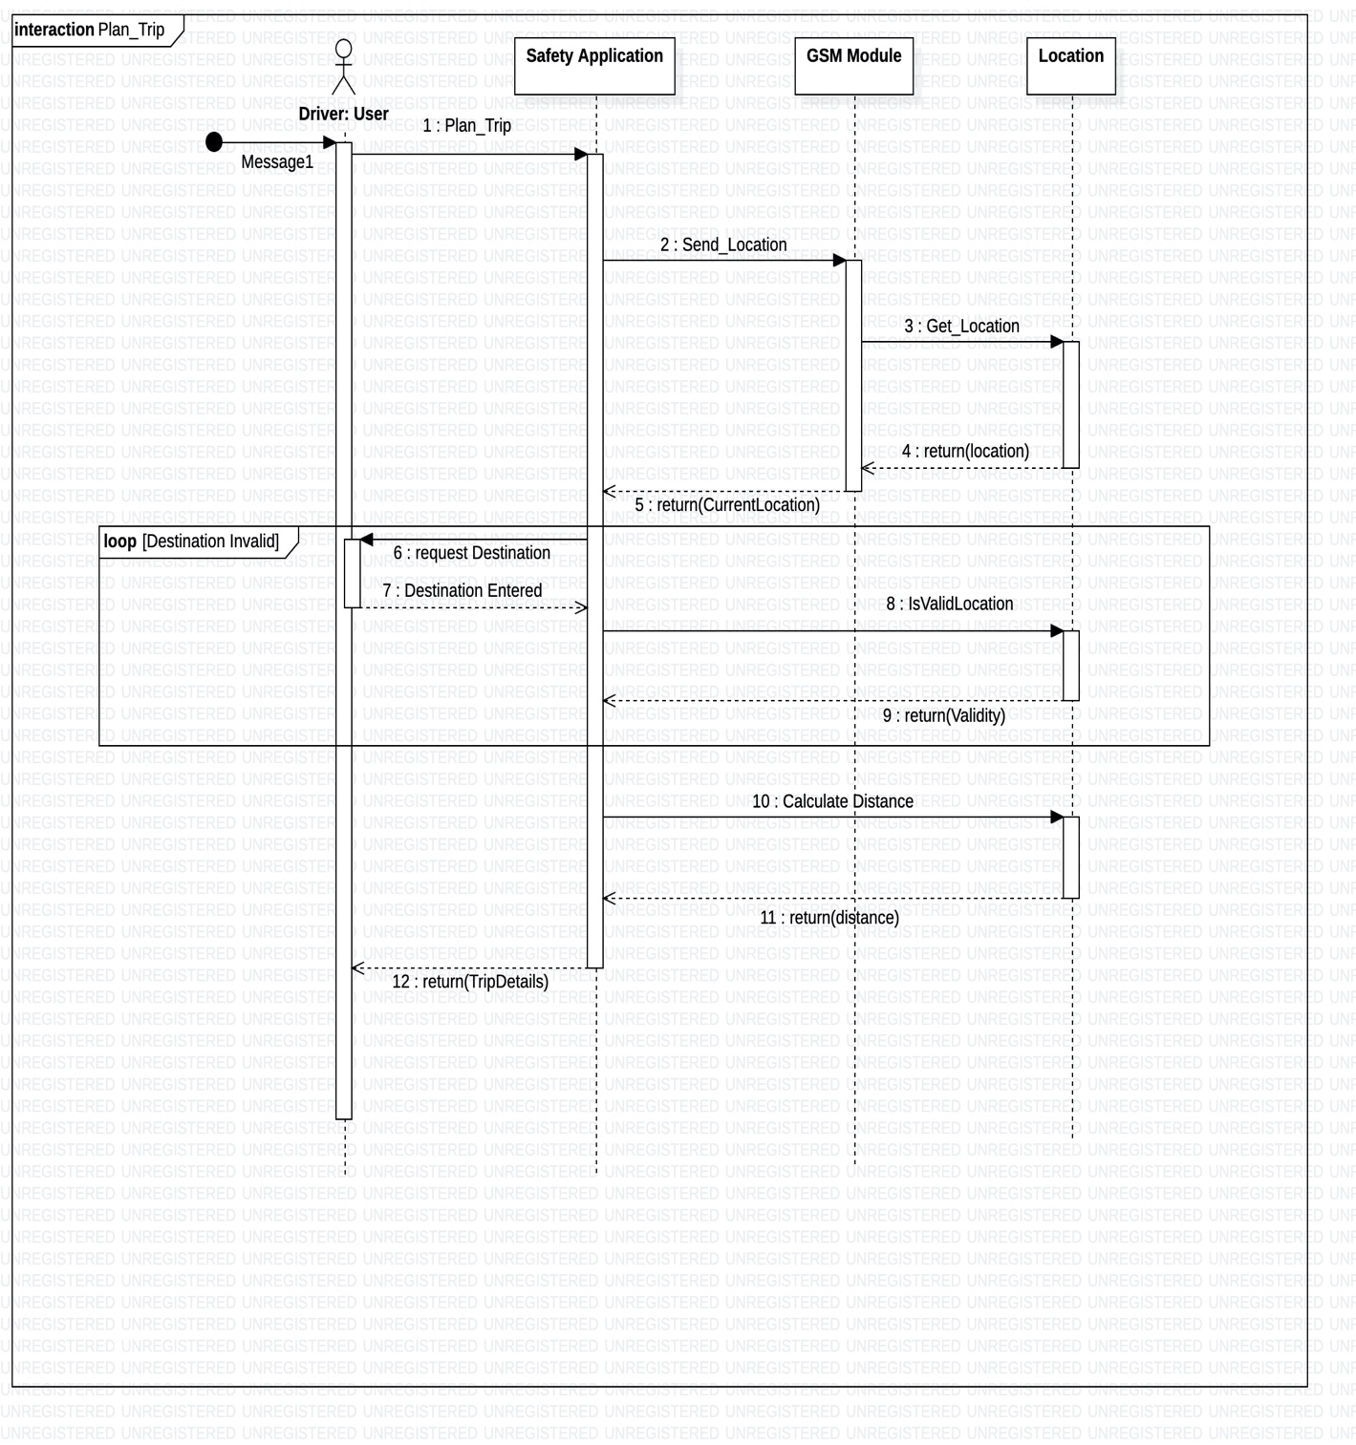

SD 2:

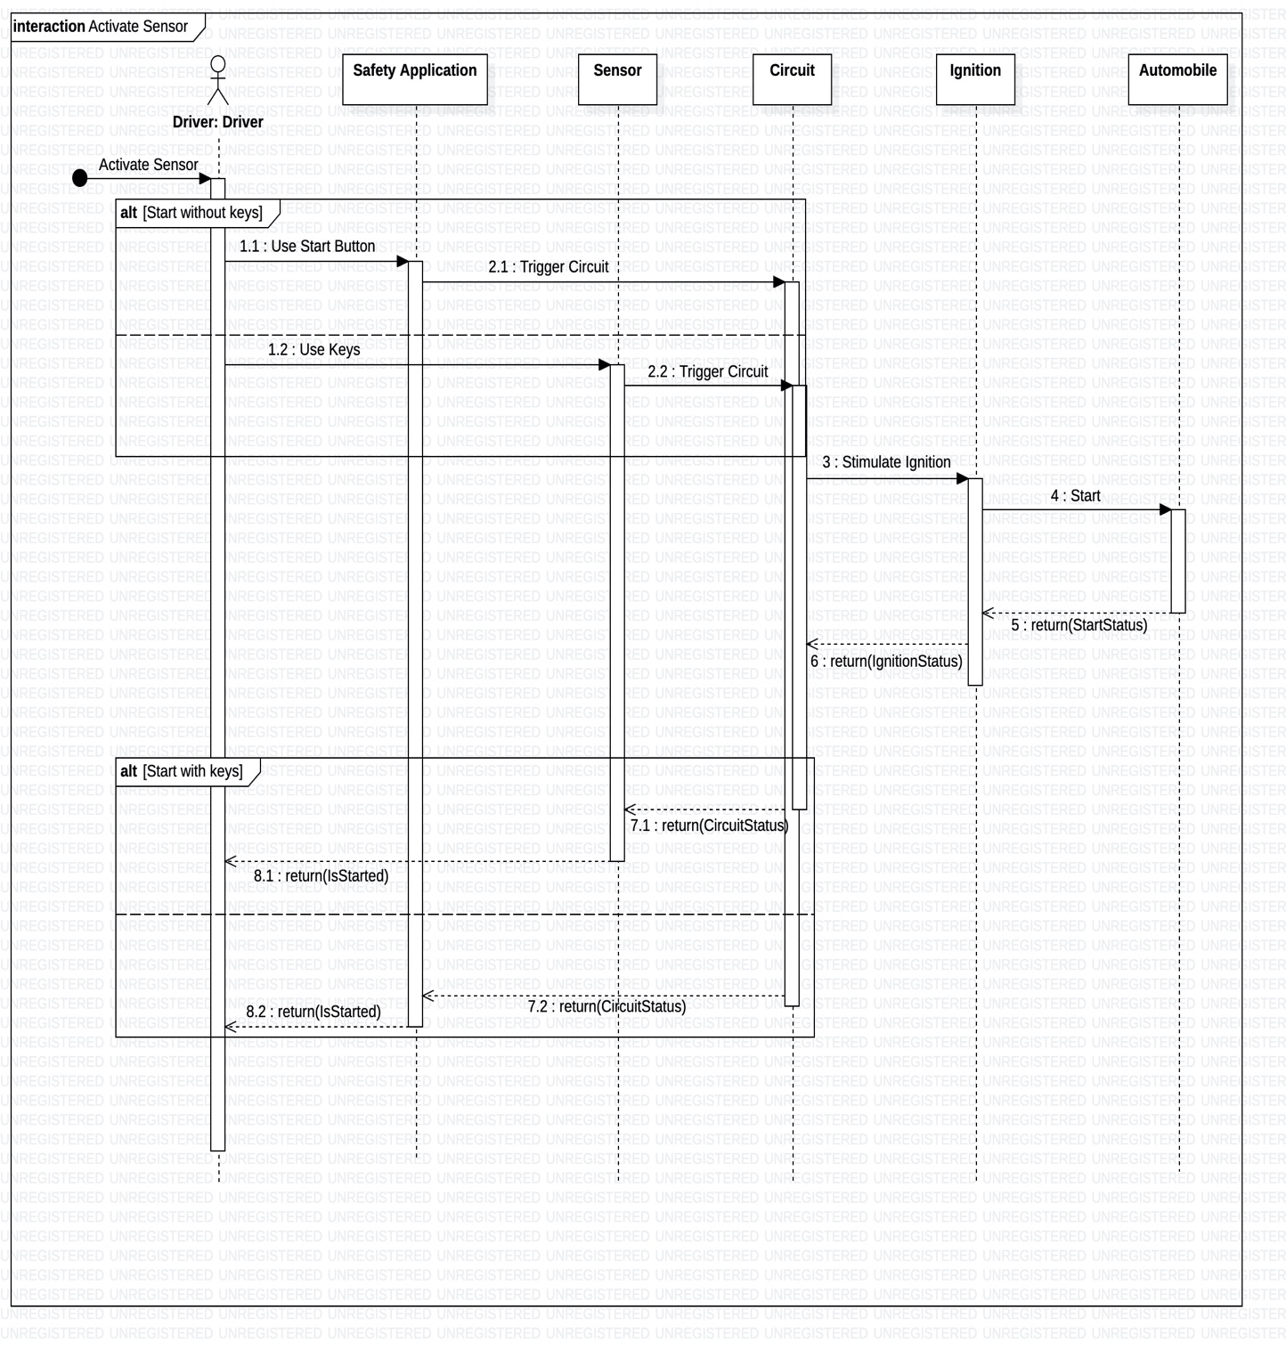

SD 3:

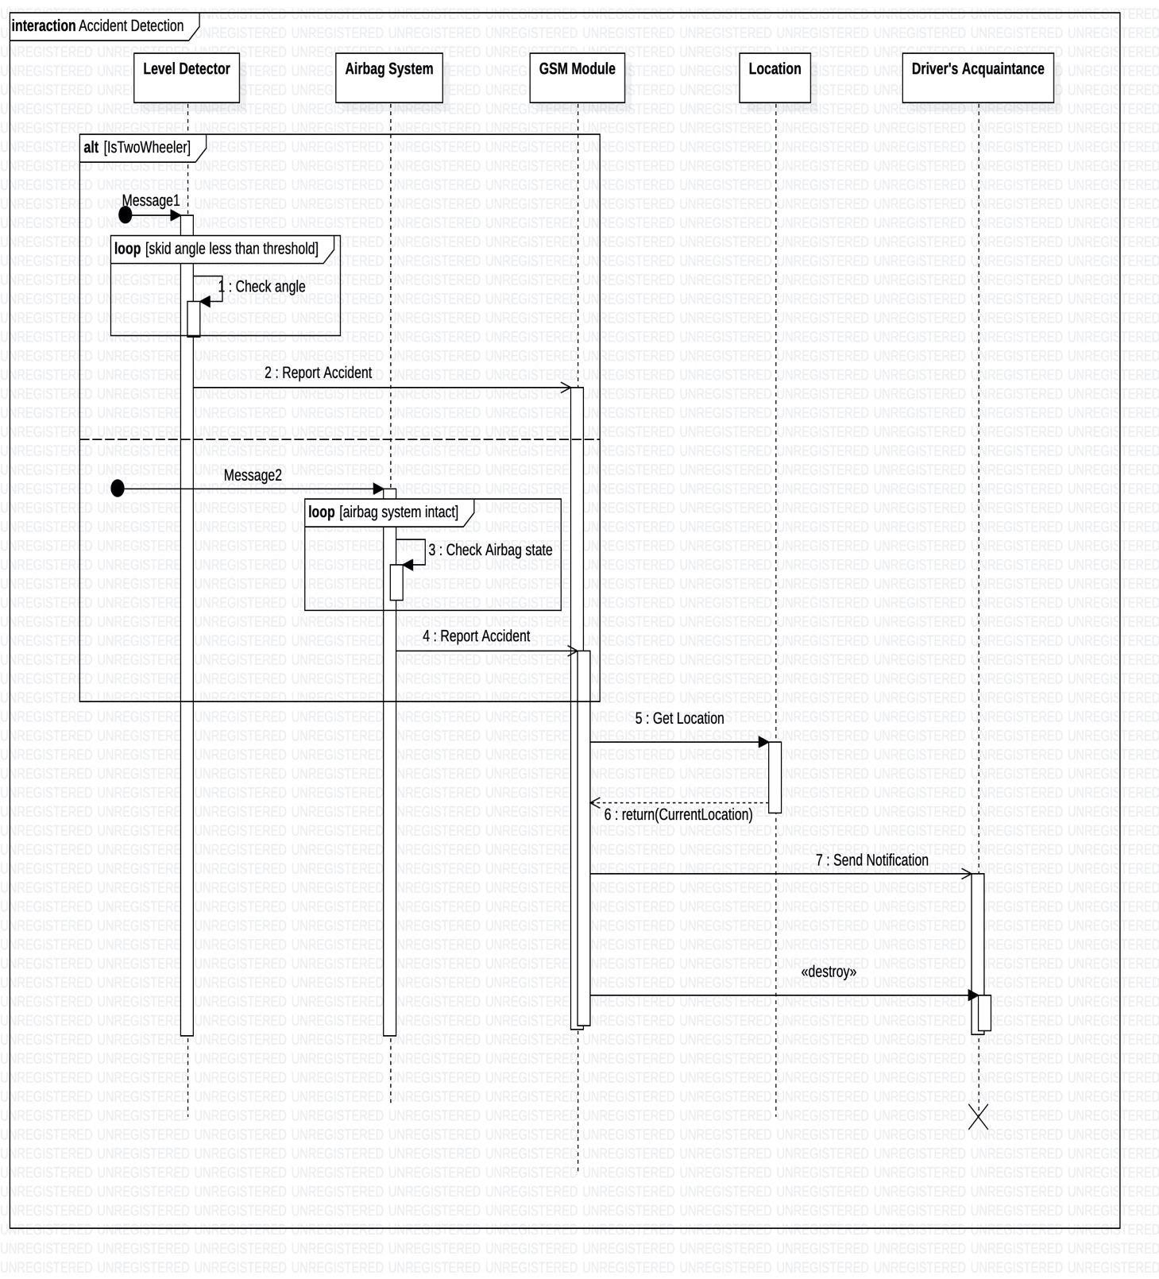

SD 4:

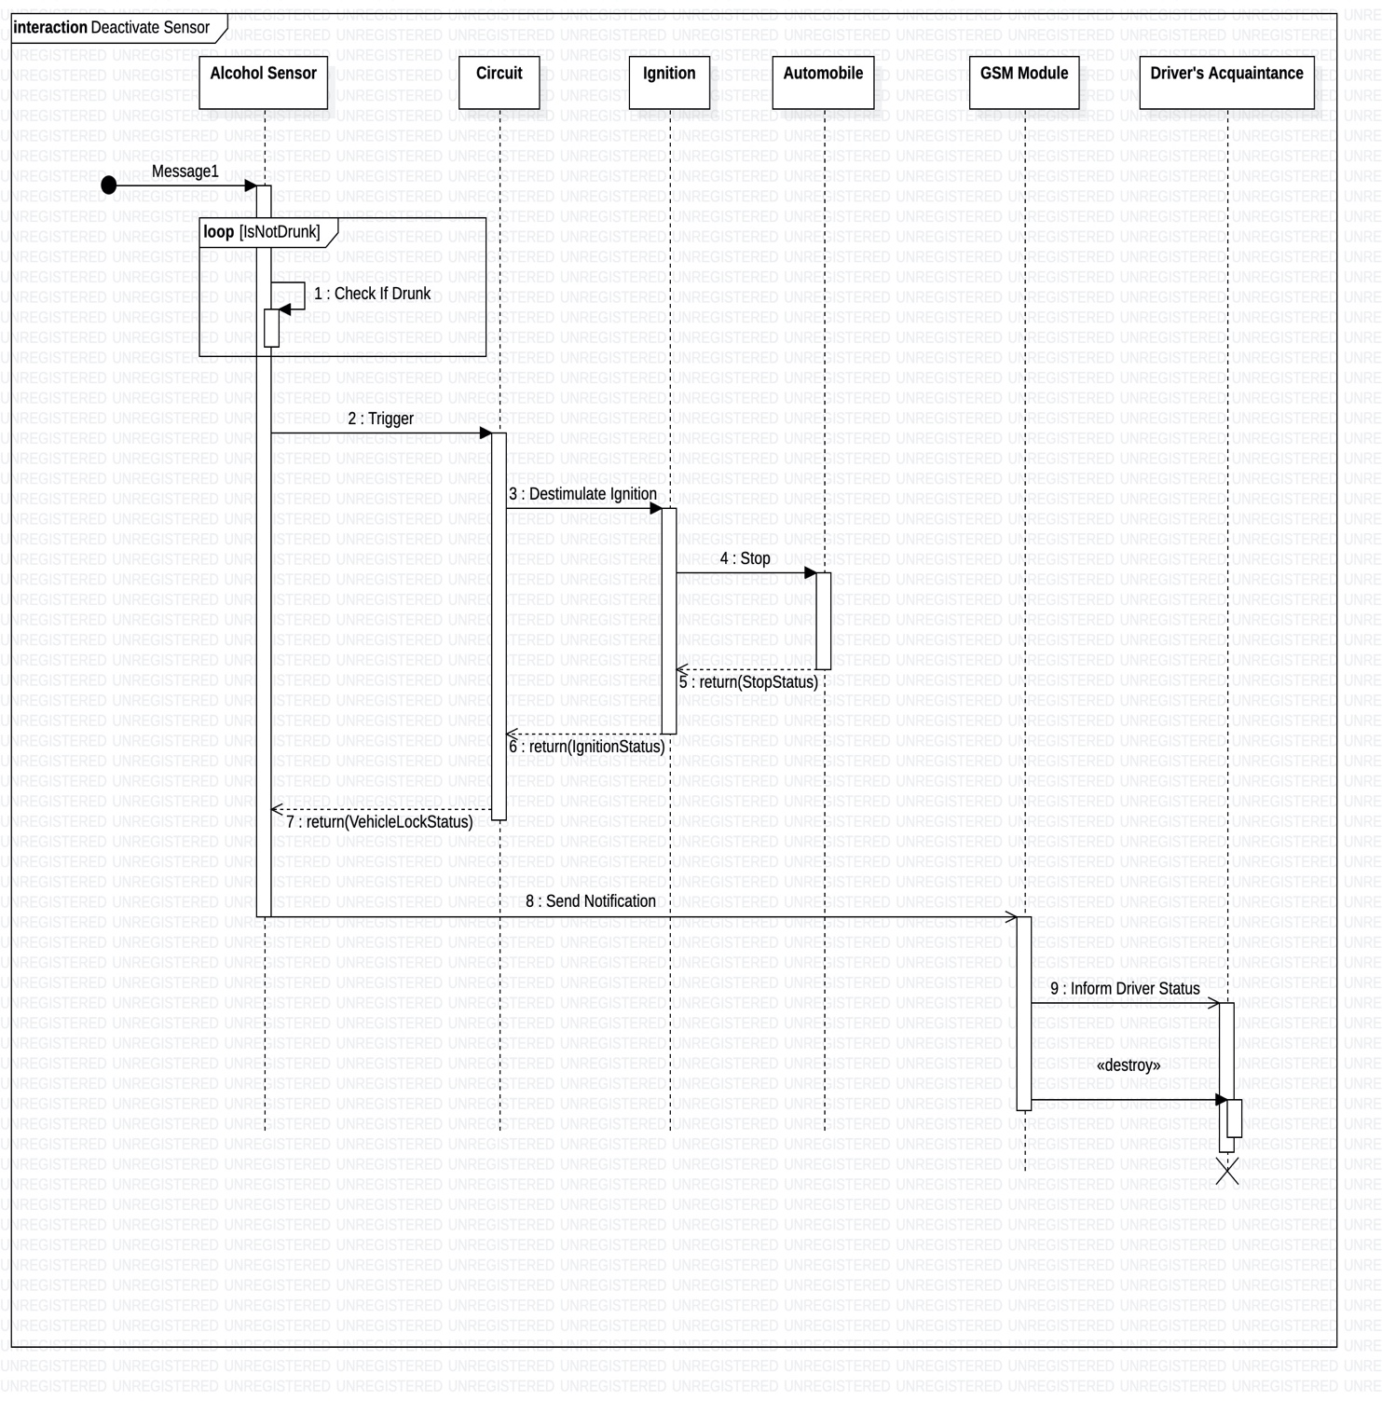

SD 5:

