**AUTOMOBILE PRUDENT SYSTEM**

**STATE MODELLING**

**GOKUL.S 2018103026  
SRIHARI.S 2018103601**

**STATE DIAGRAM 1:**

* **Associated Class:** GSM Module
* **Scenario:**
  + Driver undergoes an accident.
  + GSM Module moves from **idle** to **warning** state.
  + It fetches the location and moves to the **fetching location** state, post which it makes a transition to the **notifying accident** state.
  + It is in this state where it notifies acquaintances about the accident.
  + Once the GSM Module receives an acknowledgement that the notification has been read, it moves back to the **idle** state.

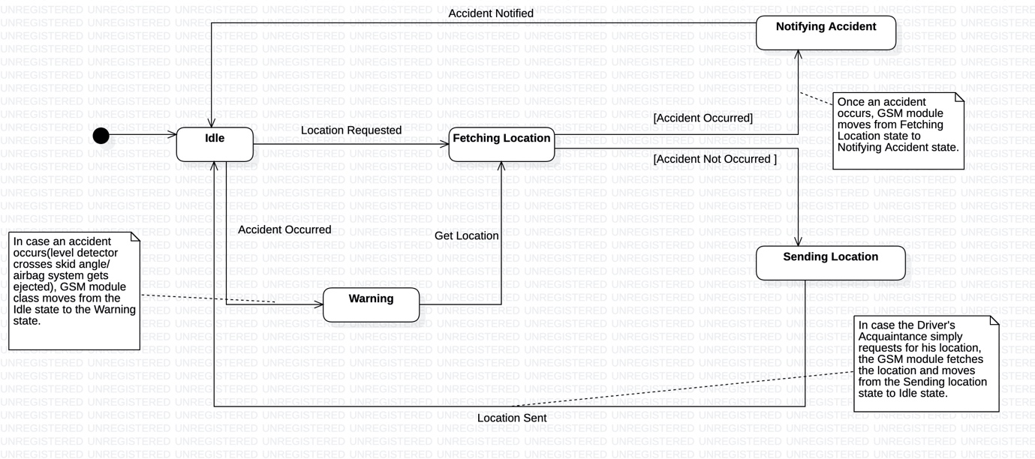

**STATE DIAGRAM 2:**

* **Associated Class:** Sensor (Helmet Sensor, Seatbelt Sensor, Alcohol Sensor)
* **Scenario:**
  + Driver gets intoxicated due to consumption of alcohol.
  + He wears his seatbelt and attempts to start his car.
  + In this case both the helmet and alcohol sensors get activated because of which sensor forks to these states to concurrently exist in them from the **inactive** state.
  + Due to the join operation, the sensor further shifts to the **alcohol and safety sensor activating** state, post which it transits to the **circuit triggering** state since he is intoxicated.
  + Upon receiving the VehicleLockStatus from the circuit class, sensor moves to the **inactive** state.
  + The vehicle is currently locked and the driver is unable to start it.

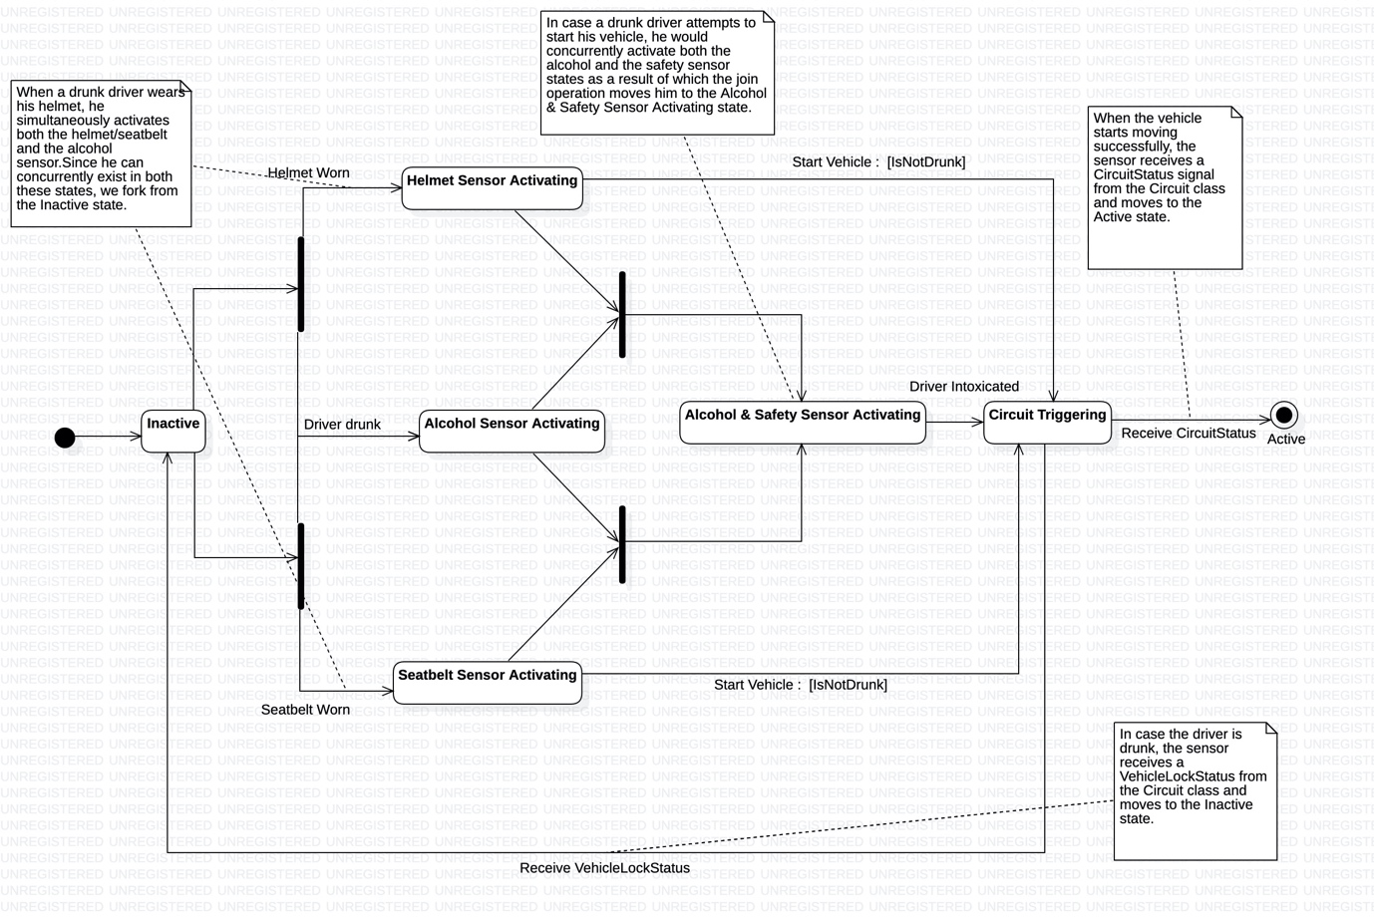

**STATE DIAGRAM 3:**

* **Associated Class:** Circuit
* **Scenario:**
  + Driver wears his helmet.
  + Circuit moves from **idle** to **safety processing** state.
  + Upon the activation of the helmet sensor, it further shifts to the **triggering** state.
  + The driver then under goes an accident.
  + Now the circuit moves to the **informing** state, destimulating the ignition after moving to the **Accident Signalling** state.
  + As the vehicle stops, it moves to the **Untriggering** state.
  + Upon the deactivation of the helmet sensor by the removal of the helmet, it moves back to the **idle** state.

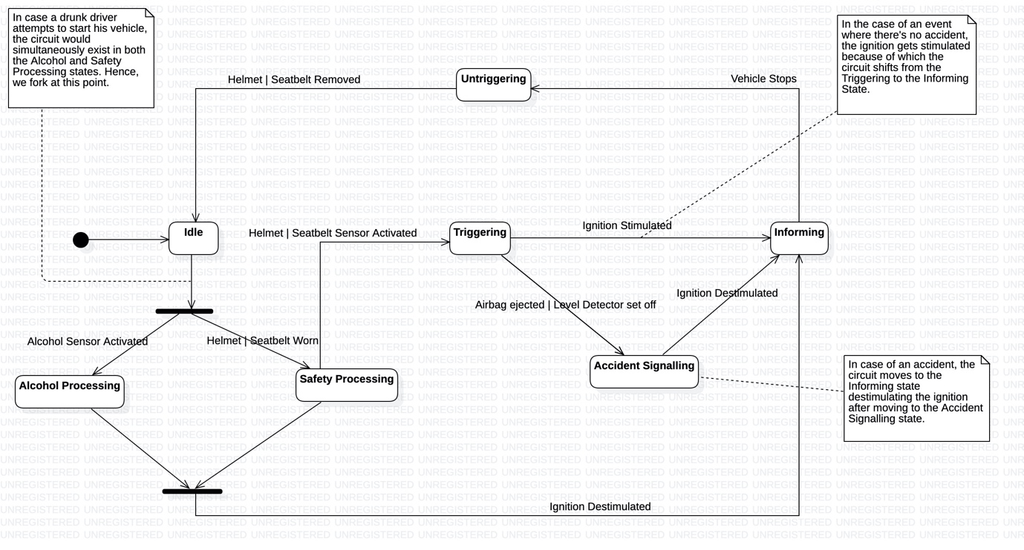

**STATE DIAGRAM 4:**

* **Associated Class:** Ignition
* **Scenario:**
  + Driver attempts to start his vehicle.
  + Upon successfully receiving the Circuit signal from the circuit class, the ignition moves from the **idle** to the **Calculating state**.
  + Since the driver isn’t drunk and the situation is normal, the ignition receives a signal of frequency 1400MHz from the circuit.
  + As this is greater than the threshold of 1200MHz, a change event gets triggered due to which it moves to the **Stimulating** state.
  + Driver drives successfully and reaches the destination.
  + Upon turning off his vehicle using the keys, the ignition receives a signal of frequency 900MHz from the circuit class (signifying a normal stop).
  + This makes it move back to the **idle** state.

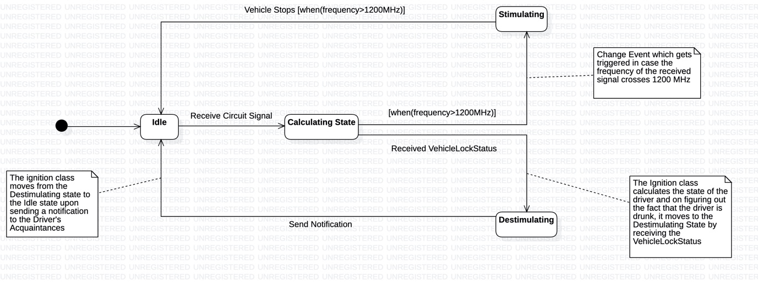

**Vehicle Stops [when(frequency<1200MHz)]**