**AUTOMOBILE PRUDENT SYSTEM**

**ACTIVITY MODELLING**

**GOKUL.S 2018103026**

**SRIHARI.S 2018103601**

**Activity Diagram 1:**

**Associated Usecase:** Plan Trip

**Classes Involved:** GSM Module, Location, Driver, Safety Application

**Scenario:**

* To plan the trip the safety application requests the current location of the vehicle from the GSM Module.
* GSM Module in-turn retrieves the location by contacting the location class.
* Current Location is returned back to the safety application.
* User is prompted to enter the required destination location
* On entering a valid location, safety application class calculates the distance and returns the trip details to the user.
* If the entered destination location is invalid, user is prompted to enter a valid destination until he gets one right.

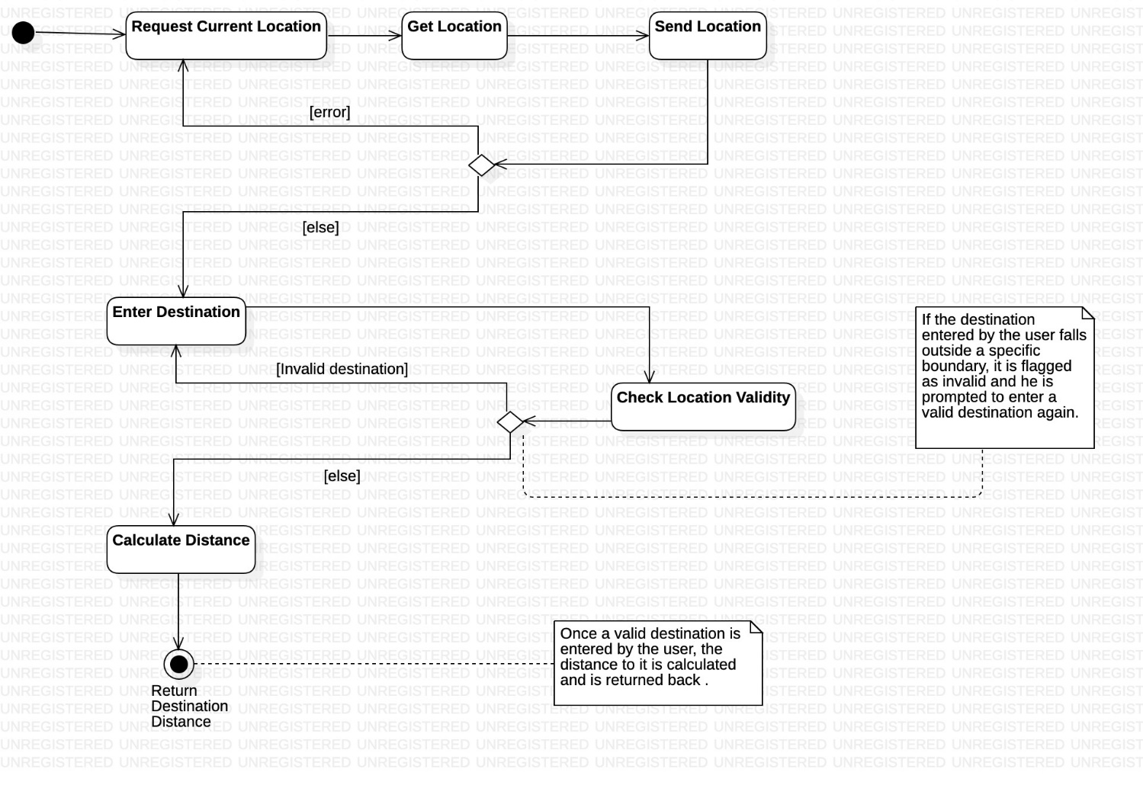

**Activity Diagram 2:**

**Associated Usecase:** Start Automobile

**Classes Involved:** Sensor, Circuit, Ignition, Safety Application

**Scenario:**

* Driver has two options to start his automobile, i.e. With keys / Using the application.
* For this purpose a decision diamond is being used.
* If either one of **Start with Keys** activity or the **Start with Application** activity get performed, merge functionality is used to invoke the **Trigger Circuit** activity.
* Once the circuit gets triggered, it stimulates ignition which in-turn starts the automobile.
* Once the stimulate ignition activity gets performed, depending on the fuel status of the vehicle the system either performs the **start vehicle** activity or moves to the **error** activity.

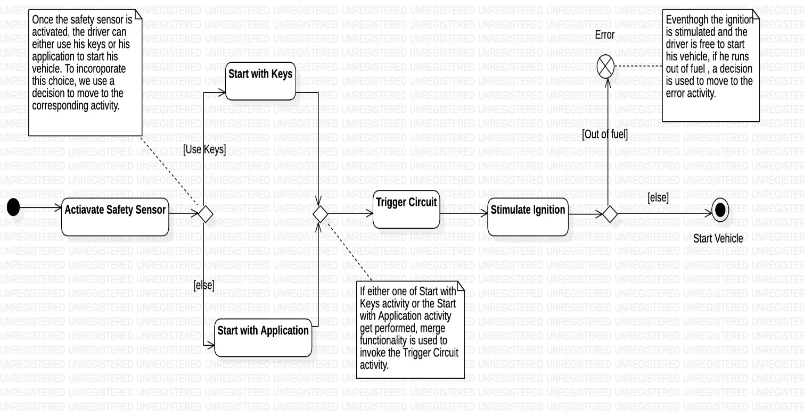

**Activity Diagram 3:**

**Associated Usecase:** Send Accident Notification

**Classes Involved:** Sensor, GSM Module, Level Detector, Airbag System, Automobile

**Scenario:**

* Once the automobile is started and is on the move, the state of the airbag/skid angle is checked depending on its type. (decision)
* If the Airbag gets ejected or if the skid angle crosses the threshold, a merge is being used to report an accident to the GSM Module.
* If either of the guard condition aren’t satisfied, the corresponding activity gets performed repeatedly.
* GSM Module contacts the location class to retrieve the current location of the driver.
* It then sends a notification to the Driver’s Acquaintance class, that contains the location.

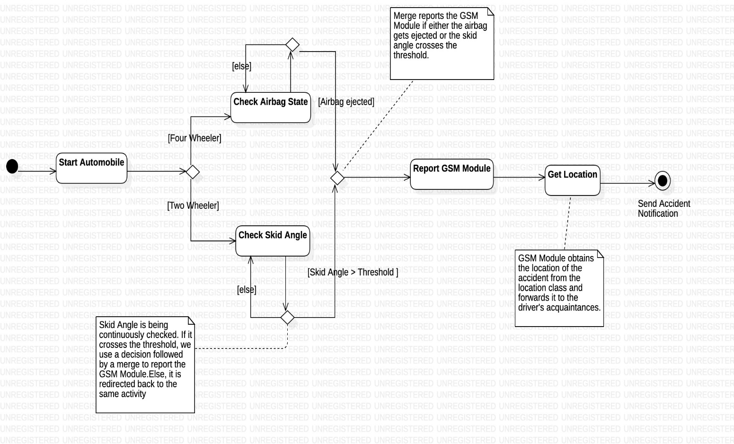

**Activity Diagram 4:**

**Associated Usecase:** Book Service

**Classes Involved:** Service Provider, Driver, Safety Application

**Scenario:**

* Driver books service for his vehicle when its on due.
* The Service Provider confirms the service date with the Driver through the safety application.
* Once the service date is confirmed, the Service Provider can update the status of the service and the driver can simultaneously check it using his application. Hence, we fork to show this concurrency.
* If the service status is complete, we use a decision to perform the **Generate Bill** activity. Else, the same activity is performed again.
* Once the bill is generated, the Driver uses the Safety Application to make the required payment by performing the **Make Payment** activity.

