**JAVA PROGRAMMING LAB EXAM**

**S.SRIHARI**

**2018103601**

Q1.

**Inventory.java**

**package** labexam;

**import** java.util.*;

**public** **class** Inventory {

**private** String itemName;

**private** **double** itemCost;

**private** **int** noOfItems;

**public** Inventory(String a,**double** b, **int** c) {

itemName = a;

itemCost = b;

noOfItems = c;

}

**void** procureItems(**int** qty) **throws** IllegalArgumentException{

**if**(noOfItems > 0)

**throw** **new** IllegalArgumentException();

**else**

noOfItems += qty;

}

**void** sellItems(**int** qty) **throws** IllegalArgumentException {

**if**(noOfItems < qty)

**throw** **new** IllegalArgumentException();

**else**

noOfItems -= qty;

}

**void** display() {

System.***out***.println("ItemName is "+itemName);

System.***out***.println("Cost of this item is "+itemCost);

System.***out***.println("No of items is "+noOfItems);

}

**public** **static** **void** main(String[] args) {

// **TODO** Auto-generated method stub

Scanner sc = **new** Scanner(System.***in***);

System.***out***.println("Enter the name, cost and noof items");

Inventory obj1 = **new** Inventory(sc.nextLine(),sc.nextDouble(),sc.nextInt());

System.***out***.println("Displaying details");

obj1.display();

**try** {

System.***out***.println("Enter the no of items procured");

obj1.procureItems(sc.nextInt());

}

**catch**(IllegalArgumentException e) {

System.***out***.println("THere are already few items!!No need to procure now");

}

**try** {

System.***out***.println("Enter the no of items sold");

obj1.sellItems(sc.nextInt());

}

**catch**(IllegalArgumentException e) {

System.***out***.println("You are selling more items than what is available!");

}

}

}

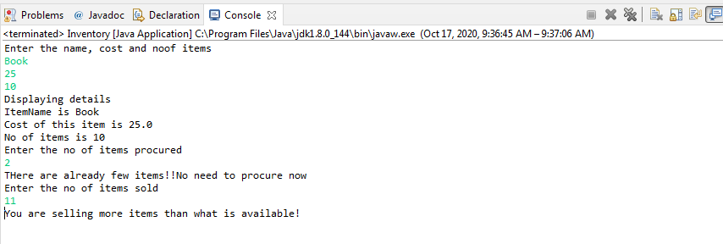

Q2.

**DepartmentFaculty.java**

**package** labexam;

**import** java.util.*;

**public** **abstract** **class** DepartmentFaculty {

**protected** String departmentName;

**protected** String facultyName;

**protected** **double** years_exp;

**protected** DepartmentFaculty(String a,String b){

departmentName = a;

facultyName = b;

}

@Override

**public** String toString() {

String res="";

res += "Name of the department: "+departmentName;

res += "Name of the faculty: "+facultyName;

res += "Years of experience: "+years_exp;

**return** res;

}

**public** **static** **void** main(String[] args) {

// **TODO** Auto-generated method stub

}

}

**TeachingFaculty.java**

**package** labexam;

**import** java.util.*;

**public** **class** TeachingFaculty **extends** DepartmentFaculty **implements** Bonus{

**private** String designation;

**private** **double** salary;

**public** **void** setYearsExp(**double** years) {

years_exp = years;

}

**public** **void** setdesignation(String d) {

designation = d;

}

**public** **void** setsalary(**double** s) {

salary = s;

}

**public** **double** getYearsExp() {**return** years_exp;}

**public** String getDesignation() {**return** designation;}

**public** **double** getSalary() {**return** salary;}

**public** TeachingFaculty(String a,String b) {

**super**(a,b);

}

**public** **double** calculateBonus() {

**return** (10*salary)/100;

}

**public** **void** getBonus() {

System.***out***.println("Bonus obtained by "+facultyName+"is "+calculateBonus());

}

@Override

**public** String toString() {

String res="";

res += "Name of the department: "+departmentName;

res += "\nName of the faculty: "+facultyName;

res += "\nYears of experience: "+years_exp;

res += "\nDesignation: "+designation;

res += "\nSalary: "+salary;

**return** res;

}

**public** **static** **void** main(String[] args) {

// **TODO** Auto-generated method stub

}

}

**NonTeachingFaculty.java**

**package** labexam;

**import** java.util.*;

**public** **class** NonTeachingFaculty **extends** DepartmentFaculty {

**private** String designation;

**private** **double** wagesPerDay;

**private** **int** no_days;

**public** NonTeachingFaculty(String a,String b) {

**super**(a,b);

}

**public** **void** setYearsExp(**double** years) {

years_exp = years;

}

**public** **void** setdesignation(String d) {

designation = d;

}

**public** **void** setwpday(**double** s) {

wagesPerDay = s;

}

**public** **void** setdaysworked(**int** s) {

no_days = s;

}

**public** **double** getYearsExp() {**return** years_exp;}

**public** String getDesignation() {**return** designation;}

**public** **double** getwagespday() {**return** wagesPerDay;}

**public** **int** getdaysworked() {**return** no_days;}

**public** **double** CalculateSalary() {

**return** no_days*wagesPerDay;

}

**public** **double** calculateBonus() {

**return** (25*CalculateSalary())/100;

}

**public** **void** getBonus() {

System.***out***.println("Bonus obtained by "+facultyName+"is "+calculateBonus());

}

@Override

**public** String toString() {

String res="";

res += "Name of the department: "+departmentName;

res += "\nName of the faculty: "+facultyName;

res += "\nYears of experience: "+years_exp;

res += "\nDesignation: "+designation;

res += "\nno of days worked: "+no_days;

res += "\nWages obtained per day: "+wagesPerDay;

res += "\nSalary: "+CalculateSalary();

**return** res;

}

**public** **static** **void** main(String[] args) {

// **TODO** Auto-generated method stub

}

}

**Bonus.java**

**package** labexam;

**import** java.util.*;

**public** **interface** Bonus {

**public** **double** calculateBonus();

}

**Q2Tester.java**

**package** labexam;

**import** java.util.*;

**public** **class** q2Tester {

**public** **static** **void** main(String[] args) {

// **TODO** Auto-generated method stub

System.***out***.println();

Scanner sc = **new** Scanner(System.***in***);

System.***out***.println("Enter the department name and the faculty name of the teaching faculty");

TeachingFaculty obj1 = **new** TeachingFaculty(sc.nextLine(),sc.nextLine());

System.***out***.println("Enter the years of experience, designation and salary also");

obj1.setYearsExp(sc.nextDouble());

obj1.setdesignation(sc.next());

obj1.setsalary(sc.nextDouble());

System.***out***.println("Displaying details\n"+obj1.toString());

obj1.getBonus();

System.***out***.println("Enter the department name and the faculty name of the non teaching faculty");

NonTeachingFaculty obj2 = **new** NonTeachingFaculty(sc.next(),sc.next());

System.***out***.println("Enter the years of experience, designation, wagesper day and days worked also");

obj2.setYearsExp(sc.nextDouble());

obj2.setdesignation(sc.next());

obj2.setwpday(sc.nextDouble());

obj2.setdaysworked(sc.nextInt());

System.***out***.println("Displaying details\n"+obj2.toString());

obj2.getBonus();

}

}

