**CS6301 – MACHINE LEARNING - WEEK-1 EXPLORING WEKA TOOL**

**22-02-2021 MONDAY**

**NAME:** SRIHARI S

**ROLLNO:** 2018103601

COMPUTER SCIENCE ENGINEERING

BATCH – P

**DATASET USED:** LABOR

**ATTRIBUTES IN THE DATASET:**

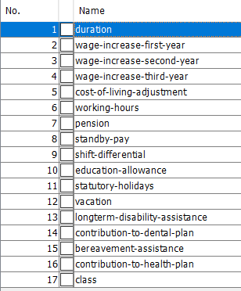

Selecting the attributes which have the major impact on the final classification using filters in WEKA.

Upon applying the filter AttributeSelection under Filters->Supervised->Attributes, we get the following attributes.

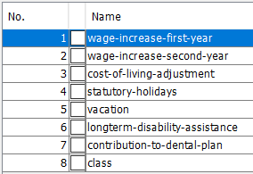

**Task for Level-1: Classification on the dataset using Logistic Regression**

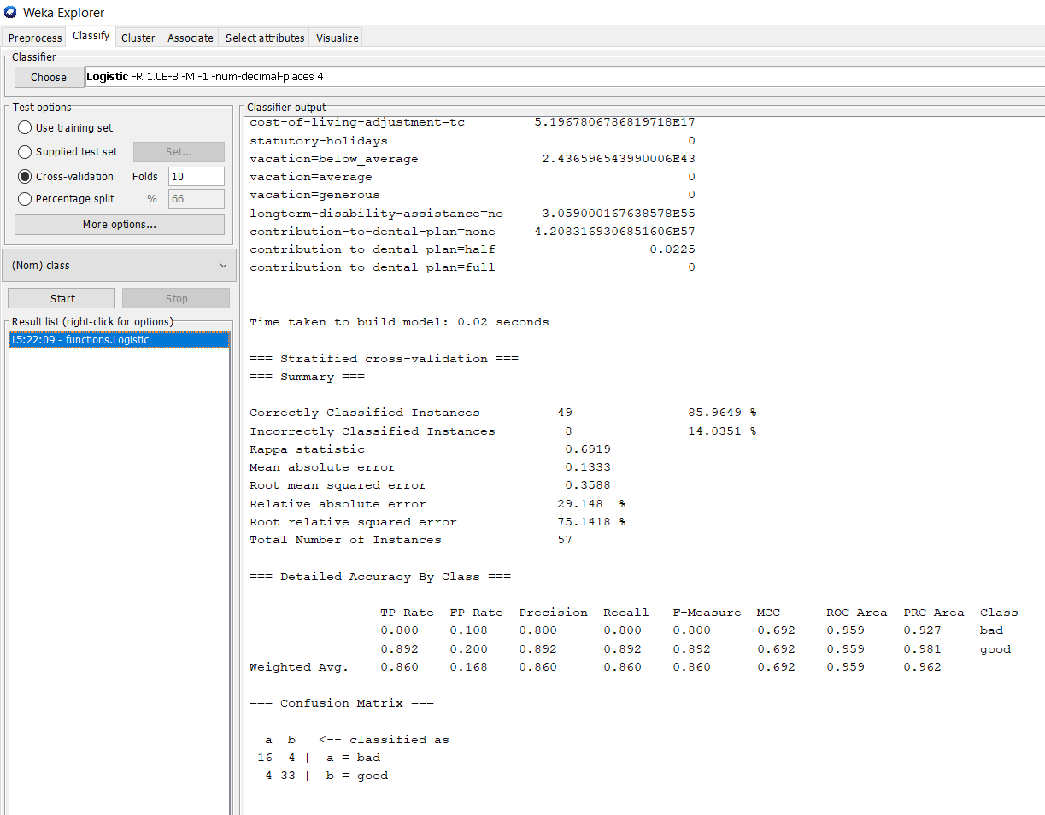

Using logistic regression, we group the employees into two classes – good and bad.

As we can see 85.9% accuracy is established.

The confusion matrix is also displayed in the bottom justifying the accuracy.

**Task for Level-2: Using SVM to the same dataset**

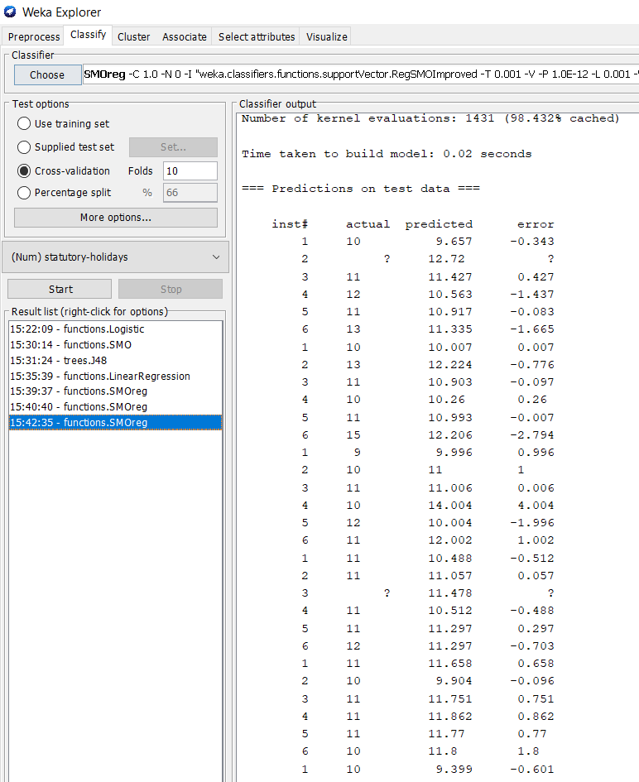

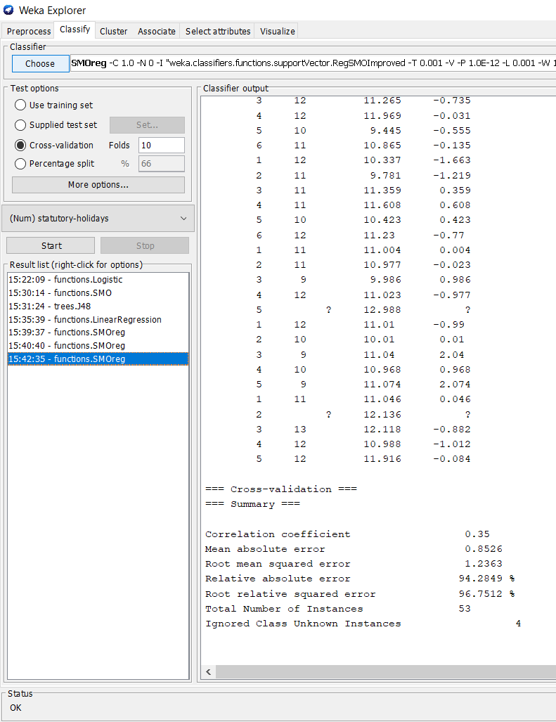

**Task for Level-3: Using Decision Tree to the same dataset**

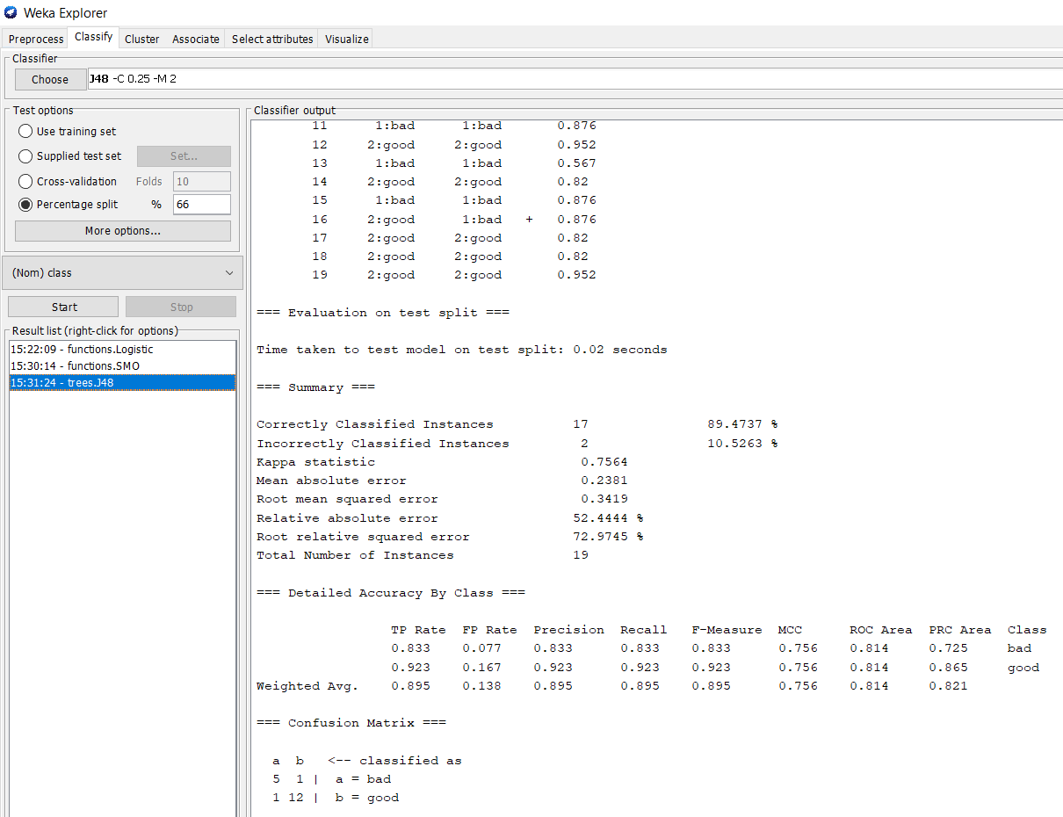

**Tree Visualizer**

