**CS6301 MACHINE LEARNING LAB WEEK – 8 KNN, KMEANS, ENSEMBLE LEARNING**

**SRIHARI. S – 2018103601**

**Date**: 10-04-2021 Saturday

**Aim**: To implement ensemble learning algorithm using various classifiers – SVM, MLP, Decision Trees and KNN and determine the results.

**Dataset:** MNIST Dataset

The MNIST database is a large database of handwritten digits that is commonly used for training various image processing systems which contains 60,000 training images and 10,000 testing images. Half of the training set and half of the test set were taken from NIST's training dataset, while the other half of the training set and the other half of the test set were taken from NIST's testing dataset.

**Input:**

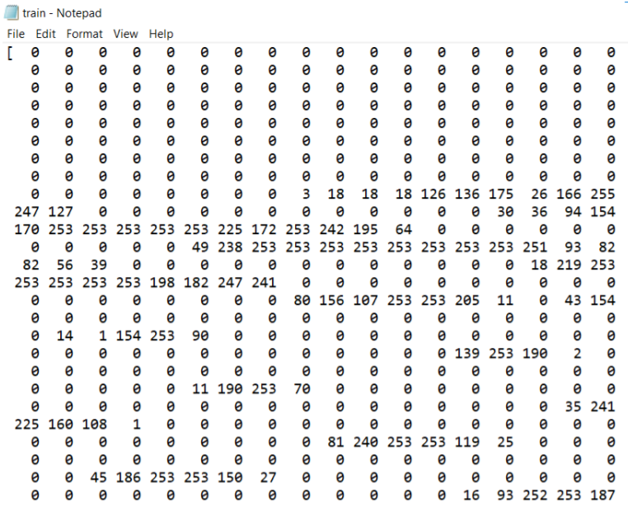

**K-MEANS ALGORITHM**

import sys

import sklearn

import matplotlib

import numpy as np

from keras.datasets import mnist

(x_train, y_train), (x_test, y_test) = mnist.load_data()

print('Training Data: {}'.format(x_train.shape))

print('Training Labels: {}'.format(y_train.shape))

print('Testing Data: {}'.format(x_test.shape))

print('Testing Labels: {}'.format(y_test.shape))

import matplotlib.pyplot as plt

# python magic function

%matplotlib inline

# create figure with 3x3 subplots using matplotlib.pyplot

fig, axs = plt.subplots(3, 3, figsize = (12, 12))

plt.gray()

# loop through subplots and add mnist images

for i, ax in enumerate(axs.flat):

ax.matshow(x_train[i])

ax.axis('off')

ax.set_title('Number {}'.format(y_train[i]))

# display the figure

fig.show()

# convert each image to 1 dimensional array

X = x_train.reshape(len(x_train),-1)

Y = y_train

# normalize the data to 0 - 1

X = X.astype(float) / 255.

print(X.shape)

print(X[0].shape)

from sklearn.cluster import MiniBatchKMeans

n_digits = len(np.unique(y_test))

print(n_digits)

# Initialize KMeans model

kmeans = MiniBatchKMeans(n_clusters = n_digits)

# Fit the model to the training data

kmeans.fit(X)

def infer_cluster_labels(kmeans, actual_labels):

inferred_labels = {}

for i in range(kmeans.n_clusters):

# find index of points in cluster

labels = []

index = np.where(kmeans.labels_ == i)

# append actual labels for each point in cluster

labels.append(actual_labels[index])

# determine most common label

if len(labels[0]) == 1:

counts = np.bincount(labels[0])

else:

counts = np.bincount(np.squeeze(labels))

# assign the cluster to a value in the inferred_labels dictionary

if np.argmax(counts) in inferred_labels:

# append the new number to the existing array at this slot

inferred_labels[np.argmax(counts)].append(i)

else:

# create a new array in this slot

inferred_labels[np.argmax(counts)] = [i]

#print(labels)

#print('Cluster: {}, label: {}'.format(i, np.argmax(counts)))

return inferred_labels

def infer_data_labels(X_labels, cluster_labels):

"""

Determines label for each array, depending on the cluster it has been assigned to.

returns: predicted labels for each array

"""

# empty array of len(X)

predicted_labels = np.zeros(len(X_labels)).astype(np.uint8)

for i, cluster in enumerate(X_labels):

for key, value in cluster_labels.items():

if cluster in value:

predicted_labels[i] = key

return predicted_labels

# test the infer_cluster_labels() and infer_data_labels() functions

cluster_labels = infer_cluster_labels(kmeans, Y)

X_clusters = kmeans.predict(X)

predicted_labels = infer_data_labels(X_clusters, cluster_labels)

print(predicted_labels[:20])

print(Y[:20])

from sklearn import metrics

def calculate_metrics(estimator, data, labels):

# Calculate and print metrics

print('Number of Clusters: {}'.format(estimator.n_clusters))

print('Inertia: {}'.format(estimator.inertia_))

print('Homogeneity: {}'.format(metrics.homogeneity_score(labels, estimator.labels_)))

clusters = [10, 16, 36, 64, 144, 256]

# test different numbers of clusters

for n_clusters in clusters:

estimator = MiniBatchKMeans(n_clusters = n_clusters)

estimator.fit(X)

# print cluster metrics

calculate_metrics(estimator, X, Y)

# determine predicted labels

cluster_labels = infer_cluster_labels(estimator, Y)

predicted_Y = infer_data_labels(estimator.labels_, cluster_labels)

# calculate and print accuracy

print('Accuracy: {}\n'.format(metrics.accuracy_score(Y, predicted_Y)))

# test kmeans algorithm on testing dataset

# convert each image to 1 dimensional array

X_test = x_test.reshape(len(x_test),-1)

# normalize the data to 0 - 1

X_test = X_test.astype(float) / 255.

# initialize and fit KMeans algorithm on training data

kmeans = MiniBatchKMeans(n_clusters = 256)

kmeans.fit(X)

cluster_labels = infer_cluster_labels(kmeans, Y)

# predict labels for testing data

test_clusters = kmeans.predict(X_test)

predicted_labels = infer_data_labels(kmeans.predict(X_test), cluster_labels)

# calculate and print accuracy

print('Accuracy: {}\n'.format(metrics.accuracy_score(y_test, predicted_labels)))

kmeans = MiniBatchKMeans(n_clusters = 36)

kmeans.fit(X)

# record centroid values

centroids = kmeans.cluster_centers_

# reshape centroids into images

images = centroids.reshape(36, 28, 28)

images *= 255

images = images.astype(np.uint8)

# determine cluster labels

cluster_labels = infer_cluster_labels(kmeans, Y)

# create figure with subplots using matplotlib.pyplot

fig, axs = plt.subplots(6, 6, figsize = (20, 20))

plt.gray()

# loop through subplots and add centroid images

for i, ax in enumerate(axs.flat):

# determine inferred label using cluster_labels dictionary

for key, value in cluster_labels.items():

if i in value:

ax.set_title('Inferred Label: {}'.format(key))

# add image to subplot

ax.matshow(images[i])

ax.axis('off')

# display the figure

fig.show()

print("Accuracy = ",metrics.accuracy_score(y_true=y_test, y_pred=predicted_labels)*100)

class_wise = metrics.classification_report(y_true=y_test, y_pred=predicted_labels)

print(class_wise)

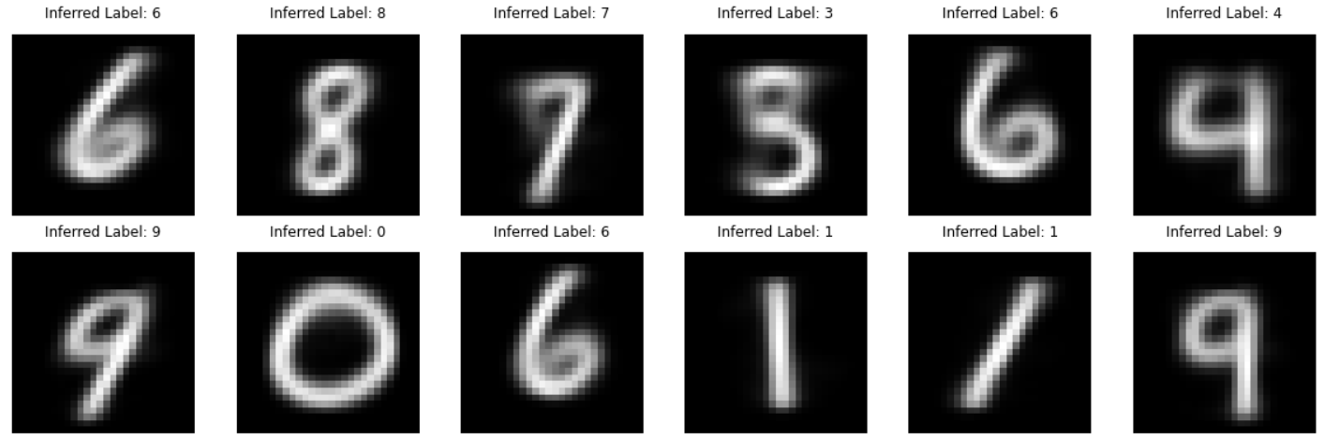

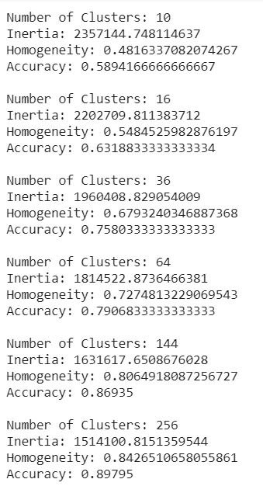

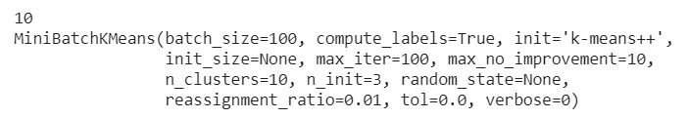 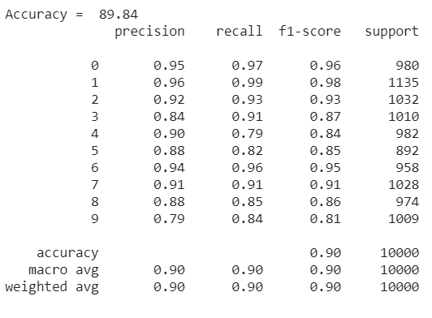

**KNN**

import csv

import math

import random

def loadDataset(filename, split, trainingset = [], testset = []):

with open(filename,'r') as csvfile:

lines = csv.reader(csvfile)

dataset = list(lines)

for x in range(1,math.ceil((len(dataset)+1)/10)):

for y in range(1,len(dataset[x])):

dataset[x][y] = float(dataset[x][y])

if random.random() < split:

trainingset.append(dataset[x])

else:

testset.append(dataset[x])

trainingset = []

testset = []

loadDataset('/content/sample_data/mnist_train_small.csv',0.66,trainingset,testset)

print("train "+repr(len(trainingset)))

print("test "+repr(len(testset)))

import math

def euclideandistance(instance1,instance2,length):

distance = 0

for x in range(1,length):

distance += pow((instance1[x]-instance2[x]),2)

return math.sqrt(distance)

import operator

def getNeighbours(trainingset,testinstance,k):

distances = []

length = len(testinstance)-1

for x in range(1,len(trainingset)):

dist = euclideandistance(testinstance, trainingset[x],length)

distances.append((trainingset[x],dist))

distances.sort(key=operator.itemgetter(1))

neighbours = []

for x in range(k):

neighbours.append(distances[x][0])

return neighbours

import operator

def getResponse(neighbours):

classvotes = {}

for x in range(len(neighbours)):

response = neighbours[x][0]

if response in classvotes:

classvotes[response] += 1

else:

classvotes[response] = 1

sortedvotes = sorted(classvotes.items(),key = operator.itemgetter(1),reverse = True)

return sortedvotes[0][0]

def getAccuracy(testset, predictions):

correct = 0

for x in range(len(testset)):

if testset[x][0] == predictions[x]:

correct= correct + 1

#print("Srihari",correct)

return (correct/float(len(testset)))*100.0

from sklearn import metrics

trainingset = []

testset = []

split = 0.66

loadDataset('/content/sample_data/mnist_train_small.csv',split,trainingset,testset)

print("train "+repr(len(trainingset)))

print("test "+repr(len(testset)))

predictions = []

y_test = []

k = 1

i=1

for x in range(len(testset)):

neighbours = getNeighbours(trainingset,testset[x],k)

result = getResponse(neighbours)

predictions.append(result)

y_test.append(testset[x][0])

print(i)

i = i + 1

#print("Predicted = "+repr(result)+' actual = '+repr(testset[x][-1]))

#accuracy = getAccuracy(testset, predictions)

#print("accuracy = ",repr(accuracy),"%")

confusion = metrics.confusion_matrix(y_true = y_test, y_pred = predictions)

confusion

print("Accuracy = ",metrics.accuracy_score(y_true=y_test, y_pred=predictions)*100)

class_wise = metrics.classification_report(y_true=y_test, y_pred=predictions)

print(class_wise)



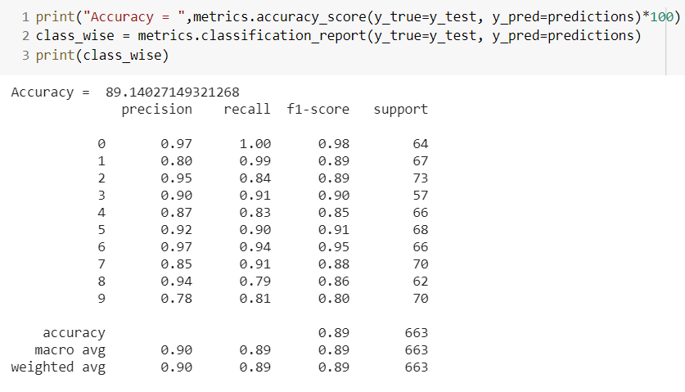

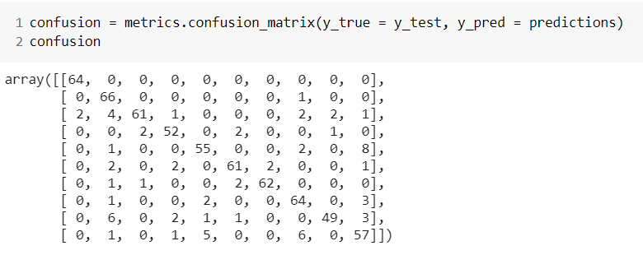

**TABULAR INFERENCE**

|  |  |  |
| --- | --- | --- |
| **ALGORITHM** | **K-MEANS** | **K-NN** |
| **PRECISION** | 0.90 | 0.90 |
| **RECALL** | 0.90 | 0.89 |
| **F1-SCORE** | 0.90 | 0.89 |
| **ACCURACY** | 89.84 % | 90.24 % |

**ALGORITHM 1 – K-MEANS**

|  |  |  |  |  |  |  |
| --- | --- | --- | --- | --- | --- | --- |
| **VALUE OF K** | **10** | **16** | **36** | **64** | **144** | **256** |
| **ACCURACY** | 58.9% | 63.1% | 75.8% | 79.06% | 86.9% | 89.84% |

**ALGORITHM 2 – K-NN**

|  |  |  |  |  |  |
| --- | --- | --- | --- | --- | --- |
| **VALUE OF K** | **1** | **8** | **10** | **12** | **20** |
| **ACCURACY** | 90.24% | 88.19% | 89.6% | 87.15% | 84.2% |

**Inference: Thus, the K-Means Clustering and K-Nearest Neighbours algorithms were implemented. It was applied on the MNIST dataset as well. The accuracies obtained by varying the value of k is tabulated.**

**ENSEMBLE METHODS**

**CLASSIFIER 1: Multi-Layer Perceptron**

import numpy as np

from sklearn.model_selection import GridSearchCV

from sklearn.neural_network import MLPClassifier

mlp = MLPClassifier()

params_mlp = {'max_iter':[500,1000], 'activation': ['tanh','relu','identity','logistic']}

mlp_gs = GridSearchCV(mlp, params_mlp, cv=5)

mlp_gs.fit(X_train, y_train)

#save best model

mlp_best = mlp_gs.best_estimator_

#check best n_neigbors value

print(mlp_gs.best_params_)

pred_mlp_gs = mlp_gs.predict(X_test)

print("Accuracy = ",metrics.accuracy_score(y_true=y_test, y_pred=pred_mlp_gs))

class_wise = metrics.classification_report(y_true=y_test, y_pred=pred_mlp_gs)

print(class_wise)

print('mlp: {}'.format(mlp_gs.score(X_test, y_test)))

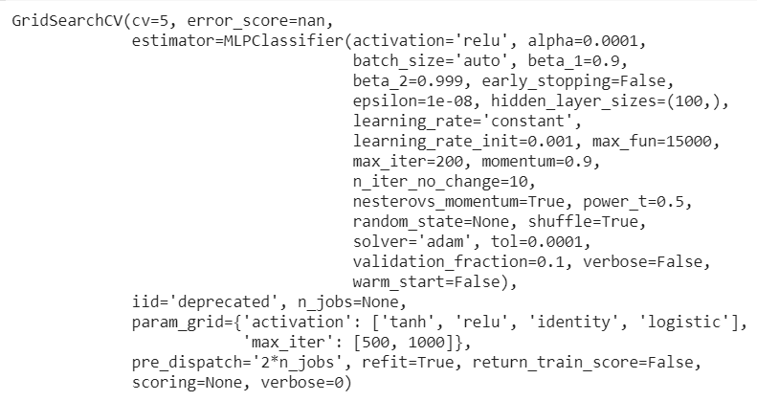



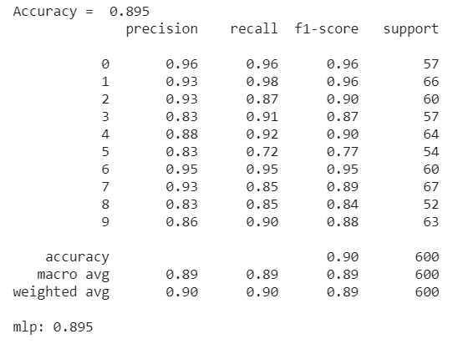

**CLASSIFIER 2: Support Vector Machine**

import numpy as np

from sklearn import metrics

from sklearn.model_selection import GridSearchCV

from sklearn.svm import SVC

svm_rbf = SVC(kernel='rbf')

params_svm = {'C':[1, 10, 100], 'gamma': ['scale',1e-2, 1e-3, 1e-4]}

svm_gs = GridSearchCV(svm_rbf, params_svm, cv=5)

svm_gs.fit(X_train, y_train)

#save best model

svm_best = svm_gs.best_estimator_

#check best n_neigbors value

print(svm_gs.best_params_)

pred_svm_gs = svm_gs.predict(X_test)

print("Accuracy = ",metrics.accuracy_score(y_true=y_test, y_pred=pred_svm_gs))

class_wise = metrics.classification_report(y_true=y_test, y_pred=pred_svm_gs)

print(class_wise)

print('svm: {}'.format(svm_gs.score(X_test, y_test)))

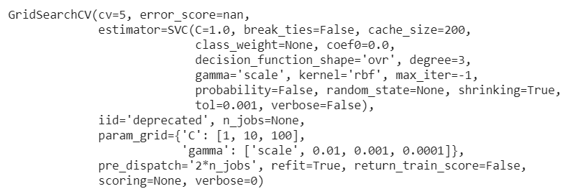



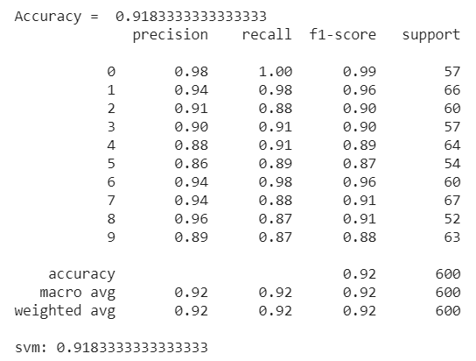

**CLASSIFIER 3: Decision Tree**

import numpy as np

from sklearn import metrics

from sklearn.model_selection import GridSearchCV

from sklearn.tree import DecisionTreeClassifier

dt = DecisionTreeClassifier()

params_dt = {'max_depth': np.arange(1, 10),'criterion':['gini','entropy'],'splitter':['best','random']}

dt_gs = GridSearchCV(dt, params_dt, cv=10)

#fit model to training data

dt_gs.fit(X_train, y_train)

dt_best = dt_gs.best_estimator_

print(dt_gs.best_params_)

pred_dt_gs = dt_gs.predict(X_test)

print("Accuracy = ",metrics.accuracy_score(y_true=y_test, y_pred=pred_dt_gs))

class_wise = metrics.classification_report(y_true=y_test, y_pred=pred_dt_gs)

print(class_wise)

print('dt: {}'.format(dt_gs.score(X_test, y_test)))

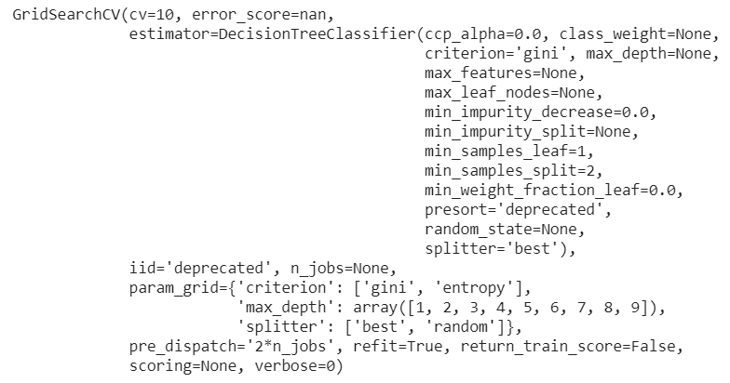



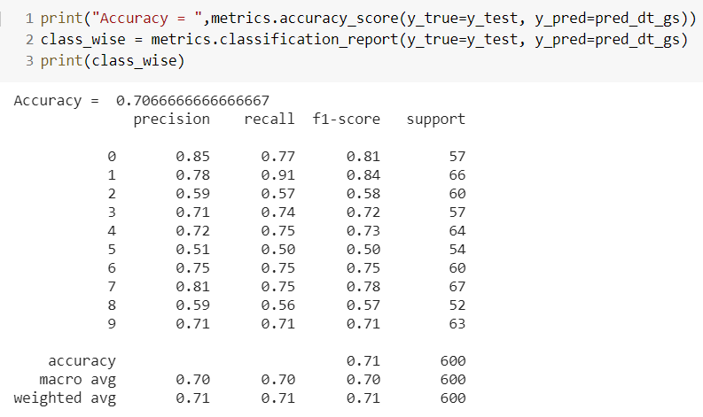

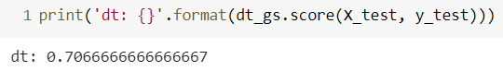

**CLASSIFIER 4: K-Nearest Neighbours**

import numpy as np

from sklearn import metrics

from sklearn.model_selection import GridSearchCV

import numpy as np

from sklearn.model_selection import GridSearchCV

from sklearn.neighbors import KNeighborsClassifier

#create new a knn model

knn = KNeighborsClassifier()

#create a dictionary of all values we want to test for n_neighbors

params_knn = {'n_neighbors': np.arange(1, 25)}

#use gridsearch to test all values for n_neighbors

knn_gs = GridSearchCV(knn, params_knn, cv=5)

#fit model to training data

knn_gs.fit(X_train, y_train)

#save best model

knn_best = knn_gs.best_estimator_

#check best n_neigbors value

print(knn_gs.best_params_)

pred_knn_gs = knn_gs.predict(X_test)

print("Accuracy = ",metrics.accuracy_score(y_true=y_test, y_pred=pred_knn_gs))

class_wise = metrics.classification_report(y_true=y_test, y_pred=pred_knn_gs)

print(class_wise)

print('knn: {}'.format(knn_gs.score(X_test, y_test)))

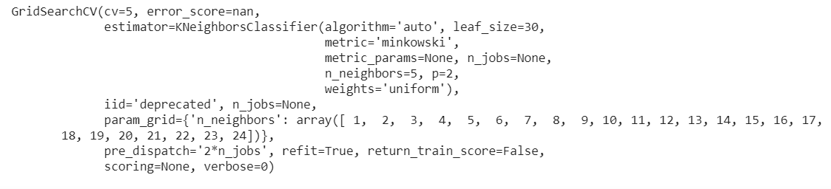



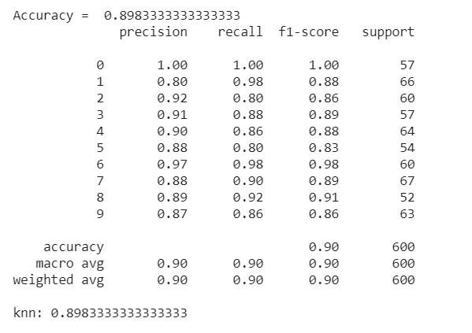

**VOTING CLASSIFIER**

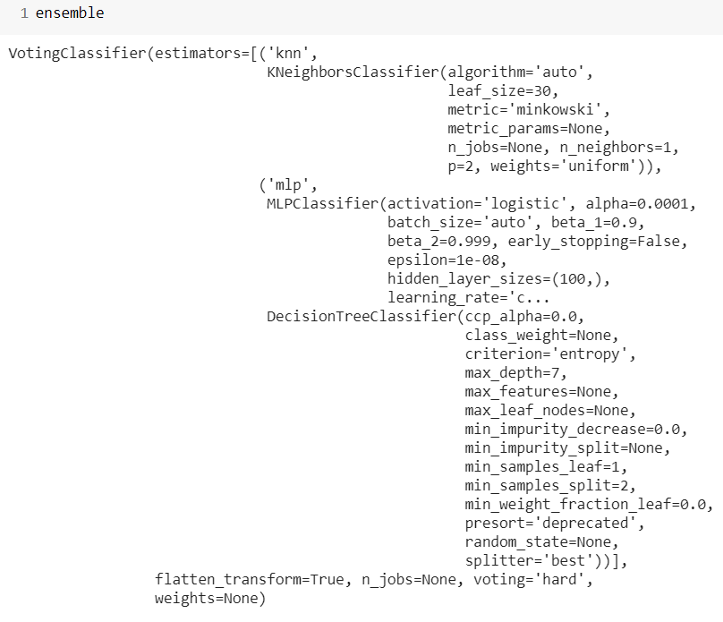

**Hard Voting:**

from sklearn.ensemble import VotingClassifier

#create a dictionary of our models

estimators=[('knn', knn_best), ('mlp', mlp_best), ('svm', svm_best), ('dt', dt_best)]

#create our voting classifier, inputting our models

ensemble = VotingClassifier(estimators, voting='hard')

ensemble.fit(X_train, y_train)

pred_em = ensemble.predict(X_test)

print("Accuracy = ",metrics.accuracy_score(y_true=y_test, y_pred=pred_em))

class_wise = metrics.classification_report(y_true=y_test, y_pred=pred_em)

print(class_wise)

print('EM: {}'.format(ensemble.score(X_test, y_test)))

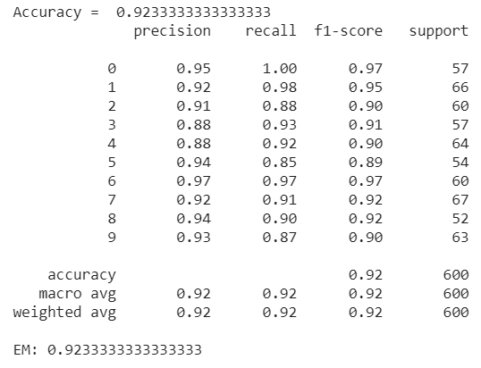

**Soft Voting:**

from sklearn.ensemble import VotingClassifier

estimators=[('knn', knn_best), ('mlp', mlp_best), ('svm', svm_best), ('dt', dt_best)]

ensemble = VotingClassifier(estimators, voting='soft')

ensemble.fit(X_train, y_train)

#test our model on the test data

ensemble.score(X_test, y_test)

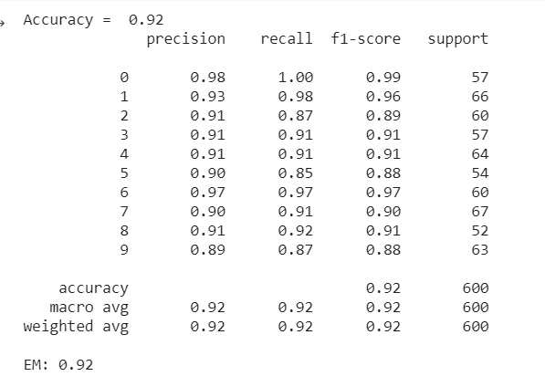

**TABULAR INFERENCE**

|  |  |  |  |  |
| --- | --- | --- | --- | --- |
| **CLASSIFIER** | **PRECISION** | **RECALL** | **F1-SCORE** | **ACCURACY** |
| **MLP** | 0.89 | 0.89 | 0.89 | 89.5% |
| **SVM** | 0.92 | 0.92 | 0.92 | 91.8% |
| **Decision Tree** | 0.70 | 0.70 | 0.70 | 70.6% |
| **KNN** | 0.90 | 0.90 | 0.90 | 89.8% |
| **Hard Voting Classifier** | 0.92 | 0.92 | 0.92 | **92.3%** |
| **Soft Voting Classifier** | 0.92 | 0.92 | 0.92 | **92%** |

**Inference: Thus, using four different classifiers – MLP, SVM, DT and KNN ensemble methods were implemented. It was applied on the MNIST dataset as well. The accuracies obtained are found to be higher than the individual accuracies of the classifiers using both hard voting and soft voting.**