A report on

SATEUREKA – THE MODERN-DAY SATELLITE DATABASE

by

2018103547 | S. KARTHICK RAJA

2018103553 | KIRAN SEKHAR

2018103601 | S. SRIHARI

Submitted for the course

CS6105- Database Management Systems

Evaluator Name and Signature

Date:

Abstract

Assembled by experts at the Union of Concerned Scientists (UCS), the **SATEUREKA** is a listing of many operational satellites orbiting around Earth. Our intent in producing the database is to create a research tool for specialists and non-specialists alike by collecting open-source information on operational satellites and presenting it in a format that can be easily manipulated for research and analysis.

SATEUREKA denotes “SATELLITE - EUREKA”, which stores golden significant information about the rocketry system across globe. This database minimizes redundancy of data, and in the same time provides the required information at our doorstep.

Privilege of dashboard access is given only to the project directors who can perform a variety of operations in the dashboard. It includes viewing the details of candidates who would be interning at the organization. Upload of Fuel amount and getting the value of payload proportions are done with the help of stored procedures and functions. Triggers are used to indicate a fuel warning if the fuel capacity drops drastically. Backup information of the employees who have retired or resigned is achieved using triggers. Views are used to get the list of active satellites and the astronaut list who are fit to pursue their missions.

Front End: HTML, CSS, JAVASCRIPT

Back End: PHP, MYSQL

Salient Features of the System

1. The Mentors List for internees would be available in the home page, along with their expertise which enables the interns to choose the scientist under whom they wish to work based on their domain of interest.
2. Confidential status of Missions can be obtained.
3. An auto warn system to indicate Fuel-Warningif the fuel amount of the rocket falls below 50% mark.
4. Authenticated information storage of scientists who have resigned or retired.
5. Provision of quick retrieval of Astronaut details, including their fitness, role in the mission, exclusively for Project Directors.
6. Three level monitored scrutinizing system for viewing the dashboard.
7. A chat query system which addresses the queries raised directly by the project director.
8. Countdown for the upcoming mission is always displayed in the homepage.
9. Latest Achievements would be displayed

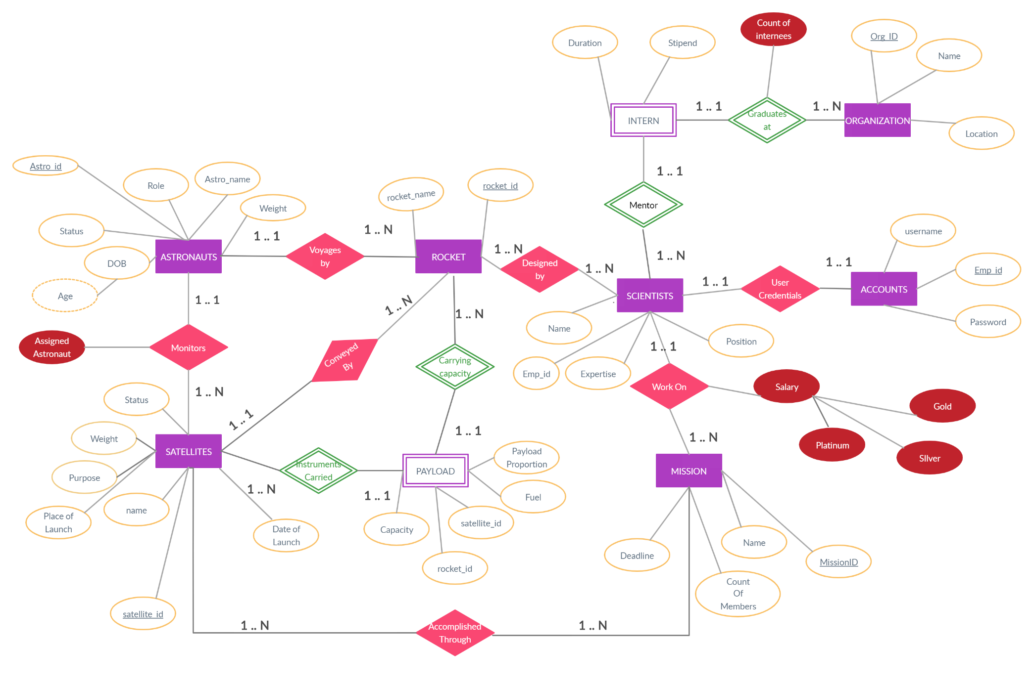

SATEUREKA

ER Diagram

DATABASE Schema

SATEUREKA

Instances of each Relation

ASSIGNED_ASTRO 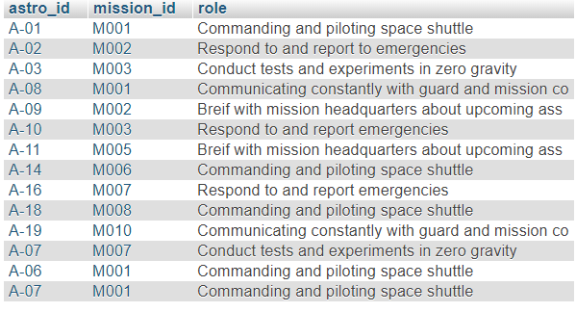

ASTRONAUTS 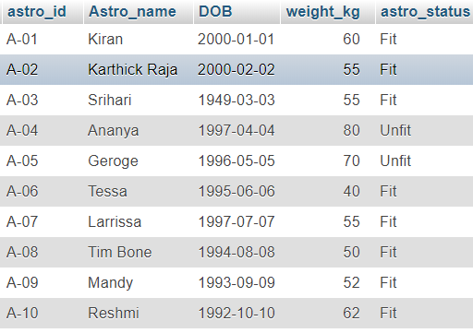

INTERN 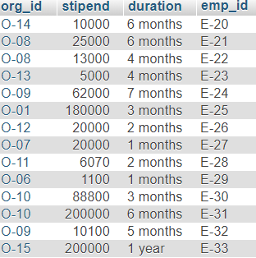

SATELLITES

SCIENTISTS

Views

|  |  |  |  |
| --- | --- | --- | --- |
| # | **Name** | **Tables Involved** | **Description** |
| 1 | Active – Satellites | Satellites | To indicate the list of satellites  Which are currently active. |
| 2 | Fit- Astronauts | Astronauts | To provide the essential details of the astronaut who are fit enough to get a GO for their mission |
| 3 | Internship | Intern, Scientists,  organisation | To display the list of internees who have been qualified to work in Sateureka |
| 4 | Mentors | Scientists | To provide the list of mentors of Sateureka, so that qualified interns can approach them based on their expertise |

Procedures

|  |  |  |  |
| --- | --- | --- | --- |
| # | **Name & Description** | **Tables Involved** | **IN & OUT Parameter(s)** |
| 1 | **Get Scientist Level**  A procedure to display earnings of all scientists, using a categorization level based on their salary | Salary info | **IN** – EmployeeNumber VARCHAR 4 |
| **OUT** – EmployeeLevel VARCHAR 20 |
| 2 | **Mission Name**  A procedure to provide mission name and satellite name of the scientist given his employee id. | Scientists | **IN** – EmpID VARCHAR 4  **OUT** – MissionName VARCHAR 20  **OUT** – SatelliteName VARCHAR 20 |
| 3 | **Get_Scientist_Profile**  A procedure to display the position, expertise and the mission, satellite under which the scientist is currently working | Scientist, Mission, Satellites | **IN** – EmpId VARCHAR 4  **OUT**- Position Varchar 80  **OUT**- Expertise Varchar 80  **OUT**- MissionName Varchar 80  **OUT**- SatelliteName Varchar 80 |
| 4 | **List_Name**  A procedure which lists the names of internees representing a geographical location | Organisation, Intern, Satellites | **IN** – Location Varchar 4  **INOUT** – Namelist Varchar 400 |

Functions

|  |  |  |  |  |
| --- | --- | --- | --- | --- |
| **#** | **Name & Description** | **Tables Involved** | **Parameter(s)** | **Return Type** |
| 1 | **Mission_status**  a function that gets the mission_id and find the corresponding mission status | Mission, Satellites | (mid VARCHAR (4)) | varchar |
| 2 | **Payload_proportion (in percentage)**  A function that gets the satellite_id and returns the corresponding payload proportion in percentage | Payload | (sid VARCHAR (4)) | float |
| 3 | **Salary (In lakhs)**  A function that gets the emp_id and returns his/her salary figures in Lakhs | Salary_info | (eid VARCHAR (4)) | decimal (8,4) |
| 4 | **get_astronaut_role**  A function that returns the role of an astronaut given his id | Astronauts,  Assigned_astro | (inpname VARCHAR (20)) | varchar (60) |

Triggers

|  |  |  |  |
| --- | --- | --- | --- |
| **#** | **Name & Description** | **Trigger Type** | **Tables Involved** |
| 1 | **Astro_status**  Trigger is to set the status of a newly enrolled astronaut as FIT. | Before Insert | Assigned_astro,  astronauts |
| 2 | **Fuel_status**  Trigger is to set the satellite status as FUEL WARNING or ACTIVE based on the updated fuel amount | After Update | Payload, Satellites |
| 3 | **Intern_checker**  Trigger is to increment the count based on new internees | Before Insert | Intern, Organisation_count |
| 4 | **Intern_dechecker**  Trigger is to maintain the organization count of internees and to delete from Employees table of Sateureka | Before Delete | Intern, organization_count, scientist |
| 5 | **Resigned_or_retire**  Trigger is to backup essential details of outgoing employees and to delete their salary info | Before delete | Scientists, Salary_info |

**SQL**

|  |  |  |  |
| --- | --- | --- | --- |
| **#** | **Name** | **Tables Involved** | **Constructs Used** |
| 1 | To provide the details of internees grouped based on organization name and duration of the internship | Intern, Organization | Aggregate Function, Join, Group by |
| 2 | To provide an in-depth insight about missions and the corresponding satellites involved | Mission, Satellites | Join |
| 3 | To find the most successful mission in terms of salary earned by grouping the salary of members in the same mission | Scientists, Salary_info | Aggregate function, Join, Group by, Order by |
| 4 | To find the name and emp_id of scientists who are not interns | Scientists, Intern | Sub queries |
| 5 | To find the best rockets in terms of their capacity and fuel amount | Rocket, Payload | Join, Order by |
| 6 | To display the details of missions which are on time. i.e. Launched before their deadline | Satellites, Mission | Join, Date functions |
| 7 | To provide the astronaut profile in his/her mission | Astronauts, Assigned_astro, Mission | Join, Order by |

***VIEWS***

1. **create view `active - satellites` as select sat_id,sat_name, purpose from `satellites`;**
2. **create view `fit-astronauts` as select astro_id,Astro_name,weight_kg from `astronauts`;**
3. **create view `internship` as select emp_id,ename,org_id,name,duration from `organisation` natural join `intern` natural join `scientists`;**
4. **create view `mentor` as select emp_id,ename,expertise from `scientists`;**

***VIEWS***

**ACTIVE SATELLITES**  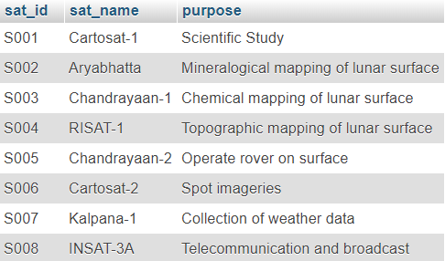

***FIT ASTRONAUTS***

***INTERNSHIP***

***MENTORS***

***SQL QUERIES***

1. **SELECT name, duration,count(emp_id) as InternCount FROM `intern` natural join `organisation` group by `name`,`duration`;**

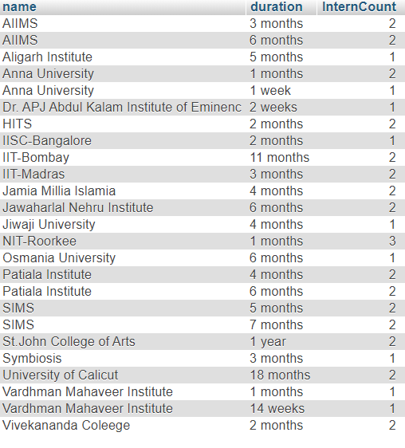

1. **SELECT * FROM `mission` NATURAL JOIN `satellites`;**A screenshot of a cell phone

   Description automatically generated
2. **SELECT mission_id, sum(salary) FROM `scientists` NATURAL JOIN `salary_info` group by mission_id order by sum(salary);**

1. **select a.emp_id,a.ename from `scientists` as a where a.emp_id NOT IN (select b.emp_id from `intern` as b );**

1. **SELECT rocketname, capacity_tons,fuel FROM `rocket` NATURAL JOIN `payload` order by capacity_tons desc,fuel desc;A screenshot of a cell phone

   Description automatically generated**
2. **select * from `satellites` natural join `mission` where DATEDIFF(DOL, deadline) < 0;**A screenshot of a cell phone

   Description automatically generated
3. **select Astro_name,mission_name,role from `astronauts` NATURAL join `assigned_astro` natural join `mission` order by mission_name;**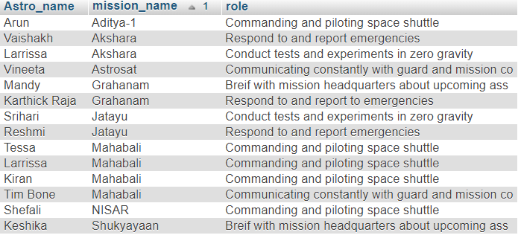

***PROCEDURES***

1. **GetScientistLevel**

CREATE PROCEDURE `GetScientistLevel`(IN `EmployeeNumber` VARCHAR (4), OUT `EmployeeLevel` VARCHAR(20))

BEGIN

DECLARE credit DECIMAL (10,2) ;

SELECT salary INTO credit FROM salary_info WHERE emp_id = EmployeeNumber;

IF(credit > 50000 )THEN

SET EmployeeLevel = 'PLATINUM';

ELSEIF (credit <= 50000 AND credit > 10000) THEN

SET EmployeeLevel = 'GOLD';

ELSE

SET EmployeeLevel = 'SILVER';

END IF;

END

SET @P0=’E-81’

CALL `GetScientistLevel` (@p0,@p1);

SELECT @p1 AS `EmployeeLevel`;

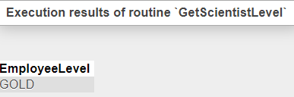

1. **MissionName**

CREATE PROCEDURE `MissionName`(IN `Empid` VARCHAR (4), OUT `M_Name` VARCHAR(20), OUT `S_Name` VARCHAR(20))

BEGIN

DECLARE mid VARCHAR (100);

SELECT mission_id INTO mid FROM scientists WHERE emp_id = Empid;

CASE mid

WHEN 'M001' THEN

SET M_Name = 'Mahabali';

SET S_Name = 'Ladee';

WHEN 'M002' THEN

SET M_Name = 'Grahanam';

SET S_Name = 'Chandrayaan-2';

WHEN 'M003' THEN

SET M_Name = 'Jatayu';

SET S_Name = 'Maven';

WHEN 'M004' THEN

SET M_Name = 'Mars Orbiter Mission';

SET S_Name = 'Mangalyaan';

WHEN 'M005' THEN

SET M_Name = 'Shukyayaan';

SET S_Name = 'Saral';

WHEN 'M006' THEN

SET M_Name = 'Aditya-1';

SET S_Name = 'Galex';

WHEN 'M007' THEN

SET M_Name = 'Akshara';

SET S_Name = 'Cartosat-2';

WHEN 'M008' THEN

SET M_Name = 'NISAR';

SET S_Name = 'INSAT-3A';

WHEN 'M009' THEN

SET M_Name = 'Gaganyaan';

SET S_Name = 'Bhaskara';

WHEN 'M010' THEN

SET M_Name = 'Astrosat';

SET S_Name = 'Mariner';

ELSE

SET M_Name = 'Enter a valid mission no';

SET S_Name = ' ';

END CASE;

END

SET @p0=’E-99’;

CALL `MissionName`(@p0,@p1,@p2);

SELECT @p1 AS `M_Name`,@p2 AS `S_Name`;

1. **get_scientist_profile**

CREATE PROCEDURE `get_scientist_profile`(IN `names` VARCHAR(40), OUT `de_pos` VARCHAR(40), OUT `de_exp` VARCHAR(40), OUT `de_sat` VARCHAR(40), OUT `de_m` VARCHAR(40))

BEGIN

DECLARE de_names VARCHAR( 40 ) DEFAULT "";

DECLARE de_nams VARCHAR( 40 ) DEFAULT "";

DECLARE de_na VARCHAR( 40 ) DEFAULT "";

DECLARE de_n VARCHAR( 40 ) DEFAULT "";

SELECT POSITION INTO de_names FROM scientists WHERE emp_id = names;

SELECT EXPERTISE INTO de_nams FROM scientists WHERE emp_id = names;

SELECT sat_name INTO de_na FROM scientists NATURAL JOIN mission NATURAL JOIN satellites WHERE emp_id = names;

SELECT mission_name INTO de_n FROM scientists NATURAL JOIN mission NATURAL JOIN satellites WHERE emp_id = names;

SET de_exp = de_nams;

SET de_pos = de_names;

SET de_sat = de_na;

SET de_m = de_n;

END

SET @p0=’E-61’;

CALL `get_scientist_profile`(@p0,@p1,@p2,@p3,@p4);

SELECT @p1 AS `de_pos` , @p2 AS `de_exp` , @p3 AS `de_sat` , @p4 AS `de_m`;

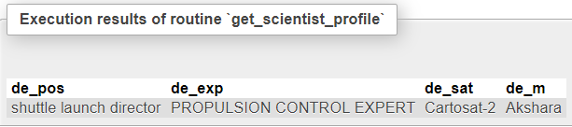

**4. list_name**

CREATE PROCEDURE `list_name`(IN `loc` VARCHAR(20), INOUT `name_list` VARCHAR(400))

BEGIN

DECLARE is_done INTEGER DEFAULT 0;

DECLARE s_name varchar(200) DEFAULT "";

DECLARE stud_cursor CURSOR FOR

SELECT ename FROM organisation NATURAL JOIN intern NATURAL JOIN scientists WHERE location = loc;

DECLARE CONTINUE HANDLER FOR NOT FOUND SET is_done = 1;

OPEN stud_cursor;

get_list : LOOP

FETCH stud_cursor INTO s_name;

IF is_done = 1 THEN

LEAVE get_list;

END IF;

SET name_list = CONCAT(s_name,' ;', name_list);

END LOOP get_list;

CLOSE stud_cursor;

END

SET @p0 = ‘Mumbai’;

SET @p1=’’;

CALL `list_name`(@p0,@p1);

SELECT @p1 AS `name_list`;

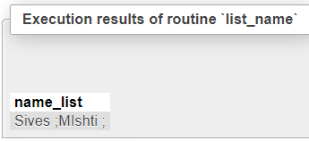

**FUNCTIONS**

1. **Mission_Status**

CREATE FUNCTION `Mission_Status`(`mid` VARCHAR(4))

RETURNS VARCHAR(20) CHARSET

BEGIN

DECLARE C VARCHAR(20) ;

SELECT sat_status into C from `mission` natural join `satellites` where mission_id = mid;

RETURN C;

END

SET @p0=’M010’;

SELECT `MissionStatus`(@p0) AS `MissionStatus`;

1. **Payload_proportion(in percentage)**

CREATE FUNCTION `Payload_proportion(in percentage)`(`s` VARCHAR(4))

RETURNS FLOAT

BEGIN

DECLARE C NUMERIC(6,6) ;

SELECT payload_prop into C from `payload` where sat_id = s;

RETURN C*100;

END

SET @p0=’S020’;

SELECT `Payload_Proportion(in percentage)`(@p0) AS ` Payload_Proportion(in percentage)`;

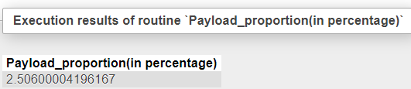

1. **Salary(In lakhs)**

CREATE FUNCTION `Salary(In lakhs)`(`e` VARCHAR(4))

RETURNS DECIMAL(8,4)

BEGIN

DECLARE C INT ;

SELECT salary into C from `salary_info` where emp_id = e;

RETURN C/100000;

END

SET @p0=’E-36’;

SELECT `Salary(In lakhs)`(@p0) AS `Salary(In lakhs)`;

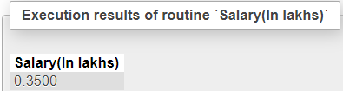

1. **get_astronaut_role**

CREATE FUNCTION `get_astronaut_role`(`inpname` VARCHAR(20))

RETURNS VARCHAR(60) CHARSET

BEGIN

DECLARE de_name VARCHAR( 60 ) DEFAULT "";

SELECT role INTO de_name FROM astronauts NATURAL JOIN assigned_astro WHERE Astro_name = inpname;

RETURN de_name;

END

SET @p0=’Shefali’;

SELECT `get_astronaut_role` (@p0) AS `get_astronaut_role`;

