**12.**

**AIM:** To write DFA using simulator to accept the input string “a” , ”ac” and ”bac”.

**DIAGRAM:**

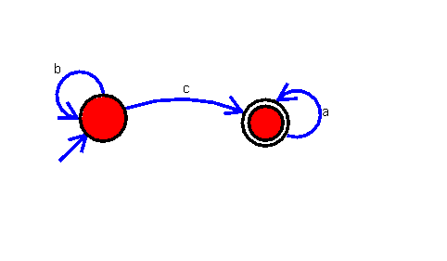

**INPUT**:

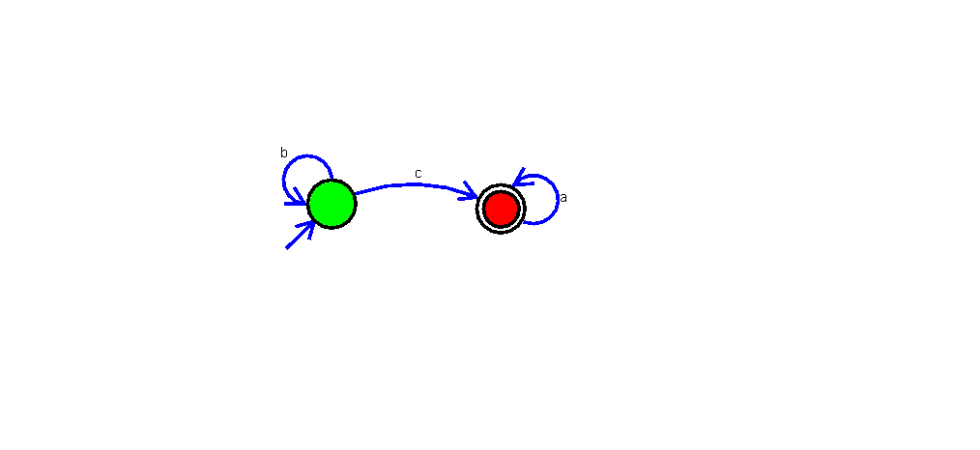 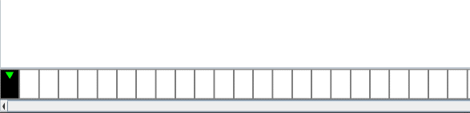

**OUTPUT**:

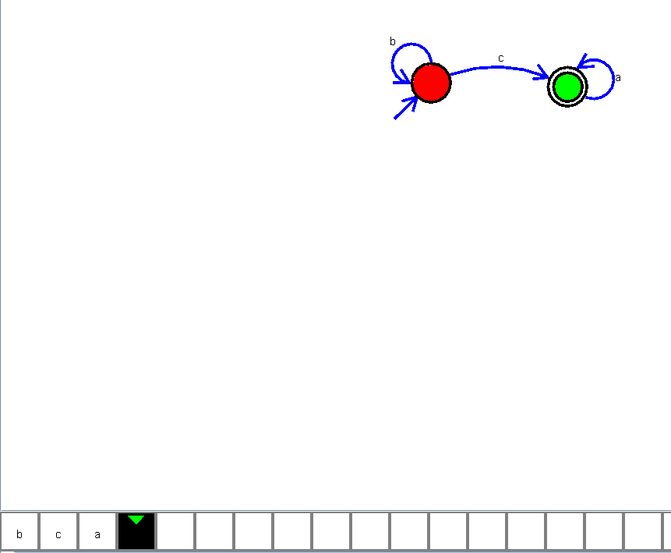Z

**RESULT**:

The implementation of DFA using simulator to accept the input string “a” , ”ac” and ”bac” is successfully completed.