**13.**

**AIM**:TO Design PDA using simulator to accept the input string aabb

**DIAGRAM:**

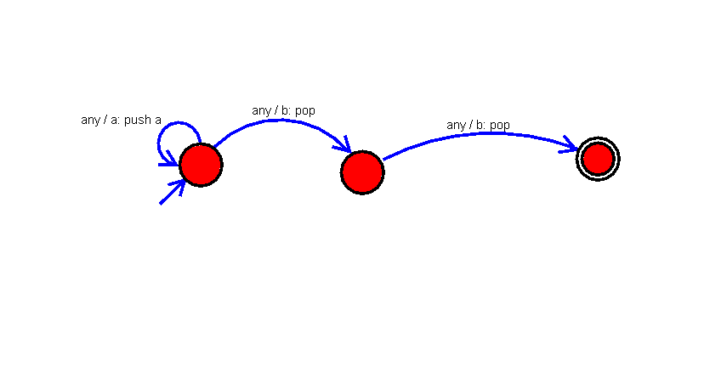

**INPUT**:

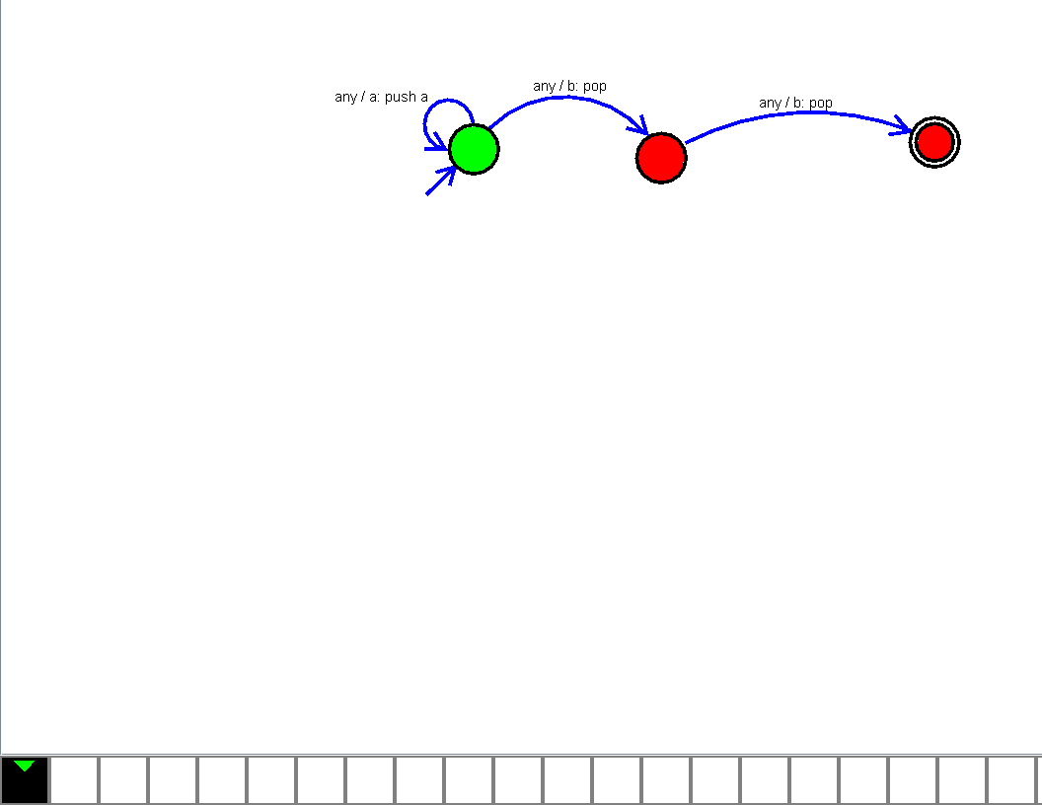

U

**OUTPUT**:

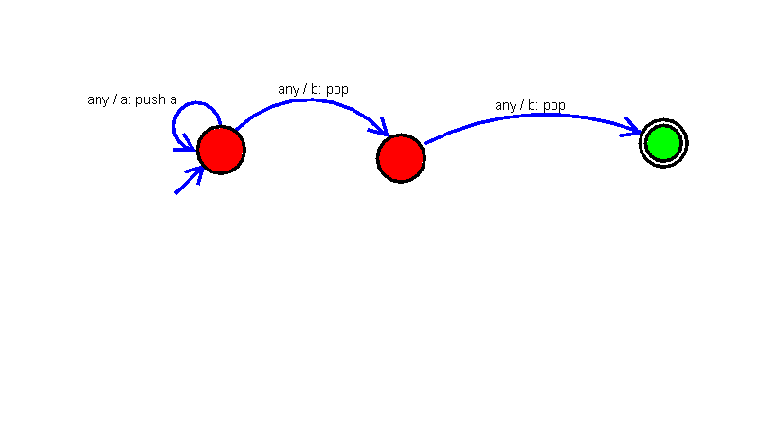

**RESULT**:

The implementation of Design PDA using simulator to accept the input string aabb

successfully completed.