**14.**

**AIM**:TO Design PDA using simulator to accept the input string anb2n

**DIAGRAM:**

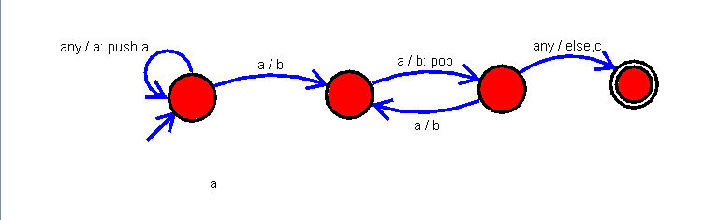

**INPUT:**

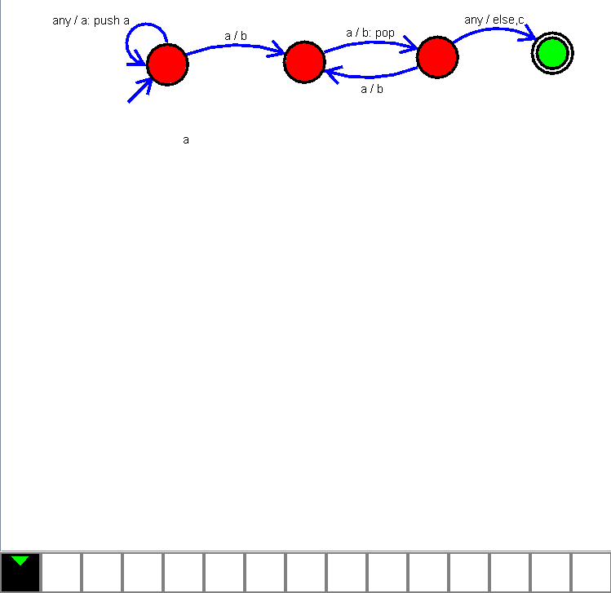

U

**OUTPUT:**

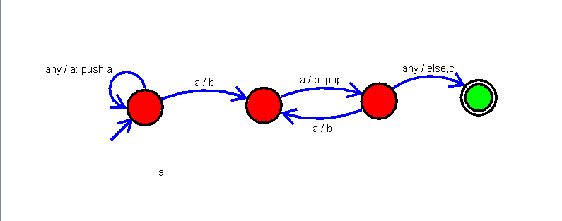

**RESULT:**

The implementation of Design PDA using simulator to accept the input string anb2n

successfully completed.