**15.**

**AIM**:TO Design TM using simulator to accept the input string anb**n**

**DIAGRAM:**

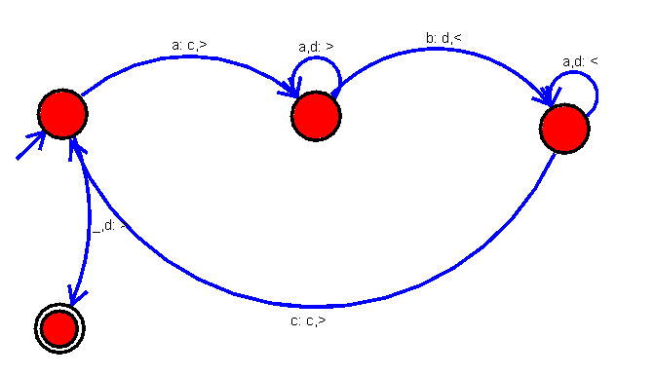

**INPUT:**

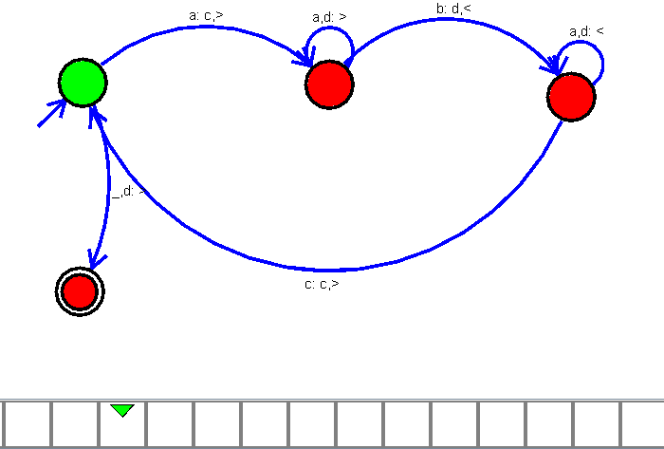

**OUTPUT:**

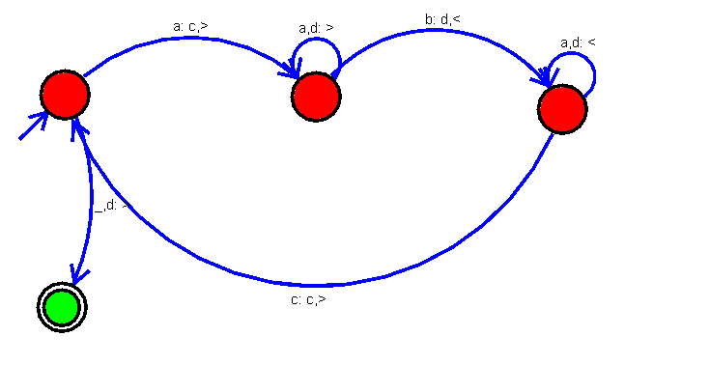

**RESULT:**

The implementation of Design TM using simulator to accept the input string anbn

successfully completed.