**16.**

**AIM:** Design TM using simulator to accept the input string anb2n

**INPUT:**

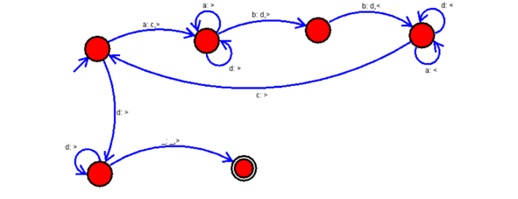

**OUTPUT:**

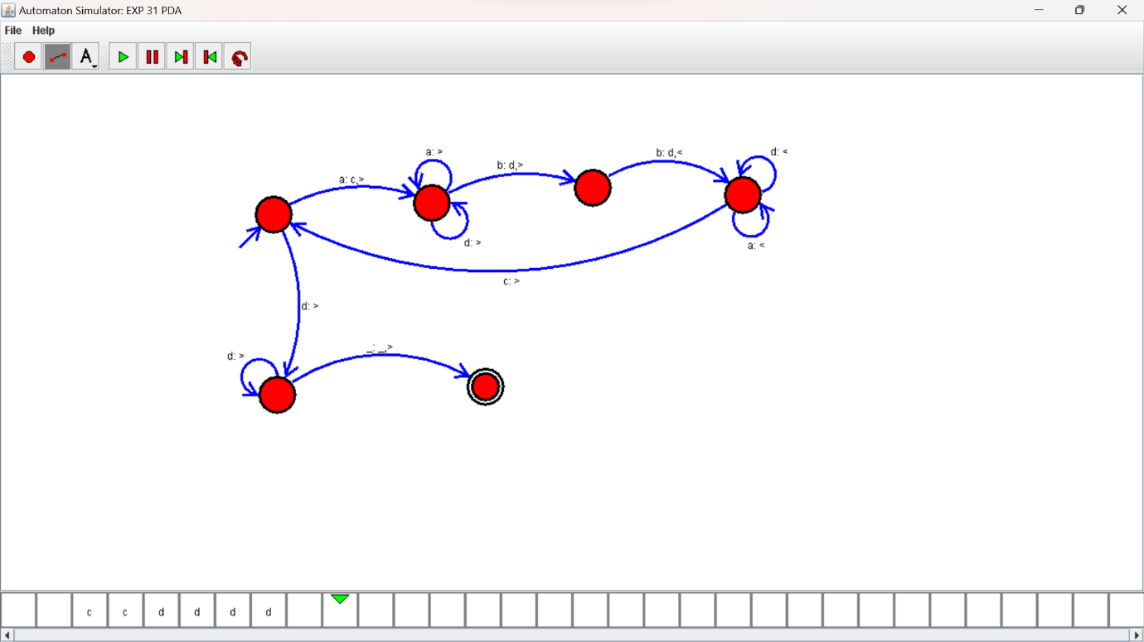

**RESULTS:**

TM using simulator to accepting the input string anb2n