**17**

**AIM**: Design TM using simulator to accept the input string Palindrome ababa

**INPUT:**

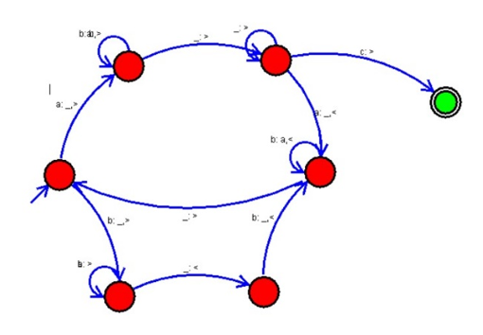

**OUTPUT:**

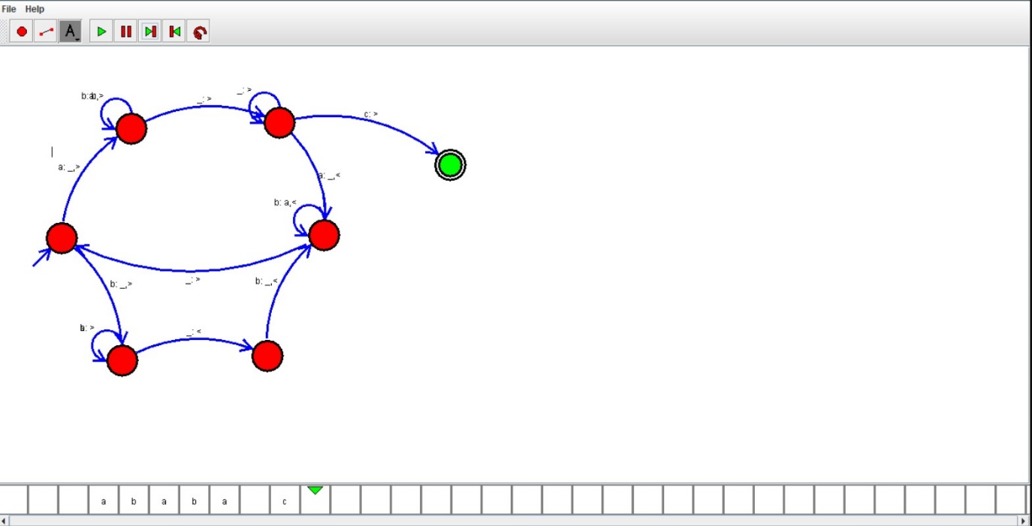

**RESULTS:** Tm using simulator to accept the input string Palindrome ababa by using autosim