**18**

**AIM:** Design TM using simulator to accept the input string “ww”

**INPUT**:

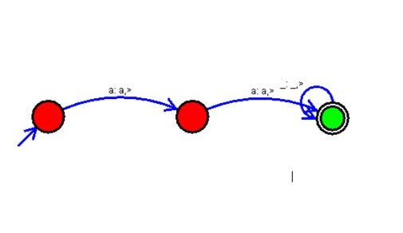

**OUTPUT**:

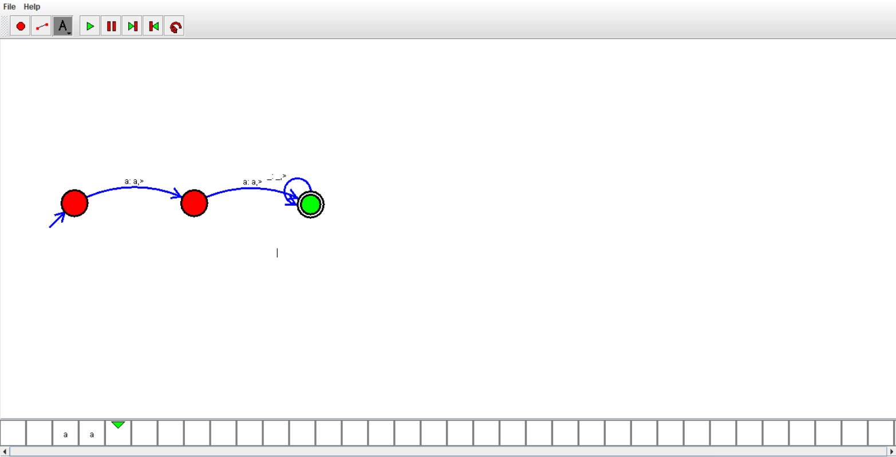

**RESULTS**:

We designedTM using to accept the input string ww by using autosim