**19**

**AIM**: Design TM using simulator to perform addition of ‘aa’ and ‘aaa’

**INPUT:**

W=aa+aaaaa 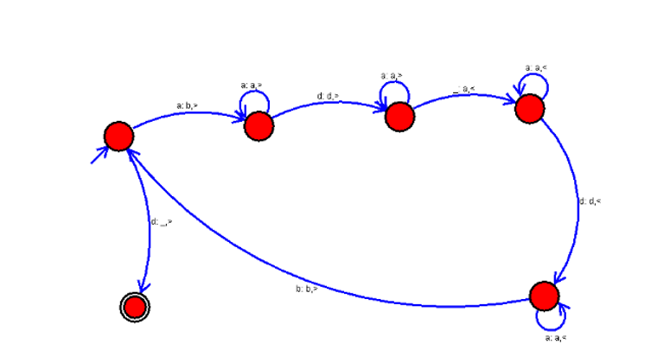

**OUTPUT:**

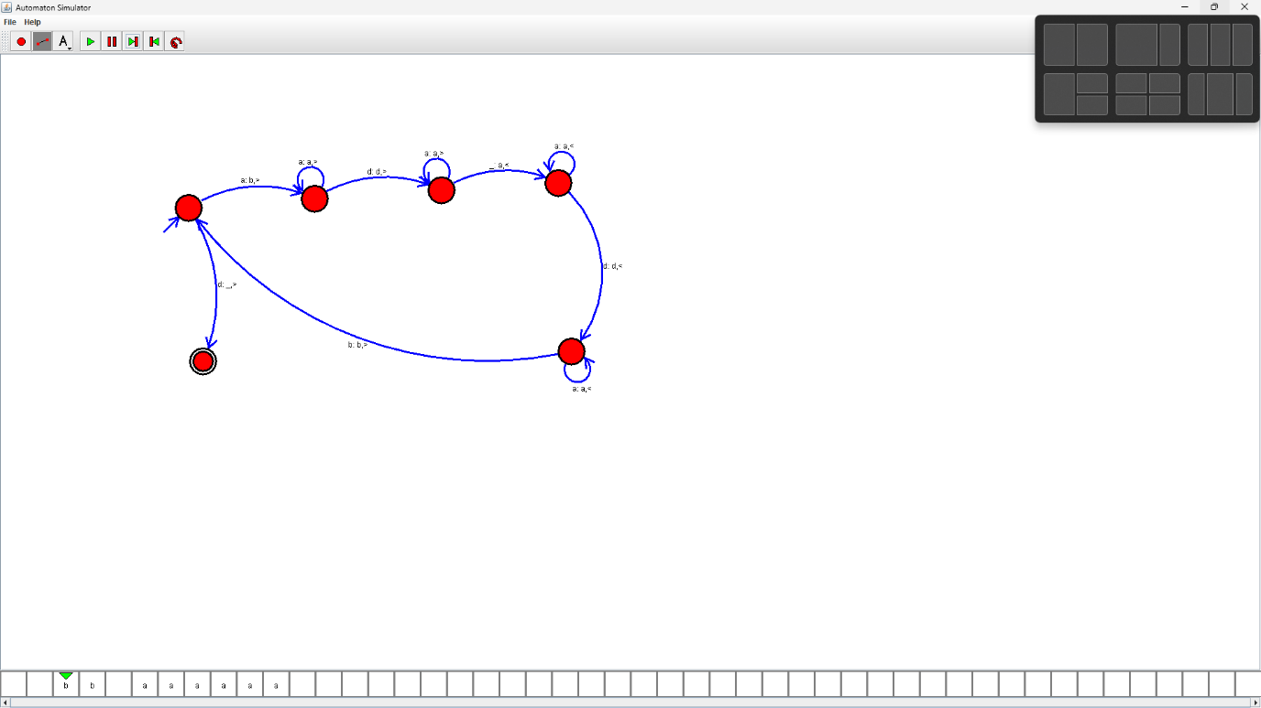

**RESULTS:**

We designedTM using to perform addition of ‘aa’ and ‘aaa’ by using autosim