**20.**

**AIM:** Design TM using simulator to perform subtraction of aaa-aa

**INPUT**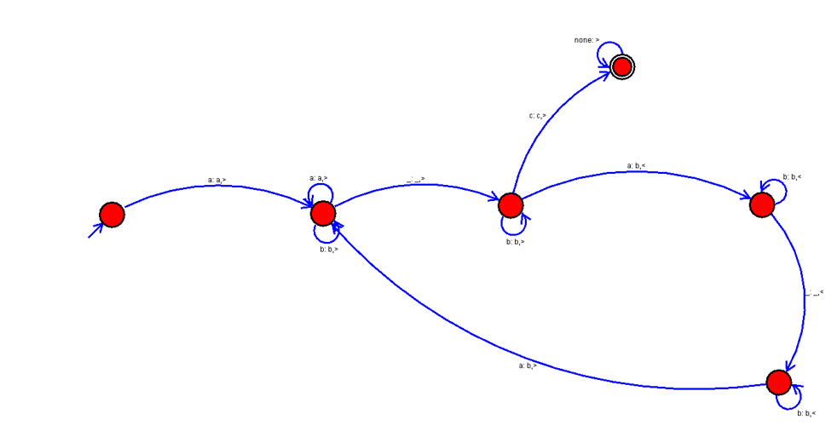

**OUTPUT:**

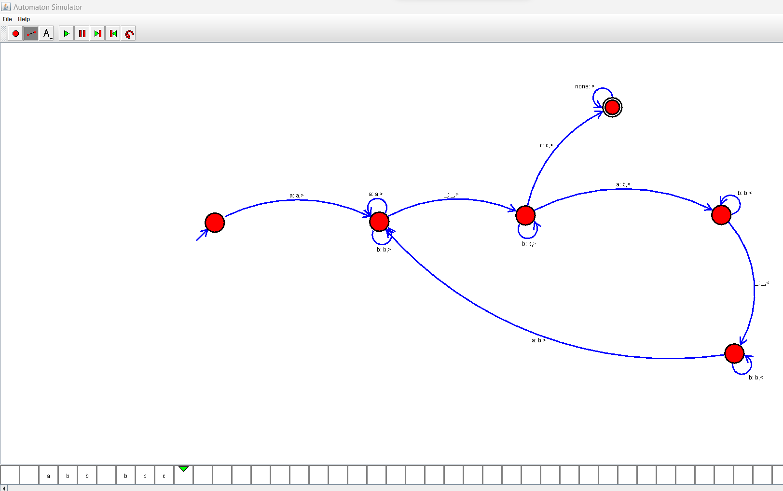

**RESULTS:**

We designed TM using simulator to perform subtraction of aaa-aa by using autosim