**21**

**AIM:**Design DFA using simulator to accept even number of a’s

**INPUT:**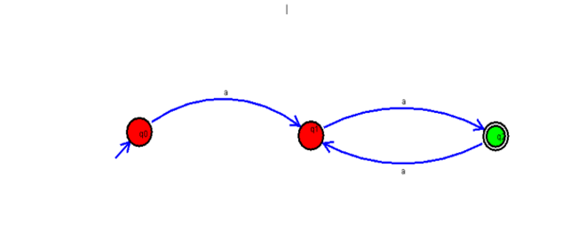

**OUTPUT:**

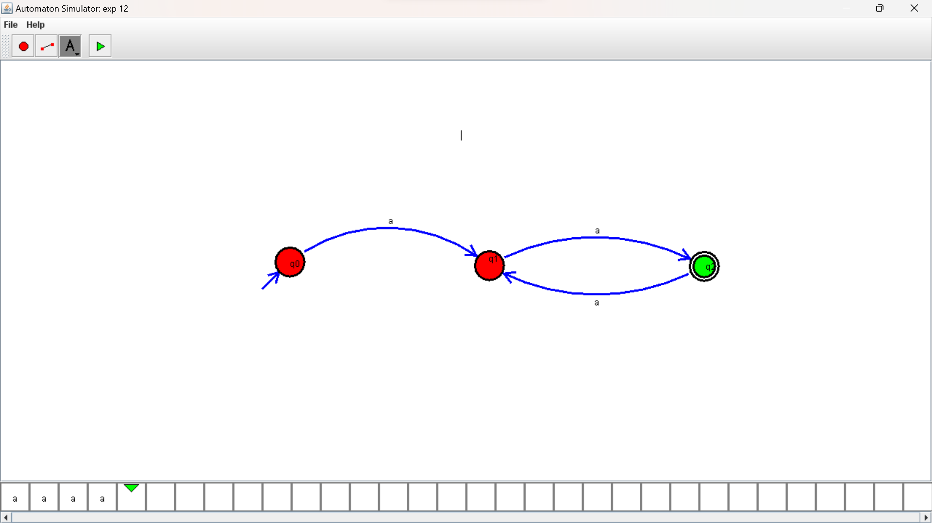

**RESULTS:**

DFA using simulator to accept even number of a’s