**22.**

**AIM:** Design DFA using simulator to accept odd number of a’s

**INPUT:**

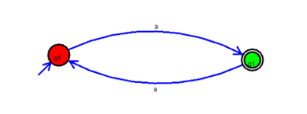

**OUTPUT:**

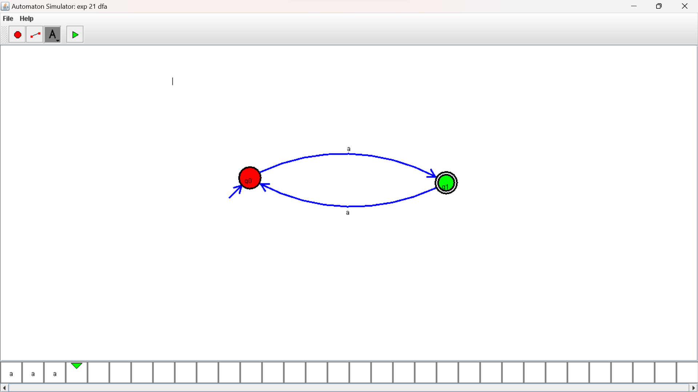

**RESULTS**:

DFA using simulator to accept odd number of a’s