**23.**

**AIM:**  Design DFA using simulator to accept the string the end with ab over set {a,b)

W= aaabab

**INPUT:**

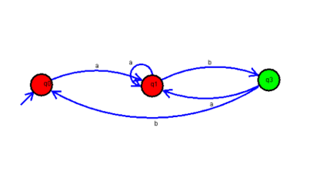

**OUTPUT:**

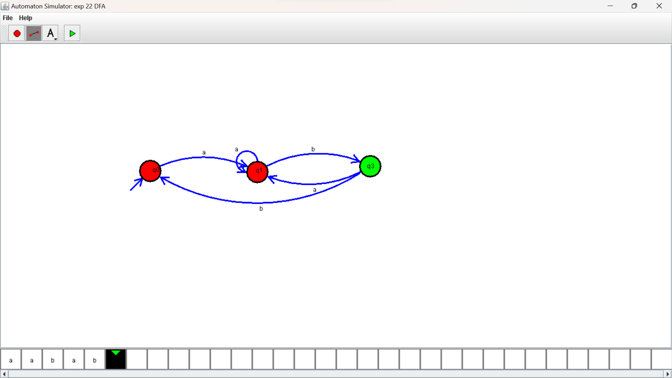

**RESULTS:**

DFA using simulator to accept the string the end with ab over set {a,b) W= aaabab