**24**

**AIM:** Design DFA using simulator to accept the string having ‘ab’ as substring over the set {a,b}

**INPUT**

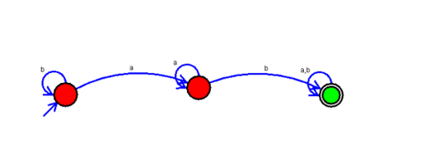

**OUTPUT:**

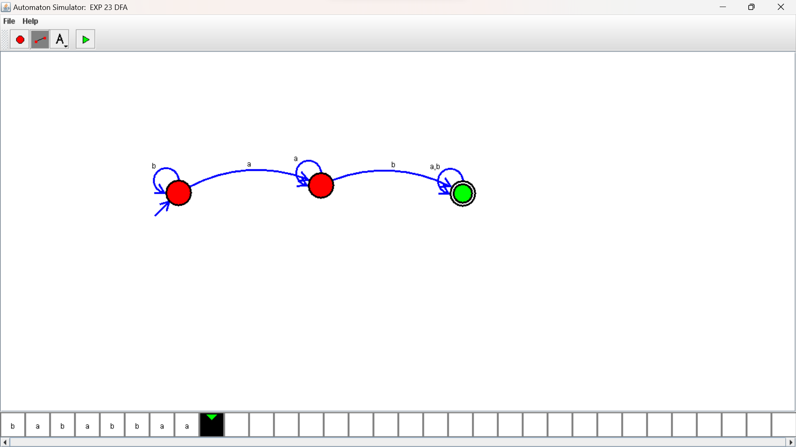

**RESULTS:**

DFA using simulator to accept the string having ‘ab’ as substring over the set {a,b}