25.

**AIM:** Design DFA using simulator to accept the string start with a or b over the set {a,b}

**INPUT**:

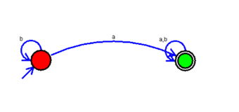

**OUTPUT:**

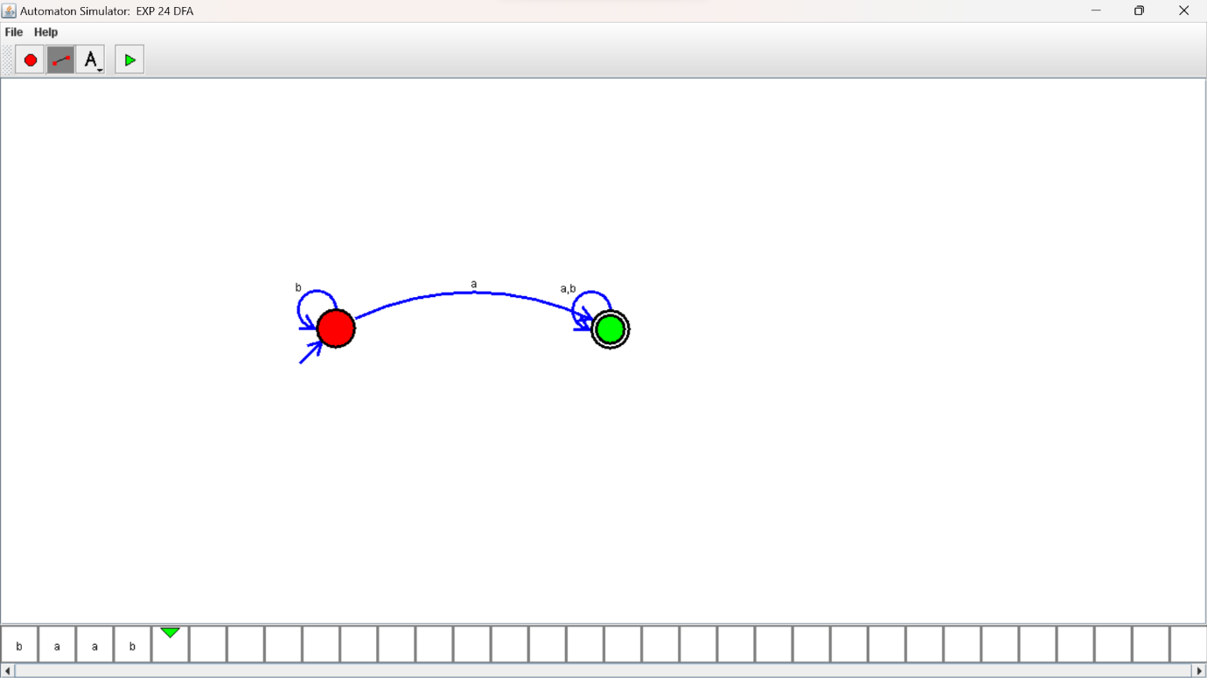

**RESULTS:**

DFA using simulator to accept the string start with a or b over the set {a,b}