**26.**

**AIM:**  Design TM using simulator to accept the input string Palindrome bbabb

**INPUT:**

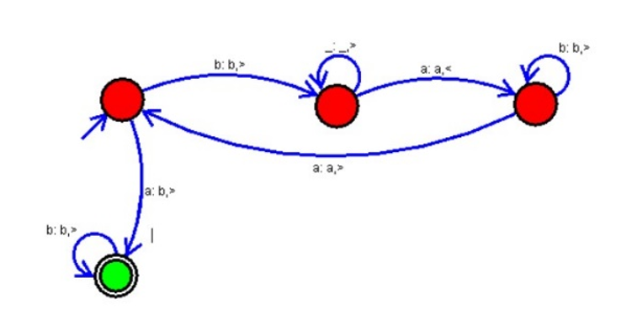

**OUTPUT:**

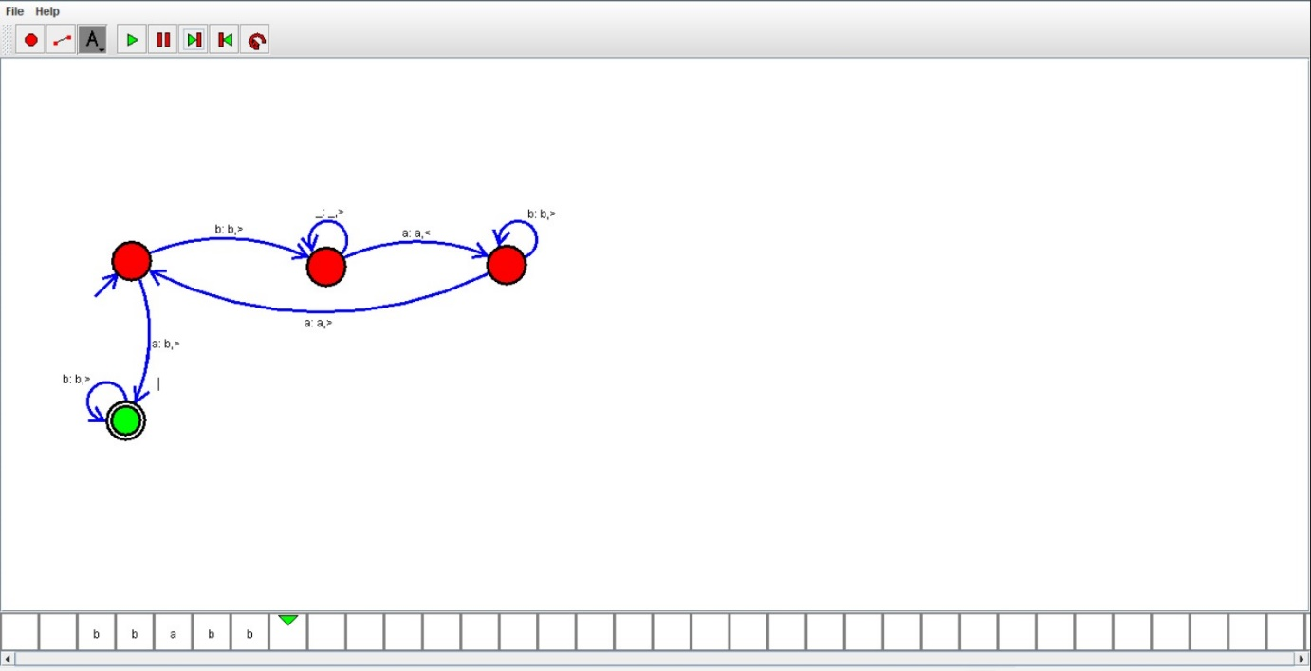

**RESULT:**

We designed TM using simulator to accept the input string Palindrome bbabb by using autosim