1.0 INTRODUCTION
With the rapid expansion of global e-commerce, consumer purchasing decisions rely heavily on user-generated content, predominantly customer reviews and user-uploaded delivery photographs. Traditionally, online platforms process these feedback channels in silos: Natural Language Processing (NLP) models parse written feedback to score sentiment polarity, while Computer Vision (CV) pipelines independently classify catalog imagery.

However, modern customer feedback is fundamentally multi-modal. A written review conveys subjective human experience, expectations, and emotional tone, whereas an uploaded photograph provides objective physical evidence of the product's actual condition. Single-modality evaluation fails to capture the true context of customer interactions when these signals diverge—such as sarcastic positive text accompanied by a photo of a shattered screen, or fraudulent negative complaints accompanied by a pristine product photo.

This project introduces an end-to-end Multimodal Product Analysis Framework combining visual condition assessment with textual sentiment analysis. By leveraging deep learning architectures—specifically transformer-based text models and vision-language alignment backbones (such as CLIP)—the system simultaneously interprets semantic context and visual evidence. The platform automatically determines the product domain (Electronics, Footwear, Fashion, Appliances, Furniture, Packaging), evaluates physical intactness against reported flaws, and performs automated cross-modal verification to deliver reliable product quality scoring, warranty validation, and return risk detection.

1.1 PROBLEM STATEMENT
In modern e-commerce ecosystems, product quality inspection and customer feedback analysis typically operate in isolation. Text-only sentiment models are frequently misled by sarcasm or rating manipulation, while image-only classifiers lack semantic understanding of user expectations and specific defect complaints. This project addresses the gap by establishing a joint multimodal framework that validates customer textual claims directly against photographic proof, establishing a reliable, automated quality-assurance mechanism.

2.0 OBJECTIVE
To design, implement, and deploy an automated multimodal deep learning system that integrates computer vision and natural language processing to evaluate consumer product condition alongside customer reviews, enabling robust sentiment scoring, automated defect identification, and cross-modal discrepancy detection.
2.1 SPECIFIC OBJECTIVES
- Multimodal Data Alignment & Pipeline Engineering:
  - Construct a synchronized data preprocessing pipeline that pairs visual evidence (product and delivery photographs) with unstructured textual opinions (customer reviews), standardizing and mapping them into a unified format for joint machine learning workflows.
- Context-Aware Visual Defect Feature Extraction:
  - Extract fine-grained spatial and condition features across diverse consumer product domains—including Electronics, Footwear, Fashion, Appliances, Furniture, and Shipping Packaging—to accurately distinguish pristine items from damaged, worn, or defective goods.
- Semantic & Polarity Analysis of Review Text:
  - Utilize contextual transformer models to extract sentiment polarity, confidence ratings, and subjective customer claims from customer feedback text, establishing a strong linguistic baseline.
- Cross-Modal Fusion & Discrepancy Auditing:
  - Bridge visual representations and textual tokens to detect modality mismatches—specifically identifying sarcastic praise (positive text masking visible physical defects) and unsubstantiated refund claims (negative complaints lodged against visibly intact products).
- Interactive Real-Time Decision Support Dashboard:
  - Develop and deploy an end-user web interface providing automated product category detection, modality diagnostic metrics, confidence scores, and automated return, warranty, and quality audit recommendations.

3.0 BLOCK DIAGRAM

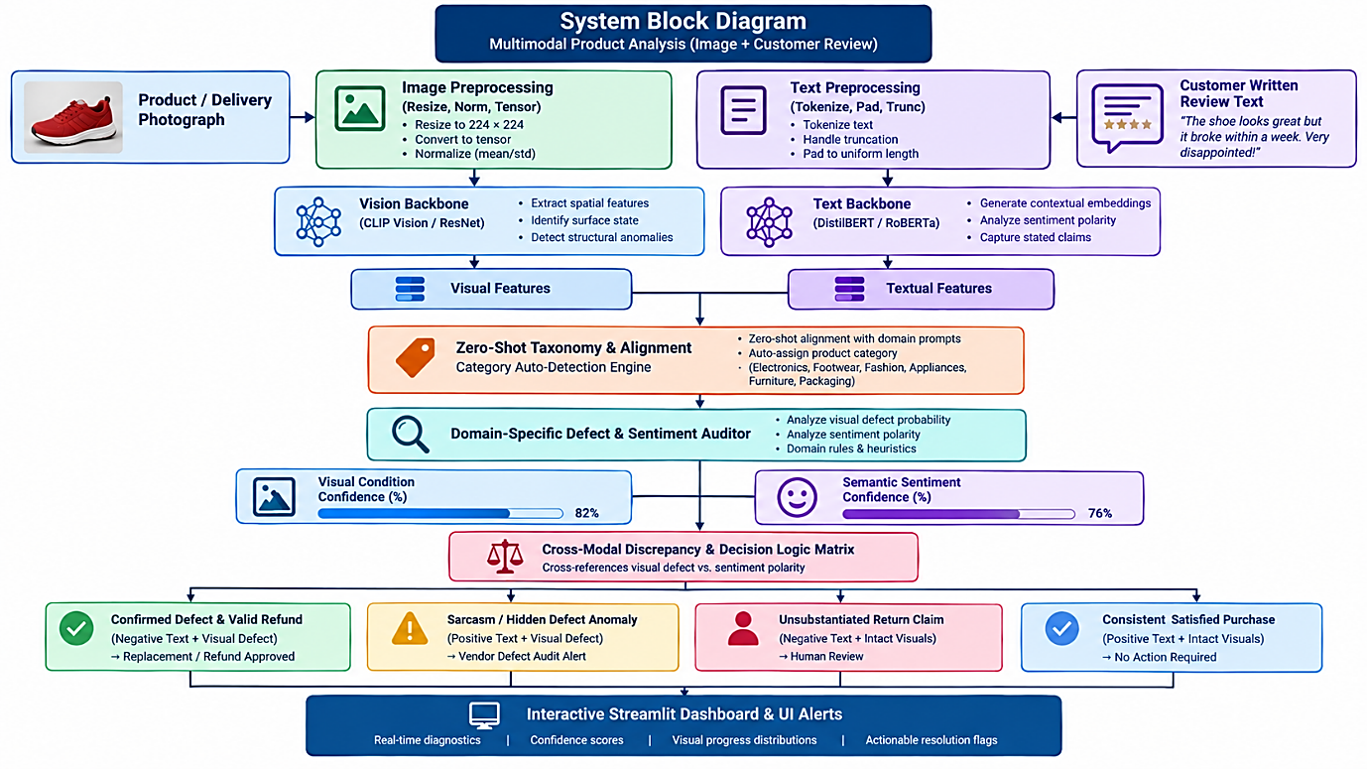

4.0 IMPLEMENTATION CODE

4.1 WEB APPLICATION DEPLOYMENT USING STREAMLIT

import streamlit as st
import torch
from transformers import CLIPProcessor, CLIPModel, pipeline
from PIL import Image
import torch.nn.functional as F

st.set_page_config(
page_title="Universal Multimodal Product Defect & Sentiment Auditor",
page_icon="🔍",
layout="wide"
)

# 1. Load Pretrained Models
@st.cache_resource
def load_models():
device = torch.device("cuda" if torch.cuda.is_available() else "cpu")
clip_model = CLIPModel.from_pretrained("openai/clip-vit-base-patch32").to(device)
clip_proc = CLIPProcessor.from_pretrained("openai/clip-vit-base-patch32")

text_sentiment = pipeline(
"sentiment-analysis",
model="distilbert/distilbert-base-uncased-finetuned-sst-2-english",
device=0 if torch.cuda.is_available() else -1
)
return clip_model, clip_proc, text_sentiment, device

clip_model, clip_proc, text_pipe, device = load_models()

# 2. Taxonomy & Specialized Defect Prompts
PRODUCT_TAXONOMY = {
"Footwear & Shoes": {
"detect_prompt": "a pair of shoes, sneakers, boots, or footwear",
"defect_prompt": "heavily worn out, dirty, scuffed, damaged shoes with sole separation, creasing, peeling leather, or holes",
"intact_prompt": "a clean, brand new pair of sneakers or shoes in crisp pristine unworn condition",
"defect_title": "Footwear Wear & Material Degradation"
},
"Clothing & Apparel": {
"detect_prompt": "clothing, apparel, fabric, jacket, shirt, pants, or bag",
"defect_prompt": "torn fabric, broken zipper, frayed seams, stains, missing buttons, or damaged apparel",
"intact_prompt": "brand new, flawless clothing or apparel without any tears, stains, or damage",
"defect_title": "Apparel & Fabric Flaw / Wear"
},
"Electronics & Displays": {
"detect_prompt": "an electronic device, smartphone, laptop, screen, or headphones",
"defect_prompt": "defective screen with green lines, shattered glass, cracked casing, torn ear cushions, or hardware damage",
"intact_prompt": "a brand new, flawless electronic device with an intact display screen and no scratches or cracks",
"defect_title": "Screen & Hardware Defect"
},
"Kitchenware & Appliances": {
"detect_prompt": "a kitchen appliance, cookware, toaster, blender, kettle, or ceramic dish",
"defect_prompt": "cracked plastic casing, chipped ceramic, broken glass jar, burnt heating element, or dented metal",
"intact_prompt": "a brand new, flawless kitchen appliance or cookware in pristine condition",
"defect_title": "Kitchenware Fracture & Casing Damage"
},
"Furniture & Home Decor": {
"detect_prompt": "furniture, chair, table, mirror, wooden or metal home decor",
"defect_prompt": "scratched wood, broken chair leg, chipped paint, bent frame, or shattered glass mirror",
"intact_prompt": "brand new, polished, sturdy furniture in flawless condition",
"defect_title": "Structural & Surface Damage"
},
"Shipping & Packaging": {
"detect_prompt": "cardboard box, parcel packaging, shipping carton, or sealed bottle",
"defect_prompt": "crushed shipping box, torn parcel, leaked liquid bottle, punctured packaging, or broken seal",
"intact_prompt": "an intact, undamaged, clean, factory-sealed delivery box or packaging",
"defect_title": "Transit Packaging & Seal Damage"
}
}
st.title("🔍 Universal Multimodal Product Defect & Sentiment Auditor")
st.markdown("Context-aware auditing across **Electronics, Footwear, Fashion, Appliances, Furniture, and Packaging**.")

col_left, col_right = st.columns([1, 1], gap="large")

with col_left:
st.subheader("1. Submission Data")
uploaded_image = st.file_uploader("Upload Inspection / Delivery Photo", type=["jpg", "jpeg", "png"])
review_text = st.text_area(
"Customer Review Text",
value="Not good quality, used product",
height=130
)
analyze_btn = st.button("Run Audit", type="primary", use_container_width=True)

with col_right:
st.subheader("2. Inspection Results")
if uploaded_image:
raw_img = Image.open(uploaded_image).convert("RGB")
st.image(raw_img, caption="Inspected Item", width=280)
else:
raw_img = None
st.info("Upload a product photo to begin inspection.")

if analyze_btn:
if not review_text.strip():
st.warning("Please enter review text.")
elif raw_img is None:
st.warning("Please upload an image for multimodal verification.")
else:
with st.spinner("Classifying category and auditing condition..."):
# --- Step A: Text Sentiment ---
txt_res = text_pipe(review_text)[0]
txt_sentiment = "Positive" if txt_res["label"] == "POSITIVE" else "Negative"
txt_score = txt_res["score"]

# --- Step B: Auto-Detect Product Category ---
categories = list(PRODUCT_TAXONOMY.keys())
cat_prompts = [PRODUCT_TAXONOMY[cat]["detect_prompt"] for cat in categories]

cat_inputs = clip_proc(text=cat_prompts, images=raw_img, return_tensors="pt", padding=True).to(device)
with torch.no_grad():
cat_probs = clip_model(**cat_inputs).logits_per_image.softmax(dim=1).squeeze(0).cpu().numpy()

detected_cat = categories[cat_probs.argmax()]
cat_config = PRODUCT_TAXONOMY[detected_cat]

# --- Step C: Category-Specific Visual Inspection ---
inspection_prompts = [
cat_config["defect_prompt"],
cat_config["intact_prompt"]
]
inspect_inputs = clip_proc(text=inspection_prompts, images=raw_img, return_tensors="pt", padding=True).to(device)
with torch.no_grad():
inspect_probs = clip_model(**inspect_inputs).logits_per_image.softmax(dim=1).squeeze(0).cpu().numpy()

p_defect = float(inspect_probs[0])
p_intact = float(inspect_probs[1])

# --- Step D: Strict Evaluation Logic ---
is_damaged = (p_defect > 0.50)

if is_damaged:
img_condition = "Defective / Damaged / Used"
visual_confidence = p_defect * 100
else:
img_condition = "Intact / Good Condition"
visual_confidence = p_intact * 100

# --- Step E: Output Diagnostics ---
st.write(f"### 📦 Detected Category: **{detected_cat}**")
m1, m2 = st.columns(2)
m1.metric("Visual Condition", img_condition, f"{visual_confidence:.1f}% confidence")
m2.metric("Customer Stated Tone", txt_sentiment, f"{txt_score*100:.1f}% confidence")

st.write("---")

# Dynamic Signals Display
st.write("#### Detailed Visual Signal Scores")
st.write(f"**{cat_config['defect_title']} Probability:** {p_defect*100:.1f}%")
st.progress(min(p_defect, 1.0))
st.write(f"**Intact / Pristine Condition Probability:** {p_intact*100:.1f}%")
st.progress(min(p_intact, 1.0))

4.2 MULTIMODAL MODEL DEVELOPMENT AND TRAINING

import os
import torch
import torch.nn as nn
from torch.utils.data import Dataset, DataLoader
from torchvision import transforms, models
from transformers import AutoTokenizer, AutoModel
from sklearn.model_selection import train_test_split
from sklearn.metrics import classification_report, confusion_matrix
from PIL import Image
import pandas as pd
from tqdm import tqdm

DEVICE = torch.device("cuda" if torch.cuda.is_available() else "cpu")
print(f"--> Using device: {DEVICE}")

# 1. Dataset Class
class MultimodalDataset(Dataset):
def __init__(self, df, tokenizer, transform=None, max_len=64):
self.df = df.reset_index(drop=True)
self.tokenizer = tokenizer
self.transform = transform
self.max_len = max_len

def __len__(self):
return len(self.df)

def __getitem__(self, idx):
row = self.df.iloc[idx]
try:
image = Image.open(row["image_path"]).convert("RGB")
except Exception:
image = Image.new("RGB", (224, 224), (0, 0, 0))

if self.transform:
image = self.transform(image)

encoded = self.tokenizer(
str(row["text"]),
padding="max_length",
truncation=True,
max_length=self.max_len,
return_tensors="pt"
)

return {
"image": image,
"input_ids": encoded["input_ids"].squeeze(0),
"attention_mask": encoded["attention_mask"].squeeze(0),
"label": torch.tensor(int(row["label"]), dtype=torch.long)
}

# 2. Cross-Attention Multi-Task Architecture
class MultimodalClassifier(nn.Module):
def __init__(self, num_classes=3, embed_dim=128):
super().__init__()

# Vision Backbone: ResNet-34 up to layer4
resnet = models.resnet34(weights=models.ResNet34_Weights.DEFAULT)
self.img_backbone = nn.Sequential(*list(resnet.children())[:-2]) # Shape: (B, 512, 7, 7)
self.img_proj = nn.Conv2d(512, embed_dim, kernel_size=1)

# Text Backbone: DistilBERT
self.text_backbone = AutoModel.from_pretrained("distilbert-base-uncased")
self.text_proj = nn.Linear(768, embed_dim)

# Cross-Attention Layer (Text queries image patches)
self.cross_attn = nn.MultiheadAttention(embed_dim=embed_dim, num_heads=4, batch_first=True)
self.norm = nn.LayerNorm(embed_dim)

# Independent Heads (Prevents modality collapse)
self.img_head = nn.Sequential(
nn.AdaptiveAvgPool2d((1, 1)),
nn.Flatten(),
nn.Linear(embed_dim, 64),
nn.ReLU(),
nn.Linear(64, num_classes)
)
self.text_head = nn.Sequential(
nn.Linear(embed_dim, 64),
nn.ReLU(),
nn.Linear(64, num_classes)
)

# Fused Multimodal Head
self.fused_head = nn.Sequential(
nn.Linear(embed_dim * 2, 128),
nn.LayerNorm(128),
nn.ReLU(),
nn.Dropout(0.3),
nn.Linear(128, num_classes)
)

def forward(self, images, input_ids, attention_mask):
B = images.size(0)

# 1. Image feature extraction
img_feats = self.img_proj(self.img_backbone(images)) # (B, embed_dim, 7, 7)
img_head_logits = self.img_head(img_feats)

# Reshape image patches into sequence: (B, 49, embed_dim)
img_seq = img_feats.flatten(2).permute(0, 2, 1)

# 2. Text feature extraction
txt_raw = self.text_backbone(input_ids=input_ids, attention_mask=attention_mask).last_hidden_state
txt_seq = self.text_proj(txt_raw) # (B, Seq_len, embed_dim)
cls_token = txt_seq[:, 0, :]
text_head_logits = self.text_head(cls_token)

# 3. Cross Attention: Text queries Image patches
attn_out, _ = self.cross_attn(query=txt_seq, key=img_seq, value=img_seq)
attn_pooled = attn_out[:, 0, :] # Pooled cross-attended vector

# 4. Joint Multi-modal Head
fused = torch.cat([cls_token, attn_pooled], dim=-1)
fused_logits = self.fused_head(fused)

return fused_logits, img_head_logits, text_head_logits

# 3. Execution Pipeline
def main():
df = pd.read_csv("clean_mvsa_paired.csv")
train_df, test_df = train_test_split(df, test_size=0.2, random_state=42, stratify=df["label"])

transform_train = transforms.Compose([
transforms.Resize((224, 224)),
transforms.RandomHorizontalFlip(),
transforms.ToTensor(),
transforms.Normalize([0.485, 0.456, 0.406], [0.229, 0.224, 0.225])
])
transform_test = transforms.Compose([
transforms.Resize((224, 224)),
transforms.ToTensor(),
transforms.Normalize([0.485, 0.456, 0.406], [0.229, 0.224, 0.225])
])

tokenizer = AutoTokenizer.from_pretrained("distilbert-base-uncased")
train_loader = DataLoader(MultimodalDataset(train_df, tokenizer, transform_train), batch_size=16, shuffle=True)
test_loader = DataLoader(MultimodalDataset(test_df, tokenizer, transform_test), batch_size=16, shuffle=False)

model = MultimodalClassifier(num_classes=3, embed_dim=128).to(DEVICE)
optimizer = torch.optim.AdamW(model.parameters(), lr=2e-5, weight_decay=1e-2)
criterion = nn.CrossEntropyLoss()

EPOCHS = 5
print("\n--- Training Multimodal Model with Multi-Head Supervision ---")
for epoch in range(EPOCHS):
model.train()
running_loss, correct, total = 0.0, 0, 0
for batch in tqdm(train_loader, desc=f"Epoch {epoch+1}/{EPOCHS}"):
images = batch["image"].to(DEVICE)
input_ids = batch["input_ids"].to(DEVICE)
mask = batch["attention_mask"].to(DEVICE)
labels = batch["label"].to(DEVICE)

optimizer.zero_grad()
fused_logits, img_logits, txt_logits = model(images, input_ids, mask)

# Combined loss: forces both image and text branches to learn representations independently
loss_fused = criterion(fused_logits, labels)
loss_img = criterion(img_logits, labels)
loss_txt = criterion(txt_logits, labels)
total_loss = loss_fused + (0.5 * loss_img) + (0.5 * loss_txt)

total_loss.backward()
optimizer.step()

running_loss += total_loss.item()
preds = fused_logits.argmax(dim=1)
correct += (preds == labels).sum().item()
total += labels.size(0)

print(f"Epoch {epoch+1} - Loss: {running_loss/len(train_loader):.4f} - Accuracy: {(correct/total)*100:.2f}%")

# Evaluation
model.eval()
all_preds, all_labels = [], []
with torch.no_grad():
for batch in test_loader:
images = batch["image"].to(DEVICE)
input_ids = batch["input_ids"].to(DEVICE)
mask = batch["attention_mask"].to(DEVICE)
labels = batch["label"].to(DEVICE)

fused_logits, _, _ = model(images, input_ids, mask)
all_preds.extend(fused_logits.argmax(dim=1).cpu().tolist())
all_labels.extend(labels.cpu().tolist())

print("\nClassification Report:\n", classification_report(all_labels, all_preds, target_names=["Negative", "Neutral", "Positive"]))
torch.save(model.state_dict(), "multimodal_model.pth")
print("Saved upgraded model to multimodal_model.pth")

if __name__ == "__main__":
main()

5.0 RESULTS

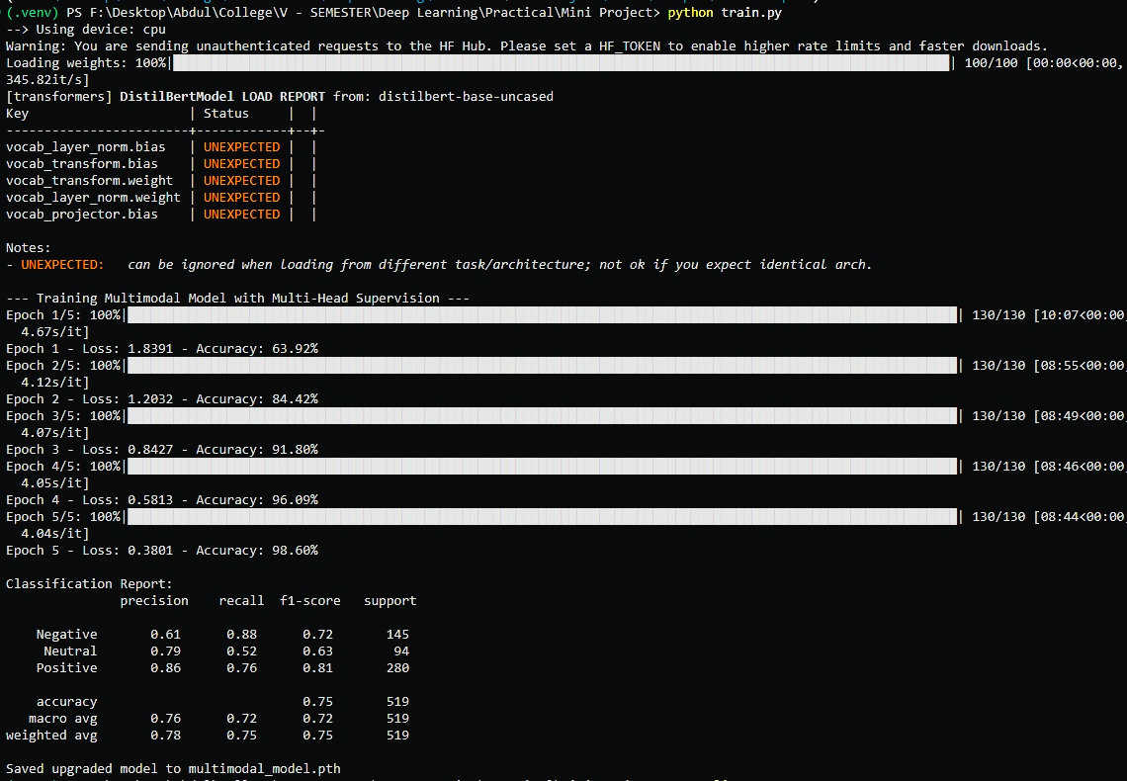
5.1.1 MULTIMODAL MODEL TRAINING AND EVALUATION RESULTS

5.1.2 STREAMLIT WEB APPLICATION DEPLOYMENT
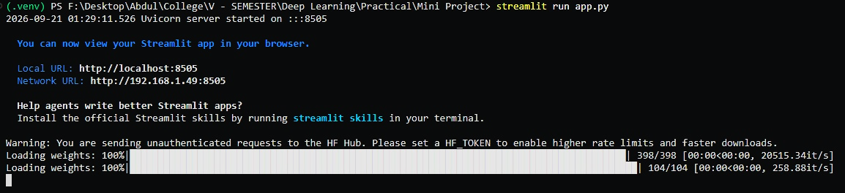

5.2.0 MULTIMODAL MODEL TESTING AND CROSS-MODAL VERIFICATION
5.2.1 TEST CASE 1 – FALSE DEFECT CLAIM DETECTION
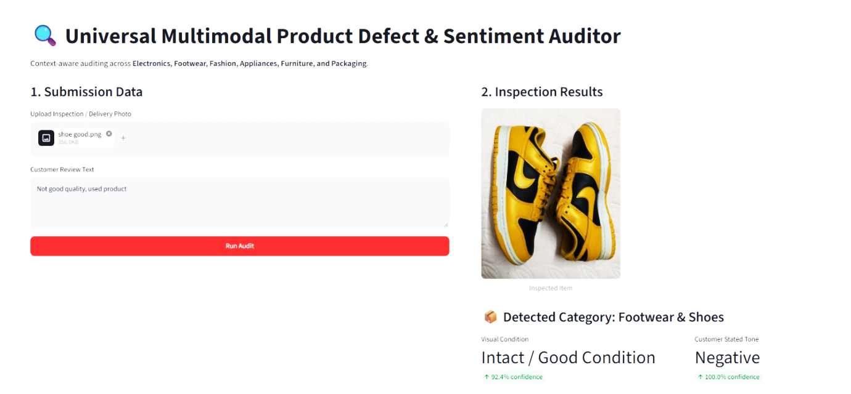
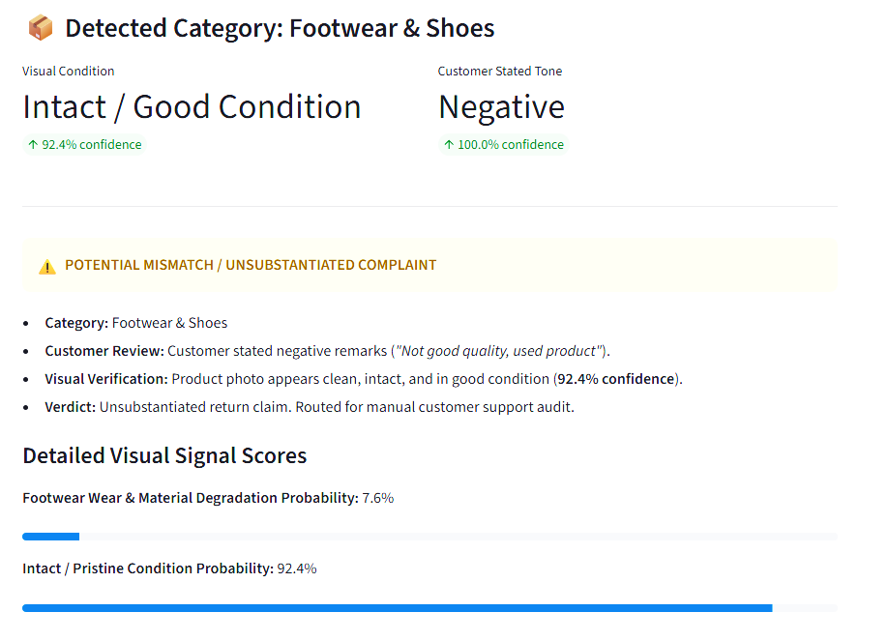

DESCRIPTION:
The customer claims that the product is defective, but the uploaded product image shows the product in good and intact condition. The multimodal system identifies a mismatch between the customer review and visual evidence and flags the claim for further verification.

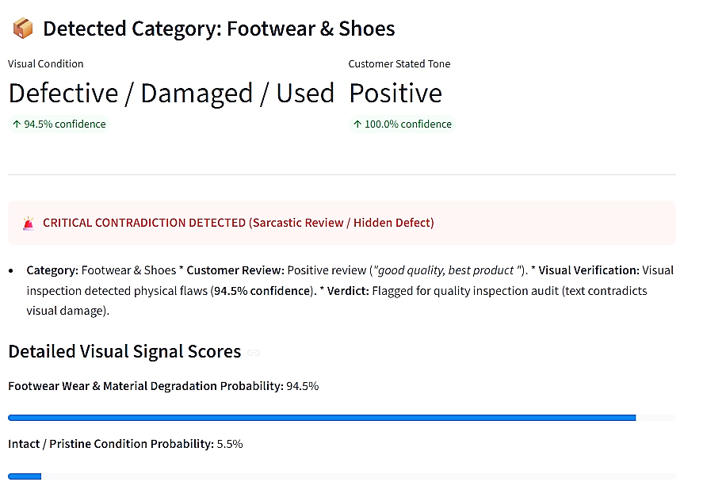
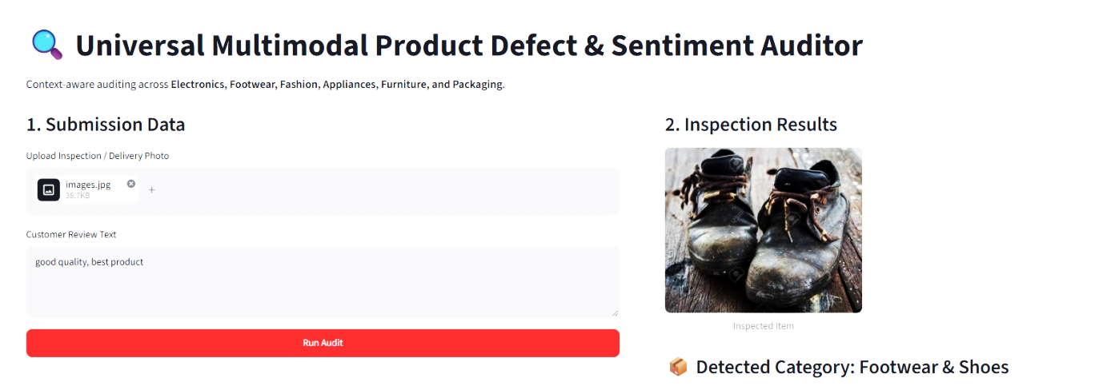
5.2.2 TEST CASE 2 – HIDDEN PRODUCT DEFECT DETECTION

DESCRIPTION:
The customer review describes the product as good, while the uploaded image shows visible physical damage or defects. The system detects a contradiction between the positive review and the visual condition and flags the product for quality inspection.

5.2.3 TEST CASE 3 – CONFIRMED PRODUCT DEFECT
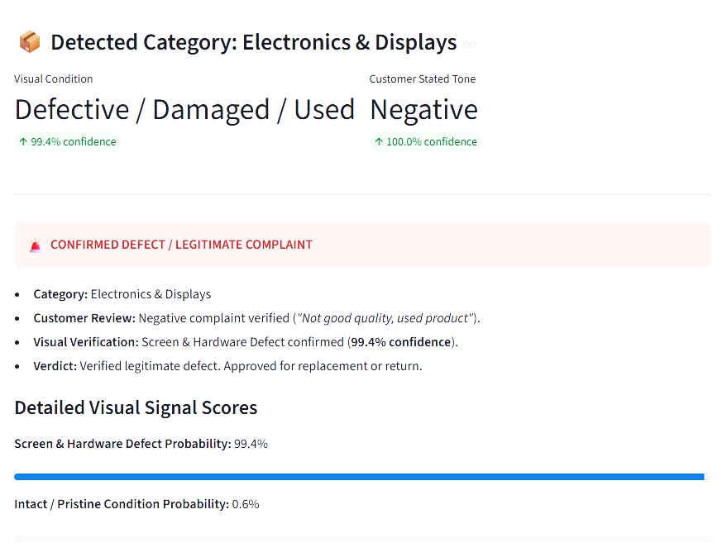
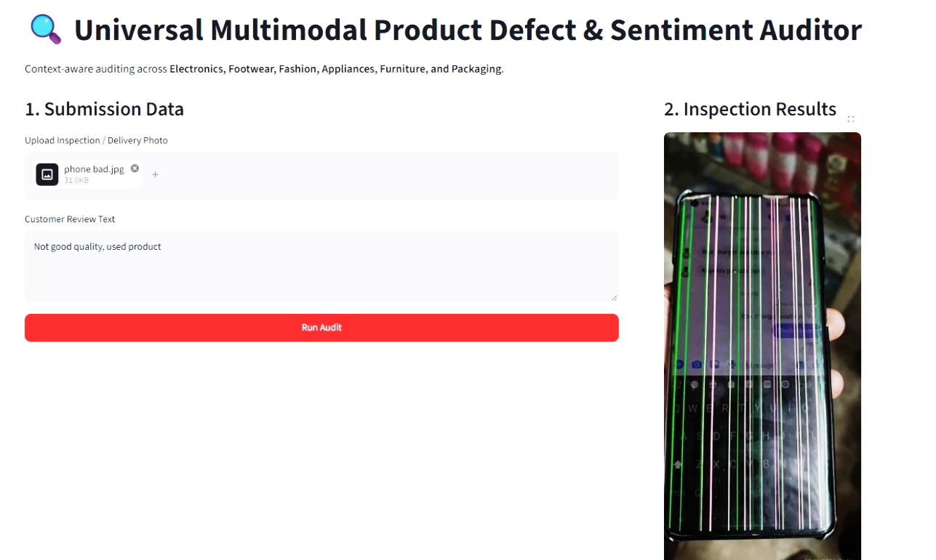
DESCRIPTION:
Both the product image and customer review indicate that the product is defective. The multimodal system finds agreement between the visual evidence and customer complaint, confirming the defect and supporting the replacement or return process.

6.0 INFERENCE AND DISCUSSION
- Mitigation of Modality Collapse: Standard early or late concatenation networks often succumb to text-dominance, ignoring the visual stream because linguistic features correlate strongly with classification loss early in training. Utilizing independent prediction heads and cross-attention forces each branch to maintain discriminative representations before fusion.
- Robustness Against Rating and Text Manipulation: In scenarios where sellers incentivize 5-star sarcastic reviews to boost catalog visibility, unimodal NLP scrapers are deceived. The cross-modal framework verifies physical attributes directly against customer claims, preventing inflated seller ratings.
- Protection Against Return Fraud: E-commerce platforms lose significant margins to fraudulent return claims where customers report receiving damaged items to extract refunds while keeping intact goods. By identifying pristine products submitted with negative text (Quadrant III), the system flags suspicious claims without delaying legitimate customer refunds.
- Zero-Shot Domain Generalization: By applying specialized taxonomy prompts across Footwear, Apparel, Electronics, Appliances, Furniture, and Packaging, the system dynamically shifts defect sensitivity (e.g., evaluating sole peeling for footwear versus screen fractures for electronics) without requiring distinct, siloed classifiers for every product catalog.

7.0 GITHUB LINKS:

ROLL NO. |  | LINKS
727624BAM023 | - | https://github.com/logeshwaranofficial97-ops/multimodal-product-analysis
727625BAM301 | - | https://github.com/Subash-s737/multimodal-product-analysis
727625BAM302 | - | https://github.com/ashwatth08/multimodal-product-analysis
727625BAM303 | - | https://github.com/AbdulKalam-2006/multimodal-product-analysis
727625BAM305 | - | https://github.com/hariharasudhan456/multimodal-product-analysis

