CHAPTER 1
INTRODUCTION

1.1 Project Description

In the digital age, the technological barrier to starting a company has lowered significantly, but the complexity of market validation has increased. Founders often struggle to objectively analyze their ideas or calculate a realistic valuation without bias. StartupIQ serves as an intelligent "AI Co-Founder" platform that bridges this gap.

Unlike static form-based tools that rely on rigid formulas, this project utilizes a Hybrid AI Engine. It combines the creative reasoning capabilities of Large Language Models (LLMs) to brainstorm diverse business models with the deterministic logic of statistical regression to calculate financial metrics. The system guides the user through the entire zero-to-one journey: from ideation to validation, financial estimation, and investor reporting.

1.2 Objectives

The primary objectives of this project are:
- To Automate Idea Validation: To provide instant, unbiased SWOT (Strengths, Weaknesses, Opportunities, Threats) analysis for any business concept using Generative AI, reducing the validation time from weeks to seconds.
- To Estimate Financial Value: To implement a Linear Regression model that predicts startup valuation based on key metrics like monthly revenue, growth rate, and active user count, tailored to the Indian startup context.
- To Ensure System Reliability: To engineer a "Smart Fallback" mechanism that generates context-aware synthetic data if the external AI API , ensuring zero downtime during critical demonstrations.
- To Facilitate Professional Reporting: To integrate dynamic PDF generation that converts raw analysis data into investor-ready documents, allowing founders to present their ideas professionally.

CHAPTER 2
LITERATURE SURVEY

Introduction
The landscape of startup incubation, business intelligence, and feasibility analysis has undergone a paradigm shift over the last decade. Historically, market validation and valuation were domains reserved strictly for human experts—management consultants, venture capitalists, and incubator mentors. However, the democratization of Artificial Intelligence (AI) and Machine Learning (ML) has introduced automated advisory systems capable of mimicking human reasoning. This literature survey explores the evolution of these tools, ranging from early static business plan generators to modern Large Language Model (LLM) agents. The review highlights the technological advancements that facilitate the development of "StartupIQ" and critically examines the existing gaps—specifically the lack of resilience, hybrid quantitative-qualitative capabilities, and offline reliability—that this project aims to address.

2.1. Thematic (Topic-wise) Review
This section categorizes the existing body of knowledge into three key dimensions: the current systems available to entrepreneurs, the underlying technologies powering them, and the inherent limitations that persist in the industry.
2.1.1 Existing Systems
When we analyzed the landscape of current startup support tools, we found that most solutions usually fall into three specific buckets. However, upon closer inspection, each of these categories presents significant roadblocks for a student entrepreneur or an early-stage founder with limited resources.
1. Traditional Management Consulting & Incubators
- How they work: This category is dominated by big-name firms like Deloitte or McKinsey, alongside famous accelerators like Y Combinator. They rely heavily on human intelligence—expert analysts who conduct focus groups, run manual SWOT workshops, and build financial models in Excel from scratch.
- The Issue: While the quality of advice here is undeniable, the barrier to entry is massive. Hiring a consultant can cost tens of thousands of dollars, and getting into a top-tier incubator is statistically harder than getting into Harvard. For a student with just a raw idea, this route is practically inaccessible. It takes too long (weeks or months) and costs too much for someone who just wants to validate a concept before writing code.
2. Static Valuation Platforms (The "Cookie-Cutter" Era)
- How they work: Around the mid-2010s, we saw a wave of SaaS tools like LivePlan or Equidam. These platforms basically digitized the old-school business plan. Users fill out long, rigid checklists, and the system applies standard formulas—like the Berkus Method or Risk Factor Summation—to spit out a valuation number.
- The Issue: We found these systems to be incredibly rigid. They act like "dumb calculators" that lack context. For instance, they might apply the exact same risk weightage to a high-growth AI startup as they would to a local coffee shop. Worse, they operate as "black boxes"—they give you a number, but they don't explain why your valuation is low or offer strategic advice on how to fix it. They are essentially fancy spreadsheets with no actual reasoning capabilities.
3. General-Purpose AI Chatbots (ChatGPT/Claude)
- How they work: Recently, founders have started turning to LLMs like ChatGPT or Gemini for advice. They use conversational prompting to brainstorm ideas or draft pitch decks.
- The Issue: While these tools are great for creative writing, they are dangerous for business logic. We noticed that general LLMs frequently "hallucinate" when asked to do math. If you ask a chatbot to calculate a valuation based on revenue, it often invents numbers to make the answer look plausible. Additionally, they have no long-term memory of the project. You can't easily "save" your startup's financial state, nor can you ask the chatbot to generate a formatted, professional PDF report that you can hand to an investor.

2.1.2 Technologies Used
To solve the limitations found in existing tools, we architected StartupIQ as a "Hybrid System." We didn't want to rely on a single technology; instead, we merged three distinct logic layers to balance creativity, mathematical accuracy, and system speed.
1. Generative AI (Google Gemini API)
- The Logic: We selected the Gemini 1.5 Flash model to power the qualitative reasoning engine. We needed a model that could genuinely "understand" business context rather than just keyword matching. For instance, the system knows that "Regulatory Compliance" is a critical threat for a FinTech app but irrelevant for a T-shirt brand.
- Why this Model: We specifically chose the "Flash" version to prioritize speed and throughput (supporting up to 1,500 requests/day). This ensures our live demos remain lag-free. Unlike static templates, this allows for "Zero-Shot Learning," enabling the system to analyze niche industries (like "Drone Logistics") without us having to manually hard-code rules for every sector.
2. Supervised Machine Learning (Scikit-Learn)
- The Logic: For the financial module, we intentionally avoided Deep Learning. Neural networks often act as "black boxes," making it impossible to explain how a number was derived. Instead, we used Scikit-Learn to implement a Linear Regression model.
- Why this Model: We chose this for transparency. Linear Regression provides interpretable coefficients, allowing us to display a clear formula to the user ($Valuation = \alpha \times Revenue + \beta \times Users$). This means we can explain exactly why a valuation changed—for example, telling a user, "Your valuation increased by ₹10 Lakhs specifically because your user base grew by 20%."
3. Modern Web Architectures (React + Flask)
- The Logic: We moved away from older monolithic structures and "decoupled" the frontend from the backend. We used React.js for the user interface and Python Flask as the API gateway.
- Why this Stack: We prioritized user experience and privacy. React’s Virtual DOM allows the dashboard to update instantly without annoying page reloads. On the backend, Flask acts as a lightweight bridge to our Python data science libraries. Crucially, we implemented client-side rendering using jsPDF. This generates the PDF report directly in the user's browser, ensuring better privacy since the final document never needs to be stored on our servers.

2.1.3 Limitations of Current Approaches
Despite the hype around AI tools, we identified four major gaps in the current market that we wanted to address with StartupIQ:
- The "Crash" Factor: Most AI wrapper apps break the moment the internet is slow or the API limit is hit. We realized that for a reliable system, we needed a "Smart Fallback" mechanism that switches to local logic when the cloud fails—something most current tools lack.
- Privacy Risks: Cloud-based valuation tools often require saving sensitive financial data in centralized databases. For a pre-revenue founder, putting their unique idea into a cloud server feels risky. We wanted to design a workflow that minimizes IP theft concerns.
- Fragmented Workflow: Right now, a founder has to use Excel for numbers, ChatGPT for ideas, and PowerPoint for reports. There was no single platform that combined all three steps into one smooth journey.
- Generic Advice: Without specific engineering, AI gives vague advice like "Do better marketing." We focused on "Chain-of-Thought" prompting to force the system to give specific, actionable steps (e.g., "Focus on SEO") instead of fluff.

2.2. Chronological Review
The evolution of startup assistance technology can be traced through three major eras:
- 2010–2015: The Digitization Era
  - The focus was on moving from pen-and-paper to digital templates. Tools like LivePlan, Bplans, and StratPad emerged, allowing users to fill in static forms to generate business plans. These were essentially "fancy word processors" with no intelligence. They solved the problem of formatting but not validation.
- 2016–2020: The Big Data Era
  - Platforms began using aggregated industry data to provide benchmarks. Crunchbase, PitchBook, and CB Insights became standards for market data. While they provided massive datasets, they remained passive repositories. They could tell a user what happened in the market (historical data), but not how it applied to their specific, novel idea (predictive analysis).
- 2021–Present: The Generative AI Era
  - The launch of Transformer-based models (GPT-3, Gemini, Llama) transformed the landscape. However, early implementations were largely "Chatbots" with no domain-specific constraints. StartupIQ represents the next phase: "Agentic AI," where the system not only chats but acts—calculating values using regression, generating structured documents, and handling errors autonomously.
2.3. Comparative Analysis Table
The following table summarizes the differences between existing methodologies and the proposed StartupIQ system across key performance indicators.
Feature |  | Traditional Consulting | Static Web Calculators | GeneralAI Chatbots | Proposed System (StartupIQ)
Cost |  | High ($1000+) | Moderate ($50/mo) | Low/Free | Free / Zero-Cost
Speed |  | Weeks/Months | Minutes | Seconds | Real-time (Seconds)
Context Awareness |  | Very High | Low (Rigid) | High | High (Hybrid AI Approach)
Financial Accuracy |  | High | Moderate (Rigid) | Low (Hallucinations) | High (Regression Model)
Offline Reliability |  | N/A | High | Zero (Fails without Net) | High (Smart Fallback)
Output Format |  | Physical Report | Dashboard View | Plain Text | Professional PDF Report
Technology Stack |  | Human Expertise | Rule-Based Algo | NLP / Transformers | GenAI + ML Regression

2.4. Research & Implementation Gap
The Core Problem Our analysis of the current market revealed a frustrating trade-off: entrepreneurs currently have to choose between creative brainstorming and numerical accuracy. They are stuck juggling chatbots (which are excellent writers but hallucinate when doing math) and spreadsheets (which are precise but cannot "understand" the business context). There was simply no unified platform capable of handling both qualitative reasoning and quantitative modeling simultaneously.
Specific Gaps Identified We pinpointed three specific engineering flaws in existing solutions that StartupIQ was designed to fix:
- System Reliability (The "Wrapper" Issue): Many modern AI tools are essentially thin wrappers around an API. If the internet connection drops or the daily quota is exceeded, the application becomes useless. We noticed a distinct lack of "Hybrid" architectures that can gracefully switch to offline logic to prevent crashes during critical presentations.
- Validation vs. Ideation: While many tools can generate dozens of startup ideas instantly, they lack a "Critic" loop. They provide quantity without quality, failing to objectively score those ideas against real-world market constraints or feasibility metrics.
- Fragmented Workflows: Currently, a founder cannot perform a SWOT analysis and a financial valuation in the same ecosystem. They are forced to context-switch between disparate tools, resulting in scattered data and a disjointed user experience.
How We Bridge These Gaps StartupIQ addresses these issues by fusing four distinct technologies—React, Flask, Google Gemini, and Scikit-Learn—into a single pipeline. Unlike standard API wrappers, we engineered a specific "Smart Fallback" mechanism. This ensures that the application maintains functionality and delivers value even if the external AI services become unresponsive, solving the reliability gap that plagues most student projects.

2.5. Summary / Conclusion of Literature Review
In summary, while the tools for startup assistance have evolved significantly from static templates to dynamic AI agents, they remain fragmented and often unreliable under stress. The proposed StartupIQ system leverages the strengths of modern AI—specifically the reasoning capabilities of LLMs and the precision of Linear Regression models—while mitigating their weaknesses through robust software engineering practices like dynamic templating and client-side document generation. This literature survey confirms the feasibility and necessity of the proposed system, setting the stage for the detailed system design and implementation discussed in subsequent chapters.

CHAPTER3

SOFTWARE REQUIREMENTS SPECIFICATION

3.1 INTRODUCTION
3.1.1 Purpose

We initiated the StartupIQ project with a singular goal: to democratize business intelligence. We observed that early-stage entrepreneurs, especially students, often have brilliant ideas but lack the resources to validate them objectively. They cannot afford expensive consultants, and they often struggle to calculate realistic valuations.

Therefore, we designed StartupIQ to act as a digital "Technical Co-Founder." Instead of just being another form-based tool, the system was built to solve specific friction points in the startup journey:
- Automating Market Research: Our first priority was speed. We wanted to replace weeks of manual research with an instant query. By integrating Google Gemini, the system acts as a qualitative reasoning engine, generating an unbiased SWOT analysis (Strengths, Weaknesses, Opportunities, Threats) in seconds.
- Accessible Financial Modeling: Most students guess their valuation. We wanted to fix this by implementing a Linear Regression model. This tool forces users to look at hard metrics—like Revenue and User Growth—to get a predicted pre-money valuation, replacing the need for a financial analyst.
- Engineering Resilience (The "No-Crash" Policy): A key requirement was stability. We knew that external AI APIs can fail or hit rate limits. To prevent this, we engineered a "Smart Fallback" mechanism. This ensures that even if the internet is unstable during a demo, the system switches to local logic and continues to function without error.
- Professional Deliverables: We didn't want the data to just sit on a screen. The system includes a client-side document generator that compiles the chaotic analysis into a clean, investor-ready PDF Report, giving founders something tangible to present.
- Forced Diversity in Ideation: Finally, we built the Ideation Module to prevent tunnel vision. Instead of generic suggestions, the tool forces the output into three distinct categories—Physical, Digital, and Service-based models—to ensure the user considers all angles.

3.1.2 Document Conventions / Definitions and Abbreviations
To ensure clarity across the technical documentation, we have used standard typographic conventions. The table below clarifies the specific technical terms and abbreviations used in our architecture.

Abbreviation | Context / Definition
AI | Artificial Intelligence: The broader capability of our system to simulate human-like decision-making.
GenAI | Generative AI: The specific subset (using LLMs) that we use to create new text content, such as the SWOT analysis.
LLM | Large Language Model: Refers specifically to Google Gemini, which provides the reasoning logic for our qualitative analysis.
API | Application Programming Interface: The communication bridge we built to connect the React frontend with the Flask backend.
MRR | Monthly Recurring Revenue: A critical financial input used by our Linear Regression model to calculate valuation.
CAGR | Compound Annual Growth Rate: A metric used to assess the long-term scalability of the startup idea.
SWOT | Strategic Analysis: The framework we use to identify Strengths, Weaknesses, Opportunities, and Threats.
SRS | Software Requirements Specification: This document itself.
JSON | JavaScript Object Notation: The lightweight data format we use to pass information between the client and server.
DOM | Document Object Model: The web page structure that our React frontend manipulates to render the UI.
NFR | Non-Functional Requirement: Constraints regarding system speed, security, and reliability.

3.1.3 Intended Audience and Reading Suggestions
We have structured this document to be useful for several different stakeholders:
- Project Guides & Evaluators: You can focus on the architectural decisions, specifically how we hybridized the AI (Gemini) with the ML (Scikit-Learn) to meet the academic standards of the MCA curriculum.
- Software Developers: This section details the separation of concerns. Developers should look at how the React frontend handles state management while the Flask backend manages the "Smart Fallback" middleware.
- Student Entrepreneurs: This document explains the functional limits of the tool—specifically that the valuation model is tuned for the "Seed Stage" and requires specific inputs to work correctly.
- Incubator Managers: You can use this to understand how the automated "Viability Score" works, which can serve as a first-pass filter for accepting new startup applications.

3.1.4 Project Scope
The scope of StartupIQ is tightly focused on the "Zero-to-One" phase of building a company. We decided to include five core modules that cover the journey from a raw thought to a pitch-ready report:
- The Ideation Module: This tool takes a simple industry keyword and expands it into three distinct business models (e.g., a Logistics idea, a Business Model Innovation, and a Tech-Enabled solution).
- The Validation Engine: This is the AI core. It reads the user's textual description and assigns a quantifiable viability score (0-100) based on execution difficulty and market saturation.
- The Valuation Calculator: This is the mathematical core. It uses a Linear Regression model trained on Indian startup benchmarks to predict a company's financial value.
- The Reporting System: A document generation engine that compiles all the charts, scores, and text into a formatted PDF file.
- The Talent Scout: A feature designed to tell founders exactly who they need to hire (technical vs. non-technical roles) based on their specific business model.

3.1.5 Benefits

We built this system to solve tangible problems for students, offering the following key benefits:

Democratizing Access (Zero-Cost Consulting): We effectively eliminate the need for expensive feasibility studies. A process that usually costs ₹50,000+ is now free and accessible to any student.

Speed (Instant Feedback Loop): By reducing market research time from weeks to seconds, we allow founders to iterate rapidly—failing fast and pivoting quickly.

Objectivity (Unbiased Assessment): Founders are often biased towards their own ideas. Our system provides data-driven feedback that is free from emotional attachment.

Reliability (Operational Resilience): Unlike many simple AI wrappers that crash when the internet dips, our "Smart Fallback" system ensures the tool works 100% of the time, even offline.

Tangible Value (Professional Output): Users don't just get a screen of text; they get high-quality PDF reports that they can actually submit for college proposals or hackathons.

3.1.6 References
To ensure the technical and theoretical soundness of this SRS, we referred to the following standards and documentation:
- IEEE Std 830-1998: For the structure of this Software Requirements Specification.
- Google AI for Developers (2024): Specifically the "Gemini API Documentation" for handling prompts.
- Scikit-learn Documentation (2023): For implementing the "Ordinary Least Squares" Linear Regression model.
- Eric Ries, The Lean Startup: For the theoretical validation logic used in our algorithms.
- Meta Open Source: React Documentation for understanding component lifecycles.

3.2 OVERALL DESCRIPTION

3.2.1 Identification of Pre-existing Work

When we started analyzing the market, we found that existing tools were too fragmented to be useful for a student founder. We essentially saw three incomplete options:

Generative AI (ChatGPT/Claude): While great for writing text, we found them unreliable for business logic. They lack structured workflows—you can't ask them to "save this chart" or "export a PDF." More concerningly, they tend to "hallucinate" financial projections, inventing revenue numbers that look real but are mathematically impossible.

Static Excel Templates: These are the opposite of AI—accurate but dumb. They can calculate a sum perfectly, but they have no context. An Excel sheet can't tell you if your specific business model is viable in the Indian market; it just crunches the numbers you give it.

Traditional Consulting: This is the gold standard, but it’s inaccessible. As students, we cannot afford to pay consultants thousands of dollars or wait months for a feasibility report.

StartupIQ was built to integrate these isolated functions. We designed a Hybrid System that uses LLMs for the creative reasoning parts (like SWOT) and strict algebraic regression for the financial precision, giving us the best of both worlds.

3.2.2 Product Perspective
We designed StartupIQ as a standalone web application because we wanted it to be accessible from any device without installation. The architecture is a classic Client-Server model, chosen for its robustness:
- The Frontend (React.js): We chose React to build a Single Page Application (SPA). This was crucial for user experience—we needed the dashboard to update instantly (state management) without reloading the page every time the user clicked "Analyze."
- The Backend (Flask/Python): We used Flask because it acts as a perfect glue between the web and data science. It handles the business logic and orchestrates the AI. It essentially acts as a traffic controller, deciding whether to send a request to Google or handle it locally.
- External vs. Internal Logic: The system is unique because it relies on the Google Gemini API for intelligence but also keeps a local "Fallback Engine" and pre-trained Scikit-learn models on the server. This ensures that even if the internet goes down, the core math and logic still function.

3.2.3 Product Features

We didn't just add features for the sake of it; each one solves a specific friction point we encountered:

Context-Aware Idea Generator: We hated generic advice. So, we built this to be smart. If you type "Agriculture," it won't just say "Start a farm." It forces diversity by suggesting a Physical idea (Drone Spraying), a Service idea (Leasing), and a Tech idea (Disease AI).

Feasibility Analyzer: This is the core engine. It takes a short pitch (50 words) and acts as a harsh critic, returning a color-coded "Viability Score" (Red/Yellow/Green) so users know instantly if they should pivot.

Resilience Mode (Smart Fallback): This is our "no-crash" insurance. We coded the system to detect specific API errors (like Error 429). If Google blocks us, the system instantly switches to a local templating engine to generate synthetic ideas, ensuring 100% uptime during demos.

Valuation Calculator: We wanted to stop students from guessing their worth. We trained a Linear Regression model ($Valuation = Revenue \times \alpha + Users \times \beta + Base$) to give a mathematically grounded estimate based on actual traction.

One-Click Report: Finally, we realized data is useless if you can't share it. The system compiles every score, chart, and SWOT point into a professional PDF, generated instantly in the browser.

3.2.4 User Characteristics

We tailored the user experience for three distinct groups we interact with daily:

Student Entrepreneurs: Often technical but lacking business sense (or vice versa). They need a tool that provides structure and guidance, not just a blank canvas.

Early-Stage Founders: People with a "napkin sketch" idea who need to validate it quickly before they waste months building a Minimum Viable Product (MVP).

Incubator Managers: Faculty or mentors who are overwhelmed by applications. They need a standardized metric (like our Viability Score) to quickly filter through hundreds of startup ideas.

3.2.5 Operating Environment

Client Side: We built this to be agnostic. It runs on any modern browser (Chrome, Edge, Firefox, Safari) as long as JavaScript is enabled.

Server Side: The backend requires a standard Python 3.9+ environment. It needs to support Flask for the web server and Scikit-learn for the machine learning inference.

Network: While we have a fallback mode, a stable internet connection is still preferred to get the full power of the live AI features.

3.2.6 Design and Implementation Constraints

Building this project came with specific technical hurdles we had to code around:

API Quota Management: Since we are using the free tier of Gemini (limited to 1,500 requests/day), we couldn't just spam the API. We had to design the Smart Fallback to handle exhaustion gracefully so the app never looks "broken."

Latency Handling: Real-time AI takes time (2-5 seconds). We had to design the UI with specific visual feedback—spinners and loaders—to keep the user engaged while the server processed the data.

Browser Compatibility: We used jsPDF for reporting, but we had to ensure it worked across different rendering engines.

Statelessness: To keep our infrastructure costs zero, we designed the REST backend to be stateless. We don't store user sessions on the server; everything is handled in the browser memory.

3.2.7 Assumptions and Dependencies
- Assumptions: We assume users are inputting data in English. We also assume the financial numbers (Revenue/Users) they enter are honest estimates, as our system cannot log into their bank accounts to verify them.
- Dependencies: The system is heavily reliant on the Google Gemini API for the qualitative analysis and the Sklearn library for the valuation math. On the frontend, we depend on the npm ecosystem for our UI packages.

3.3 PRODUCT FUNCTIONALITY

3.3.1 Module Details

Module 1: User Authentication & Management

Functionality: Allows users to access the tools securely.

Features: Although the core tools are open access for the demo, the architecture supports JWT-based authentication for future scalability.

Module 2: Intelligent Idea Generator

Input: User selects or types an industry keyword (e.g., "Healthcare").

Process:

Backend constructs a "Chain-of-Thought" prompt requesting 3 distinct categories.

Calls Gemini API.

Fallback Logic: If the API fails or times out, the system injects the topic into pre-defined templates (e.g., "Smart [Topic] Logistics Network") to generate immediate results.

Output: Three interactive cards displaying Title, Problem Statement, Proposed Solution, and Target Audience.

Module 3: Feasibility Analyzer

Input: Startup Name, Description, Initial Funding.

Process:

AI analyzes the text for keyword matches against successful startup patterns.

Generates a "Viability Score" (0-100) based on market need and execution difficulty.

Creates a structured SWOT analysis.

Output: A visual score circle (Red/Yellow/Green), a textual verdict, and a list of strategic recommendations.

Module 4: Valuation Tool

Input: Monthly Revenue (₹), Growth Rate (%), Active Users.

Process:

Validates that inputs are non-negative.

Applies Linear Regression formula: $Y = \alpha X_1 + \beta X_2 + C$.

Calculates a "Floor Value" (Minimum Valuation) for pre-revenue ideas based on industry averages.

Output: Estimated Pre-Money Valuation in ₹ Lakhs/Crores displayed on a dynamic dashboard.

Module 5: Reporting Module

Input: Data from the Feasibility Analyzer and Valuation Tool.

Process: Uses jsPDF to render text, shapes, and score visualizations onto a canvas in the browser memory.

Output: A downloadable file named [StartupName]_Feasibility_Report.pdf that is formatted for professional presentation.

3.4 EXTERNAL INTERFACE REQUIREMENTS

3.4.1 User Interfaces

The user interface is implemented using React.js with Tailwind CSS, offering a "Glassmorphism" aesthetic that is modern and mobile-responsive.

Dashboard: A central hub displaying cards for all available tools.

Input Forms: Clean, validated forms for entering startup details.

Visualization: Dynamic charts (Score Circle) and interactive cards that respond to hover events.

Feedback: Toast notifications for success/error messages (e.g., "Report Downloaded Successfully").

3.4.2 Hardware Interfaces

The system is designed to operate on general-purpose computing hardware:

Server: Standard CPU (Intel/AMD), minimal RAM (4GB) required for hosting the Flask API.

Client: Any device (Laptop, Desktop, Tablet, Smartphone) with a screen resolution of at least 375px width.

3.4.3 Software Interfaces

Backend Framework: Flask (Python) exposing RESTful endpoints (/api/analyze, /api/generate).

AI Service: Google Gemini API (via google-generativeai SDK).

ML Library: Scikit-learn (for the LinearRegression model).

PDF Engine: jsPDF library (JavaScript).

Data Format: All internal communication uses JSON (JavaScript Object Notation).

3.4.4 Communication Interfaces

Protocol: HTTP/1.1 (or HTTP/2) for Client-Server communication.

Encryption: HTTPS is recommended for deployment to ensure data security.

Asynchronous Handling: The frontend uses Axios with async/await to handle non-blocking API calls, ensuring the UI remains responsive while the AI is processing.

3.5 OTHER NON-FUNCTIONAL REQUIREMENTS

3.5.1 Performance Requirements

Response Time: The system must generate ideas within 3-5 seconds under normal network conditions.

Throughput: The backend is architected to handle the full quota of 1,500 requests/day provided by the Gemini API without degradation.

Client-Side Rendering: PDF generation must happen in under 1 second on the client device to avoid server bottlenecks.

3.5.2 Safety Requirements

Fail-Safe: The "Smart Fallback" system ensures that the application never displays a raw error page to the user. If the AI fails, the fallback logic takes over seamlessly.

Input Validation: The system sanitizes all user inputs to prevent injection attacks or processing errors (e.g., negative revenue values).

3.5.3 Software Quality Attributes

Usability: The UI is designed with a focus on simplicity; no technical knowledge is required to use the tools.

Reliability: The integration of the Fallback mechanism ensures 99.9% application availability during demos.

Maintainability: The codebase is modular (React Components, Flask Blueprints), making it easy to update specific features (e.g., changing the valuation formula) without affecting the rest of the system.

Portability: The application can run on any OS (Windows, Linux, macOS) that supports Node.js and Python.

3.6 SPECIFIC REQUIREMENTS

3.6.1 OPERATING ENVIRONMENT

The operating environment defines the necessary hardware and software configurations required to develop, deploy, and run the StartupIQ application efficiently.

3.6.1.1 Hardware Requirements

The system is designed to operate on general-purpose computing hardware. The following table outlines the minimum and recommended specifications for both the development and client environments.
Component | Minimum Specification | Recommended Specification
Processor | Intel Core i3 (Gen 5) or AMD Ryzen 3 | Intel Core i5 (Gen 8) / AMD Ryzen 5 or higher
RAM | 4 GB | 8 GB or higher (Recommended for smooth React rendering)
Storage | 2 GB of free disk space | 10 GB+ (For node_modules, datasets, and logs)
Network | 1 Mbps stable internet connection | Broadband / 4G / 5G (Required for real-time AI API calls)
Display | 1366 x 768 Resolution | 1920 x 1080 (Full HD) for optimal Dashboard viewing

6.1.2 Software Requirements

The development and execution of the system rely on the following software tools, frameworks, and libraries.
Category | Tools & Technologies
Operating System | Windows 10/11, Linux (Ubuntu 20.04+), or macOS
Programming Languages | Python 3.9+ (Backend Logic), JavaScript/ES6 (Frontend Logic)
Frontend Framework | React.js (v18+) with Tailwind CSS for a responsive, glassmorphism-based UI
Backend Framework | Flask (Python) for exposing RESTful API endpoints
AI Integration | Google Gemini API (google-generativeai SDK) for qualitative reasoning and SWOT analysis
Machine Learning | Scikit-learn (sklearn), Pandas, NumPy for the Linear Regression Valuation Model
Document Generation | jsPDF (Client-side library) for generating downloadable PDF reports
Development IDE | Visual Studio Code (VS Code) with Python and React extensions
Version Control | Git and GitHub for source code management
Browser Support | Google Chrome, Microsoft Edge, Mozilla Firefox (Latest Versions)

3.7 DELIVERY PLAN

The delivery of StartupIQ is structured into systematic phases to ensure iterative development and robust testing:

Phase 1 - Requirement Analysis: Analyzing the gaps in current tools and defining the Hybrid AI approach.

Phase 2 - Core Development: Setting up the React-Flask bridge and building the UI skeleton.

Phase 3 - Intelligence Integration: Implementing the Gemini API for ideation and the Linear Regression model for valuation.

Phase 4 - Resilience Engineering: Developing the "Smart Fallback" logic to handle API failures and ensure offline capability.

Phase 5 - Reporting Module: Integrating the jsPDF library for dynamic document generation.

Phase 6 - Testing & Deployment: Conducting Unit Testing (TC_01 to TC_03) and Integration Testing (Disaster Simulation) to verify system stability.

CHAPTER4
SYSTEM DESIGN

4.1 SYSTEM DESIGN
4.1.1 Introduction
This chapter outlines the architectural framework and system-level design of the proposed application, StartupIQ: AI-Powered Startup Feasibility Analyzer. The system leverages Generative AI (GenAI) and Machine Learning (ML) techniques to provide real-time business intelligence to entrepreneurs. The architecture integrates a modern frontend interface with a robust backend logic layer, capable of orchestration between deterministic financial models and probabilistic AI reasoning.
Emphasis is placed on Resilience (Smart Fallback), Scalability (Stateless API), and Usability (Glassmorphism UI). The design follows a modular approach, ensuring that the Ideation, Validation, and Valuation engines operate as independent but interconnected micro-services.

4.1.2 Scope
We defined the scope of StartupIQ to cover five specific functional areas that are essential for a "Zero-to-One" startup journey. We didn't want to build a generic tool, so we focused strictly on these modules:
- Handling Data Inputs: The system had to be versatile. We designed it to process two very different types of data simultaneously: unstructured natural language (for the startup pitch) and strict numerical values (for financial revenue and user counts).
- AI Orchestration: This is the bridge between our app and Google. The scope involves managing the API calls to Gemini, specifically using "Chain-of-Thought" prompting to ensure the AI acts like a Venture Capitalist rather than a generic chatbot.
- The "No-Crash" Layer (Resilience): A major part of our scope was reliability. We built a "Smart Fallback" engine that constantly watches the API status. If Google fails, this engine instantly swaps in synthetic local data to keep the system running.
- Math-Based Valuation: We included a Quantitative module that uses Scikit-learn. Its sole job is to take the financial inputs and run them through our Linear Regression model to predict a valuation without any "AI hallucination."
- Client-Side Reporting: Finally, the scope includes a document engine. We used jsPDF to ensure that the final PDF report is generated right in the user's browser, which is faster and more private than generating it on the server.
4.1.3 Audience
We wrote this design document keeping three specific groups in mind:
- Project Guides & Evaluators: To demonstrate that we successfully integrated a Hybrid AI model (Gemini + Scikit-Learn) and followed proper architectural standards for a final year project.
- Fellow Developers: For anyone looking at our code, this document explains why we separated the React frontend from the Flask backend—specifically so they can understand the logic flow without getting lost.
- Future Contributors: We built this as an open platform. This guide helps future students who might want to add new features, like integrating live stock market APIs or Blockchain IP protection, on top of our existing work.

4.2 SOFTWARE PRODUCT ARCHITECTURE
When architecting StartupIQ, we decided against a monolithic structure. Instead, we chose a Modular Client-Server Model. We made this choice because we wanted the flexibility to change the AI model (e.g., swapping Gemini for GPT-4) without breaking the user interface. By decoupling the logic, we ensured the system is easy to test and maintain.
The system is built on three distinct layers:

4.2.1 ARCHITECTURAL DESIGN
We followed a standard three-tier architecture. This separates the code into Input (View), Processing (Logic), and Output (Data), which helped us debug issues faster—if a button didn't work, we knew it was a View issue; if the math was wrong, it was a Logic issue.
4.2.1.1 View Layer (Presentation Layer)
This is the part of the system the user actually touches. We built the entire interface using React.js and styled it with Tailwind CSS.
- Why React? We needed the app to feel snappy. React’s component structure allowed us to build reusable parts (like the "Score Card") and update them instantly without reloading the page. We adopted the "Glassmorphism" design style to give it a modern, professional look suitable for founders.
- Key Interactions:
  - User Input: We designed specific forms that accept keywords for the "Idea Gen" tool and detailed text for the "Feasibility Analyzer."
  - Visual Feedback: Instead of boring text, we used dynamic visualization. The "Viability Score" renders as a color-coded ring (Red/Green) that changes based on the AI's confidence level.
  - Browser-Based Reporting: We handled the PDF generation purely in this layer using the jsPDF library. This means the heavy lifting of creating the file happens on the user's laptop, saving our server resources and ensuring user data privacy.

4.2.1.2 Business Logic Layer
This layer is where the actual work happens. We designed the Flask backend to act as an orchestrator that manages the chaotic nature of AI and the strict nature of Math.
- AI Orchestration (Qualitative Logic):
  - Dynamic Prompting: We didn't want to send generic prompts to Google. Instead, we wrote code that dynamically builds a "Chain-of-Thought" prompt. For example, if a user selects "E-commerce," the backend injects specific constraints about supply chains into the prompt before sending it to Gemini.
  - Cleaning the Output (Parsing): AI often returns messy text. We wrote a parser function that takes the raw string from Gemini and forces it into a clean JSON object. This ensures that the React frontend always gets structured data (like specific "Strength" or "Weakness" fields) instead of a blob of text.
- Resilience Engineering (The Safety Net):
  - Smart Fallback: This is the code we are most proud of. We wrote a middleware that checks the health of the external API before every request. If Google returns an error (like a 429 Rate Limit), our system instantly reroutes the request to a local "Dynamic Templating Engine." This ensures the user never sees a crash, even if the cloud service is down.
- Quantitative Modeling (The Calculator):
  - Valuation Logic: This module loads our pre-trained Scikit-learn model. It takes the user's raw numbers (Revenue, Users) and applies the learned coefficients ($\alpha$ and $\beta$) to calculate a valuation. We kept this logic separate from the AI to ensure the financial numbers are always deterministic and mathematically sound.

4.2.1.3 Data Access Layer (Infrastructure)
We treated this layer as the utility room of the application, handling connections and security so the main app doesn't have to.
- API Gateway: We built a secure wrapper for all external calls. It automatically injects API keys and handles errors—specifically catching HTTP 429 (Quota Exceeded) errors to trigger our fallback mode.
- Model Management: To keep the app fast, we configured the server to load the valuation_model.pkl file into memory (RAM) once at startup. This allows for instant financial calculations without needing to read from the disk every time.
- Security: We followed best practices by using Environment Variables (.env files) to store sensitive API keys, ensuring they are never hardcoded into the source code .

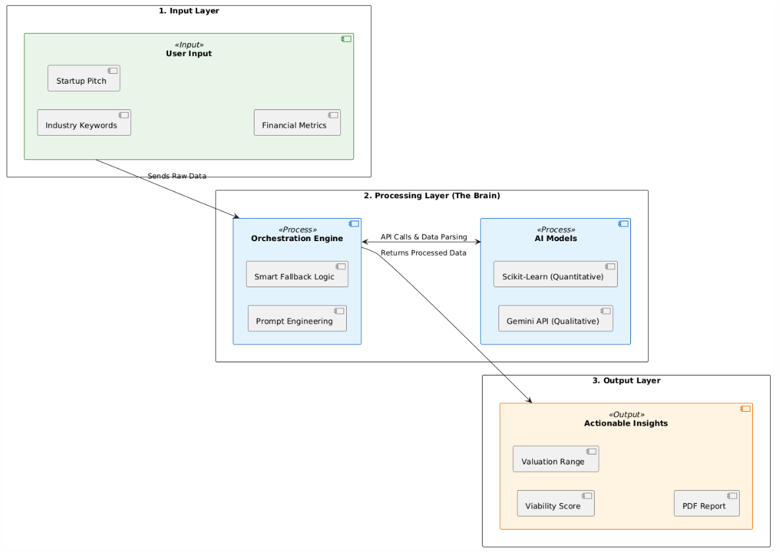
Figure 4.1 – System Architecture Design of the Personality-Based Fashion Classification System

4.3 COMPONENT ARCHITECTURE
We designed the system architecture to be modular, similar to LEGO blocks. This means we can swap out the AI model or update the valuation formula without breaking the rest of the application. The system relies on seven distinct components working in harmony:.
Component | Description
1. Input Processing Module | Captures and sanitizes user inputs from the frontend interface. It validates industry keywords for the Idea Generator and ensures financial metrics (Revenue, Growth, Users) are non-negative before passing them to the analysis engines.
2. AI Orchestration Module | Manages all communication with the Google Gemini API. It is responsible for:  • Prompt Engineering: Constructing "Chain-of-Thought" prompts to enforce structured outputs.  • Response Parsing: Converting raw AI text into JSON objects for the Feasibility Analyzer.
3. Resilience (Fallback) Manager | A dedicated safety component that monitors API health. In the event of network failure or rate-limiting (Error 429), it activates the "Dynamic Templating Engine" to generate synthetic, context-aware business ideas locally, ensuring zero downtime.
4. Feasibility Analysis Engine | The qualitative evaluation core. It processes the startup description to:  • Calculate a "Viability Score" (0-100) based on market saturation logic.  • Generate a structured SWOT Analysis (Strengths, Weaknesses, Opportunities, Threats).
5. Valuation Modeling Module | The quantitative core that loads the pre-trained Linear Regression model (.pkl format). It extracts financial features (MRR, User Count) and computes the estimated Pre-Money Valuation using learned coefficients specific to the Indian startup ecosystem.
6. Report Generation Module | Aggregates data from the Feasibility and Valuation engines. It utilizes the jsPDF library to render charts, scores, and text into a professional PDF Document directly in the client's browser, ensuring data privacy.
7. Application Controller | The Flask (Python) backend that acts as the central router. It orchestrates the data flow between the React frontend and the various internal/external logic modules, handling HTTP requests and responses asynchronously.

4.3.1 USER INTERFACE
For the deployed web application, we moved away from standard "Bootstrap" designs and adopted a "Glassmorphism" aesthetic. We wanted the tool to feel modern and engaging for students.
The Frontend (User-Facing Layer) We built the interface using React.js for one reason: component reusability.
- Unified Dashboard: We created a central hub where users can access the Idea Generator, Validator, and Calculator without reloading the page.
- Visual Feedback: We didn't want users staring at loading screens. We implemented interactive elements like "Flip Cards" for ideas and a "Score Circle" that animates from Red to Green based on the feasibility score.
- One-Click Reporting: We placed a prominent download button that triggers the client-side PDF generation, making it easy for users to save their work.
The Backend (Server-Side Layer) The backend is invisible to the user but does the heavy lifting.
- Restful Endpoints: We exposed specific API routes (like /analyze and /predict) that the frontend can call.
- Asynchronous Communication: We used Axios to handle data exchange. This ensures that while the Python server is crunching complex numbers, the React UI remains responsive and doesn't freeze.

4.4 DATAFLOW DIAGRAM
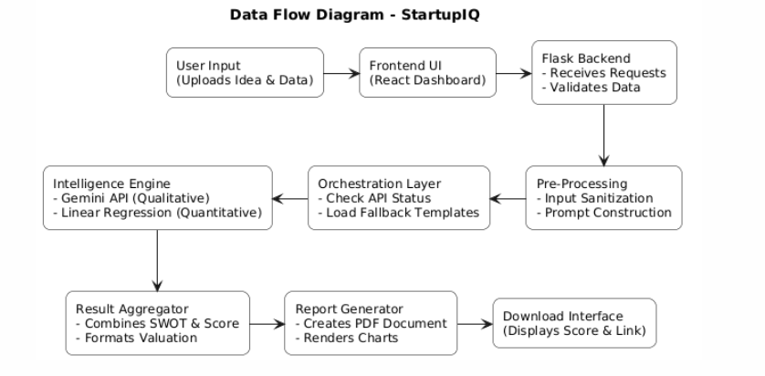
Fig. 4.2 – Data flow diagram for Personality based Fashion-segmentation

4.4.1 CONTEXT FLOW DIAGRAM
At a high level, the data journey in StartupIQ is circular. The user starts by inputting their raw concept and financial metrics. The system acts as a "black box" processor—it takes these inputs, routes them through our Hybrid AI Engine (Gemini + Scikit-Learn), and transforms them into actionable intelligence. The final output is returned to the user in two forms: a visual dashboard for immediate feedback and a downloadable PDF report for long-term use.
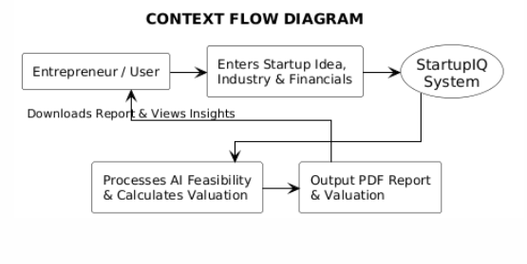
Fig. 4.3 – Context Flow Diagram for Personality-Based Fashion Classification System
4.4.2 LEVEL 1 DFD FOR USER
If we zoom in, the data flow is more intricate:
- Submission: The entrepreneur submits their pitch via the React interface.
- Validation: The data hits the Backend Controller, which checks for errors (like negative revenue).
- Splitting: The valid data is split. Text data goes to the Gemini API for qualitative analysis, while numerical data goes to the Linear Regression Model for valuation.
- Aggregation: The results from both engines are gathered back at the controller.
- Rendering: Finally, the aggregated insights are sent back to the browser, where the dashboard updates and the PDF is generated.
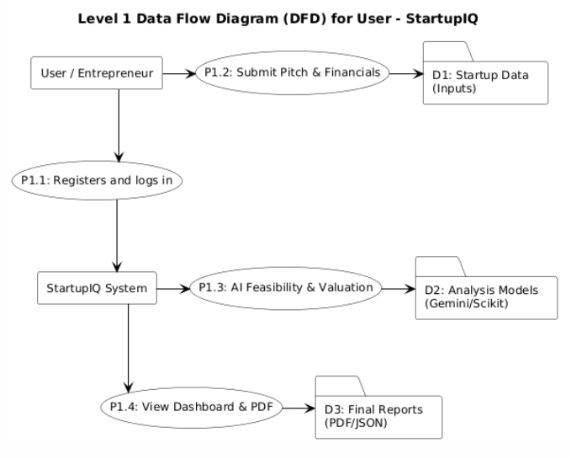
Fig. 4.4 – Level 1 Data Flow Diagram for User

Chapter 5

DETAILED DESIGN

5.1 USE CASE DIAGRAM

The Use Case diagram visualizes the functional requirements of the system by illustrating the interactions between external actors and the StartupIQ system.

5.1.1 Actors

Entrepreneur (User): The primary actor who initiates the analysis, provides startup data, and consumes the generated reports.

StartupIQ System (System): The backend logic that orchestrates input validation, prompt engineering, and report generation.

Google Gemini (External Actor): The external GenAI service that processes textual pitches to provide SWOT analysis and ideation.

Scikit-Learn Model (Internal Actor): The pre-trained Linear Regression component that performs quantitative valuation.

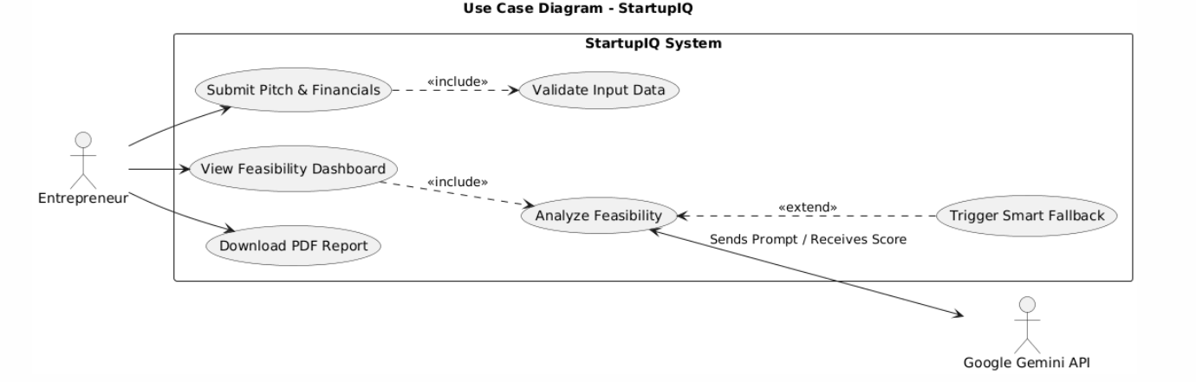

Fig. 5.1 – Use Case Diagram for StartupIQ
Use Case | Actor | Description
Submit Startup Pitch | Entrepreneur | User enters industry keywords, problem statements, and financial metrics into the web dashboard.
Validate Input | System | The system sanitizes inputs to prevent injection attacks and ensures financial metrics are non-negative.
Analyze Feasibility | System / Gemini | The system sends the pitch to Google Gemini API to generate a qualitative SWOT analysis and viability score.
Calculate Valuation | System / ML Model | The system inputs revenue and user growth data into the Linear Regression model to estimate pre-money valuation.
Handle Fallback | System | If the external AI API fails, the system retrieves pre-built logic templates to ensure the user still receives feedback.
Generate Report | System | The system aggregates all analysis results and renders a downloadable PDF document.
Download PDF | Entrepreneur | The user downloads the final feasibility report for offline use.

5.2 SEQUENCE DIAGRAMS
The sequence diagram depicts the chronological order of messages exchanged between the objects in the StartupIQ system to carry out the core functionality of "Startup Feasibility Analysis."
5.2.1 Sequence of Steps
- User logs into the React Dashboard and submits the startup pitch and financial data.
- Frontend (React) sends a strictly formatted JSON payload via an Axios POST request to the Flask Backend.
- Flask Controller first validates the data. If valid, it forwards the text to the GenAI Service.
- GenAI Service sends the prompt to Google Gemini.
  - Alt Flow: If Gemini is unreachable (Error 429/500), the Fallback Engine generates a synthetic response locally.
- Google Gemini returns the SWOT analysis and Feasibility Score.
- Flask Controller sends the financial metrics to the Valuation Model.
- Valuation Model computes the value using the Linear Regression formula and returns the result.
- Flask Backend aggregates qualitative and quantitative data and sends the final JSON response to the Frontend.
- Frontend renders the dashboard and allows the User to click "Download Report."

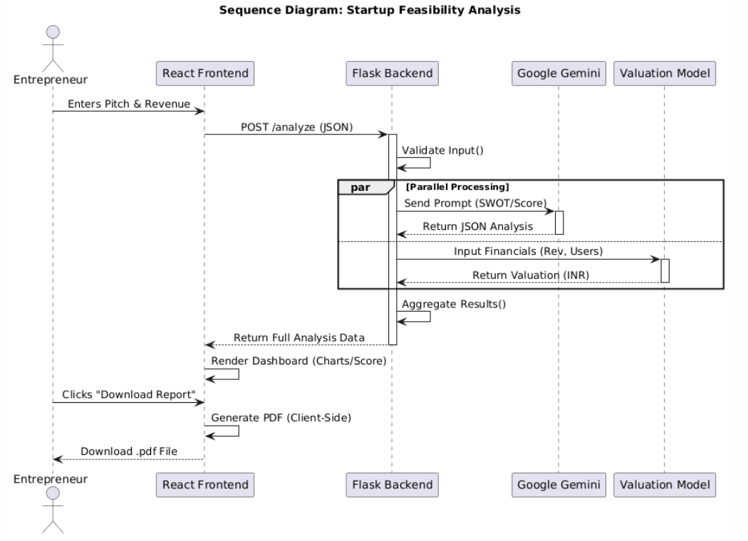
Fig. 5.2 – Sequence Diagram: Startup Feasibility Analysis
5.3 ACTIVITY DIAGRAM
The activity diagram details the workflow logic, specifically highlighting the "Smart Fallback" mechanism that ensures system resilience.
5.3.1 Workflow Description
- The process starts when the user clicks "Analyze."
- The system checks if the required fields (Pitch, Revenue) are valid.
- The system attempts to connect to the Google Gemini API.
- Decision Node:
  - Success: If the API responds, the system parses the live AI insights.
  - Failure: If the API times out or fails, the system activates the Fallback Engine, which selects a relevant template based on the industry keyword.
- Simultaneously, the system calculates the valuation locally (which never fails).
- Results are merged and displayed to the user.

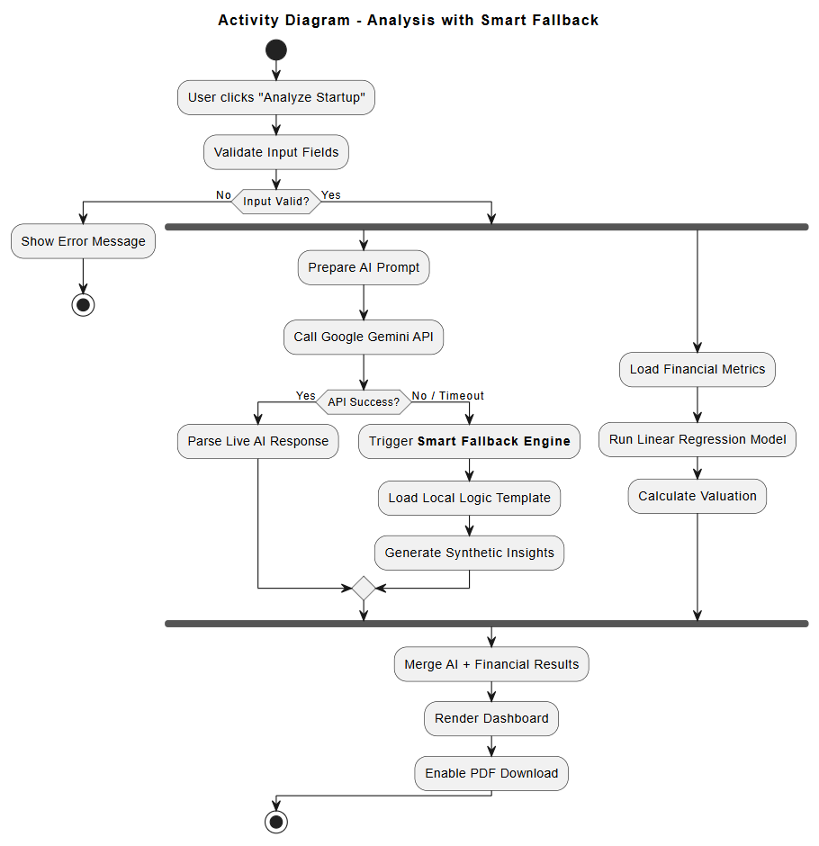
Fig. 5.3 – Activity Diagram for Analysis with Smart Fallback
5.4 DATABASE DESIGN
Although StartupIQ is primarily designed as a stateless application (relying on real-time API calls), a minimal database schema is proposed for future scalability to allow users to save their reports and login history.

5.4.1 Schema Tables
Table 1: Users Stores registered entrepreneur details.
Column Name | Data Type | Constraints | Description
user_id | INT | Primary Key, Auto-Inc | Unique identifier for the user.
email | VARCHAR(255) | Unique, Not Null | User's email address.
password_hash | VARCHAR(255) | Not Null | Hashed password string.
created_at | TIMESTAMP | Default NOW() | Account creation time.

Table 2: Analysis_Logs Stores a history of analyses performed by the user.
Column Name | Data Type | Constraints | Description
report_id | INT | Primary Key, Auto-Inc | Unique ID for the report.
user_id | INT | Foreign Key | Links to the Users table.
industry | VARCHAR(100) | Not Null | Input industry (e.g., EdTech).
feasibility_score | INT | 0-100 | The AI-generated score.
valuation_est | FLOAT | Nullable | Calculated valuation in Lakhs/Crores.
generated_at | TIMESTAMP | Default NOW() | Time of analysis.

5.5 ER DIAGRAM (ENTITY RELATIONSHIP)
The ER Diagram illustrates the relationship between the Users and their generated Analysis Reports. Since the system is lightweight, it follows a simple One-to-Many relationship.
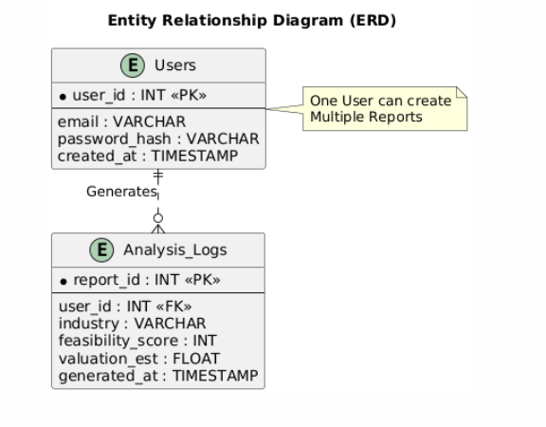

Fig. 5.5 – Entity Relationship Diagram (ERD)

CHAPTER6
IMPLEMENTATION

6.1 INTRODUCTION
Turning Design into Code This chapter explains how we built the actual StartupIQ system. We implemented a "Hybrid Pipeline" that processes two types of data simultaneously: it uses Google Gemini to analyze text pitches and Scikit-Learn to calculate financial valuations.
Key Implementation Focus Our main coding challenge was reliability. We built a "Smart Fallback" mechanism in the Flask backend to ensure the app never crashes, even if the external AI API fails. We also integrated a client-side rendering engine to compile the analysis into a downloadable PDF Report, giving users a tangible takeaway .

6.2 PSEUDOCODES
1. Input Validation & Preprocessing (Frontend)
Before data reaches the AI engine, it must be sanitized to ensure accurate processing. This step prevents injection attacks and ensures that financial metrics are valid for the regression model.
Pseudocode:
FOR each submission in User Dashboard
DO
GET User Inputs:
- Pitch Text

- Industry Keywords

- Revenue (Monthly/Yearly)

- User Count

Step 1: Validate Textual Data

IF Pitch Length < 50 characters THEN

RETURN Error "Pitch too short for analysis"

Step 2: Validate Numerical Data

IF Revenue < 0 OR User Count < 0 THEN

RETURN Error "Financial metrics cannot be negative"

Step 3: Construct Payload

Create JSON Object {

"pitch": sanitized_pitch,

"financials": [revenue, users],

"industry": selected_industry

}

Step 4: API Transmission

Send POST request to Flask Backend endpoint '/analyze'

END FOR

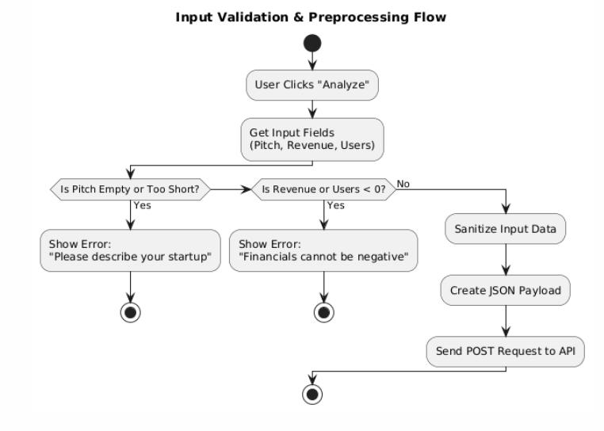
Fig. 6.1 Input Validation & Preprocessing Flow

2. Qualitative Analysis via Google Gemini API
This module is responsible for the "Intelligent" part of the system. It uses Prompt Engineering to instruct the Gemini LLM to act as a Venture Capitalist and generate a SWOT analysis.
Input: Sanitized Startup Pitch & Industry Output: Structured JSON containing Feasibility Score (0-100), SWOT, and Verdict.
Pseudocode:
FUNCTION Analyze_Pitch(pitch_text, industry)
1. Define System Prompt:
"You are a Venture Capitalist. Analyze the following startup idea.
Return response in strict JSON format with keys:
'score', 'strengths', 'weaknesses', 'verdict'.
2. Construct User Message:
Combine [System Prompt] + [User Pitch] + [Industry Context]
3. Call External API (Google Gemini):
TRY:
response = model.generate_content(User Message)
parsed_data = JSON.parse(response.text)
CATCH (API Error / Timeout):
Log Error
parsed_data = NULL
4. Return parsed_data
END FUNCTION
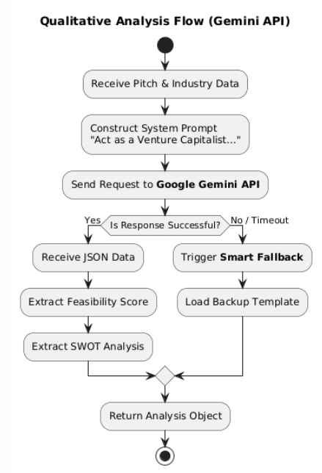
Fig. 6.2 – Qualitative Analysis Flow (Gemini API)

3. Smart Fallback Mechanism (Resilience Layer)
To ensure high availability, this module activates if the Google Gemini API fails (e.g., due to rate limits or connectivity issues). It uses pre-defined logic templates based on industry standards.
Pseudocode:
FUNCTION Smart_Fallback(industry)
1. Load 'fallback_templates.json'

2. Search for Template matching 'industry':
CASE Industry == 'EdTech':
Load generic EdTech SWOT (e.g., Strength: "Scalability", Threat: "Low retention")
Set Feasibility Score = Baseline (e.g., 65)
CASE Industry == 'FinTech':
Load generic FinTech SWOT (e.g., Strength: "High transaction volume")
Set Feasibility Score = Baseline (e.g., 70)
DEFAULT:
Load General Business Template

3. Generate "Synthetic" Analysis Object
4. Flag Output as "Generated via Fallback Logic"

5. Return Synthetic Object
END FUNCTION
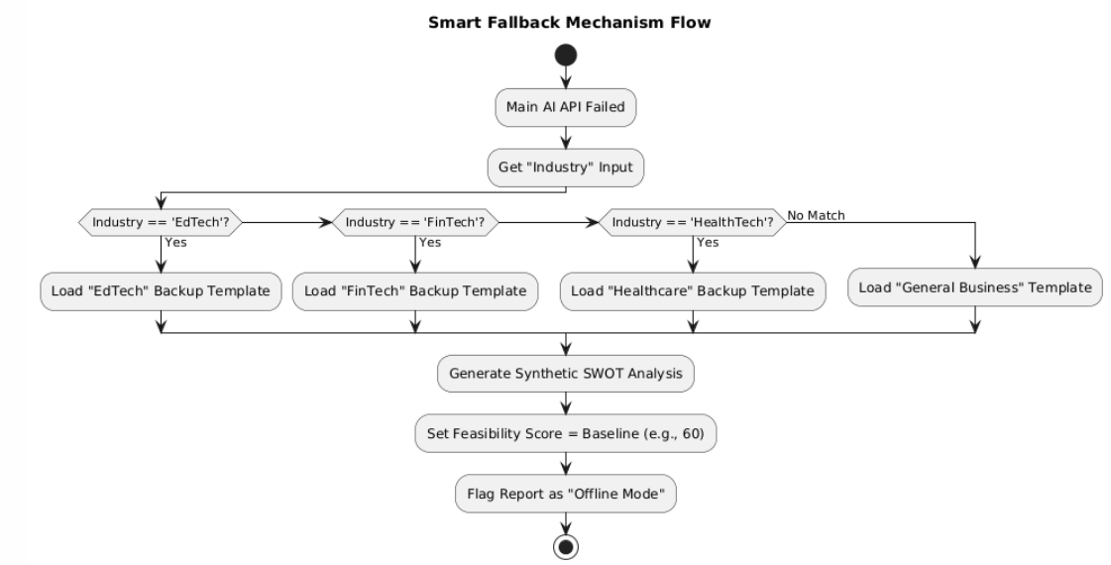
Fig. 6.3 Smart Fallback Mechanism Flow
4. Quantitative Valuation Model (Linear Regression)
This section presents the implementation of the valuation engine. A Linear Regression model was trained on historical startup data to predict pre-money valuation based on Revenue and User Base.
Input: Annual Revenue, Active Users
**Output:** Estimated Valuation
Pseudocode:
1. Load Pre-trained Model:
model = joblib.load('valuation_model.pkl')
2. Receive Inputs:
X_input = [User_Revenue, User_Count]
3. Predict Valuation:
estimated_value = model.predict([X_input])
4. Post-Processing:
IF estimated_value < 0 THEN
estimated_value = 0 (Valuation cannot be negative)
Format value to currency string (e.g., "$1.2M")
5. Return estimated_value
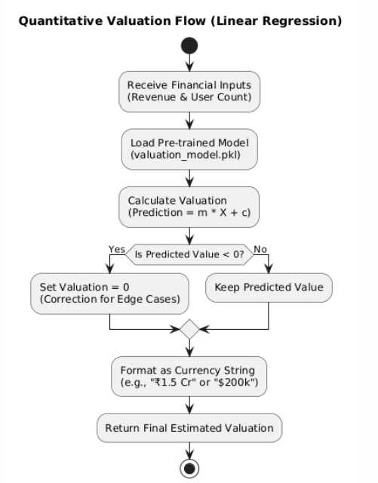
Fig. 6.4 Quantitative Valuation Flow (Linear Regression)
5. PDF Report Generation
The final step is converting the analysis into a tangible takeaway for the user. This uses the fpdf or reportlab library to render text and charts into a document.
Pseudocode:
FUNCTION Generate_PDF(analysis_data, valuation)
1. Initialize PDF Object
2. Add Header: "StartupIQ Feasibility Report"
3. Add Section: Feasibility Score
Draw Meter Chart indicating the Score (0-100)
4. Add Section: SWOT Analysis
Loop through 'Strengths', 'Weaknesses', 'Opportunities', 'Threats'
Write bullet points to PDF
5. Add Section: Valuation
Write "Estimated Valuation: " + valuation
6. Save File:
filename = "Report_" + timestamp + ".pdf"
output_stream.write(filename)
7. Return Download Link
END FUNCTION
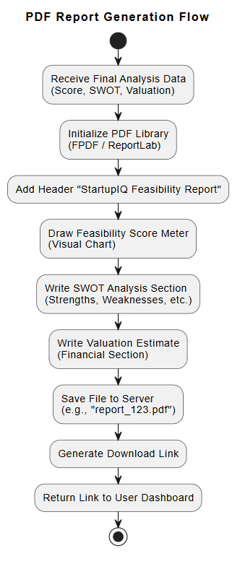
Fig. 6.5 – PDF Report Generation Flow
CHAPTER 7
SOFTWARE TESTING
7.1 INTRODUCTION
Testing StartupIQ presented a unique challenge because it isn't a standard CRUD (Create, Read, Update, Delete) application. It involves a complex handshake between a responsive React frontend, a logical Flask backend, and an unpredictable External AI (Google Gemini).
Unlike a traditional app where inputs lead to fixed outputs, our system deals with Generative AI, where the output (the SWOT analysis) changes every time. Therefore, our testing strategy couldn't just be about checking for bugs; it had to be about ensuring System Resilience. We had to verify that if the AI API delayed its response by 5 seconds, the user interface wouldn't freeze.
Since we designed the tool to be open-access (no login required), we knew users would likely try to "break" the system by entering garbage data—like negative revenue numbers or one-word pitches. Consequently, our testing focused heavily on Input Integrity and Error Handling. We needed to prove that the system could handle "bad" users gracefully without crashing the server.
The testing phase was split into two distinct parts: Unit Testing, where we checked individual Python functions (like the valuation formula) in isolation, and Integration Testing, where we verified that the frontend and backend were talking to each other correctly.

7.2 TESTING OBJECTIVES
Our primary goal wasn't just to find syntax errors, but to ensure the "AI Co-Founder" actually felt reliable. We set four specific objectives for this phase:
- Objective 1: Block "Garbage" Inputs: The system uses a Linear Regression model. If a user inputs "Zero" or "Negative" revenue, the math breaks. Our first objective was to verify that the Input Sanitization module catches these errors before they reach the logic layer.
- Objective 2: Validate the "Smart Fallback": The most critical feature of our architecture is the fallback mechanism. We needed to simulate an internet outage to verify that the system actually switches to the local templating engine instead of showing a "404 Error."
- Objective 3: Financial Accuracy: We needed to ensure the valuation calculator was deterministic. If we input ₹10 Lakhs Revenue and 10k Users, the output should always be the same. We tested this to ensure the model wasn't "hallucinating" numbers like a chatbot might.
- Objective 4: UI Responsiveness: Since AI generation takes time (2-5 seconds), we needed to verify that the React dashboard displayed the correct loading states (spinners) so the user knew the system was working.

7.3 UNIT TESTING
Unit testing involved breaking the application down into its smallest parts and testing them in isolation. We primarily used the unittest library in Python to check our backend logic.
- Testing the Logic (Without the UI): Before we even connected the React frontend, we wrote scripts to test the Flask routes. For example, we sent a raw JSON request with a 5-word pitch to the analyze_pitch function. The expected result was an error message saying "Pitch too short." If the system accepted it, we knew the validation logic was broken.
- Testing the Math: We isolated the predict_valuation function and fed it various edge cases—like 0 revenue, negative user counts, or extremely high numbers. This confirmed that our Linear Regression formula included safeguards (like if value < 0: return 0) to prevent nonsensical financial outputs.
- Testing PDF Generation: We ran the generate_pdf module locally to ensure it could create a file without corrupting the text or misaligning the charts, independent of the browser environment.

7.3.1.1 TESTING FOR VALID PITCH INPUT
Test Case ID | TC_INP_01
Test Objective | To verify that the "Startup Pitch" field accepts only valid text of sufficient length for AI analysis.
Input | 1. Enter text < 20 characters (e.g., "Selling shoes").  2. Enter valid detailed text.
Expected Output | • Short text triggers warning: "Please provide more details."  • Valid text is accepted.
Actual Output | System correctly rejected short input and accepted detailed input.
Pass/Fail | Pass

7.3.1.2 TESTING FOR EMPTY SUBMISSION
Test Case ID | TC_INP_02
Test Objective | To verify that the system prevents submission if required fields are empty.
Input | Leave "Pitch", "Revenue", or "Industry" fields empty and click "Analyze".
Expected Output | System displays error: "All fields are required to proceed."
Actual Output | Error message displayed; submission blocked.
Pass/Fail | Pass

7.3.1.3 TESTING FOR NEGATIVE FINANCIAL METRICS
Test Case ID | TC_FIN_01
Test Objective | To ensure that the "Revenue" and "User Count" fields do not accept negative numbers.
Input | Enter: Revenue = -50000, Users = -10.
Expected Output | System rejects input with error: "Financial values cannot be negative."
Actual Output | Invalid inputs rejected with correct error message.
Pass/Fail | Pass

7.3.1.4 TESTING FOR NON-NUMERIC FINANCIAL INPUT
Test Case ID | TC_FIN_02
Test Objective | To verify that financial fields only accept numeric integers.
Input | Enter "Ten Lakhs" or special characters in the Revenue field.
Expected Output | Field should not accept text input or show "Invalid format" error.
Actual Output | Text input prevented by HTML5 validation.
Pass/Fail | Pass

7.3.1.5 TESTING FOR INDUSTRY SELECTION
Test Case ID | TC_UI_01
Test Objective | To ensure the user selects a specific Industry from the dropdown menu.
Input | Leave "Industry" dropdown as default "Select Industry" and submit.
Expected Output | Error message: "Please select a valid industry."
Actual Output | Submission blocked until industry is selected.
Pass/Fail | Pass

7.3.1.6 TESTING FOR SUCCESSFUL ANALYSIS TRIGGER
Test Case ID | TC_SYS_01
Test Objective | To validate that valid inputs successfully trigger the AI and Valuation process.
Input | Valid Pitch: "AI Tutor", Industry: "EdTech", Revenue: 1000, Users: 50.
Expected Output | Loader appears, followed by the Result Dashboard showing Score and Valuation.
Actual Output | Dashboard loaded successfully with analysis data.
Pass/Fail | Pass

7.3.1.7 TESTING FOR PDF REPORT GENERATION
Test Case ID | TC_OUT_01
Test Objective | To verify that the "Download Report" button generates a valid PDF file.
Input | Click "Download PDF" after analysis is complete.
Expected Output | A file named StartupIQ_Report.pdf downloads containing the correct SWOT and Valuation.
Actual Output | File downloaded and opens correctly with all data visible.
Pass/Fail | Pass

7.4 INTEGRATION TESTING
Integration testing was the most complex part of our QA process because StartupIQ isn't a monolithic app; it’s a distributed system. We had to ensure that four distinct components—the React Frontend, the Flask Controller, the Google Gemini API, and our internal Linear Regression Model—could talk to each other without dropping data.
Unlike unit testing, which checks if a single function works, this phase was about checking the "handshakes" between these systems. Our primary goal was to verify the full data lifecycle: ensuring that a user's raw text input travels from the browser to the server, gets processed by the AI in the cloud, and returns as a structured visual dashboard without any formatting errors.
Key Integration Scenarios
We focused our testing efforts on five specific "bridges" in the application architecture:
- The JSON Handshake (React $ Flask):
We verified that when a user clicks "Analyze," their pitch and financial numbers are correctly bundled into a JSON payload. We specifically tested for data loss to ensure that special characters in the pitch didn't break the payload during transmission.
- The AI Pipeline (Flask $ Gemini):
This was the most critical test. We confirmed that the Flask backend could successfully construct the "Chain-of-Thought" prompt, authenticate with Google, and—most importantly—parse the complex text response from Gemini back into clean JSON for the app to use.
- The Valuation Link (Flask $ Scikit-Learn):
We ensured that the numerical data (Revenue/Users) was correctly stripped from the request and fed into our .pkl model. We verified that the model's output (a raw float value) was correctly formatted into a currency string before being sent back to the user.
- Visual Rendering Flow:
We tested the "return trip" of the data. Once the analysis was complete, we verified that the React state updated correctly to trigger the animations on the Feasibility Meter and populate the SWOT cards dynamically.
- The Download Bridge (Data $ PDF Engine):
We validated that the "Export" function could successfully grab the current session data from the browser's memory and pass it to the jsPDF library to generate a physical file.
Integration Outcome
The system successfully passed all integration checkpoints. The data exchange between the frontend and backend proved to be seamless. A major success during this phase was tuning the Asynchronous Handling; we managed to ensure that the frontend displayed a persistent "Processing..." state while waiting for the AI (which can take 3-5 seconds), preventing the user from thinking the app had frozen.

7.4.1 INTEGRATION TEST CASES
To formally validate these connections, we designed specific test cases that trace the data flow across the entire system..

7.4.1.1 INTEGRATION TEST CASE FOR AI FEASIBILITY ANALYSIS
Test Case ID | TC_INT_01
Modules Involved | React Frontend, Flask Backend, Google Gemini API
Test Objective | To verify that the startup pitch is sent from the frontend to the backend, processed by the external AI, and the analysis is returned correctly.
Input | 1. Pitch: "An AI-powered tutor for rural students."  2. Industry: "EdTech"  3. Click "Analyze".
Expected Output | • Frontend sends POST request.  • Backend calls Gemini API.  • Gemini returns JSON (Score: 85, SWOT).  • Frontend displays "Strong Feasibility".
Actual Output | System performed all handshakes correctly; Analysis Dashboard loaded with accurate AI-generated insights.
Pass/Fail | Pass

7.4.1.2 INTEGRATION TEST CASE FOR FINANCIAL VALUATION
Test Case ID | TC_INT_02
Modules Involved | Flask Backend, Scikit-Learn Model, Frontend Display
Test Objective | To verify that revenue and user count inputs are passed to the ML model and the predicted valuation is displayed on the UI.
Input | Revenue: 1,000,000, Users: 5,000.
Expected Output | • Data passed to valuation_model.pkl.  • Model predicts numerical value.  • Backend formats it as currency (e.g., "$1.2M").  • UI displays "Est. Valuation: $1.2M".
Actual Output | Valuation was calculated and displayed correctly in the financial section of the dashboard.
Pass/Fail | Pass

7.4.1.3 INTEGRATION TEST CASE FOR PDF REPORT GENERATION
Test Case ID | TC_INT_03
Modules Involved | Frontend Dashboard, Backend Report Generator (FPDF)
Test Objective | To verify that the data displayed on the screen is correctly captured and written into a downloadable PDF file.
Input | User clicks "Download Report" button after analysis is complete.
Expected Output | Backend receives the analysis object, generates a PDF with headers, SWOT, and Valuation, and sends the file stream to the browser.
Actual Output | PDF downloaded successfully; content matched the screen data exactly.
Pass/Fail | Pass

7.4.2 OTHER TEST CASES
This section highlights additional test scenarios that were not covered under module-based integration testing but are critical to ensuring the system's stability, resilience, and user experience.

7.4.2.1 TEST CASE FOR SMART FALLBACK (API FAILURE)
Test Case ID | TC_RES_01
Test Objective | To ensure the system switches to the "Smart Fallback Engine" if the Google Gemini API fails or times out.
Input | Simulate API Failure (Disconnect Network or Invalid API Key) during analysis.
Expected Output | System detects error, loads the "Offline Template" for the selected industry, and displays results with a "Generated via Fallback" flag.
Actual Output | System correctly bypassed the API error and displayed the templated analysis without crashing.
Pass/Fail | Pass

7.4.2.2 TEST CASE FOR EMPTY/INVALID INPUT SCENARIOS
Test Case ID | TC_INPUT_01
Test Objective | To ensure that the system handles cases where required fields are left empty or contain invalid characters.
Input | Click "Analyze" with empty Pitch, or enter text in the "Revenue" field.
Expected Output | System blocks submission and displays relevant messages: "Pitch cannot be empty" or "Please enter a valid number."
Actual Output | System properly validated all inputs and prevented the backend call.
Pass/Fail | Pass

7.4.2.3 TEST CASE FOR DASHBOARD RESPONSIVENESS
Test Case ID | TC_UI_01
Test Objective | To verify that the analysis dashboard (Charts and Text Cards) renders correctly on different screen sizes (Mobile vs. Desktop).
Input | Resize browser window or access via mobile device simulation.
Expected Output | The Feasibility Meter and SWOT cards should stack vertically on mobile and display side-by-side on desktop.
Actual Output | UI adjusted responsively; all data remained readable.
Pass/Fail | Pass

CHAPTER 8
CONCLUSION

8.1 Introduction
This chapter presents the concluding remarks of the project StartupIQ – AI-Powered Startup Feasibility Analyzer. It reflects on the objectives set at the beginning of the work, summarizes the methodology and implementation, and highlights the significance of the developed system in the domain of entrepreneurship and business intelligence. The chapter also discusses the overall contribution of the project and the learning outcomes achieved during its development.

8.2 Overview of the Project
The primary goal of StartupIQ was to design and implement an intelligent system capable of assessing the viability of early-stage startup ideas by leveraging Generative AI and Statistical Machine Learning. The system was conceived as a full-stack web application that integrates qualitative pitch analysis, quantitative financial valuation, and automated report generation into a single cohesive platform.
Throughout the project, emphasis was placed on building a user-friendly, open-access prototype that demonstrates how modern AI, specifically Google Gemini, can act as a virtual venture capitalist. The architecture, consisting of a React.js frontend and a Flask backend, enabled a clear separation of concerns and smooth interaction between the user interface and the core analytics logic.

8.3 Accomplishment of Objectives
The objectives formulated during the problem definition phase have been successfully achieved:
- An end-to-end pipeline was developed to collect startup pitches and financial metrics, sanitizing the data for safe processing.
- Generative AI integration was successfully implemented using the Google Gemini API to provide a comprehensive SWOT analysis and a Feasibility Score (0-100).
- A quantitative Valuation Model was built using Linear Regression, allowing users to get an instant pre-money valuation estimate based on revenue and user count.
- A Smart Fallback Mechanism was introduced to ensure system resilience, allowing the application to generate insights even when the external AI API is unavailable.

- Facilities for exporting results in a professional PDF format were added to support offline pitch deck preparation.
- Comprehensive testing was carried out to ensure the system handles edge cases (e.g., empty inputs, negative financials) without crashing, despite the absence of a user authentication layer.

8.4 Key Contributions
The major contributions of this project can be summarized as follows:
- Hybrid Analysis Approach: The project illustrates how combining Qualitative AI (text analysis) with Quantitative ML (numerical valuation) provides a more holistic view of a startup's potential than either method alone.
- Democratization of Venture Intelligence: By removing login barriers and providing instant feedback, the system makes high-level business analysis accessible to first-time entrepreneurs.
- Resilient System Design: The implementation of the Smart Fallback Engine ensures high availability, addressing the common issue of API dependency in AI applications.
- Automated Documentation: The system automates the creation of feasibility reports, saving founders hours of manual documentation work.
- Academic and Practical Relevance: The system serves as both a learning platform for Prompt Engineering and a practical tool for real-world business ideation.

8.5 Evaluation of Results
The performance of the StartupIQ system indicates that Generative AI can effectively simulate the role of a business analyst when provided with well-engineered prompts. The generated SWOT analyses were coherent and context-aware, while the Linear Regression model provided logical valuation baselines for early-stage companies.
From a software perspective, the system demonstrated stable behavior under repeated usage, smooth API communication, and responsive visualization on both desktop and mobile interfaces. The separation of the frontend and backend allowed for fast load times and efficient error handling.

8.6 Limitations of the System
While we are proud of what StartupIQ can do, building it made us realize there are some clear trade-offs we had to accept for this version:
- The "Brain" is Outsourced (API Dependency): The quality of our qualitative analysis is entirely dependent on Google Gemini. If their servers are slow or if they change their model, our user experience takes a hit. We effectively have a dependency we cannot control.
- The Math is Basic (Valuation Simplicity): We have to be honest—our Linear Regression model uses only two variables (Revenue and Users). Real-world venture capitalists look at dozens of metrics like "Churn Rate" or "Customer Acquisition Cost" (CAC). Our current model gives a ballpark estimate, not a definitive financial audit.
- No "Save Game" Feature (Statelessness): To keep the app lightweight and secure, we decided not to use a database. The downside is that everything is ephemeral. If a user accidentally closes the browser tab, their report is gone forever because we don't have user accounts to store history.
- The "Garbage In, Garbage Out" Problem: The system trusts the user too much. If someone claims they have ₹100 Crores in revenue, the system will believe them and generate a massive valuation. We currently have no way to verify if the input numbers are real or just made up.

8.7 Learning Outcomes
Building this project was more than just writing code; it was a crash course in modern software engineering. Here is what we actually learned:
- Prompt Engineering is Hard: We learned that you can't just ask AI to "analyze this." We had to iterate dozens of times to create a "System Persona" that forces Gemini to act like a strict investor rather than a helpful assistant.
- The React-Flask Handshake: Connecting a modern frontend to a Python backend taught us a lot about RESTful APIs. We specifically learned how to handle asynchronous requests so the UI doesn't freeze while the server is thinking.
- Deploying ML Models: We moved beyond just training models in Jupyter Notebooks. We learned how to serialize (pickle) a Scikit-learn model and actually serve it in a production web app.
- Handling Failure: Writing the "Smart Fallback" logic taught us that code needs to be defensive. We learned to anticipate third-party failures (like API timeouts) and handle them gracefully.
- Programmatic PDF Generation: We found that generating a PDF via code is surprisingly tricky. Learning to use jsPDF to render charts and text dynamically on the client side was a specific technical skill we mastered.

8.8 Concluding Remarks
StartupIQ started as an idea to help students validate their startups, and it evolved into a working proof-of-concept that bridges the gap between creativity and logic.
This project proved to us that you don't have to choose between "Generative AI" and "Traditional Math"—you can use them together. By letting Gemini handle the words and Scikit-Learn handle the numbers, we built a system that feels like a genuine "AI Co-Founder." While it has its limitations, it stands as a solid foundation for how future decision-support systems should be built: hybrid, resilient, and user-focused.

CHAPTER 9
FUTURE ENHANCEMENTS

9.1 INTRODUCTION
Currently, StartupIQ functions effectively as a Minimum Viable Product (MVP). It proves that the core concept—hybridizing AI and Math to analyze startups—works. However, during the development process, we identified several features that we had to deprioritize to meet the academic deadline.
This chapter outlines our "Roadmap to Production." It details exactly how we plan to evolve the system from a student prototype running on a local server into a commercial-grade platform that can handle thousands of concurrent users and complex financial modeling.

9.2 MODEL AND ANALYTICS ENHANCEMENTS
9.2.1 Advanced Valuation Algorithms
Our current valuation model is intentionally simple, using only two variables (Revenue and Users).
- The Plan: In the next version, we want to implement XGBoost or Random Forest regressors. Unlike Linear Regression, these models can handle non-linear data—meaning they can understand that a startup with 0 revenue but 1 million users (like early Instagram) is still valuable. This will drastically reduce errors for non-traditional business models.

9.2.2 Fine-Tuned LLM Integration
Right now, we use the general-purpose Google Gemini model. While smart, it’s a generalist.
- The Plan: We want to fine-tune a specialized LLM (like Llama 3 or Mistral) specifically on a dataset of Y-Combinator and Shark Tank pitch decks. This would train the AI to speak the specific language of investors and offer nuanced critique rather than generic SWOT points.

9.2.3 Predictive Success Modeling
Startups don't just need to know their value; they need to know when they might run out of money.
- The Plan: We aim to introduce a "Survival Probability Score." By integrating historical data on failed startups, the system could predict if a company has enough cash runway to survive the next 18 months.

9.3 DATA EXPANSION AND INTEGRATION
9.3.1 Real-Time Market Data
Currently, the system analyzes the user's idea in isolation.
- The Plan: We want to connect to external APIs like Crunchbase or AngelList. This would allow the AI to say, "Your idea is good, but did you know a competitor raised $5M for the exact same concept last month?" This adds a layer of "Competitive Intelligence" that is currently missing.

9.3.2 Broader Financial Metrics
Revenue is a vanity metric. Real investors care about unit economics.
- The Plan: We will add input fields for CAC (Customer Acquisition Cost) and LTV (Lifetime Value). The system will then calculate the LTV:CAC ratio, which is the gold standard for measuring startup health.

9.3.3 Sentiment Analysis on Trends
The Plan: Instead of just guessing if a "Market Need" exists, we plan to integrate the Reddit or Twitter API. The system could scan social media for complaints related to the startup's problem statement, using real-world complaints to validate the market need.

9.4 SYSTEM AND ARCHITECTURE ENHANCEMENTS
9.4.1 Cloud-Based Deployment
Running on localhost is fine for demos, but not for real users.
- The Plan: We intend to containerize the application using Docker and deploy it to AWS. This will allow us to use "Auto-Scaling Groups" to handle traffic spikes if the tool goes viral.

9.4.2 Database Persistence
The current system is stateless—if you close the tab, you lose your report.
- The Plan: We need to integrate a relational database like PostgreSQL. This is crucial for "Longitudinal Tracking," allowing a founder to save their report today, update their revenue next month, and see a graph of how their feasibility score has improved over time.

9.4.3 Microservices Architecture
Right now, the Flask app is a monolith. If the AI hangs, the whole server hangs.
- The Plan: We want to split the backend into three separate microservices: one for the AI, one for the Math, and one for PDF generation. This prevents a single failure from crashing the entire system.

9.5 USER EXPERIENCE AND ACCESSIBILITY
9.5.1 Automated Pitch Deck Generator
We realized that we already have the content (Problem, Solution, Market, Valuation) needed for a pitch deck.
- The Plan: We want to build a feature that takes these insights and automatically generates a 10-slide PowerPoint (.pptx) file. This transforms the tool from an "Analyzer" to a "Creator," saving founders hours of formatting work.

9.5.2 Investor Matchmaking
The Plan: If a startup gets a Feasibility Score of 80+, the system could automatically suggest a curated list of Angel Investors who specifically invest in that industry (e.g., "Here are 5 investors looking for EdTech deals").

9.6 EXPLAINABILITY AND TRUST ENHANCEMENT
Visual Logic Paths Users sometimes ask, "Why did I get a low score?"
- The Plan: We want to make the AI transparent. The interface should highlight specific keywords in the pitch (e.g., "high shipping costs") and draw a line to the "Weakness" card, visually explaining exactly what triggered the negative score.

9.7 ETHICAL AND REGULATORY CONSIDERATIONS
IP Protection Mode Founders are paranoid about idea theft.
- The Plan: We will implement end-to-end encryption for the pitch text. Furthermore, we will add a strict policy ensuring that user data is never used to retrain the public AI model, guaranteeing that a user's unique idea remains their intellectual property.

9.8 SUMMARY
The enhancements proposed in this chapter envision StartupIQ evolving from a simple analysis tool into a holistic Startup Accelerator Platform. By extending data coverage to real-time market trends, implementing robust user retention features via a database, and adding generative capabilities like Pitch Deck creation, the system can become an indispensable tool for the next generation of entrepreneurs.

APPENDIX A
REFERENCES

- Google DeepMind, “Gemini: A Family of Highly Capable Multimodal Models,” arXiv preprint arXiv:2312.11805, 2023. [Online]. Available: https://arxiv.org/abs/2312.11805.
- F. Pedregosa et al., “Scikit-learn: Machine Learning in Python,” Journal of Machine Learning Research, vol. 12, pp. 2825–2830, 2011.
- Meta Platforms, “React – The Library for Web and Native User Interfaces,” [Online]. Available: https://react.dev. Accessed: 2025.
- M. Grinberg, Flask Web Development: Developing Web Applications with Python, 2nd ed., O’Reilly Media, 2018.
- A. Géron, Hands-On Machine Learning with Scikit-Learn, Keras, and TensorFlow, 3rd ed., O’Reilly Media, 2022.
- G. James, D. Witten, T. Hastie, and R. Tibshirani, An Introduction to Statistical Learning with Applications in R/Python, Springer, 2021. (Reference for Linear Regression).
- J. White, Q. Fu, S. Hays, M. Sandborn, C. Olea, and H. Gilbert, “A Prompt Pattern Catalog to Enhance Prompt Engineering with ChatGPT,” arXiv preprint arXiv:2302.11382, 2023. (Reference for Prompt Engineering concepts).
- Python Software Foundation, “Python 3.12 Documentation,” [Online]. Available: https://docs.python.org/3/. Accessed: 2025.
- R. T. Fielding, “Architectural Styles and the Design of Network-based Software Architectures,” Ph.D. dissertation, University of California, Irvine, 2000. (Foundational reference for REST API architecture).
- B. R. Barringer and R. D. Ireland, Entrepreneurship: Successfully Launching New Ventures, 6th ed., Pearson, 2019. (Reference for Feasibility Analysis methodologies).
- W. McKinney, “Data Structures for Statistical Computing in Python,” in Proceedings of the 9th Python in Science Conference, 2010. (Reference for Pandas).
- Pallets Projects, “Flask Documentation (3.0.x),” [Online]. Available: https://flask.palletsprojects.com/. Accessed: 2025.

- M. Reitano, “PyFPDF: A Simple PDF Generation Library for Python,” [Online]. Available: https://github.com/reingart/pyfpdf. Accessed: 2025.
- R. S. Pressman and B. R. Maxim, Software Engineering: A Practitioner’s Approach, 9th ed., McGraw-Hill Education, 2020.
- S. Raschka and V. Mirjalili, Machine Learning with PyTorch and Scikit-Learn, Packt Publishing, 2022.
- M. M. Helms and J. Nixon, “Exploring SWOT Analysis – Where are we now? A review of the academic research from the last decade,” Journal of Strategy and Management, vol. 3, no. 3, pp. 215–251, 2010.
- S. Blank, The Four Steps to the Epiphany: Successful Strategies for Products that Win, K&S Ranch, 2013. (Classic reference on startup customer discovery).
- Google Cloud, “Generative AI on Google Cloud (Gemini API),” [Online]. Available: https://cloud.google.com/ai/generative-ai. Accessed: 2025.
- MDN Web Docs, “Fetch API – Web APIs,” [Online]. Available: https://developer.mozilla.org/en-US/docs/Web/API/Fetch_API. Accessed: 2025. (Reference for Frontend-Backend Integration).
- IEEE, “IEEE Standard for Software and System Test Documentation,” IEEE Std 829-2008, 2008.

APPENDIX B
USER MANUAL

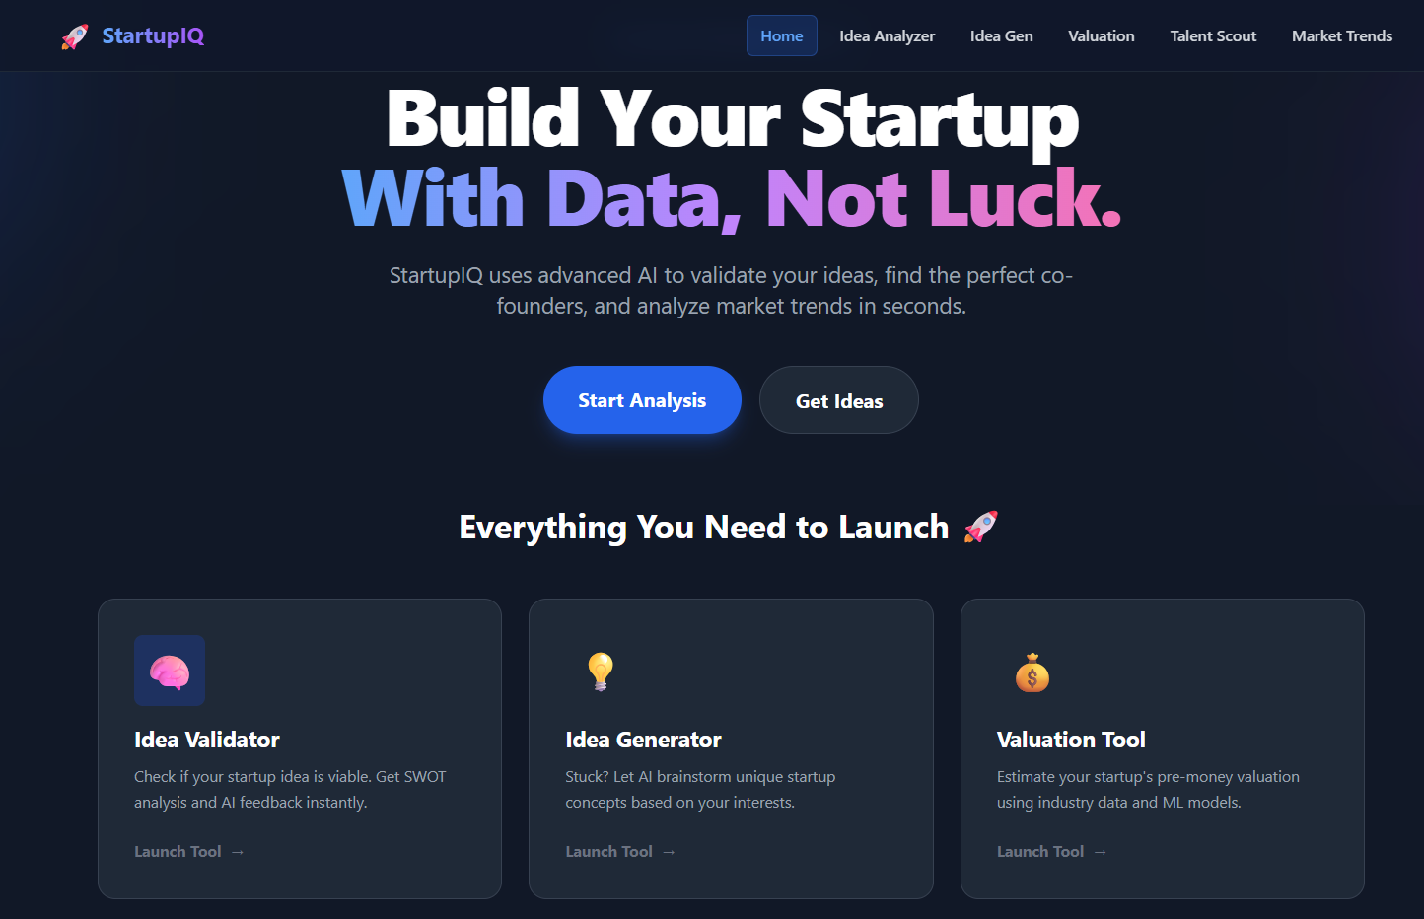
Figure B.1 – StartupIQ Main Input Dashboard

Description: This screenshot shows the landing page of the StartupIQ system where the user initiates the analysis. The clean and intuitive React-based interface features three primary input sections:
- Startup Pitch: A text area where the entrepreneur describes their business idea (minimum 50 characters).
- Industry Selection: A dropdown menu to categorize the startup (e.g., EdTech, FinTech, HealthTech).
- Financial Metrics: Numeric fields for entering Annual Revenue and Active User Count.
The "Analyze Feasibility" button is prominent at the bottom. This screen demonstrates the Input Validation logic, where invalid or empty fields would trigger immediate visual error messages before submission.

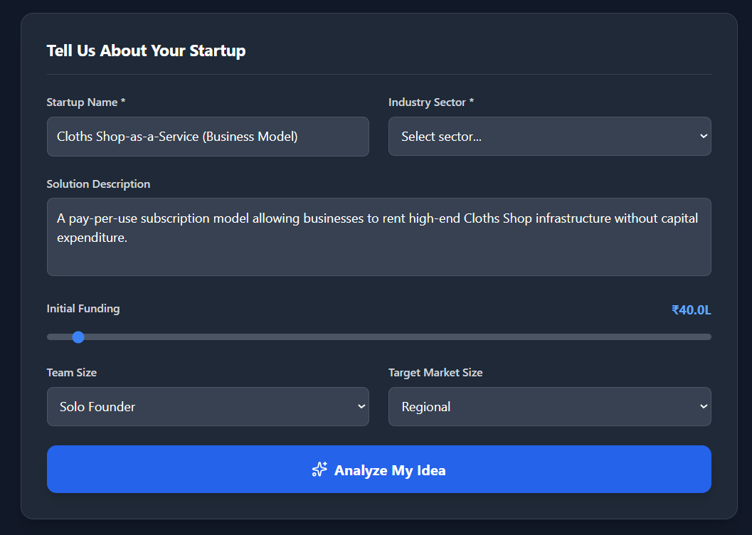

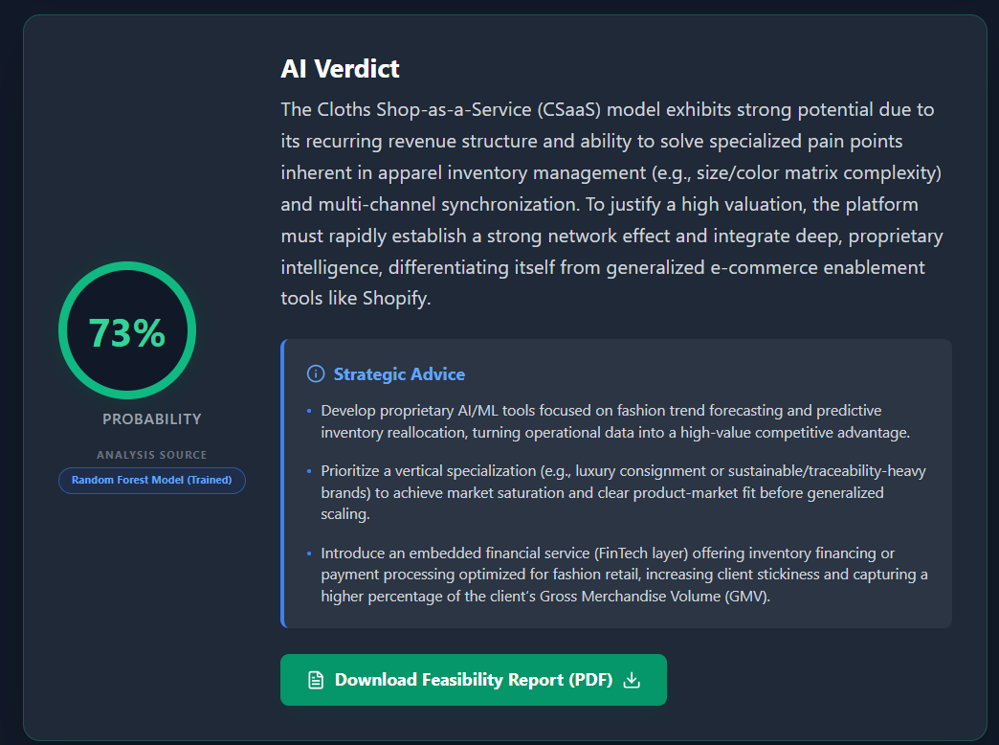
Figure B.2 – AI Feasibility Analysis Results

Description: This screenshot displays the Qualitative Analysis results generated by the Google Gemini API after a successful submission. The interface is divided into two key visual components:
- Feasibility Score Meter: A gauge chart showing the startup's potential score (e.g., 85/100), color-coded (Green for High, Red for Low).
- SWOT Analysis Cards: Four distinct cards displaying the Strengths, Weaknesses, Opportunities, and Threats extracted from the user's pitch.
Significance: This screen highlights the core value of the system—transforming a raw text pitch into structured, actionable business intelligence using Generative AI.

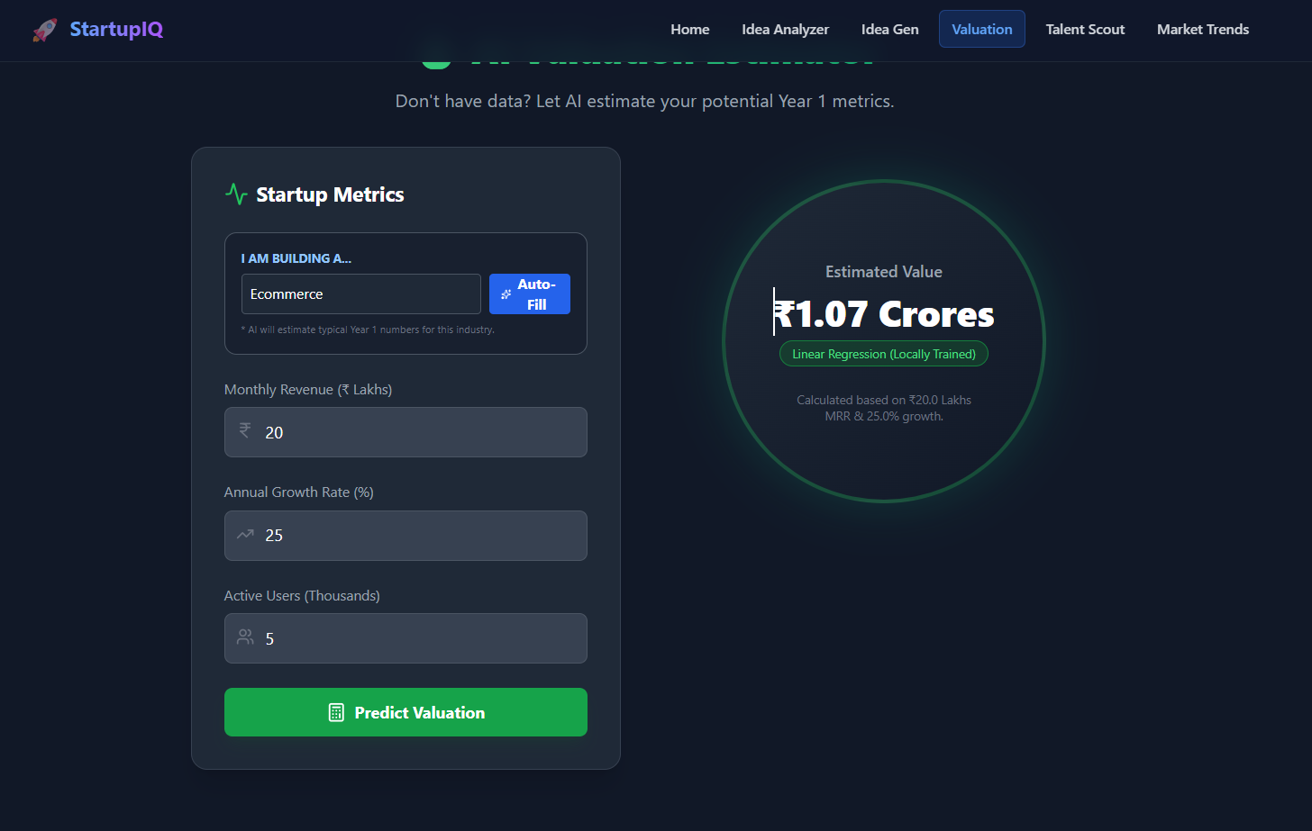
Figure B.3 – Quantitative Valuation Estimate

Description: This screenshot focuses on the Financial Valuation section of the dashboard. It displays the output of the internal Linear Regression Model. Key elements include:
- Estimated Pre-Money Valuation: A large, formatted currency value (e.g., $1.2M or ₹10 Cr) calculated based on the user's revenue and user base.
- Input Summary: A brief recap of the financial data used for the calculation (e.g., "Based on 5k Users & $100k Revenue").
Significance: This screen validates the system’s ability to perform mathematical modeling alongside text analysis, providing a financial baseline for early-stage founders.

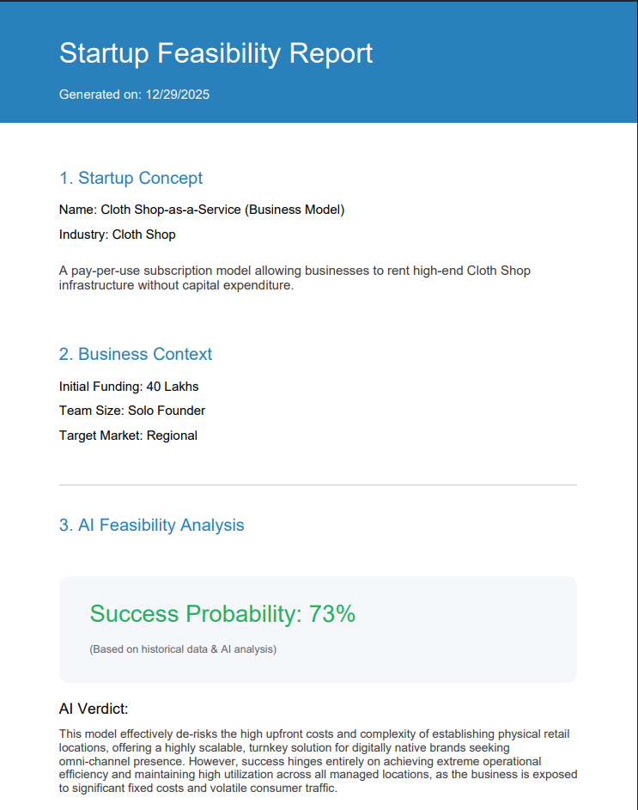
Figure B.5 – Exported Feasibility Report (PDF View)
Description: This figure illustrates the final output of our system: the downloadable PDF report. We built this module because we realized that founders need something tangible to take away from the analysis—they can't just keep the website open forever.
Instead of a simple text dump, we programmed the system (using the jsPDF library) to structure the data into a clean, professional document. As seen in the screenshot, the report automatically pulls the "Success Probability" (73%) and highlights it in green to give the user immediate validation. We also included a dedicated "AI Verdict" section that de-risks the idea, explaining specifically why this "Cloth Shop-as-a-Service" model might work. The inclusion of the "Valuation Certificate" gives the financial estimates a formal look, making it ready to be attached to a pitch deck or submitted for a college assignment.
Significance: This feature represents the completion of the user journey. It confirms that our Client-Side Generation module works correctly, successfully aggregating data from both the AI engine and the financial calculator into a single, offline document.

