Generating and Evaluating STEM Teaching Analogies with Small Language Models
Sriharsha Meduriª Mohit Pratap Singh Rathoreª Gunveer Kalsiª Pratap Chandra Mandal^{b}
ªOviqo ^{b}Indian Institute of Management Shillong
Correspondence: sriharshameduri07@gmail.com
2026-07-24
Abstract
Analogies help teachers make abstract STEM concepts concrete, and language models can now generate them on demand. This raises two practical questions: how should one prompt for good analogies, and how can analogy quality be evaluated at scale without a human rating every item? We study both using only small, open models on a single consumer GPU, with no paid API and no human annotation. For 64 school-level concepts across four subjects, three open models generate analogies under four source-domain strategies (unconstrained, everyday, sports, cooking), and a four-model panel evaluates each with a purpose-built five-dimension rubric (SAQR). Because small models score leniently and inconsistently, we take comparative ranking as the primary signal and validate the panel against planted analogies of known quality. Constraining the source domain confers no advantage over unconstrained generation: equivalence tests place all four strategies within a small margin. Judged quality is highly predictable ($R^{2}=0.72$), but from length and subject, not strategy, a verbosity bias we quantify. The panel screens out planted-wrong analogies almost perfectly yet barely agrees when ranking good ones; a plain explanation lifts weak students’ accuracy while an added analogy does not; and a preliminary Hindi replication is consistent, though the automated evaluation does not carry over. A judge twice the panel’s size sheds the verbosity bias and resolves a small but significant advantage for unconstrained generation, so the equivalence partly reflects the small panel’s own limitation. The paper contributes a reusable, fully automated, reproducible protocol and a candid account of automated evaluation’s failure modes and their mitigations.

1 Introduction
A good analogy can turn an abstract STEM concept into something a student already understands. Comparing electric current to water in a pipe, or a chemical equilibrium to a crowded two-way bridge, lets a learner import familiar structure onto unfamiliar ideas, and decades of work in the learning sciences treat this mapping of relations as central to how people understand new material [4, 5]. Analogies are not a panacea: reviews of classroom use find that their benefit is real but conditional, and that a carelessly chosen analogy can just as easily plant a misconception a student then has to unlearn [2, 3]. The quality of the analogy, and its fit to the concept, is what matters.
Large language models change the economics of producing such analogies. A teacher can now ask a model for ten analogies for photosynthesis in seconds, and early studies show that model-generated analogies can help learners, particularly when a teacher curates them [1, 8]. This possibility raises two practical questions that the present paper addresses together. First, how should one prompt a model to obtain good analogies: does it help to constrain the analogy’s source domain (“explain it with a sports analogy”), or is the model’s own unconstrained choice at least as good? Second, and prerequisite to answering the first at any scale, how can analogy quality be measured without a human expert rating every candidate? The natural answer, to have a language model judge the analogies, inherits the known reliability problems of LLM-as-a-judge evaluation, including leniency, verbosity preference, self-preference, and sensitivity to the order in which options are presented [10].
We study both questions using only small, openly available models that run on a single consumer GPU, with no paid API and no human annotation in the loop. This choice is deliberate: it keeps the whole protocol reproducible on commodity hardware and forces us to confront, rather than paper over, the reliability limits of automated evaluation. Along the way we find that those limits bite in two concrete places: a capable “student” model ceilings on our comprehension questions because it already knows the material, and small judge models rate almost everything highly and are easily biased by option order. We develop mitigations (a weak-to-strong student ladder, comparative ranking with shuffled labels, and a validation probe of planted known-quality analogies) that keep the measurements honest. This fully-automated regime is a deliberate scope, not a claim that automated proxies replace human teachers and learners: it is the setting a resource-constrained educator or a large-scale content pipeline actually faces, and the one in which a cheap, reproducible screening protocol is most useful. Human validation is a complementary next step, which we discuss in Section 7, not a prerequisite for the questions we ask here.
Research questions.
Do analogy generation strategies (the source domain the model is asked to draw the analogy from) differ in the quality of the analogies they produce, as judged by an automated multi-model panel?
What do the automated judges reward? Can an analogy’s judged score be predicted from cheap features, and what does that reveal about the judges’ biases rather than about true quality?
Does an added analogy carry information that measurably improves a proxy “student” model’s answers to conceptual questions, and how does that depend on the student’s capability?
Do these findings replicate in Hindi, a mid-resource language, and how far do small open models degrade when generating and judging analogies outside English?
Research objectives. Each question is paired with a research objective (RO) that operationalises it, so that every objective is answered by a specific analysis reported later in the paper.
To measure and compare, with an automated multi-model panel, the instructional quality of analogies generated under different source-domain prompting strategies (addresses RQ1; Section 5.2).
To audit the automated judges by predicting their scores from cheap features and quantifying the biases, such as verbosity, that threaten automated quality measurement (addresses RQ2; Section 5.4).
To test whether an added analogy improves a proxy student model’s answers to conceptual questions, and how this depends on the student’s capability (addresses RQ3; Section 5.5).
To assess how far both the generation findings and the automated-evaluation protocol transfer from English to Hindi, a mid-resource language (addresses RQ4; Section 5.6).
Contributions. We organise the contributions along three pillars: academic and research, industry and managerial, and society.
Academic and research. (i) The STEM Analogy Quality Rubric (SAQR), a five-dimension rubric for instructional analogies grounded in the learning-sciences literature, together with a judge-validation probe of planted known-quality analogies that objectively tests whether an automated judge can tell good analogies from bad ones. (ii) Empirical findings on prompting strategy (no reliable source-domain effect), on what the automated judges actually reward (surface length and subject, a bias we quantify in this instructional setting), on how an added analogy interacts with a proxy student’s capability, and on how far these carry into Hindi rather than only English. (iii) A candid account of two failure modes of automated evaluation (student ceiling effects, and lenient, position-biased judges) and the mitigations (weak-student gradients, comparative ranking, label shuffling, probe validation) that keep the protocol honest.
Industry and managerial. A fully automated, reproducible protocol for generating and screening STEM analogies with small open models on a single consumer GPU, with no paid API or human annotation, that an educational-technology team or a content pipeline can adopt directly. It yields actionable guidance: let a capable model choose the analogy’s domain rather than engineering source-domain constraints, treat a small-model panel as a cheap screen rather than a fine-grained ranker and validate it against known-quality anchors, and scale the judge only when finer discrimination is needed.
Society. By requiring neither paid services nor specialised hardware, the protocol lowers the barrier for resource-constrained teachers, schools, and education regulators to vet automatically generated teaching material before it reaches learners. The Hindi study also surfaces an equity concern with practical weight: at this model scale automated evaluation is an English-first tool, so learners and educators working in mid-resource languages are currently underserved, which we name as a target for the field.
How this study differs from prior work. SAQR is a new rubric we introduce for this problem, not a pre-existing standard, and the study as a whole occupies a combination that earlier work does not. Prior evaluations of language-model-generated analogies either rely on human raters or paid frontier judges [8, 10], target analogy identification or solving rather than the quality of instructional generation [6, 9], or report judge scores without testing whether the judge can actually distinguish good analogies from bad. We instead evaluate instructional generation with a purpose-built rubric using only small open models, and we validate the judges against planted known-quality analogies, quantify their biases, tie quality to a comprehension outcome across a student-capability gradient, and test transfer to Hindi, while being explicit about where the automation fails. It is this combination, not any single component, that is new.

2 Related Work
Analogy in the learning sciences. Gentner’s structure-mapping theory frames an analogy as a mapping of relations (not surface features) from a familiar base to an unfamiliar target, and it explains why some analogies illuminate while others merely decorate [5]. In science education specifically, analogies and metaphors are ubiquitous, and their instructional value has been studied for decades [4]. The picture is mixed: reviews find that analogies help under the right conditions but can also seed durable misconceptions when the mapping breaks down in a place the learner over-extends, which motivated structured classroom techniques such as bridging analogies and explicit mapping of correspondences [2, 3]. This literature grounds two of our rubric dimensions, conceptual accuracy and the absence of misleading simplification, as the qualities that most distinguish a helpful analogy from a harmful one.
Computational and LLM-based analogy generation. Analogy has long been a target for natural language processing, historically through word-level proportional analogies and, more recently, through free-form generation with LLMs. Bhavya et al. [1] showed that prompting can elicit serviceable analogies from instruction-tuned models, and subsequent work has built corpora and benchmarks for story-level and abstract analogical reasoning [6, 9]. These efforts largely evaluate whether models can identify or solve analogies; we instead study how the prompting strategy shapes the quality of generated instructional analogies, and how that quality can be measured automatically.
LLMs as instructional-content generators. Language models are increasingly used to draft explanations, questions, feedback, and other teaching materials [7]. Closest to our setting, Shao et al. [8] evaluated LLM-generated analogies with high-school students and teachers, reporting comprehension gains, especially in biology, but also a need for teacher curation to prevent over-reliance. Their study centres human judgement; ours is complementary, asking how far a fully automated pipeline of small open models can generate and screen analogies before a human is involved, and being explicit about where that automation is and is not trustworthy.
LLM-as-a-judge and its reliability. Using a strong model to score generated text correlates well with human preference in aggregate but is subject to well-documented biases: position/order bias, verbosity bias, and self-enhancement bias, among others [10]. Most of this evidence concerns large frontier judges; we find the problems are sharper with the small local models we are constrained to, which additionally exhibit strong leniency (rating nearly everything highly) and, in ranking, a tendency to default to presentation order. Our response adapts standard LLM-as-a-judge practice to a small-model, education-specific setting: comparative ranking with per-item label shuffling, exclusion of self-judgements, and an objective judge-validation probe of planted good/wrong analogies. It quantifies when the resulting scores can and cannot be trusted.

3 The STEM Analogy Quality Rubric (SAQR)
We designed a compact rubric for judging an analogy as a teaching aid for a specific concept, rather than as free-standing text. SAQR has five dimensions, each scored from 1 (poor) to 5 (excellent) against anchored descriptions: conceptual accuracy (do the important relationships in the concept correspond to matching relationships in the analogy?), clarity (is it easy to follow and does it actually aid understanding?), memorability (is it vivid and concrete enough to be remembered?), absence of misleading simplification (does it avoid planting a misconception?), and overall usefulness. The full rubric with all anchors is given in Appendix [app:rubric]. The dimensions were chosen to separate the two ways an analogy can fail that matter most in teaching (being wrong, that is, low conceptual accuracy, or subtly misleading, that is, low non-misleading score) from the ways it can merely be ineffective (low clarity or memorability). Empirically the five dimensions are moderately correlated but not redundant (mean pairwise $r=0.31$ across all judgments), and the absence-of-misleading-simplification dimension is close to orthogonal to the rest ($r$ between $−0.07$ and $0.11$ with conceptual accuracy, memorability, and overall usefulness). Whether an analogy misleads is therefore not captured by whether it is clear, accurate, or memorable, which is exactly why it earns a place as its own dimension.

4 Method

4.1 Overview
The study has one manipulated variable (the analogy generation strategy) and a fixed pipeline of automated measurements around it. For each concept we hold the standard textbook explanation constant and vary only the prompt used to elicit an analogy. Every generated analogy is then (a) ranked against its siblings by a judge panel, (b) scored on the SAQR rubric by the same panel, and, for a subset of concepts with multiple-choice questions, (c) placed in front of “student” models of differing capability to measure a comprehension outcome. All generation and evaluation is performed by small open models served locally through Ollama on a single NVIDIA GTX 1650 (4 GB); no external API or human annotation is used at any stage.

4.2 Concept dataset
We authored 64 school-curriculum concepts, balanced across four subjects (Physics, Chemistry, Mathematics, Biology; 16 each) and spanning grades 8–12. Each concept carries a concise, curriculum-accurate standard explanation (mean 62 words). A 16-concept subset additionally carries four four-option multiple-choice questions ($64$ questions in total), written to probe conceptual understanding and transfer rather than verbatim recall; these support the comprehension study (RQ3). Concept content (the explanations and the questions with their verified keys) was authored and checked by the researcher; only the analogies are model-generated, so that the manipulated variable is cleanly separated from the fixed teaching content. The full concept list appears in Appendix [app:concepts].

4.3 Analogy generation strategies (the independent variable)
Each analogy is produced by prompting a generator model with a system role of an expert STEM teacher and a user prompt that supplies the concept, its standard explanation, and one strategy instruction constraining the source domain of the analogy. The four strategies are: free (any source domain, the unconstrained reference), everyday (ordinary daily-life objects and routines), sports (sports, games, or physical play), and cooking (cooking, baking, or the kitchen). The prompt asks for a single analogy of two to four sentences that “maps correctly onto the concept.” To check that the choice of generator does not drive the result, we run the full strategy set with three open models as generators (qwen2.5:3b, llama3.2:3b, and gemma2:2b), yielding $64×4×3=768$ analogies. Generation uses temperature 0.7 with a fixed per-item seed; every prompt and completion is logged verbatim for reproducibility.

4.4 Automated evaluation
Small local models turn out to be unreliable absolute scorers: they cluster at the top of the scale and anchor it differently from one another (Section 5.3). We therefore use two complementary evaluation channels and treat the comparative one as primary.
Comparative ranking (primary). For each concept and each generator, a judge is shown all four strategy analogies at once, with their presentation letters shuffled per (judge, concept) to control position bias, and is asked to rank them from best (1) to worst (4) as teaching aids, each rank used once. Rankings are parsed as permutations; invalid outputs (missing or duplicated ranks) are discarded. A model never ranks analogies it generated itself (self-preference control). The panel comprises qwen2.5:3b, llama3.2:3b, gemma2:2b, and phi3.5, so each analogy set is ranked by the three panel members that did not generate it. We report the mean rank per strategy, a Friedman test across strategies (using per-concept mean ranks), and inter-judge agreement as the mean pairwise Spearman correlation between judges’ rankings of the same set.
Absolute rubric scoring (secondary). The same panel independently scores each analogy on all five SAQR dimensions from 1 to 5. Scores are parsed per dimension; we report per-dimension means by strategy and inter-judge agreement as Krippendorff’s $α$ (interval). Self-generated analogies are again excluded from a model’s judging load. This channel supplies the dimension-level detail (what, specifically, distinguishes a good analogy) and the target for the prediction study.
Judge-validation probe. To test whether the panel can discriminate quality at all, rather than merely emit plausible numbers, we constructed a probe of 5 concepts, each with four analogies of known relative quality: a correct one, a merely decent one, a vague one, and a deliberately wrong one that plants a clear misconception (for example, an “analogy” that inverts Ohm’s law). A functioning judge should rank the wrong analogy last and the correct one first. We report, per judge, how often the planted-wrong analogy is ranked below the correct one, and the mean rank of each quality tier.

4.5 Comprehension outcome across a student-capability gradient (RQ3)
To connect analogy quality to a behavioural outcome we use the model itself as a proxy “student.” For each question in the 16-concept MCQ subset, a student model answers under six conditions: baseline (question only), standard (standard explanation then question), and four analogy conditions (standard explanation plus one strategy’s analogy). Answer options are shuffled to control position bias, and each item is asked under multiple shuffles. Accuracy is scored objectively against the key, so the measure never depends on a model judging itself. Crucially, we run this across a ladder of student capability, from qwen2.5:0.5b through llama3.2:1b up to qwen2.5:3b, because a capable model already “knows” textbook material and ceilings on the questions regardless of the teaching text; only where the student has headroom can added explanation or analogy help. Gains of each analogy condition over the standard-explanation condition are tested with the Wilcoxon signed-rank test, paired over concepts.

4.6 Auditing the judges: what predicts a judge score? (RQ2)
We deliberately frame this as an audit of the judges, not as a model of true analogy quality. The logic is simple: if an analogy’s judged score can be predicted from surface features it never should depend on, then those features are what the automated panel rewards. We predict the mean judged score from cheap, interpretable features computed directly from the analogy’s text and metadata: length in words and sentences, mean word length and a Flesch readability score, use of explicit simile markers and second-person address, presence of numerals, and the categorical strategy and subject. A random-forest regressor (and, for interpretability, a standardized ridge model) is fit with five-fold cross-validation ($R^{2}$ and mean absolute error), and the feature importances reveal which properties the judges reward. Because the target is a judge score rather than a human quality rating, a high $R^{2}$ is evidence of predictable judge behaviour, not of predictable quality; we return to this distinction when interpreting the result.

4.7 Cross-lingual replication in Hindi (RQ4)
Hindi is among the world’s most widely spoken languages, with several hundred million speakers, and is the most widely spoken language of India; for natural language processing it is nonetheless a mid-resource language, with far less training data and tooling than English. We focus on it for three reasons. First, equity: a large share of STEM teaching in India and the wider Global South takes place in Hindi and other regional languages, so an analogy generation and screening tool that works only in English would leave those learners and teachers behind. Second, stringency: replicating the pipeline in a lower-resource language is a demanding test of whether the automated protocol generalises beyond English or merely reflects the abundance of English training data. Third, realism: Indian STEM classrooms routinely use a code-mixed register (Hindi grammar with English technical terms), which we adopt rather than an artificially pure Hindi.
To test whether the English picture is language-specific, and how far small open models cope with a mid-resource language, we replicate the whole generation-and-evaluation pipeline in Hindi on a paired subset of 20 concepts (five per subject). The concepts are written in the natural code-mixed register, Hindi grammar with English technical terms, that is standard in Indian STEM classrooms. The same three generators produce Hindi analogies under the four strategies with fully Hindi prompts, and the same four-model panel ranks and scores them with Hindi rubric instructions; parsers additionally normalise Devanagari digits to compare with English on equal footing. A five-concept Hindi validation probe mirrors the English one. We then compare the two languages on parse-reliability (how often the panel returns usable output at all), the strategy effect, inter-judge agreement, probe discrimination, and the verbosity bias, asking in each case whether the English finding replicates or breaks down.

4.8 Models, implementation, and reproducibility
All models are quantized open checkpoints served by Ollama and run on a single GTX 1650. Generation and judging use temperature-0 decoding for the evaluation calls and fixed seeds throughout; option and label orders are deterministically seeded so the whole pipeline is reproducible. Every stage writes append-only JSONL logs and is resumable. Code, prompts, the concept dataset, the rubric, and all raw model outputs are released with the paper.

4.9 Statistical analysis
RQ1 uses the Friedman test across the four strategies with Holm-corrected pairwise Wilcoxon post-hoc tests, plus mean-rank comparisons from the ranking channel; agreement is reported as mean pairwise Spearman (ranking) and Krippendorff’s $α$ (absolute). RQ2 reports cross-validated $R^{2}$/MAE and feature importances. RQ3 uses Wilcoxon signed-rank tests of analogy-versus-standard gains, paired over concepts, separately for each student model.

5 Results
We report results in the order in which they should be read: first whether the automated judges can be trusted at all (the probe), then the strategy comparison and the agreement that qualifies it, and finally the prediction and comprehension studies.

5.1 Do judges discriminate quality? (probe validation)
Before interpreting any panel judgement we test whether the judges can tell a good analogy from a bad one. On the five-concept validation probe, the panel’s mean rank of each planted quality tier follows the intended order exactly (rank 1 = best of four): good 1.79, decent 1.95, vague 2.63, and wrong 3.63. Discrimination is unanimous at the item level: every one of the four judges ranks the deliberately wrong analogy (one that, for example, inverts Ohm’s law) below the correct analogy in 100% of probe items it rated. The panel is therefore a valid detector of gross quality differences, which licenses the comparisons that follow; the open question is how fine a difference it can resolve.

5.2 Which prompting strategy yields the best analogies? (RQ1)
In the primary ranking channel (541 valid rankings: four judges $×$ three generators $×$ 64 concepts, minus self-judgements and unparsable outputs), the four strategies are nearly indistinguishable in mean rank (Table 1): free 2.45, sports 2.50, cooking 2.52, and everyday 2.53. A Friedman test using per-concept mean ranks is far from significant ($χ^{2}=1.33$, $p=0.72$, $n=64$). An earlier 32-concept pilot had shown a faint tendency in the same direction ($p=0.095$); doubling the dataset did not sharpen it into an effect but flattened it further, which is itself informative. This is not merely an absence of significance under low power: two one-sided tests (TOST) confirm that all six pairs of strategies are statistically equivalent within a margin of $0.3$ rank (all $p<0.004$), the largest pairwise effect is negligible (Cohen’s $d_{z}=0.12$), and it lies well below the effect the design could detect at 80% power ($d_{z}=0.35$). To a good approximation the strategies are interchangeable in quality (Figure 1). This interchangeability is a property of the small panel, though: a larger, cleaner judge resolves a modest but significant advantage for the unconstrained strategy (Section 5.7), so the safest reading is that any difference between source domains is too small for a lenient small-model panel to detect rather than exactly zero.
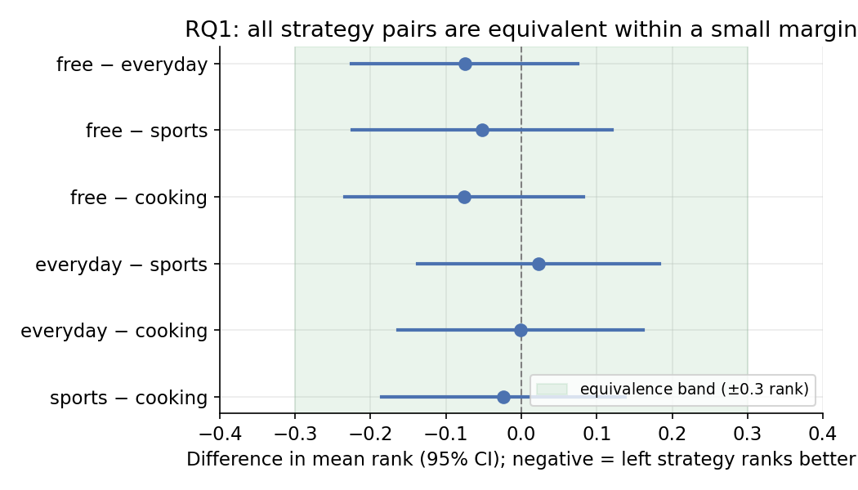
RQ1: pairwise differences in mean rank between strategies (points) with 95% confidence intervals ($n=64$ concepts). Every interval lies entirely within the $±0.3$-rank equivalence band (shaded), so the strategies are statistically equivalent, not merely non-significantly different.
The secondary absolute-scoring channel agrees that there is no real effect, but it is instructive about how small models score. Ranked by mean overall usefulness on the 1–5 rubric, the order is likewise flat and not significant (everyday 4.08, free 4.02, sports 4.01, cooking 3.96; Friedman $χ^{2}=3.67$, $p=0.30$). The two channels do trend toward different orderings, though: ranking mildly favours the concise “free” strategy while absolute scoring mildly favours the wordier “everyday” one. The reconciliation is a verbosity bias in absolute scoring: analogy length correlates positively with the absolute score (Spearman $0.15$, $p<{10}^{−11}$), and the “free” analogies are the shortest on average (63 words, versus 72–74 for the constrained strategies), so brevity is rewarded head-to-head but penalised when scoring one analogy in isolation. Comparative ranking is the more trustworthy channel precisely because it is not fooled by length; either way, RQ1’s answer is the same: no source-domain constraint gives a reliable quality advantage over letting the model choose.
By subject, no ordering is stable across both evaluation channels and both dataset sizes, with the partial exception that the unconstrained strategy is consistently among the best for Physics (rank 2.42). Subject “winners” otherwise shift between the two protocols and between the 32- and 64-concept datasets (Table 1), which is exactly what one expects when the underlying differences are noise. Generator identity mattered as little as strategy: the three open generators produced analogies of similar judged quality, so the findings are not an artefact of one model’s style.
RQ1: mean rank of each generation strategy (1 = best of four), overall and by subject, pooled over judges and generators. Lower is better; the best strategy in each row is in bold.
 | free | everyday | sports | cooking
Overall | 2.45 | 2.53 | 2.50 | 2.52
Physics | 2.42 | 2.43 | 2.47 | 2.67
Chemistry | 2.40 | 2.62 | 2.56 | 2.42
Mathematics | 2.50 | 2.51 | 2.43 | 2.56
Biology | 2.47 | 2.57 | 2.53 | 2.44
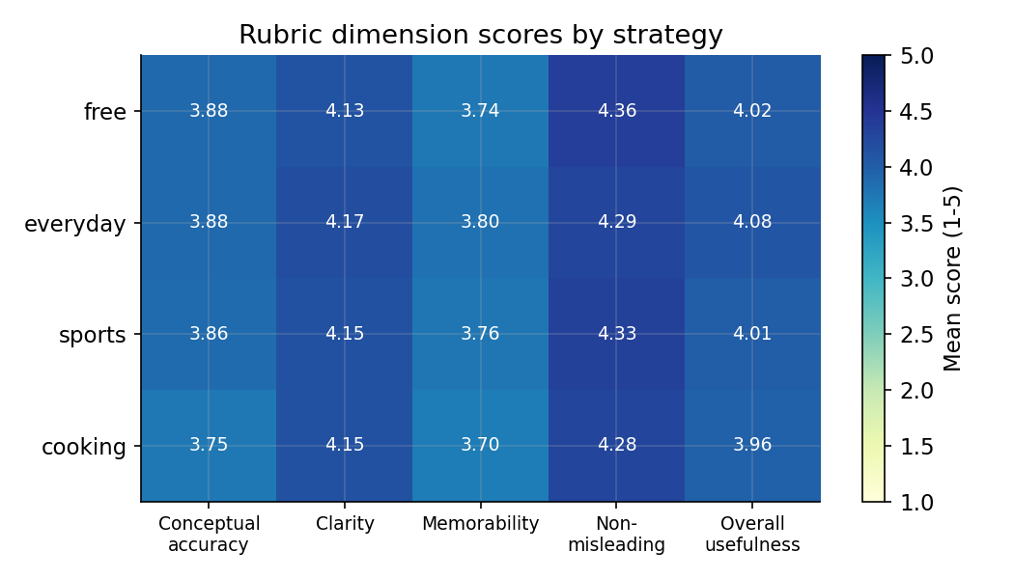
Mean absolute rubric scores (1–5) by strategy and dimension, pooled over judges, generators, and concepts. Scores cluster high (3.7–4.4) across every strategy and dimension; this leniency, together with the length effect, makes absolute scoring an unreliable discriminator of near-equal analogies.

5.3 How well do the judges agree?
The two evaluation channels tell one consistent story about when the panel is reliable. Inter-judge agreement on the main comparison is very low (mean pairwise Spearman correlation of 0.032 across judge-pairs and items for the rankings, and Krippendorff’s $α$ between $−0.19$ and $0.12$ across the five rubric dimensions, 0.007 for overall usefulness, for the absolute scores), even though the very same judges agreed almost perfectly on the probe. The reconciliation is that agreement is bounded by the true quality variance among the items being compared. The four strategies produce analogies of similar quality, so there is little real signal for judges to agree on, whereas the probe’s planted-wrong analogies create a large signal every judge detects. Near-zero agreement among small automated judges would be unremarkable on its own [10]; the informative part is the contrast with the same judges’ unanimous agreement on the probe, which shows the low coefficient reflects the items’ narrow quality spread rather than broken judges. An agreement coefficient reported without this context would be actively misleading, which is why we pair it with the probe. Practically, the panel should be used to screen out bad analogies, not to finely rank good ones.
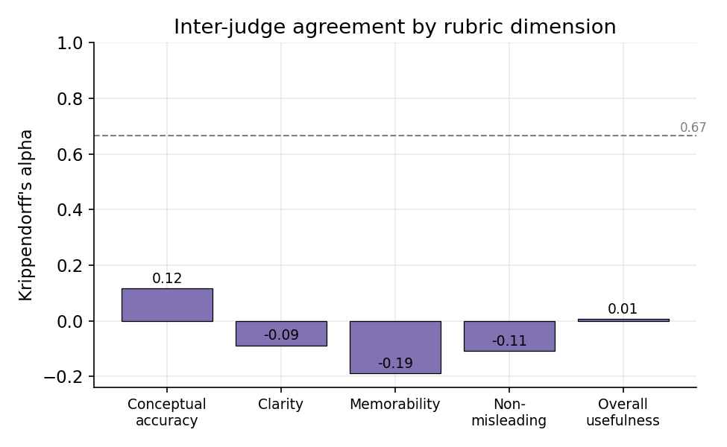
Inter-judge agreement (Krippendorff’s $α$) on absolute rubric scores is near zero or negative for every dimension, far below the 0.67 rule-of-thumb (dashed), even though the same judges agree unanimously on the planted-quality probe. Agreement is bounded by the true quality variance among the items compared.

5.4 What do the automated judges reward? (RQ2)
We read this predictor strictly as an audit of the judges: whatever predicts the judged score is what the panel rewards, and, because the target is a judge score rather than a human rating, a high $R^{2}$ diagnoses the evaluator rather than validating the analogies. An analogy’s mean judged usefulness turns out to be highly predictable from cheap surface features: a random-forest regressor attains a five-fold cross-validated $R^{2}$ of 0.72 (mean absolute error 0.13 on the 1–5 scale, $n=1556$ analogies with judgements). What it predicts from is the revealing part. The dominant features are all measures of length and lexical complexity (word count, proportion of long words, mean word length, readability, and words per sentence), followed by grade level and subject, while the generation strategy contributes almost nothing (Figure 4). The automated quality score is therefore largely a function of how long and lexically dense an analogy is, and of its subject, rather than of the pedagogical strategy that produced it. This is the same verbosity bias that reconciles the two RQ1 channels (Section 5.2), now shown to be large enough to make quality “predictable” while being substantively about surface form. Verbosity and leniency biases in automated judges are themselves well documented [10]; the audit does not rediscover them so much as show that, for the automated evaluation of instructional analogies, they grow strong enough to dominate the quality signal, that they are worst in the small models one can run locally, and (Section 5.7) that they recede once the judge is larger. The lesson is a caution, not a capability: a predictor this accurate is tracking the judges’ biases as much as the analogies’ merit, and any deployment that optimises analogies against such a score would be optimising partly for length.
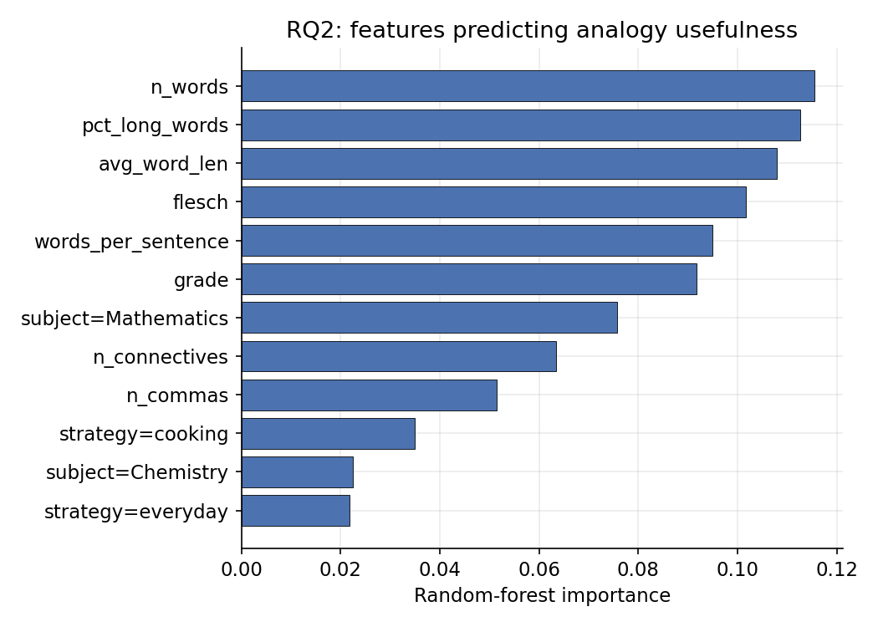
RQ2: random-forest feature importances for predicting an analogy’s mean absolute usefulness ($R^{2}=0.72$, five-fold CV). Surface length/complexity and subject dominate; the generation strategy contributes little.

5.5 Do analogies help a student model? (RQ3)
It helps to be precise about what this test measures before reading anything into the numbers. Holding the concept and its questions fixed, we ask whether prepending a teaching text changes a model’s objective multiple-choice accuracy. That is a test of whether the text carries information the model can use to answer, not a model of how a person learns; a claim about human learning would need human learners, which is outside the scope of this fully automated study (Section 7). Read in those narrower terms the measure still earns its place: if an added analogy supplies no usable information beyond a plain explanation, that is at least a weak mark against it, and it lines up with the quality findings above. The comprehension study first establishes that the measure can detect a teaching effect at all, and then finds that analogies are not where that effect comes from. Baseline accuracy (question only, no teaching text) rises steeply with student capability (51.6% for Qwen2.5-0.5B, 63.3% for Llama3.2-1B, and 92–94% for the 2–3B models), so only the smaller students have room to improve (Figure 5). Supplying the standard explanation raises the weakest students sharply ($+15.6$ points for the 0.5B model and $+10.9$ for the 1B model) while leaving the near-ceiling larger models essentially unchanged: a clean headroom pattern that confirms the paradigm works. Adding an analogy on top of that explanation, however, produces no reliable improvement for any student. The analogy-minus-standard gain is $+1.8$, $−0.4$, $+1.6$, and $−0.4$ points across the four models from weakest to strongest, all within noise, and no prompting strategy stands out within the analogy conditions. The comprehension benefit our method can detect therefore comes from the explanation, not from the analogy layered on top of it. This dovetails with RQ1 (the analogies are not strongly differentiated in quality) and with the human-subjects finding that LLM analogies help learners chiefly after a teacher curates them [8]: raw, automatically generated analogies do not, on their own, move a proxy learner’s comprehension beyond a plain explanation.
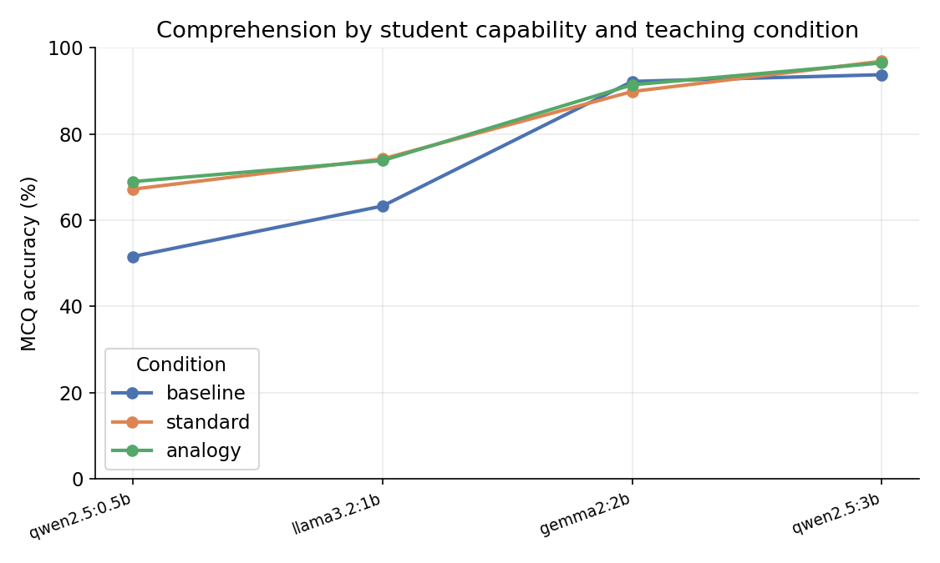
RQ3: multiple-choice accuracy by student model (increasing capability, left to right) and teaching condition. A standard explanation (orange) lifts the weak students well above baseline (blue), but adding an analogy (green) tracks the explanation almost exactly at every capability level, and all conditions converge at the ceiling for the 2–3B students.

5.6 Does it replicate in Hindi? (RQ4)
Repeating the pipeline in Hindi separates a finding that seems to carry across languages from tooling that plainly does not. The substantive result is at least consistent across languages: over the 20 paired concepts the four strategies are again statistically indistinguishable (Friedman $χ^{2}=1.95$, $p=0.58$). We read this as suggestive rather than a firm replication, and the rest of the section is why: the Hindi panel parses and discriminates so poorly that a small strategy effect, had one been present, could easily have been lost in the noise rather than truly absent. The result we can state without reservation is the negative one about the tooling, which degrades sharply (Table 2). First, the panel’s output stops being well-formed: only 55% of Hindi ranking prompts and 35% of Hindi rubric-scoring prompts return parseable output, against 94% and 97% in English, because the small models frequently lapse into commentary, mix scripts, or abandon the requested format in Hindi. Second, and more seriously, the judges largely lose the ability to tell good analogies from bad: on the Hindi validation probe the planted-wrong analogy is ranked below the correct one only 58% of the time, barely above the 50% chance level, versus 100% in English, and the clean good $<$ decent $<$ vague $<$ wrong ordering collapses. Inter-judge agreement is no better than in English (Spearman $−0.18$), and the verbosity bias does not clearly reappear, though that last comparison rests on the thin 35% of Hindi scores that parsed at all.
The reading is cautionary and, we think, useful. At this model scale the automated screening protocol is largely an English capability: the claim it establishes for English, that source-domain constraints do not help, appears to hold in Hindi too, though with the caveat just noted that a panel this degraded could as easily be masking a small effect, and in any case the panel that establishes it can no longer be trusted to screen Hindi analogies. Deploying such a pipeline for Hindi, and by extension for other mid- and low-resource languages, would need either stronger multilingual models or a human in the loop. Reporting this breakdown honestly is more useful to a practitioner than a figure showing that the protocol nominally “ran” in Hindi.
Cross-lingual comparison (RQ4). The no-strategy-effect finding appears to hold in Hindi, but the automated evaluation degrades sharply: output stops parsing and the judges stop discriminating quality, so the apparent replication is read cautiously. Hindi covers a paired 20-concept subset.
 | English | Hindi
Ranking output parseable | 94% | 55%
Rubric output parseable | 97% | 35%
Strategy effect (Friedman $p$) | 0.72 | 0.58
Probe: wrong ranked below good | 100% | 58%
Inter-judge agreement (Spearman) | 0.03 | $−0.18$​
Length–score correlation (verbosity) | $+0.15$​ | $−0.09$​

5.7 Does it hold with a larger judge?
Because every panel model is small (0.5–3.8B parameters), we re-ran the full evaluation with a larger judge, qwen2.5-7B (roughly twice the panel’s size), over all 64 concepts (192 rankings, 768 absolute scores) and the probe. Two findings replicate and two are sharpened, and the sharpening runs in the direction of the small panel being the limitation rather than the result. Replicating: the larger judge screens the planted-wrong probe analogies perfectly (100%) and produces cleaner output (100% parse, versus the panel’s 97%). Sharpened: first, the verbosity bias essentially vanishes (the length–score correlation falls from $+0.15$ to $−0.02$), and with it the disagreement between the two evaluation channels; the 7B judge rates the concise “free” strategy highest in both ranking and absolute scoring, so the channel divergence we saw with small judges was itself a symptom of their length bias. Second, and more consequentially, the larger judge resolves a modest strategy ordering the small panel could not: it ranks free best and cooking worst, and a Friedman test is now significant ($χ^{2}=22.3$, $p=0.0001$, $n=64$). The direction matches the small panel’s non-significant trend (free best in the ranking channel), so the reading is not that source domain suddenly matters, but that a cleaner judge detects a small real advantage for unconstrained generation that a lenient small panel washes out into apparent equivalence. Frontier-scale judges remain untested (we use no paid API), but the trajectory is consistent: better judges screen as well, shed the verbosity bias, and mildly favour letting the model choose its own analogy, exactly the practical guidance of Section 5.2 (Table 3). The picture is symmetric on the generation side: when the larger 7B model instead writes the analogies, the small panel still finds no strategy effect among them (Friedman $p=0.40$, free best), and the same length pattern holds (free is the most concise, at 52 words). So neither the no-effect finding nor the length confound is an artefact of using small generators either.
The findings under a larger judge: the small panel (0.5–3.8B) versus a single 7B judge over the full 64 concepts. The larger judge screens as well, but it sheds the small-model verbosity bias, agrees across its two channels, and resolves a strategy effect the panel cannot.
 | Small panel | 7B judge
Probe: wrong analogy caught | 100% | 100%
Output parseable | 97% | 100%
Strategy effect (Friedman $p$) | 0.72 | $<0.001$​
Verbosity (length–score $r$) | $+0.15$​ | $−0.02$​
Best strategy (ranking / absolute) | free / everyday | free / free

6 Discussion
Prompting: let the model choose the domain. The clearest practical message from RQ1 is a negative one, and negative results are useful here precisely because the intuition they overturn is so common. Constraining the analogy’s source domain does not reliably produce better analogies than simply asking for the best analogy the model can think of. The evidence for “no reliable effect” is unusually direct: neither evaluation protocol finds a significant strategy effect (Friedman $p=0.72$ for ranking and $p=0.30$ for absolute scoring, at $n=64$ concepts), and the mild orderings they do produce point in opposite directions (comparative ranking favours the concise unconstrained “free” strategy, absolute rubric scoring the wordier “everyday” one), a divergence we trace to a verbosity bias in the small judges rather than to any genuine quality gap (Sections 5.2 and 5.4). Under the small panel the four strategies are statistically equivalent within a small margin. A larger, cleaner judge (Section 5.7) refines rather than overturns this: it sheds the length bias, its two channels agree, and it resolves a modest but significant advantage for the unconstrained strategy. Both readings point the same way: what survives is that leaving the domain unconstrained is at least as good as any constraint, and by the better judge mildly the best, while producing shorter analogies, so the practical guidance is to let a capable model pick the source domain by default and to reach for a specific domain only where the subject makes a mapping obviously natural (as for Physics, the one subject in which “free” wins under both protocols). This fits the structure-mapping view that what matters is whether the base’s relational structure maps onto the target, not which corner of everyday life it is drawn from [5].
Automated evaluation screens well but ranks poorly. The single most important methodological finding is the gap between two things people routinely conflate when they report “LLM-judge agreement.” On our validation probe, where one analogy in each set is deliberately wrong, every judge places the wrong analogy below the correct one essentially always, and the panel’s tier ordering is exactly right. On the main comparison, where four reasonable strategies produce analogies of genuinely similar quality, inter-judge agreement collapses toward zero. Both facts are true of the same judges at the same time; the difference is entirely in how much real quality variance there is to detect. The lesson is that a panel of small models is trustworthy as a screen, for catching analogies that are actually wrong or misleading, but should not be over-interpreted as a fine-grained ranker of near-equal candidates, and that a bare agreement coefficient is meaningless without stating the quality spread of the items it was computed over. This is why we report the probe alongside the agreement statistics rather than either one alone.
Comprehension gains live where the learner has headroom. Tying quality to a behavioural outcome exposes a third pattern: whether added explanation or analogy helps at all depends on the “student.” A capable model already answers our conceptual questions correctly without any teaching text and therefore cannot show a gain, whereas smaller models have the headroom for teaching material to matter (Section 5.5). In our data the standard explanation raised the weakest model’s accuracy by roughly sixteen points while leaving the ceilinged models flat, yet adding an analogy on top of the explanation produced no reliable gain for any model, so even the comprehension effect we can detect is attributable to the explanation rather than to the analogy. The methodological implication generalises beyond our setting: using an over-competent model as a proxy learner will systematically understate the value of any instructional intervention, and studies that use LLMs as stand-in students should report the proxy’s baseline competence for exactly this reason.
A reusable, honest protocol. Taken together, the pieces form a template that others can run on commodity hardware: fix the concept content, vary only the generation prompt, rank rather than absolutely score, shuffle to defeat position bias, exclude self-judgements, and, above all, validate the judges against planted known-quality items before trusting any number they produce. None of these steps requires a paid API or a human rater, which makes the protocol cheap enough to use as a first-pass filter in an actual content pipeline, with humans reserved for the close calls the automated panel cannot resolve.
Implications for educational practice and technology. For the different stakeholders in education, the results translate into concrete guidance. For a teacher or content author the message is permissive: a capable model’s own choice of analogy domain is, on average, as good as a hand-specified one, so effort is better spent curating and checking a few candidates than engineering elaborate “use a sports analogy” prompts. For an educational-technology team building an analogy feature, a panel of small open models is a usable and essentially free quality gate: it reliably filters out wrong and misleading analogies before they reach a learner, and its cost profile (no paid API, one commodity GPU) makes it deployable at scale, provided it is treated as a screen and validated against known-quality anchors rather than trusted as a fine-grained ranker. For an institution or regulator vetting automatically generated material, the study offers both a reusable rubric and a candid map of where automated evaluation is trustworthy (catching clear errors) and where it is not (splitting hairs among already-good analogies, or working outside English). And for learners in mid-resource languages, the Hindi result is a caution: the same automated safeguards that protect English content do not yet transfer, so human oversight remains essential wherever the tooling is weakest.

7 Limitations and threats to validity
Several limitations bound our claims, and we state them plainly because the paper’s value depends on being honest about what automated evaluation can and cannot do. Each is numbered so that Section 8 can pair it, one to one, with a corresponding avenue of future research.
L1. Proxies for people. The judges and the “students” are language models standing in for human teachers and learners, and this is the paper’s central scope limitation: absent human ratings, our quality and comprehension numbers are automated proxy measurements. Two of the four measurements are, deliberately, not one model judging another. The judge-validation probe scores each panel against planted analogies of known, author-fixed quality (including analogies that are objectively wrong), so it measures discrimination against ground truth; and the comprehension study (RQ3) scores multiple-choice answers objectively against fixed keys. The learner is still a model, however, so RQ3 is best read as measuring whether a teaching text carries information a model can use, and it bears on human learning only indirectly. These objective anchors let us state the paper’s firmest claims without resting them on one model rating another; the remaining subjective judgements (the rubric panel) are reported throughout with their agreement caveats.
L2. Small-model judging. Our judges are 2–3.8B-parameter models chosen to run on a 4 GB GPU. They are lenient, they disagree on near-equal items, and, before we shuffled labels and switched to ranking, some defaulted to presentation order rather than reading the analogies. We mitigate these behaviours and validate against a probe, and our larger-judge check (Section 5.7) bears this out in part: at 7B the screening and no-effect findings replicate and the verbosity bias weakens. Frontier-scale judges remain untested, so some quantitative details (the exact agreement levels and the size of the verbosity bias) may be specific to this model scale.
L3. Scope of the dataset. We study 64 concepts across four subjects at grades 8–12, with a 16-concept multiple-choice subset. This is enough to detect subject-level patterns but is far from full curriculum coverage, and the concepts, explanations, and questions were authored by a single researcher, which may embed idiosyncratic choices. The parts that serve as ground truth, however, are objective: the multiple-choice keys are verifiable curriculum facts and the probe’s planted-wrong analogies contain clear, checkable errors.
L4. Cross-lingual scope. The Hindi replication covers a single language, 20 concepts, and a code-mixed register, and the low Hindi parse rates mean that some Hindi metrics (notably the absolute-scoring comparisons, computed on the 35% of outputs that parsed) rest on limited data. It establishes that the automated protocol degrades sharply outside English, but not precisely how it would behave for other languages or scripts, and the apparent replication of the no-effect finding in Hindi is therefore best read as exploratory.
L5. Generator/judge overlap and self-preference. Three of the four panel models also serve as generators. We exclude every model from judging its own analogies, which removes direct self-preference, but shared training lineages could still induce subtler family-level preferences that our design does not fully rule out.
L6. Rubric validation. SAQR is grounded in the learning-sciences literature and is behaviourally validated only indirectly (through the discrimination probe and the comprehension study). A formal validation against expert human ratings, and a test of its dimensions’ independence, are not attempted here.

8 Avenues of Future Research
We map each limitation above to a concrete next step, one to one, so that the research agenda follows directly from the boundaries of the present study.
FR1 (addresses L1). Conduct a human validation study: have expert teachers rate a sample of the generated analogies and have students take the comprehension test, then calibrate the automated proxy measurements against those human judgements. This is the single most important step for turning the protocol’s proxy screen into evidence about human learning, and for an educational-technology team it is the study that would justify placing automated screening in front of real learners.
FR2 (addresses L2). Repeat the protocol with progressively larger and frontier judges to establish how inter-judge agreement, discrimination, and the verbosity bias scale with judge size, and so to locate the reliability ceiling. For a product team this quantifies the cost-reliability trade-off between a free small-model screen and a paid larger judge.
FR3 (addresses L3). Expand to full-curriculum coverage authored by multiple subject-matter experts, enabling per-topic and cross-author analyses and reducing single-author idiosyncrasy. This is what a curriculum body or textbook publisher would need before treating the protocol as a system-wide quality gate.
FR4 (addresses L4). Extend the cross-lingual study to more languages and scripts, with improved parsers or lightly instruction-tuned judges to raise parse rates, and map precisely where the protocol holds and where it fails. This directly targets the equity gap the Hindi arm surfaced.
FR5 (addresses L5). Use judge models drawn from disjoint training lineages, or held-out judges that never serve as generators, to rule out family-level preferences and further harden the panel against self-preference.
FR6 (addresses L6). Formally validate SAQR against expert human ratings and test the statistical independence of its five dimensions, yielding a rubric that other researchers and edtech teams can adopt with calibrated confidence.

9 Conclusion
We set out to answer two coupled questions about instructional analogies in the age of language models: how to prompt for good ones, and how to judge them at scale, using only a protocol cheap and reproducible enough to run on a single consumer GPU with no paid API and no human annotation. The prompting answer is deflationary but useful: constraining the analogy’s source domain does not reliably beat letting a capable model choose for itself, and domain constraints help only where the subject makes a particular mapping natural. The evaluation answer is more consequential. A panel of small open models is a valid screen: it detects wrong and misleading analogies almost perfectly, as our planted-quality probe shows, but it is not a reliable fine-grained ranker of analogies that are already good, and its inter-judge agreement is meaningful only when read against the quality spread of the items being compared. Coupled with the finding that an over-competent model masks comprehension gains that only appear once the learner has headroom, the overall message is that automated evaluation of instructional content is genuinely usable, but only when it is validated against known-quality anchors and its limits are stated rather than hidden. Scaling the judge is the clearest lever for reliability: our larger-model check sheds the small models’ verbosity bias and resolves quality differences the small panel cannot. A Hindi replication draws that boundary sharply: the no-effect finding holds across languages, but the automated panel that establishes it parses and discriminates reliably only in English at this model scale, so the protocol is, for now, an English-first tool. We release the concept dataset, the SAQR rubric, all prompts, code, and raw model outputs so that the protocol, and its honest accounting of what it can and cannot measure, can be reused and stress-tested.

References
10
Bhavya Bhavya, Jinjun Xiong, and ChengXiang Zhai. Analogy generation by prompting large language models: A case study of InstructGPT. In Proceedings of the 15th International Conference on Natural Language Generation (INLG), 2022.
John Clement. Using bridging analogies and anchoring intuitions to deal with students’ preconceptions in physics. Journal of Research in Science Teaching, 30 (10): 1241–1257, 1993.
Zoubeida R. Dagher. Review of studies on the effectiveness of instructional analogies in science education. Science Education, 79 (3): 295–312, 1995.
Reinders Duit. On the role of analogies and metaphors in learning science. Science Education, 75 (6): 649–672, 1991.
Dedre Gentner. Structure-mapping: A theoretical framework for analogy. Cognitive Science, 7 (2): 155–170, 1983.
Cheng Jiayang, Lin Qiu, Tsz Ho Chan, Tianqing Fang, Weiqi Wang, Chunkit Chan, Dongyu Ru, Qipeng Guo, Hongming Zhang, Yangqiu Song, Yue Zhang, and Zheng Zhang. : Deriving story-level analogies from large language models to unlock analogical understanding. In Proceedings of the 2023 Conference on Empirical Methods in Natural Language Processing (EMNLP), 2023.
Enkelejda Kasneci, Kathrin Seßler, Stefan Küchemann, Maria Bannert, Daryna Dementieva, Frank Fischer, Urs Gasser, Georg Groh, Stephan Günnemann, Eyke Hüllermeier, et al. for good? on opportunities and challenges of large language models for education. Learning and Individual Differences, 103, 2023.
Zekai Shao, Siyu Yuan, Lin Gao, Yixuan He, Deqing Yang, and Siming Chen. Unlocking scientific concepts: How effective are LLM-generated analogies for student understanding and classroom practice? In Proceedings of the 2025 CHI Conference on Human Factors in Computing Systems (CHI), 2025.
Xiao Ye, Andrew Wang, Jacob Choi, Yining Lu, Shreya Sharma, Lingfeng Shen, Vijay Tiyyala, Nicholas Andrews, and Daniel Khashabi. : Benchmarking the identification of abstract and long-context analogies. In Proceedings of the 2024 Conference on Empirical Methods in Natural Language Processing (EMNLP), 2024.
Lianmin Zheng, Wei-Lin Chiang, Ying Sheng, Siyuan Zhuang, Zhanghao Wu, Yonghao Zhuang, Zi Lin, Zhuohan Li, Dacheng Li, Eric P. Xing, Hao Zhang, Joseph E. Gonzalez, and Ion Stoica. Judging LLM-as-a-judge with MT-Bench and chatbot arena. In Advances in Neural Information Processing Systems (NeurIPS), 2023.

Supplementary material
The following appendices (the full SAQR rubric, the concept dataset, the prompt templates, and worked example analogies and judgments) are provided as supplementary material. They document and support the study but are not essential to the main argument, and can be moved to an online supplement in line with the target journal’s policy.

Appendix A. The SAQR rubric in full
Each dimension is scored from 1 to 5 (1 = absent/poor, 2 = weak, 3 = adequate, 4 = good, 5 = excellent). Use the full range; reserve 5 for genuinely excellent cases and give low scores where the analogy is weak.
Conceptual accuracy (conceptual_accuracy ). Does the analogy map correctly onto the target concept, so that the important relationships in the concept correspond to matching relationships in the analogy? 1: The analogy is wrong or maps to the wrong idea; following it would teach an incorrect concept. 3: The analogy captures the main relationship correctly, with minor gaps. 5: The analogy maps the key relationships of the concept faithfully and precisely.
Clarity (clarity ). Would a school student find the analogy easy to follow, and does it actually make the concept easier to grasp than the bare explanation? 1: Confusing or harder to follow than the concept itself. 3: Clear and does help understanding. 5: Immediately clear and noticeably illuminates the concept.
Memorability (memorability ). Is the analogy vivid, concrete, and relatable enough that a student is likely to remember it and, through it, the concept? 1: Bland or abstract; nothing to hold onto. 3: Concrete and reasonably sticky. 5: Vivid, concrete, and highly memorable.
Absence of misleading simplification (non_misleading ). Does the analogy avoid introducing misconceptions? A good analogy either does not break down in a harmful way, or its limits are not likely to mislead a student. 1: Introduces a clear misconception a student would plausibly carry away. 3: Mostly safe; minor over-simplification unlikely to mislead. 5: No misleading simplification; the analogy breaks down only in ways a student would not over-extend.
Overall usefulness (overall_usefulness ). All things considered, how useful is this analogy for teaching this concept to a school student? 1: Not useful; better to omit it. 3: Useful; a fair teacher would include it. 5: Highly useful; a strong teaching aid.

Appendix B. Concept dataset
The 32 concepts, balanced across four subjects and grades 8–12. Concepts marked $⋆$ carry the four-option multiple-choice items used in the comprehension study.
ID | Subject | Grade | Concept
bio_osmosis | Biology | 9 | Osmosis across a semipermeable membrane $⋆$
bio_enzyme | Biology | 10 | Enzymes as biological catalysts $⋆$
bio_photosynthesis | Biology | 10 | Photosynthesis
bio_homeostasis | Biology | 11 | Homeostasis and negative feedback $⋆$
bio_mitosis | Biology | 11 | Mitosis (cell division)
bio_neuron | Biology | 11 | Nerve impulse and the action potential
bio_dna_replication | Biology | 12 | DNA replication
bio_natural_selection | Biology | 12 | Natural selection $⋆$
che_mole | Chemistry | 9 | The mole as a counting unit $⋆$
che_covalent_bond | Chemistry | 10 | Covalent bonding
che_exothermic | Chemistry | 10 | Exothermic and endothermic reactions
che_ph | Chemistry | 10 | The pH scale for acids and bases $⋆$
che_catalyst | Chemistry | 11 | Catalysts and activation energy $⋆$
che_equilibrium | Chemistry | 11 | Dynamic chemical equilibrium $⋆$
che_ideal_gas | Chemistry | 11 | The ideal gas law
che_redox | Chemistry | 11 | Oxidation and reduction (redox)
mat_slope | Mathematics | 9 | Slope of a straight line $⋆$
mat_probability | Mathematics | 10 | Basic probability of independent events $⋆$
mat_derivative | Mathematics | 11 | The derivative as an instantaneous rate of change $⋆$
mat_function | Mathematics | 11 | Functions, domain and range
mat_logarithm | Mathematics | 11 | Logarithms
mat_vectors | Mathematics | 11 | Vectors as magnitude and direction
mat_integral | Mathematics | 12 | The definite integral as accumulated area $⋆$
mat_matrix | Mathematics | 12 | Matrices and matrix multiplication
phy_pressure | Physics | 8 | Pressure as force per unit area
phy_newton3 | Physics | 9 | Newton’s third law of motion $⋆$
phy_ohm | Physics | 10 | Ohm’s law and electrical resistance $⋆$
phy_refraction | Physics | 10 | Refraction of light
phy_gravitation | Physics | 11 | Newton’s law of universal gravitation
phy_momentum | Physics | 11 | Momentum and its conservation
phy_resonance | Physics | 11 | Resonance in oscillating systems $⋆$
phy_induction | Physics | 12 | Electromagnetic induction (Faraday’s law) $⋆$

Appendix C. Prompts
Analogy generation (system). You are an expert STEM teacher. You explain a concept with ONE vivid analogy that a school student (Class 8 to 12) can understand. The analogy must be scientifically faithful: the important relationships in the concept must correspond to matching relationships in the analogy. Do not teach a misconception for the sake of simplicity. Generation strategy instructions.
- free: Use the single best analogy you can think of, from any source domain.
- everyday: Use an analogy drawn from ordinary everyday life (the home, daily routines, common objects).
- sports: Use an analogy drawn from sports, games, or physical play.
- cooking: Use an analogy drawn from cooking, baking, or the kitchen.
Comparative ranking (system). You are an experienced STEM teacher comparing teaching analogies. You will see several analogies for the SAME concept, each labelled with a letter. Rank them from best to worst as teaching aids for a school student (Class 8 to 12), judging conceptual accuracy, clarity, and whether they mislead. Output ONLY lines of the form ’LETTER: rank’, one per analogy, where 1 is best. Use each rank exactly once. No commentary. Absolute rubric scoring (system). You are an experienced STEM teacher evaluating a teaching analogy on a fixed rubric. Score each dimension from 1 to 5 as a whole number, using the full range: 1 is poor, 3 is adequate, 5 is excellent. Do not give every dimension the same high score; discriminate. Output ONLY lines of the form ’dimension_key: score’, one per dimension, no commentary.

Appendix D. Example analogies and judgments
Judge validation (a probe item). For the Ohm’s-law probe, the panel’s mean ranks (1 = best of four) were good 1.33, decent 2.00, and the vague and wrong analogies tied at 3.33; every judge placed the wrong analogy below the correct one. (Aggregated over all five probe concepts the ordering is strict: 1.79 / 1.95 / 2.63 / 3.63.) The four planted analogies were:
“Voltage is like the water pressure in a pipe, current is the rate at which water flows, and resistance is how narrow the pipe is: for a fixed pressure, a narrower pipe lets less water flow, so the current is smaller.”
“A circuit is like people walking down a corridor. Voltage is how hard they are pushed from behind and resistance is how narrow the corridor is.”
“Electricity is a bit like a river: it just flows along from one place to another.”
“Resistance is like adding an extra battery to the circuit. The more resistance you add, the harder it pushes the charges, so a higher resistance always makes a larger current flow.” (This inverts Ohm’s law.)
Generated analogies and the two channels. For the same concept, the analogies Qwen2.5-3B generated show the absolute-versus-ranking disagreement in miniature. The concise free analogy, “Resistance is like a dam in a river system; more resistance means water (current) slows down and flows less even if pressure (voltage) remains constant”, drew the highest absolute usefulness (4.67/5) yet a worst-tied mean rank (2.67), whereas the wordier everyday “traffic jam” analogy scored lower in isolation (4.33) but ranked best (2.33). Brevity is rewarded head-to-head and penalised when scoring one analogy at a time: the verbosity bias of Section 5.4 in a single example.

