**Abstract**

**Table of Contents**

**List of Figures**

**Chapter**

1. **Preamble**
   1. **Introduction**
   2. **Problem Statement**
2. **System Design**
3. **SRS**
4. **Implementation / Methodology**
5. **Software Testing**
6. **Code**
7. **Snapshots**
8. **Conclusion**
9. **References**

**Abstract**

Research shows that people with visual impairments are 31% less likely to access the internet than individuals without disabilities. This paper illustrates the implementation of software that provides assistance to the visually impaired for accessing the internet.

The software shall prove instrumental in the way we access the internet and will increase the ease of use drastically. Although technology has grown leaps and bounds, the internet - especially websites are still inaccessible by the visually impaired.

The software provides a way to interact with these websites with much ease. With the use of voice commands instead of the traditional keyboard and mouse, our software provides a new dimension to access and provide commands to any website.

The software will read out the content of the website and then using speech to text and text to speech modules along with selenium, our software can automate any website. The user is free from remembering complex braille keyboard commands or the hassle of typing, he/she can simply voice out his/her command and the software will execute it. The system also has the functionality of providing a summary of the content on the website and answering questions asked by the user.

**List of Figures**

**Chapter**

1. **Preamble**
   1. **Introduction**

In today’s era almost all tasks are digitalized. We have Smartphone in hands and it is nothing less than having world at your finger tips. These days we aren’t even using fingers. We just speak of the task and it is done. There exist systems where we can say Text Dad, “I’ll be late today.” And the text is sent. That is the task of a Virtual Assistant. It also supports specialized task such as booking a flight, or finding cheapest book online from various ecommerce sites and then providing an interface to book an order are helping automate search, discovery and online order operations.

Virtual Assistants are software programs that help you ease your day to day tasks, such as showing weather report, creating reminders, making shopping lists etc. They can take commands via text (online chat bots) or by voice. Voice based intelligent assistants need an invoking word or wake word to activate the listener, followed by the command. For my project the wake word is Google Assistant. We have so many virtual assistants, such as Apple’s Siri, Amazon’s Alexa and Microsoft’s Cortana. For this project, wake word was chosen Google Assistant.

Voice searches have dominated over text search. Web searches conducted via mobile devices have only just overtaken those carried out using a computer and the analysts are already predicting that 50% of searches will be via voice by 2020.Virtual assistants are turning out to be smarter than ever. Allow your intelligent assistant to make email work for you. Detect intent, pick out important information, automate processes, and deliver personalized responses.

This project was started on the premise that there is sufficient amount of openly available data and information on the web that can be utilized to build a virtual assistant that has access to making intelligent decisions for routine user activities

**b. Problem Statement**

Usually, user needs to manually manage multiple sets of applications to complete one task. For example, a user trying to make a travel plan needs to check for airport codes for nearby airports and then check travel sites for tickets between combinations of airports to reach the destination. There is need of a system that can manage tasks effortlessly.

We already have multiple virtual assistants. But we hardly use it. There are number of people who have issues in voice recognition. These systems can understand English phrases but they fail to recognize in our accent. Our way of pronunciation is way distinct from theirs. Also, they are easy to use on mobile devices than desktop systems. There is need of a virtual assistant that can understand English in Indian accent and work on desktop system.

When a virtual assistant is not able to answer questions accurately, it’s because it lacks the proper context or doesn’t understand the intent of the question. Its ability to answer questions relevantly only happens with rigorous optimization, involving both humans and machine learning. They require large amount of information to be fed in order for it to work efficiently.

Virtual assistant should be able to model complex task dependencies and use these models to recommend optimized plans for the user. It needs to be tested for finding optimum paths when a task has multiple sub-tasks and each sub-task can have its own sub-tasks. In such a case there can be multiple solutions to paths, and the it should be able to consider user preferences, other active tasks, priorities in order to recommend a particular plan.

1. **System Design**
2. **SRS**

**3.1 Functional Requirements:**

Hardware Requirements

* Intel Processor 3 or Higher
* Min 20GB HDD
* RAM 4 GB or Higher
* 2.4 GHz or faster Processor

Software Requirements:

* Windows Vista onwards, Linux, Mac OS
* In the case of building the Project from the source
  + Python Compiler
  + Tensorflow Machine learning library
  + Keras
  + SciKit Learn
  + Pandas
  + Numpy
  + Flask

**3.2 Non Functional Requirements:**

Performance Requirements:

* The formats of the scanned copies should be in the standard format
* Should have a training error of as low as possible

Software Quality Attributes

* Robustness
* Reliability
* Better learning methods
* Acquiring good accuracy results.

1. **Implementation / Methodology**

**Data collection**

The user first interacts with the main menu of the software once the Mobile has been switched on. The main menu of the software can be invoked by either the integrated voice assistant, for example Google, or by a predefined keyboard shortcut, being the only keyboard interaction required.

The main menu interface provides the available options to the user viz. Installed website modules, pace of the audio, accent of the audio. Each of the website modules contains a speech-to-text and text-to-speech bundle, a Java and kotlin script that automates the website and the features specific to the website.

For efficient speech recognition, the user is provided with a beep at all stages after which he is free to speak. The input received and recognized by the system from the user is also played back to the user so that the user can confirm his intended input, to reduce any errors right at that particular stage, thus, enabling a sense of editing. The methodology followed to implement three modules – Message inbox, Phone manager, Battery Status, Weather Assistant, Currency Recognition, Object detection and Current Date & Time - and the main menu is described below.

**1.Message Inbox:** When a person clicks on message box model, he/she gets prompt message saying “you clicked on message”, once he/she long clicks on message box he/she can send message through voice assistance by saying his/her number.

**2.Phone Manager:** When a person clicks on phone manager model, he/she gets prompt message saying “you clicked on phone manager”, once he/she long clicks on phone manager he/she can call through voice assistance by saying his/her number.

**3.Battery Status:** When a person clicks on Battery Status model, he/she gets prompt message saying “you clicked on Battery Status”, once he/she long clicks on Battery Model he/she gets the status of battery.

**4.Weather Assistant:** When a person clicks on Weather Assistant model, he/she gets prompt message saying “you clicked on Weather Assistant”, once he/she says the city name he/she gets the weather details of the city.

**5.Currency Recognition:** When a person clicks on Currency Recognition model, he/she gets prompt message saying “you clicked on Currency Detection”, the app detects any Indian Currency shown through the camera.

**6.Object Detection:** When a person clicks on Object Detection model, he/she gets prompt message saying “you clicked on Object Detection”, the app detects any Objects shown through the camera.

**7.Current Date and Time:** When a person clicks on Date & Time model, he/she gets to know the Current Date and Time.

**Experimental Setup**

In this Experiment/Project we have used Android Studio as an App Development IDE.

**1.**We have make used of many Modules of Machine Learning such TensorFlow lite.

**2.**We have implemented both text to speech and speech to text modules making it easier for blind People.

**3.**We have implemented Machine Learning in Currency Detection enabling Camera access and using “TensorFlow Lite”. Different type of notes are trained officially, making the detection more accurate and fast.

**4.**We have also implemented a direct feed transfer from google to get the update of Weather details of any City in India.

**5.** We have implemented Machine Learning in Object Detection enabling Camera access and using “TensorFlow Lite”. Different type of Objects are trained officially, making the detection more accurate and fast.

**6.**While at backend, we have used Java and Kotlin as main languages which helps the app look better with more features, it boosts the app productivity and makes it easier to maintain and its user friendly.

1. **Software Testing**

• **Test Case 1**

**Test Title:** Response Time

**Test ID:** T1

**Test Priority:** High

**Test Objective:** To make sure that the system respond back time is efficient.

**Description:**

Time is very critical in a voice based system. As we are not typing inputs, we are speaking them. The system must also reply in a moment. User must get instant response of the query made.

**• Test Case 2**

**Test Title:** Accuracy

**Test ID:** T2

**Test Priority:**  High

**Test Objective:** To assure that answers retrieved by system are accurate as per gathered data.

**Description:**

A virtual assistant system is mainly used to get precise answers to any question asked. Getting answer in a moment is of no use if the answer is not correct. Accuracy is of utmost importance in a virtual assistant system

**• Test Case 3**

**Test Title:** Approximation

**Test ID:** T3

**Test priority:** Moderate

**Test Objective:** To check approximate answers.

**Description:**

There are times when mathematical calculation requires approximate value. For example, if someone asks for value of PI the system must respond with approximate value and not the accurate value. Getting exact value in such cases is undesirable.

**Note: There might include a few more test cases and these test cases are also subject to change with the final software development.**

1. **Code**

For the code of project follow the GitHub link given below:

[**https://github.com/rohit97433/bemyeyes**](https://github.com/rohit97433/bemyeyes)

**7.Snapshots**

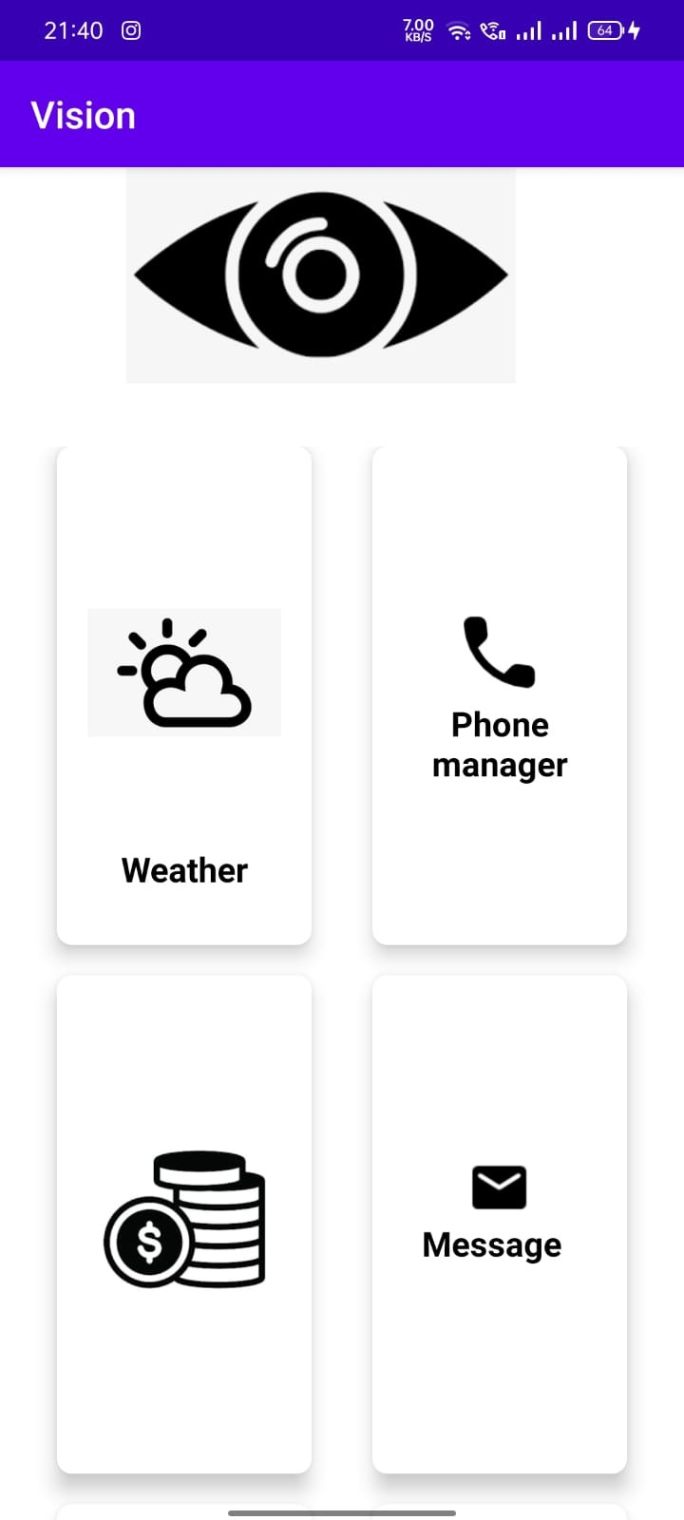 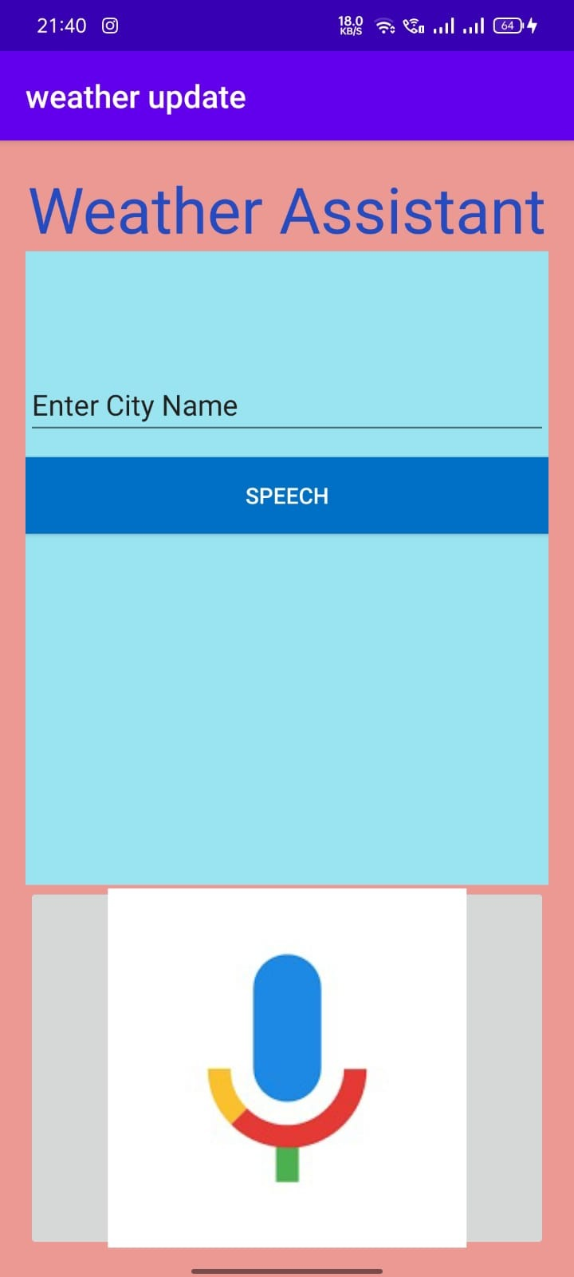

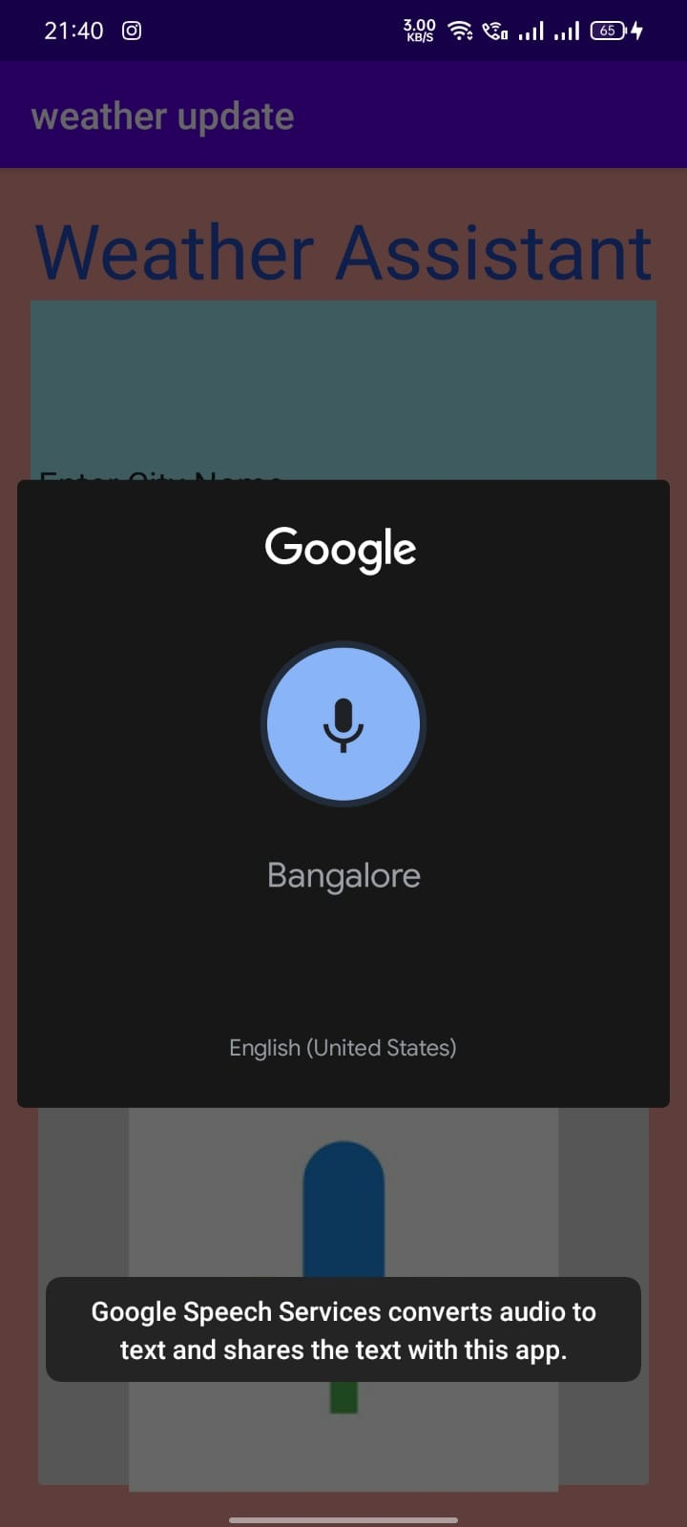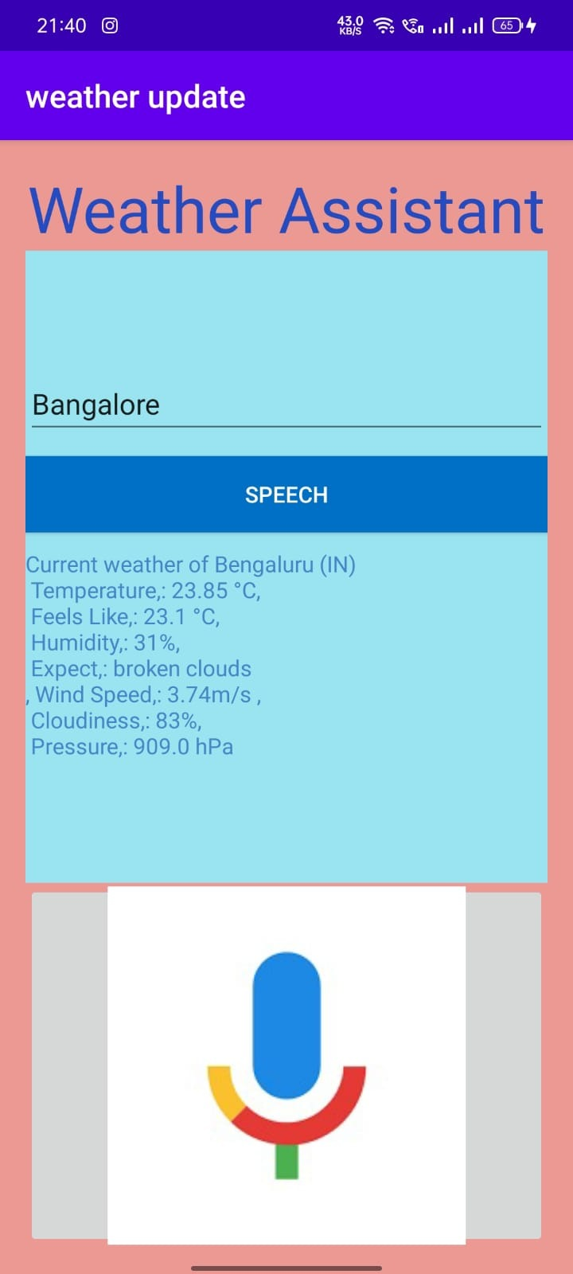

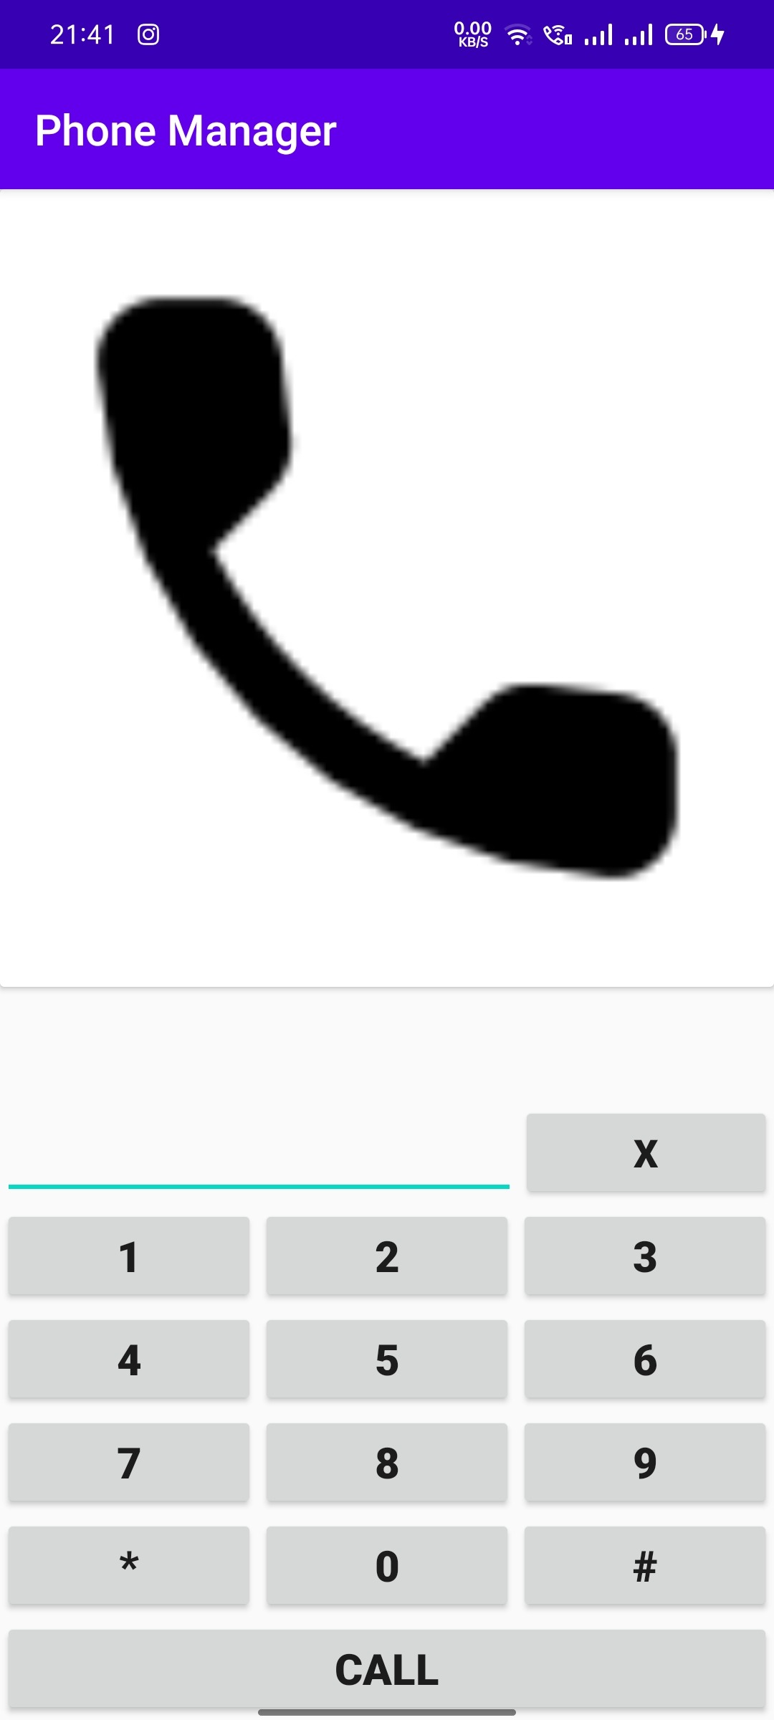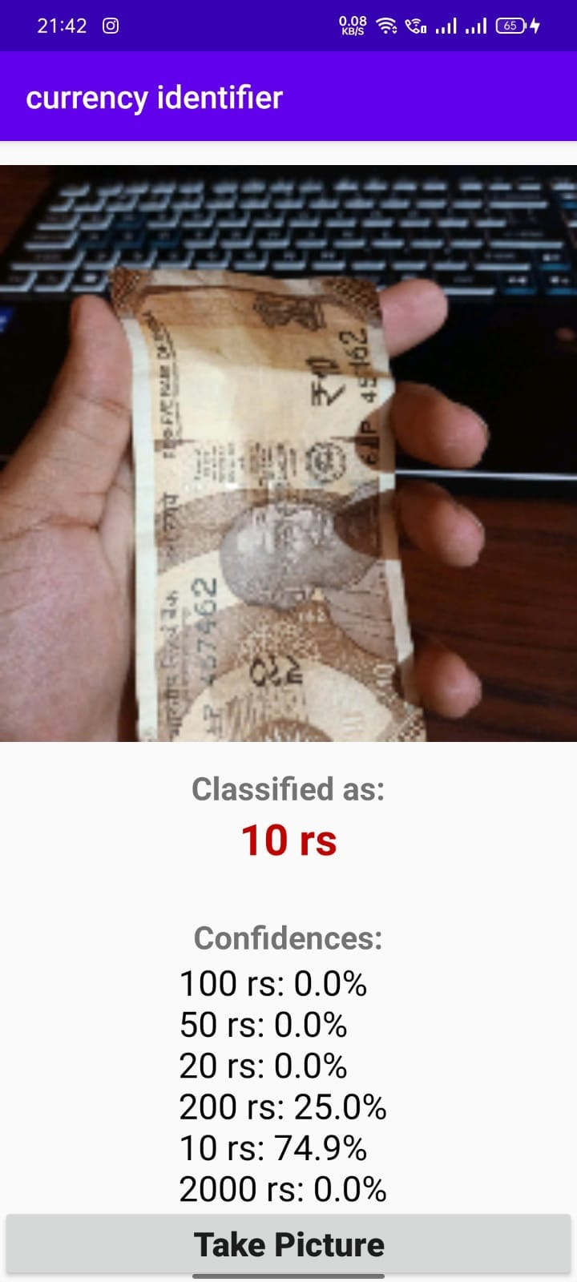

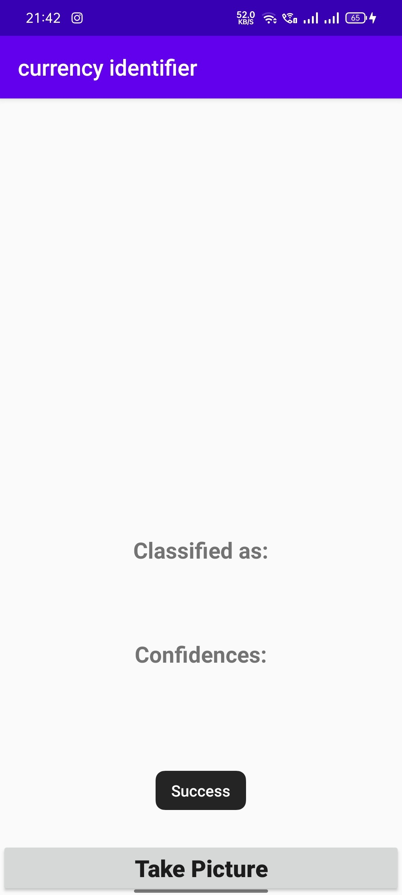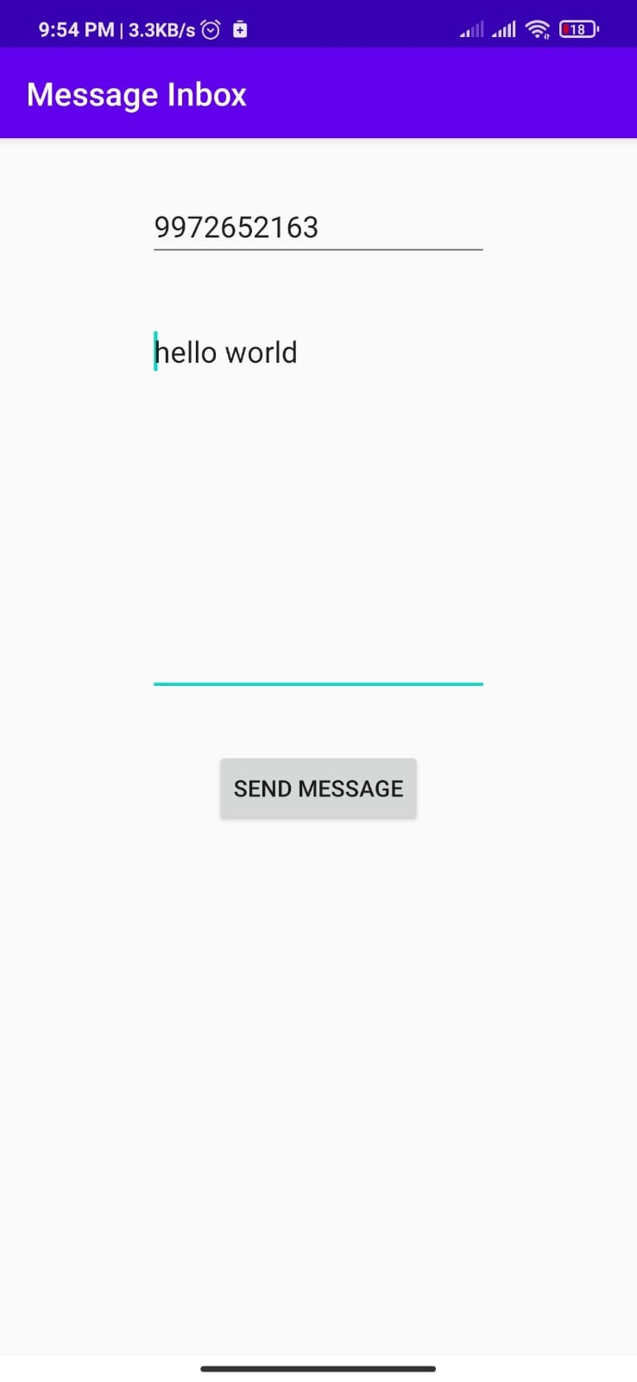

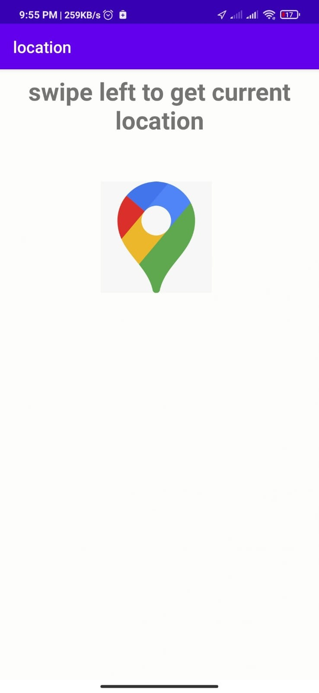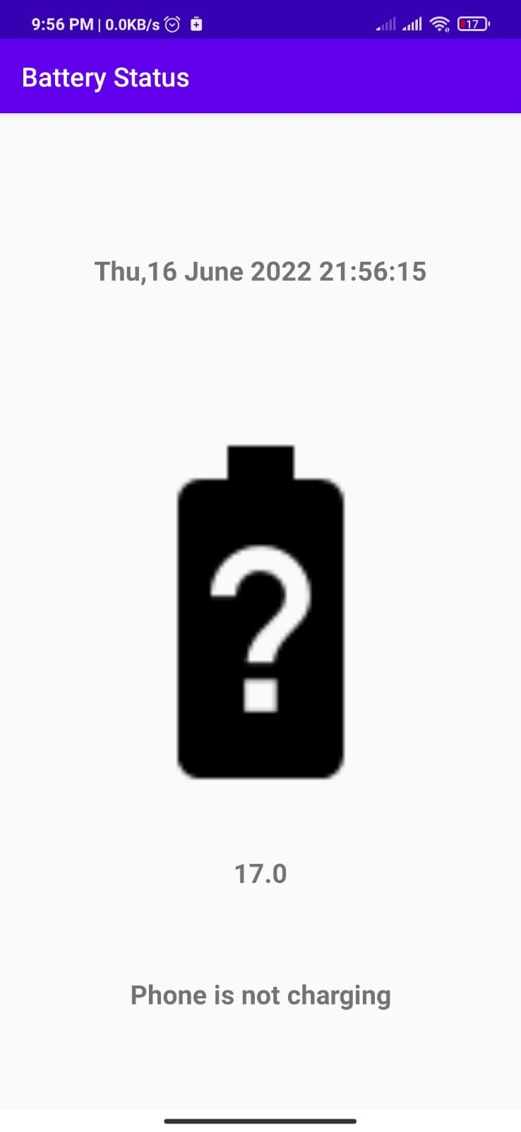

**8.Conclusion**

In this project, we presented a modular solution to improve web based accessibility for the visually impaired. The virtual assistant is operating system independent and does not rely on keyboard inputs from the user to maximize ease of use and aims to provide a hassle-free experience for the user. Through speech to text and text to speech interfaces, the user can communicate with and customize the system. We presented the system design and methodology of the five modules that is currently implemented.

The Exact Match was found to be 80.88%. The virtual assistant provides an easy way to access any website for the visually impaired. It eliminates the need to remember complex keyboard commands or the use of screen readers. The assistant is not only a great way to interact with the websites but also an effective way to do so.

**9.References**

• Websites referred

♣ [www.stackoverflow.com](http://www.stackoverflow.com)

♣ [www.pythonprogramming.net](http://www.pythonprogramming.net)

♣ [www.codecademy.com](http://www.codecademy.com)

♣ [www.tutorialspoint.com](http://www.tutorialspoint.com)

♣ [www.google.co.in](http://www.google.co.in)

• Books referred

♣ Java Programming -[Herbert Schildt](https://www.amazon.in/Herbert-Schildt/e/B001H6PSMG/ref=dp_byline_cont_book_1)

♣ Kotlin Programming-David Greenhalgh and Josh Skeen

• YouTube Channels referred

♣ Code with Harry

• Documents referred

♣ Designing Personal Assistant Software for Task Management using Semantic Web Technologies and Knowledge Databases

♣ Python code for Artificial Intelligence: Foundations of Computational Agents - David L. Poole and Alan K. Mackworth