**# Blockchain-Based Product Authentication**

This repository contains the smart contract and supporting files for a blockchain-based product authentication system. The project demonstrates how to register and verify product authenticity using the Ethereum Sepolia Testnet and Solidity smart contracts

**Repository Contents**

**- `ProductRegistry.sol`**: Smart contract that allows product registration and verification by product ID.

**- `register.png`**: Screenshot showing successful product registration.

**- `verify.png`**: Screenshot showing successful product verification.

**Smart Contract Functions**

- `registerProduct(string _id, string _name, string _manufacturer, string _metadata)`

Registers a new product if the product ID does not already exist.

- `getProduct(string _id)`

Retrieves product details for the given ID if it is registered.

**Sample Product (Used for Demo)**

- Product ID: `PRD124`

- Name: `iPhone 15`

- Manufacturer: `Apple`

- Metadata: `WARRANTY-QR-ABC123`

**Demo Screenshots**

**1.Deploy a contract**

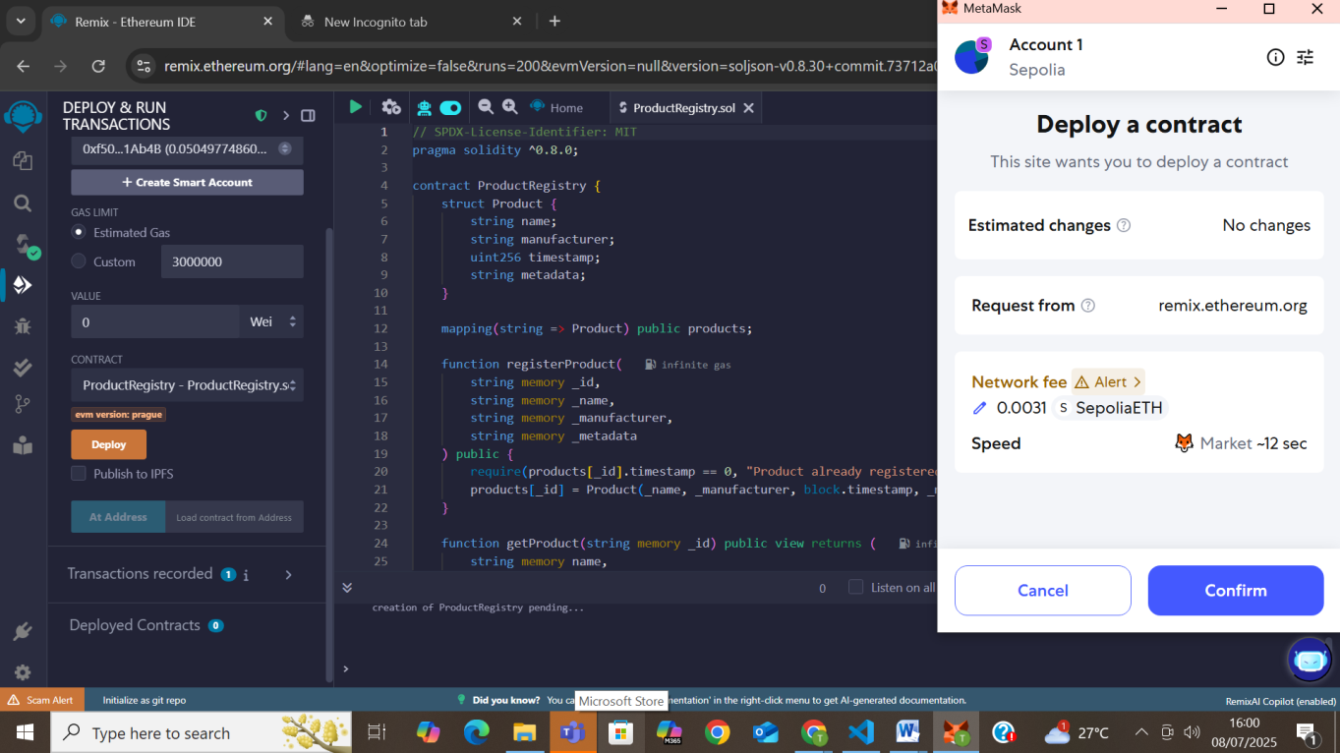

**2 Register a product**

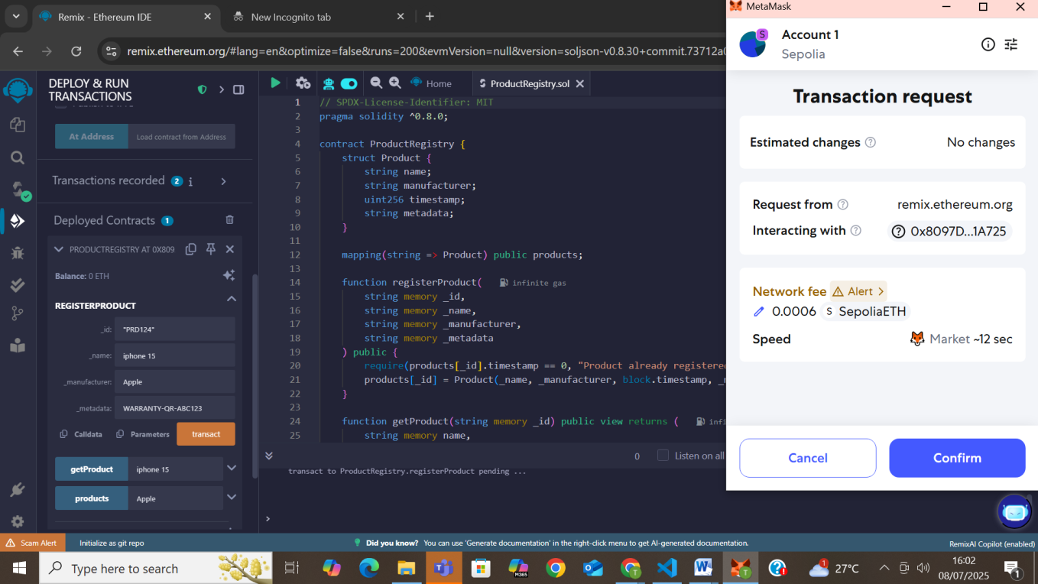

**3.Verify Product**

**Real Product**

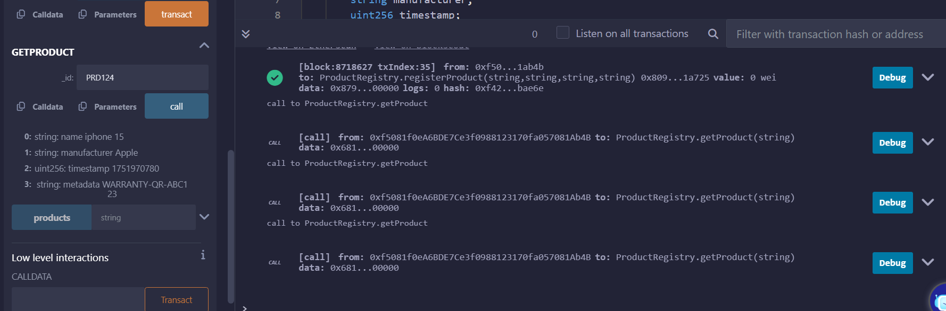

**Fake Product:**

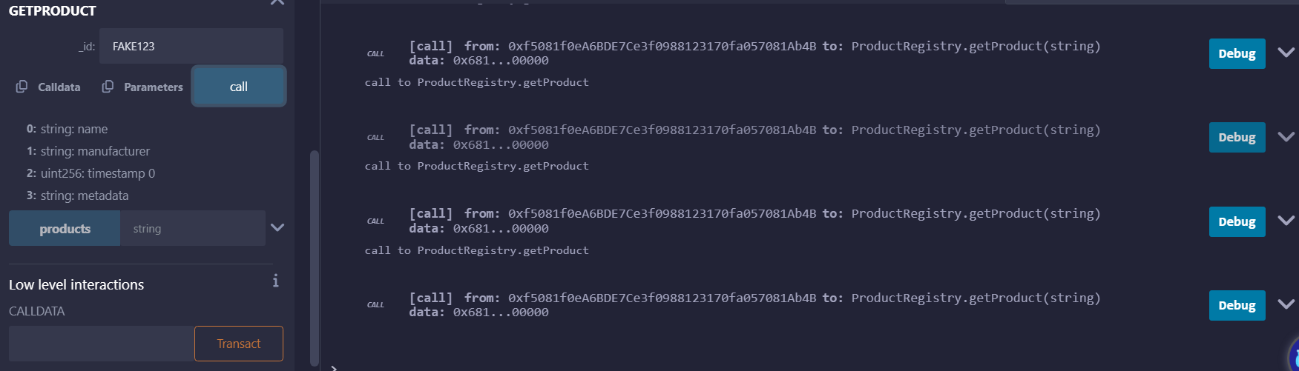

**Author**

**Tumma Srihita**

M.Sc. (AI & ML)

St. Francis College for Women