MediSlot design and implementation specification

- Architecture inventory
Layer | AWS resources
Web application | Amazon EC2 — Flask
API and authentication | API Gateway REST API, Authentication Lambda, Lambda Authorizer, SSM Parameter Store
Application logic | Generalized Application Lambda
Relational data | Amazon RDS for MySQL
Slot and temporary state | Amazon DynamoDB
Object storage | Amazon S3 — profile photos and assets; artifacts bucket for templates and Lambda packages
Event processing | EventBridge event bus, SQS notification queue, SQS DLQ
Scheduling | EventBridge Scheduler, Slot Materialiser Lambda
Workflow | AWS Step Functions — reschedule saga
Notifications | Notification Dispatcher Lambda, SNS application topic
Monitoring | CloudWatch Logs, metrics, dashboard and alarms; SNS alarm topic
Deployment | GitHub, GitHub Actions, CloudFormation
1.VPC LAYOUT
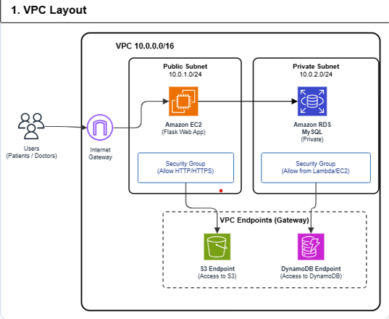
The MediSlot application runs inside an Amazon VPC with CIDR block 10.0.0.0/16, divided into public and private subnets.
- Public Subnet (10.0.1.0/24): Hosts the Amazon EC2 instance running the Flask web application. Users (patients and doctors) access the application through the Internet Gateway.
- Private Subnet (10.0.2.0/24): Hosts Amazon RDS for MySQL, which stores application data and is not directly accessible from the internet. Access is restricted through security group rules.
- Security Groups: Control network traffic. The EC2 security group allows the required web traffic (HTTP/HTTPS), while the RDS security group allows database connections only from authorized application resources.
- VPC Gateway Endpoints: The Amazon S3 and DynamoDB gateway endpoints enable resources in the VPC to access these services privately without requiring a NAT Gateway.
This layout separates the public-facing web application from the private database and supports controlled access to AWS storage services.
2. DATA FLOW DIAGRAMS
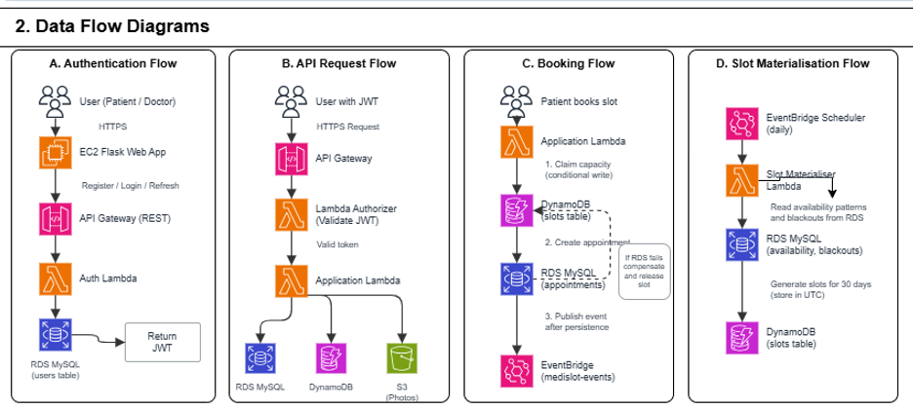
The MediSlot data flow is divided into four main processes: authentication, API request handling, appointment booking, and slot materialisation.
A. Authentication Flow
Users (patients or doctors) access the Flask web application hosted on Amazon EC2 through HTTPS. Registration, login and token refresh requests are routed through Amazon API Gateway to the Authentication Lambda. The Lambda interacts with the RDS MySQL users table to validate credentials and manage user authentication, then returns a JWT to the application.
B. API Request Flow
Authenticated users send HTTPS requests through the Flask web application to API Gateway. The Lambda Authorizer validates the JWT before allowing protected requests to reach the Application Lambda. The Application Lambda processes the request and accesses the appropriate data stores: RDS MySQL for relational data, DynamoDB for slot and temporary state, and Amazon S3 for profile photos.
C. Booking Flow
When a patient books an appointment, the Application Lambda attempts to reserve slot capacity in DynamoDB using a conditional write to prevent overbooking. It then creates the appointment record in RDS MySQL. After successful persistence, it publishes the booking event to the medislot-events EventBridge bus. If RDS persistence fails, the system must compensate by safely releasing the reserved slot after checking the transaction outcome.
D. Slot Materialisation Flow
EventBridge Scheduler triggers the Slot Materialiser Lambda daily. The Lambda reads doctors' availability patterns and blackout dates from RDS MySQL, generates appointment slots for the next 30 days, and stores them in DynamoDB in UTC. This prepares upcoming appointment slots for patients to view and book while avoiding duplicate slot creation during repeated executions.
3.EVENT TOPOLOGY
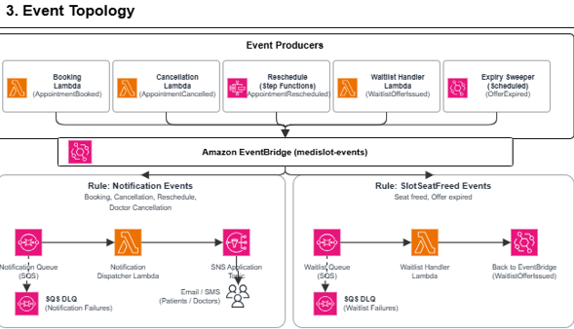
The MediSlot event topology uses Amazon EventBridge as the central event bus to route events generated by appointment booking, cancellation, rescheduling, waitlist management and hold-offer expiry. It separates notification processing from waitlist processing so that each workflow can operate independently.
A. Event Producers
The following components publish events to the medislot-events EventBridge bus:
- Booking Lambda: Publishes AppointmentBooked when an appointment is successfully booked.
- Cancellation Lambda: Publishes AppointmentCancelled when an appointment is cancelled.
- Reschedule Step Functions: Publishes AppointmentRescheduled after a reschedule completes successfully.
- Waitlist Handler Lambda: Publishes WaitlistOfferIssued when a waitlist offer is created.
- Expiry Sweeper: Publishes OfferExpired when a waitlist hold expires.
Events should be published only after the corresponding state changes have been persisted successfully.
B. Notification Events Flow:EventBridge routes booking, cancellation and rescheduling events to the Notification Queue (Amazon SQS) using notification rules.
- The Notification Dispatcher Lambda consumes messages from the queue.
- It processes the event and publishes the appropriate notification to the SNS Application Topic.
- SNS distributes notifications to the configured patient and doctor subscribers through the supported delivery channels.
- If message processing repeatedly fails, the message is moved to the SQS Dead-Letter Queue (DLQ) for investigation and recovery.
This flow keeps notification processing separate from the main appointment request, allowing transient failures to be retried without repeating the booking or cancellation.
C. Waitlist and Freed-Slot Flow:EventBridge routes SlotSeatFreed and OfferExpired events to the Waitlist Queue (Amazon SQS).
- The Waitlist Handler Lambda consumes the message and identifies the next eligible patient in the waitlist.
- It creates an exclusive hold offer for the available seat, with a 15-minute expiry.
- If the patient accepts the offer in time, the booking workflow confirms the appointment.
- If the offer expires, the Expiry Sweeper publishes an expiry event, and the next eligible patient can be offered the seat.
- If waitlist processing repeatedly fails, the message moves to the Waitlist SQS DLQ for investigation and recovery.

4.CI/CD Pipeline — Description
The MediSlot CI/CD pipeline automates code validation, testing, and deployment using GitHub Actions, Amazon S3, and AWS CloudFormation.
1. Developer — Feature Branch: Developers implement changes in separate feature branches.
2. Pull Request: GitHub Actions runs linting, unit tests, security scans, and CloudFormation validation.
3. Review and Approval: At least one reviewer must approve the pull request, and all required checks must pass.
4. Merge to Master: Approved changes are merged into master, triggering the deployment workflow.
5. Package: GitHub Actions packages Lambda code and CloudFormation templates.
6. Upload to S3: Deployment artifacts are uploaded to the private S3 artifacts bucket.
7. Deploy: CloudFormation Change Sets deploy the infrastructure using AWS OIDC-based access.
8. Verify: Integration tests, API smoke tests, and four mandatory booking tests are executed.
9. Deployment Complete: Successful deployments are verified through CloudWatch Logs, metrics and alarms.
RDS TABLES AND E-R DIAGRAM
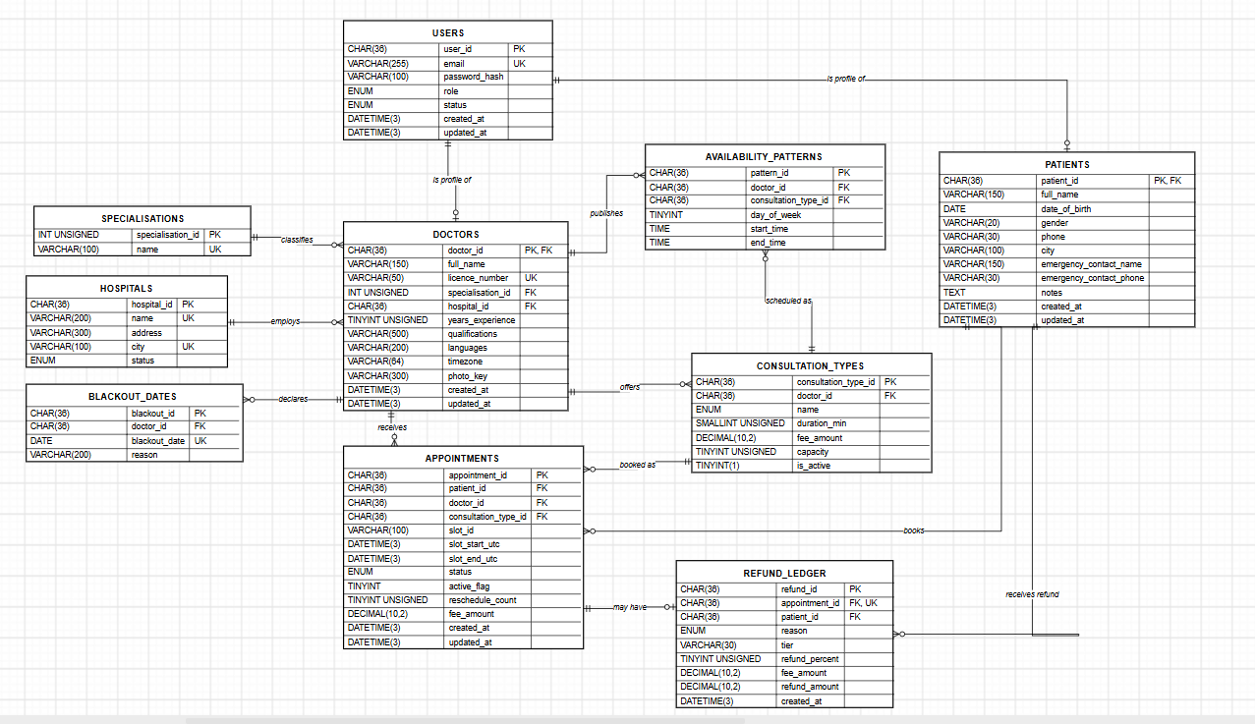
1. Relationships
users 1–1 doctors or patients; hospitals 1–N doctors; specialisations 1–N doctors; doctors 1–N ; consultation_types; doctors 1–N availability_patterns; doctors 1–N blackout_dates; patients 1–N appointments; doctors 1–N appointments; consultation_types 1–N appointments; appointments 1–0..1 refund_ledger

2.users

Column | Type | Constraints
user_id | CHAR(36) | PK
email | VARCHAR(255) | NOT NULL, UNIQUE
password_hash | VARCHAR(100) | NOT NULL, bcrypt hash
role | ENUM('doctor','patient') | NOT NULL
status | ENUM('ACTIVE','INACTIVE','SUSPENDED') | NOT NULL, default ACTIVE
created_at, updated_at | DATETIME(3) | NOT NULL, UTC
The unique email constraint applies across both user roles.
3. specialisations and hospitals
Table | Columns | Constraints
specialisations | specialisation_id INT UNSIGNED, name VARCHAR(100) | PK; UNIQUE(name)
hospitals | hospital_id CHAR(36), name VARCHAR(200), address VARCHAR(300), city VARCHAR(100), status VARCHAR/ENUM | PK; INDEX(city); UNIQUE(name, city)
status on hospitals can be an ENUM('ACTIVE','INACTIVE') to prevent inactive hospitals appearing in search results.
4. doctors
Column | Type | Constraints
doctor_id | CHAR(36) | PK, FK → users.user_id
full_name | VARCHAR(150) | NOT NULL
licence_number | VARCHAR(50) | NOT NULL, UNIQUE
specialisation_id | INT UNSIGNED | FK → specialisations.specialisation_id
hospital_id | CHAR(36) | FK → hospitals.hospital_id
years_experience | TINYINT UNSIGNED | Optional
qualifications | VARCHAR(500) | Optional
languages | VARCHAR(200) | Optional; comma-separated
timezone | VARCHAR(64) | NOT NULL; IANA timezone, e.g. Asia/Kolkata
photo_key | VARCHAR(300) | Nullable; S3 object key
created_at, updated_at | DATETIME(3) | UTC
5. patients
Column | Type | Constraints
patient_id | CHAR(36) | PK, FK → users.user_id
full_name | VARCHAR(150) | NOT NULL
date_of_birth | DATE | Optional
gender | VARCHAR(20) | Optional
phone | VARCHAR(30) | Optional
city | VARCHAR(100) | Optional
emergency_contact_name | VARCHAR(150) | Optional
emergency_contact_phone | VARCHAR(30) | Optional
notes | TEXT | Optional; limited free text
created_at, updated_at | DATETIME(3) | UTC

6. consultation_types
Column | Type | Constraints
consultation_type_id | CHAR(36) | PK
doctor_id | CHAR(36) | FK → doctors.doctor_id, NOT NULL
name | ENUM('QUICK','STANDARD','DETAILED','HEALTH_CAMP') | NOT NULL
duration_min | SMALLINT UNSIGNED | NOT NULL; 15, 30 or 60
fee_amount | DECIMAL(10,2) | NOT NULL, ≥ 0
capacity | TINYINT UNSIGNED | NOT NULL; 1 normally, 2–10 for HEALTH_CAMP
is_active | TINYINT(1) | NOT NULL; soft-delete flag

7. availability_patterns and blackout_dates
Table | Columns | Constraints
availability_patterns | pattern_id CHAR(36), doctor_id CHAR(36), consultation_type_id CHAR(36), day_of_week TINYINT, start_time TIME, end_time TIME | PK; FKs to doctors and consultation types; INDEX(doctor_id, day_of_week); CHECK start_time < end_time
blackout_dates | blackout_id CHAR(36), doctor_id CHAR(36), blackout_date DATE, reason VARCHAR(200) | PK; FK to doctors; UNIQUE(doctor_id, blackout_date)

8. appointments — System of Record
Column | Type | Constraints
appointment_id | CHAR(36) | PK
patient_id | CHAR(36) | FK → patients.patient_id, NOT NULL
doctor_id | CHAR(36) | FK → doctors.doctor_id, NOT NULL
consultation_type_id | CHAR(36) | FK → consultation_types.consultation_type_id, NOT NULL
slot_id | VARCHAR(100) | NOT NULL; DynamoDB slot key
slot_start_utc, slot_end_utc | DATETIME(3) | NOT NULL, UTC
status | ENUM(...) | NOT NULL
active_flag | TINYINT | Nullable; 1 while confirmed, NULL otherwise
reschedule_count | TINYINT UNSIGNED | NOT NULL, default 0; maximum 2
fee_amount | DECIMAL(10,2) | NOT NULL; fee snapshot at booking
created_at, updated_at | DATETIME(3) | UTC
Proposed status values:
CONFIRMED, COMPLETED, CANCELLED_BY_PATIENT, CANCELLED_BY_DOCTOR, NO_SHOW
Constraints and indexes
- UNIQUE(patient_id, slot_id, active_flag) — prevents duplicate active bookings for the same patient and slot, provided inactive rows use NULL.
- INDEX(patient_id, slot_start_utc)
- INDEX(doctor_id, slot_start_utc)
- INDEX(patient_id, doctor_id, status)
- INDEX(status, slot_end_utc)
The unique constraint does not prevent overbooking by different patients. DynamoDB conditional writes enforce slot capacity.
9. refund_ledger
Column | Type | Constraints
refund_id | CHAR(36) | PK
appointment_id | CHAR(36) | FK → appointments.appointment_id, UNIQUE
patient_id | CHAR(36) | FK → patients.patient_id, NOT NULL
reason | ENUM('PATIENT_CANCEL','DOCTOR_CANCEL','NO_SHOW') | NOT NULL
tier | VARCHAR(30) | Refund tier applied
refund_percent | TINYINT UNSIGNED | 0–100
fee_amount | DECIMAL(10,2) | NOT NULL
refund_amount | DECIMAL(10,2) | NOT NULL
created_at | DATETIME(3) | UTC
The unique appointment_id constraint allows at most one refund record per appointment.
10. Indexes and the queries they serve
Index | Query served
doctors(specialisation_id, hospital_id) | Search by specialisation, optionally narrowed by hospital
hospitals(city) | Search hospitals by city
doctors(full_name) | Doctor name prefix search, such as LIKE 'abc%'
appointments(patient_id, slot_start_utc) | Patient's upcoming and past appointments
appointments(doctor_id, slot_start_utc) | Doctor's schedule and date-range view
appointments(patient_id, doctor_id, status) | Check the maximum three upcoming appointments with the same doctor
appointments(status, slot_end_utc) | Find confirmed appointments eligible for no-show processing
refund_ledger(patient_id, created_at) | Patient refund history

DynamoDB Design (Proposed)
Six DynamoDB tables, each designed around the access patterns in the MediSlot architecture. Point-in-time recovery (PITR) is enabled on all six tables. TTL is used only for data cleanup; application logic handles booking, hold expiry, and token revocation because TTL deletion is not immediate.

1. Table design overview
Table | Partition key (PK) | Sort key (SK) | GSIs | TTL
MediSlotSlots | slotId | None | gsi-doctor-time: doctorId + startUtc | Optional, after slot end
MediSlotIdempotency | idemKey (userId#Idempotency-Key) | None | None | 24 hours
MediSlotWaitlists | slotId | W#joinedAt#patientId or P#patientId | gsi-patient: patientId + slotId | None
MediSlotHoldOffers | offerId | None | gsi-slot: slotId + expiresAt; gsi-patient: patientId + expiresAt; sparse gsi-active: activeBucket + expiresAt | After expiry
MediSlotAuthTokens | tokenId (R#hash or D#jti) | None | None | Token expiry
MediSlotNotificationDispatch | dispatchKey (appointmentId#eventOrInterval#recipient) | None | None | Configurable retention
2. Table attributes
2.1 MediSlotSlots
Stores materialised appointment slots and controls available capacity.
Attribute | Purpose
slotId | Deterministic ID: doctorId#consultationTypeId#startUtc
doctorId | Doctor identifier from RDS
consultationTypeId | Consultation type from RDS
startUtc, endUtc | Slot start and end in UTC
tz, localDate | Doctor's IANA timezone and local date
capacity | 1 for regular appointments; 2–10 for Health Camps
bookedCount | Number of confirmed seats
heldCount | Number of seats reserved by active waitlist offers
version | Incremented on every successful update
status | OPEN or CANCELLED
Capacity rule: A seat is available only when:
bookedCount + heldCount < capacity
Booking and hold operations use conditional UpdateItem writes to prevent overbooking. A version check can additionally prevent conflicting updates.
2.2 MediSlotIdempotency
Prevents duplicate bookings when a client retries the same request.
Attribute | Purpose
idemKey | Composite key: userId#Idempotency-Key
appointmentId | Resulting appointment ID
requestHash | Identifies the original request payload
status | Processing or completed state
createdAt | Request creation timestamp
expiresAt | TTL cleanup timestamp
Replaying the same key should return the original result, provided the request matches. Reusing a key with a different payload should be rejected.
2.3 MediSlotWaitlists
Maintains each slot's waiting queue and prevents the same patient from joining the same waitlist twice.
Attribute | Purpose
slotId | Appointment slot identifier
entry SK | W#joinedAt#patientId for queue entries
guard SK | P#patientId for duplicate-membership protection
patientId | Patient identifier
joinedAt | Queue-entry timestamp
status | WAITING, OFFERED, or REMOVED
The gsi-patient index uses patientId as the partition key and slotId as the sort key.
The entry and guard are created together using TransactWriteItems. The patient's five-waitlist limit must also be enforced by application logic with appropriate concurrency protection.
2.4 MediSlotHoldOffers
Tracks temporary, exclusive appointment offers for waitlisted patients.
Attribute | Purpose
offerId | Unique offer identifier
slotId | Slot being offered
patientId | Patient receiving the offer
createdAt | Offer creation time
expiresAt | End of the 15-minute hold
status | ACTIVE, ACCEPTED, EXPIRED, or CANCELLED
activeBucket | Present only while the offer is active
Indexes:
- gsi-slot: find offers for a particular slot.
- gsi-patient: find offers belonging to a patient.
- gsi-active: find active offers whose expiry time has passed.
The active index is sparse because activeBucket is removed when an offer is no longer active. The sweeper must still check the current offer status and expiry before changing state. TTL is only for eventual cleanup.
2.5 MediSlotAuthTokens
Supports refresh-token validation and access-token revocation.
Attribute | Purpose
tokenId | R#<SHA-256 refresh-token hash> or D#<JWT jti>
userId | Associated user
tokenType | REFRESH or DENYLIST
createdAt | Creation timestamp
expiresAt | Expiry/TTL timestamp
Raw refresh tokens are never stored. Refresh-token records expire after the refresh-token lifetime; denylist records expire when the corresponding access token can no longer be valid. Authentication logic checks revocation explicitly rather than relying on TTL deletion.
2.6 MediSlotNotificationDispatch
Tracks notification dispatches to prevent duplicate processing during retries.
Attribute | Purpose
dispatchKey | appointmentId#eventOrInterval#recipient
appointmentId | Related appointment
eventOrInterval | Event type or reminder interval, such as REMINDER_24H
recipient | Intended recipient identifier
status | PENDING, SENT, or FAILED
createdAt | Dispatch creation time
sentAt | Successful dispatch timestamp
expiresAt | Optional cleanup timestamp
A conditional write on dispatchKey prevents duplicate dispatch records. Use retry-safe state transitions so a crash between sending a notification and recording success can be recovered safely. SNS itself does not guarantee exactly-once delivery.
3. Access patterns
Access pattern | Table/index | Operation
Retrieve a slot for booking | MediSlotSlots | GetItem by slotId
Find a doctor's slots for a date range | MediSlotSlots, gsi-doctor-time | Query by doctorId and startUtc range
Claim or release a seat | MediSlotSlots | Conditional UpdateItem
Materialise a slot once | MediSlotSlots | Conditional PutItem
Replay an idempotent request | MediSlotIdempotency | GetItem by idemKey
Claim an idempotency key | MediSlotIdempotency | Conditional PutItem
Find the first waitlisted patient | MediSlotWaitlists | Query slotId, queue-entry sort-key prefix W#
Join a waitlist once | MediSlotWaitlists | Transactional entry and guard creation
Find a patient's waitlists | MediSlotWaitlists, gsi-patient | Query by patientId
Find offers for a slot | MediSlotHoldOffers, gsi-slot | Query by slotId
Find a patient's offers | MediSlotHoldOffers, gsi-patient | Query by patientId
Find expired active offers | MediSlotHoldOffers, gsi-active | Query bucket and expiresAt <= now
Validate refresh token or check revocation | MediSlotAuthTokens | GetItem by token hash or JWT jti
Claim a notification dispatch | MediSlotNotificationDispatch | Conditional PutItem by dispatchKey

Concurrency Strategy
Overbooking is prevented using an atomic conditional write on a single DynamoDB slot item. Conflicting requests retry a limited number of times. No distributed lock is required.
1. Contended resource
The MediSlotSlots item for the requested slotId.
Its capacity, bookedCount, and heldCount determine whether a seat is available.
A seat is available when:
bookedCount + heldCount < capacity
2. Booking write path
- Validate the slot and patient eligibility using RDS.
- Claim the Idempotency-Key in MediSlotIdempotency.
- Read the slot from MediSlotSlots.
- If the slot is full, return 409 Conflict.
- Atomically claim a seat using the conditional write below.
- Save the appointment in RDS and publish AppointmentBooked.
- Mark the idempotency record as COMPLETED.
3. Conditional write
Table: MediSlotSlots
Key: slotId
UpdateExpression:
SET bookedCount = bookedCount + :one,
version = version + :one
ConditionExpression:
version = :expectedVersion
AND status = :open
AND bookedCount + heldCount < capacity
The capacity condition prevents overbooking. The version condition detects concurrent updates.
4. Retries
- If the slot is full, return 409 Conflict.
- If the version changed but capacity remains, retry using the latest version.
- Use exponential backoff with jitter.
- Maximum attempts: 5, configurable through SSM Parameter Store.
- If retries are exhausted, return 503 Service Unavailable.
- Record conflicts in CloudWatch using BookingConflictRetries.
5. Failure handling
Failure | Handling
RDS appointment insert fails after seat claim | Reconcile the booking and release the seat if no appointment was committed.
Lambda fails during booking | Retry with the same idempotency key and recover the existing operation.
Event publication fails | Retry publishing through a durable recovery mechanism.
Two requests compete for the final seat | Only one can claim it successfully.
Rescheduling fails | Step Functions coordinates recovery and compensation.

6. Guarantees
The system guarantees | The system does not guarantee
Bookings never exceed slot capacity. | Strict first-come, first-served ordering.
Duplicate requests are handled using idempotency keys. | One atomic transaction across DynamoDB and RDS.
Held seats are protected from normal bookings. | Every request succeeds under heavy contention.
Failed operations can be recovered through retries and compensation. | Immediate TTL deletion or exactly-once SNS delivery.

- Step sequence
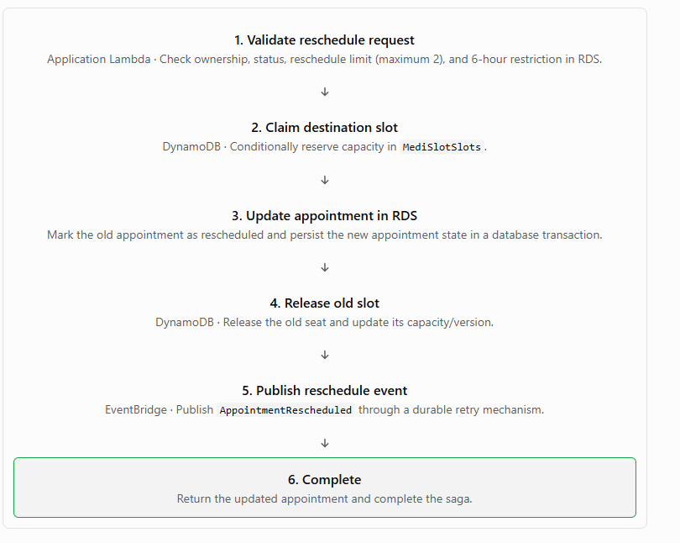
2. Failure points and compensating actions
Step / failure | Compensating action
Validation fails | Stop the saga. Do not modify either slot.
Destination slot is full | Return 409 Conflict. Keep the original appointment unchanged.
Destination slot is claimed, but the RDS update fails | Release the destination seat if the appointment transaction did not commit.
RDS update succeeds, but the workflow times out | Read RDS to determine the committed state. Resume the workflow instead of blindly undoing the update.
Old-slot release fails | Retry the release idempotently. Keep the workflow recoverable until capacity is reconciled.
EventBridge publication fails | Retry publishing using a durable outbox or equivalent recovery mechanism. Do not undo a committed reschedule solely because event publication failed.
3. Important rules
- Step Functions Standard orchestrates the saga and its retries.
- DynamoDB conditional writes prevent destination-slot overbooking.
- RDS transactions and conditional updates protect appointment state.
- Every step and compensation must be idempotent.
- Do not release the original seat until the new appointment state is safely committed.
- If a failure leaves the outcome uncertain, reconcile RDS and DynamoDB before compensating.
Success condition: The patient ends with exactly one valid active appointment, and both slot capacities reflect the final appointment state.
Event Catalogue
Six domain events are published to the custom Amazon EventBridge bus medislot-events. Each consumer has its own EventBridge rule, SQS queue, and dead-letter queue (DLQ).
1. Domain events
Event | Producer | Payload | Consumer
AppointmentBooked | Booking Lambda | appointmentId, patientId, doctorId, slotId, startUtc, endUtc, consultationTypeId | Notification consumer
AppointmentRescheduled | Reschedule saga | appointmentId, patientId, doctorId, oldSlotId, newSlotId, newStartUtc, newEndUtc, rescheduleCount | Notification consumer
AppointmentCancelled | Cancellation Lambda | appointmentId, patientId, doctorId, slotId, cancelledBy, refundPercent, refundAmount | Notification consumer
SlotSeatFreed | Cancellation Lambda / Reschedule saga | slotId, doctorId, startUtc, reason | Waitlist handler
WaitlistOfferIssued | Waitlist handler | offerId, slotId, patientId, expiresAt | Notification consumer
WaitlistOfferExpired | Expiry sweeper | offerId, slotId, patientId | Notification consumer
2. Common event envelope
Every event includes:
- eventId — unique UUID
- eventType — matches EventBridge detail-type
- version — schema version, starting at 1
- occurredAt — UTC timestamp
- correlationId — request tracing ID
3. Queues and SNS topics
Rule | SQS queue | DLQ | Consumer
Five notification events | notification-queue | notification-dlq | Notification consumer
SlotSeatFreed | waitlist-queue | waitlist-dlq | Waitlist handler
SNS topics: patient-notifications, doctor-notifications, and a separate alarm topic. Notification recipients follow the event's cancellation type and recipient rules. Real email/SMS delivery is out of scope.
- Scheduled jobs — not on the bus

Job | Schedule | Purpose
Reminder dispatcher | Every 5 minutes | Send 24-hour and 2-hour reminders using RDS and the dispatch log
Hold expiry sweeper | Every minute | Expire offers and release held seats
No-show sweeper | Every 15 minutes | Mark eligible appointments NO_SHOW
Slot materialiser | Daily | Generate slots for the rolling 30-day window
5. Delivery guarantees
- EventBridge and SQS use at-least-once delivery; consumers must be idempotent.
- The notification dispatch key is appointmentId#eventOrInterval#recipient.
- Use a durable outbox or equivalent retry mechanism to avoid losing events after database commits.
- Failed messages go to their DLQs for investigation and recovery.
- No-show processing does not publish a notification event under this catalogue.
MediSlot — API Surface (Proposed)
All endpoints are exposed through one Amazon API Gateway REST API and invoke the appropriate AWS Lambda function. Every endpoint except registration, login, and token refresh uses the Lambda Authorizer.
The acting user's ID and role come from the authorizer context, not from client-supplied identity fields.
- 401 Unauthorized: Missing, expired, invalid, or revoked token.
- 403 Forbidden: Valid token, but the user lacks the required role or access to the resource.
1. Authentication endpoints
Method | Path | Role | Purpose
POST | /auth/doctors/register | Public | Register a doctor
POST | /auth/doctors/login | Public | Authenticate a doctor
POST | /auth/patients/register | Public | Register a patient
POST | /auth/patients/login | Public | Authenticate a patient
POST | /auth/refresh | Public + refresh token | Issue refreshed tokens
POST | /auth/logout | Doctor or patient | Revoke refresh token and deny-list access-token jti(JWT id)
2. Doctor endpoints
All routes require the doctor role.
Method | Path | Purpose
GET | /doctors/me | View own profile
PUT | /doctors/me | Update own profile
POST | /doctors/me/photo | Generate a pre-signed S3 upload URL
POST | /doctors/me/consultation-types | Create consultation type
GET | /doctors/me/consultation-types | List consultation types
PUT | /doctors/me/consultation-types/{typeId} | Update consultation type
DELETE | /doctors/me/consultation-types/{typeId} | Deactivate consultation type
PUT | /doctors/me/availability | Replace weekly availability
POST | /doctors/me/blackouts | Add blackout date
GET | /doctors/me/blackouts | List blackout dates
DELETE | /doctors/me/blackouts/{blackoutId} | Remove blackout date
GET | /doctors/me/schedule?date= | View daily schedule
GET | /doctors/me/appointments?from=&to=&status= | List own appointments by date/status
DELETE | /doctors/me/slots/{slotId} | Cancel a slot and initiate full refunds for affected patients
POST | /doctors/me/appointments/{id}/outcome | Mark appointment COMPLETED or NO_SHOW
3. Patient endpoints
All routes require the patient role unless explicitly marked public.
Method | Path | Purpose
GET | /patients/me | View own profile
PUT | /patients/me | Update own profile
DELETE | /patients/me | Delete/deactivate own profile
GET | /doctors?name=&hospital=&specialisation=&city= | Search doctors
GET | /doctors/{doctorId} | View public doctor profile, consultation types, and fees
GET | /doctors/{doctorId}/slots?from=&to=&consultationTypeId= | View available slots
POST | /appointments | Book appointment; requires Idempotency-Key
GET | /appointments | List own upcoming and past appointments
GET | /appointments/{id} | View own appointment
PATCH | /appointments/{id} | Reschedule appointment through Step Functions saga
DELETE | /appointments/{id} | Cancel appointment and calculate refund
POST | /slots/{slotId}/waitlist | Join waitlist
DELETE | /slots/{slotId}/waitlist | Leave waitlist
GET | /patients/me/waitlists | View active waitlists and pending offers
POST | /waitlist-offers/{offerId}/accept | Accept a hold offer
GET | /patients/me/refunds | View refund history
The doctor search and public profile routes may be accessible without authentication if that matches the final security configuration. If they are public, exclude them from the Lambda Authorizer requirement.
4. Common HTTP status codes
Code | Meaning
200 | Successful read or update
201 | Resource created
202 | Reschedule accepted for processing
400 | Invalid input or missing required header
401 | Missing, invalid, expired, or revoked token
403 | Insufficient role or access to another user's resource
404 | Resource not found
409 | Slot full, duplicate booking, waitlist limit, or reschedule restriction
429 | API throttling limit exceeded
503 | Booking retries exhausted; client may retry after the indicated delay
5. API implementation rules
- Authentication: Lambda Authorizer validates access tokens; the authentication Lambda handles registration, login, refresh, and logout.
- Data: RDS MySQL stores profiles, appointments, availability, and refunds. DynamoDB manages slot capacity, idempotency, waitlists, holds, and token revocation.
- Booking: POST /appointments requires an Idempotency-Key header and uses a conditional DynamoDB capacity update.
- Rescheduling: PATCH /appointments/{id} starts the Step Functions saga.
- Cancellation: Patients can cancel their own appointments; doctors can cancel their own slots. Refund rules depend on the cancellation reason and timing.
- Notifications: Successful operations publish domain events through EventBridge, with durable recovery for failed event publication.
MediSlot — Authentication Design
MediSlot uses a custom authentication system built with AWS Lambda, Amazon API Gateway, DynamoDB, and AWS Systems Manager (SSM) Parameter Store. Doctors and patients use the same token design, with role-based access enforced by the Lambda Authorizer.
1. Token lifetimes
Token | Lifetime | Storage
Access token (JWT) | 15 minutes | Client side; sent as a Bearer token
Refresh token | 7 days | Client side; SHA-256 hash stored in DynamoDB
Revocation record | Remaining access-token lifetime | DynamoDB TTL for eventual cleanup

2. JWT claim structure
The access token is signed using HS256 and contains these claims:
{
"sub": "user-uuid",
"role": "patient",
"iat": 1792701000,
"exp": 1792701900,
"jti": "unique-token-uuid"
}
Claim | Purpose
sub | User ID
role | doctor or patient
iat | Issued-at time
exp | Expiration time
jti | Unique JWT ID used for revocation
The Lambda Authorizer validates the signature, expiry, and revocation status before allowing access. A valid token with the wrong role receives 403; a missing, invalid, expired, or revoked token receives 401.
3. Login and refresh flow
- The user logs in through the Authentication Lambda.
- The Lambda verifies the password hash stored in RDS MySQL.
- It issues a 15-minute access JWT and a 7-day opaque refresh token.
- The refresh token's SHA-256 hash is stored in MediSlotAuthTokens.
- When the access token expires, the client submits the refresh token to POST /auth/refresh.
- The Authentication Lambda validates the refresh token, rotates it, and issues a new access JWT and refresh token.
Refresh-token rotation must be atomic or conditionally coordinated so that concurrent refresh requests cannot both successfully reuse the same token.
4. Revocation and logout
When a user calls POST /auth/logout:
- The Authentication Lambda invalidates the refresh-token record.
- It adds a denylist record for the access token's jti to MediSlotAuthTokens.
- The Lambda Authorizer checks the denylist before authorizing protected requests.
- The denylist record receives a TTL corresponding to the access token's expiry.
DynamoDB TTL is only for cleanup; the application checks revocation explicitly. API Gateway authorizer caching must be configured carefully so a cached authorization decision cannot continue allowing a logged-out token.
5. Where the signing secret lives
Item | Design
Secret location | AWS Systems Manager Parameter Store
Parameter type | SecureString
Suggested parameter name | /medislot/auth/jwt-secret
Access | Only the required Lambda execution roles can retrieve the secret
Usage | Authentication Lambda signs JWTs; Lambda Authorizer verifies them
Source control | Never commit the secret to GitHub or CloudFormation template defaults
CloudFormation should create the parameter and configure the Lambda roles to access it. The actual secret value should be supplied securely during deployment, not hardcoded in the template or application code.
Architecture summary: RDS MySQL stores user accounts and password hashes; the Authentication Lambda issues tokens; DynamoDB stores refresh-token hashes and revocation records; the Lambda Authorizer protects API Gateway routes; and SSM Parameter Store securely holds the JWT signing secret.
CI/CD Pipeline Design and GitHub Secrets Strategy
MediSlot uses GitHub Actions, AWS CloudFormation, Amazon S3, and AWS IAM OIDC federation to automate testing and deployment. Infrastructure and application resources are defined in CloudFormation so deployments remain repeatable.
CI/CD PIPELINE
Developer branch
|
v
Pull request to master
|
v
GitHub Actions
Lint + Unit Tests + API/Schema Checks
+ Security Scan + CloudFormation Validation
|
v
One Approving Review
+ Required Checks Pass
|
v
Merge to master
|
v
Package Lambda Functions and Web Assets
|
v
Upload Versioned Artifacts to Private S3
|
v
Assume AWS Deployment Role using GitHub OIDC
|
v
CloudFormation Validate
|
v
Create Change Set -> Review -> Execute
|
v
API Smoke Tests + Integration Tests
|
v
Publish Test Results and Deployment Summary
2. Pipeline stages
- Pull request checks: Python linting, unit tests, API/schema checks, CloudFormation validation, secret scanning, and dependency vulnerability checks.
- Packaging: Package Lambda functions and web assets reproducibly and upload versioned artifacts to a private S3 bucket.
- AWS authentication: Use GitHub OIDC to assume a restricted IAM deployment role with short-lived credentials.
- Infrastructure deployment: Validate CloudFormation templates, create Change Sets, review proposed changes, and execute approved changes.
- Post-deployment verification: Run authentication and API smoke tests, followed by critical booking and concurrency integration tests in a controlled environment.
- Failure handling: Stop deployment if smoke tests fail and follow the approved rollback procedure.
Unit tests should run without AWS credentials wherever possible. Production deployment must not run from arbitrary feature branches.
3. CloudFormation stacks and deployment order
Deploy stacks in dependency order, using parameters and cross-stack exports where appropriate.
Order | Stack | Contents
0 | bootstrap | GitHub OIDC provider, deployment role, private artifact bucket; initial setup documented in the runbook
1 | network | VPC, public/private subnets, route tables, security groups
2 | data | RDS MySQL, six DynamoDB tables, S3 buckets
3 | config | SSM parameters for configuration, rules, and thresholds
4 | iam | Least-privilege Lambda execution roles
5 | auth | Authentication Lambdas, Lambda Authorizer, API Gateway authentication resources
6 | doctor-patient-apis | Profiles, doctor search, availability, slot materialisation
7 | booking | Booking, cancellation, refunds, reschedule saga, waitlist
8 | notifications | EventBridge bus/rules, SQS queues/DLQs, SNS topics, scheduled jobs
9 | web | EC2-hosted Flask application and bootstrap configuration
10 | monitoring | CloudWatch dashboard, alarms, budgets
The stack names are proposed logical deployment boundaries; align them with the actual CloudFormation templates in the repository.
4. AWS authentication and secrets strategy
- The deployment role trusts GitHub's OIDC provider and is restricted to the MediSlot repository and approved deployment branch/environment.
- Pull-request tests run with no AWS credentials where possible. If AWS integration tests are needed, use a separate restricted test role.
- Workflows request only necessary permissions, typically contents: read and id-token: write.
- Pin third-party GitHub Actions to commit SHAs.
- Use a concurrency group to prevent simultaneous deployments against the same environment.
- Never print passwords, JWTs, refresh tokens, or secret parameter values in workflow logs.
5. GitHub variables and secrets
Normal pipeline: no long-lived AWS access keys and no GitHub secrets are required for AWS authentication.
Name | Store as | Purpose
AWS_ROLE_ARN | GitHub variable or protected environment variable | IAM role assumed using OIDC
AWS_REGION | GitHub variable | Deployment region, e.g. ap-south-1 if confirmed
ARTIFACT_BUCKET | GitHub variable | Private S3 artifact bucket name
CLOUDFORMATION_STACK_PREFIX | GitHub variable | Consistent stack naming
DEPLOY_ENVIRONMENT | Protected environment variable | dev or test; production protected separately if introduced
JWT signing secret | SSM Parameter Store SecureString | Runtime JWT signing and verification secret
RDS password | SSM SecureString or approved secret store | Database credentials
SNS topic ARN | CloudFormation output or variable | Reference notification and alarm topics
AWS access key and secret key | Not used | OIDC provides temporary credentials
The JWT signing secret should be securely seeded into SSM by an authorised operator or secure bootstrap process. CloudFormation templates must not contain the actual secret value as a default or hardcoded string.
6. Branch protection and deployment controls
- Require pull requests before merging into master.
- Require one approving review and passing status checks.
- Require checks for lint, secret-scan, iac-scan, and unit; add integration when configured.
- Block force pushes and branch deletion.
- Restrict deployment permissions and use protected environments.
- Review CloudFormation Change Sets before execution.

