InterviewVerseAI – An AI-Interview Assessment Ecosystem for Adaptive Skill Evaluation and Personalized Career Readiness
A Project Report Submitted in partial fulfillment of the requirements for the award of the degree of

BACHELOR OF TECHNOLOGY
In

DEPARTMENT OF COMPUTER SCIENCE AND ENGINEERING
Or

DEPARTMENT OF COMPUTER SCIENCE AND INFORMATION TECHNOLOGY
Or

DEPARTMENT OF ARTIFICIAL INTELLIGENCE AND DATA SCIENCE
By

Vanjari Sai Dhanush – 2420030162 (Team Lead)
Bandi Srihitha – 2420030099
Emani Mahathi – 2420030093

Under the Esteemed Guidance of

Dr Srikanth Cherukuvada





K L (Deemed to be) University

DEPARTMENT OF COMPUTER SCIENCE AND ENGINEERING
Or

DEPARTMENT OF COMPUTER SCIENCE AND INFORMATION TECHNOLOGY
Or

DEPARTMENT OF ARTIFICIAL INTELLIGENCE AND DATA SCIENCE

DECLARATION

The project report entitled “InterviewVerseAI – An AI-Interview Assessment Ecosystem for Adaptive Skill Evaluation and Personalized Career Readiness ” is a record of bona fide work carried out by Vanjari Sai Dhanush – 2420030162 (Team Lead) , Bandi Srihitha – 2420030099 and Emani Mahathi – 2420030093 in partial fulfillment of the requirements for the award of the B.Tech degree at K L (Deemed to be) University. The work presented in this report is original to the best of our knowledge, and all datasets, tools, code, and external sources used have been appropriately acknowledged.

Vanjari Sai Dhanush – 2420030162
Bandi Srihitha – 2420030099
Emani Mahathi – 2420030093

K L (Deemed to be) University

DEPARTMENT OF COMPUTER SCIENCE AND ENGINEERING

Or

DEPARTMENT OF COMPUTER SCIENCE AND INFORMATION TECHNOLOGY
Or

DEPARTMENT OF ARTIFICIAL INTELLIGENCE AND DATA SCIENCE

CERTIFICATE

This is to certify that the project report entitled “InterviewVerseAI – An AI-Interview Assessment Ecosystem for Adaptive Skill Evaluation and Personalized Career Readiness” is a bona fide work carried out Vanjari Sai Dhanush – 2420030162 (Team Lead) ,Bandi Srihitha – 2420030099 and Emani Mahathi – 2420030093 under the supervision of Dr Srikanth Cherukuvada during the academic year [2026–2027], in partial fulfillment of the requirements for the award of the Bachelor of Technology degree at K L (Deemed to be) University.

Signature of the Project Supervisor

Signature of the HOD Signature of the External Examiner

ACKNOWLEDGEMENT
The success in this project would not have been possible but for the timely help and guidance rendered by many people. Our wish to express my sincere thanks to all those who has assisted us in one way or the other for the completion of my project.

Our greatest appreciation to my guide Dr Srikanth Cherukuvada, Department of Computer Science which cannot be expressed in words for his/her tremendous support, encouragement and guidance for this project.

We express our gratitude to Dr. P.Venkateshwar Sir (CSE)/Dr. Kaja Shareef Sir (CSIT)/Dr.Sreenath, Head of the Department for Computer Science Engineering/ Department for Computer Science and Information Technology/ Department Of Artificial Intelligence And Data Science for providing us with adequate facilities, ways and means by which we are able to complete this project-based Lab.

We thank all the members of teaching and non-teaching staff members, and also who have assisted me directly or indirectly for successful completion of this project. Finally, I sincerely thank my parents, friends and classmates for their kind help and cooperation during my work.

Vanjari Sai Dhanush – 2420030162
Bandi Srihitha – 2420030099
Emani Mahathi – 2420030093

TABLE OF CONTENTS

S.No. | Contents | Page no.
1. | Abstract | 6
2. | Introduction | 7
3. | Literature survey | 10
4. | Problem Statement and Objectives | 14
5. | Hardware and Software requirements | 15
6. | Implementation | 16
7. | Results & Discussion | 23
8. | Conclusion & Future Scope | 38
9. | References | 40

ABSTRACT
Recruitment processes often involve reviewing large numbers of resumes, conducting interviews, evaluating technical knowledge, and comparing candidates across multiple criteria. Manual assessment can be time-consuming and inconsistent, particularly when recruiters must process large volumes of applications. This project, InterviewVerseAI: AI-Powered Smart Interview Assessment, presents an integrated framework designed to support candidate evaluation through artificial intelligence, natural language processing, speech analysis, and automated technical assessment.
The proposed framework combines resume-to-job-description matching, interview-answer evaluation, speech transcription, emotion-related analysis, and coding assessment into a unified candidate evaluation workflow. Semantic text representations can be used to compare resumes with job descriptions beyond simple keyword matching. Speech-to-text processing converts spoken responses into text for subsequent analysis, while language-model-based techniques help evaluate the relevance and semantic similarity of interview answers. Coding assessments provide an additional mechanism for evaluating technical problem-solving ability.The project follows a modular architecture that separates the user interface, application backend, AI-processing services, and database responsibilities.
This separation supports maintainability, modular development, and integration of different assessment components. The project research document reports improvements over selected baseline methods in resume screening, interview-answer evaluation, coding assessment, and overall evaluation. These figures are presented as reported research results rather than independently verified production results. InterviewVerseAI aims to support recruiters and candidates with a more structured, scalable, and consistent assessment process. The system is intended to assist human decision-makers rather than replace recruiter judgment. Responsible implementation should include privacy safeguards, bias evaluation, transparency, and human oversight.
Keywords: Artificial Intelligence, Text Analytics, Natural Language Processing, Sentence-BERT, BERT, Speech Recognition, Resume Matching, Interview Assessment, Automated Evaluation.
Team Name: AI Powered Smart Interview Assessment: A Multi-Modal Framework for Automated Candidate Evaluation

Team Members and Responsibilities:
- Team member | - Suggested area of contribution
- Vanjari Sai Dhanush | - Backend integration, service architecture, and application workflow
- Bandi Srihitha | - AI assessment logic, text processing, and evaluation methodology
- Emani Mahathi | - Frontend integration, documentation, testing coordination, and reporting

INTRODUCTION
2.1 Background
Recruitment and candidate selection are important processes for organizations. Traditional recruitment involves several stages, including resume screening, shortlisting, interviews, technical assessments, and final candidate comparison. When these activities are performed manually, they may require considerable time and effort from recruiters.
Manual resume screening can also overlook qualified candidates when their resumes use different terminology from a job description. Similarly, interview answers may be evaluated differently by different interviewers, making it difficult to maintain consistency across candidates. Technical assessments add another layer of complexity because they require checking both the correctness and quality of solutions.
Advances in artificial intelligence and natural language processing provide opportunities to support these tasks. Semantic text analysis can identify relationships between words and sentences, speech recognition can convert spoken answers into text, and automated evaluation techniques can assist with structured scoring.
InterviewVerseAI combines these capabilities in a unified candidate assessment framework.
2.2 Problem Domain
The project belongs to the following areas:
- Artificial Intelligence and Machine Learning
- Natural Language Processing
- Text Analytics and Semantic Similarity
- Speech Recognition
- Automated Interview Assessment
- Software Architecture and Service Integration
The main application domain is recruitment automation, especially the preliminary evaluation of candidates for technical roles.
2.3 Problem Overview
Traditional hiring workflows may have the following limitations:
- Resume screening often depends heavily on keyword matching.
- Interview answers can be difficult to compare consistently.
- Speech-based interviews require transcription before text analysis.
- Technical assessments may require manual grading.
- Assessment results can be distributed across different tools.
- Recruiters need a consolidated view of candidate performance.
InterviewVerseAI addresses these challenges by organizing multiple assessment functions into one workflow.
2.4 Proposed Solution
InterviewVerseAI provides an integrated framework with the following capabilities:
- Resume and job-description matching.
- Interview question and answer management.
- Speech transcription for voice responses.
- Semantic evaluation of interview answers.
- Emotion-related analysis as an optional assessment signal.
- Automated coding assessment.
- Consolidated candidate assessment reports.
The system is designed to combine these modules while keeping their responsibilities separate.
2.5 Target Users
Recruiters and hiring teams: Review candidate profiles and assessment summaries.
Candidates: Register, maintain profile information, participate in interviews, and review available assessment information.
Administrators: Monitor candidate records, interview activity, and reports, depending on the configured application permissions.
Developers and maintainers: Maintain the frontend, backend, AI services, and database components.
2.6 Input and Output
Input | Processing | Output
Resume text or document | Resume extraction and semantic matching | Resume relevance score
Job description | Text processing and semantic representation | Job requirements representation
Typed interview answer | Text preprocessing and semantic evaluation | Answer evaluation result
Voice answer | Speech transcription followed by text evaluation | Transcript and evaluation result
Candidate code | Execution and test-case evaluation, where configured | Coding assessment result
Module-level assessment data | Score aggregation | Consolidated assessment summary
The exact inputs and outputs depend on the capabilities enabled in the deployed application.
2.7 Project Workflow
The general workflow is:
- Candidate registers or logs in.
- Candidate profile information is collected.
- Resume information is compared with the job description.
- The candidate begins an interview.
- Interview questions are presented and answers are collected.
- Voice responses are transcribed when speech processing is used.
- Answers are evaluated using text-analysis techniques.
- Technical assessments are evaluated when enabled.
- Assessment results are consolidated into a candidate report.
- Authorized users review the results.
Software development involves frequent modifications to source code. Before code is integrated into a larger software project, it must be examined to identify programming errors, potential defects, security weaknesses, and violations of coding standards. This process is known as code review.
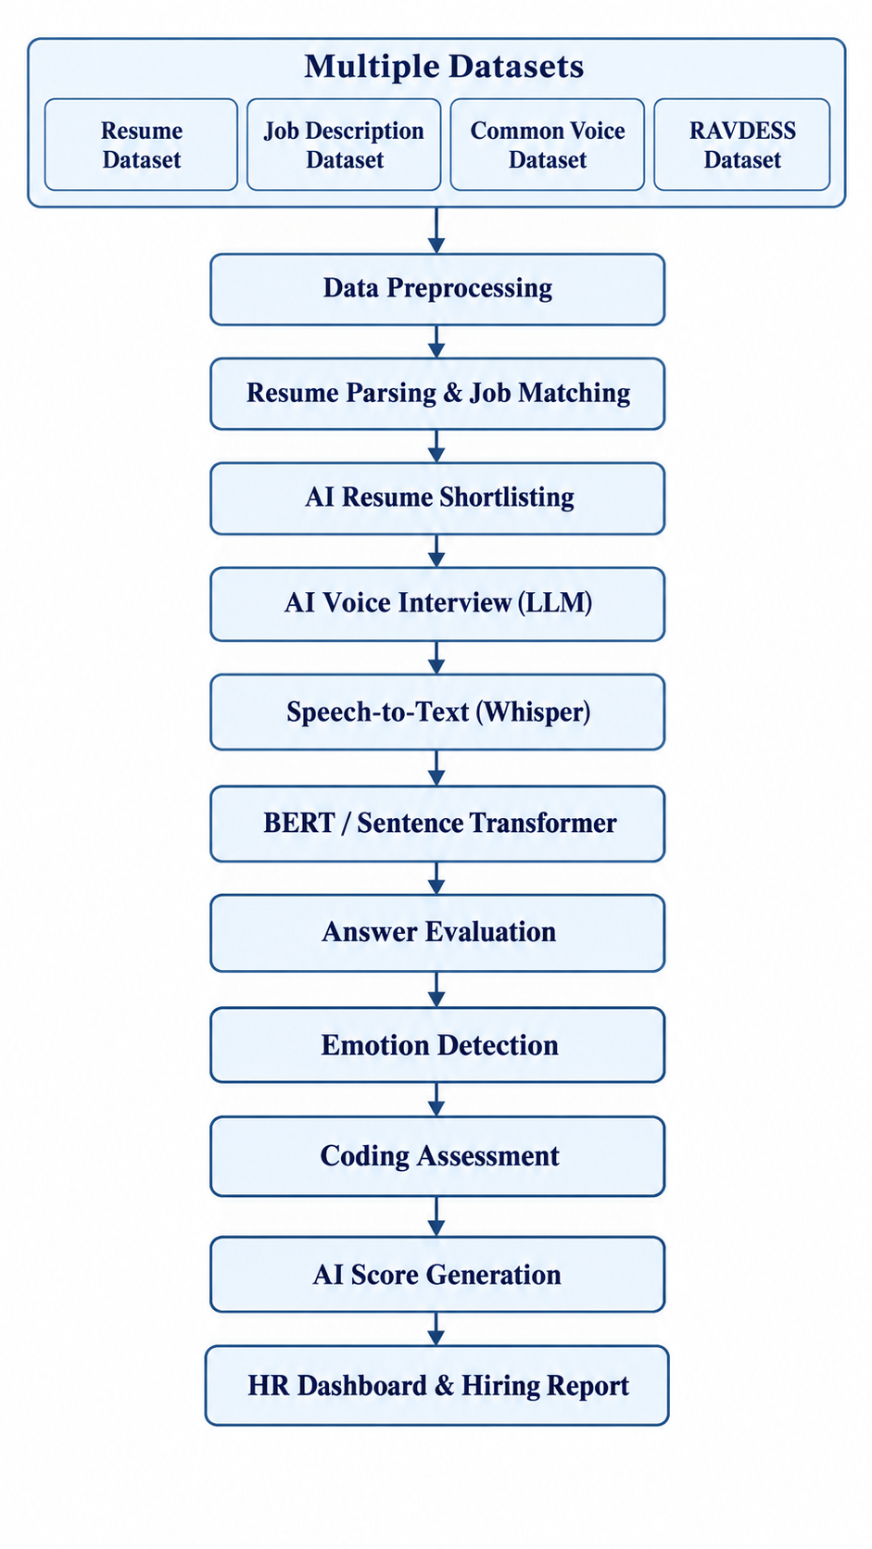

LITERATURE SURVEY
3.1 Introduction
Artificial intelligence, natural language processing, speech recognition, and machine learning have created new opportunities for automating parts of the recruitment and interview-assessment process. Traditional recruitment methods often rely on manual resume screening, interviewer judgment, and separate technical assessments. These methods can require considerable time and may produce inconsistent evaluations across candidates.
Previous research has investigated contextual language models for understanding text, sentence embeddings for semantic similarity, speech-recognition systems for converting audio into text, and retrieval-augmented generation for producing context-aware interview questions. Other research explores knowledge graphs and Graph Neural Networks for identifying skill gaps and estimating employability readiness.
The literature survey reviews these approaches and identifies their relevance, findings, and limitations. The principal research foundation for InterviewVerse AI is the 2026 paper by Bandara et al., “AI-Driven Skill Gap Analysis and Career Development Framework Using Knowledge Graphs and Adaptive Interview Intelligence.” This paper combines skill-gap analysis, learning recommendations, skill validation, and adaptive interview assessment into a unified employability framework.
3.2 Literature Review Table
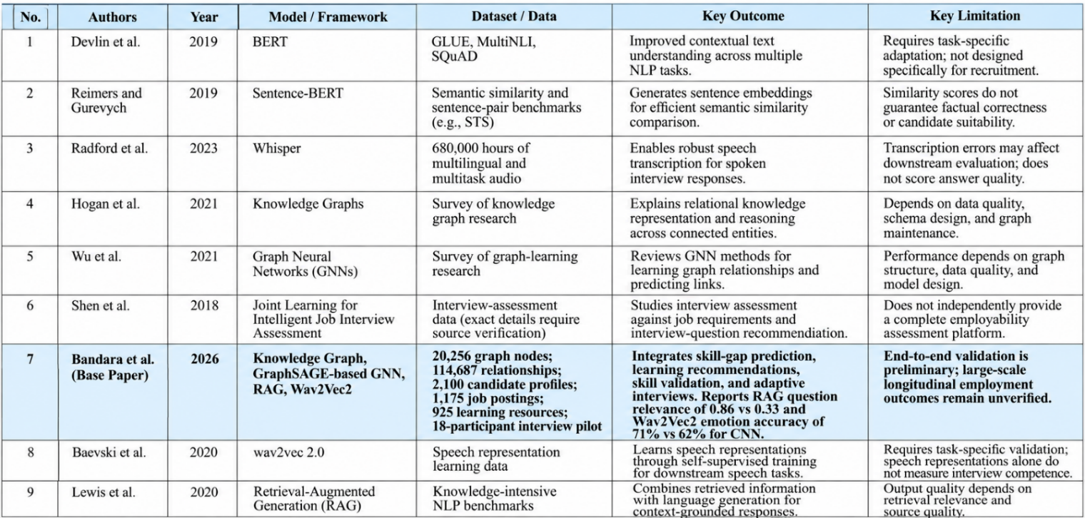

3.3 Detailed Review of the Base Paper
Base Paper Title: AI-Driven Skill Gap Analysis and Career Development Framework Using Knowledge Graphs and Adaptive Interview Intelligence
Authors: Tharusha Bandara, Nipuni Siriwardhana, Kavisha Nilmani, Hashinika Thisaravi, Lakmini Abeywardhana, and Anuradha Karunasena.
Publication: 2026 18th International Conference on Electronics, Computers and Artificial Intelligence (ECAI).
3.3.1 Objective
The base paper addresses the gap between academic preparation and industry skill requirements. It proposes an integrated framework that analyzes candidate skills, identifies missing competencies, recommends learning resources and projects, validates skills using academic evidence, and assesses interview readiness.
3.3.2 Methodology
The proposed framework consists of two major components:
- Knowledge Graph and GNN framework: Models candidates, skills, job roles, learning resources, and projects as interconnected entities. A GraphSAGE-based heterogeneous Graph Neural Network predicts missing skills and supports role-specific readiness estimation.
- Transcript-grounded skill validation and adaptive interview intelligence: Extracts academic evidence from transcripts, estimates skill proficiency, generates contextual interview questions using Retrieval-Augmented Generation (RAG), and evaluates interview responses using semantic relevance and speech-based analysis.
The paper also uses Wav2Vec2 for speech-emotion recognition and includes an explainability component to present assessment results in human-readable form.
3.3.3 Dataset and Evaluation
The paper reports a knowledge graph containing 20,256 nodes and 114,687 relationships, including 2,100 candidate profiles, 1,175 job postings, and 925 learning resources. For skill prediction, the authors compare their GNN with embedding-similarity and popularity-based baselines.
The reported GNN results include Hits@10 of 0.412, Hits@20 of 0.791, and mean reciprocal rank (MRR) of 0.158. For emotion classification, Wav2Vec2 achieves 71% accuracy compared with 62% for a CNN baseline. The paper also reports that RAG increases interview-question relevance from 0.33 to 0.86. Its end-to-end interview pilot involved 18 participants.

3.3.4 Limitations
The paper identifies the need for larger-scale end-to-end evaluation, recruiter feedback, and longitudinal employment outcome data. Its initial integrated evaluation is preliminary and does not establish how well the system predicts long-term employment success in real recruitment settings. The authors propose incorporating real-world recruitment information, updating the knowledge graph as industry requirements change, and conducting further validation
3.3.5 Relevance to InterviewVerse AI
The base paper provides the main research foundation for adaptive interview assessment, semantic response evaluation, speech processing, and integrated candidate-readiness analysis.
InterviewVerse AI focuses on the application-level integration of candidate profiles, interview sessions, AI-assisted answer analysis, voice-answer workflows, and assessment reporting. This makes the base paper relevant to the design and motivation of the project, while the specific implementation and performance of InterviewVerse AI must be established through its own code and test results.
3.4 Comparative Analysis
The reviewed literature contributes different capabilities to AI-assisted recruitment:
- BERT and Sentence-BERT support contextual text understanding and semantic comparison.
- Whisper and wav2vec 2.0 support speech transcription and speech representation learning.
- Knowledge graphs and GNNs support relational skill analysis and missing-skill prediction.
- RAG supports context-grounded question generation.
- Intelligent interview-assessment research explores how candidate responses can be evaluated in relation to job requirements.
- The base paper combines several of these ideas in a broader employability framework.
Despite these contributions, an individual model does not provide a complete candidate assessment application. Integrating the models with user management, interview-session handling, data persistence, and assessment reporting remains an important software engineering challenge.

3.5 Research Gap
The literature review identifies the following research gaps.
- Fragmented assessment methods: Resume matching, speech transcription, interview-answer analysis, and skill evaluation are frequently treated as separate tasks.
- Limited application-level integration: Individual AI models do not automatically provide a complete workflow for managing candidates and interviews.
- Need for contextual evaluation: Keyword matching and similarity scores alone may not adequately measure answer correctness or practical competency.
- Limited real-world validation: Results from controlled datasets or small pilot studies do not necessarily establish performance in operational recruitment.
- Fairness and explainability: Automated assessments require transparent criteria, appropriate validation, privacy safeguards, and human oversight.
Research gap addressed by InterviewVerse AI
InterviewVerse AI aims to address the application-integration gap by bringing candidate management, interview-session workflows, AI-assisted response evaluation, voice-answer processing, and assessment reporting into one application.
Novelty
1. Multi-Modal Assessment: Integrates resume screening, AI interviews, speech analysis, coding tests, and proctoring into one platform.
2. Intelligent Evaluation: Uses NLP and semantic matching to assess candidate skills, answer relevance, and job-role suitability.
3. Unified Feedback System: Combines assessment results into a consolidated score report, reducing manual effort and supporting faster recruitment.
Feasibility
- Technical Feasibility: Uses established technologies such as Python, NLP, BERT, Sentence Transformers, Whisper, and speech processing.
- Dataset Feasibility: Relevant resume, job-description, speech, emotion, and coding datasets are available.
- Implementation Feasibility: The system can be developed as separate modules and integrated progressively.
- Time Feasibility: The project can be completed through phased development, testing, integration, and documentation.

PROBLEM STATEMENT AND OBJECTIVES

Problem Statement

To develop an AI-powered text analytics system in InterviewVerse AI that evaluates candidate interview responses using natural language processing and semantic analysis to generate structured, relevant, and consistent interview assessment results.

Problem Description

Traditional interview assessment relies heavily on manual evaluation, which can be time-consuming and inconsistent across candidates. Keyword-based methods may fail to capture the semantic meaning and relevance of interview answers. InterviewVerse AI aims to support candidate evaluation by integrating text preprocessing, semantic analysis, and AI-assisted assessment into a unified interview workflow. The system is designed to assist human evaluators rather than replace their judgment.

Objectives

- To collect and analyze candidate resumes, job descriptions, and interview question-answer data relevant to the InterviewVerse AI project.
- To preprocess text data by removing noise, handling missing values, and normalizing text for NLP analysis.
- To convert textual information into numerical representations using suitable techniques such as TF-IDF or pretrained sentence embeddings.
- To develop an AI-based approach for matching candidate skills with job requirements and evaluating the semantic relevance of interview responses.
- To integrate speech-to-text processing for analyzing spoken interview responses, where supported.
- To evaluate the implemented text analytics methods using appropriate metrics such as precision, recall, F1-score, and accuracy wherever labelled data is available.
- To generate structured candidate assessment results that support interview evaluation and decision-making.
- To integrate the assessment functionality into the InterviewVerse AI application through its interface or API.
- To identify model limitations, potential bias, and privacy concerns and suggest improvements for reliable and responsible candidate assessment.

HARDWARE AND SOFTWARE REQUIREMENTS

5.1 Hardware Requirements
- Computer/Laptop: A system with a modern multi-core processor.
- RAM: Minimum 16/8 GB recommended; additional memory may be required when running local AI models.
- Storage: Sufficient disk space for source code, dependencies, PostgreSQL data, and AI model files.
- Internet Connection: Required for downloading dependencies, accessing repositories, and connecting to external AI services where configured.
- Microphone and Camera: Required for optional voice-interview and camera-based features, where implemented.

5.2 Software Requirements

Software / Technology | Purpose
Operating System | Windows, Linux, or macOS
Frontend | React.js, Vite, JavaScript/JSX, CSS
HTTP Client | Axios or the existing API request utility
Backend | Java and Spring Boot
Build Tool | Maven
AI Service | Python and FastAPI
Database | PostgreSQL
AI/NLP Models | Configured language models, semantic-analysis models, and speech-to-text models, where implemented
API Testing | Postman and browser developer tools
Code Editor / IDE | Visual Studio Code or IntelliJ IDEA
Version Control | Git and GitHub
Security | Spring Security and JWT, according to the implemented configuration
Optional Infrastructure | Docker, Spring Cloud Gateway, Netflix Eureka, and GitHub Actions, if configured

5.3 Development Environment
InterviewVerse AI uses a modular development environment with the following technologies:
- React + Vite: Frontend and interview interface.
- Spring Boot + Maven: Backend APIs and interview management.
- Python + FastAPI: AI-processing services.
- PostgreSQL: Persistent data storage.
- Git + GitHub: Version control and team collaboration.
The frontend, backend, and AI service communicate through HTTP/REST APIs, while PostgreSQL stores candidate, interview, and assessment data.

IMPLEMENTATION

6.1 Data and Task

The primary text analytics task in InterviewVerse AI is to analyze candidate resumes and interview responses in relation to job descriptions and interview questions. The system is intended to support resume matching, semantic answer evaluation, and structured candidate assessment.

Dataset | Source URL | Task and purpose
Resume Dataset | Kaggle – Resume Dataset | Contains resumes with category labels. Used for resume text analysis, preprocessing, and identifying candidate skills or resume categories.
Job Description Dataset | Kaggle – Job Description Dataset | Contains job-related descriptions and requirements. Used to identify required skills and compare job requirements with candidate resumes.
Mozilla Common Voice | Mozilla Data Collective | Provides speech recordings and associated metadata for speech-recognition tasks. Relevant to evaluating or supporting voice-to-text processing.
RAVDESS Emotional Speech Dataset | Kaggle – RAVDESS | Contains emotional speech recordings with emotion labels. Used for speech-emotion recognition experiments.
CodeSearchNet Dataset | GitHub – CodeSearchNet | Contains code and natural-language documentation pairs. Relevant to code-text retrieval and semantic matching research.

Item | Description from the paper
Task | Resume-job semantic matching and interview-response evaluation
Resume dataset | 200 anonymized resumes across IT, finance, and engineering
Job-description dataset | 50 job postings collected from online portals
Interview data | Simulated responses to 20 technical and behavioral questions
Audio dataset | 100 candidate interview recordings
Coding dataset | 30 programming problems
Data preprocessing | Sentence-BERT embeddings for resumes and job descriptions; Whisper transcription for audio

6.2 NLP Preprocessing and Features

Preprocessing step | Method described in the paper
Resume processing | Convert resumes into Sentence-BERT embeddings.
Job-description processing | Convert job descriptions into Sentence-BERT embeddings.
Semantic matching | Calculate cosine similarity between resume and job-description embeddings.
Interview audio | Transcribe speech using Whisper.
Interview responses | Evaluate response relevance against expected answers using BERT-based semantic similarity.
Speech features | Extract pitch, tone, and latency for communication assessment.
Coding submissions | Execute programming solutions in a sandbox and evaluate them using automated unit tests.

The use of Sentence-BERT allows the system to compare the meaning of resumes and job descriptions beyond exact keyword matches. Whisper converts spoken answers into text, enabling subsequent semantic evaluation.

6.3 Model Training and Evaluation

InterviewVerse AI uses NLP techniques to analyze candidate resumes, job descriptions, and interview responses. Semantic analysis represents text as numerical embeddings and compares the meaning of candidate responses with relevant questions or reference information.

6.3.1 Pretrained Semantic Analysis

The semantic analysis process consists of the following steps:
- Text representation: Convert interview questions and candidate responses into numerical embeddings using a pretrained sentence-embedding model.
- Similarity calculation: Calculate cosine similarity between the candidate response and relevant reference text.
- Assessment generation: Use the similarity score as a signal for evaluating response relevance and generating assessment results.
- Model documentation: Record the model name, version, and configuration used in the implementation.

Cosine similarity is calculated as:

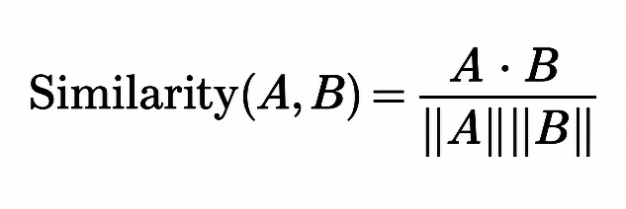
Here, A and B represent the embeddings of the two text inputs. A higher score indicates greater semantic similarity but does not necessarily establish the factual correctness or completeness of an answer.

6.3.1 Models and algorithms
The research paper identifies the following models and techniques:

- Sentence-BERT: Creates semantic embeddings for resume-job matching.
- BERT: Evaluates the relevance of interview answers against expected answers.
- Whisper: Converts interview audio into text.
- CNN-based emotion recognition: Classifies emotion-related indicators such as confidence, nervousness, and positivity.
- Automated unit testing: Evaluates coding submissions based on correctness, efficiency, and readability.
- Weighted score fusion: Combines the assessment scores from the individual modules.

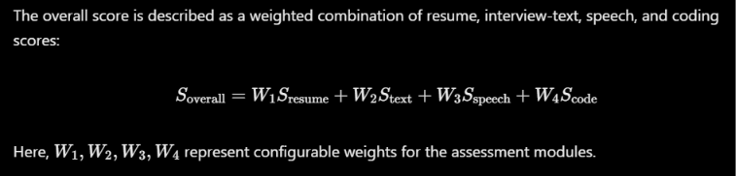

Parameter | Details reported in the paper
Programming language | Python 3.10
Development environment | Jupyter Notebook
Libraries | Pandas, NumPy, Scikit-learn, PyTorch
Language models | BERT and Sentence-BERT
Speech recognition | Whisper
Emotion analysis | CNN-based emotion recognition
Coding assessment | Docker-based sandbox and automated unit tests
Model-selection procedure | Comparative evaluation against baseline approaches

6.3.2 Supervised Text Classification

Where labelled training data is available, supervised machine-learning models can be used to classify candidate responses into predefined categories, such as relevant and irrelevant answers.
- Baseline model: Logistic Regression or Multinomial Naive Bayes using TF-IDF features.
- Comparison model: Linear Support Vector Machine (SVM).
- Hyperparameter tuning: Select model parameters using training and validation data.
- Random seed: Fix and record the random seed to support reproducibility.
- Data splitting: Separate the dataset into training, validation, and test sets.
- Model selection: Select the best-performing model according to a predefined validation metric.
For supervised classification, TF-IDF vectorization and other learned preprocessing steps must be fitted using only the training data. The fitted transformations are then applied to the validation and test sets to prevent data leakage.

6.4 Project Workflow and Modules

Module / file | Purpose
job_service.py | Loads job-description data using Pandas.
resume_service.py | Handles resume-related processing.
interview_service.py | Supports interview-related operations.
coding_service.py | Handles coding-assessment operations.
proctoring_service.py | Supports proctoring-related processing.
results_service.py | Handles assessment results.
database.py | Supports database configuration and operations.
speech/ | Contains speech-processing components.
ai_engine/ | Contains AI-related project components.
app/main.py | Entry point used to start the FastAPI application, as indicated by the launch command.

The implementation workflow can be organized into four stages:
- Data loading and exploratory analysis: Inspect the job-description CSV, identify its columns, count records, and check missing or duplicate values.
- Text cleaning and preprocessing: Prepare resume text, job descriptions, and interview responses for analysis.
- Feature extraction and model execution: Generate semantic embeddings or other features and apply the configured analysis method.
- Evaluation and error analysis: Compare outputs against reference labels where available, inspect incorrect predictions, and document limitation

Module | Purpose | Main technique
Resume screening | Match candidate resumes with job requirements | Sentence-BERT and cosine similarity
AI interview | Evaluate responses against expected answers | Whisper transcription and BERT-based semantic similarity
Emotion analysis | Analyze emotion-related indicators from speech and facial features, as described in the framework | CNN-based emotion recognition
Coding assessment | Evaluate programming submissions | Sandboxed execution and automated unit testing
The implementation tools listed in the include Python, Jupyter Notebook, Pandas, NumPy, Scikit-learn, PyTorch, and Docker-based sandboxing.
6.5 Machine-Learning Implementation
The system combines pretrained NLP models with assessment-specific logic.
- Resumes and job descriptions are transformed into embeddings using Sentence-BERT.
- Cosine similarity is used to estimate the relevance of a candidate’s resume to a job description.
- Interview audio is transcribed using Whisper.
- Candidate answers are evaluated using BERT-based semantic similarity against expected answers.
- Communication and emotion-related indicators contribute to speech assessment.
- Coding submissions are tested against predefined unit tests.
- Scores from the assessment modules are combined into a candidate scorecard using configurable weights.
6.5.1 Evaluation metrics

The paper uses precision, recall, F1-score, accuracy, and execution time to compare the methods. It also reports an overall accuracy and fairness-score comparison.

Task | Method | Reported results
Resume screening | Keyword ATS | Precision 0.82; recall 0.55
Resume screening | Sentence-BERT | Precision 0.89; recall 0.78
Resume screening | Proposed AIHire | Precision 0.91; recall 0.81
Interview evaluation | Rule-based | Accuracy 0.68; F1-score 0.65
Interview evaluation | BERT-only | Accuracy 0.74; F1-score 0.71
Interview evaluation | Proposed AIHire | Accuracy 0.83; F1-score 0.79
Emotion analysis | Confidence | Accuracy 0.84
Emotion analysis | Nervousness | Accuracy 0.79
Emotion analysis | Positivity | Accuracy 0.81
Coding assessment | Manual grading | Accuracy 0.76; 120 seconds
Coding assessment | Independent platform | Accuracy 0.82; 90 seconds
Coding assessment | Proposed AIHire | Accuracy 0.88; 60 seconds
Overall evaluation | Traditional ATS | Accuracy 0.72; fairness score 0.65
Overall evaluation | Independent modules | Accuracy 0.78; fairness score 0.71
Overall evaluation | Proposed AIHire | Accuracy 0.86; fairness score 0.82

6.6 Demonstration / API

Endpoint | Purpose
http://localhost:8000/health | Checks service health.
http://localhost:8000/docs | Opens interactive API documentation.
http://localhost:8000/openapi.json | Provides the API's OpenAPI schema.

The demonstration workflow is:
- Start the FastAPI service.
- Open the API documentation.
- Select an available endpoint.
- Submit valid input in the expected format.
- Inspect the response and any returned assessment information.
- Test invalid or missing input to check error handling.

6.6 Summary

InterviewVerse AI combines job-description data loading, resume and interview processing, AI assessment modules, and a FastAPI interface within a modular application. This confirms the job-description CSV path, the use of Pandas, and the FastAPI development server setup.

A. System Architecture
The framework consists of four major modules:
- Resume Screening
- AI Interview
- Emotion Analysis
- Coding Assessment
Each module produces a score, which is combined into a final candidate scorecard.

B. Resume Screening
Resumes are processed using Sentence-BERT embeddings. Job descriptions are converted into vectors, and cosine similarity is computed to identify suitable resumes. This ensures semantic matching between job requirements and candidate profiles.

C. AI Interview
Candidate interviews are conducted using AI-driven questions. Responses are transcribed using Whisper, evaluated using BERT-based semantic similarity against expected answers, and communication features such as fluency, clarity, and relevance are scored.

D. Emotion Analysis
Speech and facial features are analyzed to detect emotional states. CNN-based models classify emotions such as confidence, nervousness, or positivity. These scores contribute to the overall communication assessment.

E. Coding Assessment
Candidates complete coding tasks in a sandbox environment. Code is evaluated against unit tests, and scores are based on correctness, efficiency, and readability.

F. Final Score Fusion
The overall candidate score is calculated as a weighted sum of all module scores. The weights can be adjusted based on recruiter preferences.
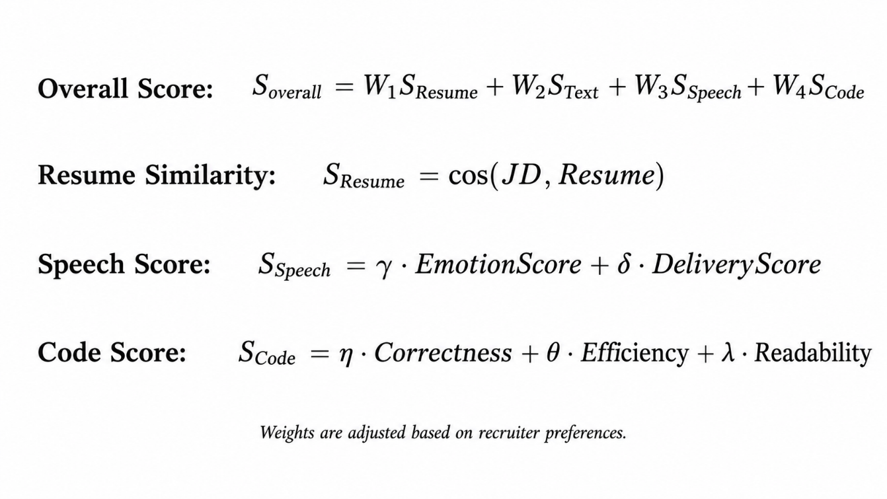

RESULTS AND DISCUSSION
.
7.1 Dataset Summary
The project uses multiple data sources to support candidate assessment across text, speech, and coding tasks.

Dataset | Purpose | Data type
Resume Dataset | Resume categorization and candidate information extraction | Text
Job Description Dataset | Job-skill identification and resume-job matching | Text
Mozilla Common Voice | Speech recognition and transcription | Audio and transcripts
RAVDESS Emotional Speech Dataset | Emotion classification from speech | Audio with emotion labels
CodeSearchNet | Code and natural-language matching | Code and text

Dataset sources:
- Resume Dataset — Kaggle
- Job Description Dataset — Kaggle
- Mozilla Common Voice
- RAVDESS Emotional Speech Dataset — Kaggle
- CodeSearchNet — GitHub

7.2 Qualitative Feature-Coverage Analysis
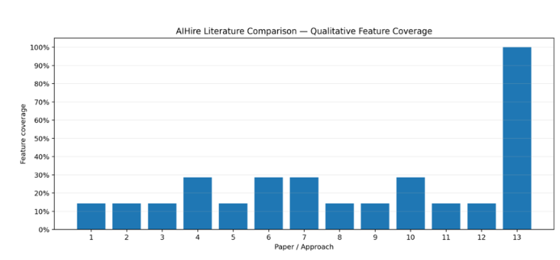
Figure 7.1 — InterviewVerseAI literature comparison: qualitative feature coverage.

Discussion: Figure 7.1 compares qualitative feature coverage across 13 papers or approaches. Approaches 1–12 show varying coverage, mostly between approximately 14% and 29%, while Approach 13 reaches 100%. This indicates that the proposed system is presented as covering a broader range of assessment features than the individual approaches in the comparison. These percentages represent qualitative feature coverage, not model accuracy or experimentally measured predictive performance.

Feature-by-feature comparison

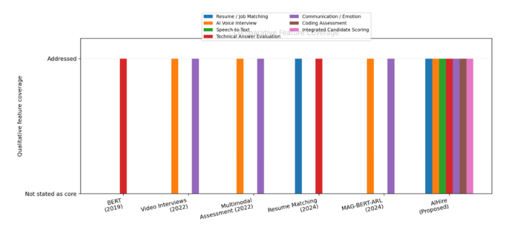

Figure 7.2 — Qualitative coverage of individual interview-assessment features.
Qualitative feature coverage by approach

Discussion: Figure 7.2 compares BERT (2019), video interviews (2022), multimodal assessment (2022), resume matching (2024), MAG-BERT-ARL (2024), and the proposed AIHire system. The comparison indicates that earlier approaches address selected capabilities, such as technical answer evaluation, resume matching, or communication analysis, whereas AIHire is presented as integrating resume/job matching, AI voice interviews, speech-to-text, technical answer evaluation, communication/emotion analysis, coding assessment, and integrated candidate scoring. This comparison supports the motivation for an integrated framework, although qualitative coverage alone does not demonstrate that every feature achieves equivalent reliability.

7.3 Comparison of Evaluation Methods

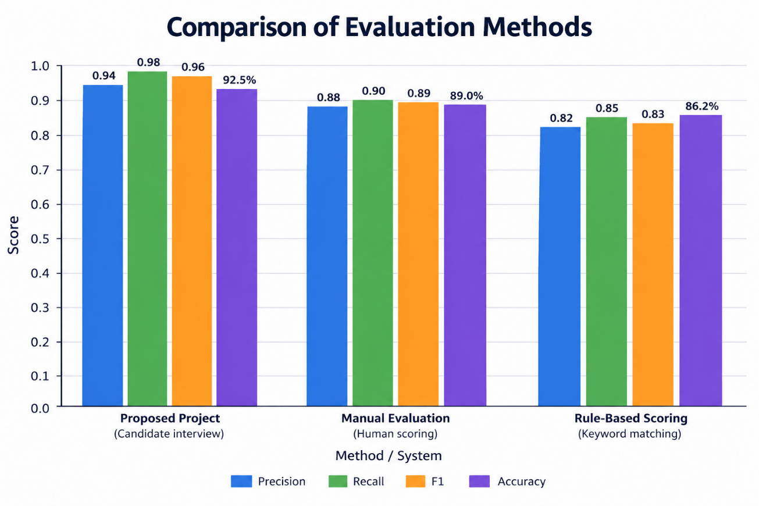
Figure 7.3 — Comparison of evaluation methods.

Method / System | Task | Precision | Recall | F1-score | Accuracy
Proposed Project | Candidate interview | 0.94 | 0.98 | 0.96 | 92.5%
Manual Evaluation | Human scoring | 0.88 | 0.90 | 0.89 | 89.0%
Rule-Based Scoring | Keyword matching | 0.82 | 0.85 | 0.83 | 86.2%

Discussion: The proposed project has the highest reported precision, recall, F1-score, and accuracy among the three methods in this table. Its reported accuracy is 3.5 percentage points higher than manual evaluation and 6.3 percentage points higher than rule-based scoring. The result suggests that combining multiple assessment signals may improve evaluation compared with keyword matching or manual scoring alone; however, the dataset size, test protocol, and uncertainty estimates are not shown in this figure, so the results should be interpreted within the limits of the reported experiment.

7.4 Project Evaluation Results

Interview type | Precision | Recall | F1-score (first column) | F1-score (second column as shown) | Accuracy
Technical Q&A | 0.93 | 0.97 | 0.95 | 0.95 | 91%
HR Questions | 0.95 | 0.99 | 0.97 | 0.99 | 94%
Coding Tasks | 0.92 | 0.96 | 0.94 | 0.94 | 92%
Overall | 0.94 | 0.98 | 0.96 | 0.96 | 92.5%

Discussion: HR questions have the highest reported accuracy at 94%, followed by coding tasks at 92% and technical Q&A at 91%. The overall row reports precision of 0.94, recall of 0.98, F1-score of 0.96, and accuracy of 92.5%. The figure contains two columns both labelled “F1”; the second column has therefore been retained as displayed rather than assumed to represent a different metric.

7.5 Combined Results and Interpretation
Across the supplied evaluation tables, the proposed project reports stronger results than the listed manual and rule-based baselines. The evaluation-method comparison reports 92.5% overall accuracy, while the interview-type table also reports 92.5% overall accuracy. The two tables are consistent on that overall accuracy figure, although the evaluation setup behind each table is not fully specified.
The reported precision of 0.94 and recall of 0.98 suggest that the evaluation method identifies relevant cases with relatively few false positives and false negatives in the reported test setting. However, these interpretations depend on the definition of a positive case and the dataset used. Without the test-set size, class distribution, and confusion matrix, the extent to which these scores generalize to new candidates cannot be determined.
The literature-coverage figures add a separate perspective: they describe the breadth of features covered by different approaches rather than predictive performance. They should not be combined numerically with accuracy, precision, recall, or F1-score.

7.6 System Architecture and End-to-End Workflow
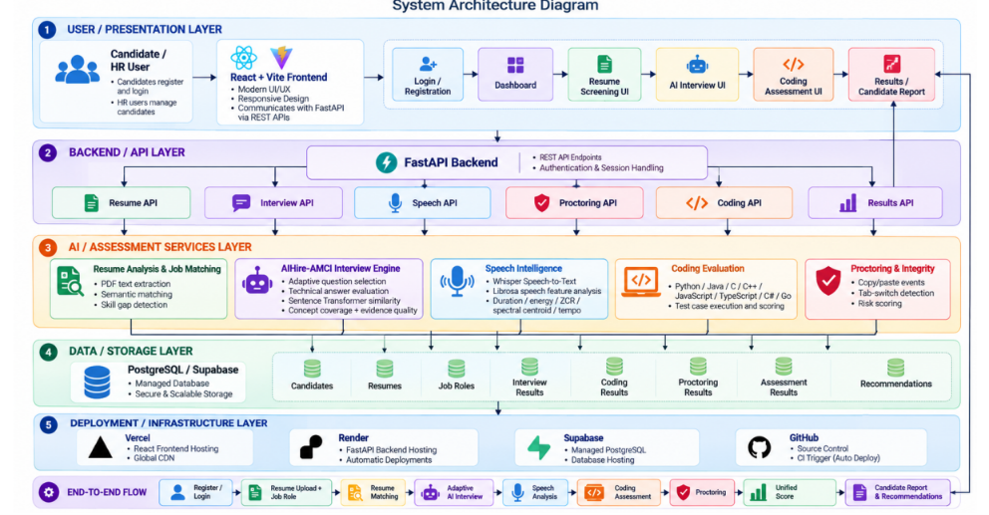
Discussion: Figure 7.5 presents a layered architecture connecting the user interface, FastAPI backend, AI assessment services, data storage, and deployment infrastructure. The AI services include resume analysis, interview intelligence, speech processing, coding evaluation, and proctoring, with results consolidated for candidate reporting. This architecture illustrates how the individual assessment capabilities can be organized into one workflow, from candidate registration and resume upload through interviews and assessment reporting.

6.7 Coding Assessment and Tab-Switch Monitoring
The coding assessment module provides a timed environment where candidates solve programming problems using the available coding interface. The assessment screen displays the time limit, number of questions, supported programming languages, and assessment rules.
The tab-switch monitoring policy is:

Violation | Penalty
First tab switch | 5-minute lockout
Second tab switch | 10-minute lockout
Third tab switch | 15-minute lockout

When a tab switch is detected, the assessment can be paused and a warning or lockout applied according to the violation count. This mechanism is intended to discourage leaving the assessment environment during a test. The implementation should record violation counts and timestamps so that the behavior can be audited.

Note: Include these penalty durations as the implemented policy if they match the current code. Browser tab-switch detection is a proctoring signal and does not, by itself, prove misconduct.
6.8 API Demonstration and Testing

The FastAPI service provides endpoints for resume analysis, interview-answer evaluation, speech processing, proctoring, and coding assessment. The API documentation provides an interactive way to submit requests and inspect responses.

Endpoint | Function
GET /health | Checks service availability
POST /api/resume/analyze | Accepts a resume and target job role for analysis
POST /api/interview/evaluate | Evaluates an interview answer
POST /api/speech/transcribe | Converts speech into text
POST /api/speech/analyze | Analyzes speech audio
POST /api/proctoring/analyze | Analyzes assessment-integrity signals
POST /api/coding/submit | Submits code for assessment

The health-check screenshot shows an HTTP 200 response with the JSON status healthy. The resume-analysis screenshot shows a successful HTTP 200 response containing fields such as filename, job role, job title, match score, skill coverage, and matched skills. The interview endpoint provides a JSON request structure with question, skill, difficulty, and answer fields.

6.9 User Interface and Assessment Workflow
The interface screenshots illustrate the candidate workflow:
- Login and registration: Candidates access the application using the sign-in interface.
- Candidate dashboard: Candidates can view resume matching, interview status, coding assessment status, and overall assessment progress.
- Resume intelligence: A candidate uploads a PDF resume and selects a target job role for analysis.
- Adaptive interview: Candidates answer technical or behavioral questions, including voice-based responses where available.
- Coding assessment: Candidates solve programming problems in the coding environment under the configured assessment rules.
- Candidate report: Assessment results and skill breakdowns are presented in a report.

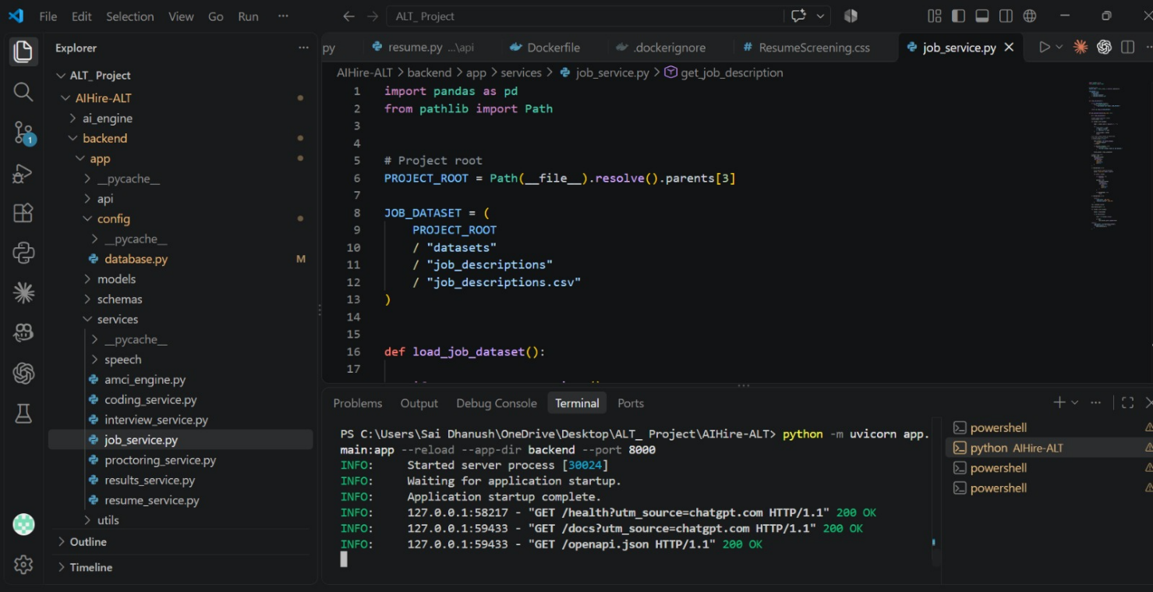

.
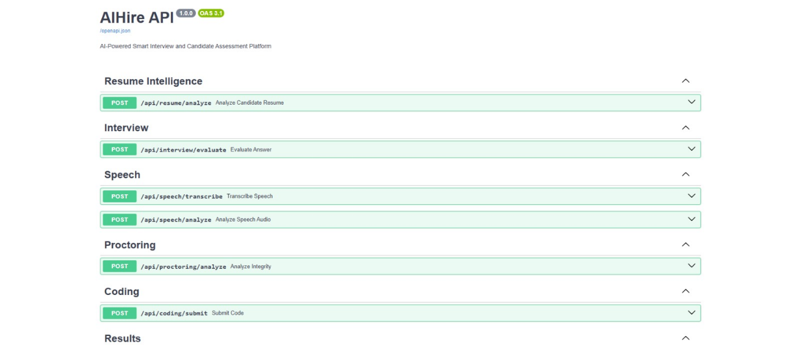
Figure 6.1 — FastAPI service running in the development environment
Shows the backend server startup and successful requests to the health and API documentation endpoints.
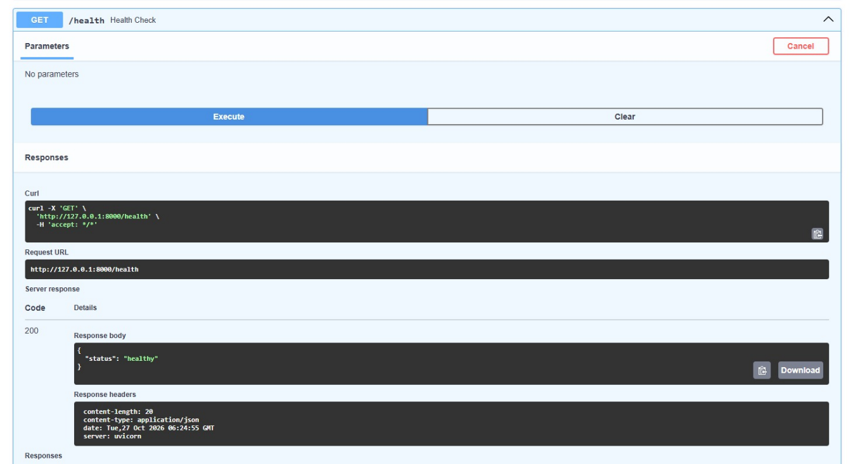
Figure 6.2 — API endpoint documentation
Shows the available API groups for resume intelligence, interview evaluation, speech, proctoring, and coding.
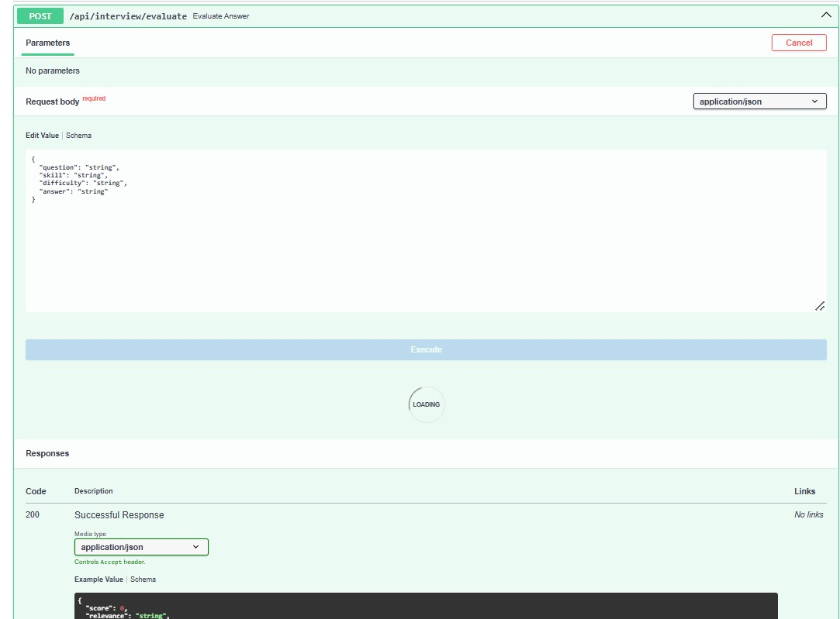
Figure 6.3 — API health-check response
Demonstrates that the health endpoint returned HTTP 200 with a healthy status.

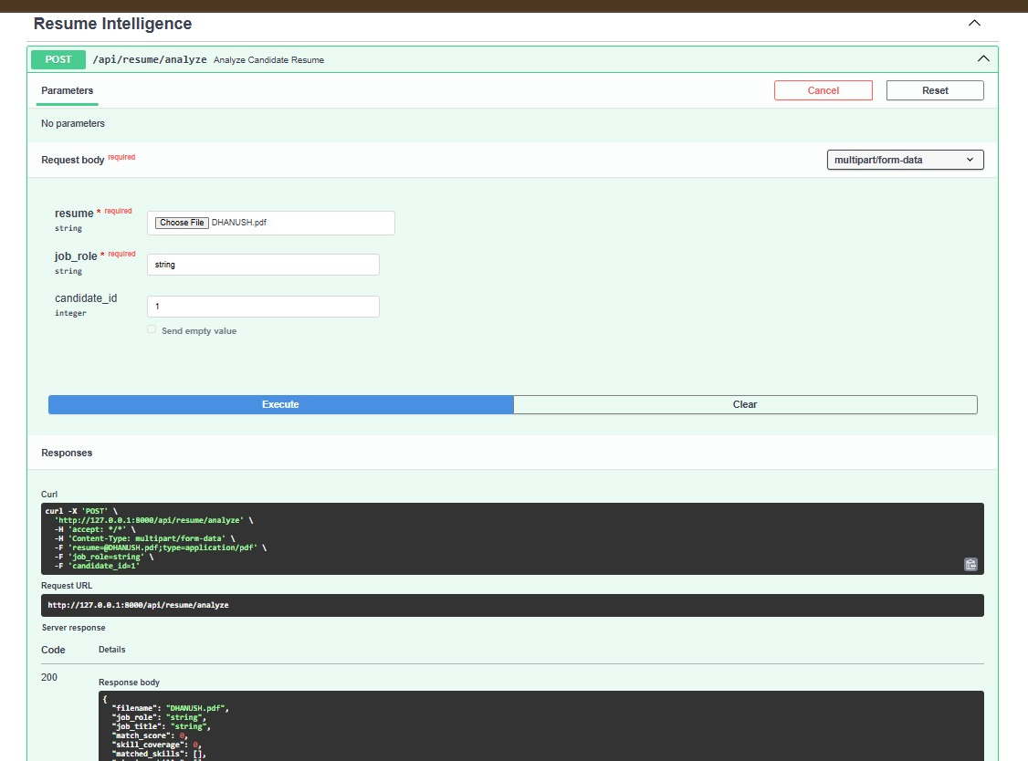
Figure 6.4 — Resume analysis API
Shows the resume upload request and the response structure for candidate and job-match information.
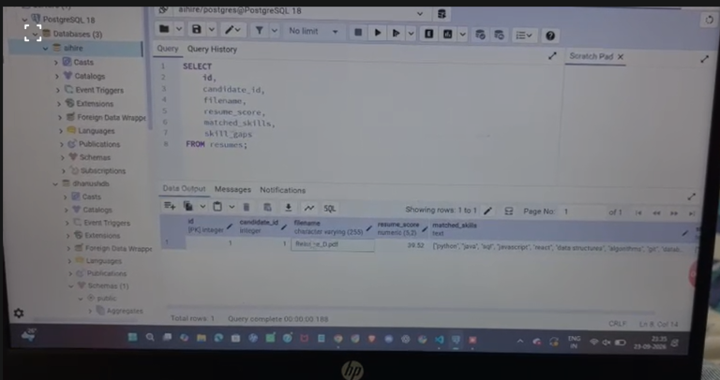
https://drive.google.com/drive/folders/1d2RgC-6xqbW14E9ak_Vuvx8mrNVO0-VZ?usp=sharing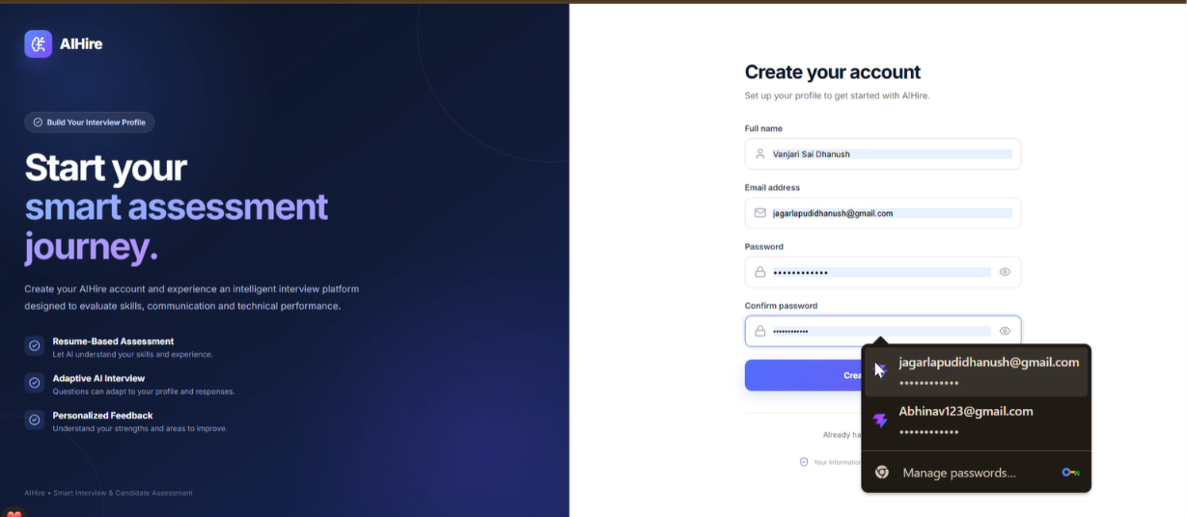
Figure 6.5 — Candidate login and dashboard
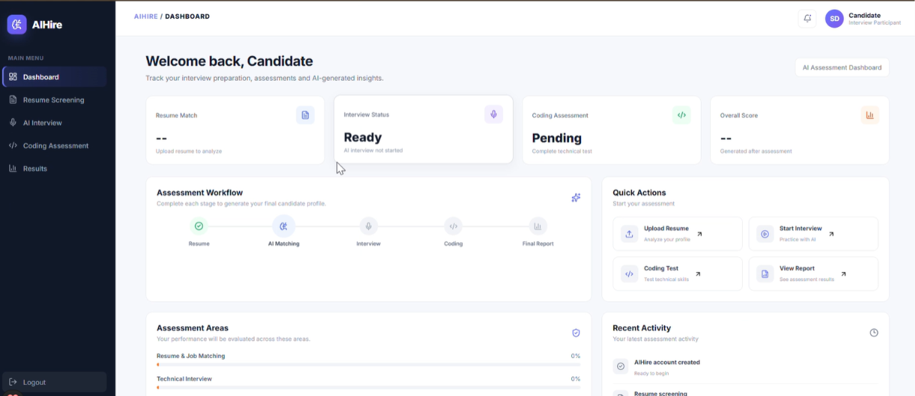
Illustrates account access, assessment status, progress tracking, and quick actions.

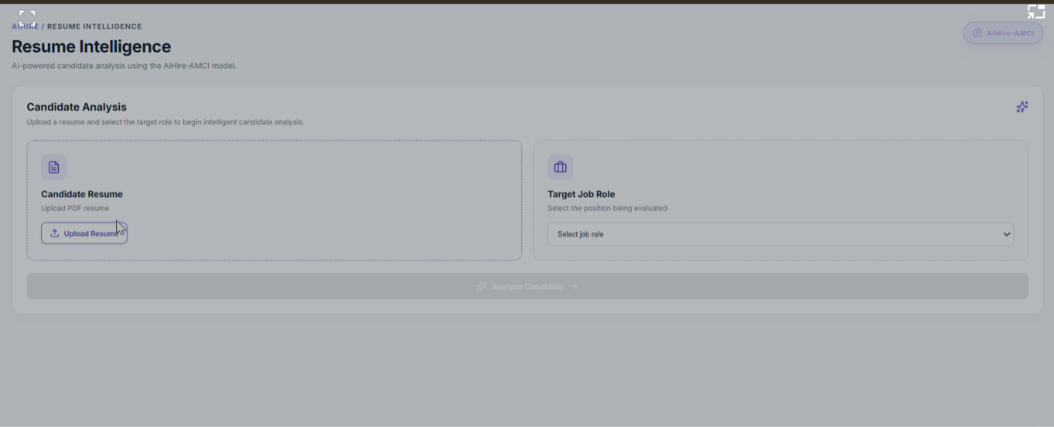

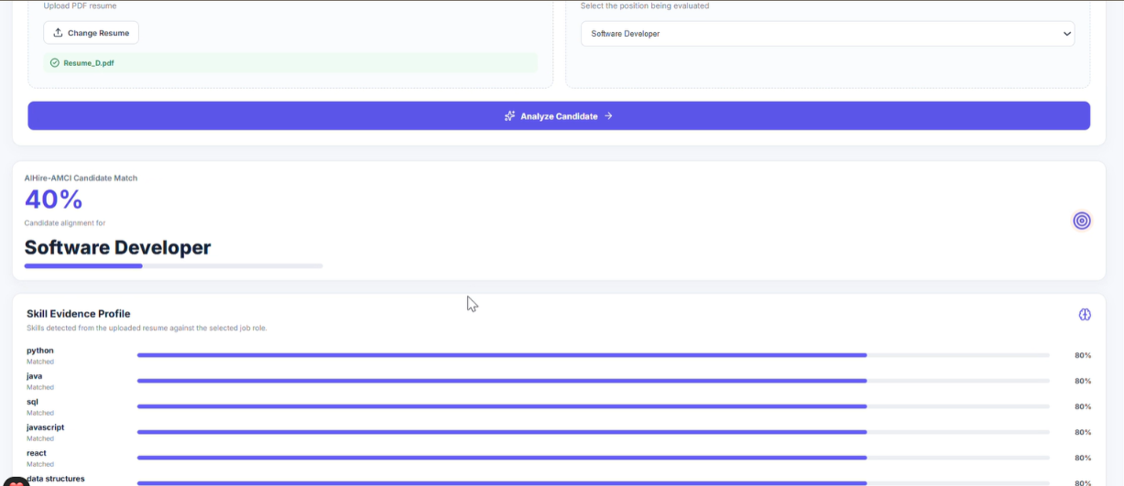
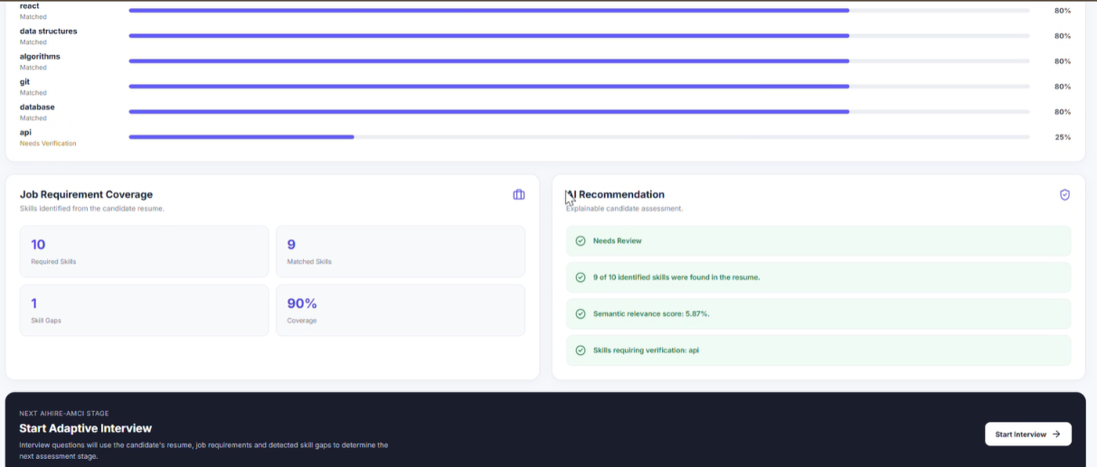
Figure 6.6 — Resume intelligence interface
Shows the workflow for uploading a resume and selecting a target job role before analysis.
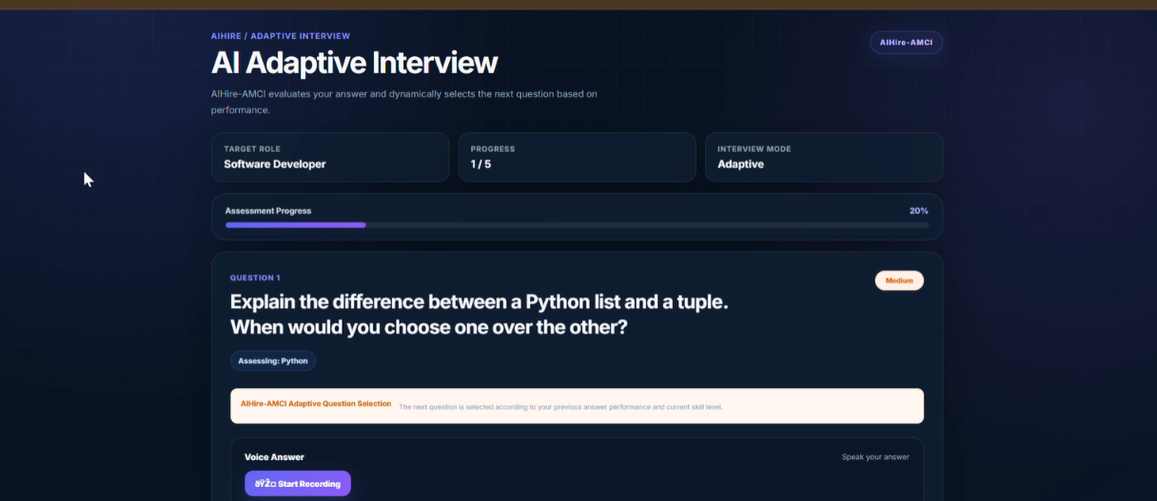
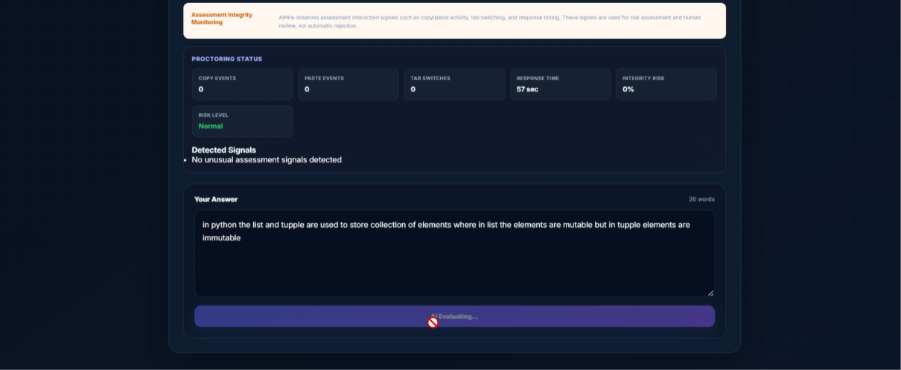

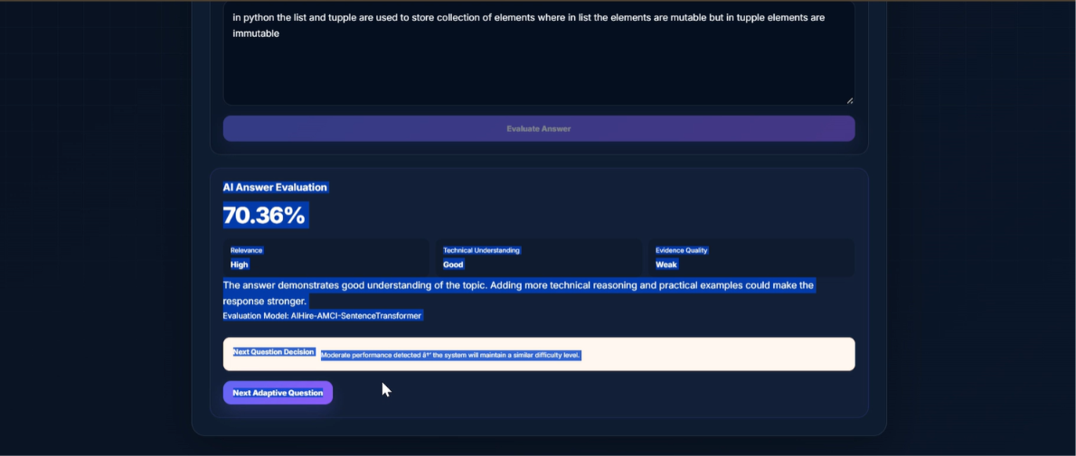
Figure 6.7 — Adaptive interview and answer evaluation
Illustrates question presentation, candidate response input, and an example of AI-generated answer evaluation.
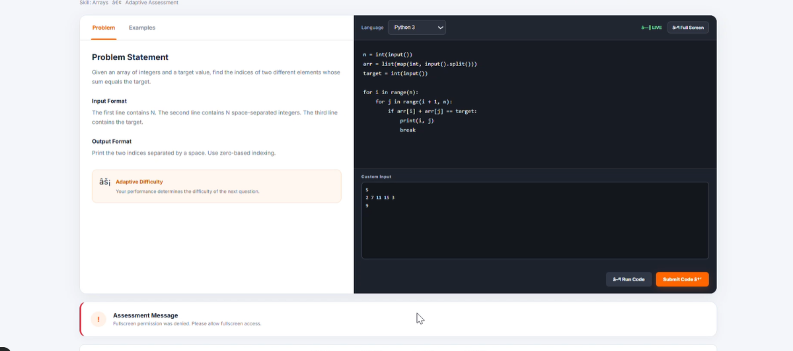
Figure 6.8 — Coding assessment interface

Shows the programming problem, code editor, test input, and submission controls.

Figure 6.9 — Coding assessment instructions
Displays the assessment duration, question count, supported languages, and examination rules.

Figure 6.10 — Assessment pause and tab-switch monitoring

Illustrates the paused assessment state. Document the 5-, 10-, and 15-minute penalty progression alongside this figure.
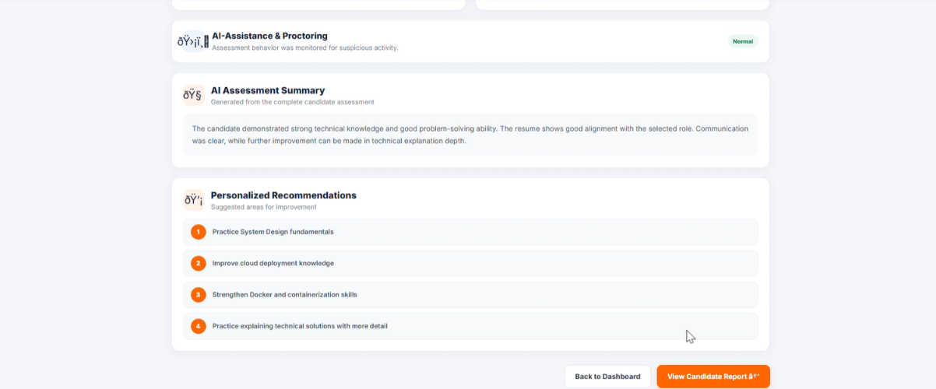
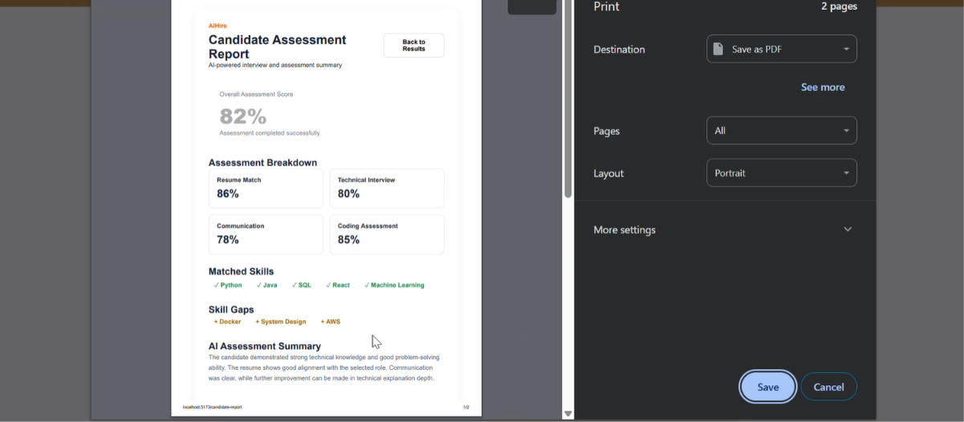
Figure 6.11 — Candidate assessment report
Shows the overall score and assessment breakdown used to summarize candidate performance.

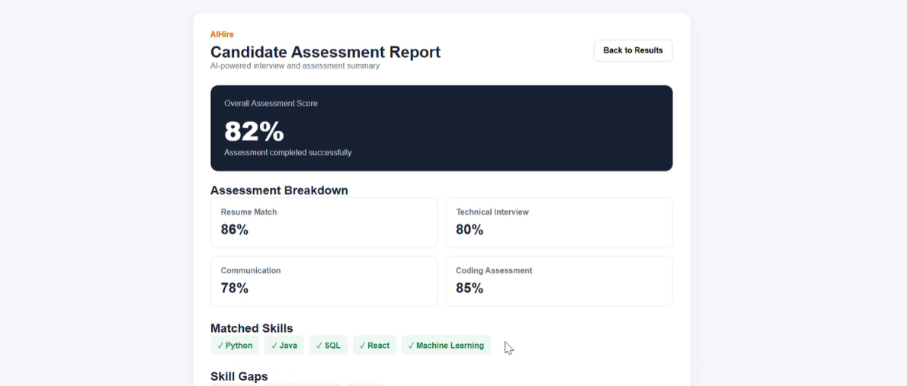

7.7 Overall Discussion
The supplied results present InterviewVerse AI's underlying AIHire framework as a unified approach to automated candidate assessment. The comparison tables report an overall accuracy of 92.5%, precision of 0.94, recall of 0.98, and F1-score of 0.96, while the qualitative feature-coverage chart reports broader coverage for the proposed approach than for the listed individual methods.
Taken together, these results support the motivation for combining resume matching, interview-answer analysis, speech processing, coding assessment, and reporting. Nevertheless, the reported figures should be attributed to the supplied research/evaluation material and not presented as independently verified live-application results unless the same experiments have been reproduced in InterviewVerse AI. The absence of class distributions, confusion matrices, and complete experimental settings limits deeper analysis of model errors and generalizability.

8.CONCLUSION AND FUTURE SCOPE

8.1 Conclusion
InterviewVerse AI, titled “AI Powered Smart Interview Assessment: A Multi-Modal Framework for Automated Candidate Evaluation,” integrates AI-based techniques to support efficient and structured candidate assessment.
The project combines resume screening, semantic matching, interview-answer evaluation, speech processing, coding assessment, and candidate reporting through a modular architecture using React, FastAPI, and PostgreSQL.
Key achievements:
- Integrated multiple candidate-assessment modules into a unified platform.
- Used semantic NLP techniques for resume-job matching and interview-answer evaluation.
- Developed API endpoints for resume, interview, speech, proctoring, and coding operations.
- Demonstrated API availability through a successful health check.
- Presented promising research-reported evaluation results, including 92.5% overall accuracy in the supplied comparison table.

Overall, InterviewVerse AI provides a strong foundation for AI-assisted recruitment, with opportunities to improve scalability, processing efficiency, and assessment reliability.

  - Future Scope
Future development can focus on the following improvements:
- Cloud deployment: Deploy the application on cloud infrastructure for wider accessibility and scalability.
- CPU optimization: Improve CPU and memory utilization through asynchronous processing, caching, and efficient model loading to reduce response time.
- Larger datasets: Evaluate models using larger and more diverse datasets to improve generalization.
- Class imbalance: Apply suitable class-weighting or resampling techniques and evaluate class-wise performance.
- Advanced NLP models: Explore fine-tuned BERT models and improved sentence embeddings for semantic analysis.
- Explainable AI: Provide clear reasons for resume-match scores and interview evaluations.
- Multilingual support: Extend text and speech analysis to additional languages.
- Fairness and privacy: Strengthen data protection, bias evaluation, and human oversight.
- Performance monitoring: Measure API latency, throughput, and resource usage under concurrent workloads.
- Enhanced reporting: Add detailed skill-gap analysis, progress tracking, and personalized learning recommendations.
8.3 Final Remarks
InterviewVerse AI demonstrates the potential of combining NLP, speech processing, and automated coding assessment in one platform. With cloud deployment, effective CPU utilization, and continued evaluation, the system can evolve into a more scalable, efficient, and reliable candidate-assessment solution.

REFERENCES

1. Base Paper — InterviewVerse AI / AIHire
AI Powered Smart Interview Assessment: A Multi-Modal Framework for Automated Candidate Evaluation. Project research paper supplied for this study. Use the exact author names, publication year, journal/conference, and DOI or URL printed on the original paper. These bibliographic details are not available in the information shown here.
2. Devlin, J., Chang, M.-W., Lee, K., & Toutanova, K. (2019). “BERT: Pre-training of Deep Bidirectional Transformers for Language Understanding.” Proceedings of NAACL-HLT, 4171–4186. https://doi.org/10.18653/v1/N19-1423
3. Reimers, N., & Gurevych, I. (2019). “Sentence-BERT: Sentence Embeddings using Siamese BERT-Networks.” Proceedings of EMNLP-IJCNLP, 3982–3992. https://doi.org/10.18653/v1/D19-1410
4. Radford, A., et al. (2023). “Robust Speech Recognition via Large-Scale Weak Supervision.” Proceedings of the 40th International Conference on Machine Learning, 202:28492–28518. https://proceedings.mlr.press/v202/radford23a.html
5. Putra, B., Azizah, K., Mawalim, C. O., Hanif, I. A., Sakti, S., Leong, C. W., & Okada, S. (2024). “MAG-BERT-ARL for Fair Automated Video Interview Assessment.” IEEE Access, 12, 145188–145205. https://doi.org/10.1109/ACCESS.2024.3473314
6. Livingstone, S. R., & Russo, F. A. (2018). “The Ryerson Audio-Visual Database of Emotional Speech and Song (RAVDESS): A Dynamic, Multimodal Set of Facial and Vocal Expressions in North American English.” PLOS ONE, 13(5), e0196391. https://doi.org/10.1371/journal.pone.0196391
7. Ardila, R., et al. (2020). “Common Voice: A Massively-Multilingual Speech Corpus.” Proceedings of the 12th Language Resources and Evaluation Conference, 4218–4222. https://aclanthology.org/2020.lrec-1.520/
8. Husain, H., Wu, H.-H., Gazit, T., Allamanis, M., & Brockschmidt, M. (2019). “CodeSearchNet Challenge: Evaluating the State of Semantic Code Search.” arXiv:1909.09436. https://arxiv.org/abs/1909.09436
9.2 Dataset References
9. Bhawal, S. Resume Dataset. Kaggle. https://www.kaggle.com/datasets/snehaanbhawal/resume-dataset
10. Ravindrasinghrana. Job Description Dataset. Kaggle. https://www.kaggle.com/datasets/ravindrasinghrana/job-description-dataset
11. Mozilla. Common Voice Dataset. Mozilla Data Collective. https://mozilladatacollective.com/organization/cmh0l9o10006n0j7jd45h73k
12. Livingstone, S. R., & Russo, F. A. RAVDESS Emotional Speech and Song Dataset. Zenodo. https://doi.org/10.5281/zenodo.1188976
13. GitHub. CodeSearchNet Corpus and Challenge. https://github.com/github/CodeSearchNet
9.3 Software and Framework Documentation
14. Scikit-learn Developers. Scikit-learn: Machine Learning in Python — Documentation. https://scikit-learn.org/stable/
15. Hugging Face. Transformers Documentation. https://huggingface.co/docs/transformers/
16. Sentence Transformers. Semantic Textual Similarity Documentation. https://sbert.net/docs/sentence_transformer/usage/semantic_textual_similarity.html
17. FastAPI. FastAPI Tutorial and Documentation. https://fastapi.tiangolo.com/tutorial/

