**E-COMMERCE APPLICATION ON IBM CLOUD FOUNDRY**

**Team Member**

**SRIVATHSAN CB - 310521104115**

**Phase 5 Document Submission**

**Objective :**

The primary objective of this project is to develop an E-commerce web application using Flask, a Python web framework, that provides a user-friendly platform for online shopping. This application aims to deliver a seamless shopping experience to users while facilitating efficient management of products, orders, and user profiles. The key goals for this project include:

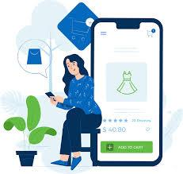

**User-Friendly Interface**: Design an intuitive and attractive user interface that makes the online shopping experience easy and enjoyable for customers.

**Product Management:** Create a system for sellers to easily add, update, and remove products, including images, descriptions, and pricing.

**User Registration and Authentication:** Implement user registration and login functionalities to personalize user experiences and ensure data security.

**Shopping Cart and Checkout:** Develop a robust shopping cart system that allows users to add and remove items, review their orders, and complete transactions securely.

**Order Processing:** Enable sellers to manage and fulfill orders efficiently, and provide users with real-time order status updates.

**Payment Integration:** Incorporate payment gateways to allow users to make secure online payments.

**Search and Filtering:** Implement search and filtering options to help users find products quickly and easily.

**Reviews and Ratings:** Enable users to leave reviews and ratings for products to build trust and inform other potential buyers.

**Responsive Design:** Ensure that the application is responsive, accessible, and compatible with various devices and browsers.

**Analytics and Reporting:** Provide data analytics and reporting tools to help sellers analyze sales trends and customer behavior.

**Design Thinking Process :**

**Empathize**

**User Research:** Conduct user surveys and interviews to understand the needs, preferences, and pain points of potential users.

**Market Analysis:** Analyze the competition and identify opportunities for differentiation in the E-commerce space.

**Define**

**User Personas:** Create user personas based on research findings to represent different customer segments.

**Feature Prioritization:** Determine which features are essential and prioritize them according to user needs and business goals.

**Ideate**

**Brainstorming:** Generate ideas for the user interface, navigation, and overall user experience.

**Wireframing and Prototyping:** Create wireframes and prototypes to visualize the application's layout and functionality.

**Prototype**

**Interactive Prototypes:** Develop interactive prototypes for user testing and validation.

**Usability Testing:** Conduct usability testing with potential users to gather feedback and iterate on the design.

**Test**

**Development and Testing:** Build the application incrementally, conducting regular testing and quality assurance.

**User Testing:** Continue user testing throughout the development process to ensure the application meets user expectations.

**Implement**

**Deployment:** Deploy the application on a web server, ensuring high availability and security.

**Monitoring and Maintenance:** Implement monitoring and maintenance processes to address issues promptly and keep the application up to date.

By following this design thinking process, we aim to create an E-commerce Flask application that not only meets user needs but also stands out in the competitive E-commerce market. The iterative nature of design thinking allows for continuous improvement and adaptation based on user feedback and changing market conditions.

**Development Phases:**

The development of the e-commerce application involves several key phases:

**Planning and Research:** In this phase, gather requirements, identify the target audience, and conduct market research. Define the application's features, functionalities, and goals. Create a project plan and set a budget.

**Design:** Design the user interface (UI) and user experience (UX) of the application. This phase involves wireframing, prototyping, and creating a visual design that aligns with the brand identity and user expectations.

**Backend Development:** Develop the backend server, database, and APIs to handle user accounts, product catalogs, shopping carts, and checkout processes. Ensure robust security measures, including data encryption and user authentication.

**Frontend Development:** Build the frontend of the application using technologies like HTML, CSS, and JavaScript frameworks (e.g., React, Angular, or Vue). Implement the user interface, shopping cart, and checkout pages.

**User Authentication:** Implement secure user registration and login processes, ensuring password encryption and authentication tokens.

**Shopping Cart and Checkout:** Develop the shopping cart functionality, including adding, removing, and updating items. Implement a checkout process that collects shipping and payment details, integrates with a payment gateway, and confirms orders.

**Testing:** Thoroughly test the application for functionality, security, and usability. Address any bugs or issues identified during testing.

**Deployment:** Deploy the application to a web server or cloud platform, ensuring high availability and scalability.

**Marketing and Promotion:** Develop a marketing strategy to attract users to the platform, including SEO optimization, social media campaigns, and email marketing.

**Maintenance and Updates:** Continuously monitor and maintain the application, addressing any issues, adding new features, and adapting to evolving user requirements and market trends.

**User Feedback and Iteration:** Gather user feedback and continuously iterate the application based on user suggestions and changing market conditions.

These development phases form a structured approach to creating a successful e-commerce application, ensuring that it meets its objectives and evolves to meet user needs over time.

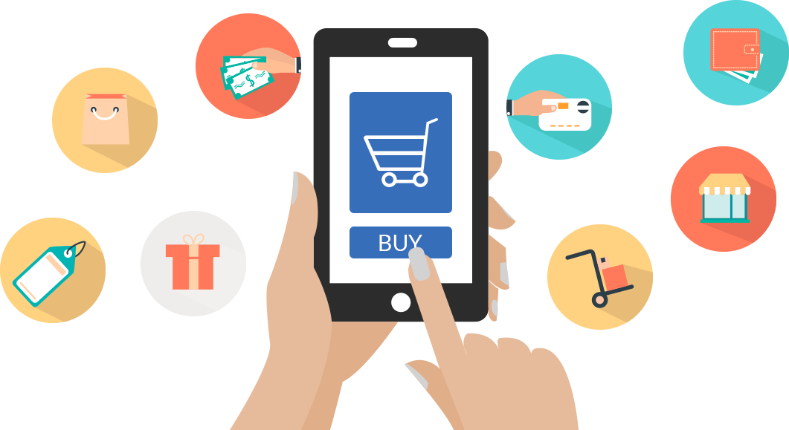

**Platform's layout, features, and technical implementation :**

**Platform’s layout :**

**Introduction**

The success of an E-commerce application heavily relies on its platform layout, as it significantly impacts user experience, navigation, and overall usability. A well-structured and intuitive platform layout is essential for a seamless online shopping experience. This document outlines the platform layout for our E-commerce application, ensuring that users can easily discover, browse, and purchase products.

**Home Page**

**1. Header**

**Logo:** Display the company logo for brand recognition.

**Navigation Menu:** Provide links to essential sections, including Home, Shop, Categories, Cart, and Account.

**Search Bar:** Enable users to search for products quickly.

**2. Hero Banner**

**Promotional Banner:** Highlight special offers, new arrivals, or seasonal promotions.

**Call-to-Action:** Include buttons or links to encourage users to explore featured products.

**3. Featured Products**

**Product Carousel:** Showcase a selection of trending or recommended products.

**Quick View**: Allow users to see product details and add to their cart without leaving the home page.

**Shop Page**

**4. Product Categories**

**Category Navigation:** Display a list of product categories, enabling users to filter products by type.

**Subcategories:** Offer subcategory options to further refine product searches.

**5. Product Listings**

**Product Grid:** Present products with clear images, titles, prices, and average ratings.

**Filters:** Include filters for price range, brand, size, and other relevant attributes.

**Sort Options:** Allow users to sort products by price, popularity, or newness.

**6. Pagination**

**Page Navigation:** Split product listings into pages to prevent overwhelming users with too many items on a single page.

**Product Details Page**

**7. Product Images**

**Image Gallery:** Display multiple product images with zoom and full-screen viewing options.

**8. Product Information**

**Title and Description:** Provide a clear product title and a detailed description.

**Price:** Show the product price and any applicable discounts.

**Add to Cart:** Allow users to add the product to their shopping cart.

**9. Product Variants**

Size, Color, etc.: If applicable, enable users to select product variants.

**10. Reviews and Ratings**

User Reviews: Display customer reviews and ratings to build trust.

**11. Related Products**

**Cross-Sell and Up-Sell:** Suggest related or complementary products to encourage additional purchases.

**Cart Page**

**12. Shopping Cart**

**Cart Contents:** List the items in the user's cart, including product details and quantities.

**Update and Remove:** Let users update quantities or remove items.

**Proceed to Checkout:** Provide a clear call-to-action to start the checkout process.

**13. Price Summary**

**Subtotal:** Display the subtotal of items in the cart.

**Shipping Costs:** Calculate and show shipping costs if applicable.

**Total Cost:** Present the total cost, including taxes and any discounts.

**Checkout Page**

**14. Checkout Steps**

**Shipping Address:** Collect shipping details.

**Payment Method:** Allow users to select their payment method.

**Order Review:** Display a summary of the order for confirmation.

**15. Order Confirmation**

**Order Number:** Provide an order number for reference.

**Thank You Message:** Express gratitude and confirm the successful order placement.

**Account Page**

**16. User Account**

**User Profile:** Enable users to view and edit their profile information.

**Order History:** Display a history of past orders with order details.

**17. Wishlist**

**Saved Items:** Let users save items for future reference or purchase.

**Footer**

**18. Footer Menu**

**Quick Links:** Include links to important pages, such as About Us, Contact, FAQs, and Policies.

**19. Contact Information**

**Contact Details:** Provide contact information, including email, phone, and physical address.

**20. Newsletter Signup**

**Newsletter Subscription:** Allow users to subscribe to newsletters for updates and promotions.

**Conclusion**

A well-designed platform layout is critical for the success of an E-commerce application. It should prioritize user-friendly navigation, product discoverability, and a streamlined checkout process. Regular user testing and feedback are essential to refine the layout and enhance the overall user experience.

By following the guidelines outlined in this document, we aim to create an E-commerce application with an optimized platform layout that ensures a positive shopping experience for our users.

**Platform Layout Output :**

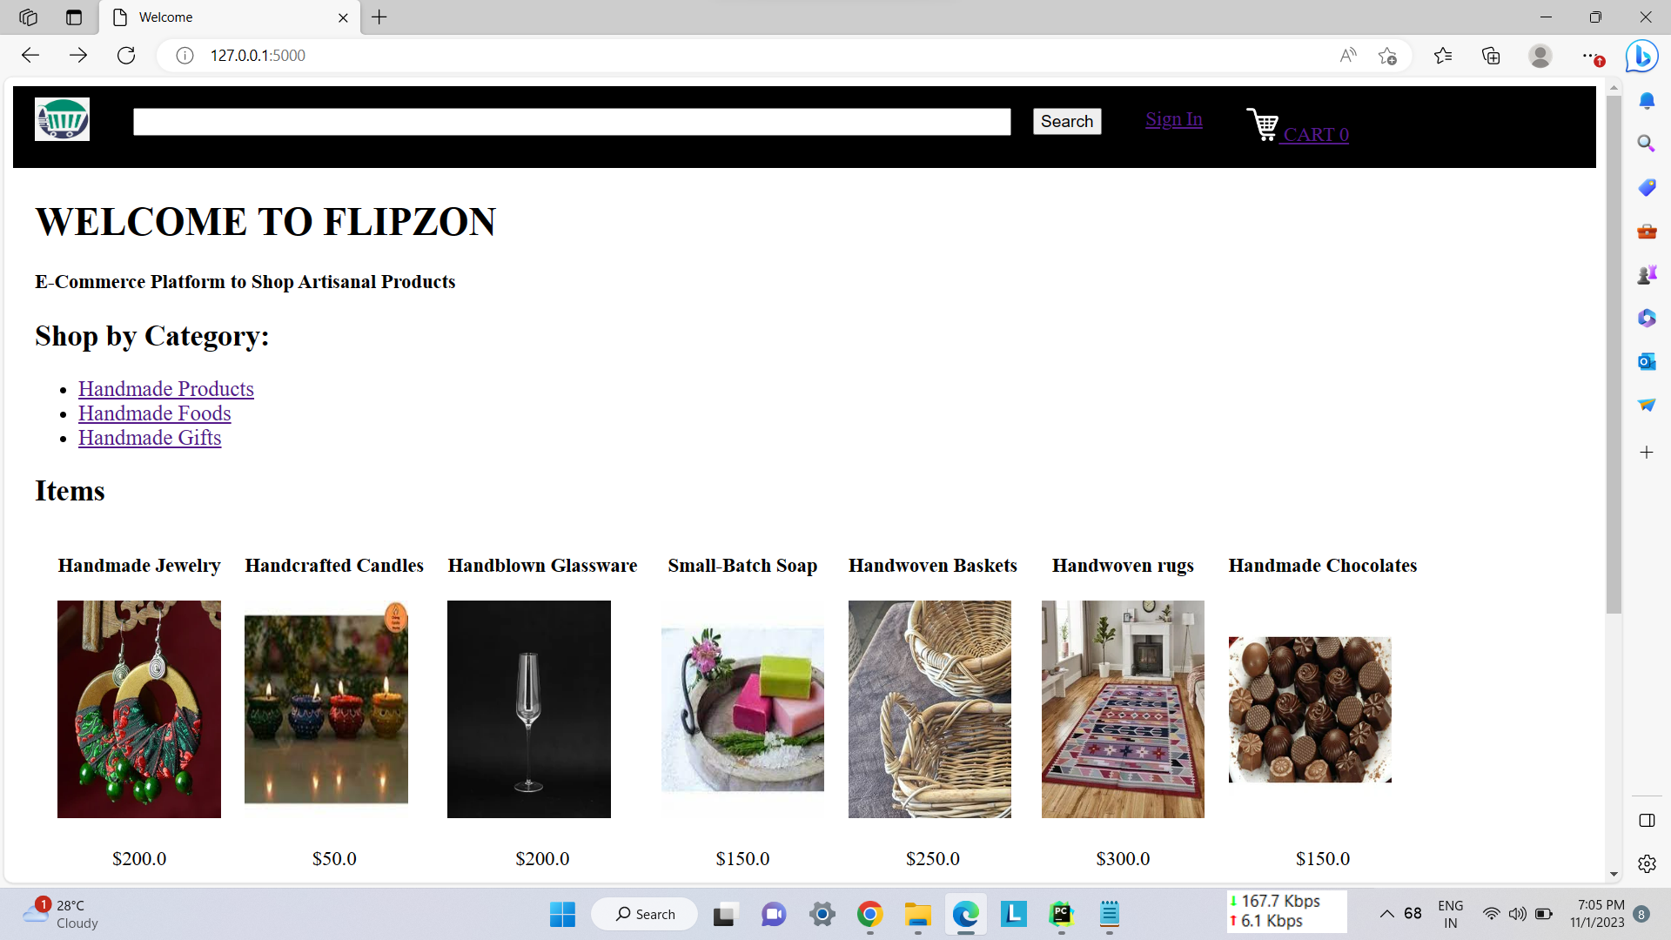

**Features :**

**1. Product Reviews:**

**Customer Feedback:**

Allow customers to leave reviews and ratings for products they have purchased. This helps other shoppers make informed decisions. Positive reviews build trust and credibility for your products and brand. Encourage users to engage with your platform by leaving reviews and sharing their experiences.

**2. Wishlists :**

**Save for Later:**

Wishlists allow users to save products they are interested in for future reference without committing to a purchase immediately. It will send email or app notifications when there are price drops or limited-time offers for items on a user's wishlist. Use wishlist data to personalize recommendations and marketing efforts.

**3. Personalized Recommendations:**

**Improved Shopping Experience:**

Utilize user browsing and purchase history to recommend products tailored to each individual's preferences and behavior.Suggest related or complementary products to increase the average order value. Keep users engaged by regularly updating recommendations on their homepage or via email notifications.

**4. Fast and Secure Checkout :**

**Multiple Payment Options :**

Offer various payment methods, including credit cards, digital wallets, and buy now, pay later. Allow guest checkout for users who prefer not to create an account.

**Secure Payment Processing :**

Ensure secure and reliable payment processing with encryption and fraud prevention. So that the Users can trust your Innovation.

**5. Social Media Integration :**

**Sharing Products :**

Enable users to share their favourite products on social media.

**Social Login :**

Allow users to sign in using their social media profiles for a seamless experience.

**User-Generated Content :**

Encourage users to post photos and reviews on social media, promoting your products.

**6. Seamless Navigation :**

**Intuitive UI/UX :**

Design an intuitive interface with clear navigation paths.

**Clear Categories and Filters :**

Organize products into categories and provide filtering options.

**Search Functionality :**

Implement a robust search feature with auto-suggestions and filters.

**7. Customer Support :**

**Live Chat :**

Provide real-time customer support through live chat for quick issue resolution.

**FAQs :**

Create a comprehensive FAQ section to address common user queries.

**Email and Phone Support :**

Offer email and phone support for more complex issues.

**9. Performance Optimization :**

**Speed and Reliability :**

Optimize website and app performance for fast loading times and reliability.

**Mobile Data Optimization :**

Ensure that your platform is not data-intensive for users with limited data plans. Frequently update your application to fix bugs and introduce new features.

**Personalized Search :**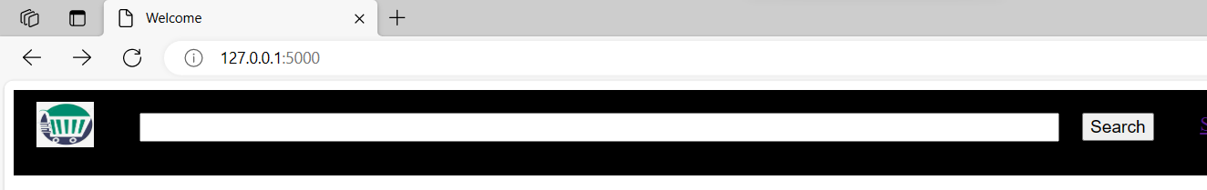

**Shop by Category** :

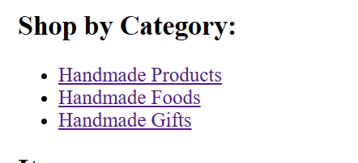

**Shopping Cart :**

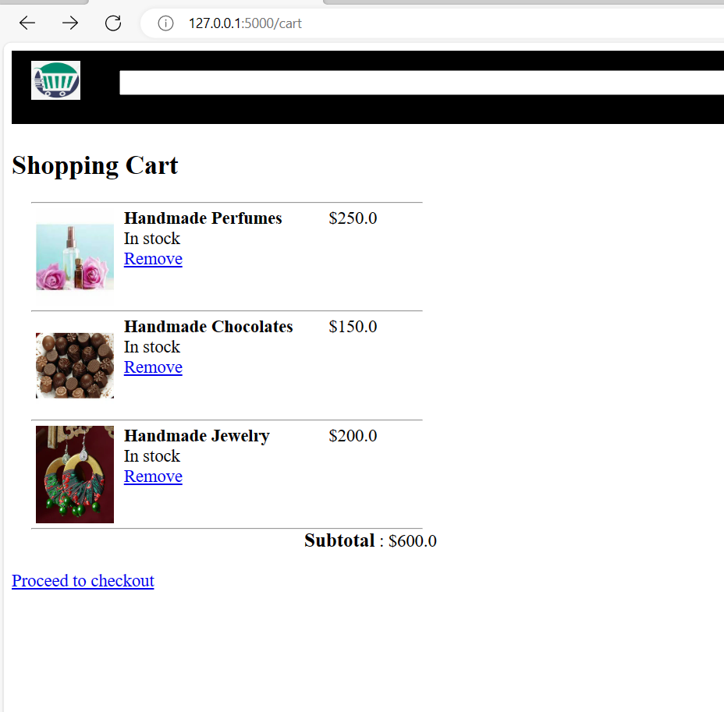

**Suggestions :**

