**ASSIGNMENT – SriiRohit P**

1. **THE MAIL SERVERS OF THE FOLLOWING DOMAIN**

**A)ibm.com**

**B)Wipro.com**

**#nslookup**

**#set type=mx**

**Ibm.com**

**#set type=mx**

**Wipro.com**

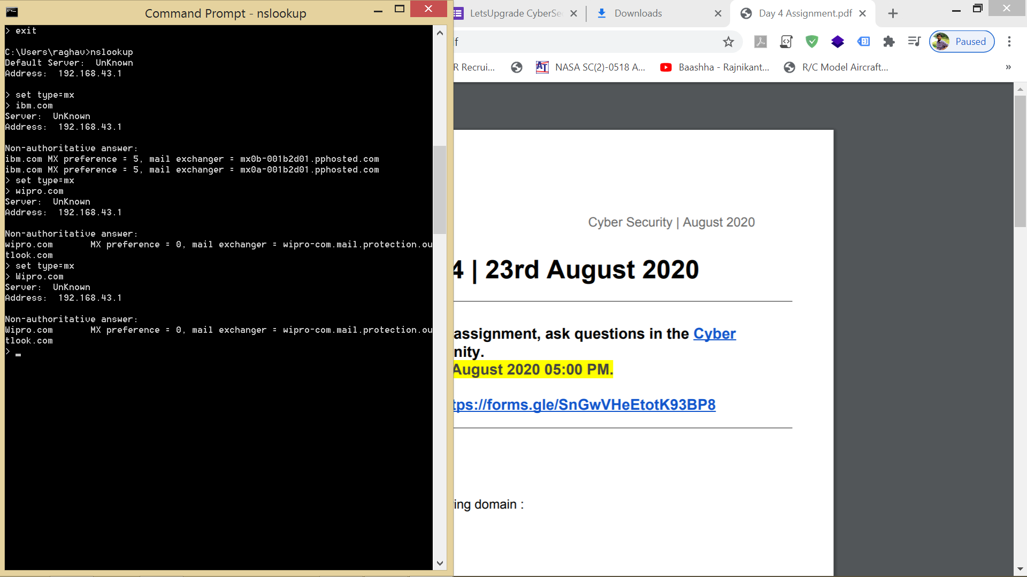

1. **THE LOCATIONS OF THE MAIL ADDRSS HOSTED**

**#Visit the link**[**http://my-addr.com/email_server_location/e-mail_box_server_location/locate_email_address_for_free.php?ept_email=bWFpbDFAaWJtLmNvbQ==&x=24&y=9**](http://my-addr.com/email_server_location/e-mail_box_server_location/locate_email_address_for_free.php?ept_email=bWFpbDFAaWJtLmNvbQ==&x=24&y=9) **Then type**[**mail@ibm.com**](mailto:mail@ibm.com)**there and verify the mailbox domain  
Similarly for wipro do,**[**mail@wipro.com**](mailto:mail@wipro.com)

1. **IBM.COM**

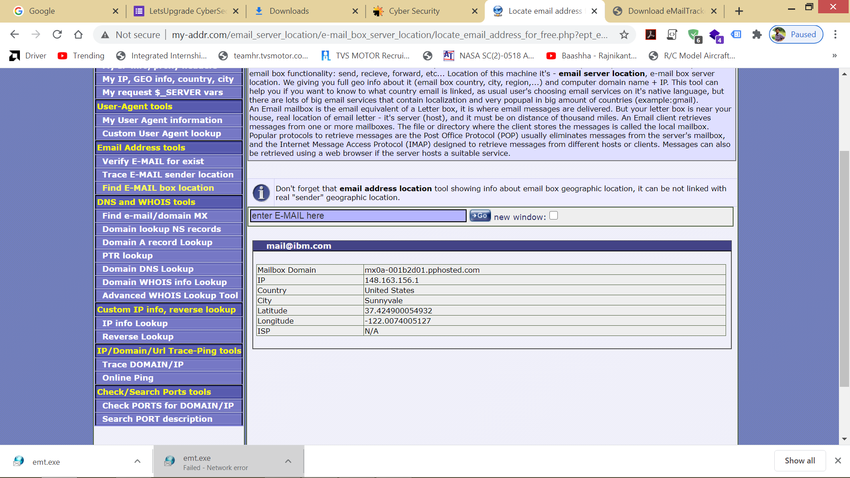

1. **WIPRO.COM**

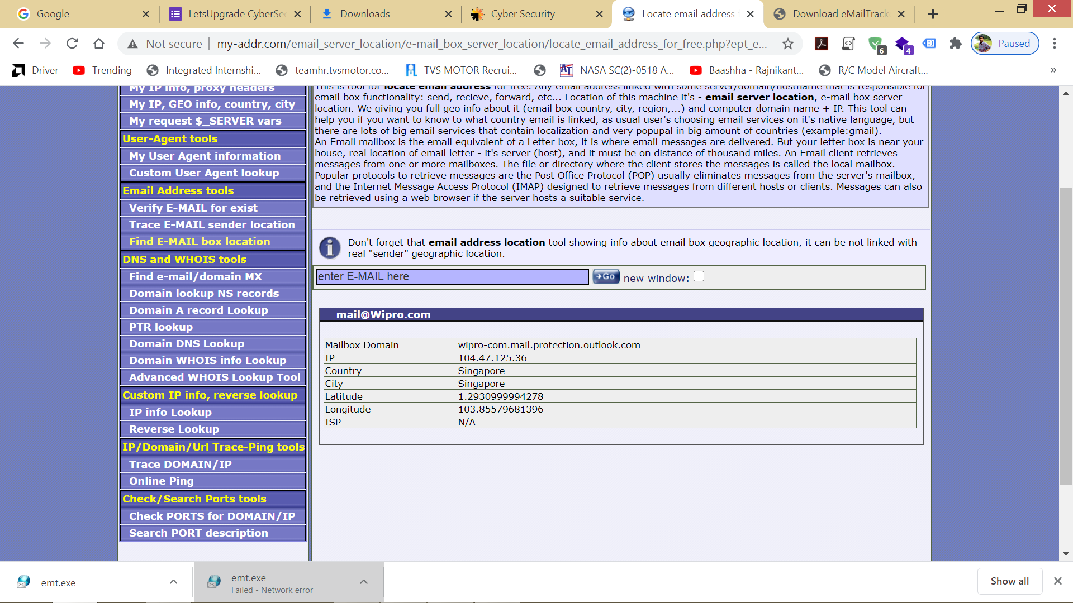

1. **Scan and find out port numbers open 203.163.246.23**

**#Download nmap or open terminal for nmap**

**#syntax : nmap -Pn 203.163.246.23**

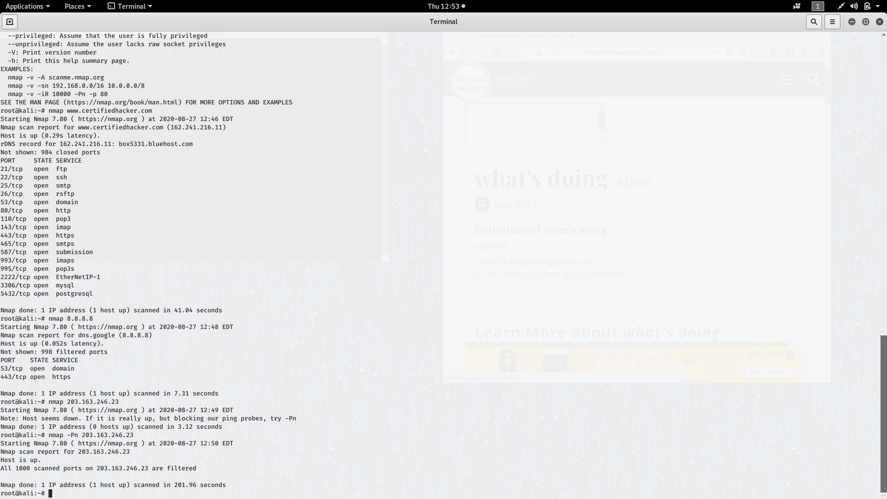

1. **To Install nessus in a VM and scan your laptop/desktop for CVE.**

**#Downloaded and Installed Nessus in VM**

**#Logged in with Activation code**

**#Selected Advanced scan**

**#Entered the name and credentials**

**#Finally scanned for vulnerabilities**

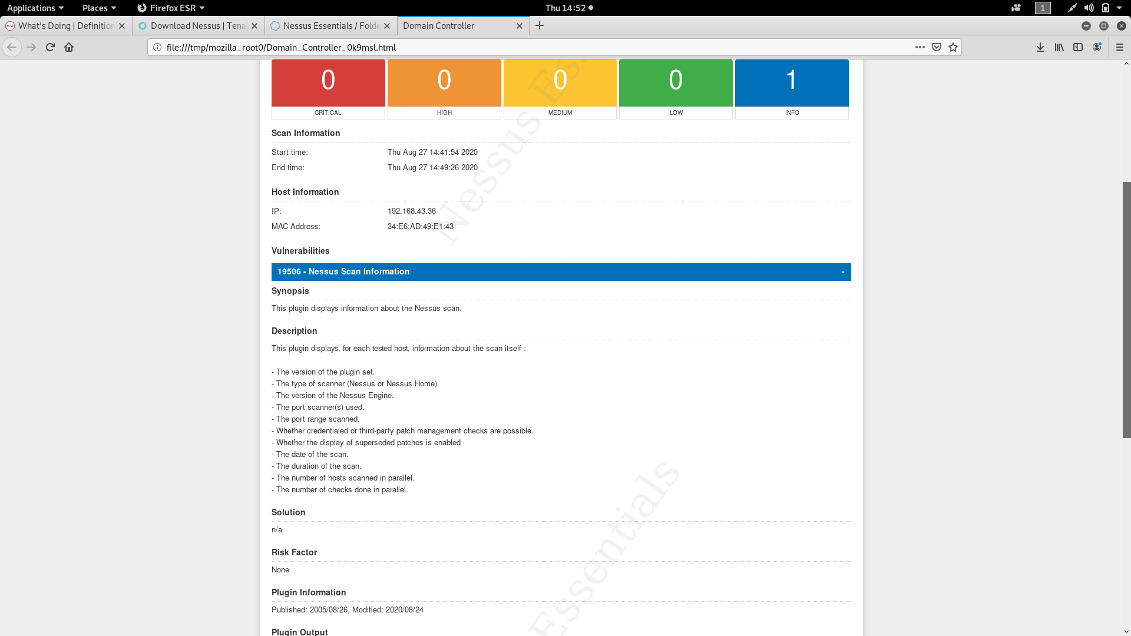

**THANK YOU**