**CAR ANALYSER**

**A PROJECT REPORT**

**FOR**

**FINAL YEAR PROJECT**

***Submitted by***

**ASHWINBALAJI G (15BCS008)**

**SRIRAM R (15BCS039)**

**IRSHAAD ABDUL GAFOOR KHAN A (15BCS046)**

***In partial fulfilment for the award of the degree*** *Of*

**BACHELOR OF ENGINEERING**

*In*

**COMPUTER SCIENCE AND ENGINEERING**

**KUMARAGURU COLLEGE OF TECHNOLOGY COIMBATORE 641049**

**(An Autonomous Institution Affiliated to Anna University, Chennai)**

**APRIL 2019**

**KUMARAGURU COLLEGE OF TECHNOLOGY COIMBATORE 641049**

**(An Autonomous Institution Affiliated to Anna University, Chennai) BONAFIDE CERTIFICATE**

Certified that this project phase-1 report **“CAR ANALYSER”** is the bonafide work of **Ashwinbalaji G (15BCS008), Sriram R(15BCS039) and Irshaad ABDUL GAFOOR KHAN A (15BCS046)** who carried out the Project work under my supervision.

**SIGNATURE SIGNATURE**

Dr. J. CYNTHIA, Ph.D., Ms D. Sathya, ME.,

**HEAD OF THE DEPARTMENT SUPERVISOR**

Department of Computer Science Department of Computer Science and Engineering, and Engineering,

Kumaraguru College of Technology, Kumaraguru College of Technology, Coimbatore-641049. Coimbatore-641049.

Were examined by as in the project viva voce held on

Internal Examiner External Examiner

**ACKNOWLEDGMENT**

First and foremost, we would like to thank the Lord Almighty for enabling us to complete this project work. We express our gratitude to Chairman, **Dr. B. K. KrishnarajVanavarayar B.Com., B.L.,** Correspondent, **Mr. M. Balasubramaniam M.Com., M.B.A.,** and Joint Correspondent**, Mr. K. Shankar Vanavarayar, M.B.A., PGDIEM.,** and Principal **Dr. Senthil Jayavel**for providing the necessary facilities to complete the project.

We wish to express our sincere gratitude to **Dr. J. Cynthia,** Professor and Head, Department of Computer Science and Engineering, for providing us her support and encouragement throughout the project.

We sincerely thank **Ms. D.Sathya,** Associate Professor, Department of Computer Science and Engineering, for her guidance and encouragement in carrying out this project work.

We would like to convey our regards to **all faculty members, non-teaching staff members and friends** for their continuous support.

**TABLE OF CONTENTS**

|  |  |  |  |
| --- | --- | --- | --- |
| **CHAPTER NO.** | **TITLE** | | **PAGE NO.** |
|  | ABSTRACT | | v |
|  | LIST OF FIGURES AND TABLES | | vi |
| 1 | INTRODUCTION | | vii |
| 2 | LITERATURE REVIEW   * Introduction * Literature Review   1. Introduction   2. Problem Statement   3. Result & Outcome   4. Conclusion | | viii |
| 3 | EXISTING SYSTEM | | xxiv |
| 4 | PROPOSED SYSTEM | | xxv |
| 5 | SOFTWARE DESCRIPTION | |  |
|  | 5.1 | Oracle Vmware | xxvi |
|  | 5.2 | Sas studio | xxvi |
| 6 | MODULE DESCRIPTION | |  |
|  | 6.1 | Methodology | xxvii |
|  | 6.2 | Architectural Design | xxviii |
| 7 | SYSTEM REQUIREMENT | |  |
|  | 7.1 | Software Requirement | xxix |
| 8 | REFERENCES | | xxx |

**ABSTRACT**

As kids, we can all relate to having fond memories of going from dealership to dealership with our parents, jumping in and out of the backseats of different cars, testing out all the different features. While test drives haven’t fallen by the wayside, the modern 2017 car shopper will only visit an average of 2 dealerships on their journey to buying their perfect new car.

The car buying journey has radically changed due to the digital boom over the past couple years. People are spending less time in dealership showrooms and more time researching and building out the perfect car. With the massive amount of information available on every model, it’s important to attract potential dealers to provide the right content, at the right time.

**LIST OF FIGURES**

|  |  |  |
| --- | --- | --- |
| Figure no. | Title | Page no. |
| 6.2 | **ARCHITECTURAL DESIGN** | xxix |

**CHAPTER 1**

Study on Consumer Buying Behavior

During Purchase of a Second Car

Study on Consumer Buying Behavior

During Purchase of a Second Car

Study on Consumer Buying Behavior

During Purchase of a Second C

**INTRODUCTION**

In India, over the last couple of years, the domestic passenger car market has witnessed a phenomenal growth. High degree of competition compels players in this industry to understand specific market needs while still providing value, in order to ensure success. In a particular year, a large portion of customers buy their second car. So, for marketers, it is important to understand the variables that influence consumer’s decision to purchase a second car. In this backdrop, an attempt has been made to uncover influencing factors behind purchase decision of a second car. From the research, it has been found that the segment who is buying second car has different priority factors that guide its buying decision. The study reveals that there are seven major factors that influence buying behaviour of a second time car buyer.

**CHAPTER 2**

**LITERATURE SURVEY**

**2.1 Factors Influencing the Purchase Decision of Passenger Cars in Puducherry:**

**INTRODUCTION:**

The automobile industry is one of the fastest growing sectors of the world.

India is the fourth largest exporter of passenger car and 6th largest producer in the world. A number of leading global automotive companies entered with the joint ventures and started producing variety of models with different features and providing value added services to attract the Customers. Hence the customer’s decision making becomes Complicated. Therefore, this study makes an attempt to identify the factors influencing the customers to purchase a passenger car. The secondary data was collected from 100 passenger car users of Puducherry with the help of a structured questionnaire. Various hypotheses were framed and tested. It is found that the customers were more focused on performance, technical features of the car during their purchase. Environmental factors were given least

importance during their purchases. The major weakness of Indian policy frame work is interstate differences and there are no much publications to create awareness among the general public. Therefore, it is essential to create awareness among the passenger car users regarding various environmental issues.

**PROBLEM STATEMENT**

**Uneven tyre wear**:It may not be obvious when driving that your car’s tyres are unevenly worn, but worn tyres can be dangerous due to their reduced grip on the road. A quick check will tell you if your tyres are worn unevenly. The easiest way is to jack up your car and inspect each tyre individually, noting whether there are any bald spots on the inside or outside of the tyre, or whether there are any dips and dents in the tyre tread.

**Problems starting the engine**: Your car either takes a long time to start, or the car simply won’t start at all.

**Air conditioner not working:** Your air con will switch on, but you notice it’s just blowing room-temperature air around rather than cold air.

**Engine overheating**:You may notice steam or smoke coming from your bonnet, or the needle on your engine temperature gauge may be through the roof.

**Noisy brakes**: You’ll know it when you hear it.

**RESULT & METRIC**

**Uneven tyre wear:** In terms of how often you should get your tyres rotated, it’s different for every vehicle and type of tyre, but having them rotated at every oil change is a good rule of thumb. Check with the tyre manufacturer for a more specific time frame. Remember that the more often you rotate your tyres, the more evenly they’ll wear, and when you have the tyres rotated, you should also get them checked for balance and alignment.

**Problems starting the engine:** There are a number of reasons which can cause a car engine not to start, the most common, of course, being a dead battery. Pay special attention to the noise it makes when you turn the key. Is the car completely silent? If so, there may be a problem with your battery terminal cable connections. Does your car crank over but not start? Then it may be your spark plugs or fuel supply to your engine. In any case, if you’re out on the road, try jumpstarting your car then investigating the cause further when you’re safely back at home.

**Air conditioner not working:** The most likely cause of this is that there is no refrigerant left in your system. This could be caused by a leak in your system somewhere, which will have to be fixed before refilling the refrigerant. If you’re car-savvy and you own a set of air conditioning gauges, refilling the refrigerant is usually easy to do yourself. However, if you’re not so confident, enlist the help of a knowledgeable friend or take a quick trip to the mechanic.

**Engine overheating**:Overheating can be caused by a few different factors. The simplest cause may be that your car needs more coolant. Yet depleted coolant can be caused by bigger problem, like leaks or faulty hoses, so always check for the underlying cause before simply filling it up with more. Another common reason for overheating may be that the radiator fan which keeps your engine cool is faulty, so check your fan motor connection and fan thermostat.

**Noisy brakes:** There could be a number of reasons for noisy brakes. It could be that your brake pads are loose, worn out, or you may have brake dust inside the drum. If you can’t see anything wrong with your brake pads, and you suspect it may be brake dust, it may be best to leave this to a professional – brake dust can be extremely dangerous if accidentally inhaled.

Research Methodology

**CONCLUSION**

It is concluded that the customers were more focused more on performance than Environmental factors and safety.Therefore it is essential to create awareness among the customers regarding various environmental issues by organizing seminars and providing information through websites to the passenger car users. Governments, nongovernmental organizations and private corporations have been adopting various strategies to assure the level of anti-environmental practices in the areas of waste disposal, air emission, use of natural resources, etc.

**2.2Indian Foreign Trade with Reference to Automobile Industry**

**INTRODUCTION**

Indian economic development and Indian foreign trade ventures are following a growth trajectory. Indian foreign trade has come a long way in terms of export value since independence in 1947. The total value of India’s merchandise exports increased from US $ 1.3 billion in 1950-51 to US $ 63.8 billion in 2003-04 at a compound rate of 7.6 per cent. Trade growth has picked up the pace post liberalization of 1991. The composition of trade is now dominated by manufactured goods and services. There is huge untapped potential for Indian foreign trade in years to come. The auto industry in India is the ninth largest in the world. After Japan, South Korea and Thailand, in 2009, India emerged as the fourth largest exporter of automobiles. Several Indian automobile manufacturers have spread their operations globally. Indian auto industry, which is currently growing at the pace of around 18 % per annum, has become a hot destination for global auto players like Volvo, General Motors and Ford. The Indian automobile industry is going through a phase of rapid change and high growth. With new projects coming up on a regular basis, the industry is undergoing technological change. The major players are expanding their plants and focusing on mass customization, mass production

**PROBLEM STATEMENT**

**Accelerator Friction Pad:** Accelerator systems are now fully electronic “drive by wire”. The electronic housings need to be light weight and strong while the pedal needs to ‘feel’ like a mechanical system.  (Heat range – 40°C to 80°C).

### Steering Position Sensor: There is a part of the steering position assembly where a shaft rotates inside the position sensor with tight tolerances which can lead to unwanted noise and wear.

### Transmission Seals &Washers: Government regulation for fuel efficiency is driving the need for higher performance wear compounds in the power-train. The industry is also trying to increase efficiency & reduce weight to increase fuel economy. This application operates in transmission fluid with high PV.

### HVAC Gears: Due to extreme temperature changes (-400c to 800c) gears were creating excessive noise leading to warranty issues**.**

**RESULT & METRIC**

**Accelerator Friction Pad:** RTP 1300 Series PPS with glass fiber and PTF

* The wear compound was successfully developed with the right balance of friction and wear to provide the ‘feel’ required by the OEM.
* Light weight
* Excellent dimensional stability

### Steering Position Sensor:RTP 4000 Series PPA with glass fibre and PTFE

* Internal lubricants
* Reduced friction
* Reduced noise (squeaking)

### Transmission Seals & Washers: RTP 2200 Series with Ultra Wear additives

* Eliminates the need to machine a part from a stock form
* Significant reduction in manufacturing cost
* Reduced coefficient of friction

### HVAC Gears:RTP 200 series and 800 series with glass fibre and PTFE.

* Noise reduction
* Low friction
* Improved wear resistance

**CONCLUSION**

India is expected to become the third largest automobile market in the world. In a developing nation and agro based economy like India, this is a great indicator of economic development. The rapid improvement in infrastructure, huge domestic market, increasing purchasing power, established financial market and stable corporate governance framework have made the country a favorable destination for investment by global majors in the auto industry. Access to latest and most efficient technology and techniques will bring competitive advantage to the Indian players. The role of Industry will primarily be in designing and manufacturing products of world-class quality establishing cost competitiveness and improving productivity in labor and in capital. With a combined effort of manufacturers and conducive Governmental policies, the Indian Automotive industry will emerge as the destination of choice in the world for design and manufacturing of automobiles.

* 1. **Study on Consumer Behaviour During Buying Purchase of a Second-hand Car:**

**INTRODUCTION**

In modern world economy, car ownership is a major parameter to understand economic development of any country. Increasing degree of car ownership signals countries’ economic and social development. It plays a major catalytic role in developing transport sector on one hand, and helps industrial sector on the other to grow faster and thereby generate significant employment opportunities. It is modelled as a function of socio economic variables, household characteristics or public transport services According to Chamon et.al cars have been one of the main tradable goods in modern economies for a decade. They are the second most expensive single item purchased by a household after a house. It is viewed that increasing incomes during the second half of the 20th century have allowed a marked increase in car ownership in all industrialized countries, and more recently in many parts of the developing world because saturation levels vary across countries. As second most populated country of the world, the growth rate of Indian economy is very high. This indicates the presence of huge demand in different industrial sectors. In this regard, automobile industry is no exception. Indian automobile sector has a huge demand from its own country. In India, over the last couple of years, especially the domestic passenger car market has witnessed a phenomenal growth. Arrival of new and existing models, easy availability of finance, competitive pricing, and guarantee of superb quality service have stimulated the demand for vehicles and witnessed a robust growth of the Indian passenger car industry.

**FACTORS**

* **Factor 1: Product Efficacy:**

For a new car purchase, a car’s attraction is not only at the functional, tangible level but also at the intangible, symbolic level. As a result, consumers’ reactions to cars are often

emotional and unconscious (Seidel et al.,2005). From this study, it has been revealed that major important factor that influences buying decision of a second car is product efficacy. In present study, significant items in this factor are: ‘I choose my brand which has a good resale value’, ‘After sales service is my primary concern when buying my second car brand’, ‘Riding comfort is my primary concern when buying my second car’, ‘I chose my second car for space and comfortable /stylish interiors’, ‘I have more than one preferred brand’, ‘Look of the car is an important concern when buying my second car’. This factor explains that at the time of buying their second car, consumers give more emphasis on product performance. Attributes like reliability, performance, driving comfort, status conveying interiors, residual value, cost of driving, and look of the car are some of the benefits consumers are looking for at the time of picking their second car. This might be due to the fact that as consumers already have satisfied their social and psychological need with their first car, at the time of next purchase, they are banking more on tangibles in terms of attributes and benefits

* **Factor 2: Image Equalizer:**

Grubb and Grathwohl (1967) specified that the consuming behaviour of an individual would be directed towards enhancing self-concept through the consumption of goods as symbols. Consumers were thought to prefer products with images that were congruent with their self-concepts (Levy, 1959). Self-image congruity, the relationship between one’s self-image and one’s image of a product or service, is a widely accepted consumer behaviour. Self-concept in the sense of self- image is of the interest to marketers because many consumers select products and brands that fit or match their images of themselves (Goldsmith, 1999). In this study, it has been found that consumer’s image consciousness is the second most important influencing factor behind the choice of the second car. The loading of variables is ‘My choice of brand says something about me as a person’, ‘I would like to move upmarket to luxury segment in the second car’, ‘I think my brand should go with my designation’, ‘I like to change brands for the sake of novelty and variety’. This reveals that after product efficacy, consumers evaluate the brand after considering their own self-image and social self-image. In this process, whenever a person thinks of a particular car brand, an image forms in his mind about the car. In case this image is aligned with the image the person has built about himself, or in case this image is aligned with the image the person would like others to have about him, he will go in for making the purchase

* **Factor 3: Experienced Maven:**

Since there are many sources of conflicting information in the market, Morwitz and Schmittlein (1992) found that past usage of a durable good moderated the accuracy of future purchase intention. The level of satisfaction determines the depth of customers’ commitment towards a brand (Fornell 1992). Experienced consumers should be better able to assess the pros and cons of engaging in the behaviour and to understand the factorsthat will influence the decision than other consumers (Morwitz, 1997). In this study, we have seen that a second car is bought in most cases as an outcome of the satisfaction level of the first car. Major dimensions in the factor ‘I will prefer to buy a brand from the stable previous car company as it gives me service assurance’, ‘My choice of brand is largely based on my own experience’, ‘I stick with my previous brand as this saves me time’, ‘My choice of brand is largely based on market reputation’ reveal that a customer generally relies a lot on the past experience. This includes his experience about performance, reputation, kind of service, quality and image of other cars manufactured by them, the image and attractiveness of spokesperson, the type of dealerships through which they sell. The second car choice is a more conscious decision and driving experience of first car and unfulfilled desires in buying and driving the first car are of utmost importance. Satisfaction with the previous car and previous dealer influence car repurchase (Lapersonne, Laurent, and Le Goff, 1995).

* **Factor 4: Social Appreciation:**

In a social context, it has been viewed that the enjoyment from sharing is enhanced when other people provide positive judgments about the shared stimuli and diminished when they provide negative judgments about them (Cruz, Henningsen and Williams, 1999). Social approval acts as a deterrent as well as a driving motive for certain consumer decisions. Every individual strives for and seeks respect from society, but more so fears disrespect or disapproval from the same. It has been seen that the influence of reference of society is much higher on those people whose fear of negative evaluation is higher, and those who have a higher need for affiliation in the society. The present study also supports the same as car purchase is a socially visible object. The loading of variables like ‘I buy the brand my colleagues buy’, ‘My choice of brand is based on what my friends buy’ indicate that probable social appreciation attached with the purchase guides the selection. The social respect in India is a big factor when it comes to buying goods depicting social status. So, at the time of buying a second car, consumers may face the prospect of being looked down upon by the society

* **Factor 5: Favourite Fondness:**

Eagly and Chaiken (1993) argue that consumption attitude is a psychological tendency that is expressed by evaluating a particular consumption related entity with some degree of favour or disfavour. Purchase intentions are likely to be highly and positively correlated with attitudes toward the product. All other factors, such as price or subjective norms, held constant, consumers should hold favourable purchase intentions for products they like and unfavourable intentions for products they dislike (Morwitz, 1997). This study deliberates that respondents are vocal about their preferences for specific brands. The loading variables are: ‘I make my purchase according to my favourite brand, regardless of the company making the same’, ‘I make my purchase according to my favourite brand, regardless of the country of origin of the car’, and ‘I make my purchase according to my favourite brand, regardless of price’

* **Factor 6: Family First:**

With respect to the family life cycle, it has been observed that the second cars are purchased mostly in the “parenthood stage”. In India, because of the high degree of family orientation, brands with identities that support family values tend to be popular and accepted easily by the segment. Family is of dominant concern for most Indians (Mandelbaum, 1970). It encourages connectedness and mutual deference or compromise and social interdependence as dominant values creating a collective identity among individuals (Tafarodi and Swann, 1996). Second car buying decision also follows the trend. Factor loading variables like ‘My family would like to make a statement in the second car’, ‘Seating capacity is my primary concern when buying a second car’, ‘The second car is more for my family needs than for my own use’ support the influence and importance of family behind selection of second car.

**PROBLEM DEFINITION**

The decision of buying the second car is extremely complex, and requires huge investment in terms of money and time. From the study, one may see that there are several issues that make the purchase of a second car different from that of a new car. To ensure a quick understanding about various influencing factors behind the selection of second car, we summarize importance of different influencers through this study.

For instance, functional level factor like product efficacy is a major concern for a second car buyer. Further, a typical consumer only thinks about those brands in his consideration set that gel with his own image. Moreover, at the time of buying a second car, a typical consumer banks more own past experiences. So, high level of investment in promotional schemes may not assure high level of repeat purchase.

On the contrary, a long term customer relationship may become fruitful to the marketer in order to motivate the consumer to pick his second car from the same stable from where he picked his first one. Dibb (2001) defined segmentation as ‘a process of grouping customers in markets with some heterogeneity into smaller, more similar or homogeneous segments; the identification of target customer groups in which customers are aggregated into groups with similar requirements and buying characteristics’.

**RESULT & METRIC**

It has been seen that majority of the respondents bought existing car from mini or compact hatchback segment. For example, 29% of respondents own mini cars, 42% respondents own compact hatchback and only 18% of them own three box sedans. Ownership age of existing car varies between one to five years. Majority of the respondents (near about 64%) would like to buy a second car after four/ five years of existing car ownership. Another interesting finding is that near about 53% of them are satisfied with their existing car and 29% of them are highly satisfied with their existing car. Respondents are asked to indicate their choice about second car segment. Out of them 40% would like to buy their new car from sedan segment and 25% would like to elevate to SUV/MPV segment. Near about 30% still would like to buy it from compact segment and a fraction would like to be a proud owner of a luxury car.

**CONCLUSION AND FUTURE WORK**

The findings of this study uncover underlying factors that influence buying behaviour of a second car. However, the study is conducted in India, and the results and discussion should be viewed in context to India. However, the result may further be verified in cross country context to understand the similarities and differences among factors. Moreover, the association among notable demographic variable and the degree of influence of factors may be analysed in next phase of study. This requires further in-depth analysis with large sample size. Future research on factors influencing buying behaviour of second car should be further examined by considering additional variables and dimensions of demographic, economic, cultural, social, psychographic, and behavioural aspects.

**2.4 A STUDY ON THE CUSTOMER PREFERENCES OF AUTOMOBILES USING FUZZY LOGIC**

**INTRODUCTION**

This paper has made a scientific approach to identify the key factors that influence the consumers (1) while selecting the appropriate four wheelers especially cars by considering the parameters such as mileage, maintenance cost, brake failure, comfort and brand which are obscure and imprecise in nature. With regards to the selection of four wheelers like cars, the consumers are in dilemma to identify and select an appropriate model. The survey has been conducted in an automobile industry by analyzing the customer’s preferences in buying a car. Hence, decision making is a challenging and not a facile task. For the above study, this paper has successfully utilized Multi Criteria Decision Making (MCDM) tool called Graph Theory and Matrix Approach (GTMA) (3) for a successful purchasing decision making by the customer. The parameters were identified by conducting a pilot study and questionnaires were distributed to the respondents and thus data have been collected, and the data were consolidated for the analysis

**PROBLEM DESCRIPTION**

Very often, understanding and fulfilling requirements based on customer’s preferences (6) -(9) is a challenging task for any sector. Beyond technical aspects, certain human aspects such as Ergonomic design and aesthetic design govern the automobile industry to a great extent. This paper deals with the consumer preferences which mainly depend on the factors such as maintenance cost, mileage, comfort, brake failure and brand image while taking a decision to buy a car. The above factors are nebulous and obscure in nature. Selecting the product which is suitable to consumer’s desire is not a facile task. The consumer’s requirements are high mileage, minimum maintenance cost, zero brake failure, developed and stabilized talkative brand and luxury interior. The major influencing factor deciding the consumer preferences must be known.

**RESULT & METRIC**

The concept of fuzzy set helps us to unravel the quantum of uncertainty associated with events. These events may be well defined engineering problems, such as design and development, control system design or fabrication of machine tools. The inputs may be time-varying, interactive in nature leading to multi input, multi output system. Thus each system possesses a degree of uncertainty associated with them. There are different faces of uncertainty. They are

∙ Inexactness – Inability to measure variables un precise manner.

∙ Semantic ambiguity – Property of possessing several distinct, but plausible and reasonable, interpretations of a particular state.

∙ Visual ambiguity – Refers to or arises due to the position or location or trajectory of an object or a system due to the representation of the object or observer position with reference to object.

∙ Structural ambiguity – The interconnections and interactions of different components can cause a high level of vagueness.

∙ Undesirability – This originates from our responsibility of discriminating different systems of an event

**CONCLUSION**

It was decided to analyze the customer preferences in automobile for 1200cc vehicles. Survey was conducted among the consumers. Multi Criteria Decision Making Tool Graph Theory and Matrix Approach has been successfully applied to identify the consumer preferences. Fuzzy logic decision making tool was also applied to analyze the influencing factor in customer preference among the 1200cc vehicles. The scope of the study was confined to only 1200cc four wheelers. The study might be extended for 1500cc and 2000cc vehicles too.

**2.5 Present Indian Automobile Industry**

**INTRODUCTION**

As India’s economy continues to grow at a rapid pace, the automobile industry will be a key beneficiary. This is widely true across automotive markets—from those serving customers with two-wheelers and four-wheelers to those offering commercial vehicles. The main factors behind such growth are the increasing affluence of the average consumer, overall GDP growth, the arrival of ultra-low-cost cars, and the increasing maturity of Indian original equipment manufacturers (OEMs). The automotive Industry in India is now working in terms of the dynamics of an open market. In India, automobile sector is one of the largest growing industries. Many joint ventures have been set up in India with foreign collaboration. India also has one of the fastest growing economies, and many U.S. companies view India as a potentially lucrative market. It is expected that the automotive industry will play an important role in helping the economy to continue this growth. This paper gives an overview of Indian Automobile Industry.

**PROBLEM STATEMENT**

Low R&D: In India Research and Development program is in automotive sector is very low compared to other countries.

• Fuel price volatility: It is one of the major factor. As price of fuel increases, rate of vehicle purchasing decreases.

• Slowdown in demand: There is slowdown in demand of vehicles India due to high price of vehicles.

• Skilled manpower: Auto industry, like many other industries is facing severe shortage of skilled technical as well as managerial manpower. This challenge becomes all the more daunting because of lack of adequate training infrastructure. There is also an urgent need to improve the quality of skilled and semiskilled manpower working in the auto industry.

• Growing competition: There is fierce competition among the automobile players in India. Everyone wants to have a share in the domestic market. Manufacturers’ margins have been squeezed severely and they are all under pressure to cut costs to be profitable and competitive.

• Taxation Complexity: Tax laws in India are believed to be one of the most complex laws across the globe. The complexity is due to a plethora of associated processes.

• The inadequacy of road infrastructure in India is a big bottleneck in the Indian automotive sector. This is compounded by the fact that traffic management is very poor non-existent. Also, port capacity is not adequate to ship exports from India. in a number of locations.

• Infrastructural constraint Land acquisition norms, processes, and timelines: Due to lack of proper implementation of standardized processes relating to land acquisition as well as difficulty in approaching the concerned department/ ministry/organisation or at the right time, it becomes difficult to acquire required land and Other challenges includes Environmental issue, changing customer preferences, growth in input cost.

**RESULT & METRIC**

**Connected Cars**

Connected cars and infotainment are the future. Auto manufacturers are increasingly focusing (and should continue to focus) on connected cars to significantly advance the driving experience of drivers. A connected vehicle could also have Predictive Diagnostic Tools to check vehicle’s health and accordingly warn the driver in case there are any issues with the vehicle, eliminating any unexpected breakdowns. With additional features like parking assistance, driver warning systems, weather and traffic reports, and music streaming, connected cars promise to make driving more safe, convenient and enjoyable. However, this trend is not restricted to passenger vehicles alone and is applicable to public transportation as well.

**Green Cars**

Indian Government is on a serious mission to go green. Rising fuels costs and pollution levels are some of the reasons for this endeavour. In fact, the India National Electric Mobility Mission Plan 2020 envisages that by 2020, there will be 5-7 million electric vehicles (EVs) on the roads. There has also been a conscious shift by auto manufacturers to move towards energy efficient vehicles and hybrid/ electric vehicles.

**Cloud and Big Data**

Indian auto industry has usually carried out processes for marketing and sales manually. Cloud and big data has the potential to not just bring in operational efficiency in the automotive functions but also drive down IT applications and infrastructure costs. Adopting cloud-based solutions will enable Indian auto manufacturers to standardize processes and automate data-heavy transactions that come in the form of invoices, purchase orders and shipping notices, and so on, thereby eliminating delays and human errors.

**CONCLUSION**

The automotive industry is at the core of India’s manufacturing economy. India is positioned to become one of the world’s most attractive automotive markets for both manufacturers and consumers. The resulting benefits to society—in economic growth, increased jobs, and stability for families employed by the automotive industry—are considerable. All in all, India is set to become one of the biggest automobile industry in coming time.

**CHAPTER 3**

**3.1 EXISTING SYSTEMS**

Several approaches based on machine learning are implemented, such as

* Naive Bayes,
* SVM Classifier,
* Linear Regression.

**DRAWBACKS**

* That’s **perpetually** **counting on** previous **knowledge**.
* Miss classification (Doesn’t supports Multi-Label Classification)
* Less prediction
* Normally, **lots** of users tend **to buy** vehicles **based mostly** upon false **data** given by **on-line** **automotive** websites.
* People **sometimes** **take into account** **the value** **instead of** **the necessities** that **they have** **while not** knowing that there are **higher** cars **which can** suit them **beneath** their budget

**CHAPTER 4**

**4.1 PROPOSED SYSTEM**

* We’ll use machine learning algorithms in order to get the requirements from the user.
* For e.g., the environment in which the user uses the vehicle, miles travelled per day, performance requirements etc.
* Finally, the analysis will yield a result which will be a right choice for the user based upon the simple information given rather than more complex technical terms.

**CHAPTER 5**

**ALGORITHM DESCRIPTION**

The KNN formula trained with the options extracted and predict the simplest automobile model.

Well, KNN it capable of doing each classification on multi-labelled knowledge.

The profit is that you just will capture way more complicated relationships between your knowledge while not having to perform troublesome transformations on your own.

KNN formula from the Scikit-learn Python library that implements this algorithm. This formula produces a prediction label.

Label encoder technique is employed label the automobile model within the dataset and makes classification additional correct than general label data. when the inverse label data, it offers foreseen automobile model all details.

Also this implementation is more improved with user interface interface for simple accessing by the users.

**CHAPTER 6**

**MODULE DESCRIPTION**

**6.1 METHODOLOGY**

So the goal is to get the requirements from the user and predict the appropriate suggestions of cars which match the requirements .  
  
1.Splitting up of cars into three genres ( Performance, Luxury, class)  
2.Fusing together the columns of the dataset based upon conditions which will be unique for the three classes.  
3.Getting the user requirements  
4.Using supervised learning algorithm to predict the suggestions based upon the conditions that were fused earlier.

**MODULE 1: - software package installation & packages configuration. Load Train Dataset & Pre-processing**

**MODULE 2: - Feature Extraction, produce train model**

**MODULE 3: - Load take a look at information, Pre-processing & Feature Extraction**

**MODULE 4: - Classify the simplest automotive by taken their options**

**CARS.CSV**

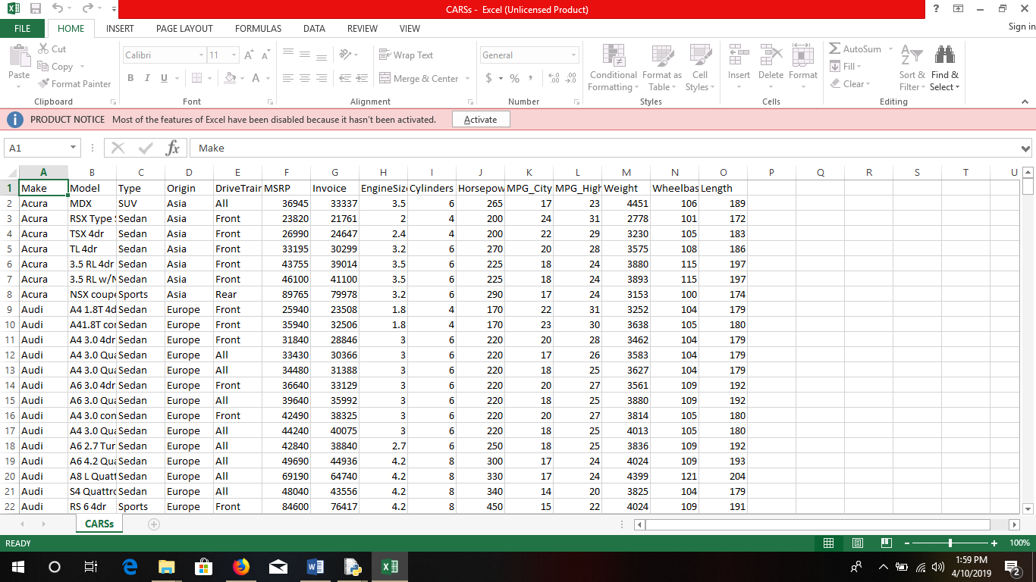

**CLASS_CARS.PY**

import warnings

warnings.filterwarnings('ignore')

import os

import numpy as np

import pandas as pd

from sklearn.preprocessing import StandardScaler

from sklearn.preprocessing import LabelEncoder

cars = pd.read_csv('CARSs.csv', delimiter=',')

print cars

lux_cars=cars.loc[(cars['Type']=='Sedan')]

X=cars[['MSRP','MPG_City','MPG_Highway']]

yy=cars['Model']

le = LabelEncoder()

le.fit(list(yy))

y = le.transform(yy)

##from sklearn.svm import SVC

##

##clf =SVC()

from sklearn.neighbors import KNeighborsClassifier

clf = KNeighborsClassifier(n_neighbors=5)

#clf =OneVsOneClassifier(SVC())

#clf.fit(X, y)

clf.fit(X, y)

##car_MSRP=input("Enter MSRP")

##car_Weight=input("Enter MPG_City")

##car_Length=input("Enter MPG_Highway")

def get_detail(car_MSRP,car_Weight,car_Length):

df={'col1':[car_MSRP],'col2':[car_Weight],'col3':[car_Length]}

x_test=pd.DataFrame(df)

pred,neigh=clf.predict(x_test)

'''pred_y=le.inverse_transform(pred)

ans=cars.loc[(cars['Model']==pred_y[0])]

return (ans.iloc[0].values)'''

temp_label=[]

temp_ans=[]

neigh_pred=neigh[0]

for i in range(0,len(neigh_pred)):

temp_le=le.inverse_transform([neigh_pred[i]])

ans=cars.loc[(cars['Model']==temp_le[0])]

ans=str(ans)

#ans=str(ans[:-20:1])

temp_label.append(ans)

seperator = '\n'

result=seperator.join(temp_label)

result=" ".join(result.split("[1 rows x 15 columns]"))

return result

if __name__=="__main__":

print(get_detail(89765,17,24))

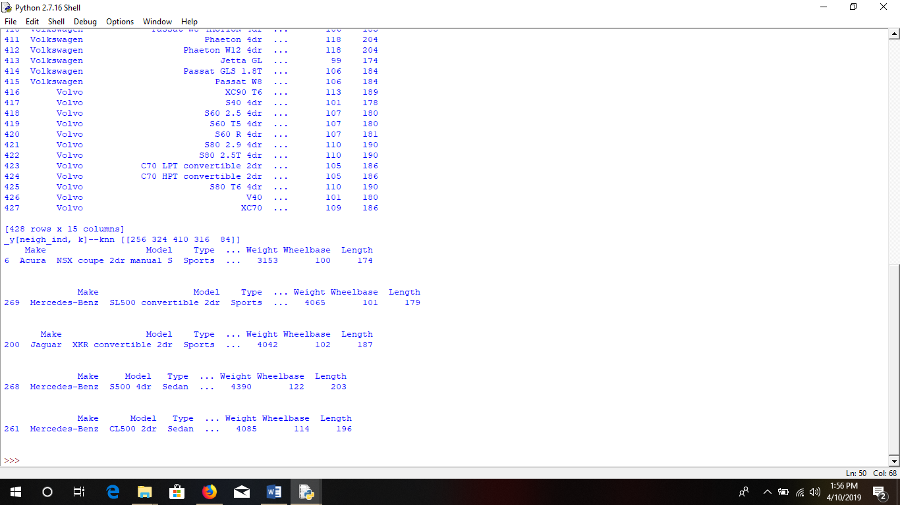

LUX_PERF.PY

import warnings

warnings.filterwarnings('ignore')

import os

import numpy as np

import pandas as pd

from sklearn.preprocessing import StandardScaler

from sklearn.preprocessing import LabelEncoder

cars = pd.read_csv('CARSs.csv', delimiter=',')

print cars

lux_cars=cars.loc[(cars['Type']=='Sedan')]

X=lux_cars[['MSRP','Cylinders','Horsepower','Weight','Length']]

yy=lux_cars['Model']

le = LabelEncoder()

le.fit(list(yy))

y = le.transform(yy)

##from sklearn.svm import SVC

##

##clf =SVC()

from sklearn.neighbors import KNeighborsClassifier

clf = KNeighborsClassifier(n_neighbors=3)

#clf =OneVsOneClassifier(SVC())

clf.fit(X, y)

#clf.fit(X, y)

##car_MSRP=input("Enter MSRP")

##car_Weight=input("Enter Weight")

##car_Length=input("Enter Length")

def get_detail(car_MSRP,car_Cylinders,car_HP,car_Weight,car_Length):

df={'col1':[car_MSRP],'col2':[car_Cylinders],'col3':[car_HP],'col4':[car_Weight],'col5':[car_Length]}

x_test=pd.DataFrame(df)

pred, neigh=clf.predict(x_test)

temp_label=[]

temp_ans=[]

neigh_pred=neigh[0]

for i in range(0,len(neigh_pred)):

temp_le=le.inverse_transform([neigh_pred[i]])

ans=cars.loc[(cars['Model']==temp_le[0])]

ans=str(ans)

#ans=str(ans[:-20:1])

temp_label.append(ans)

seperator = '\n'

result=seperator.join(temp_label)

result=" ".join(result.split("[1 rows x 15 columns]"))

result=" ".join(result.split("[2 rows x 15 columns]"))

return result

'''pred_y=le.inverse_transform(pred)

ans=cars.loc[(cars['Model']==pred_y[0])]

return (ans.iloc[0].values)'''

if __name__=="__main__":

#print(get_detail(89765,17,24))

print "luxury n performance cars"

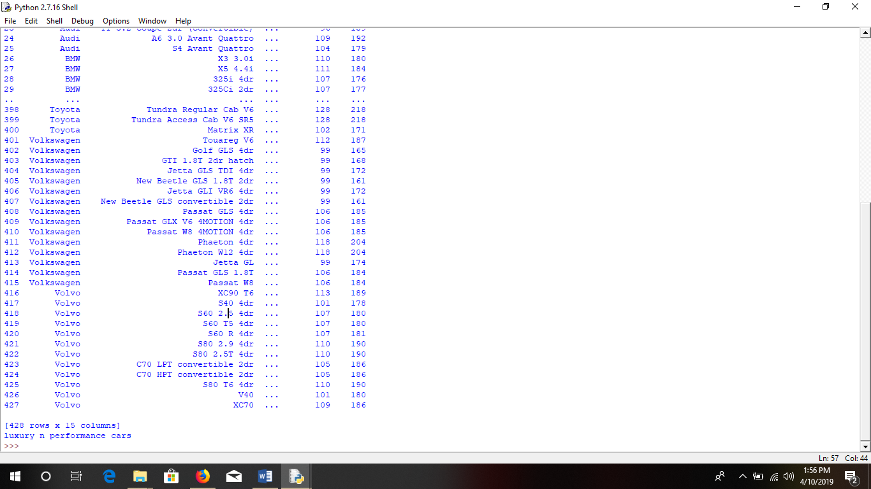

LUX_CARS.PY

import warnings

warnings.filterwarnings('ignore')

import os

import numpy as np

import pandas as pd

from sklearn.preprocessing import StandardScaler

from sklearn.preprocessing import LabelEncoder

cars = pd.read_csv('CARSs.csv', delimiter=',')

print cars

lux_cars=cars.loc[(cars['Type']=='Sedan')]

X=lux_cars[['MSRP','Weight','Length']]

yy=lux_cars['Model']

le = LabelEncoder()

le.fit(list(yy))

y = le.transform(yy)

##from sklearn.svm import SVC

##

##clf =SVC()

from sklearn.neighbors import KNeighborsClassifier

clf = KNeighborsClassifier(n_neighbors=3)

#clf =OneVsOneClassifier(SVC())

clf.fit(X, y)

#clf.fit(X, y)

##car_MSRP=input("Enter MSRP")

##car_Weight=input("Enter Weight")

##car_Length=input("Enter Length")

def get_detail(car_MSRP,car_Weight,car_Length):

df={'col1':[car_MSRP],'col2':[car_Weight],'col3':[car_Length]}

x_test=pd.DataFrame(df)

pred, neigh=clf.predict(x_test)

temp_label=[]

temp_ans=[]

neigh_pred=neigh[0]

for i in range(0,len(neigh_pred)):

temp_le=le.inverse_transform([neigh_pred[i]])

ans=cars.loc[(cars['Model']==temp_le[0])]

ans=str(ans)

#ans=str(ans[:-20:1])

temp_label.append(ans)

seperator = '\n'

result=seperator.join(temp_label)

result=" ".join(result.split("[1 rows x 15 columns]"))

return result

'''pred_y=le.inverse_transform(pred)

ans=cars.loc[(cars['Model']==pred_y[0])]

return (ans.iloc[0].values)'''

if __name__=="__main__":

print(get_detail(89765,17,24))

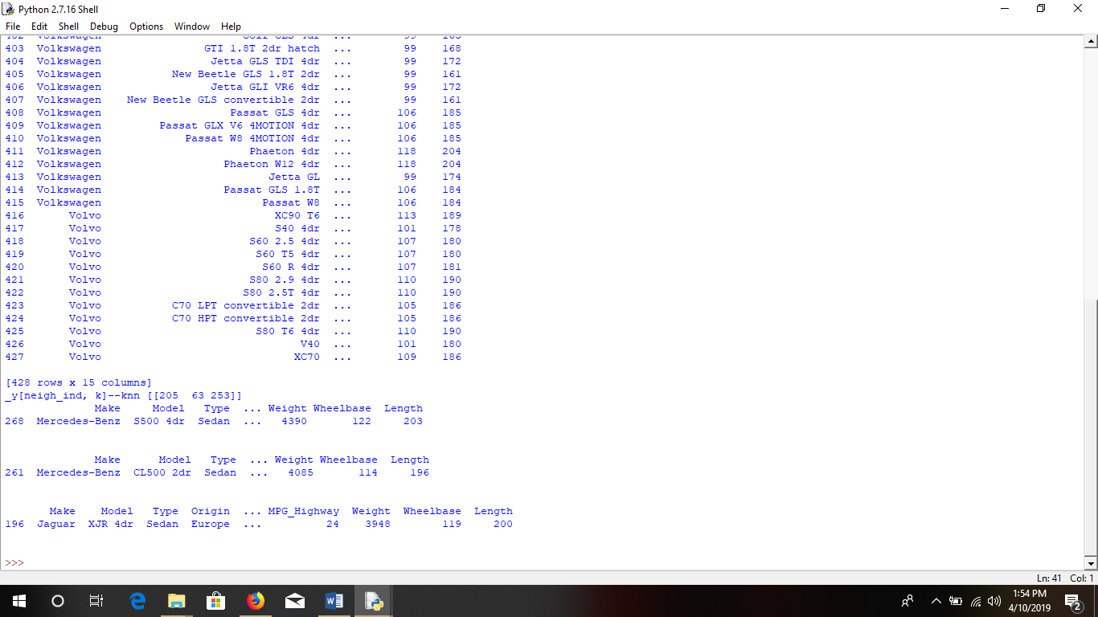

PERF_CARS.PY

import warnings

warnings.filterwarnings('ignore')

import os

import numpy as np

import pandas as pd

from sklearn.preprocessing import StandardScaler

from sklearn.preprocessing import LabelEncoder

from sklearn.multiclass import OneVsOneClassifier

cars = pd.read_csv('CARSs.csv', delimiter=',')

print cars

lux_cars=cars.loc[(cars['Type']=='Sedan')]

X=cars[['MSRP','Cylinders','Horsepower']]

yy=cars['Model']

le = LabelEncoder()

le.fit(list(yy))

y = le.transform(yy)

##from sklearn.svm import SVC

##clf=SVC()

from sklearn.neighbors import KNeighborsClassifier

clf = KNeighborsClassifier(n_neighbors=3)

#clf =OneVsOneClassifier(SVC())

clf.fit(X, y)

##car_MSRP=input("Enter MSRP")

##car_Weight=input("Enter Cylinders")

##car_Length=input("Enter Horsepower")

def get_detail(car_MSRP,car_Weight,car_Length):

df={'col1':[car_MSRP],'col2':[car_Weight],'col3':[car_Length]}

x_test=pd.DataFrame(df)

pred,neigh=clf.predict(x_test)

print(pred)

'''pred_y=le.inverse_transform(pred)

print (pred_y)'''

temp_label=[]

temp_ans=[]

neigh_pred=neigh[0]

for i in range(0,len(neigh_pred)):

temp_le=le.inverse_transform([neigh_pred[i]])

ans=cars.loc[(cars['Model']==temp_le[0])]

ans=str(ans)

#ans=str(ans[:-20:1])

temp_label.append(ans)

seperator = '\n'

result=seperator.join(temp_label)

result=" ".join(result.split("[1 rows x 15 columns]"))

return result

#return (temp_label)

if __name__=="__main__":

car_MSRP=input("Enter MSRP")

car_Weight=input("Enter Cylinders")

car_Length=input("Enter Horsepower")

result=get_detail(car_MSRP,car_Weight,car_Length)

print(result)

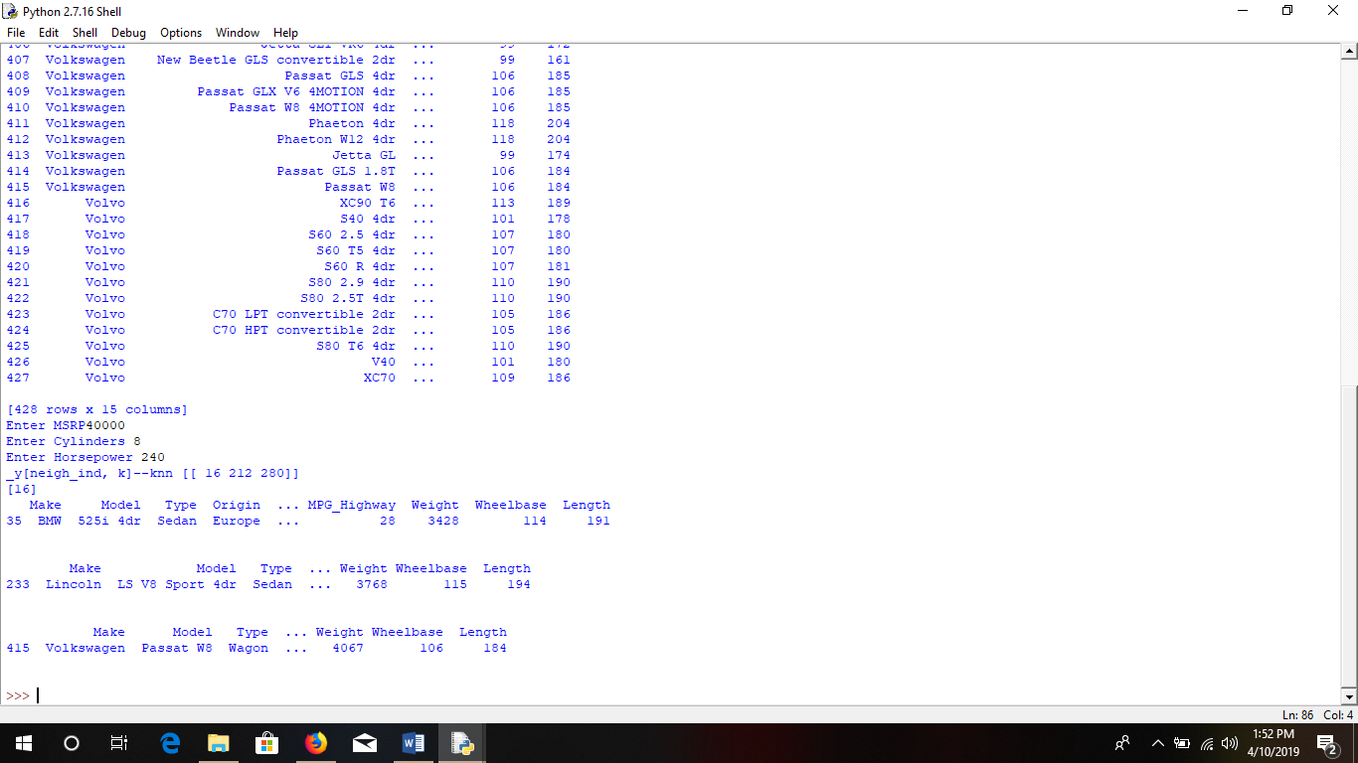

GUI

ASH.PY

**import Tkinter as tk**

**from functools import partial**

**import class_cars**

**print"start1"**

**import luxury_cars**

**print"start2"**

**import perf_cars**

**print"start3"**

**import lux_perf_cars**

**print"start4"**

**print"start"**

**def call_result1(label_result, n1, n2,n3):**

**num1 = (n1.get())**

**num2 = (n2.get())**

**num3 = (n3.get())**

**## result = int(num1)+int(num2)**

**## label_result.config(text="Result = %d" % result)**

**## return**

**result=class_cars.get_detail(num1, num2,num3)**

**label_result.config(text=result)**

**def call_result2(label_result, n1, n2,n3):**

**num1 = (n1.get())**

**num2 = (n2.get())**

**num3 = (n3.get())**

**## num1 = (n1.get())**

**## num2 = (n2.get())**

**## result = int(num1)+int(num2)**

**## label_result.config(text="Result = %d" % result)**

**## return**

**result= luxury_cars.get_detail(num1, num2,num3)**

**label_result.config(text=result)**

**def call_result3(label_result, n1, n2,n3):**

**num1 = (n1.get())**

**num2 = (n2.get())**

**num3 = (n3.get())**

**## num1 = (n1.get())**

**## num2 = (n2.get())**

**## result = int(num1)+int(num2)**

**## label_result.config(text="Result = %d" % result)**

**## return**

**result= perf_cars.get_detail(num1, num2,num3)**

**label_result.config(text=result)**

**def call_result4(label_result,n1,n2,n3,n4,n5):**

**num1 = (n1.get())**

**num2 = (n2.get())**

**num3 = (n3.get())**

**num4 = (n4.get())**

**num5 = (n5.get())**

**## num1 = (n1.get())**

**## num2 = (n2.get())**

**## result = int(num1)+int(num2)**

**## label_result.config(text="Result = %d" % result)**

**## return**

**result= lux_perf_cars.get_detail(num1, num2,num3,num4,num5)**

**label_result.config(text=result)**

**root = tk.Tk()**

**root.geometry('1024x720')**

**root.title('Car')**

**number1 = tk.StringVar()**

**number2 = tk.StringVar()**

**number3 = tk.StringVar()**

**number4 = tk.StringVar()**

**number5 = tk.StringVar()**

**number6 = tk.StringVar()**

**number7 = tk.StringVar()**

**number8 = tk.StringVar()**

**number9 = tk.StringVar()**

**number10 = tk.StringVar()**

**number11 = tk.StringVar()**

**number12 = tk.StringVar()**

**number13 = tk.StringVar()**

**number14 = tk.StringVar()**

**labelNum1 = tk.Label(root, text="MSRP").grid(row=1, column=0)**

**labelNum2 = tk.Label(root, text="MPG_City").grid(row=1, column=2)**

**labelNum3 = tk.Label(root, text="MPG_Highway").grid(row=1, column=4)**

**labelNum4 = tk.Label(root, text="MSRP").grid(row=3, column=0)**

**labelNum5 = tk.Label(root, text="MPG_Weight").grid(row=3, column=2)**

**labelNum6 = tk.Label(root, text="MPG_Lenngth").grid(row=3, column=4)**

**labelNum7 = tk.Label(root, text="MSRP").grid(row=5, column=0)**

**labelNum8 = tk.Label(root, text="MPG_Cylinders").grid(row=5, column=2)**

**labelNum9 = tk.Label(root, text="MPG_Horsepower").grid(row=5, column=4)**

**labelNum10 = tk.Label(root, text="MSRP").grid(row=7, column=0)**

**labelNum11 = tk.Label(root, text="MPG_Cylinders").grid(row=7, column=2)**

**labelNum12 = tk.Label(root, text="MPG_Horsepower").grid(row=7, column=4)**

**labelNum13 = tk.Label(root, text="MPG_Weight").grid(row=7, column=6)**

**labelNum14 = tk.Label(root, text="MPG_Lenngth").grid(row=7, column=8)**

**labelResult = tk.Label(root)**

**labelResult.grid(row=10, column=2)**

**entryNum1 = tk.Entry(root, textvariable=number1).grid(row=1, column=1)**

**entryNum2 = tk.Entry(root, textvariable=number2).grid(row=1, column=3)**

**entryNum3 = tk.Entry(root, textvariable=number3).grid(row=1, column=5)**

**entryNum4 = tk.Entry(root, textvariable=number4).grid(row=3, column=1)**

**entryNum5 = tk.Entry(root, textvariable=number5).grid(row=3, column=3)**

**entryNum6 = tk.Entry(root, textvariable=number6).grid(row=3, column=5)**

**entryNum7 = tk.Entry(root, textvariable=number7).grid(row=5, column=1)**

**entryNum8 = tk.Entry(root, textvariable=number8).grid(row=5, column=3)**

**entryNum9 = tk.Entry(root, textvariable=number9).grid(row=5, column=5)**

**entryNum10 = tk.Entry(root, textvariable=number10).grid(row=7, column=1)**

**entryNum11 = tk.Entry(root, textvariable=number11).grid(row=7, column=3)**

**entryNum12 = tk.Entry(root, textvariable=number12).grid(row=7, column=5)**

**entryNum13 = tk.Entry(root, textvariable=number13).grid(row=7, column=7)**

**entryNum14 = tk.Entry(root, textvariable=number14).grid(row=7, column=9)**

**call_result1 = partial(call_result1, labelResult, number1, number2, number3)**

**call_result2 = partial(call_result2, labelResult, number4, number5, number6)**

**call_result3 = partial(call_result3, labelResult, number7, number8, number9)**

**call_result4 = partial(call_result4, labelResult, number10, number11, number12,number13,number14)**

**buttonCal = tk.Button(root, text="Class", command=call_result1).grid(row=2, column=0)**

**buttonCal1 = tk.Button(root, text="Luxury", command=call_result2).grid(row=4, column=0)**

**buttonCal2 = tk.Button(root, text="Perf", command=call_result3).grid(row=6, column=0)**

**buttonCal3 = tk.Button(root, text="Lux+Perf", command=call_result4).grid(row=8, column=0)**

**root.mainloop()**

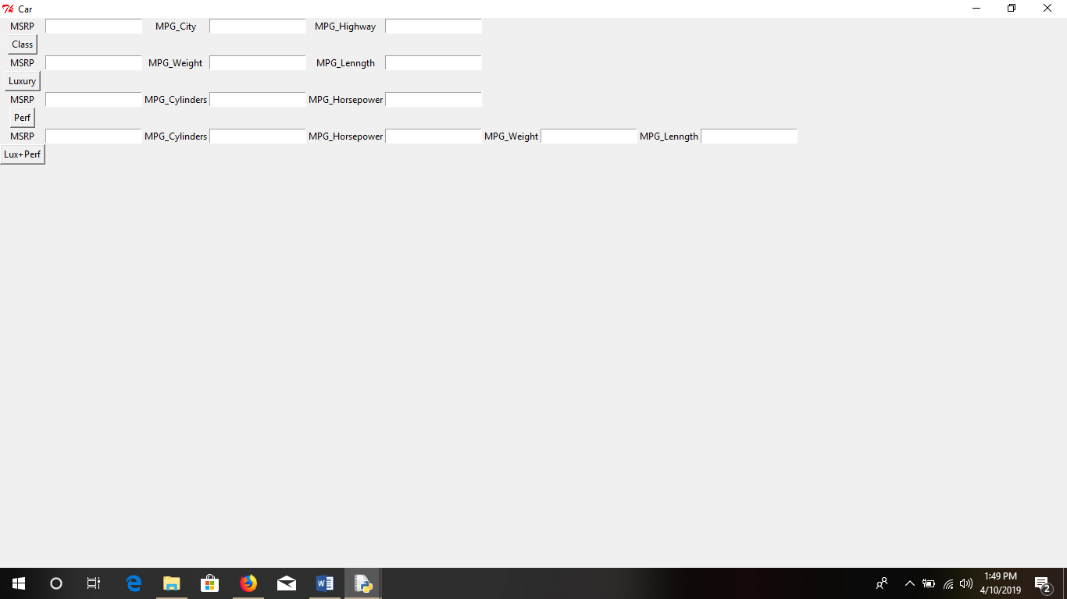

**TESTING DATA**

* Test **knowledge** is data **that** has been specifically **known** **to be used** in tests, **usually** of a **malicious program**.
* Some **knowledge** **could also be** **employed in** a **confirmative** **approach**, **usually** to verify that a given set of input to a given **operate** produces some expected result.

**PRE-PROCESSING**

* Data preprocessing includes **cleansing**, Instance **choice**, **standardization**, transformation, feature extraction and **choice**.
* Data **cleansing** **is that the** **method** of **detective work**, correcting or removing **the incorrect** records from **knowledge**

**FEATURE EXTRACTION**

* Feature extraction **is that the** **method** **of remodeling** the **input file** into **a group** of vector **options** **which might** **o.k.** represent the input data
* Hence Label encoder **is employed** for that label vector **illustration**.

**6.2 ARCHITECTURAL DESIGN**















**KNN Algorithm**

* Detection **could be a** **vital** **facet** **within the** fight against **purchase** **completely different** **automotive** **while not** **data** .
* In this study, **a unique** **methodology** is **projected** to **observe** to classify **supported** SVM.
* This impact is **most blatant** in tests performed **victimization** the SVM **methodology** since **the utilization** of the **performing** distance **joined** of the input characteristics of our system has improved **the popularity** rate of **twenty one**.8%
* We have to classified **information** in between the plane, **it's** the boundary of **the information**. From **that** **we tend to** predict the given **automotive** **ought to** be which **category**, from that **we tend to** determined best one. by taken **the worth** -1 and **one** from the boundary **zero**.

**Instance-based Learning--KNN ALGORITHM**

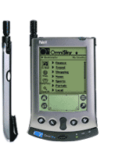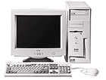

**K-Nearest Neighbor**

**Features**

* All instances correspond to points in **associate** n-dimensional **Euclidean space**
* Classification is delayed **until** **a replacement** instance arrives
* Classification done by **scrutiny** feature vectors of **the various** points
* Target **operate** **is also** **separate** or real-valued

1-Nearest Neighbor





**K-Nearest Neighbor**

* An **discretionary** instance is **portrayed** by (a1(x), a2(x), a3(x),.., an(x))
* ai(x) denotes **options**
* Euclidean distance between **2** instances
* d(xi, xj)=sqrt (sum for r=1 to n (ar(xi) - ar(xj))2)
* Continuous valued target **operate**
* mean value of the k nearest **coaching** examples

**Voronoi Diagram**



**Distance-Weighted Nearest Neighbor Algorithm**

* Assign weights to the neighbors **supported** their ‘distance’ from the **question** **purpose**
* Weight ‘may’ be inverse **sq.** of the distances
* All **coaching** points **could** influence **a selected** instance
* Shepard’s **technique**

**Remarks**

+Highly effective inductive **abstract thought** **methodology** for **noisy coaching** **information** **and complicated** target functions

+Target **perform** for **an entire** **house** **could also be** **represented** as **a mix** of less **complicated** **native** approximations

+Learning **is extremely** **easy**

- Classification is time **intense**.

**CHAPTER 7**

**(EDIT THIS WHOLE PAGE SRIRAM)**

**SYSTEM REQUIREMENTS**

**7.1 SOFTWARE REQUIREMENTS**

**Oracle Vmware**

Virtualize your mission-critical Oracle software, including database, middleware and applications, and achieve quantifiable time-to-market and TCO improvements. A simplified IT environments lets your Oracle IT and application administrators better leverage your storage, network and computing resources to control costs and respond faster to changing business needs.

VirtualBox is a powerful x86 and AMD64/Intel64 [virtualization](https://www.virtualbox.org/wiki/Virtualization) product for enterprise as well as home use. Not only is VirtualBox an extremely feature rich, high performance product for enterprise customers, it is also the only professional solution that is freely available as Open Source Software under the terms of the GNU General Public License (GPL) version

Presently, VirtualBox runs on Windows, Linux, Macintosh, and Solaris hosts and supports a large number of [guest operating systems](https://www.virtualbox.org/wiki/Guest_OSes) including but not limited to Windows (NT 4.0, 2000, XP, Server 2003, Vista, Windows 7, Windows 8, Windows 10), DOS/Windows 3.x, Linux (2.4, 2.6, 3.x and 4.x), Solaris and OpenSolaris, OS/2, and OpenBSD.

**SAS Studio**

SAS Studio is a developmental web application for SAS that you access through your web browser. With SAS Studio, you can access your data files, libraries, and existing programs, and you can write new programs. You can also use the predefined tasks in SAS Studio to generate SAS code for you. When you run a program or task, SAS Studio processes the SAS code on a SAS server.

The SAS server can be a server in a cloud environment, a server in your local environment, or SAS installed on your local machine. After the code is processed, the results are returned to SAS Studio in your browser.

**CHAPTER 8**

**REFERENCE**

* <https://www.carwale.com/>
* <https://www.analyticsvidhya.com/blog/category/sas/>
* <https://video.sas.com/detail/video/5360560641001/getting-started-with-sas-visual-data-mining-and-machine-learning-8.1-on-sas-viya>
* <https://www.lynda.com/VMware-training-tutorials/2036-0.html>
* <https://www.researchgate.net/publication/281634018_Study_on_Consumer_Buying_Behavior_During_Purchase_of_a_Second_Car>
* <https://www.researchgate.net/publication/308325959_Factors_Influencing_the_Purchase_Decision_of_Passenger_Cars_in_Puduchery>
* <http://shodhganga.inflibnet.ac.in/bitstream/10603/190581/9/08_chapter2.pdf>
* <https://www.ijbmi.org/papers/Vol(2)9/Version-1/J0291062071.pdf>
* <https://www.academia.edu/7108135/FACTORS_AFFECTING_CAR_BUYING_BEHAVIOUR_OF_CUSTOMERS>
* <https://www.rtpcompany.com/markets/automotive/problems-solutions/>