**Document Manager**

**Description**

Store document with our desired type and search the document in the simple dashboard with any keyword in the document.

**Technical Details**

* **Framework** – Django
* **Language** – Python
* **Web Technoligies** – HTML,Js, Jquery, CSS
* **Database** - Sqlite3
* **Models** used in the document
  + **Document** – Stored the file with OCR to make the search easier.
  + **DocumentType –** To categorize the document in a simple way
* **Pypi** package used to generate a OCR data for a file – **textract==1.6.3**

**Function Details**

User login to the application with the credentials

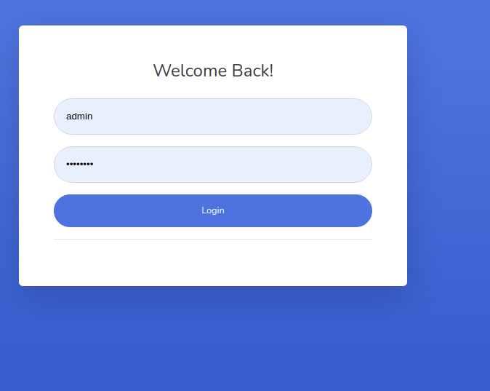

Fig 1.0

After entering a valid credentials application will take the user to the Dashboard screen (refer below snapshot)

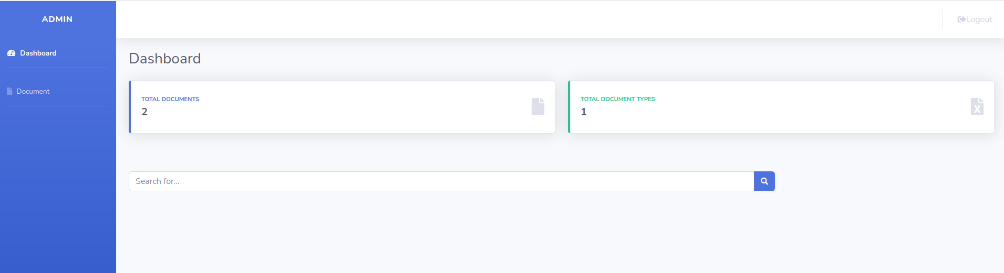**Fig 1.1**

Dashabord will display the general details like number of Documents and Document type and one Search box to search the document with keyword.

**1) DocumentType creation**

DocumentType will be a admin level data, So kept didn’t include it for general user login and handling it in the admin interface would be a effective one.

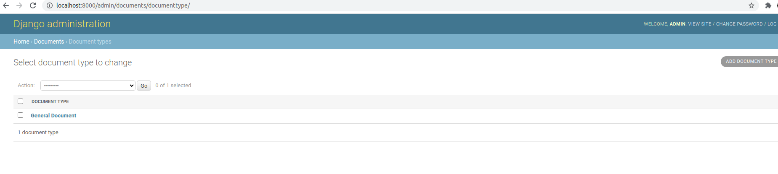**Fig 1.2**

**2) Document Creation**

**Document** menu is for viewing / adding / editing / deleting a document in a user friendly manner explained below.

Clicking on the Document menu in the dashboard will take you to the document list screen.

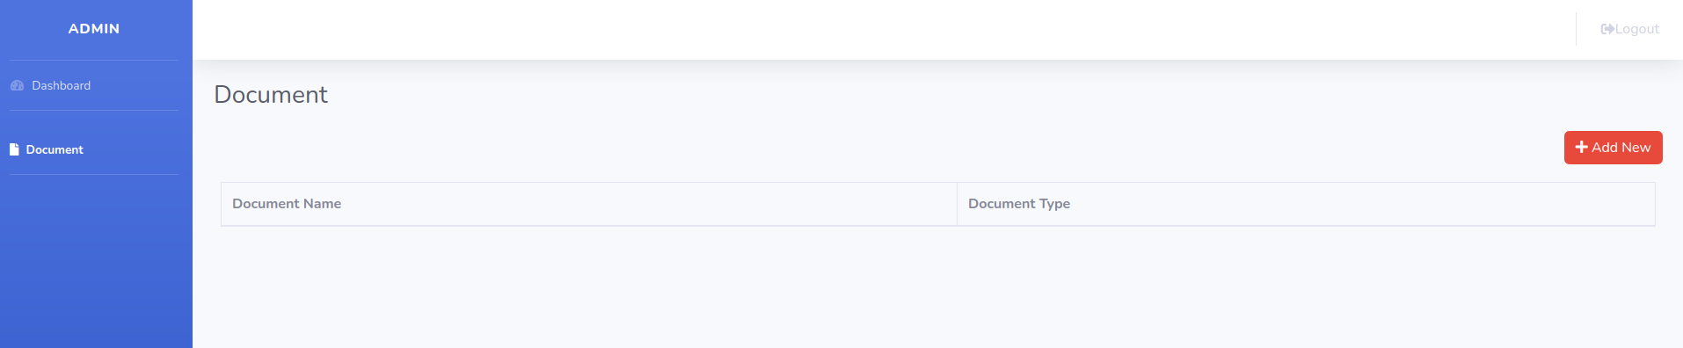**Fig 1.3**

In list view we are displaying only the general details like document name as link to view the details and document type. To add a new document click the **+ ADD NEW** button at the right top cornor, it will get you to the document addition form (refer below snapshot)

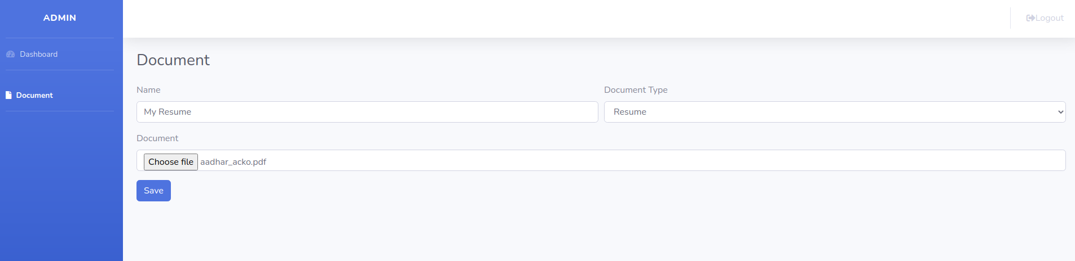**Fig 1.4**

Enter the Document name and choose your desired document type and upload the document and click save.

On the backend we are extracting the OCR data from the document attached using **textract** package and store it along with all the other details in **Document** table in database. We are not displaying the OCR data to the user and kept available only for admin level

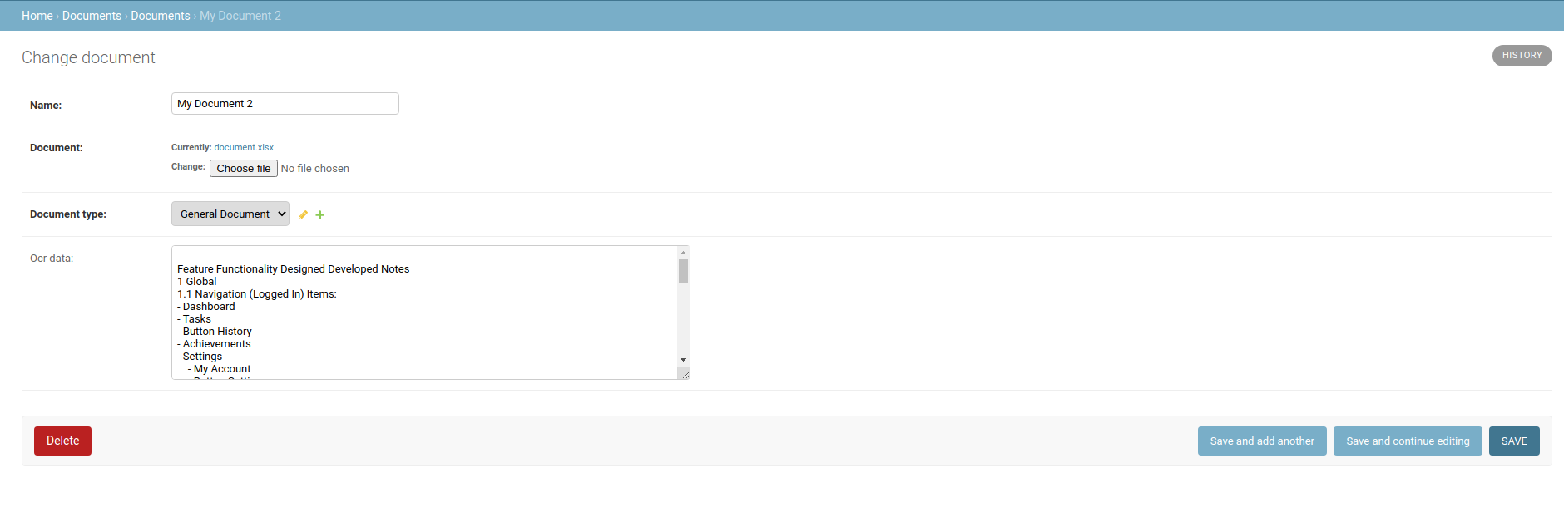**Fig 1.5**

After saving the document it will be listed in the document list page like

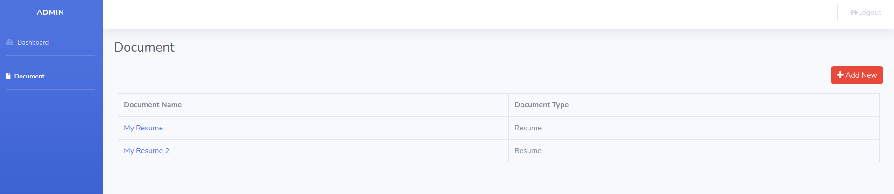**Fig 1.6**

**3) Search Functionality**

Since we added the search functionality in dashboard only(**refer Fig1.1**) goto dashboard and type the keyword or a document name in the search box and hit enter or click the search icon at the end of the searchbox. It will look for the document contains the search string in document name or OCR content and redirect you to the document list page like below

Here I searched the word **“payment”** keyword available in 2 documents I attached

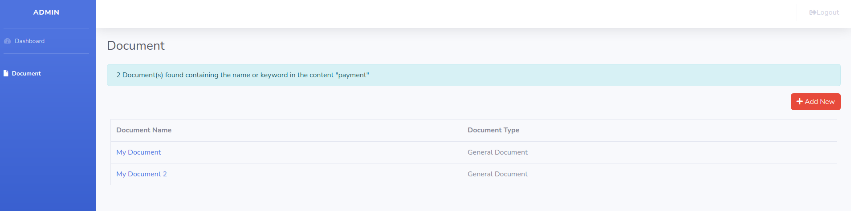**Fig 1.7**

To differentiate the usual document list page with search result page I’ve just added the information message like **“2 Document(s) found containing the name or keyword in the content ‘payment’”**