
School of Computer Science and Artificial Intelligence

Lab Assignment # 16
Course Title : AI Assistant Coding Name of Student : K.Srija
Enrollment No. : 2303A54023
Batch No. : 48

Lab 16 – Database Design and Queries: Schema Design and SQL Generation

Task 1 – Hospital Management Database
Task:
Create schema and queries for a Hospital Management System.
Instructions:
• Tables: Doctors, Patients, Appointments.
• Use AI to define constraints (unique IDs, valid dates).
• Generate queries:
• List all appointments for a specific doctor.
• Retrieve patient history by patient ID.
• Count total patients treated by each doctor.
Expected Output:
• Normalized schema and SQL queries with joins.

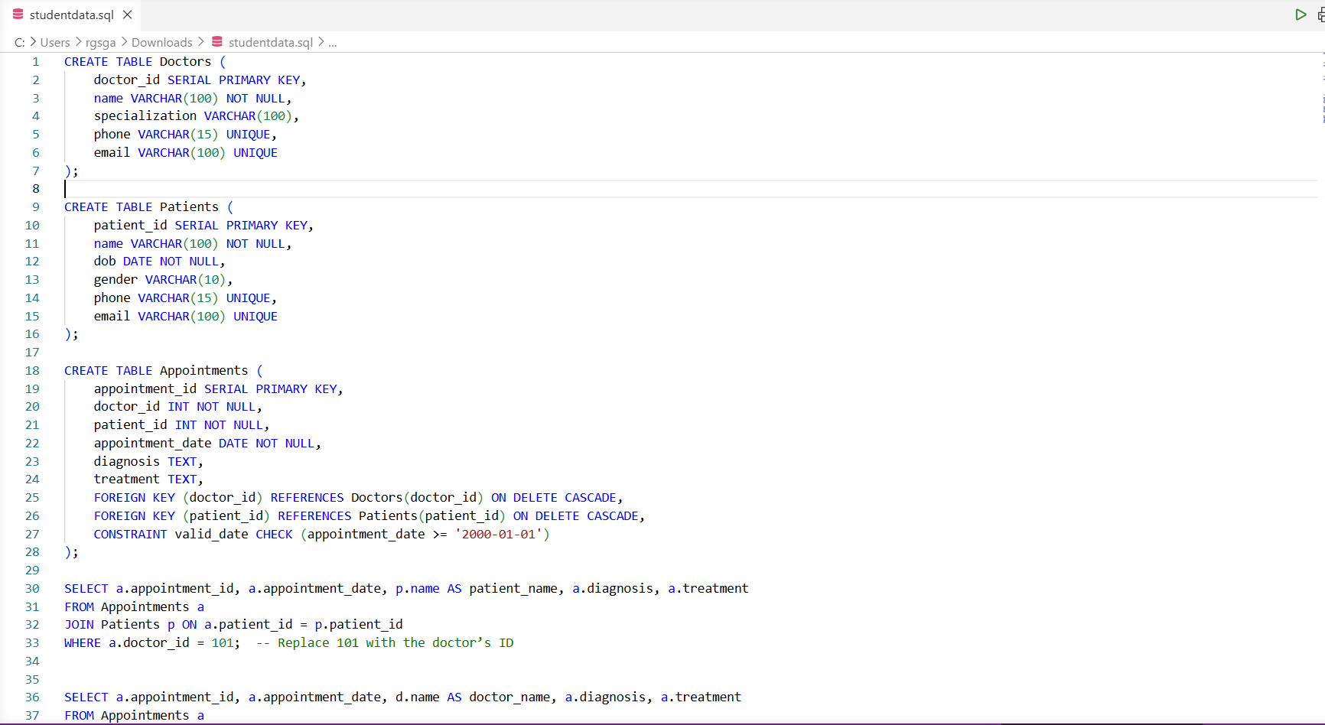

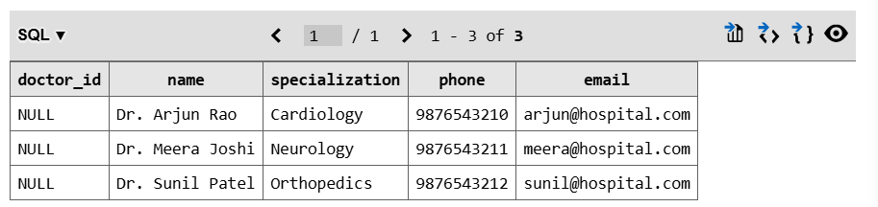
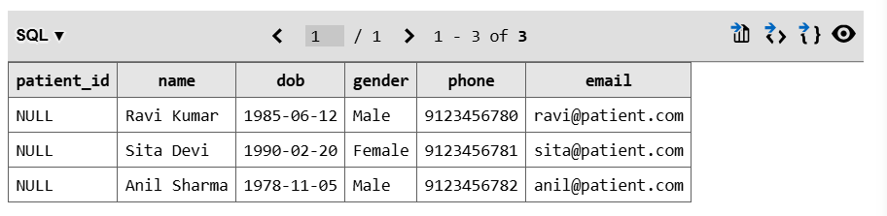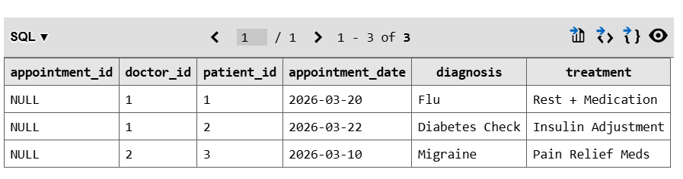

Task 2 – Real-Time Application: Online Shopping Database
Scenario: Design a database for an E-commerce platform.
Requirements:
• Tables: Users, Products, Orders, OrderDetails.
• Generate queries to:
• Retrieve all orders by a user.
• Find the most purchased product.
• Calculate total revenue in a given month.
• AI should also suggest normalization improvements and query
optimization.
Expected Output:
• Complete schema with relationships + SQL queries for analytics.

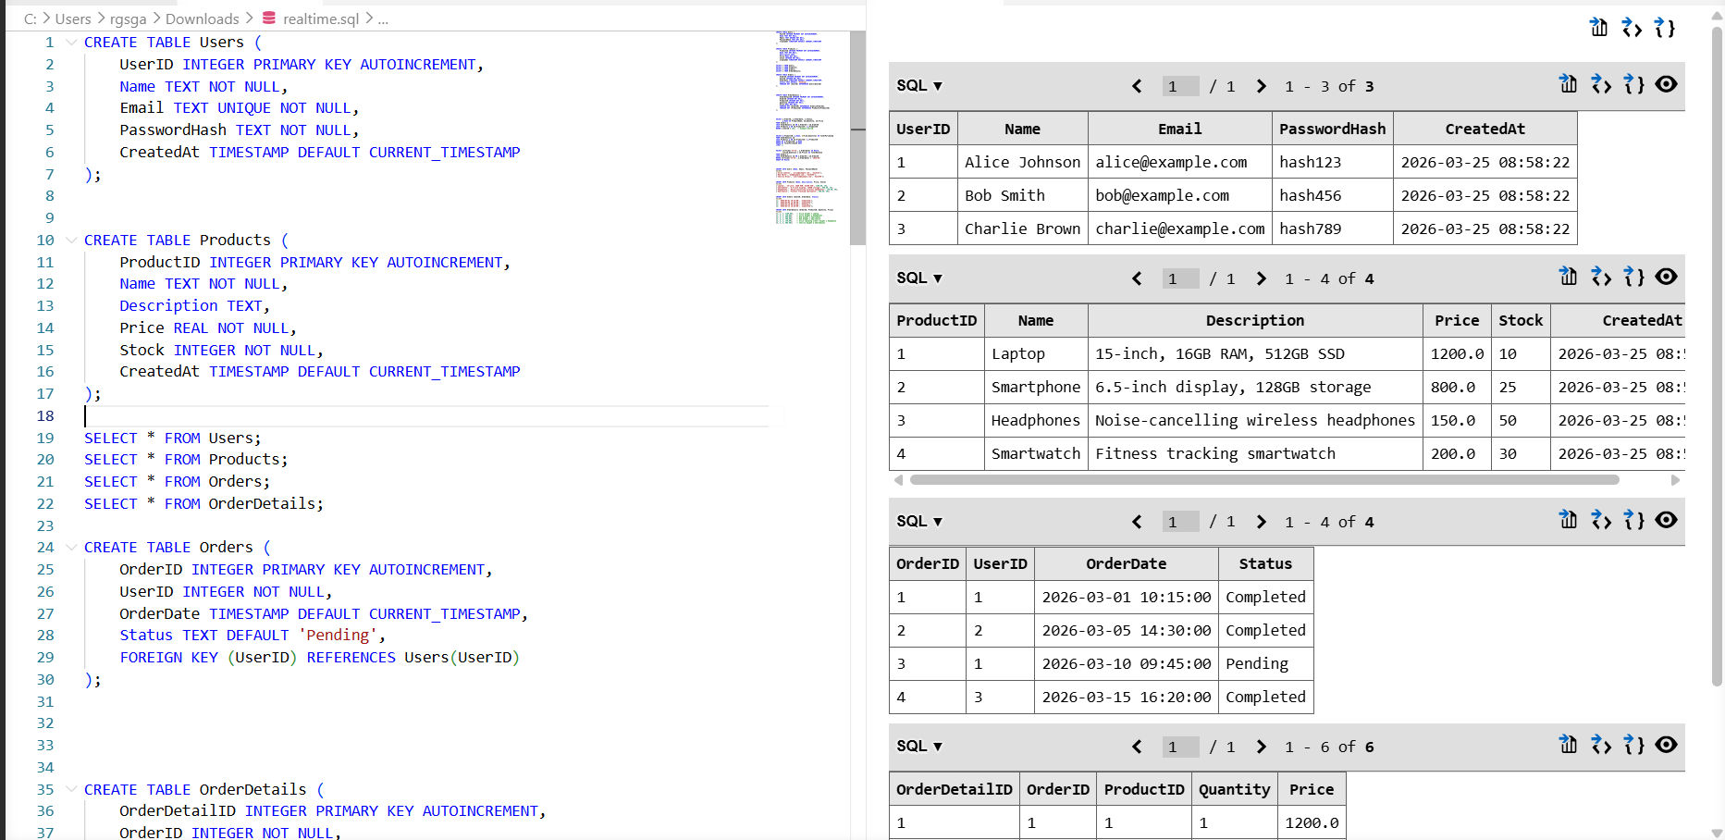

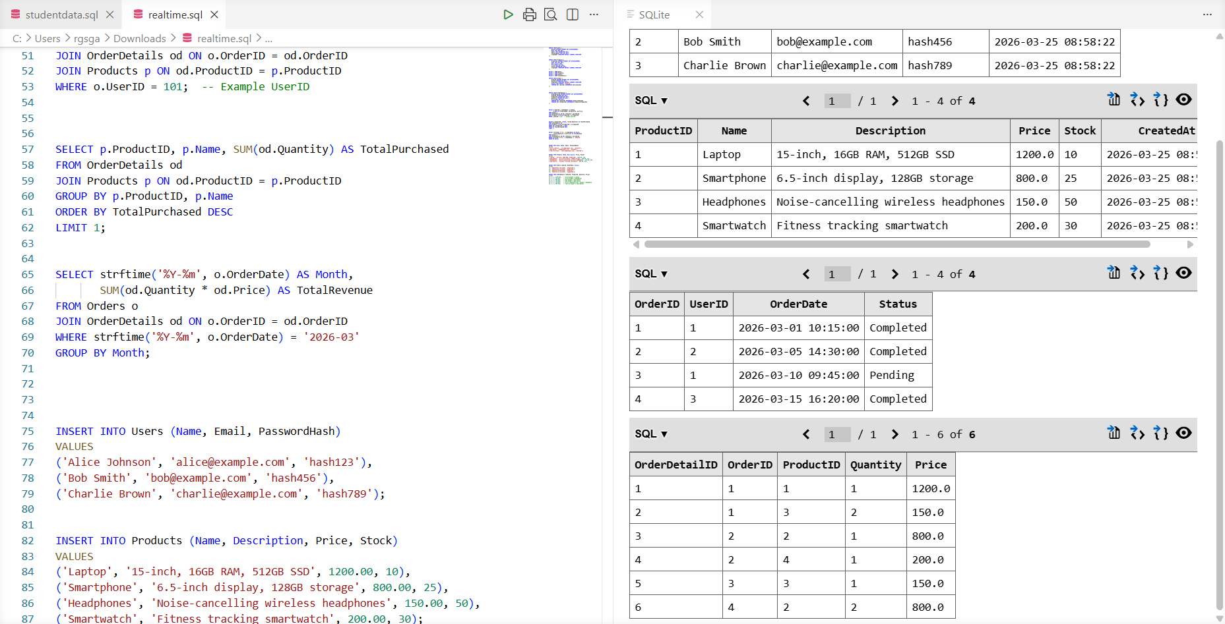

Task 3 – Library Database
Task: Design schema for a Library Management System.
Instructions:
• Tables: Books, Members, Loans.
• Use AI to suggest indexing strategy for faster queries.
• Generate queries:
• Retrieve all books currently issued.
• Find overdue books (loan date > 30 days).
• Count number of books loaned by each member.
Expected Output:
• Schema + SQL queries demonstrating joins and conditions.

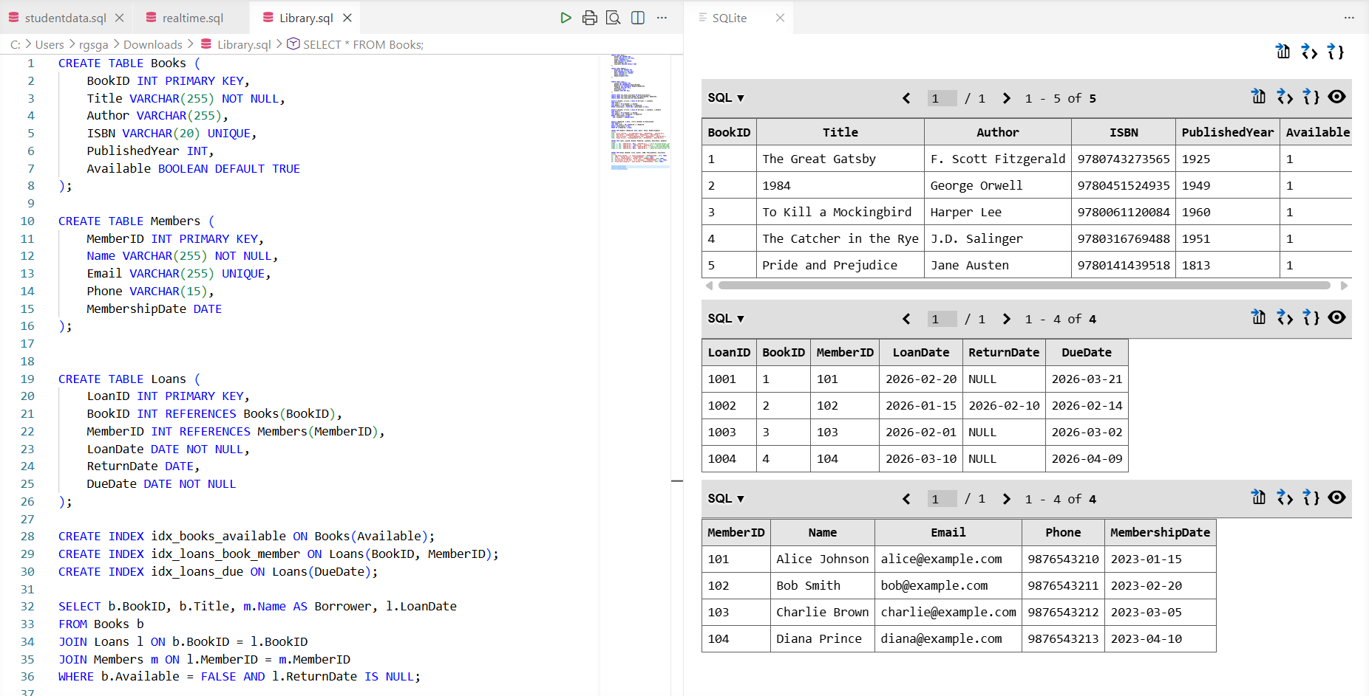

Task 4: Optimize Queries
Instructions:
• Use AI tools to analyze query efficiency.
• Optimize inefficient queries using joins, indexes, or reducing subqueries.
• Test optimized queries for correctness.
Starter Code Example:
-- Original query
SELECT * FROM Books WHERE author_id IN (SELECT author_id FROM
Authors WHERE country='UK');
-- Optimized query
SELECT b.*
FROM Books b
JOIN Authors a ON b.author_id = a.author_id
WHERE a.country = 'UK';
Expected Output:
• Both queries return the same result: all books written by UK authors.
• Optimized query performs faster for larger datasets.

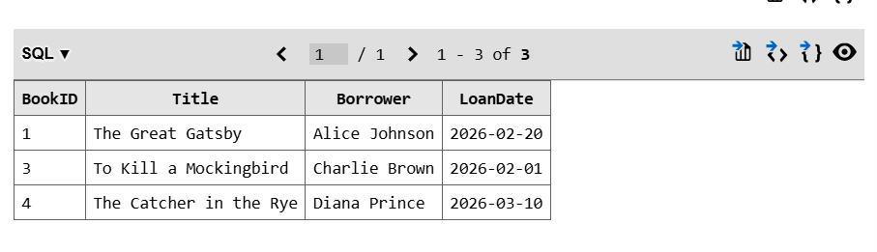

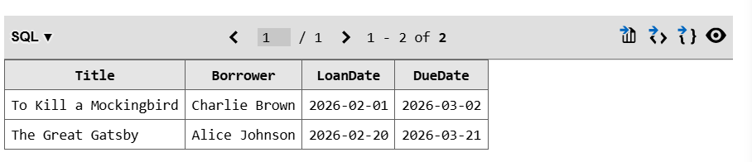
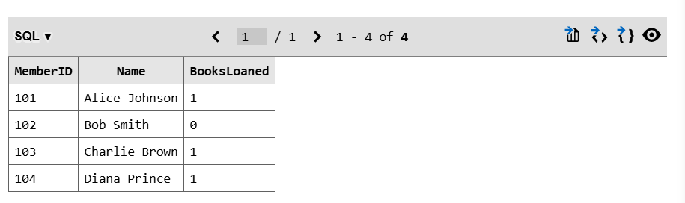

Task 5: University Course Registration
Scenario:
SR University needs a course registration system for students enrolling in
different courses under faculty supervision.
• Use Copilot to design schema tables: Students, Courses, Faculty, and
Registrations.
• Define relationships:
• Each student can register for multiple courses.
• Each course is taught by a faculty member.
• Write SQL queries to:
• List all students enrolled in a specific course.
• Find faculty members teaching more than 2 courses.
• Retrieve courses with the highest number of registrations.

