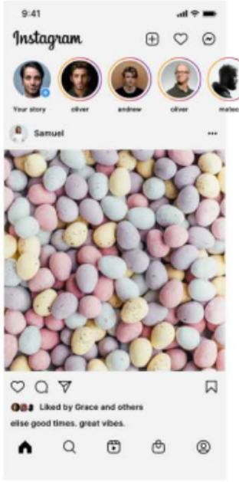

SRIJAN JAISWAL

12307766

ROLL NO 11

