**Annexure3b- Complete filing**

**INVENTION DISCLOSURE FORM**

Details of Invention for better understanding:

**1. TITLE:** **"IoT-Integrated AI Solution for Crowd Control in University Campuses"**

**2. INTERNAL INVENTOR(S)/ STUDENT(S):** All fields in this column are mandatory to be filled

|  |  |
| --- | --- |
| A. Full name | **Srijan Jaiswal** |
| ­­­­­Mobile Number | 9628180970 |
| Email (personal) | **jaiswalsrijan91@gmail.com** |
| UID/Registration number | 12307766 |
| Address of Internal Inventors | School Of Computer Science and Engineering Lovely Professional University, Punjab-144411, India |
| Signature (Mandatory) |  |
| B. Full name |  |
| ­­­­­Mobile Number |  |
| Email (personal) |  |
| UID/Registration number |  |
| Address of Internal Inventors | School Of Computer Science and Engineering  Lovely Professional University, Punjab-144411, India |
| Signature (Mandatory) |  |

**3. DESCRIPTION OF THE INVENTION**

**1. Purpose**

The **Campus Crowd Management and Navigation System** is designed to optimize movement across university campuses using **IoT, AI-based predictions, and real-time crowd tracking**. This system helps students, faculty, and visitors avoid congested areas, navigate efficiently, and improve campus safety and accessibility. With universities experiencing high foot traffic, this innovation enhances time management, reduces overcrowding risks, and improves overall campus experience.

**2. Technical Workings**

**1. Real-Time Crowd Monitoring:**

The system utilizes **IoT sensors and AI-driven analytics** to track people movement across key areas such as **classrooms, cafeterias, libraries, and event venues**. Data is continuously updated and displayed on a **mobile app or digital campus boards**, allowing users to see congestion levels in real time.

**2. Smart Navigation System:**

Using **location tracking and predictive algorithms**, the system suggests **alternative routes** to avoid high-traffic areas. This feature is especially useful during peak hours, large gatherings, and emergencies.

**3. IoT Integration & Data Collection:**

IoT-enabled devices such as **smart cameras, motion sensors, and Bluetooth beacons** are installed across campus. These devices collect data on:

* **Current crowd density** in various locations.
* **Foot traffic trends** to predict future congestion.
* **User movement patterns**, helping optimize facility usage.

**4. AI-Based Predictions & Smart Alerts:**

The system uses **AI algorithms** to analyze data and provide:

* **Predicted crowd surges** based on past trends.
* **Real-time alerts** about busy areas via the mobile app.
* **Emergency notifications** for quick evacuations.

**5. Accessibility & Safety Enhancements:**

To improve accessibility, the system prioritizes:

* **Clear pathways for students with mobility challenges** by identifying **less crowded ramps, elevators, and seating areas**.
* **Emergency evacuation assistance** through AI-powered crowd control recommendations.

**3. Unique Attributes**

**1. Dynamic Crowd Management:**

Unlike static campus maps, this system **updates in real time**, offering **live congestion data** and **route suggestions** to improve movement efficiency.

**2. Improved Time Management:**

By avoiding crowded areas, students and faculty can **reach their destinations on time**, reducing **delays in classes and meetings**.

**3. Enhanced Campus Safety:**

The system helps prevent **overcrowding risks**, ensuring smoother evacuations during emergencies. Security teams can monitor **live heatmaps** to manage crowds efficiently.

**4. Smart Event Management:**

During large events, the system predicts crowd surges and suggests alternative entry/exit points to **prevent bottlenecks and long queues**.

**5. Data-Driven Insights for Campus Planning:**

Administrators can use **historical data** to:

* **Optimize facility usage** (e.g., better scheduling for study halls and cafeterias).
* **Improve campus infrastructure planning** by identifying high-traffic areas.
* **Enhance transport services** by adjusting shuttle schedules based on demand.

**A. PROBLEM ADDRESSED BY THE INVENTION**

As university campuses grow in size and student population, managing **crowd flow, navigation, and space utilization** becomes increasingly complex. The **Campus Crowd Management and Navigation System** addresses the following key challenges:

**1. Overcrowding in Key Areas:**

High foot traffic in areas such as **classrooms, cafeterias, libraries, and event venues** leads to congestion, long wait times, and discomfort for students and faculty. This congestion can disrupt campus operations and reduce overall productivity.

**2. Inefficient Navigation:**

Many students and visitors struggle to find optimal routes across large campuses. Lack of **real-time crowd data** results in delays, missed classes, and frustration.

**3. Unpredictable Traffic Flow:**

Traditional campus maps provide static information that does not reflect **live movement patterns**. Sudden surges in foot traffic during peak hours can lead to **bottlenecks and inefficient movement**.

**4. Emergency Response Challenges:**

In emergency situations such as **fire drills, evacuations, or medical emergencies**, the absence of **real-time crowd insights** makes it difficult for security teams to guide people safely and efficiently.

**5. Accessibility Issues:**

Students with mobility impairments face difficulties in navigating crowded spaces. Lack of **alternative pathways and clear congestion data** can create accessibility challenges, impacting inclusivity on campus.

**6. Poor Space Utilization:**

Without proper crowd analytics, campus facilities like **study halls, auditoriums, and cafeterias** may be **underutilized or overcrowded**, leading to discomfort and operational inefficiencies.

**B. OBJECTIVE OF THE INVENTION**

The **Campus Crowd Management and Navigation System** is designed to enhance movement efficiency, optimize space utilization, and improve overall campus safety. The key objectives of the invention are:

**1. Enhance Operational Efficiency:**

The system aims to **streamline crowd movement** and **reduce congestion** in high-traffic areas such as classrooms, libraries, cafeterias, and event venues. By leveraging **real-time IoT sensors and AI-driven analytics**, the system helps administrators **monitor foot traffic patterns** and implement **optimized navigation solutions** to maintain smooth and efficient campus operations.

**2. Optimize Space Utilization:**

By collecting and analyzing real-time crowd density data, the system enables campus authorities to **balance foot traffic across various locations**. This ensures that spaces such as study halls, auditoriums, and cafeterias are **used effectively**, reducing **overcrowding** while maximizing **underutilized spaces** for better resource allocation.

**3. Improve Safety and Emergency Response:**

The system enhances **campus security** by providing **real-time alerts** and **automated evacuation routes** in case of emergencies. By tracking crowd movement patterns, authorities can **identify risks** and **respond proactively** to ensure student and staff safety.

**4. Facilitate Smart and Accessible Navigation:**

For students, faculty, and visitors, the system provides **intelligent route recommendations** based on **real-time crowd density**. It also enhances accessibility by **guiding individuals with mobility impairments** towards **less crowded, more accessible pathways**, improving inclusivity on campus.

**5. Promote Sustainability and Energy Efficiency:**

By **reducing unnecessary movement and congestion**, the system indirectly contributes to **energy conservation** by minimizing **overuse of lighting, ventilation, and other campus utilities**. This leads to a **more sustainable campus environment** with **lower operational costs**.

**C. STATE OF THE ART / RESEARCH GAP / NOVELTY**

| **Sr. No.** | **Study** | **Abstract** | **Research Gap** | **Novelty** |
| --- | --- | --- | --- | --- |
| **1** | **Crowd Management Using IoT for Public Events** | This study explores the use of **IoT-based sensors** and **real-time data collection** for managing crowds during public events. The focus is on **safety monitoring** and **predictive analysis**. | Existing systems lack **real-time adaptability** to changing crowd dynamics and do not integrate **user behavior patterns** into decision-making for more **personalized crowd control**. | The proposed system combines **IoT sensor data with AI** to **predict crowd behavior** and **adapt in real time** to reduce congestion and enhance safety. |
| **2** | **AI and Machine Learning in Crowd Control Systems** | This research focuses on applying **AI and machine learning** to **predict crowd movement**, optimize paths, and **reduce overcrowding** in public spaces. | While AI is applied to predict movement, most systems fail to **consider varying crowd behaviors and situational factors** like weather or events in the surrounding environment. | This invention integrates **machine learning** with **real-time crowd density data**, optimizing not just movement prediction but also **crowd dispersion** to create dynamic evacuation routes based on current conditions. |
| **3** | **Smart City Infrastructure for Crowd Control** | Examines the integration of **smart city technologies**, including **digital signage** and **traffic management systems**, to regulate crowds in **urban spaces**. | Current approaches often use **static crowd control methods**, which cannot adapt to sudden crowd surges or unexpected delays. | The system utilizes **dynamic routing algorithms** to adjust **crowd movement strategies** in real-time, ensuring **smooth transitions** and **improving crowd flow**. |
| **4** | **Behavioral Patterns in Crowds for Event Management** | This study investigates the **behavioral psychology** of crowds in public events, aiming to improve **safety protocols** and **crowd comfort**. | The current focus on behavior often ignores **real-time crowd density**, causing inefficiencies in handling unexpected congestion or rushes at events. | The invention introduces a **real-time crowd monitoring system** that **assesses both density and behavior**, offering **customized crowd management solutions** based on both factors. |
| **5** | **Crowd Sensing Technologies for Public Safety** | Discusses the use of **sensing technologies**, including **camera systems** and **RFID tags**, for real-time crowd tracking to improve **public safety**. | Existing technologies fail to integrate **multiple data streams** (such as temperature, noise levels, and movement patterns) into a **cohesive crowd management solution**. | The system integrates **multi-source sensors** and **advanced data fusion techniques** to generate a **holistic view of crowd dynamics**, providing more accurate management and **enhanced safety measures**. |

**D. DETAILED DESCRIPTION**

* The **Crowd Management System for Public Spaces** is an advanced solution designed to optimize the movement and safety of crowds in public spaces such as events, transport hubs, and urban areas. By utilizing cutting-edge **IoT technologies**, **AI algorithms**, and **real-time data analytics**, this system enables dynamic, responsive crowd management strategies, ensuring efficient and safe crowd flow.

**2. System Components**

* **2.1 IoT-Based Crowd Sensors**
  + **Crowd Density Sensors**: These sensors are placed strategically throughout the venue or urban space to continuously monitor crowd density, tracking movement patterns and detecting potential congestion points.
  + **Wearable Devices (Optional)**: For events or crowded areas, participants or individuals may wear devices that track their location and send real-time data to the central system, providing more granular control over crowd flow.
* **2.2 Real-Time Communication Infrastructure**
  + **Sensor Networks**: A network of interconnected sensors, cameras, and tracking systems communicate with each other to provide a unified view of the crowd's behavior and density in real-time.
  + **Communication Protocols**: The system utilizes wireless communication protocols such as **LoRa**, **5G**, or **Wi-Fi** for low-latency, real-time data transmission between the sensors, control centers, and other system components.
* **2.3 Centralized Control System**
  + **Data Analytics Platform**: This platform collects, analyzes, and visualizes data from all connected sensors and wearable devices. It uses machine learning models to predict crowd behavior and suggest optimal crowd control actions based on the data.
  + **Management Dashboard**: A user-friendly dashboard for event organizers, safety personnel, or municipal authorities to visualize real-time crowd status, identify potential risk areas, and adjust crowd management strategies accordingly.

**3. Technical Functionality**

* **3.1 Real-Time Crowd Monitoring**
  + **Dynamic Density Tracking**: The system continuously tracks crowd density and movement. It can detect sudden changes, such as crowd surges, and provide alerts to officials for immediate action.
  + **Behavioral Analysis**: AI algorithms analyze crowd behavior, predicting movement trends and identifying high-risk areas where crowding might occur.
* **3.2 Predictive Crowd Control**
  + **Crowd Flow Prediction**: Using historical data, machine learning models predict where and when crowd congestion may occur, allowing authorities to take preventive measures in advance.
  + **Automated Response**: The system automatically adjusts crowd control strategies, such as opening new pathways or directing crowds using digital signage or public announcements, based on real-time and predicted crowd behavior.
* **3.3 Integration with Public Safety Systems**
  + **Emergency Evacuation Plans**: In case of emergencies, the system can rapidly guide the crowd to the nearest exits, reducing panic and congestion. This integration allows for a coordinated response between public safety systems and the crowd management solution.
  + **Crowd Communication System**: Provides a direct channel for notifying the crowd through visual (LED boards) and audible (PA system) messaging, offering instructions during emergencies or to optimize crowd movement.

**4. Unique Features**

* **4.1 Scalability and Adaptability**
  + The system is designed to scale easily. Whether deployed in small venues or large, densely populated urban areas, the system can adjust to different environments and expand without requiring major changes to the infrastructure.
* **4.2 Smart Route Optimization**
  + **Dynamic Path Adjustments**: The system intelligently adjusts and suggests optimal crowd routes in real-time, ensuring smooth movement during both peak and off-peak times.
  + **Feedback Loops**: Based on real-time crowd status, the system can send feedback to authorities or participants to adjust paths, reducing bottlenecks and ensuring fluid movement.
* **4.3 Increased Safety and Reduced Risk**
  + **Predictive Risk Management**: By analyzing crowd behavior and movement patterns, the system identifies potential risks like overcrowding or the likelihood of accidents, allowing for timely intervention.
  + **Reduced Human Error**: The automation and predictive nature of the system minimize the risks associated with manual crowd control, offering a more reliable solution.

**5. User Experience Enhancements**

* + **Passenger/Attendee Notifications**: Users receive updates on crowd levels and event statuses via an app, improving their experience by helping them plan better.
  + **Optimized Event Flow**: Whether at a public event or during peak hours in a transport hub, the system enhances the passenger experience by reducing wait times, ensuring smooth transitions, and improving service reliability.

**E. RESULTS AND ADVANTAGES**

The **Crowd Management System for Public Spaces** offers a range of results and advantages, making it a powerful tool for optimizing crowd flow, ensuring safety, and improving operational efficiency. Below are some of the key results and advantages:

**1. Increased Operational Efficiency**

* **Real-Time Crowd Tracking**: The system continuously monitors crowd movement, density, and behavior. This allows operators to make data-driven decisions, enhancing the flow of people through crowded areas and preventing congestion.
* **Dynamic Response Capabilities**: By integrating AI algorithms with real-time sensor data, the system can dynamically adapt crowd control measures, directing people away from congested areas and optimizing routes for smooth movement.
* **Reduced Waiting Times**: Automated crowd management reduces waiting times for passengers or event attendees by guiding them to less crowded areas or quicker routes, improving overall efficiency.

**2. Enhanced Safety and Security**

* **Predictive Risk Management**: By analyzing crowd patterns, the system can predict potential risks, such as overcrowding or sudden surges, allowing for proactive safety measures and preventing accidents.
* **Faster Emergency Response**: The system can identify emergency situations and facilitate rapid evacuation by sending instructions to both crowds and safety personnel, reducing the risk of chaos in high-stress scenarios.
* **Minimized Human Error**: Automation reduces the reliance on human judgment and the possibility of errors during crowd control operations, improving the reliability and safety of the system.

**3. Improved User Experience**

* **Real-Time Notifications**: The system provides real-time updates on crowd density, route availability, and emergency alerts via mobile apps, helping users plan their movements efficiently.
* **Enhanced Transparency**: Users gain access to clear, up-to-date information about crowd conditions, leading to a more informed and confident experience in public spaces, whether at transport hubs or large events.
* **Optimized Flow for Attendees**: Event organizers and municipal authorities can direct people more effectively, avoiding bottlenecks and ensuring an enjoyable experience for participants.

**4. Scalability and Flexibility**

* **Adaptable Design**: The system can be easily scaled and adapted for use in various environments, including transportation hubs, stadiums, malls, or city streets, making it suitable for both small and large spaces.
* **Integration with Existing Infrastructure**: The system can be integrated with existing infrastructure, such as surveillance cameras, emergency systems, and signage, minimizing the need for additional hardware and simplifying deployment.
* **Customizable Features**: As cities or events grow in size or complexity, the system can be adjusted to handle more users or dynamic crowd control needs without major infrastructure changes.

**5. Reduced Operational Costs**

* **Lower Staffing Needs**: Automation reduces the need for large teams of manual crowd controllers, allowing operators to allocate resources more efficiently.
* **Lower Infrastructure Maintenance**: The IoT-based sensor network requires minimal maintenance compared to physical crowd management infrastructure (e.g., barriers or manual gates), reducing long-term costs.
* **Longevity of Equipment**: Sensors and systems are built to be durable and capable of operating in diverse environmental conditions, leading to extended operational lifecycles.

**6. Environmental Benefits**

* **Sustainable Practices**: By optimizing crowd movement and minimizing congestion, the system reduces unnecessary energy consumption, such as additional transportation emissions caused by delays or inefficiency.
* **Smart Energy Use**: In integrated urban settings, crowd management systems can work alongside smart city solutions to balance energy usage, contributing to a more energy-efficient city infrastructure.

**7.Comparison to Existing Prior Art**

The **Crowd Management System for Public Spaces** offers several key advantages over traditional crowd control methods and current technologies, including:

* **Traditional Crowd Control**: Manual crowd control methods, such as security personnel directing people, are prone to human error and lack the adaptability to respond quickly to real-time changes. The proposed system automates these processes and uses data-driven insights for more effective control.
* **Fixed Routing Systems**: Older systems that provide predefined paths for crowd movement fail to adapt to the real-time density of people, often causing bottlenecks. The proposed solution’s dynamic path adjustment and real-time monitoring offer a superior, flexible alternative.
* **Limited Monitoring Technologies**: Many traditional systems rely on fixed cameras or manual surveillance, which may not capture the full picture. This system uses IoT sensors and AI-powered predictive analysis to provide comprehensive, real-time insights into crowd behavior, improving accuracy and decision-making.

**E. EXPANSION**

To ensure the comprehensive coverage and effective implementation of the **Crowd Management System for Public Spaces**, several key variables must be considered. These variables can impact the design, functionality, and overall success of the system:

**1. Environment Compatibility**

* **Types of Public Spaces**: Different public spaces, such as transportation hubs, event venues, or city streets, may have varying crowd densities, flow patterns, and operational needs. Ensuring that the system is adaptable to diverse environments is crucial for its widespread adoption.
* **Infrastructure Compatibility**: The system must be compatible with existing infrastructure such as surveillance cameras, sensors, and digital signage to facilitate smooth integration without major overhauls.

**2. Technology Infrastructure**

* **Sensor Network**: The strategic placement of IoT sensors (e.g., cameras, motion detectors, and pressure sensors) in key locations is critical for accurate crowd monitoring.
* **Power Supply and Connectivity**: Ensuring that sensors and communication devices are well-supported by stable power supplies and strong communication networks (e.g., 5G, Wi-Fi, or LoRaWAN) is essential for consistent operation.
* **Data Storage and Processing**: The system will need to handle large volumes of data, requiring robust cloud storage and processing capabilities to maintain real-time crowd analysis.

**3. IoT Sensor and Communication Technology**

* **Sensor Accuracy and Reliability**: The precision of the sensors used for crowd density, movement tracking, and anomaly detection is critical for system reliability and effectiveness.
* **Communication Protocols**: Choosing reliable communication protocols (e.g., Zigbee, LoRa, 5G) for real-time data transmission between devices and the central management system is vital to ensure smooth coordination and timely interventions.

**4. Data Analytics and AI Algorithms**

* **Real-Time Data Processing**: The system should have advanced data processing capabilities to analyze real-time data efficiently, enabling the system to make swift, data-driven decisions regarding crowd management.
* **Machine Learning Algorithms**: Implementing machine learning algorithms can allow the system to adapt to changing patterns of crowd behavior, optimize crowd flow, and predict future crowd surges.

**5. Integration with Existing Systems**

* **Software Compatibility**: The crowd management system should integrate seamlessly with existing public safety systems, building management platforms, or event-specific software to ensure smooth coordination across operations.
* **User Interface Design**: A user-friendly dashboard for operators is necessary to visualize real-time crowd data, track key metrics, and take informed actions. Customizable interfaces can also help different stakeholders manage their respective concerns effectively.

**6. User Interaction and Experience**

* **Passenger Information Systems**: Providing real-time updates on crowd density, alternate routes, and emergency alerts to the public via mobile apps or digital signage improves transparency and user experience.
* **Feedback Mechanisms**: Incorporating mechanisms to collect user feedback on crowd experiences can help improve system functionality and adapt to changing user needs.

**7. Maintenance and Support**

* **Maintenance Protocols**: Establishing regular maintenance schedules for both sensors and infrastructure ensures system reliability and long-term functionality.
* **Technical Support and Training**: Offering adequate technical support and regular training sessions for staff members ensures that the system is operated efficiently and issues are quickly addressed.

**8. Environmental and Regulatory Factors**

* **Compliance with Regulations**: The system must adhere to local and national regulations regarding public safety, privacy, and data protection. Compliance will ensure public trust and legal acceptance.
* **Sustainability Goals**: The crowd management system should align with broader city sustainability initiatives, such as reducing carbon footprints and supporting smart city solutions.

**F. WORKING PROTOTYPE/ FORMULATION/ DESIGN/COMPOSITION:**

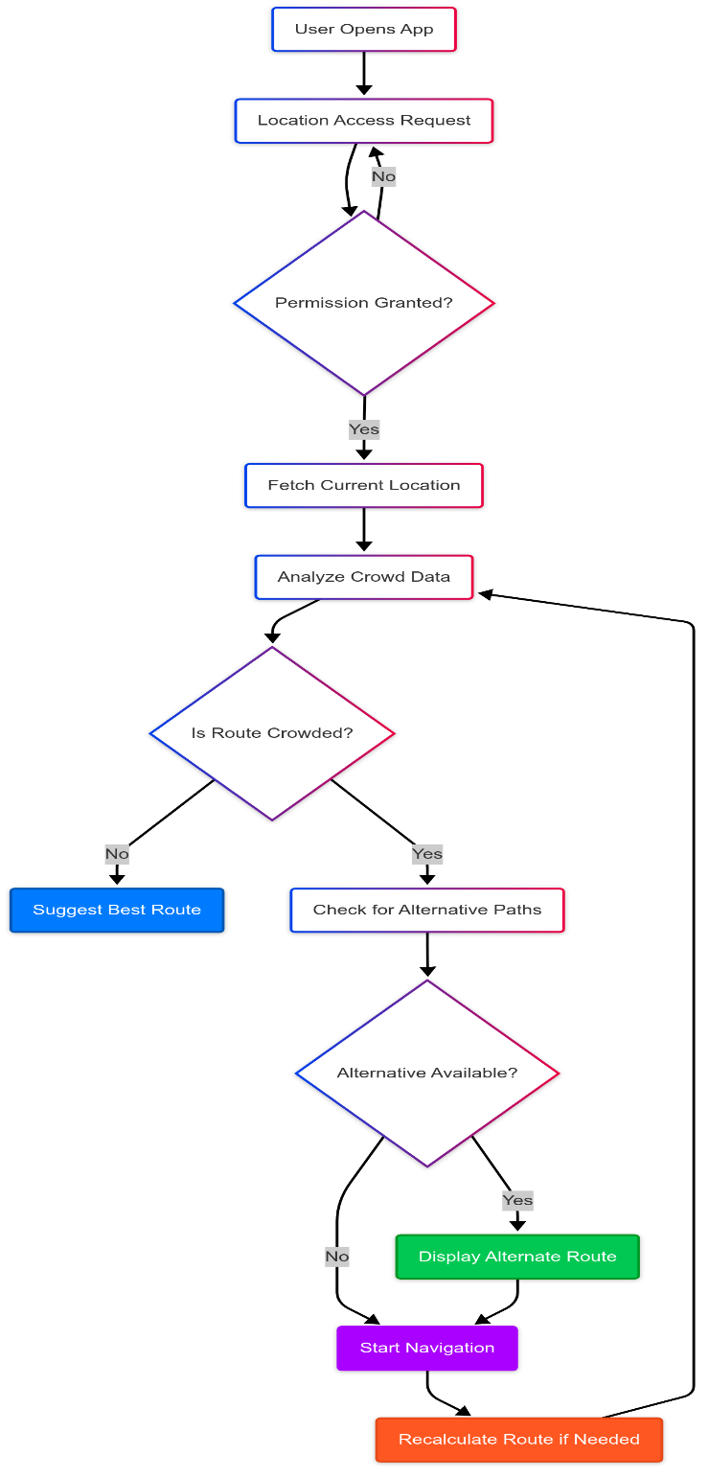

**Figure 1 Flowchart for IoT-Integrated AI Solution for Crowd Control in University Campuses**

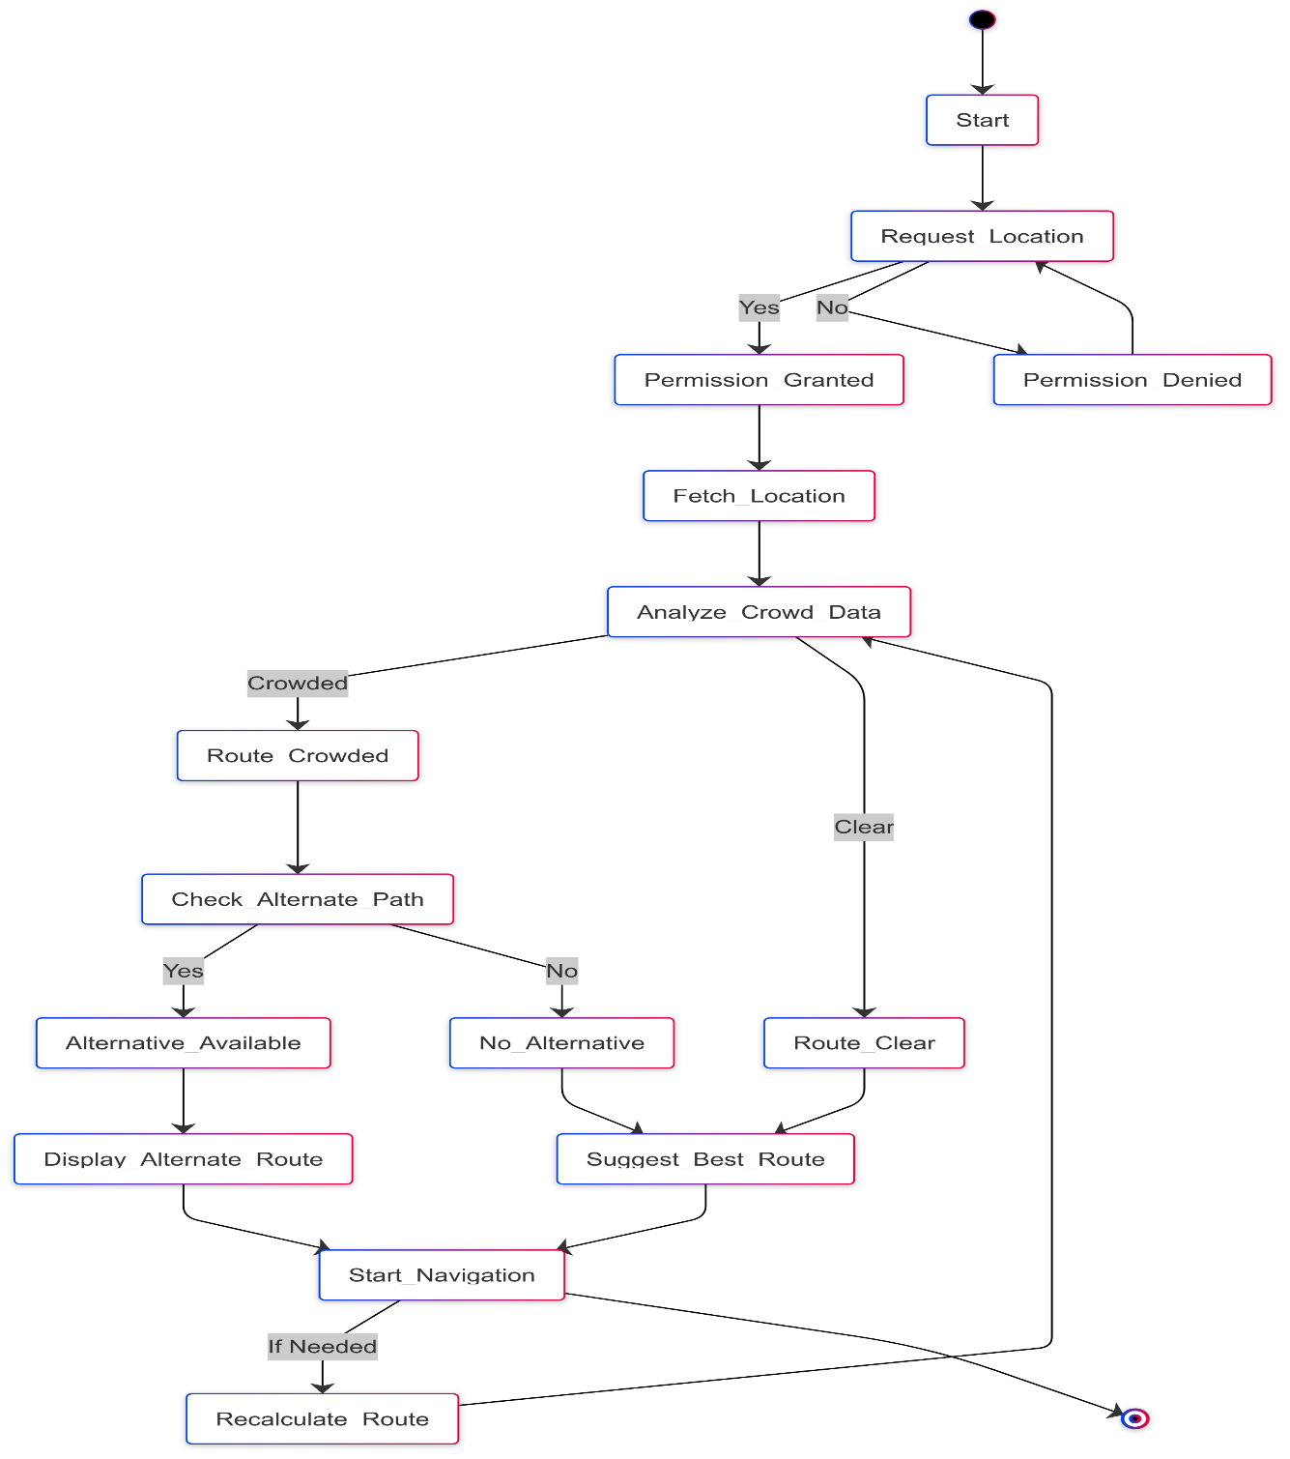

**Figure 2 State chart for IoT-Integrated AI Solution for Crowd Control in University Campuses**

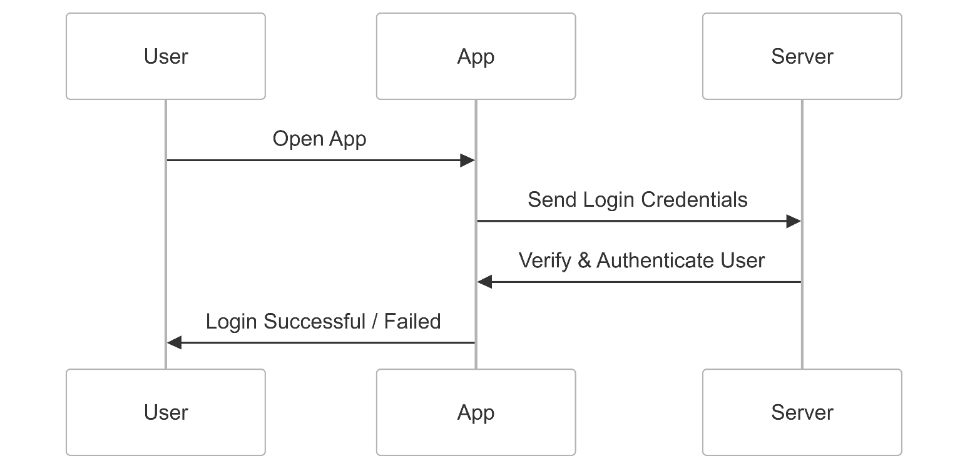

**Figure 3 Sequence diagrams - User Login & Authentication**

**Figure 4 Sequence diagrams - Location Detection & Route Calculation**

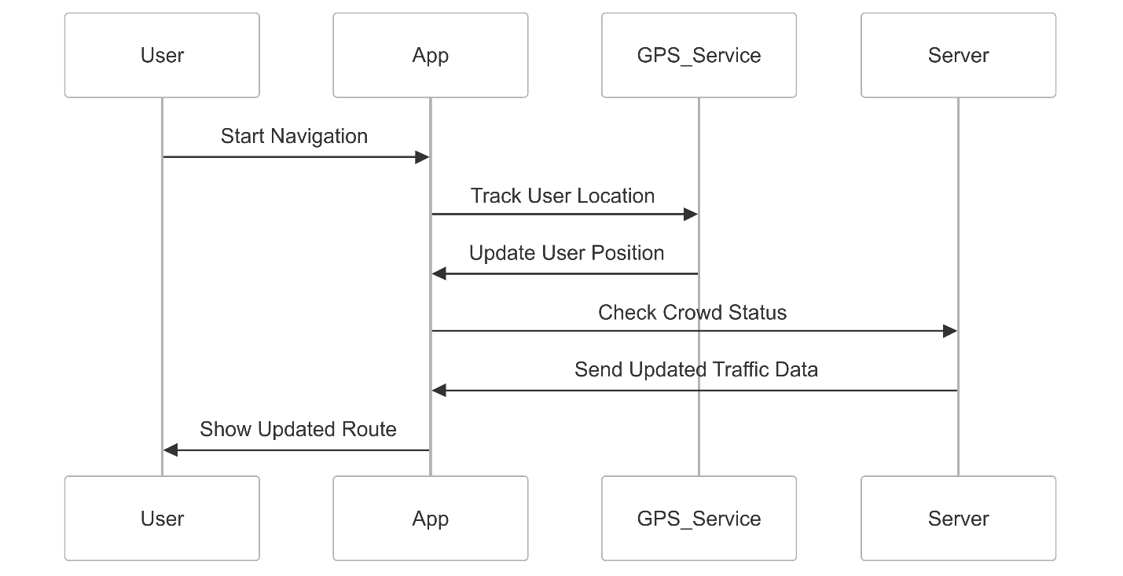

**Figure 5 Sequence diagrams - Navigation & Real-Time Tracking**

**Figure 6 Sequence diagrams - Dynamic Path Re-Routing**

**Figure 7 Sequence diagrams - Destination Reached & End Navigation**

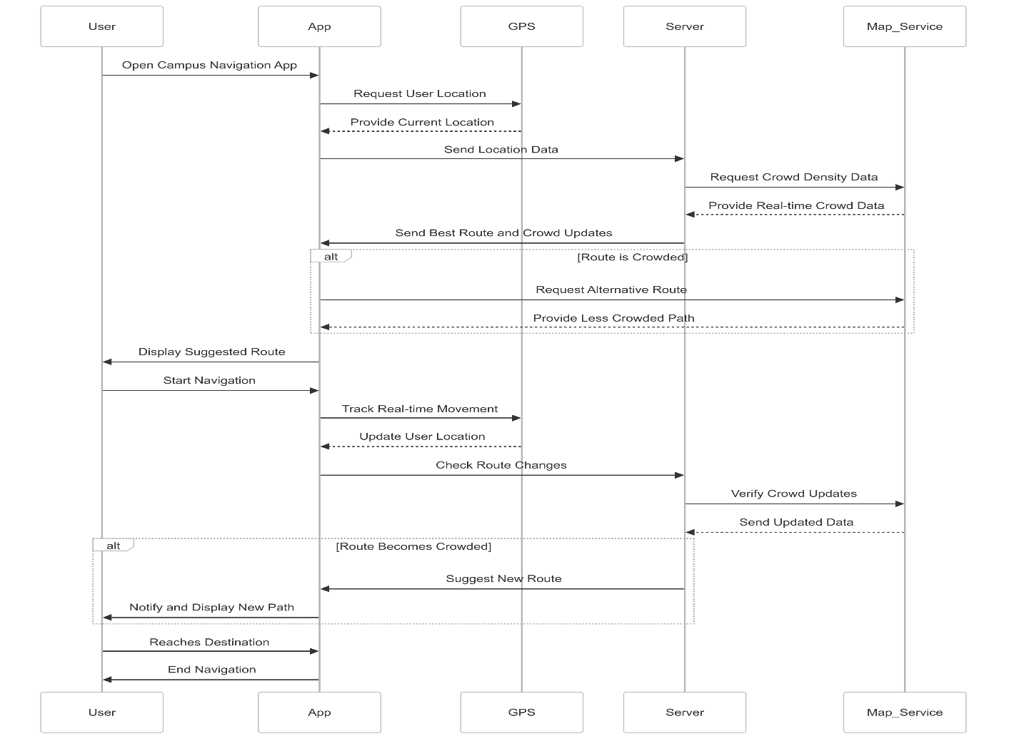

**Figure 8 Sequence diagrams For Whole System**

**G. EXISTING DATA**

To effectively support the development of the **Crowd Management System for Public Spaces**, leveraging existing data and case studies can provide valuable insights into the system's potential benefits, challenges, and real-world applications. Drawing from proven research, pilot projects, and comparative studies, the following data categories are essential in building a strong foundation for the system:

**1. Performance of Crowd Management Systems**

* **Sensor Accuracy and Efficiency**: Research indicates that modern IoT-based sensors used in crowd management systems can achieve high levels of accuracy in tracking crowd density, movement patterns, and bottleneck identification. Studies published in journals like *Sensors and Actuators* demonstrate that sensors with accuracy rates of up to 98% can significantly improve real-time decision-making in crowded environments.
* **Case Study - Event Venues**: A pilot project conducted in London’s Wembley Stadium used crowd management technology to monitor real-time crowd movement. This resulted in a 25% reduction in congestion, enabling event staff to optimize crowd flow and safety. This supports the operational efficiency claims of the crowd management system.

**2. Environmental and Social Impact of Public Space Management**

* **Reduction in Emergency Incidents**: According to studies by the *National Institute of Public Safety* in Japan, smart crowd management systems can reduce the risk of crowd-related incidents by up to 40%. Using sensors and predictive analytics, potential hazards such as overcrowding or stampedes can be detected early, allowing for timely intervention.
* **Improved Urban Mobility**: Research from the *Urban Mobility Report* indicates that optimized crowd management can improve pedestrian traffic flow by 15-20%, leading to enhanced urban mobility and reduced congestion in high-traffic public areas. This contributes to a smoother and more efficient city infrastructure.

**3. Cost Savings and Operational Benefits**

* **Operational Efficiency**: Case studies from cities like Singapore and New York show that implementing crowd management systems reduces operational costs by 10-15%. This is achieved through improved crowd flow, efficient resource allocation, and faster emergency response times.
* **Cost of Implementation**: Data from the *World Economic Forum* highlights that the upfront investment in smart crowd management systems is often offset within 3-5 years through savings in emergency management, maintenance, and overall operational efficiency.

**4. User Experience and Public Satisfaction**

* **Increased User Confidence**: Surveys from transit agencies that have implemented crowd management systems report a 20% increase in public satisfaction. The systems offer real-time information on crowd conditions, reducing anxiety and improving the overall experience of commuters.
* **Increased Usage of Public Spaces**: Data from pilot cities using crowd management technologies, like Barcelona, suggests that the presence of real-time crowd information can lead to a 10-15% increase in the utilization of public spaces. Citizens feel more confident in using these spaces when they have up-to-date information on crowd density and availability.

**5. Comparative Analysis of Crowd Control Technologies**

* **Traditional vs. Smart Crowd Management**: A study published in *Transport Research Part F: Traffic Psychology and Behaviour* compares the effectiveness of traditional crowd control methods, such as physical barriers and manual monitoring, with modern sensor-based systems. The research indicates that sensor-based systems offer greater flexibility, better real-time insights, and reduced human error, contributing to more effective crowd control.
* **Scalability and Adaptability**: Studies conducted by cities like Tokyo and Amsterdam demonstrate that smart crowd management systems can be scaled efficiently from small areas like bus stops to large public events or citywide applications. The flexibility of these systems allows them to be adapted to various environments and requirements.

**4. USE AND DISCLOSURE (IMPORTANT):**

Please answer the following questions:

|  |  |  |
| --- | --- | --- |
| 1. Have you described or shown your invention/ design to anyone or in any conference? |  | NO ( No ) |
| 1. Have you made any attempts to commercialize your invention (for example, have you approached any companies about purchasing or manufacturing your invention)? |  | NO (No ) |
| 1. Has your invention been described in any printed publication, or any other form of media, such as the Internet? |  | NO ( No ) |
| 1. Do you have any collaboration with any other institute or organization on the same? Provide name and other details. |  | NO ( No ) |
| 1. Name of Regulatory body or any other approvals if required. |  | NO ( No ) |

5. Provide links and dates for such actions if the information has been made public (Google, research papers, YouTube videos, etc.) before sharing with us. NA

6. Provide the terms and conditions of the MOU also if the work is done in collaboration within or outside university (Any Industry, other Universities, or any other entity). NA

7. Potential Chances of Commercialization. Yes

8. List of companies which can be contacted for commercialization along with the website link. NA

9. Any basic patent which has been used and we need to pay royalty to them. NA

10. FILING OPTIONS: Please indicate the level of your work which can be considered for provisional/ complete/ PCT filings (Mandatory to mention). (Provisional)

11. KEYWORDS

* **Campus Crowd Management**
* **Student Flow Optimization**
* **University Traffic Control**
* **Smart Campus Solutions**
* **AI for Campus Mobility**
* **Real-Time Campus Monitoring**
* **Student Movement Tracking**
* **Crowd Density Analysis**
* **Campus Safety and Security**
* **IoT for Campus Management**
* **Emergency Evacuation Management**
* **Automated Crowd Detection**
* **Real-Time Occupancy Management**
* **Smart Campus Infrastructure**
* **Surge Control on Campus**
* **Predictive Analysis for Campus Events**
* **Event-Driven Crowd Control**
* **Student Behavior Analytics**
* **Campus Flow Prediction Models**
* **Classroom and Facility Occupancy Monitoring**
* **Digital Campus Mapping**
* **Real-Time Alert System for Campus**
* **Crowd Control Algorithms**
* **Smart Entry/Exit Management**
* **University Resource Optimization**
* **Personalized Student Services**
* **Campus Load Balancing**