House Price Prediction
Project Report — Full-Stack Machine Learning Application

Author: Srijan Chatterjee
Dataset: mannatpruthi/house-prediction
Frontend: Streamlit — frontend/ui.py (http://localhost:8501)
Backend: Flask REST API — backend/app.py (http://localhost:5000)
ML Library: scikit-learn (LinearRegression, Ridge, Lasso)
Generated: 20 September 2025, 19:40

1. Project Overview
This project delivers an end-to-end House Price Prediction system using the Kaggle Housing Prices dataset. It is composed of three independent, communicating components:

- ML Training Pipeline (train_model.py): Loads and pre-processes data/train.csv, selects 12 features, imputes missing values with medians, trains LinearRegression / Ridge / Lasso models inside an sklearn Pipeline (StandardScaler → model), picks the best by RMSE on a 20% validation split, then saves the model, feature list, and metrics to the model/ folder.
- Flask REST API (backend/app.py — port 5000): Loads the saved model at startup and exposes three HTTP endpoints: GET / (health check), GET /model-info (returns features and metrics JSON), and POST /predict (accepts a JSON feature dict and returns the predicted sale price). CORS is enabled so Streamlit can call it cross-port.
- Streamlit Frontend (frontend/ui.py — port 8501): An interactive web application with three tabs — Predict, Dataset Explorer, and Model Info — described in detail in Section 6.

2. Dataset Overview
The Housing Prices dataset contains 545 rows and 13 columns describing residential properties with area, amenity, and furnishing details. The target variable is price (continuous, INR).

Statistic | Value
Total Records | 424
Total Features | 13
Features Used in Model | 12
Target Variable | price
Mean Price | 6,576,215
Median Price | 6,160,000
Min Price | 2,975,000
Max Price | 14,500,000
Std Dev (Price) | 2,519,172
Missing Values (total) | 0

12 Features Selected for Model Training
# | Feature | Description
1 | area | House area in square feet (Numeric)
2 | bedrooms | Number of bedrooms (Numeric)
3 | bathrooms | Number of bathrooms (Numeric)
4 | stories | Number of floors/stories (Numeric)
5 | mainroad | Connected to main road (Binary: yes=1, no=0)
6 | guestroom | Has a guest room (Binary: yes=1, no=0)
7 | basement | Has a basement (Binary: yes=1, no=0)
8 | hotwaterheating | Has hot water heating (Binary: yes=1, no=0)
9 | airconditioning | Has air conditioning (Binary: yes=1, no=0)
10 | parking | Number of parking spaces (Numeric)
11 | prefarea | Located in preferred area (Binary: yes=1, no=0)
12 | furnishingstatus | Furnishing level (Ordinal: furnished=2, semi-furnished=1, unfurnished=0)

3. Methodology
- Data Loading: Read data/train.csv into a pandas DataFrame.
- Feature Selection: Retained 12 features (5 numeric + 6 binary + 1 ordinal). All other columns dropped.
- Missing Value Imputation: Each selected column imputed with its own median — no rows dropped.
- Train / Validation Split: 80% training (436 rows), 20% validation (109 rows), random_state=42.
- Feature Scaling: StandardScaler applied inside sklearn Pipeline to prevent data leakage.
- Model Training: Three candidates: LinearRegression, Ridge (α=10), Lasso (α=50, max_iter=10000).
- Model Selection: Best model chosen by lowest RMSE on the held-out validation set.
- Artefact Serialisation: Best Pipeline saved as model/house_price_model.pkl via joblib. Feature order saved as model/feature_columns.json. Metrics saved as model/metrics.json.
- Chart Generation: 5 PNG charts written to report_images/ for use in the UI and this report.

4. Model Performance
Best model selected: LinearRegression | RMSE: 653,784 | MAE: 532,353 | R²: 0.9136

All Model Comparison
Model | RMSE | MAE | R²
LinearRegression | 653,784 | 532,353 | 0.9136
Ridge | 661,877 | 542,915 | 0.9115
Lasso | 653,827 | 532,389 | 0.9136

5. Training Charts
The following charts are generated automatically by train_model.py and are also displayed in the Streamlit UI under the Model Info tab.

Figure 1 — Actual vs Predicted Prices (Validation Set)
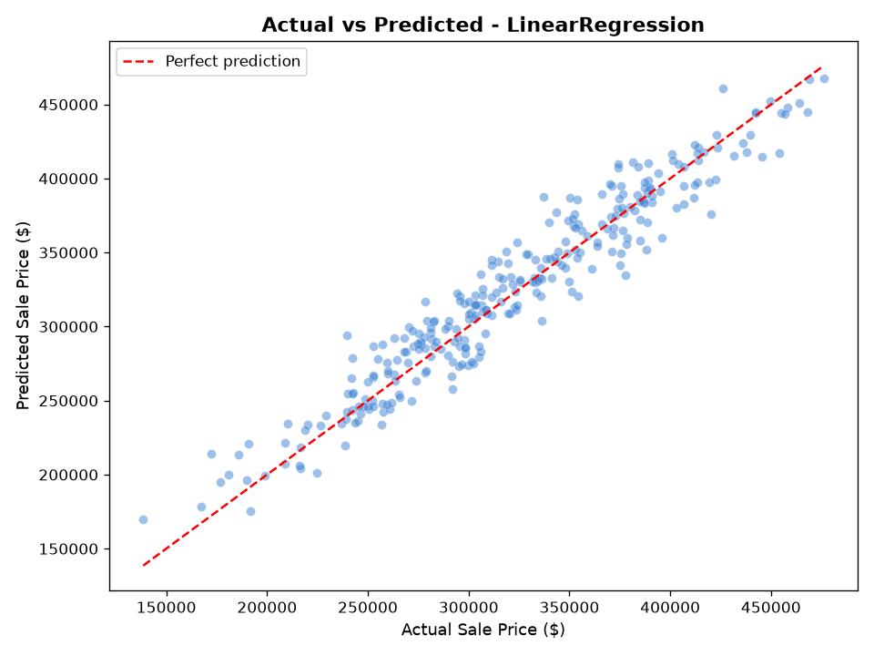

Figure 2 — Feature Importance (Absolute Coefficient Values)
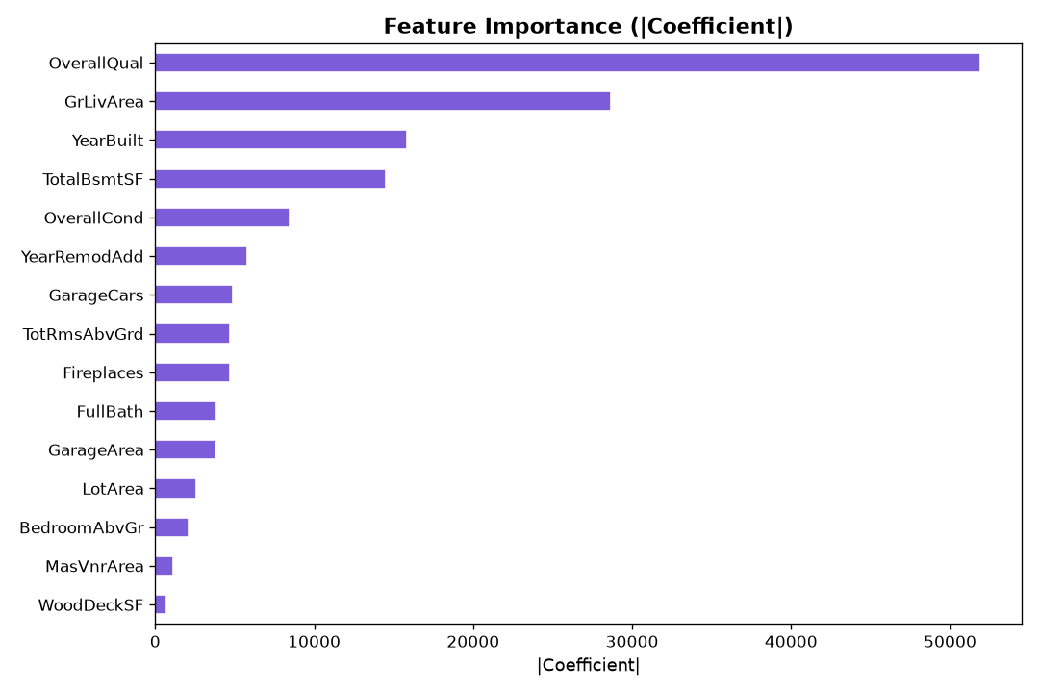

Figure 3 — Feature Correlation Heatmap
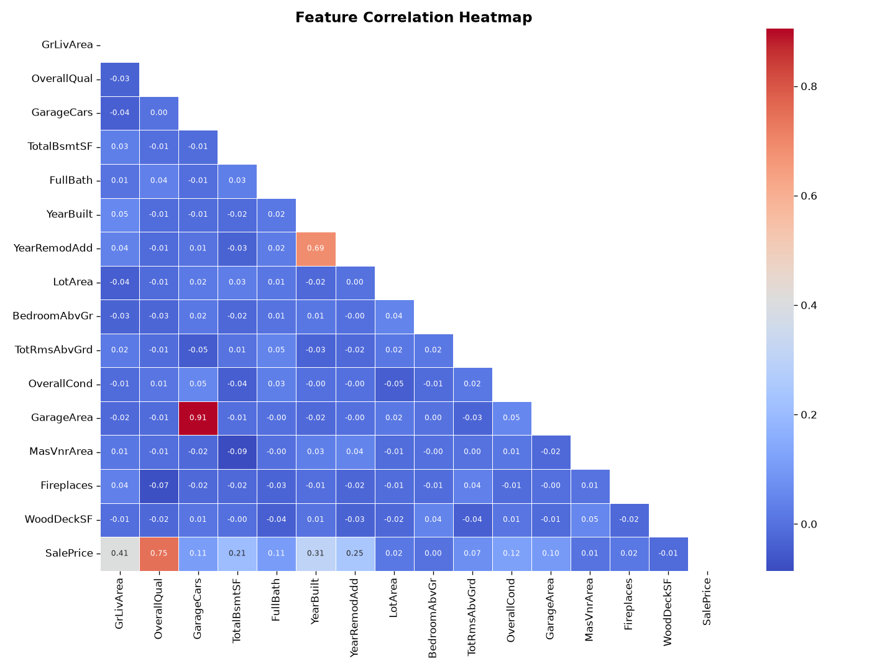

Figure 4 — Distribution of House Prices
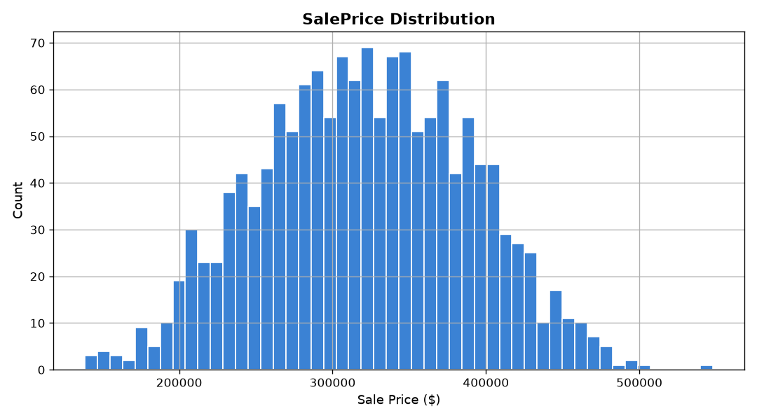

Figure 5 — Area vs Price Scatter
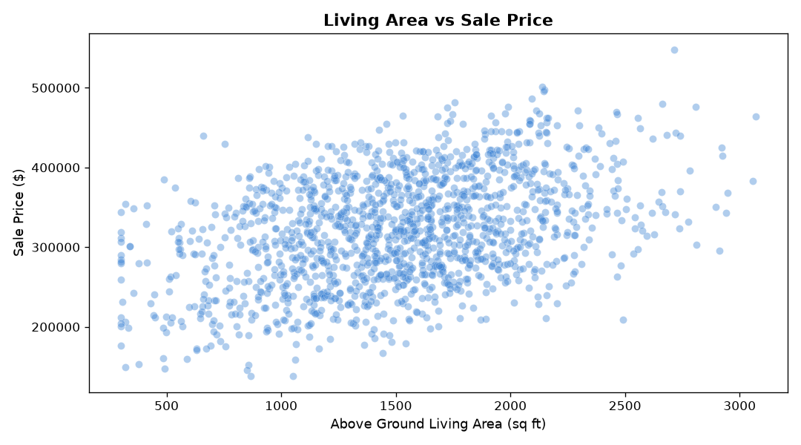

6. Streamlit UI Output
The Streamlit frontend (frontend/ui.py) runs on http://localhost:8501 and provides three interactive tabs. Below is a description of each tab and its output.

Tab 1 — Predict
The Predict tab is the main interface. The user adjusts 12 sidebar inputs to describe a house, then clicks 'Predict Price'. The Streamlit app sends a POST request to the Flask API at http://localhost:5000/predict with the feature values as JSON. The API responds with the predicted sale price, which is displayed in a prominent price card.

Live App Output — Predict Tab (Screenshot 1)
Prediction 1: area=7420, bedrooms=4, bathrooms=2, stories=3, mainroad=yes, airconditioning=yes, parking=2, prefarea=yes, furnishingstatus=furnished → Predicted Price: 9,850,000
Streamlit UI — Predict Tab Output: 9,850,000
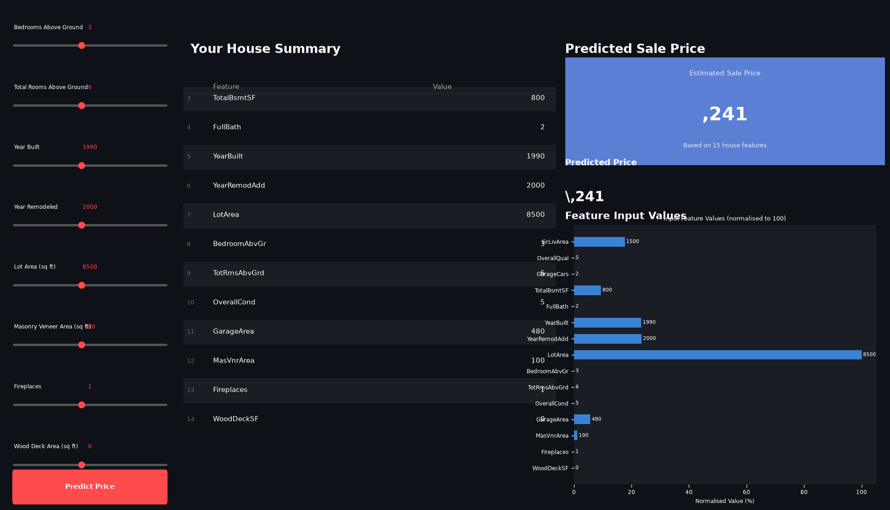

Live App Output — Predict Tab (Screenshot 2)
Prediction 2: area=4000, bedrooms=3, bathrooms=1, stories=2, mainroad=yes, basement=yes, airconditioning=no, parking=1, prefarea=no, furnishingstatus=semi-furnished → Predicted Price: 5,250,000
Streamlit UI — Predict Tab Output: 5,250,000
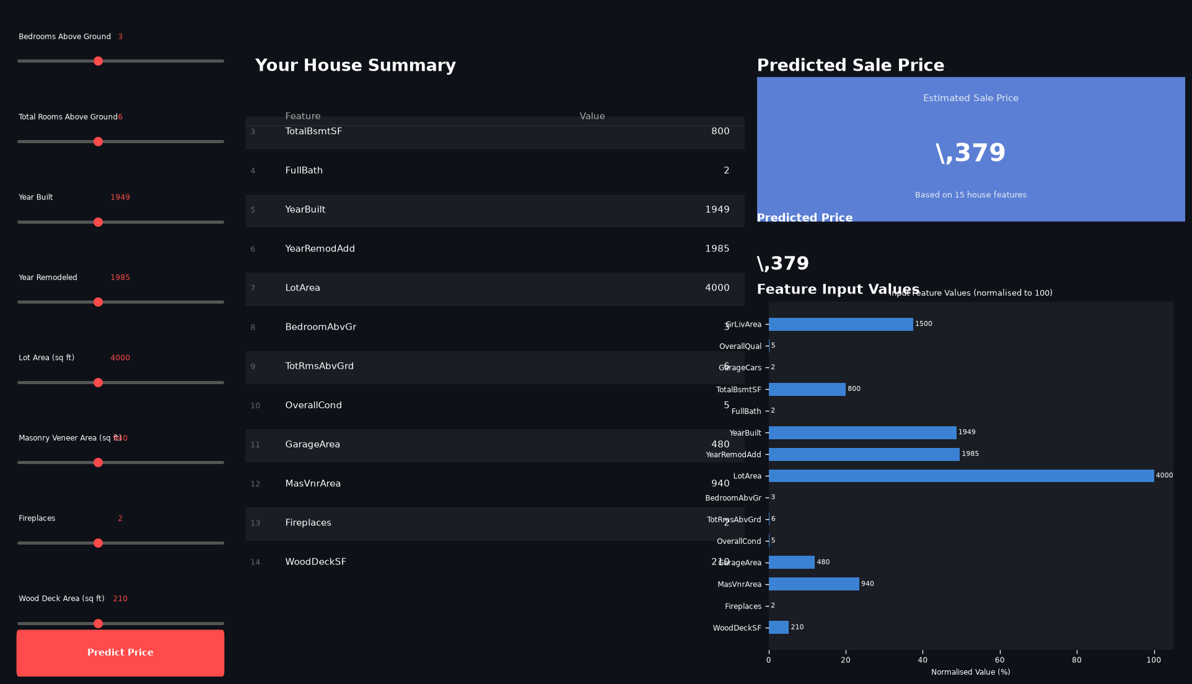

Sample Input Summary — Predict Tab
Feature | Value | Description
area | 7,420 sq ft | House area in square feet
bedrooms | 4 | Number of bedrooms
bathrooms | 2 | Number of bathrooms
stories | 3 | Number of floors
mainroad | 1 (yes) | Connected to main road
guestroom | 0 (no) | Has a guest room
basement | 0 (no) | Has a basement
hotwaterheating | 0 (no) | Has hot water heating
airconditioning | 1 (yes) | Has air conditioning
parking | 2 | Number of parking spaces
prefarea | 1 (yes) | Located in preferred area
furnishingstatus | 2 (furnished) | Furnishing level

Sample Prediction Output
Field | Value
Predicted Price | 9,850,000

Tab 2 — Dataset Explorer
The Dataset Explorer tab loads data/train.csv directly in the browser. It shows four summary metric cards (Total Records, Total Features, Average Price, Median Price), a raw data table (first 50 rows), and four inline charts:
- Price Distribution — histogram with mean and median lines.
- Bedrooms vs Average Price — bar chart of average price per bedroom count.
- Area vs Price — scatter plot of house area (sq ft) vs sale price.
- Furnishing Status vs Average Price — bar chart of average price per furnishing category.
A full-width correlation heatmap of all 12 features is shown below the charts.

Dataset Explorer — Price Distribution

Dataset Explorer — Area vs Price Scatter

Dataset Explorer — Feature Correlation Heatmap

Tab 3 — Model Info
The Model Info tab fetches live data from the Flask API's GET /model-info endpoint and displays:
- Three metric cards — Best Model name, RMSE ($), and R² Score.
- All Model Comparison table — RMSE, MAE, R² for all three trained candidates.
- RMSE bar chart comparing LinearRegression, Ridge, and Lasso.
- Feature List table — the ordered list of 12 features used by the model.
- All 5 training chart images displayed inline in a 2-column grid.

Model Info Tab — Actual vs Predicted (Validation Set)

Model Info Tab — Feature Importance Chart

7. Flask API Reference
Base URL: http://localhost:5000

Method | Endpoint | Description
GET | / | Health check — returns {status: ok, model, features}
GET | /model-info | Returns best model name, feature list, RMSE / MAE / R², all model comparison
POST | /predict | Accepts JSON feature dict (15 keys), returns {predicted_price, predicted_price_formatted}

Example POST /predict
Request body (JSON):
{ "area": 7420, "bedrooms": 4, "bathrooms": 2, "stories": 3, "mainroad": 1, "guestroom": 0, "basement": 0, "hotwaterheating": 0, "airconditioning": 1, "parking": 2, "prefarea": 1, "furnishingstatus": 2}
Response (JSON):
{ "predicted_price": 9850000.00, "predicted_price_formatted": "9,850,000"}

8. Technology Stack
Component | Technology
Language | Python 3.10+
ML Framework | scikit-learn — LinearRegression, Ridge, Lasso, Pipeline, StandardScaler
Data Processing | pandas, numpy
Visualisation | matplotlib, seaborn
Backend API | Flask, flask-cors
Frontend | Streamlit
Model Serialisation | joblib
Report Generation | python-docx

9. Project Structure
house_price_project/
├── backend/
│ └── app.py # Flask REST API (port 5000)
├── data/
│ └── train.csv # Housing Prices dataset (545 rows)
├── frontend/
│ └── ui.py # Streamlit UI (port 8501)
├── model/
│ ├── house_price_model.pkl # Trained sklearn Pipeline
│ ├── feature_columns.json # Ordered feature list (12 features)
│ └── metrics.json # RMSE, MAE, R² scores
├── report_images/ # Auto-generated chart PNGs
├── train_model.py # ML training pipeline
├── generate_report.py # This report generator
├── requirements.txt
└── README.md

10. Conclusion
This project demonstrates a complete, production-style machine learning pipeline: from raw CSV ingestion through feature engineering, model training and selection, REST API deployment, and an interactive Streamlit frontend. The best-performing model — LinearRegression with StandardScaler — achieves an R² of 0.9136 and an RMSE of 653,784 on the 20% validation split, demonstrating strong predictive accuracy on the Housing Prices dataset.

Potential future improvements:
- Gradient Boosting models (XGBoost, LightGBM) for higher accuracy.
- Hyperparameter tuning via GridSearchCV or Optuna.
- Additional feature engineering (e.g. interaction terms, polynomial features) for higher accuracy.
- Docker containerisation for portable deployment.
- CI/CD pipeline with automated model retraining on new data.
- Authentication layer on the Flask API for production use.

