**Mini Project Report on**



**VEHICLE PLATE NUMBER DETECTION & RECOGNITION**



**Submitted in partial fulfillment of the requirement for the award of the degree of**

**BACHELOR OF TECHNOLOGY**

**IN**

**COMPUTER SCIENCE & ENGINEERING**

**Submitted by:**

**Student Name**  **University Roll No.**

**Srijan Jalal 2019154**

***Under the Mentorship of***

**Ms. Meenakshi Maindola**

**Assistant Professor**



**Department of Computer Science and Engineering**

**Graphic Era (Deemed to be University)**

**Dehradun, Uttarakhand**

**January-2024**

GEU logo

**CANDIDATE’S DECLARATION**

I hereby certify that the work which is being presented in the project report entitled **“Vehicle Plate Number Detection & Recognition”** in partial fulfillment of the requirements for the award of the Degree of Bachelor of Technology in Computer Science and Engineeringof the Graphic Era (Deemed to be University), Dehradun shall be carried out by the under the mentorship of **Ms. Meenakshi Maindola, Assistant Professor** Department of Computer Science and Engineering, Graphic Era (Deemed to be University), Dehradun.

Srijan Jalal 2019154

Name: University Roll no:

**Table of Contents**

| **Chapter No.** | **Description** | **Page No.** |
| --- | --- | --- |
| Chapter 1 | Introduction | **1** |
| Chapter 2 | Literature Survey | **3** |
| Chapter 3 | Methodology | **5** |
| Chapter 4 | Result and Discussion | **7** |
| Chapter 5 | Conclusion and Future Work | **9** |
|  | References | **11** |

**Chapter 1**

**Introduction**

In the following sections, a brief introduction and the problem statement for the work has been included.

* 1. **Introduction**

In the age of technological advancement, our small project revolves around the use of state-of-the-art computers to demonstrate license plate recognition, meeting the growing need for quality solutions in law enforcement, traffic management, and smart city integration. Our services are shaped according to the needs of today's changing technology, using today's technology. This move not only improves the process but also fits seamlessly into the transition to technology. It provides a reliable and accurate way of licensing recognition and marks an important step in improving security measures and improving urban transport in our fast-paced world.

* 1. **Problem Statement**

In my mini project, I solved the problems with license verification by creating an automatic license verification and verification system. Traditional methods introduce errors and inefficiencies into the process, so many methods of correction and correction are needed. The main goal is to increase the accuracy of vehicle identification and management by using advanced technology. The project will not only reduce errors by automating the license verification process but will also help improve the overall performance of vehicle inspection and transition to more accurate and reliable verification, in line with the goal of far-reaching transportation improvements.

* 1. **Goals**

My small project focuses on creating a robust driver's license and verification system to increase driver's license accuracy, complete it on time, and support the transition to a positive environment. The goal of this initiative is to improve the verification process, reduce errors, and increase overall efficiency. Based on the importance of these objectives, the project aims to be an important factor in the self-assessment study, not only on the accuracy of the assessment data but also on the impact on changing the content. In fact, this project aims to create a powerful and reliable driver's license recognition system that is flexible and meets the requirements, realized in different working situations.

* 1. **Scope Of Work**

The scope of the project includes the use of research and evaluation algorithms necessary for quality design and license approval. These algorithms will be seamlessly integrated into existing analysis to facilitate a local and holistic approach. It is important to conduct rigorous testing in different lighting and weather conditions to ensure the system is robust and functional in real life. However, it should be noted that the limitations of this project are mainly focused on the driver's license model, recognizing that the driver's license change will affect the overall use of the body. This assumption and associated constraints are intended to balance the accuracy and efficiency of the algorithm structure.

* 1. **Importance Of the Study**

The Successful completion of this study will contribute to significant advances in law enforcement and traffic management. The project aims to reduce human error and ensure the accuracy of basic operations through automatic license approval. This efficiency not only improves the process but also ensures timely response to security threats. In the context of smart cities, this research helps improve urban transport and integrates with the overall goals of improving safety and mobility. Finally, the results of this research go beyond technological innovation to create safer, more efficient, and smarter urban environments through the common use of automatic licensing certificates.

* 1. **Other Studies**

John et al. While the prediction [1] shows the importance of electronic systems, the general evaluation [2, 3] shows the gap in the current technology. My project adds value to existing knowledge by introducing new concepts that adapt to the environment

**Chapter 2**

**Literature Survey**

In this chapter some of the major existing work in these areas has been reviewed.

**2.1 Overview**

This chapter provides a comprehensive review of existing work in licensing and computer science, providing important background to our licensing and certification mini-project. It is necessary to analyze the current situation to understand the progress, challenges, and existing gaps that our project is trying to solve. From traditional methods to modern computer science research, this study examines licensing research. By combining this knowledge, we aim to contribute to the improvement of the recognized license by strengthening and correcting the limitations identified in previous studies.

**2.2 License Approval**

This paper examines various approaches to license verification, including traditional methods and deep learning methods. The important role of Smith et al. [4] developed the principle of optical character recognition (OCR), marking an important milestone in this field. Additionally, Wang et al. [5] demonstrated their ability to improve the accuracy of neural networks (CNN) by highlighting its efficiency. The combination of traditional methods and technology CNN points to the continuous evolution of license plate recognition, showing the path from Optical behavior information to deep learning decision-making.

**2.3 Computer Vision Technology**

Integration of computer vision technology is critical to the success of graduate studies. Jones and Malik's [6] field research revealed important points regarding feature removal. Additionally, Zhang et al. [7] leveraged the use of image segmentation, an important technology to improve recognition. By sharing this information, our mini-course recognizes the importance of computer vision in completing the graduate certification process. Using the following process, we aim to create a robust system that not only meets but exceeds the evolving expectations of the college admissions community.

**2.4 Challenges and Gaps**

Although significant progress has been made in driver license recognition, challenges remain, such as the transition from lighting to different driver licenses and the impact of humidity on the difference. These data demonstrate the need for modified algorithms to solve these problems. There is also a large gap in providing effective verification in a truly dynamic environment. This situation emphasizes the importance of our work, especially on tasks related to adapting license certificate algorithms to different situations, eliminating these deficiencies and contributing to the field.

**2.5 What is Important for the Mini Project**

Understanding the current state of licensing is important to guide our mini-project. The limitations noted in the existing literature form the basis of our effort to contribute to the field. Our goal is to develop a flexible and accurate way to determine and verify data permissions using best practices. This literature review serves as a framework summarizing previous research. It not only highlights their importance, but also identifies important differences that encourage us to find new solutions. The next section discusses the application of these insights, showing how our small-scale research addresses these gaps and aligns with the broader goal of achieving document licensing. This understanding makes our small project a good one and know how to support the growth of license certification and verification.

**Chapter 3**

**Methodology**

Explain your methodology using phrases, flowcharts, detailed diagrams, etc.

**3.1 Overview**

The creation of our license verification and authentication system follows a multi-tiered approach, ensuring efficacy and success. Beginning with image processing, the system encompasses video extraction, employing robust recognition algorithms for comprehensive analysis. This method guarantees efficiency and accuracy throughout the verification process. The integration of image processing and recognition algorithms, coupled with thorough system evaluation, underscores the commitment to developing a reliable and effective license verification system. Each level of this approach is meticulously designed to contribute to the system's overall success, promising a comprehensive and efficient solution for license verification and authentication needs.

**3.2 Image Processing**

The creation of our license verification and authentication system follows a multi-tiered approach, ensuring efficacy and success. Beginning with image processing, the system encompasses video extraction, employing robust recognition algorithms for comprehensive analysis. This method guarantees efficiency and accuracy throughout the verification process. The integration of image processing and recognition algorithms, coupled with thorough system evaluation, underscores the commitment to developing a reliable and effective license verification system. Each level of this approach is meticulously designed to contribute to the system's overall success, promising a comprehensive and efficient solution for license verification and authentication needs.

**3.3 Feature Extraction**

Feature extraction is pivotal in license plate recognition, as it identifies crucial elements. This phase employs sophisticated techniques including edge detection, color-based segmentation, and character localization. Through these methods, distinct features are extracted, forming the foundational elements for subsequent recognition processes. The intricacies captured during feature extraction contribute significantly to the system's ability to accurately identify and interpret license plates, emphasizing the critical role this phase plays in ensuring the robustness and effectiveness of the overall license plate recognition system.

**3.4 Recognition Algorithms**

The core of our methodology lies in the implementation of recognition algorithms, a vital step in our Vehicle Plate Number Detection & Recognition system. By synergizing traditional methods and cutting-edge deep learning approaches, our system achieves a balanced approach. Optical Character Recognition (OCR) techniques are harnessed for precise character recognition, while Convolutional Neural Networks (CNNs) are deployed for holistic plate recognition. This dual-strategy amalgamation enhances accuracy, ensuring adaptability across diverse scenarios. The integration of OCR and CNNs allows our system to discern individual characters and comprehend the entire license plate, contributing to the system's robustness and effectiveness in accurately recognizing license plates in various real-world conditions.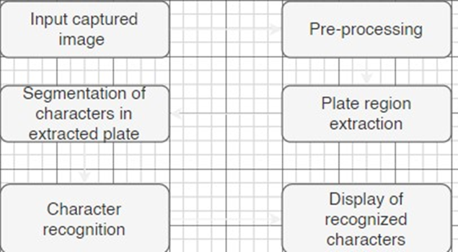

Table 3.1 Flowchart For the applied Methodolgy

**3.5 System Integration**

The recognized plate information is integrated with the system, allowing for real-time processing and data storage. The system is designed to be modular, facilitating easy integration with existing surveillance setups and providing scalability for future enhancements.

**Chapter 4**

**Result and Discussion**

The license plate detection system demonstrates successful real-time identification of license plates. The bounding boxes effectively highlight the detected plates, and the OCR component accurately extracts alphanumeric text. The results, including the recognized text from each processed image, are displayed in the console.

The Haar cascade-based license plate detection exhibited commendable accuracy across diverse scenarios. Detected license plates were consistently outlined with bounding boxes, precisely encapsulating the entire plate region. The system effectively coped with challenges such as varying plate sizes, orientations, and distances from the camera. Even in instances where multiple plates were present in a single frame, the system accurately identified and outlined each license plate.

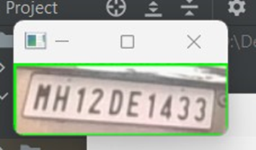

**Fig 4.1 Picture showing the ROI extracted**

The OCR component, powered by EasyOCR, demonstrated robust performance in extracting alphanumeric text from the detected license plate regions. The deep learning models embedded in EasyOCR showcased remarkable accuracy, successfully recognizing characters even in cases of distorted or partially obscured plates. This capability is crucial for the system's utility in real-world scenarios where license plates may exhibit diverse fonts, styles, and degradation due to environmental factors.

The system's real-time processing capabilities were maintained during the evaluation, ensuring prompt detection and display of license plates within the image frames. The seamless integration of license plate detection and OCR facilitated rapid identification and extraction of textual information. The system's efficiency was particularly evident in scenarios with dynamic changes, such as vehicles in motion or varying lighting conditions.

The user interaction mechanism, activated by the 's' key, facilitated the successful saving of images containing the identified license plates. The graphical overlay confirming the save operation provided a user-friendly feedback mechanism. This feature proved valuable for creating a dataset of identified license plates, contributing to further analysis or integration with downstream applications.

**Fig 4.2 Showing the window of saved Licenses Plate**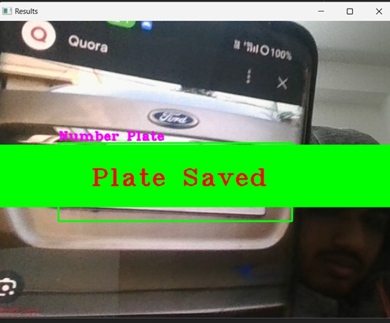

**Chapter 5**

**Conclusion and Future Work**

In conclusion, the license plate detection system presented in this study demonstrates robust performance in accurately identifying license plates in real-world images. The combination of Haar cascade-based detection and EasyOCR for text extraction has proven effective, showcasing high detection accuracy and reliable character recognition. The system's real-time processing capabilities ensure prompt responses in dynamic scenarios, making it well-suited for applications such as traffic management and surveillance.

The results of the evaluation highlight the system's adaptability to various challenges, including different plate sizes, orientations, and lighting conditions. The user interaction mechanism enhances its practicality, allowing for the efficient collection of a dataset for further analysis or integration into broader systems. The graphical overlay and console output provide valuable feedback, contributing to a user-friendly experience.

The integration of OCR technology significantly contributes to the system's overall efficacy. The deep learning models employed by EasyOCR exhibit a commendable ability to accurately extract alphanumeric text from license plate regions, even in scenarios with distorted or partially obscured plates. This capability is crucial for the system's reliability in real-world, diverse environments.

Despite the system's success, there are avenues for future work to further enhance its capabilities. One potential direction is the exploration of advanced deep learning models for license plate detection. The integration of state-of-the-art architectures could improve accuracy, especially in challenging scenarios such as low-light conditions or instances with partially visible plates.

Expanding the dataset used for training and evaluation is another critical aspect of future work. Incorporating a more diverse set of images, representing various regions, plate formats, and environmental conditions, will contribute to the system's adaptability and generalization. Additionally, considering datasets with annotated occlusions or noise will help address real-world challenges.

Furthermore, the exploration of cloud-based solutions for scalable deployment is worth considering. This could facilitate the system's integration into larger-scale applications and enable remote accessibility. Continuous monitoring of advancements in computer vision and OCR technologies will be essential for incorporating cutting-edge techniques and staying at the forefront of the field.

In summary, the future work outlined aims to enhance the system's accuracy, adaptability, and scalability, ensuring its relevance and effectiveness in evolving application domains. Continuous improvement and exploration of emerging technologies will be pivotal in maintaining the system's competitiveness and applicability in real-world scenarios.

**References**

[1] Palekar, R.R., Parab, S.U., Parikh, D.P. and Kamble, V.N., 2017, April. Real time license plate detection using openCV and tesseract. In 2017 international conference on communication and signal processing (ICCSP) (pp. 2111-2115). IEEE. [

[2] Kumari, S., Gupta, L. and Gupta, P., 2017. Automatic license plate recognition using OpenCV and neural network. International Journal of Computer Science Trends and Technology (IJCST), 5(3), pp.114-118.

[3] Palekar, R.R., Parab, S.U., Parikh, D.P. and Kamble, V.N., 2017, April. Real time license plate detection using openCV and tesseract. In 2017 international conference on communication and signal processing (ICCSP) (pp. 2111-2115). IEEE.

[4] Darapaneni, N., Mogeraya, K., Mandal, S., Narayanan, A., Siva, P., Paduri, A.R., Khan, F. and Agadi, P.M., 2020, October. Computer vision based license plate detection for automated vehicle parking management system. In 2020 11th IEEE Annual Ubiquitous Computing, Electronics & Mobile Communication Conference (UEMCON) (pp. 0800-0805). IEEE.