**Cover Page**

**Multilingual Chatbot in Healthcare**

Project report submitted for

**4th Semester Minor Project**

**in**

**Department of ______**

By,

**Parth Bhandakkar(211010241)**

**Srijan Ratrey(211020454)**



**Department of _________________**

**Dr. Shyama Prasad Mukherjee**

**International Institute of Information Technology, Naya Raipur**

**(A Joint Initiative of Govt. of Chhattisgarh and NTPC)**

**Email:** [**iiitnr@iiitnr.ac.in**](mailto:iiitnr@iiitnr.ac.in)**, Tel: (0771) 2474040, Web:** [**www.iiitnr.ac.in**](http://www.iiitnr.ac.in/)

**Table of Contents**

**Title   Page No.**

**TABLE OF CONTENTS……………………………………….......   i**

**LIST OF FIGURES………………………………………………....   ii**

**ABSTRACT………………………………………………………….  iii**

**CHAPTER 1 INTRODUCTION 1**

**CHAPTER 2 LITERATURE REVIEW 3**

1. Research Area I ……………………………………………………………….    3
2. Research Area II……………………………………………………………….    8
3. Research Area III……………………………………………………………….
4. Challenges………………………………………………………………………..

**CHAPTER 3 PROPOSED SOLUTION           10**

1. Enhance Natural Language Processing(NLP)…………..……………….   10
2. Incorporate Clinical Decision Support (CDS) …………..……………….
3. Ensure Data Privacy and Security…………..……………….
4. Use Patient Feedback to Improve the Chatbot…………..……………….
5. Integrate with Electronic Health Records (EHRs) …………..……………….
6. Provide Multilingual Support…………..……………….
7. Use Avatar-based Chatbots…………..……………….

**CHAPTER 4 RESULTS         11**

1. Section 4.1……………………………………………………………….   12
2. Section 4.2……………………………………………………………….   13

**CHAPTER 5 CONCLUSIONS         14**

1. Training Dataset……………………………………………………………….   14
2. Model……………………………………………………………….   17
3. Bot GUI …………..……………….……

**REFERENCES         18**

**List of All Figures**

|  |  |  |
| --- | --- | --- |
| **Figure No.** | **Figure Title** | **Page Number** |
| 1.1 | Figure Title………………………………………………………… | 1 |
| 2.1 | Figure Title………………………………………………………… | 6 |

Multilingual Chatbot in Healthcare

**Abstract**

This project uses natural language processing (NLP) techniques to develop a chatbot for the web. A chatbot is able to understand user queries and respond to them in a conversational manner, providing a more personalized and efficient experience for website visitors. The chatbot is trained on a dataset of frequently asked questions and uses techniques such as tokenization, sentiment analysis, and intent classification to understand and respond to user input. The ultimate goal of this project is to improve the user experience on the site by providing quick and accurate answers to common questions. Index

Terms—preprocessing, hyperparameters

I. INTRODUCTION

# A chatbot is a software application used to conduct an online chat conversation via text or text-to-speech, instead of providing direct contact with a live human agent.Chatbots are computer programs that are able to maintain a conversation with a user in natural language, understand their intent and respond based on pre-set rules and data. Designed to convincingly simulate

# the way a human would behave as a conversational partner, chatbot systems typically require constant tweaking and testing, with many people in production unable to converse adequately; in 2012, none of them passed the standard Turing test.

# Chatbots are used in dialog systems for a variety of purposes, including customer service, routing requests, or gathering information. While some chatbot applications use extensive

# others simply search for general keywords and generate answers using common phrases obtained from an associated library or database.

# Most chatbots are accessed online through website pop-ups or via virtual assistants. They can be divided into usage categories that include: business (e-commerce via chat), education, entertainment, finance, health, news and productivity.

# II. LITERATURE REVIEW

Chatbots, also known as conversational agents or virtual assistants, have become increasingly popular in the medical field in recent years. They are designed to mimic human conversation and allow patients to communicate with healthcare providers in a more natural and efficient way. The following literature review provides an overview of recent studies on the use of chatbots in the medical field.

A. Research Area I

One of the most promising areas for the use of chatbots is mental health. A study by Fitzpatrick et al. (2020) evaluated the effectiveness of a chatbot in individuals with anxiety and depression. The study found that the chatbot was also able to significantly reduce symptoms of anxiety and depression

## to improve overall mental health and well-being.

## B. Research Area II

## Another study by Y aghoubzadeh et al. (2019) evaluated the use of a chatbot in patients with chronic diseases such as diabetes and hypertension. The study found that the chatbot was effective in improving patient self-management, reducing hospitalizations and increasing patient satisfaction.

## C. Research area IIIC. Research Area III

## Chatbots are also used in patient education and health promotion. A study by Sharma et al. (2020) evaluated the effectiveness of a chatbot for promoting healthy behavior in individuals at risk of cardiovascular disease. The study found that the chatbot was effective in increasing knowledge and awareness of cardiovascular risk factors as well as promoting healthy lifestyles.

## In addition to patient care, chatbots have also been used for medical education and training. A study by Al-Taiar et al. (2020) evaluated the effectiveness of a chatbot for medical students in learning about clinical decision making. The study found that the chatbot was effective in improving students' clinical decision-making and knowledge retention skills.

# D. Challenges

# However, there are also concerns about the use of chatbots in healthcare. One of the main

# concerns is patient privacy and confidentiality. A study by Abbasi et al. (2021) emphasized the importance of ensuring that chatbots

# comply with privacy regulations and that patients are aware of the risks and benefits of using them. Also, chatbots need to be trained

# and built in different native languages ​​so that users can easily access them.

# Overall, the literature suggests that chatbots have the potential to improve patient care, education, and training in the medical field. However, further research is needed to fully understand their effectiveness and to address any privacy and confidentiality concerns.

# .III. PROPOSED SOLUTION

Some key troubleshooting steps are as follows –

A. Enhancing Natural Language Processing (NLP)

Natural language processing is the core technology behind chatbots. Improving NLP can make a chatbot conversational and effective. Advanced machine learning techniques such as deep learning and neural networks can be used to enhance NLP.

# 

Fig 3.1

## B. Incorporate Clinical Decision Support (CDS)

CDS can help chatbots provide more personalized recommendations to patients. For example, the chatbot can suggest different treatment options based on the patient’s medical history and symptoms.

## C. Ensure Data Privacy and Security

Healthcare data is sensitive and should be treated with utmost care. The chatbot should comply with HIPAA regulations and ensure that patient data is protected.

Future Enhancements

## A. Use Patient Feedback to Improve the Chatbot

Collecting patient feedback can help identify areas of improvement for the chatbot. This feedback can be used to train the chatbot and enhance its effectiveness.

## B. Integrate with Electronic Health Records (EHRs)

Integrating the chatbot with EHRs can provide more accurate and personalized recommendations. The chatbot can access the patient’s medical history and provide tailored advice based on that information.

## C. Provide Multilingual Support

Healthcare is a global issue, and chatbots should be able to communicate in different languages to be accessible to patients worldwide.

## D.. Use Avatar-based Chatbots

Avatar-based chatbots can provide a more human-like interaction with patients, improving their engagement and experience. These chatbots can use facial expressions, tone of voice, and body language to provide a more personalized experience.

# IV. RESULTS

With current project under progress we have managed to achieve training dataset and trained our model based on the parameters. Also the GUI or website have also been made and is functional. The images of the same is inserted below-

Training Dataset

We have used most used sentences in the field of healthcare which will help our chatbot to give better results

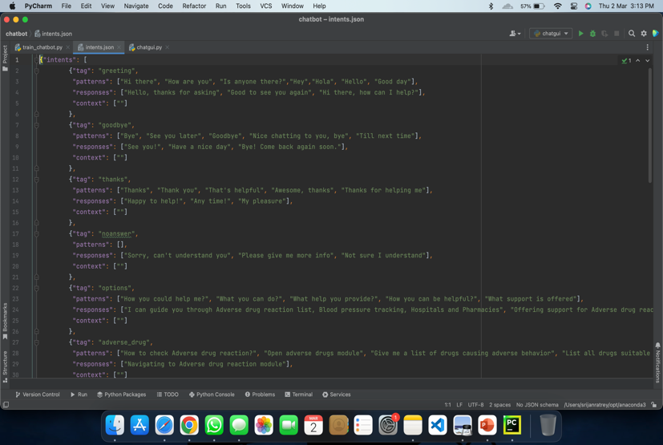

Fig 4.1

Model

Using NLTK we have used lemmatizer to enhance model learning and understanding

Use of SGD as an optimizer have made model more efficient

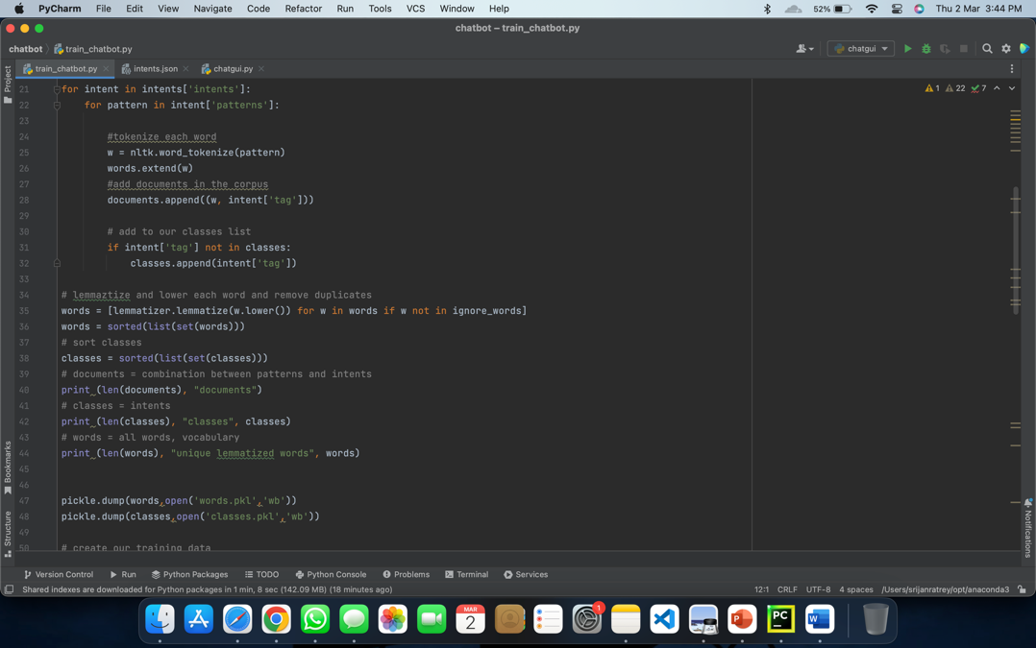

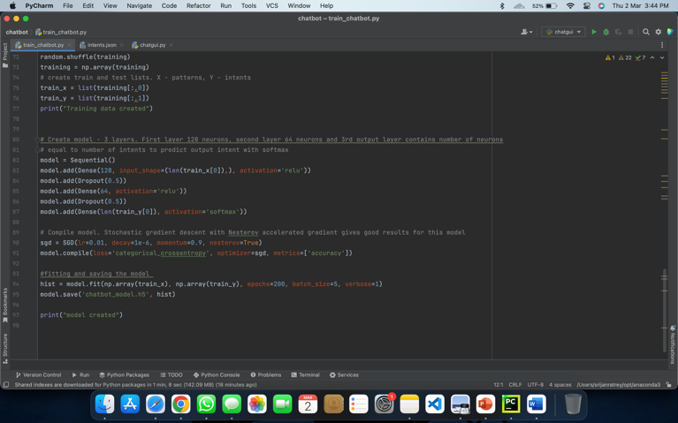

Fig 4.3

BOT GUI

The window for our chatbot appears as below which answers based on questions asked and it finds the answer via its database

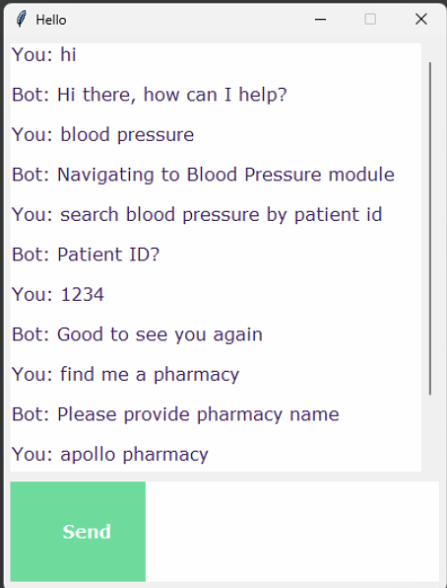

Fig 4.4

V .CONCLUSION

In conclusion, chatbots have emerged as a game-changing technology in the healthcare industry. They have the potential to revolutionize the way patients interact with healthcare providers and access medical information. By leveraging natural language processing and machine learning, chatbots can provide personalized and timely assistance to patients, offer medical advice, schedule appointments, and even monitor patients remotely.

Moreover, chatbots can significantly reduce the workload of healthcare providers, allowing them to focus on more complex tasks and providing quality care to patients. With the increasing demand for healthcare services and shortage of healthcare professionals, chatbots can bridge the gap and provide reliable and consistent care to patients.

However, as with any emerging technology, there are concerns about the accuracy and privacy of medical information and the need for ethical guidelines for the development and deployment of healthcare chatbots. Therefore, it is essential to continue to monitor and evaluate the effectiveness of chatbots in

healthcare and establish proper regulations to ensure their safe and ethical use.

Overall, chatbots have immense potential to transform the healthcare industry and improve patient outcomes. As the technology continues to evolve, it is likely that we will see more sophisticated and advanced chatbots being developed, leading to even greater improvements in healthcare delivery.

REFERENCES