An Internship Report
on
Front-end Development
at
Nepit Solutions
Submitted in partial fulfillment of the requirements of
Information Technology
Submitted To:

Purbanchal University
Faculty of Science and Technology
Biratnagar, Nepal
Submitted by:
Sneha Maharjan
Exam Roll No: 370266
Registration No: 025-3-2-03490-2021
December, 2025
An Internship Report
on
Front-end Development
at
Nepit Solutions
Submitted in partial fulfillment of the requirements of
Information technology
Submitted To:
Purbanchal University
Faculty of Science and Technology
Biratnagar, Nepal
Submitted by:
Sneha Maharjan
Exam Roll No: 370266
Registration No: 025-3-2-03490-2021
under supervision of
<Supervisor Name>
<designation>
Kantipur City College
nr
December, 2025
COMPANY LETTERHEAD Mentor Certificate
i
KCC LETTERHEAD
College Supervisor’s Recommendation
This is to certify that the internship titled "Internship in Partial Fulfillment of the Requirements for the Degree of Bachelor’s in Information Technology", carried out by Sneha Maharjan was conducted under my supervision.
I hereby recommend this internship for final evaluation as it meets the necessary academic and practical standards set forth by the program.
_______________________
SUPERVISOR NAME
Supervisor
<DESIGNATION>
Kantipur City College
Putalisadak
ii
KCC LETTERHEAD
Letter of Approval
This is to certify that the internship report submitted by Sneha Maharjan, entitled “Front-end Development”, completed at Nepit Solutions, has been evaluated.
The report has been prepared in partial fulfillment of the requirements for the Bachelor’s in Information technology degree. In our opinion, the report is satisfactory in both scope and quality, and meets the standards expected for the completion of the degree program.
_______________________ _______________________ <College Supervisor> Mr. Saroj Pandey Internal Supervisor Head, Department of IT Designation Kantipur City College Kantipur City College
_______________________ _______________________ Mr. Raju Kattel External Examiner Principal ……….……….………. Kantipur City College ……….……….………. ……….……….……….
iii
Acknowledgement
I would like to express my sincere gratitude to Purbanchal University and Kantipur City College for providing me with the opportunity to undertake this internship as a partial fulfillment of the academic requirements of my degree program. I am thankful to the college administration and faculty members for their guidance, support, and encouragement throughout the internship period.
I would also like to extend my heartfelt appreciation to Nepit Solutions for providing me with the opportunity to complete my internship in a professional working environment. I am deeply grateful to the company mentor, and supervisors for their continuous guidance, technical support, and cooperation during the internship.
I would like to thank my college supervisor for monitoring my progress and providing valuable feedback throughout the internship.
iv
Abstract
This internship report presents a summary of the activities, experiences, and skills gained during a three-month internship at Nepit Solutions, completed as a part of the academic curriculum of Purbanchal University through Kantipur City College. The internship was undertaken in the role of a Front-End Developer Intern, with the objective of gaining practical exposure to real-world web development.
During the internship period, I was involved in WordPress theme customization, front end UI development, responsive design implementation, plugin integration, and UI/UX improvements. The technologies used during the internship included HTML, CSS, JavaScript, and WordPress CMS, along with PHPMailer for SMTP-based email functionality. I also worked on debugging layout issues, improving website responsiveness, and ensuring cross-browser compatibility.
This internship experience enhanced my technical knowledge as well as professional skills such as teamwork, communication, and time management. The knowledge and experience gained during the internship have contributed significantly to my academic and professional development and prepared me for future challenges in the IT industry.
v
List of Tables
Tabel 1: Weekly log ……………………………………………………………………..8
vi
Table of Contents
Mentor certificate……………………………………………………………………...…i
College Supervisor’s Recommendation……………………………………………...…ii Letter of Approval………………………………………………………………………iii
Acknowledgement.............................................................................................................iv Abstract...............................................................................................................................v List of Tables.....................................................................................................................vi Chapter 1: Introduction ....................................................................................................1
1.1 Introduction..............................................................................................................1 1.2 Problem Statement...................................................................................................1 1.4 Scope and Limitation ...............................................................................................2 1.5 Report Organization ................................................................................................2
Chapter 2: Introduction to Organization ........................................................................3 2.1 Organization Details ................................................................................................3 2.2 Organizational Hierarchy........................................................................................3 2.3 Working Domains of Organization ........................................................................4 2.4 Description of Intern Department/Unit..................................................................4
Chapter 3: Background Study and Literature Review ..................................................5 3.1 Background Study....................................................................................................5 3.2 Literature Review....................................................................................................6
Chapter 4: Internship Activities.......................................................................................8 4.1 Roles and Responsibilities .......................................................................................8 4.2 Weekly log.................................................................................................................8 Table 1: Weekly log........................................................................................................8 4.3 Description of the Project(s) Involved During Interns.......................................10 4.4 Tasks / Activities Performed ................................................................................10
Chapter 5: Conclusion and Learning Outcomes ..........................................................11 5.1 Conclusion..............................................................................................................11
vii
5.2 Learning Outcome..................................................................................................11 References.........................................................................................................................12 Appendices........................................................................................................................13
viii
Chapter 1: Introduction
1.1 Introduction
This internship report covers the work that I did under the Nepit Solutions, where I was assigned as a Front-End Developer working on the customization of WordPress themes, integration of WordPress plugins, and the improvement of the user interface and experience. The internship gave me an opportunity to have a hands-on experience at the processes of web development, management of projects involving clients as well as collaborative working in a professional IT firm.
My major roles involved customizing the WordPress themes, creation of responsive user interface, optimization of websites, integrating contact forms, PHPMailer mailing via SMTP, and cross-browsing. The internship allowed working with the development team and having practical experience with HTML, CSS, JavaScript, PHP (WordPress functions), and WordPress CMS.
1.2 Problem Statement
∙ The inconsistent layouts and UI/UX problems were being experienced in many client websites that needed to be improved.
∙ Not all the pages were as responsive on all the devices and all the screen sizes. ∙ The available WordPress themes and the WordPress plugins were limited and could not allow the customizations needed.
∙ Certain sites had the problem of poor performance and unoptimized front-end code.
∙ Forms, elements and interactive elements required a fix or development to make them more usable and workable.
1.3 Objectives
The key goals of this internship consisted of:
∙ In order to acquire hands-on experience in front end development with the use of WordPress, HTML, CSS, JavaScript, and PHP.
1
∙ To work on the actual client projects to customize WordPress themes, fix the UI problems, and create responsive layouts.
∙ To comprehend how a professional IT company functions and enhance the collaboration, communication, and problem-solving abilities.
1.4 Scope and Limitation
The scopes are:
∙ Customization of WordPress themes.
∙ Responsive UI components development.
∙ SMTP email insertion of PHPMailer.
∙ Diagnosing layout problems, form problems, and plugin problems. ∙ Page builder (Page builder/Elementor/Classic Editor/Gutenberg) works. ∙ Optimization of web sites.
∙ Testing of cross-browser and device responsiveness.
The limitations are as follows:
∙ The development was not much in the back-end since my work was front-end based.
∙ The constraint was mainly on the client restriction and the limitation of the theme/plugins, which restricted some of the changes.
∙ My role at top-tier developers was minimal because configurations and security settings were done at the server level.
1.5 Report Organization
The report has been divided into five chapters:
1. In chapter 1, the introduction, objectives, scope and organization of the report have been provided.
2. Chapter 2 explains the host organization, its working environment and structure. 3. Chapter 3 involves the background research and literature review concerning WordPress and front-end development concepts applied in the process of the internship.
4. Chapter 4 describes the internship activities such as weekly logs, roles, responsibilities, and the description of the projects performed.
2
5. Chapter 5 summarizes the conclusion and learning outcomes acquired during the internship experience.
Chapter 2: Introduction to Organization
2.1 Organization Details
Nepit solutions is a web and mobile solution company which deals in digital agencies. ∙ They have the mission of delivering digital experiences that enhance business leaders through innovative and multifunctional solutions.
∙ Their vision focuses on their customer satisfaction by creating innovative and market leading technology to assist their clients in standardizing and improving their business portfolios.
∙ They cater to small and big businesses; and are geared towards providing result oriented solutions that perform in competitive markets.
∙ They offer web design and development, user interface and user experience, eCommerce (e.g. based on WooCommerce), and brand identity.
2.2 Organizational Hierarchy
1. Managing Director / Chief Executive Officer (CEO): Responsible for overall leadership, strategic planning, policy formulation, and major decision-making of the organization.
2. Project Manager: Manages project schedules, assigns tasks to team members, communicates with clients, and ensures timely and quality project delivery.
3. Team Leads / Senior Developers: Provide technical guidance to developers, review code quality, support junior team members, and handle complex development tasks.
4. Front-End Developers: Focus on user interface development, responsive design, WordPress theme customization, and improving user experience.
5. Back-End Developers: Handle server-side development, database management, plugin customization, and system integrations.
3
6. Graphic / UI/UX Designers: Design visual layouts, graphics, and user-centered interfaces to ensure usability and consistency.
7. Interns / Trainees: Assist senior staff, learn organizational workflows, and perform assigned tasks under supervision.
2.3 Working Domains of Organization
Nepit Solutions operates in several overlapping fields in software and web technology: ∙ Web Design and Development : the creation of custom websites on the platforms such as WordPress and other CMS, the development of UI/UX, layouts. ∙ eCommerce Solutions : we can integrate eCommerce to provide clients with the need of an online shop.
∙ Brand Identity & Strategy : providing services of brand identity: design + messaging to assist clients to develop brand presence.
∙ UI/UX Design and Responsive Web UI : working on clean, responsive and user friendly websites.
2.4 Description of Intern Department/Unit
The area where I was employed, during my internship at Nepit Solutions, was under the Front-End / Web Development Department. In this unit:
∙ The crew worked on Web sites based on WordPress ; theme customization, front end HTML/CSS/JS, responsive design, integration of a variety of plugins (e.g. a contact form, mailing, etc.), customization of the UI/UX.
∙ The scope of work entailed liaising with project managers / team leads to make daily plans, status reporting, and allocate tasks as indicated in the job posting details of the company.
∙ The department was friendly and cooperative, had flexible work hours, frequent reviews, as indicated in the employee benefits section of the company.
4
Chapter 3: Background Study and Literature Review
3.1 Background Study
During my internship at Nepit Solutions, I worked primarily as a Front-End Developer, focusing on WordPress-based web development. The background study covers fundamental concepts, terminologies, and technologies that were essential for my tasks.
1. WordPress
∙ WordPress is an open-source content management system (CMS) used to build websites and blogs.
∙ It allows customization of themes, plugins, and layouts to suit client requirements. ∙ Key features include responsive design, plugin integration, and easy content management.
2. Front-End Development
∙ Front-end development involves designing and implementing the visual elements of a website that users interact with.
∙ Technologies used include HTML for structure, CSS for styling, and JavaScript for interactivity.
∙ Responsive design ensures websites work on all devices and screen sizes. 3. WordPress Themes and Plugins
∙ Themes determine the design and layout of a WordPress site.
∙ Plugins extend functionality, such as contact forms, sliders, or email systems. ∙ During my internship, I worked on customizing themes, fixing layout issues, and integrating plugins like PHPMailer for email functionality.
4. UI/UX Concepts
∙ User Interface (UI) design focuses on the visual layout, while User Experience (UX) ensures the website is intuitive and easy to use.
5
∙ Practices include consistent typography, spacing, color contrast, and interactive elements.
5. PHPMailer and SMTP Integration
∙ PHPMailer is a PHP library used to send emails via SMTP securely. ∙ Integrating PHPMailer in WordPress ensures reliable contact form submissions and email notifications.
3.2 Literature Review
During the internship, several previous works and resources were referenced to guide development tasks:
1. WordPress Theme Customization Studies
o Studies on WordPress theme development emphasize child themes for safe customization without affecting the parent theme.
o Research highlights best practices in responsive design and plugin compatibility.
2. Front-End Optimization Research
o Literature shows that minimizing CSS and JS, optimizing images, and proper use of responsive grids improves website performance.
o Techniques like flexbox and CSS grid were applied during tasks to maintain consistent layout across devices.
3. PHPMailer Integration References
o Official PHPMailer documentation and tutorials were used to understand SMTP configuration, error handling, and security best practices.
o Similar projects on WordPress-based contact forms guided the correct implementation of email sending functionality.
4. UI/UX Best Practices
o Previous research and case studies stress the importance of intuitive navigation, clear call-to-actions, and responsive design.
o These principles were applied to improve the usability and appearance of client websites during my internship.
5. Related Project Reviews
6
o Projects from Nepit Solutions and open-source WordPress repositories were studied to understand common challenges in plugin conflicts, mobile responsiveness, and front-end customization.
o This review helped in adopting efficient solutions for the projects I handled.
7
Chapter 4: Internship Activities
4.1 Roles and Responsibilities
During my internship at Nepit Solutions, I worked as a Front-End Developer Intern. My roles and responsibilities included:
∙ Designing and customizing front-end layouts using HTML, CSS, and JavaScript. ∙ Customizing WordPress themes according to project requirements. ∙ Implementing responsive design to ensure compatibility across devices and browsers.
∙ Fixing UI/UX issues related to alignment, spacing, typography, and layout consistency.
∙ Implementing contact forms and email functionality using PHPMailer with SMTP.
∙ Testing websites for performance, responsiveness, and cross-browser compatibility.
∙ Following company coding standards and project workflows.
4.2 Weekly log
Table 1: Weekly log
Duration | Activities Performed | Technical Details
Week 1 | Orientation and environment setup | Introduction to company workflow, setup of local development environment using XAMPP, overview of WordPress CMS structure.
Week 2 | Basic front-end tasks | HTML and CSS layout fixes, understanding WordPress theme structure and template hierarchy.

8
Week 3 | Responsive design implementation | Used CSS media queries to fix mobile and tablet responsiveness, cross-browser testing.
Week 4 | Theme customization | Customized WordPress themes, modified typography, color schemes, and layout styling using CSS.
Week 5 | Contact form development | Implemented and customized contact forms, added client-side validation, integrated PHPMailer with SMTP.
Week 6 | Plugin customization and debugging | Debugged plugin conflicts, performed minor PHP modifications under supervision.
Week 7 | UI/UX improvement | Improved user interface components such as buttons, forms, and navigation menus based on feedback.
Week 8 | Performance optimization | Optimized images and assets, reduced unused CSS and JavaScript, improved page load speed.
Week 9 | Client project handling | Worked on live WordPress client projects, customized pages using page builders, fixed layout issues.
Week 10 | Advanced front-end tasks | Enhanced interactive elements using JavaScript, improved navigation and user interactions.
Week 11 | Testing and bug fixing | Conducted cross-browser and device testing, fixed UI and functional bugs.

9
4.3 Description of the Project(s) Involved During Interns
During the internship, I was involved in multiple WordPress-based client projects. These projects mainly focused on:
∙ Developing and customizing WordPress websites for business and service-based clients.
∙ Enhancing user interface and user experience through responsive design. ∙ Implementing custom contact forms and reliable email systems using PHPMailer. ∙ Fixing UI and functional issues reported by clients.
The projects required close collaboration with designers and backend developers to ensure that the final output met both technical and business requirements.
4.4 Tasks / Activities Performed
The major tasks and activities performed during the internship are listed below:
∙ WordPress theme customization and layout modification.
∙ Front-end development using HTML, CSS, and JavaScript.
∙ Responsive design implementation and testing.
∙ UI/UX improvements and design consistency checks.
∙ Plugin integration and configuration.
∙ Email system implementation using PHPMailer and SMTP.
∙ Debugging front-end and form-related issues.
∙ Cross-browser and device testing.
∙ Assisting senior developers in project development.
10
Chapter 5: Conclusion and Learning Outcomes
5.1 Conclusion
The internship at Nepit Solutions provided valuable practical exposure to real-world web development in a professional working environment. Through this internship, I was able to apply theoretical knowledge gained during academic studies to practical projects involving WordPress front-end development. The internship focused on theme customization, responsive design, UI/UX improvements, plugin integration, and email functionality using PHPMailer.
Working on real client projects enhanced my understanding of project workflows, teamwork, and deadline-oriented development. I gained hands-on experience in solving practical UI and responsiveness issues while maintaining code quality and usability standards. Overall, the internship successfully met its objectives by strengthening my technical skills and preparing me for professional challenges in the IT industry.
5.2 Learning Outcome
The major learning outcomes achieved during the internship are listed below:
∙ Gained practical experience in WordPress theme customization and front-end development.
∙ Improved skills in HTML, CSS, JavaScript, and basic PHP within WordPress. ∙ Learned to implement responsive web design for multiple devices and screen sizes.
∙ Understood the use of WordPress plugins and their integration.
∙ Acquired knowledge of PHPMailer and SMTP email integration. ∙ Developed skills in UI/UX design principles and usability improvements. ∙ Gained experience in debugging and testing front-end issues.
∙ Learned professional team collaboration, communication, and time management. ∙ Understood real-world project handling and client-based development processes.
11
References
1. WordPress.org. (n.d.). Features. Retrieved December 13, 2025, from https://wordpress.org/about/features/
2. WordPress.org. (n.d.). WordPress developer resources. Retrieved December 13, 2025, from https://developer.wordpress.org/
3. MDN Web Docs. (n.d.). HTML reference. Retrieved December 13, 2025, from https://developer.mozilla.org/en-US/docs/Web/HTML
4. MDN Web Docs. (n.d.). CSS reference. Retrieved December 13, 2025, from https://developer.mozilla.org/en-US/docs/Web/CSS
5. MDN Web Docs. (n.d.). JavaScript reference. Retrieved December 13, 2025, from https://developer.mozilla.org/en-US/docs/Web/JavaScript
6. PHPMailer. (n.d.). PHPMailer documentation. Retrieved December 13, 2025, from https://github.com/PHPMailer/PHPMailer
7. W3Schools. (n.d.). CSS selectors. Retrieved December 13, 2025, from https://www.w3schools.com/css/css_selectors.asp
12
Appendices
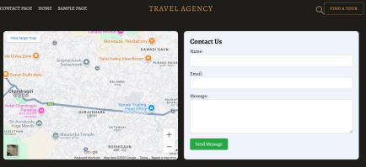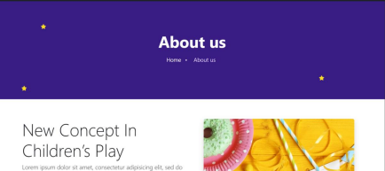
13
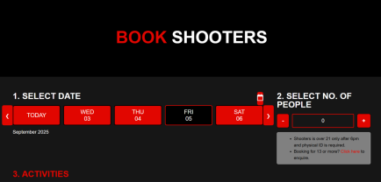
14
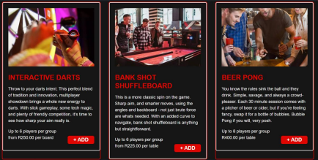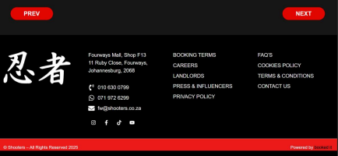
15
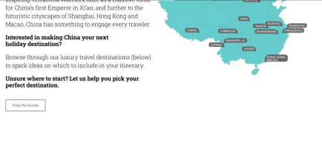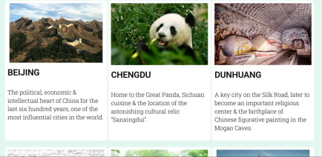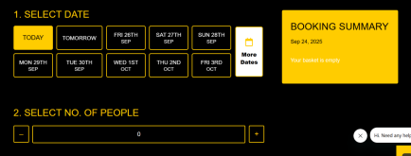
16

