Credit Risk Assessment & Automated Loan Underwriting Engine

AICTE–IBM SkillsBuild Data Analytics with AI Internship 2026
Machine Learning Pipeline with Feature Engineering and Descriptive Fairness Auditing

Srijan Das | Internship ID: IBMUEDA0483
Department of Computer Science & Engineering
Cooch Behar Government Engineering College (CGEC), West Bengal
Email: srijandas9073@gmail.com | LinkedIn: linkedin.com/in/srijandas2099
September 2026

Abstract—Manual loan underwriting varies across individual branch reviewers and creates processing bottlenecks during peak application cycles. This project evaluates whether a structured machine learning pipeline can provide consistent first-pass approval recommendations using 614 historical applicant records from the benchmark Kaggle Loan Prediction dataset. The workflow integrates domain feature engineering (Total Income, Debt-to-Income, and estimated EMI) with median imputation fitted strictly within cross-validation training folds. A regularized Random Forest classifier achieves a 74.7% (± 5.1%) 5-fold cross-validation accuracy (+6.0 percentage points over the 68.7% majority-class baseline), an 81.3% holdout test accuracy, an 84.7% approval recall (72 of 85 approved cases identified), and an 0.85 ROC-AUC score. In alignment with UN SDG 8 and UN SDG 10, demographic attributes (Gender) are omitted from model features, and a descriptive check reports a historical female-to-male approval-rate ratio of 0.966.

Introduction & Problem Definition
Manual retail underwriting often introduces operational variance across loan officers, creating turnaround delays for creditworthy borrowers while leaving institutions vulnerable to default risks.
This project builds an automated decision-support pipeline to:
- Clean and profile 614 applicant records from a benchmark retail lending dataset.
- Identify empirical default drivers through Exploratory Data Analysis (EDA).
- Train an ensemble Scikit-Learn pipeline that eliminates imputation data leakage.
- Deploy an interactive Streamlit dashboard for real-time applicant risk scoring.
  - UN Sustainable Development Goals (UN SDGs) Alignment
    - UN SDG 8 (Decent Work & Economic Growth): Streamlining initial underwriting reduces application turnaround latency, supporting financial access for eligible households and micro-enterprises.
    - UN SDG 10 (Reduced Inequalities via Fairness Auditing): Demographic variables were audited for historical rate disparities (female-to-male approval ratio = 0.966, meeting the Four-Fifths regulatory benchmark). To eliminate direct disparate treatment, Gender was excluded from the model feature matrix. Note: This comparison serves as a historical baseline check; production implementations would require continuous subgroup error-rate tracking.

Dataset Architecture & Preprocessing Pipeline
The system utilizes the Kaggle Loan Prediction Problem Dataset, containing 614 applicant records across 12 financial and demographic attributes.
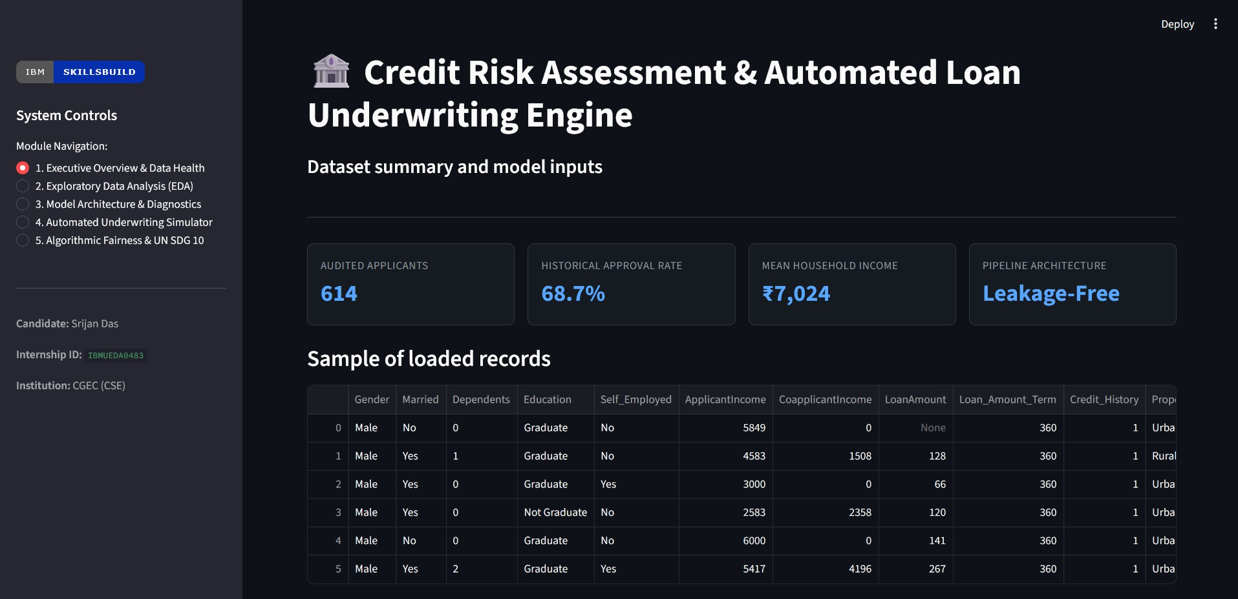
Figure 1. Executive Overview Module displaying dataset metrics, record counts, and loaded data sample.

  - Data Cleaning & Pipeline Imputation
Inspection revealed missing values across continuous and categorical fields. To eliminate data leakage, imputation is handled strictly inside a Scikit-Learn Pipeline fitted solely on training splits:
    - Integrated Imputation: Missing values in numerical features (LoanAmount, Loan_Amount_Term) and encoded binary indicators (Credit_History, Married) receive pipeline-fitted median imputation.
    - Feature Pruning: Low-variance attributes (Self_Employed, Dependents) and protected attributes (Gender) were excluded from the model matrix to reduce noise and prevent demographic bias.
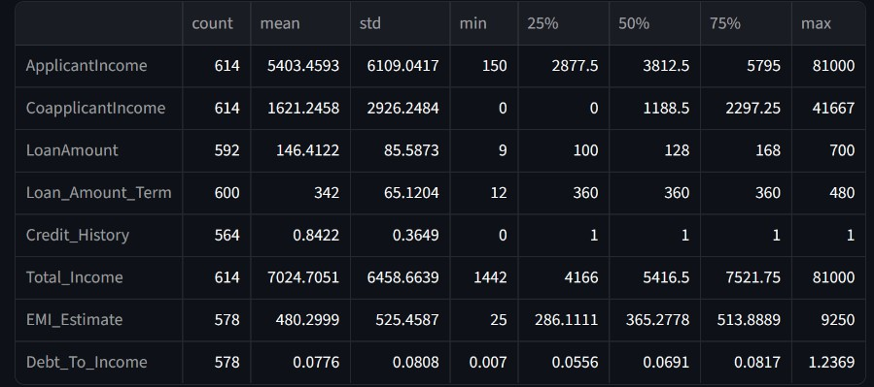
Figure 2. Summary Statistics for the Cleaned Feature Set.

  - Feature Engineering
These three engineered financial indicators provide the model with direct readouts of debt-servicing capacity rather than relying solely on raw gross income:
- Total Income = ApplicantIncome + CoapplicantIncome
- Estimated Monthly Obligation (EMI) = ^{LoanAmount×1000}
Loan_Amount_Term
- Debt-to-Income (DTI) = ^{Estimated} ^{EMI}
Total Income+𝜖

Exploratory Data Analysis (EDA) & Risk Discovery
Exploratory analysis evaluated how financial features and property locations correlate with historical loan outcomes.
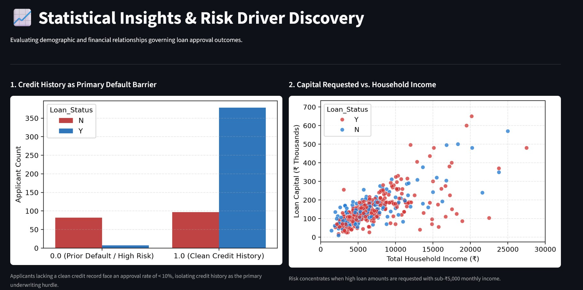
Figure 3. Exploratory Risk Analysis: (Left) Credit History approval barrier; (Right) Household Income vs. Requested Capital.

  - Key Analytical Insights
    - Credit History as Primary Hurdle: As shown in Figure 3 (Left), applicants with a clean credit record (1.0) exhibit an approval rate exceeding 79%, compared to below 10% for applicants with adverse credit records (0.0).
    - Loan Capital vs. Income Distribution: Figure 3 (Right) shows that requested loan capital scales moderately with household income, though variance widens among higher earners. Risk of default occurs across all income tiers rather than clustering solely in low-income segments.
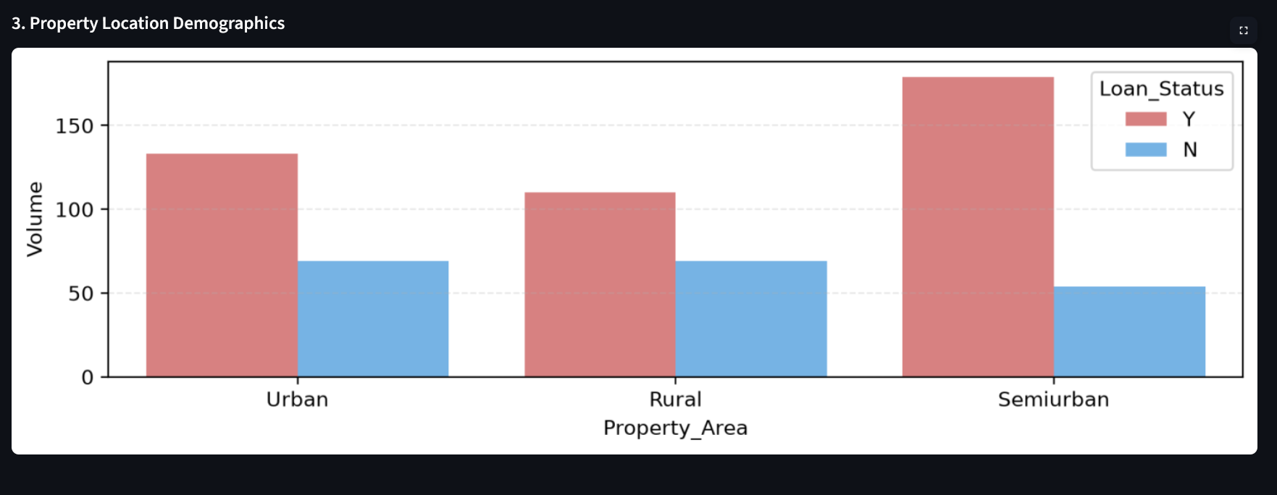
Figure 4. Property Location Demographics showing approval distribution across Urban, Rural, and Semiurban zones.

As shown in Figure 4, Semiurban applicants achieved the highest overall approval volume and rate (76.8%), while Rural applicants had the lowest (61.5%). Because mean income and credit-history rates remain broadly comparable across zones, this regional variance is reported descriptively rather than attributed to a single observed causal driver.

Machine Learning Architecture & Diagnostics
An ensemble Random Forest Classifier (𝑛 = 120 estimators, max depth = 5, balanced class weighting) was coupled with SimpleImputer inside a Scikit-Learn Pipeline using an 80/20 stratified split.
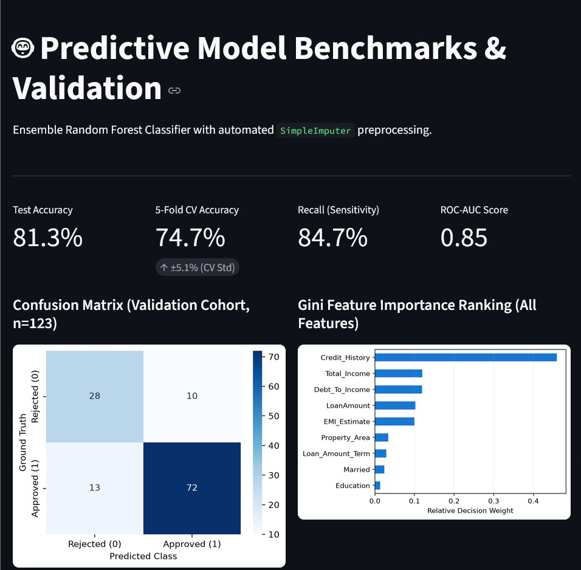
Figure 5. Model Diagnostics: Holdout Benchmarks, 5-Fold Cross-Validation, Confusion Matrix, and Gini Feature Importance.

  - Performance Validation & Baseline Lift
In this cohort, a naive majority-class rule (approving all applicants) yields a 68.7% baseline accuracy. The model was evaluated using both 5-Fold Stratified Cross-Validation and an out-of-sample holdout test set (𝑛 = 123):
    - 5-Fold Stratified Cross-Validation: 74.7% ± 5.1% (+6.0 percentage points above the 68.7% naive baseline).
    - Holdout Validation Accuracy: 81.3% (100/123).

Precision (Approval Class): 87.8% (72/82).
    - Recall (Sensitivity): 84.7% (Correctly identifying 72 of 85 approved cases).
    - ROC-AUC Score: 0.85 (Strong class separation).
The Confusion Matrix confirms 72 True Positives, 28 True Negatives, 10 False Positives, and 13 False Negatives (𝑛 = 123). The Gini Feature Importance confirms that Credit_History accounts for over 45% of the decision weight, followed by continuous indicators Total_Income (Rank 2), Debt_To_Income (Rank 3), LoanAmount (Rank 4), and EMI_Estimate (Rank 5). Credit history provides the primary baseline separation, while the engineered ratios refine predictions on borderline applications.

Underwriting Simulator & Fairness Checks
The trained pipeline was deployed inside a single-file Streamlit Underwriting Simulator to evaluate live applicant scoring.
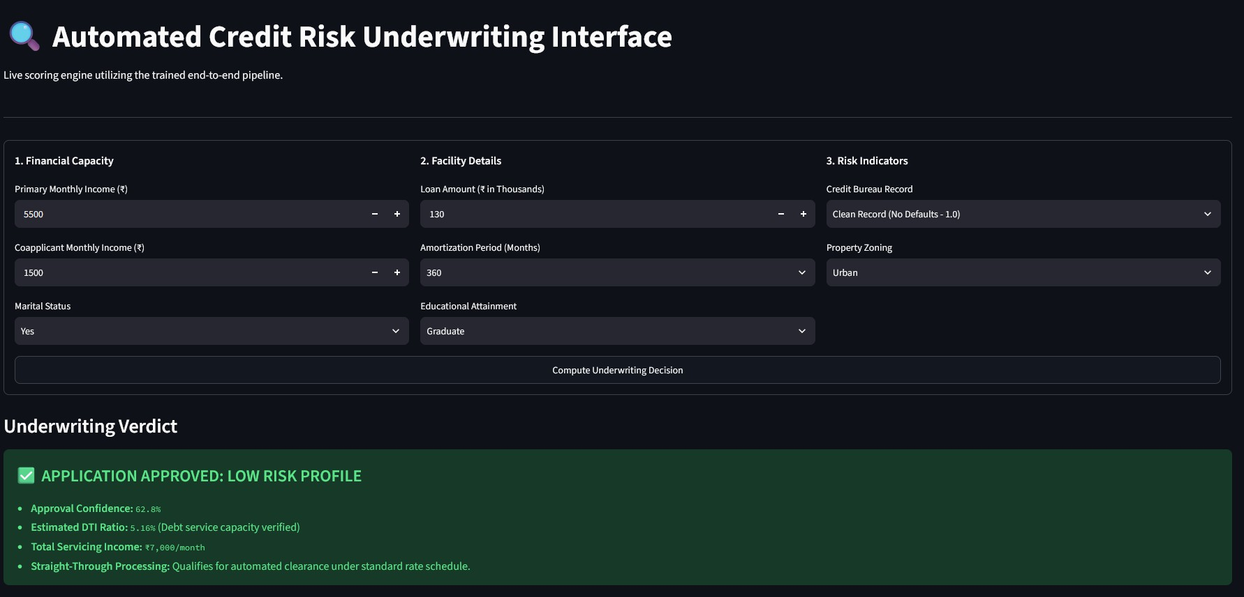
Figure 6. Streamlit Underwriting Simulator displaying input fields and model approval verdict.

  - Descriptive Fairness Check (UN SDG 10)
To evaluate demographic parity in historical data, approval rates were checked across gender groups:
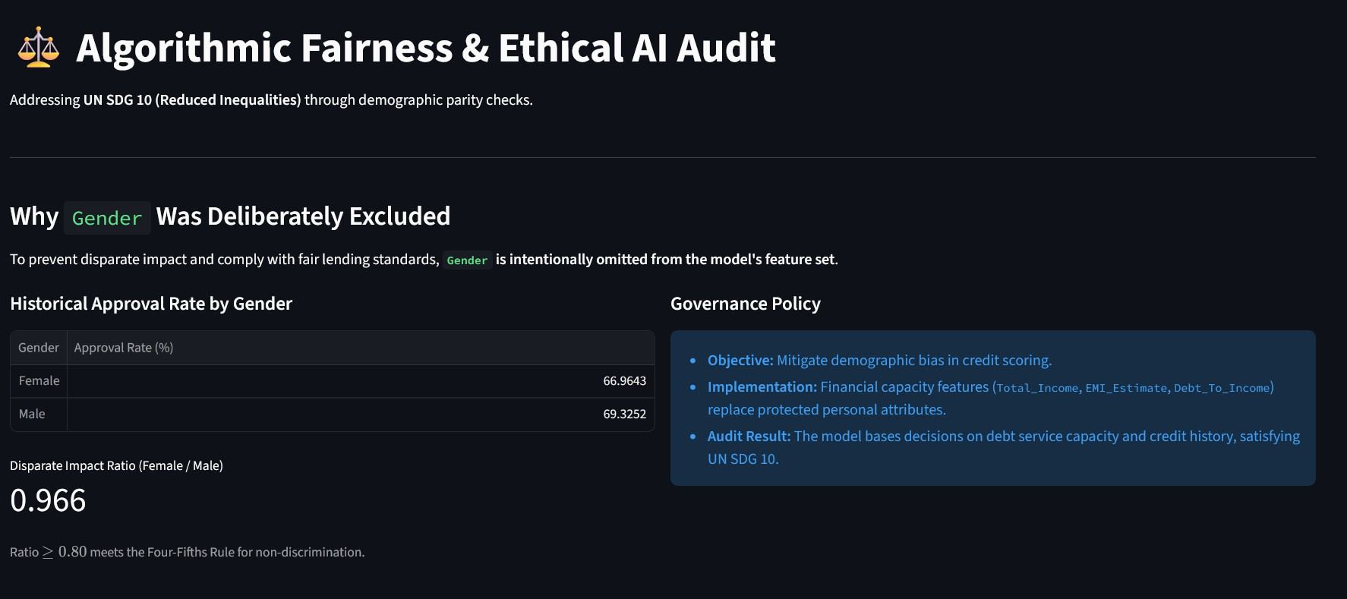
Figure 7. Descriptive Fairness Check: Historical approval distributions and female-to-male ratio calculation.

As shown in Figure 7, the historical approval ratio between female (66.96%) and male (69.33%) applicants is 0.966, satisfying the standard 0.80 Four-Fifths regulatory benchmark. Omitting Gender from the feature matrix ensures predictions remain anchored to creditworthiness and debt-service capacity.
  - Operational Routing Framework (Illustrative Policy)
To translate model probabilities into practical underwriting workflows rather than relying on a rigid 50% cutoff, lending teams can deploy tiered risk bands. The cutoffs below represent an illustrative policy template:
- Tier 1: Straight-Through Clearance: High-confidence applications (≥ 62% approval probability) with verified clean credit records can receive automated first-pass clearance.
- Tier 2: Secondary Committee Review: Borderline applications (50% − 61.9% probability) or cases with high debt-to-income ratios can be routed for manual underwriter review and collateral verification.
- Tier 3: Elevated Default Risk: Applications scoring < 50% are flagged for automated decline or restructuring under alternative lending terms.

Limitations, Reproducibility & Code Repository
  - Limitations & Future Work
This prototype is a learning exercise built on a small, single-source benchmark and has scope that a production deployment would need to extend:
    - Sample size: 614 records is small for subgroup fairness analysis; the female-to-male approval ratio (Section 5.1) is a useful descriptive signal but not a statistically robust guarantee at this sample size.
    - Fairness scope: The current check compares only aggregate approval rates by gender. A production audit would additionally need equalized-odds and calibration checks (false-positive/false-negative rates by subgroup), and a review for proxy variables that could indirectly encode Gender.
    - Threshold calibration: The routing tiers in Section 5.2 are an illustrative template, not thresholds derived from a validated precision-recall curve. Before operational use, they would need to be calibrated against business-specific cost tradeoffs between false approvals and false declines.
    - Generalization: The dataset reflects a single historical lending cohort; performance on a different applicant population, geography, or time period is untested.
  - Reproducibility
The complete pipeline code, dataset references, dependencies, and execution logs are hosted publicly on GitHub, enabling independent verification of every metric reported in Section 4:
Repository URL: https://github.com/Srijan9073/ibm-skillsbuild-analytics-capstone

  - Submission Deliverables Summary
    - Code File: app.py — integrated preprocessing pipeline, model training, and Streamlit interface.
    - Verification Script: scripts/verify_metrics.py — reproduces the reported cross-validation and holdout metrics independent of the dashboard.
    - Dependencies: requirements.txt (direct dependencies) and requirements.lock (full frozen en-vironment).
    - Dataset Source: Kaggle Open Benchmark (train_loan_data.csv), 614 records, 12 attributes.
    - Candidate: Srijan Das (Internship ID: IBMUEDA0483).

