**Hackathon - Jackfruit Level Problem solving**

Date: 02/01/2025

**Team Details**:

Team 5

Srivani : PES1UG24CS471

Spoorthi P : PES1UG24AM279

Suraj HP : PES1UG24EC221

Srijan Akshit : PES1UG24AM284

Srijan S K: PES1UG24EC214

Class: P7

**Code:**

import csv

from datetime import datetime, timedelta

import tkinter as tk

from tkinter import ttk, messagebox

class Book:

def __init__(self, book_id, title, author, available_copies):

self.book_id = book_id

self.title = title

self.author = author

self.available_copies = int(available_copies)

def to_csv(self):

return f"{self.book_id},{self.title},{self.author},{self.available_copies}"

class Student:

def __init__(self, student_id, name):

self.student_id = student_id

self.name = name

self.borrowed_books = []

def add_borrowed_book(self, book_id):

self.borrowed_books.append(book_id)

def remove_borrowed_book(self, book_id):

if book_id in self.borrowed_books:

self.borrowed_books.remove(book_id)

def to_csv(self):

return f"{self.student_id},{self.name},{','.join(self.borrowed_books)}"

def is_eligible(self):

return len(self.borrowed_books) < 3 # Assuming a student can borrow up to 3 books

class Librarian:

def __init__(self):

self.books = []

self.students = []

self.logs = []

self.load_data()

def load_data(self):

with open('books.csv', 'r') as file:

reader = csv.reader(file)

next(reader) # Skip header

self.books = [Book(row[0], row[1], row[2], row[3]) for row in reader]

with open('students.csv', 'r') as file:

reader = csv.reader(file)

next(reader) # Skip header

self.students = []

for row in reader:

student_id, name, *borrowed_books = row

student = Student(student_id, name)

student.borrowed_books = borrowed_books # Load borrowed books correctly

self.students.append(student)

with open('logs.csv', 'r') as file:

reader = csv.reader(file)

next(reader) # Skip header

self.logs = [row for row in reader]

def save_data(self):

with open('books.csv', 'w', newline='') as file:

writer = csv.writer(file)

writer.writerow(['book_id', 'title', 'author', 'available_copies'])

writer.writerows([book.to_csv().split(',') for book in self.books])

with open('students.csv', 'w', newline='') as file:

writer = csv.writer(file)

writer.writerow(['student_id', 'name', 'borrowed_books'])

writer.writerows([student.to_csv().split(',') for student in self.students])

with open('logs.csv', 'w', newline='') as file:

writer = csv.writer(file)

writer.writerow(['transaction_id', 'transaction_type', 'book_id', 'student_id', 'issue_date', 'return_date', 'penalty'])

writer.writerows(self.logs)

def check_stock(self):

return [book for book in self.books if book.available_copies > 0]

def search_book(self, query):

return [book for book in self.books if query in (book.title, book.author, str(book.book_id))]

def search_student(self, query):

return [student for student in self.students if query in (student.student_id, student.name)]

def issue_book(self, book_id, student_id):

book = next((b for b in self.books if b.book_id == book_id), None)

student = next((s for s in self.students if s.student_id == student_id), None)

if book and student and book.available_copies > 0 and student.is_eligible():

book.available_copies -= 1

student.add_borrowed_book(book_id)

issue_date = datetime.now().strftime('%m/%d/%Y')

self.update_logs('issue', book_id, student_id, issue_date)

self.save_data()

return True

return False

def return_book(self, book_id, student_id):

book = next((b for b in self.books if b.book_id == book_id), None)

student = next((s for s in self.students if s.student_id == student_id), None)

if book and student and book_id in student.borrowed_books:

book.available_copies += 1

student.remove_borrowed_book(book_id)

return_date = datetime.now().strftime('%m/%d/%Y')

issue_date = next((log[4] for log in self.logs if log[2] == book_id and log[3] == student_id and log[1] == 'issue'), None)

penalty = self.calculate_penalty(issue_date)

self.update_logs('return', book_id, student_id, issue_date, return_date, penalty)

self.save_data()

return penalty

return None

def calculate_penalty(self, issue_date):

issue_date = datetime.strptime(issue_date, '%m/%d/%Y')

print(issue_date)

return_date = datetime.now()

days_late = (return_date - issue_date).days - 2

if days_late > 0:

return min(days_late * 1, 50)

return 0

def update_logs(self, transaction_type, book_id, student_id, issue_date, return_date=None, penalty=0):

transaction_id = len(self.logs) + 1

self.logs.append([transaction_id, transaction_type, book_id, student_id, issue_date, return_date, penalty])

class LibraryApp:

def __init__(self, root):

self.root = root

self.root.title("Library Management System")

self.librarian = Librarian()

self.create_widgets()

def create_widgets(self):

# Book Management Section

tk.Label(self.root, text="Search Book:").pack()

self.book_search_entry = tk.Entry(self.root)

self.book_search_entry.pack()

tk.Button(self.root, text="Search", command=self.search_book).pack()

tk.Button(self.root, text="Check Stock", command=self.check_stock).pack()

self.book_results = tk.Text(self.root, height=10, width=50)

self.book_results.pack()

# Student Management Section

tk.Label(self.root, text="Search Student:").pack()

self.student_search_entry = tk.Entry(self.root)

self.student_search_entry.pack()

tk.Button(self.root, text="Search", command=self.search_student).pack()

self.student_results = tk.Text(self.root, height=10, width=50)

self.student_results.pack()

# Transaction Section

tk.Label(self.root, text="Issue Book:").pack()

self.issue_book_id_entry = tk.Entry(self.root)

self.issue_book_id_entry.pack()

self.issue_student_id_entry = tk.Entry(self.root)

self.issue_student_id_entry.pack()

tk.Button(self.root, text="Issue", command=self.issue_book).pack()

tk.Label(self.root, text="Return Book:").pack()

self.return_book_id_entry = tk.Entry(self.root)

self.return_book_id_entry.pack()

self.return_student_id_entry = tk.Entry(self.root)

self.return_student_id_entry.pack()

tk.Button(self.root, text="Return", command=self.return_book).pack()

self.penalty_label = tk.Label(self.root, text="")

self.penalty_label.pack()

def search_book(self):

query = self.book_search_entry.get()

results = self.librarian.search_book(query)

self.book_results.delete(1.0, tk.END)

if results:

for book in results:

self.book_results.insert(tk.END, f"{book.book_id}, {book.title}, {book.author}, {book.available_copies}\n")

else:

self.book_results.insert(tk.END, "No results found.")

def check_stock(self):

results = self.librarian.check_stock()

self.book_results.delete(1.0, tk.END)

if results:

for book in results:

self.book_results.insert(tk.END, f"{book.book_id}, {book.title}, {book.author}, {book.available_copies}\n")

else:

self.book_results.insert(tk.END, "No books available.")

def search_student(self):

query = self.student_search_entry.get()

results = self.librarian.search_student(query)

self.student_results.delete(1.0, tk.END)

if results:

for student in results:

self.student_results.insert(tk.END, f"{student.student_id}, {student.name}, {', '.join(student.borrowed_books)}\n")

else:

self.student_results.insert(tk.END, "No results found.")

def issue_book(self):

book_id = self.issue_book_id_entry.get().strip()

student_id = self.issue_student_id_entry.get().strip()

if not book_id or not student_id:

messagebox.showerror("Input Error", "Please enter both Book ID and Student ID.")

return

try:

success = self.librarian.issue_book(book_id, student_id)

if success:

messagebox.showinfo("Success", "Book issued successfully.")

self.issue_book_id_entry.delete(0, tk.END)

self.issue_student_id_entry.delete(0, tk.END)

else:

messagebox.showerror("Error", "Failed to issue book. Please check the details.")

except PermissionError as e:

messagebox.showerror("Permission Error", f"Permission error: {e}")

except Exception as e:

messagebox.showerror("Error", f"An unexpected error occurred: {e}")

def return_book(self):

book_id = self.return_book_id_entry.get()

student_id = self.return_student_id_entry.get()

penalty = self.librarian.return_book(book_id, student_id)

if penalty is not None:

messagebox.showinfo("Success", f"Book returned successfully. Penalty: ${penalty}")

self.penalty_label.config(text=f"Penalty: ${penalty}")

else:

messagebox.showerror("Error", "Failed to return book.")

if __name__ == "__main__":

root = tk.Tk()

app = LibraryApp(root)

root.mainloop()

**Output (GUI) Screenshots:**

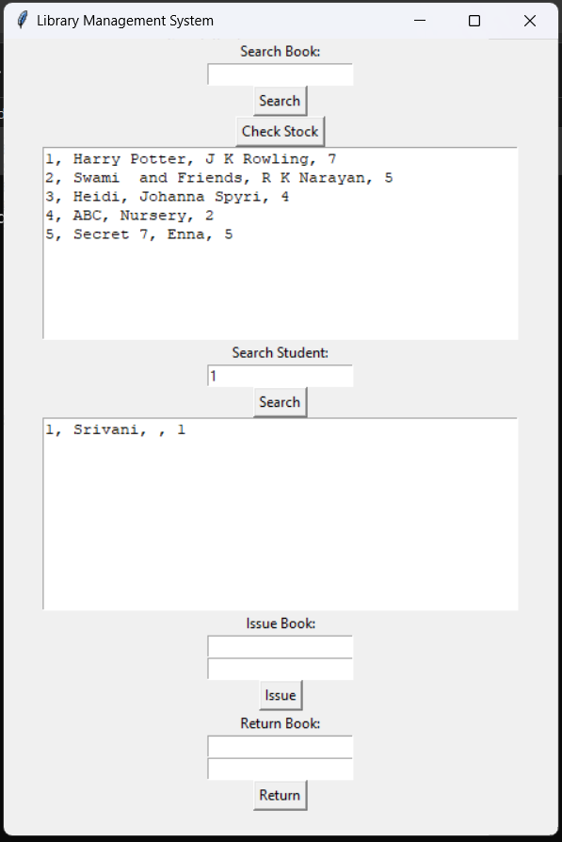

**Handling Cases like :**

1 Books out of Stock -

2. Returning a book not issued

