Test Summary Report

**Contents**

1. Purpose (Mani Chandana Kilaru) 2

2. Application Overview (Mani Chandana Kilaru) 2

3. Testing Scope (Mani Chandana Kilaru) 2

4. Metrics (Mani Chandana Kilaru) 3

5. Types of testing performed (Mani Chandana Kilaru) 5

6. Test Environment & Tools (Mani Chandana Kilaru) 6

7. Lessons Learnt (Saikar Reddypally) 7

8. Recommendations (Saikar Reddypally) 8

9. Best Practices (Saikar Reddypally 8

10. Exit Criteria (Saikar Reddypally) 8

11. Conclusion/Sign Off (Saikar Reddypally) 8

12. Definitions, Acronyms, and Abbreviations (Saikar Reddypally) 8

# Purpose (Mani Chandana Kilaru)

# This paper provides a comprehensive overview of the testing process conducted on the Purchase Order and Expense Claims Modules of the Xero Cloud-Based Accounting System.

# 2. Application Overview (Mani Chandana Kilaru)

# Xero accounting system provides a versatile cloud-based financial management solution suitable for businesses of all sizes and industries. Offering a comprehensive suite of features, Xero enables more effective financial management through functionalities such as purchase orders, invoicing, cost tracking, payroll, and reporting. Its seamless integration with third-party apps allows for automated processes and access to real-time financial data. With its intuitive design accessible from any device, businesses of all sizes can efficiently manage their finances using Xero.

# 3. Testing Scope (Mani Chandana Kilaru)

### a) In Scope

1. **Financial Data Entry:**

* Inputting and revising financial data including transactions, invoices, and payments.
* Verifying the accuracy and completeness of data entry.
* Ensuring adherence to accounting standards and regulatory requirements throughout the data entry procedures.

1. **Bank Feeds and Reconciliations:**

* Establishing and overseeing bank feeds for importing transaction data into the accounting system.
* Matching bank transactions with financial records to validate accuracy and completeness.
* Confirming bank balances and addressing any disparities between bank statements and accounting records.

**b) Out of Scope**

* 1. **Integration Testing:** The evaluation of interactions among distinct modules or systems does not fall within the purview of this testing stage.
  2. **Compatibility Testing:** Assessing the software's compatibility with diverse operating systems, browsers, or devices is not included in the scope of this testing iteration.

### c) Items not tested

* 1. **Third-Party API Integrations:** Evaluating the integration and data interchange with external APIs or services not directly linked to the functionalities under examination.
  2. **Customization and Configuration:** Thorough testing of extensively customized configurations or settings that exceed the standard system setup.
  3. **User Training and Support:** Assessing user training materials, onboarding procedures, and support documentation is not included in this testing phase

# 4. Metrics (Mani Chandana Kilaru)

### Test Coverage

|  |  |
| --- | --- |
| **Total Requirements** | **Requirements Covered by**  **Tests** |
| 26 | 21 |

### No. of test cases planned vs executed & No. of test cases passed/failed

|  |  |  |  |
| --- | --- | --- | --- |
| **Test cases planned** | **Test cases executed** | **TCs Pass** | **TCs Failed** |
| 156 | 156 | 150 | 6 |

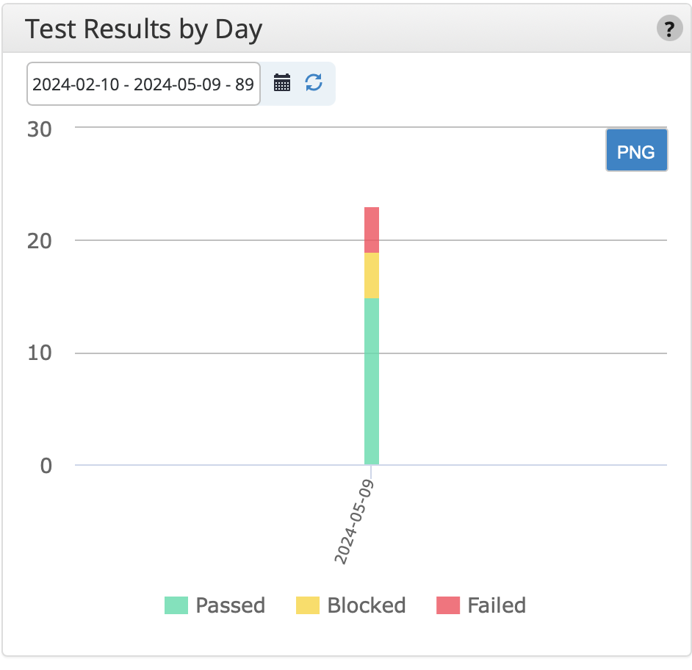

# 5. Types of testing performed (Mani Chandana Kilaru)

**2. Integration Testing:**

Integration Testing for Bank Feeds and Reconciliations aimed to confirm the smooth interaction and data transfer among these modules and other essential elements within the Xero system. This phase ensured the accurate integration of bank feeds for importing transaction data and validated the efficiency of reconciliation procedures in confirming financial records. Additionally, it evaluated the integration of bank feeds and reconciliations with associated functionalities like reporting, data analytics, and financial management tools.

**3. Functional Testing:**

Functional Testing guaranteed the precise importation and matching of transaction data by Bank Feeds and Reconciliations, while Financial Data Entry upheld data integrity, integration, and user access control across the Xero application ecosystem.

**4. Regression Testing:**

Regression Testing for Bank Feeds and Reconciliations focused on confirming the stability and functionality of these modules following recent updates or alterations. This phase ensured that bank feeds maintained their accurate integration for importing transaction data seamlessly, without any interruptions. It also validated the ongoing accuracy of reconciliation processes in matching and verifying financial records. Moreover, Regression Testing examined bank balances and integration with associated functionalities such as reporting and financial management tools to identify and address any potential regression issues.

# 6. Test Environment & Tools (Mani Chandana Kilaru)

1. **Server:**
   1. **Type:** Virtual Private Server (VPS)
   2. **Operating System:** Linux CentOS 7.5
   3. **Configuration:** 8 vCPUs, 16GB RAM, 200GB SSD Storage
   4. **Location:** Datacenter XYZ
2. **Database:**
   1. **Type:** MySQL 8.0
   2. **Configuration:** 16GB RAM, 500GB Storage
   3. **Location:** Same server as the application
3. **Application URL:** [https://www.xero.com](https://www.xero.com/)
   1. **Environment:** Production
   2. **Access Credentials:** Provided to testing team
4. **Testing Tools:**
   1. **Test Management Tool:** JIRA
   2. **Defect Logging Tool:** JIRA, qTest
5. **Browsers Tested:** Chrome, Firefox, Safari, Edge (latest versions)
6. **Devices Tested:** Desktop (Windows, macOS), Mobile (iOS, Android)

# 7. Lessons Learnt (Saikar Reddypally)

|  |  |  |
| --- | --- | --- |
| **S. No** | **Issues Faced** | **Solutions** |
| 1 | Team members failed to coordinate the execution of test cases for their individual Xero features due to a lack of communication. | Implement a centralized communication platform like Slack. Conduct regular stand-up meetings or check-ins to monitor progress and address obstacles. Ensure alignment by establishing a system for communicating the progress and outcomes of test case execution. Reinforce the importance of communication in achieving project objectives through regular reviews and reminders. |
| 2 | Discordant record-keeping of test cases by team members, such as RCT | Establish consistent standards for documenting test cases, including standardized templates. Conduct training sessions to ensure all team members are familiar with documentation requirements. Maintain consistency in test case documentation through regular reviews and feedback. |
| 3 | Poor information sharing within the team | Organize workshops or sessions for team members to share their expertise and cross-train. Encourage pair testing or job shadowing to facilitate knowledge exchange and domain-specific skill development. |

# 8. Recommendations (Saikar Reddypally)

# Streamline the authorization or credential acquisition process by establishing transparent communication channels, including compliance procedures. Practice creating and managing access rights and permissions within a test environment to become familiar with the process.

# 9. Best Practices (Saikar Reddypally)

# We've created test case documentation detailing the anticipated outcomes to direct the steps within our testing tool, Tricentis qTest. This platform allows us to execute the test cases and document their results efficiently.

# 10. Exit Criteria (Saikar Reddypally)

a) Yes, we should run all test cases.

b) Absolutely, it's crucial to verify all flaws with severity levels of Critical, Major, and Medium.

c) Definitely, we'll develop a comprehensive strategy to address any open defects that are identified.

# 11. Conclusion/Sign Off (Saikar Reddypally)

# After carefully reviewing the criteria specified in Section 10 of the Test Summary Report, the Testing team affirms that the Bank Feeds and Reconciliations as well as Financial Data Entry modules are deemed stable for deployment. All predetermined testing benchmarks have been successfully achieved, signifying comprehensive testing and validation of these modules within the Xero accounting system.

# 12. Definitions, Acronyms, and Abbreviations (Saikar Reddypally)

* + - **qTest**: A tool employed by testing teams to streamline test planning, execution, and reporting processes for Bank Feeds and Reconciliations, and Financial Data Entry modules. It fosters efficient collaboration, comprehensive test case management, tracking of test execution, defect management, and real-time reporting to ensure thorough testing coverage throughout development.
    - **JIRA**: Serving as project management and issue tracking software, JIRA is pivotal in managing tasks, issues, and bugs related to Bank Feeds and Reconciliations, and Financial Data Entry. It aids in project planning, task prioritization, assignment, tracking, and real-time reporting via customizable workflows and agile boards, ensuring effective management and resolution of issues throughout testing and development.
    - **UAT (User Acceptance Testing)**: A critical phase for Bank Feeds and Reconciliations, and Financial Data Entry modules, where end-users validate the application to ensure it meets their requirements and expectations before deployment. UAT helps pinpoint any discrepancies or areas for improvement that may affect user experience or functionality.
    - **URL (Uniform Resource Locator):** These web addresses specify the location of resources and are vital for accessing and testing Bank Feeds and Reconciliations, and Financial Data Entry modules within the application environment.
    - **Defects**: Any deviation from expected behavior identified during testing for Bank Feeds and Reconciliations, and Financial Data Entry modules is classified as a defect. These are tracked, managed, and resolved to ensure the modules meet quality standards and functional requirements.
    - **Action Plan**: In the context of Bank Feeds and Reconciliations, and Financial Data Entry, an action plan outlines detailed steps to address and resolve any identified defects or issues during testing. It ensures timely resolution and quality assurance before deployment.
    - **Test Environment:** Tailored setups of software, hardware, and network configurations used for testing Bank Feeds and Reconciliations, and Financial Data Entry modules. This ensures accurate simulation of real-world usage scenarios and comprehensive testing coverage.