**Exercise 1: Configuring a Basic Spring Application**

<dependencies>

<!-- Spring Core Context -->

<dependency>

<groupId>org.springframework</groupId>

<artifactId>spring-context</artifactId>

<version>5.3.36</version>

</dependency>

</dependencies>

<?xml version="1.0" encoding="UTF-8"?>

<beans xmlns="http://www.springframework.org/schema/beans"

xmlns:xsi="http://www.w3.org/2001/XMLSchema-instance"

xsi:schemaLocation="

http://www.springframework.org/schema/beans

https://www.springframework.org/schema/beans/spring-beans.xsd">

<!-- Bean for BookRepository -->

<bean id="bookRepository" class="com.library.repository.BookRepository" />

<!-- Bean for BookService with DI -->

<bean id="bookService" class="com.library.service.BookService">

<property name="bookRepository" ref="bookRepository" />

</bean>

</beans>

package com.library.repository;

public class BookRepository {

public void saveBook(String bookName) {

System.out.println("BookRepository: Saving book - " + bookName);

}

}

package com.library.service;

import com.library.repository.BookRepository;

public class BookService {

private BookRepository bookRepository;

public void setBookRepository(BookRepository bookRepository) {

this.bookRepository = bookRepository;

}

public void addBook(String bookName) {

System.out.println("BookService: Adding book - " + bookName);

bookRepository.saveBook(bookName);

}

}

package com.library;

import org.springframework.context.ApplicationContext;

import org.springframework.context.support.ClassPathXmlApplicationContext;

import com.library.service.BookService;

public class MainApp {

public static void main(String[] args) {

ApplicationContext context = new ClassPathXmlApplicationContext("applicationContext.xml");

BookService bookService = (BookService) context.getBean("bookService");

bookService.addBook("The Great Gatsby");

}

}

**Exercise 2: Implementing Dependency Injection**

package com.library.service;

import com.library.repository.BookRepository;

public class BookService {

private BookRepository bookRepository;

public void setBookRepository(BookRepository bookRepository) {

this.bookRepository = bookRepository;

}

public void addBook(String bookName) {

System.out.println("BookService: A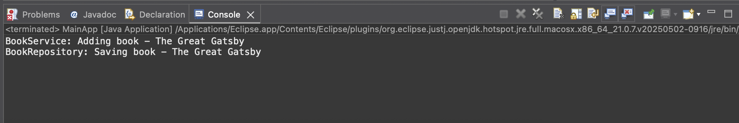dding book - " + bookName);

bookRepository.saveBook(bookName);

}

}

<?xml version="1.0" encoding="UTF-8"?>

<beans xmlns="http://www.springframework.org/schema/beans"

xmlns:xsi="http://www.w3.org/2001/XMLSchema-instance"

xsi:schemaLocation="

http://www.springframework.org/schema/beans

https://www.springframework.org/schema/beans/spring-beans.xsd">

<!-- Bean for BookRepository -->

<bean id="bookRepository" class="com.library.repository.BookRepository" />

<bean id="bookService" class="com.library.service.BookService">

<property name="bookRepository" ref="bookRepository" />

</bean>

</beans>

package com.library;

import org.springframework.context.ApplicationContext;

import org.springframework.context.support.ClassPathXmlApplicationContext;

import com.li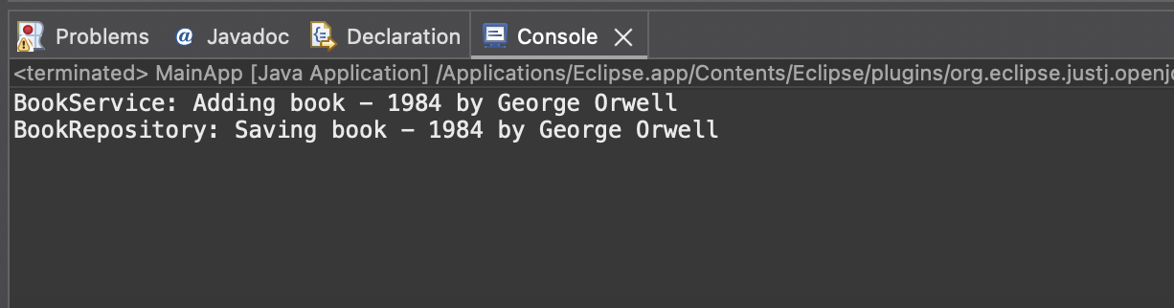brary.service.BookService;

public class MainApp {

public static void main(String[] args) {

// Load the Spring container from applicationContext.xml

ApplicationContext context = new ClassPathXmlApplicationContext("applicationContext.xml");

// Get BookService bean

BookService bookService = (BookService) context.getBean("bookService");

bookService.addBook("1984 by George Orwell");

}

}

**Exercise 4: Creating and Configuring a Maven Project**

<project xmlns="http://maven.apache.org/POM/4.0.0"

xmlns:xsi="http://www.w3.org/2001/XMLSchema-instance"

xsi:schemaLocation="http://maven.apache.org/POM/4.0.0 https://maven.apache.org/xsd/maven-4.0.0.xsd">

<modelVersion>4.0.0</modelVersion>

<groupId>com.library</groupId>

<artifactId>LibraryManagement</artifactId>

<version>0.0.1-SNAPSHOT</version>

<properties>

<maven.compiler.source>1.8</maven.compiler.source>

<maven.compiler.target>1.8</maven.compiler.target>

</properties>

<dependencies>

<!-- Spring Context (Core IoC Container) -->

<dependency>

<groupId>org.springframework</groupId>

<artifactId>spring-context</artifactId>

<version>5.3.36</version>

</dependency>

<!-- Spring AOP (Aspect Oriented Programming) -->

<dependency>

<groupId>org.springframework</groupId>

<artifactId>spring-aop</artifactId>

<version>5.3.36</version>

</dependency>

<!-- Spring WebMVC (for web applications) -->

<dependency>

<groupId>org.springframework</groupId>

<artifactId>spring-webmvc</artifactId>

<version>5.3.36</version>

</dependency>

</dependencies>

<build>

<plugins>

<!-- Maven Compiler Plugin for Java 1.8 -->

<plugin>

<artifactId>maven-compiler-plugin</artifactId>

<version>3.10.1</ver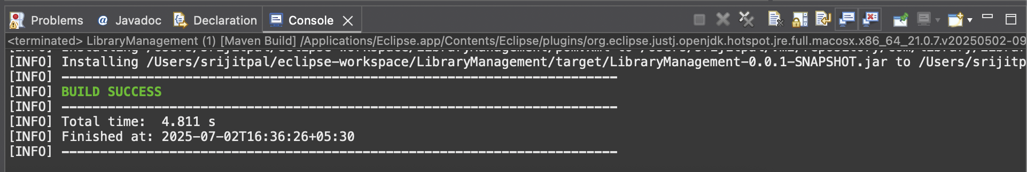sion>

<configuration>

<source>${maven.compiler.source}</source>

<target>${maven.compiler.target}</target>

</configuration>

</plugin>

</plugins>

</build>

</project>

Right-click → Run As > Maven build…

Goal: clean install → Click Run

**Exercise 5: Configuring the Spring IoC Container**

<?xml version="1.0" encoding="UTF-8"?>

<beans xmlns="http://www.springframework.org/schema/beans"

xmlns:xsi="http://www.w3.org/2001/XMLSchema-instance"

xsi:schemaLocation="

http://www.springframework.org/schema/beans

https://www.springframework.org/schema/beans/spring-beans.xsd">

<!-- Define BookRepository bean -->

<bean id="bookRepository" class="com.library.repository.BookRepository" />

<!-- Define BookService bean and inject BookRepository -->

<bean id="bookService" class="com.library.service.BookService">

<property name="bookRepository" ref="bookRepository" />

</bean>

</beans>

package com.library.service;

import com.library.repository.BookRepository;

public class BookService {

private BookRepository bookRepository;

// Setter for Spring to inject BookRepository

public void setBookRepository(BookRepository bookRepository) {

this.bookRepository = bookRepository;

}

public void addBook(String bookName) {

System.out.println("BookService: Adding book - " + bookName);

bookRepository.saveBook(bookName);

}

}

package com.library.repository;

public class BookRepository {

public void saveBook(String bookName) {

System.out.println("BookRepository: Saving book - " + bookName);

}

}

package com.library;

import org.springframework.context.ApplicationContext;

import org.springframework.context.support.ClassPathXmlApplicationContext;

import com.library.service.BookService;

public class MainApp {

p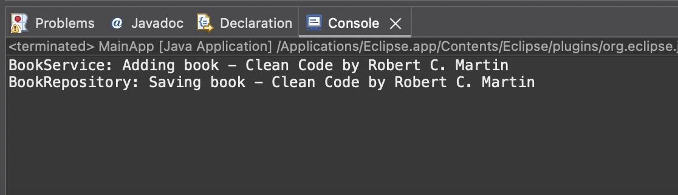ublic static void main(String[] args) {

// Load Spring context from XML

ApplicationContext context = new ClassPathXmlApplicationContext("applicationContext.xml");

// Get BookService bean

BookService bookService = (BookService) context.getBean("bookService");

// Call a method to test the wiring

bookService.addBook("Clean Code by Robert C. Martin");

}

}

**Exercise 7: Implementing Constructor and Setter Injection**

package com.library.service;

import com.library.repository.BookRepository;

public class BookService {

private BookRepository bookRepository;

private String serviceName; // example of constructor-injected primitive

// Constructor injection for serviceName

public BookService(String serviceName) {

this.serviceName = serviceName;

}

// Setter injection for BookRepository

public void setBookRepository(BookRepository bookRepository) {

this.bookRepository = bookRepository;

}

public void addBook(String bookName) {

System.out.println("[" + serviceName + "] BookService: Adding book - " + bookName);

bookRepository.saveBook(bookName);

}

}

package com.library.repository;

public class BookRepository {

public void saveBook(String bookName) {

System.out.println("BookRepository: Saving book - " + bookName);

}

}

<?xml version="1.0" encoding="UTF-8"?>

<beans xmlns="http://www.springframework.org/schema/beans"

xmlns:xsi="http://www.w3.org/2001/XMLSchema-instance"

xsi:schemaLocation="

http://www.springframework.org/schema/beans

https://www.springframework.org/schema/beans/spring-beans.xsd">

<!-- Bean for BookRepository -->

<bean id="bookRepository" class="com.library.repository.BookRepository" />

<!-- Bean for BookService with constructor and setter injection -->

<bean id="bookService" class="com.library.service.BookService">

<!-- Constructor injection -->

<constructor-arg value="Library Management Service" />

<!-- Setter injection -->

<property name="bookRepository" ref="bookRepository" />

</bean>

</beans>

package com.library;

import org.springframework.context.ApplicationContext;

import org.springframework.context.support.ClassPathXmlApplicationContext;

import com.library.service.BookService;

public class MainApp {

public static void main(String[] args) {

ApplicationContext context = new ClassPathXmlApplicationContext("applicationContext.xml");

BookService bookService = (BookService) context.getBean("bookService");

bookService.addBook("The Pragmatic Programmer");

}

}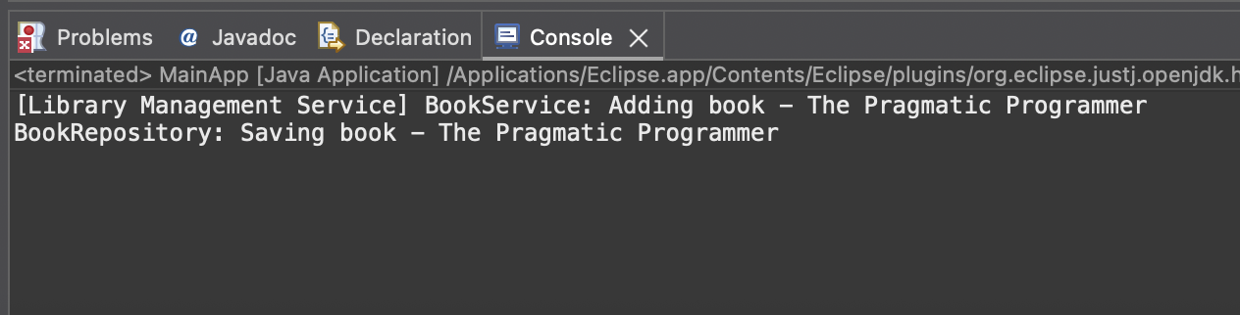

**Exercise 9: Creating a Spring Boot Application**

# H2 in-memory DB

spring.datasource.url=jdbc:h2:mem:librarydb

spring.datasource.driverClassName=org.h2.Driver

spring.datasource.username=sa

spring.datasource.password=

# Hibernate

spring.jpa.database-platform=org.hibernate.dialect.H2Dialect

spring.jpa.hibernate.ddl-auto=update

# H2 Console

spring.h2.console.enabled=true

spring.h2.console.path=/h2-console

package com.library.LibraryManagement;

import org.springframework.boot.SpringApplication;

import org.springframework.boot.autoconfigure.SpringBootApplication;

@SpringBootApplication

public class LibraryManagementApplication {

public static void main(String[] args) {

SpringApplication.run(LibraryManagementApplication.class, args);

}

}

package com.library.LibraryManagement.entity;

import jakarta.persistence.*;

@Entity

public class Book {

@Id

@GeneratedValue(strategy = GenerationType.IDENTITY)

private Long id;

private String title;

private String author;

public Book() {}

public Book(String title, String author) {

this.title = title;

this.author = author;

}

// Getters and Setters

public Long getId() { return id; }

public String getTitle() { return title; }

public void setTitle(String title) { this.title = title; }

public String getAuthor() { return author; }

public void setAuthor(String author) { this.author = author; }

}

package com.library.LibraryManagement.repository;

import com.library.LibraryManagement.entity.Book;

import org.springframework.data.jpa.repository.JpaRepository;

public interface BookRepository extends JpaRepository<Book, Long> {

}

package com.library.LibraryManagement.controller;

import com.library.LibraryManagement.entity.Book;

import com.library.LibraryManagement.repository.BookRepository;

import org.springframework.beans.factory.annotation.Autowired;

import org.springframework.web.bind.annotation.*;

import java.util.List;

@RestController

@RequestMapping("/api/books")

public class BookController {

@Autowired

private BookRepository bookRepository;

@GetMapping

public List<Book> getAllBooks() {

return bookRepository.findAll();

}

@PostMapping

public Book addBook(@RequestBody Book book) {

return bookRepository.save(book);

}

@GetMapping("/{id}")

public Book getBookById(@PathVariable Long id) {

return bookRepository.findById(id).orElse(null);

}

@PutMapping("/{id}")

public Book updateBook(@PathVariable Long id, @RequestBody Book updatedBook) {

return bookRepository.findById(id).map(book -> {

book.setTitle(updatedBook.getTitle());

book.setAuthor(updatedBook.getAuthor());

return bookRepository.save(book);

}).orElse(null);

}

@DeleteMapping("/{id}")

public void deleteBook(@PathVariable Long id) {

bookRepository.deleteById(id);

}

}

