# Creating Microservices for account and loan

## Account Microservice

package com.cognizant.account.controller;

import org.springframework.web.bind.annotation.GetMapping;

import org.springframework.web.bind.annotation.PathVariable;

import org.springframework.web.bind.annotation.RestController;

import java.util.Map;

@RestController

public class AccountController {

@GetMapping("/accounts/{number}")

public Map<String, Object> getAccountDetails(@PathVariable String number) {

return Map.of(

"number", number,

"type", "savings",

"balance", 234343

);

}

}

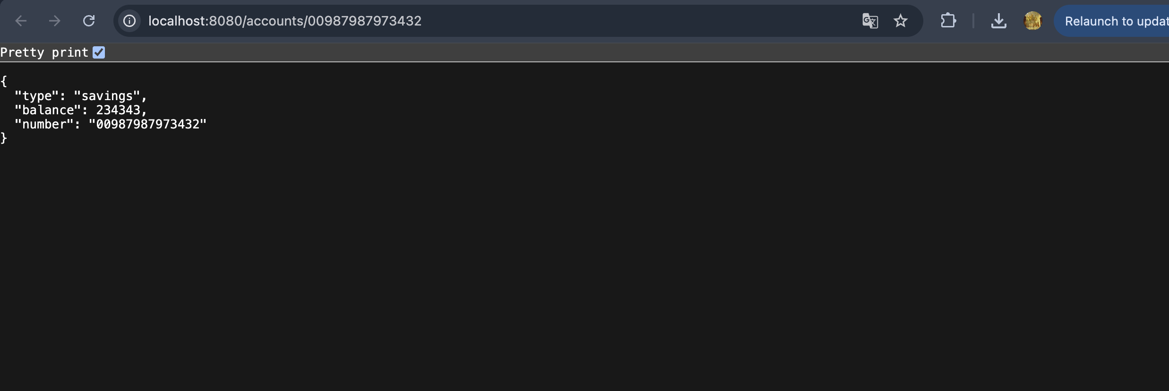

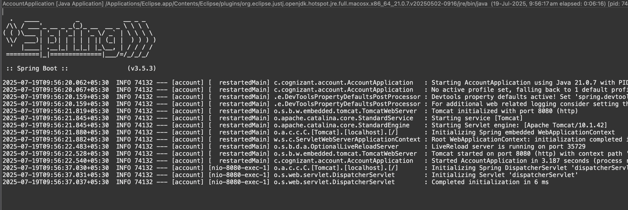

## Loan Microservice

server.port=8081

package com.cognizant.loan.controller;

import org.springframework.web.bind.annotation.GetMapping;

import org.springframework.web.bind.annotation.PathVariable;

import org.springframework.web.bind.annotation.RestController;

import java.util.Map;

@RestController

public class LoanController {

@GetMapping("/loans/{number}")

public Map<String, Object> getLoanDetails(@PathVariable String number) {

return Map.of(

"number", number,

"type", "car",

"loan", 400000,

"emi", 3258,

"tenure", 18

);

}

}

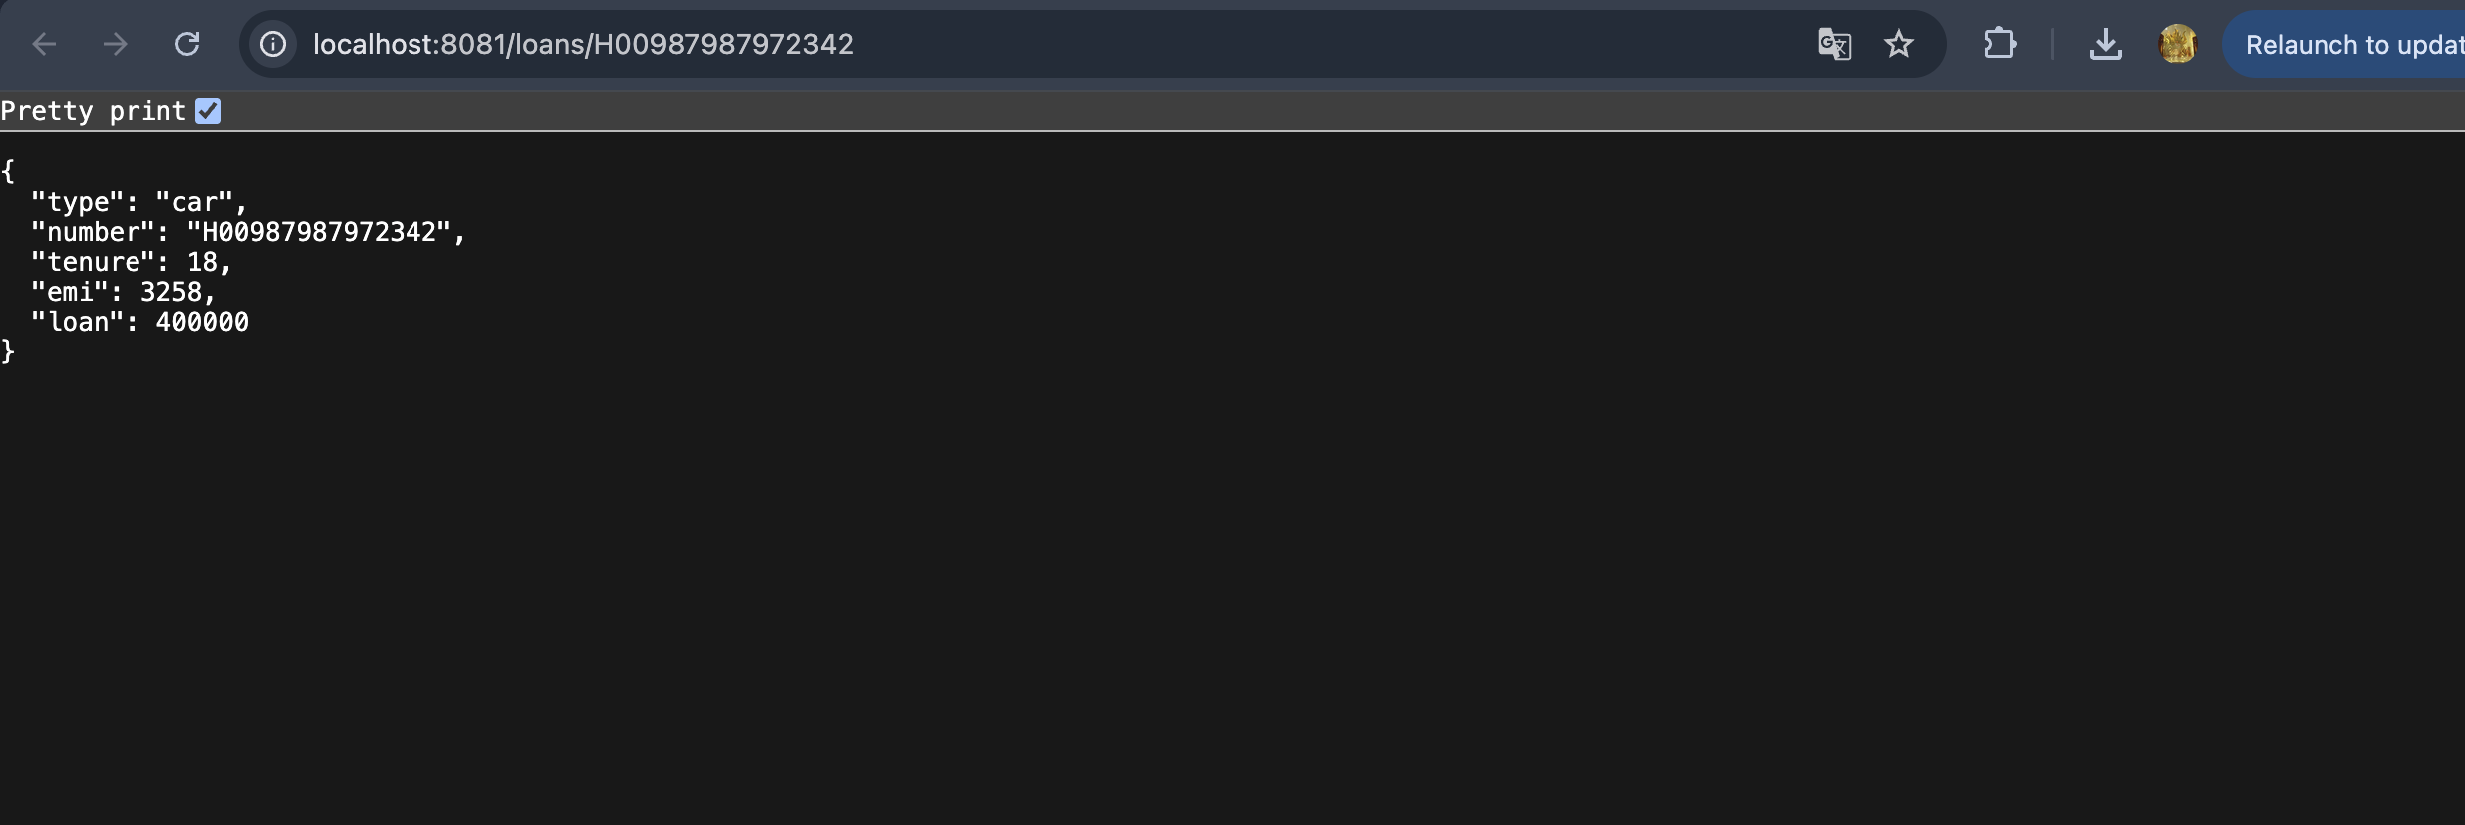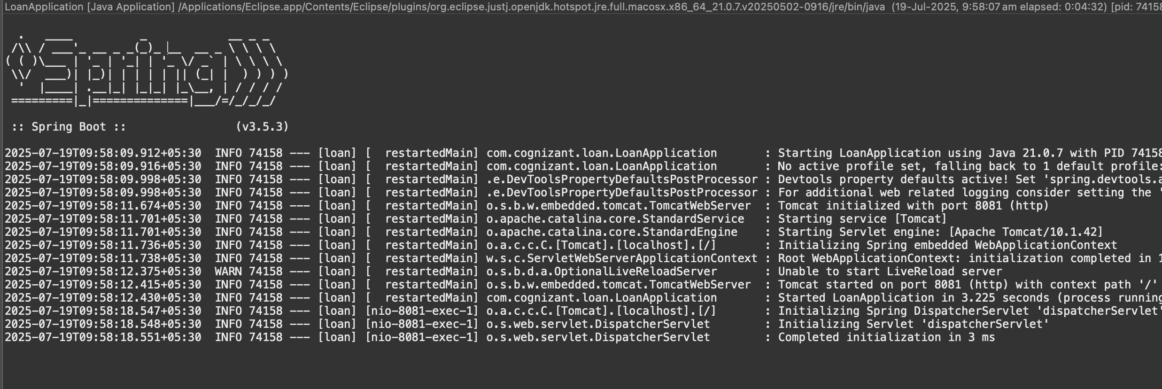

## To switch between different consoles use the monitor icon within the console view :

