# 1. ReactJS-HOL

import './App.css';

function App() {

return (

<h1 className='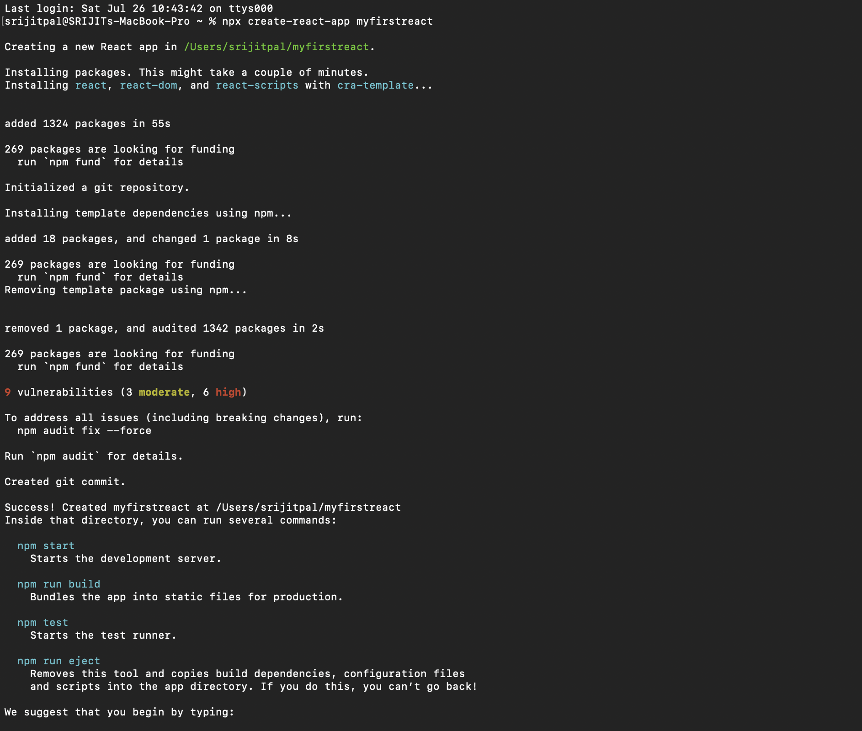App'>Welcome to the first session of React</h1>

);

}

export default App;

# 2. ReactJS-HOL

import React,{Component} from 'react'

class Home extends Component{

render(){

return(

<div>

<h3>Welcome to the Home Page of Student Management</h3>

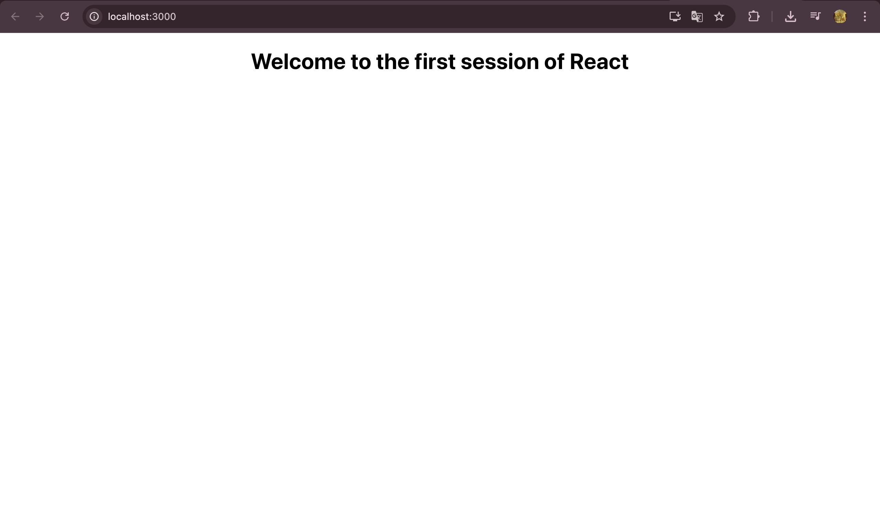

</div>

);

}

}

export default Home;

import React,{Component} from 'react'

class Contact extends Component{

render(){

return(

<div>

<h3>Welcome to the Contact Page of Student Management Portal</h3>

</div>

);

}

}

export default Contact;

import React,{Component} from 'react'

class About extends Component{

render(){

return(

<div>

<h3>Welcome to the About Page of Student Management Portal</h3>

</div>

);

}

}

export default About;

import './App.css';

import About from './components/About';

import Contact from './components/Contact';

import Home from './components/Home';

function App() {

return (

<div className="App">

<Home/>

<About/>

<Contact/>

</div>

);

}

export default App;

# 3. ReactJS-HOL

import '../Stylesheets/mystyle.css';

const percentToDecimal = (decimal) => {

return (decimal.toFixed(2) + '%')

}

const calcScore = (total, goal) => {

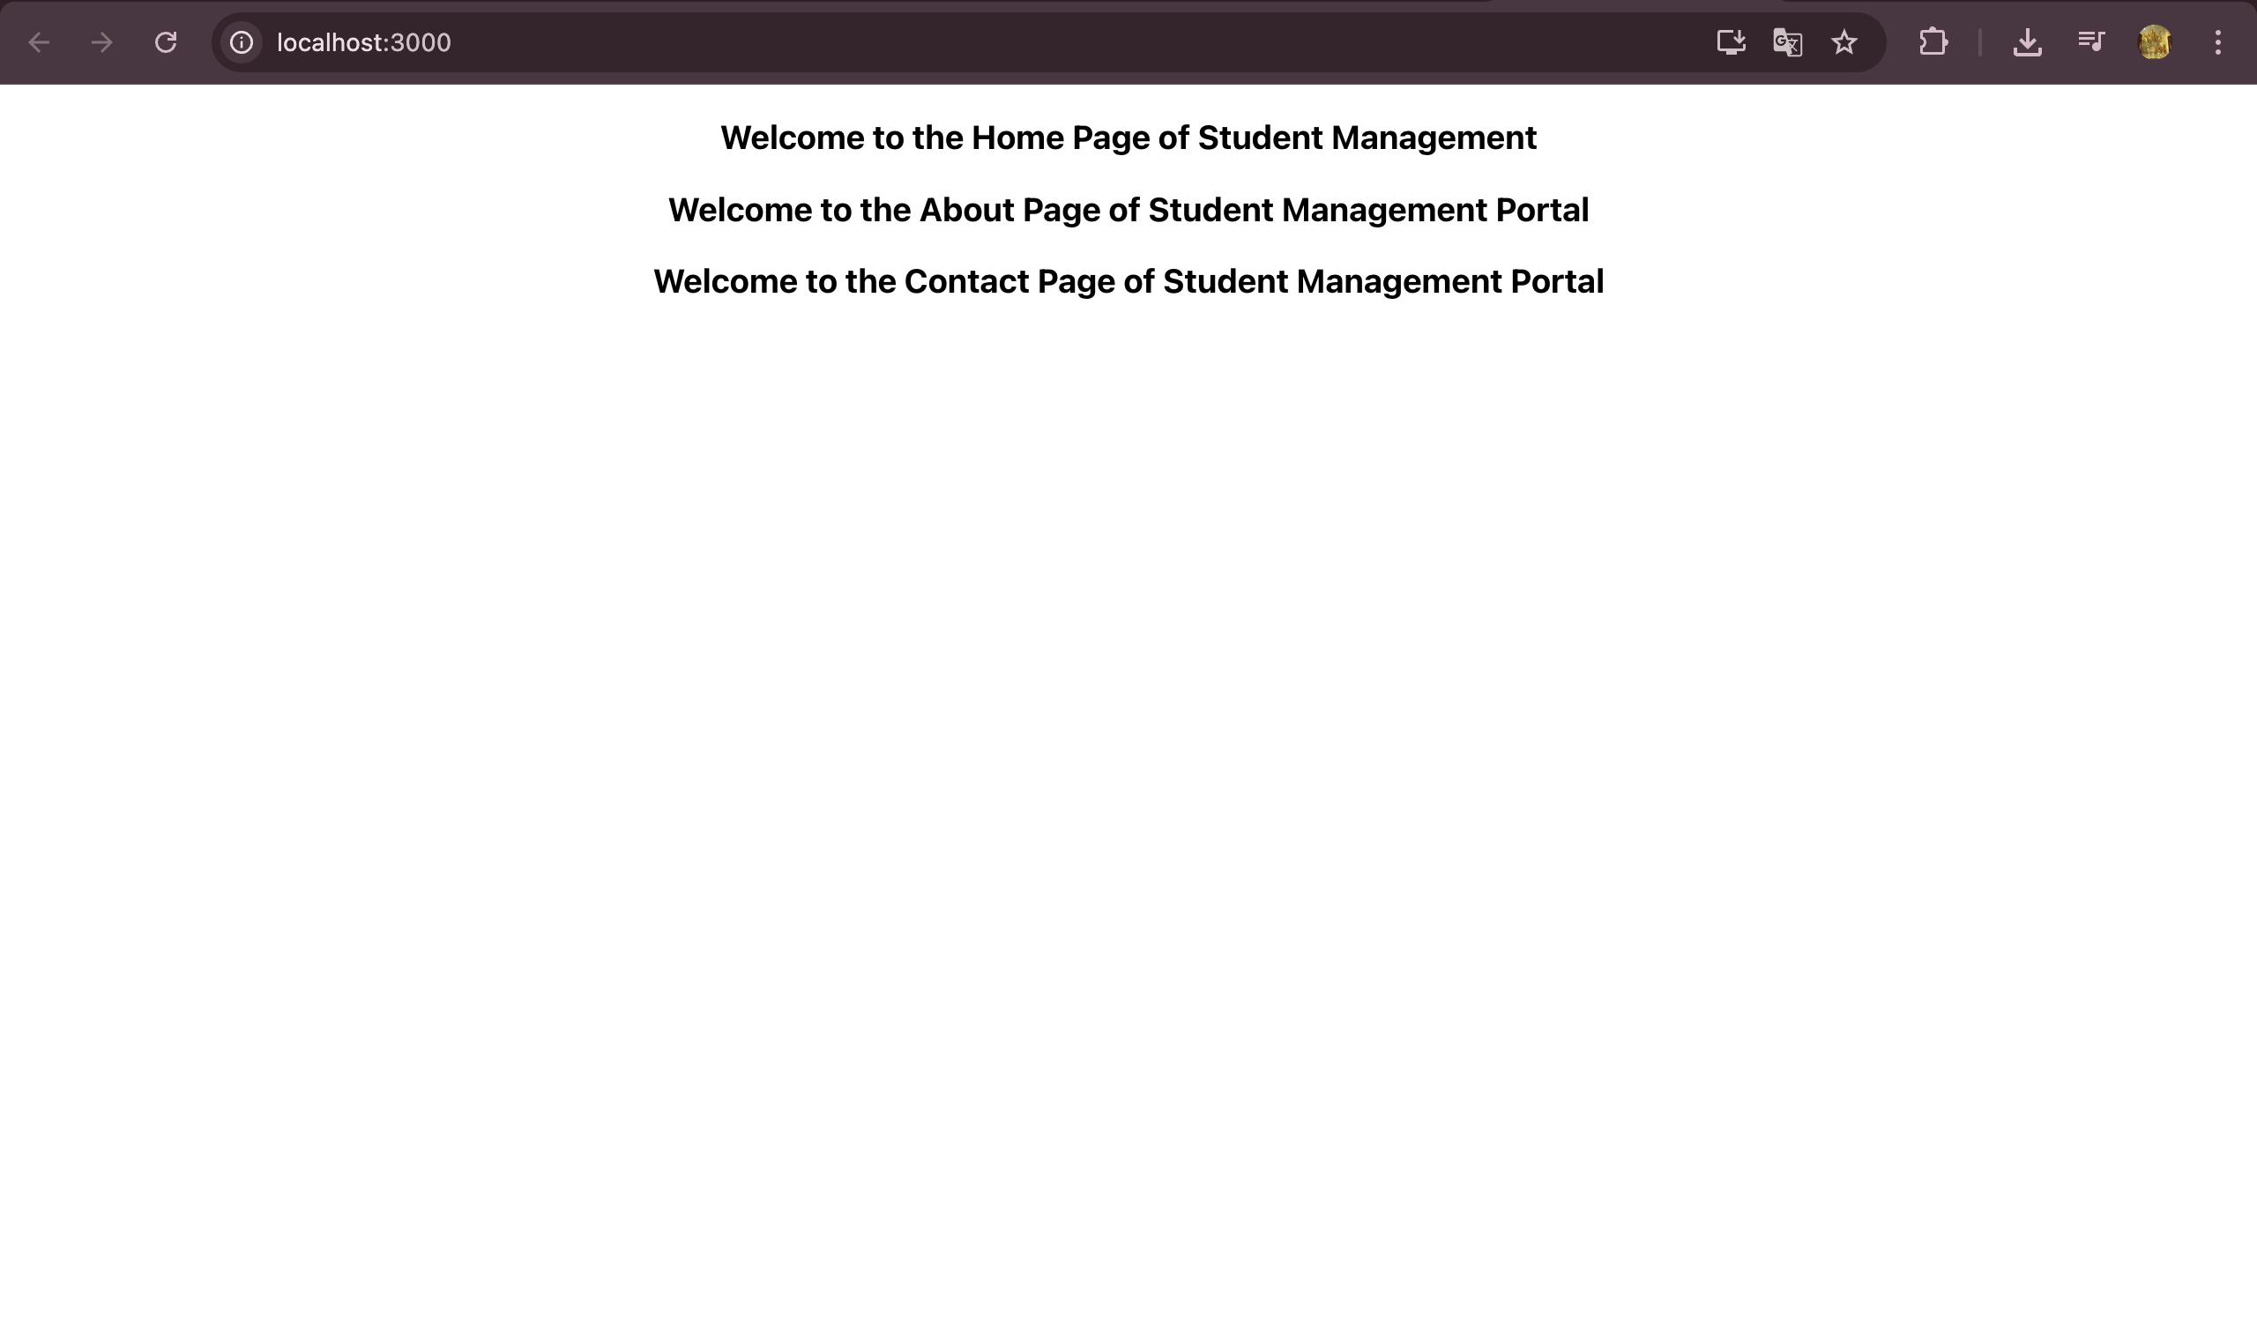

return percentToDecimal(total / goal)

}

export const CalculateScore = ({ Name, School, total, goal }) => (

<div className="formatstyle">

<h1><font color="Brown">Student Details:</font></h1>

<div className="Name">

<b><span> Name: </span></b>

<span>{Name}</span>

</div>

<div className="School">

<b><span> School: </span></b>

<span>{School}</span>

</div>

<div className="Total">

<b><span>Total:</span></b>

<span>{total}</span>

<span> Marks</span>

</div>

<div className="Score">

<b>Score:</b>

<span>

{calcScore(

total,

goal

)}

</span>

</div>

</div>

)

.Name {

font-weight: 300;

color: blue;

}

.School {

color: crimson;

}

.Total {

color: darkmagenta;

}

.formatstyle {

text-align: center;

font-size: large;

}

.Score {

color: forestgreen;

}

import { CalculateScore } from './Components/CalculateScore';

function App() {

return (

<div>

<CalculateScore

Name={"Steeve"}

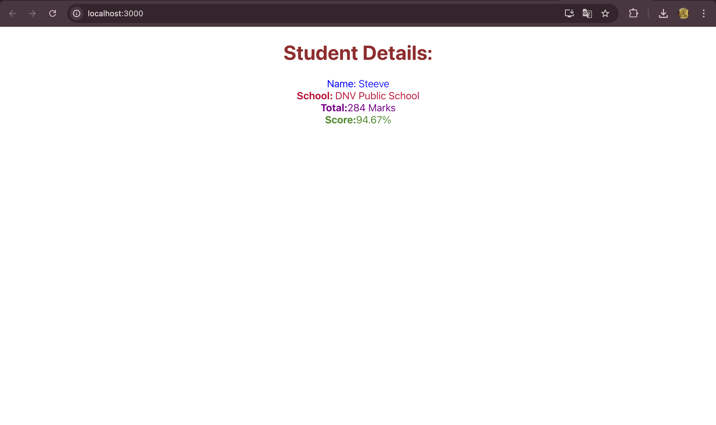

School={"DNV Public School"}

total={284}

goal={3}

/>

</div>

);

}

export default App;

# 4. ReactJS-HOL

class Post {

constructor(id, title, body) {

this.id = id;

this.title = title;

this.body = body;

}

}

export default Post;

import React from "react";

import Post from "./Post";

class Posts extends React.Component {

constructor(props) {

super(props);

this.state = {

posts: []

};

}

loadPosts() {

fetch("https://jsonplaceholder.typicode.com/posts")

.then(response => response.json())

.then(data => {

const postsData = data.map(

item => new Post(item.id, item.title, item.body)

);

this.setState({ posts: postsData });

})

.catch(error => {

console.error("Error fetching posts:", error);

});

}

componentDidMount() {

this.loadPosts();

}

componentDidCatch(error, info) {

alert("Something went wrong: " + error);

}

render() {

return (

<div>

<h1>Blog Posts</h1>

{this.state.posts.map(post => (

<div key={post.id}>

<h2>{post.title}</h2>

<p>{post.body}</p>

</div>

))}

</div>

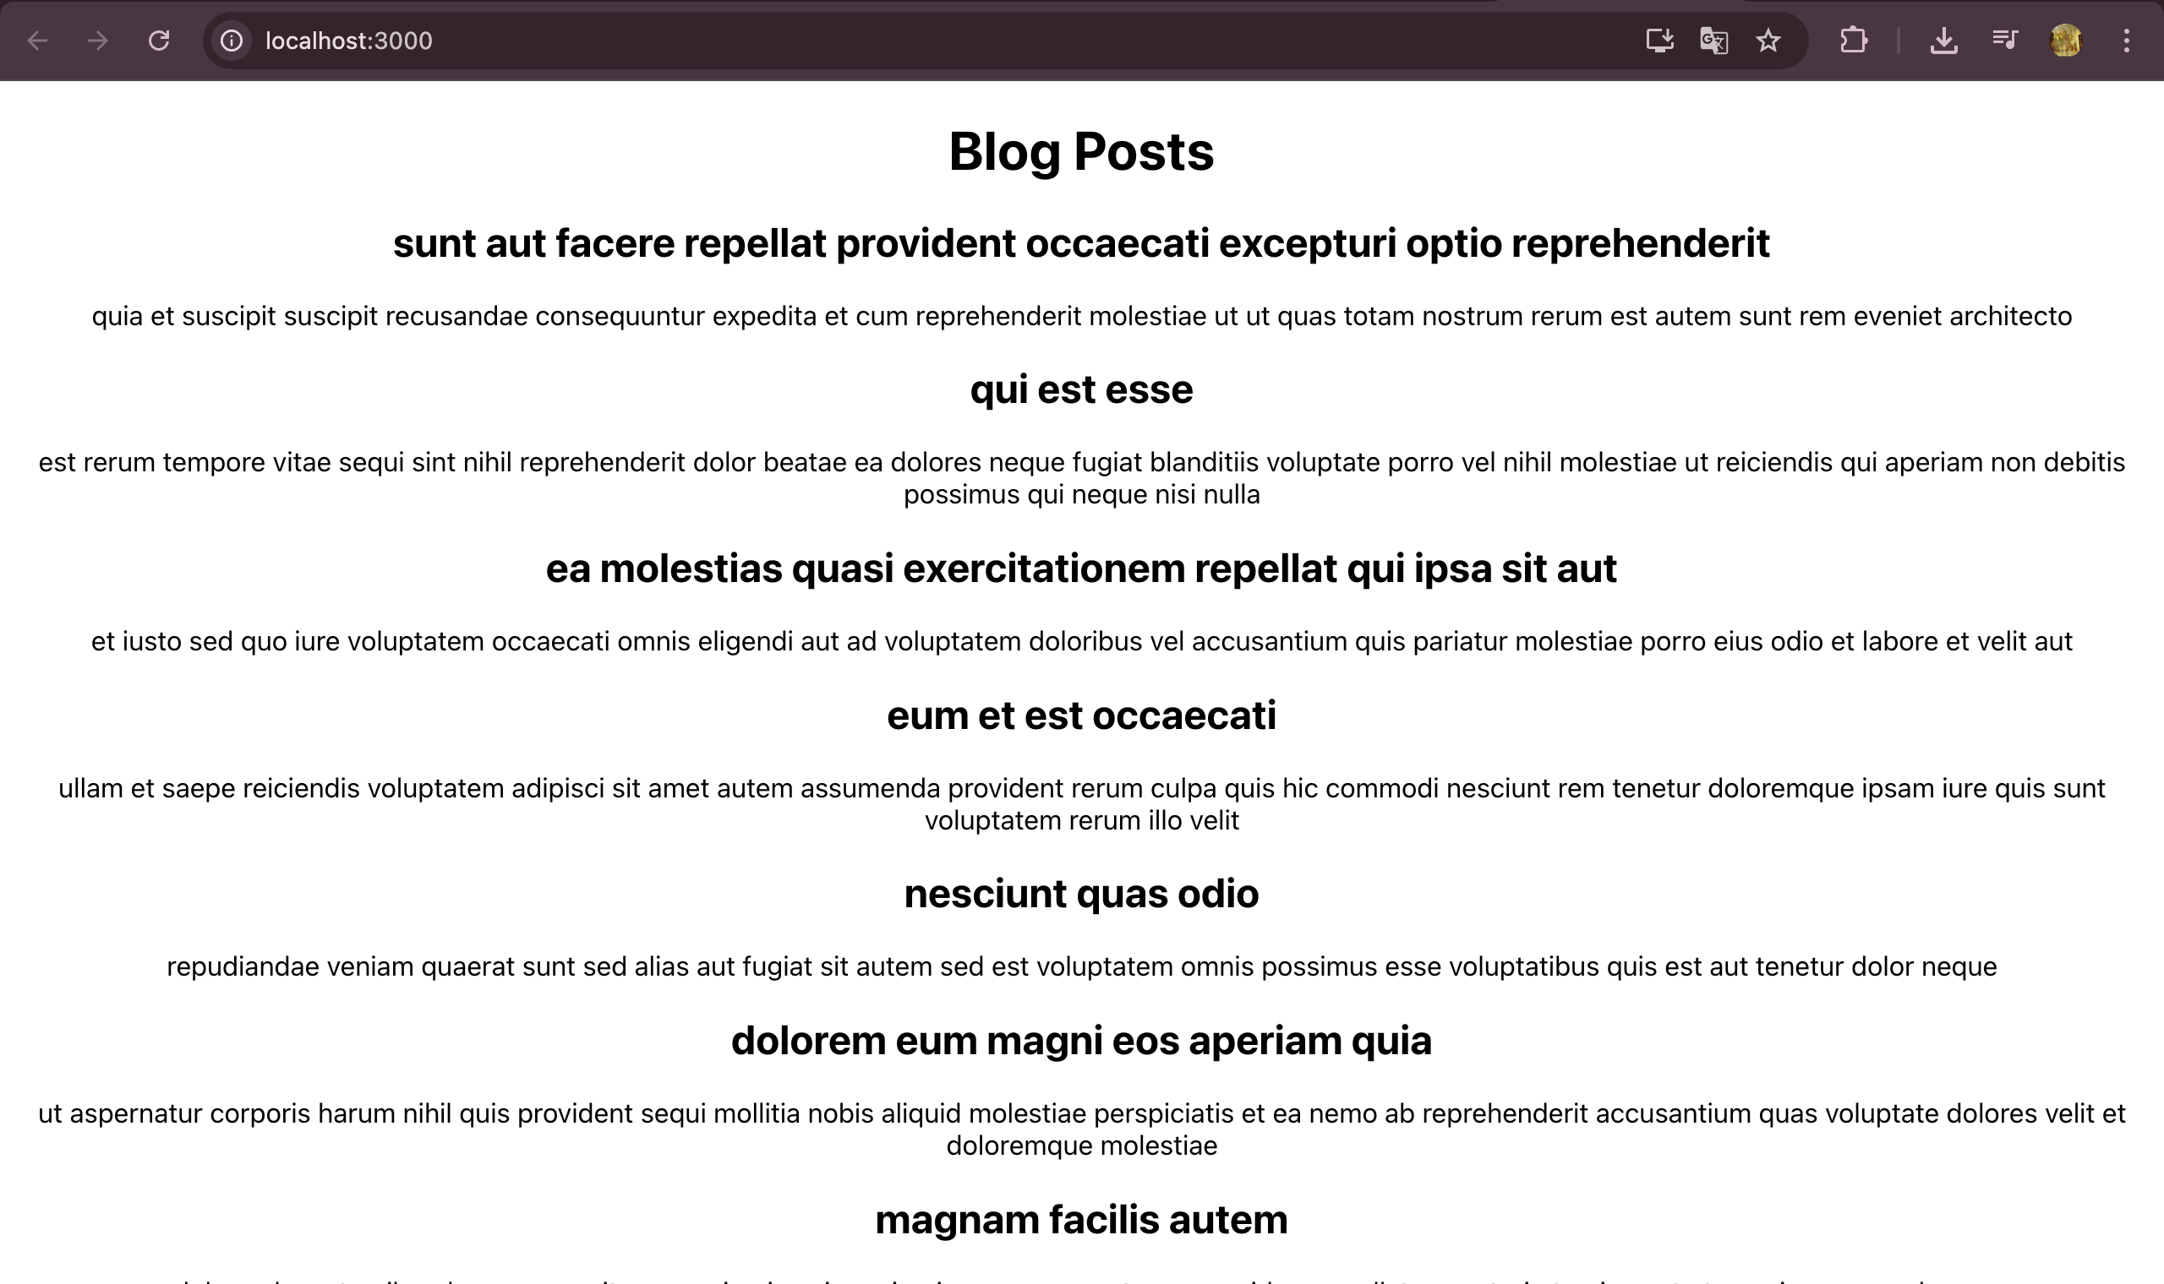

);

}

}

export default Posts;

import './App.css';

import Posts from "./Posts";

function App() {

return (

<div className="App">

<Posts />

</div>

);

}

export default App;

# 5. ReactJS-HOL

import React from "react";

import styles from "./CohortDetails.module.css";

const CohortDetails = ({ cohort }) => {

return (

<div className={styles.box}>

<h3

style={{

color: cohort.status.toLowerCase() === "ongoing" ? "green" : "blue"

}}

>

{cohort.cohortName}

</h3>

<dl>

<dt>Started On</dt>

<dd>{cohort.startedOn}</dd>

<dt>Current Status</dt>

<dd>{cohort.status}</dd>

<dt>Coach</dt>

<dd>{cohort.coach}</dd>

<dt>Trainer</dt>

<dd>{cohort.trainer}</dd>

</dl>

</div>

);

};

export default CohortDetails;

.box {

width: 300px;

display: inline-block;

margin: 10px;

padding: 10px 20px;

border: 1px solid black;

border-radius: 10px;

}

dt {

font-weight: 500;

}

import './App.css';

import CohortDetails from "./CohortDetails";

function App() {

const cohorts = [

{

cohortName: "INTADMDf10 -.NET FSD",

startedOn: "22-Feb-2022",

status: "Scheduled",

coach: "Aathma",

trainer: "Jojo Jose"

},

{

cohortName: "ADM21JF014 -Java FSD",

startedOn: "10-Sep-2021",

status: "Ongoing",

coach: "Apoov",

trainer: "Elisa Smith"

},

{

cohortName: "CDBJF21025 -Java FSD",

startedOn: "24-Dec-2021",

status: "Ongoing",

coach: "Aathma",

trainer: "John Doe"

}

];

return (

<div>

<h1>Cohorts Details</h1>

{cohorts.map((cohort, index) => (

<CohortDetails key={index} cohort={cohort} />

))}

</div>

);

}

export default App;

